Master's thesis planning report

Accessibility of teaching materials
Exploring obtainability and testing usability in design of shareable teaching materials

Introduction // Seb

Background
Teaching materials encompass many different things. In the context of this study, they are materials that are used in a teaching situation with students, but chosen by the teacher, and that are shareable and reusable by many teachers. It's essentially a limitation of the concept of OER, or Open Educational Resources [Källa: UNESCO]:
“Open Educational Resources (OERs) are any type of educational materials that are in the public domain or introduced with an open license. The nature of these open materials means that anyone can legally and freely copy, use, adapt and re-share them. OERs range from textbooks to curricula, syllabi, lecture notes, assignments, tests, projects, audio, video and animation.”
While OER can be used by students independently, this thesis limits its focus by defining teaching materials as such that are chosen and used directly by teachers. The reason for choosing this focus is because of the complex role a teacher plays in education. While the Swedish education system consists of many other actors, such as students, principals, administrators, school curriculum writers, parents, and more, the teacher is often one who has to take into consideration the many different interests of these actors [KÄLLA]. Even if it's the goal of the educational system to teach the students, taking the teacher's perspective into consideration therefore becomes an important aspect of designing effective teaching materials.
- The teacher's roles have been expanded. Also mentions the control systems putting pressure on teachers: https://muep.mau.se/bitstream/handle/2043/9960/Examens%20Arbete%20HT%2009.pdf?sequence=1
- Var går gränsen för lärarens ansvar? https://pedagogiskamagasinet.se/var-gar-gransen-for-larares-ansvar/
- Don't reinvent the wheel.
- About school segregation in Sweden: https://www.skolinspektionen.se/globalassets/publikationssok/granskningsrapporter/kvalitetsgranskningar/2014/segregation/kvalgr-segregation-slutrapport.pdf
- Mentions law about segregation: https://www.skolverket.se/om-skolverket/publikationer/visa-enskild-publikation?_xurl_=http%3A%2F%2Fwww5.skolverket.se%2Fwtpub%2Fws%2Fskolbok%2Fwpubext%2Ftrycksak%2FBlob%2Fpdf2204.pdf%3Fk%3D2204
- The magical OECD report: “Despite the large effect of teachers on student performance, disadvantaged schools are not always staffed with the highest quality teachers. Policies must raise teacher quality for disadvantaged schools and students by: providing targeted teacher education to ensure that teachers receive the skills and knowledge they need for working in schools with disadvantaged students; providing mentoring programmes for novice teachers; developing supportive working conditions to improve teacher effectiveness and increase teacher retention; and develop adequate financial and career incentives to attract and retain high quality teachers in disadvantaged schools.“,
mentions successful strategies: “Systemic support can also take the shape of extra resources and more teacher time, to have time to participate actively in networks and for common planning, and guidance on improving expertise, among others (Reynolds et al, 2002).”, “Formal common planning time at school. The reorganisation of the timetable to allow block release for professional learning teams, and for the collaborative planning of strategies for improvement, can lead to a strong alignment between staff in the school and to tangible results.”: https://www.oecd.org/education/school/50293148.pdf
- Historical and current perspective on the use of the maths book as a basis for education, with a lot of criticism of how the books define what mathematics is for a lot of teachers and students: http://www.diva-portal.se/smash/get/diva2:646710/FULLTEXT01.pdf
Even more perspectives on maths books through history, including an awesome comparison of the different curriculums (läroplaner) through the years, and their level of detail/control: https://muep.mau.se/bitstream/handle/2043/3734/Microsoft%20Word%20-%20Abqari_Shaur_Valfridsson%5B1%5D.pdf?sequence=1&isAllowed=y
- OER; “OER are teaching, learning, and research resources that reside in the public domain or have been released under an intellectual property license that permits their free use and re-purposing by others. Open educational resources include full courses, course materials, modules, textbooks, streaming videos, tests, software, and any other tools, materials, or techniques used to support access to knowledge.": https://wiki.creativecommons.org/wiki/What_is_OER%3F
- A report on the accessibility of OER; “Knowing where to find resources is one of the biggest challenges to using OER”, “General knowledge of well-established OER repositories is low”, “Only 5% of educators say they don’t share information about OER”, “The more educators use OER, the more they are willing to share”, “Only 12.4% of educators create resources and publish them on a Creative Commons license”, “Videos are the most common type of OER used”, "Cost of and access to materials can have an effect on student retention” https://oerresearchhub.files.wordpress.com/2014/11/oerrh-evidence-report-2014.pdf
- Background stuff on usability testing. Important stuff.

Purpose
The aim of the thesis is to study how design of teaching materials affect their accessibility from a teacher's perspective. Accessibility in this study is defined as the following description in the Oxford dictionary [KÄLLA: https://en.oxforddictionaries.com/definition/accessibility]
“The quality of being easy to obtain or use.”
With this definition, there is both a use aspect and an obtainability aspect to accessibility. Since this thesis aims to study the design of teaching materials, the use aspect is prioritized over the obtainability aspect. However, if relevant for certain cases, obtainability of a material might be studied as well.
Studying accessibility from a teacher's perspective means to study how a teaching material's design affects its accessibility for a teacher, not for the teacher's students or others actor involved in the teaching process. The reason for picking this focus is because the teacher is in a position where accessibility is very important: They need to take into consideration factors such as the students' previous knowledge, the school curriculum, time management, classroom leadership, and more. This also means that the material's accessibility is, hypothetically, tested against several factors at once.
Summarized:
- The aim of the thesis is to study how the design of teaching materials affect their accessibility from a teacher's perspective, where accessibility is defined as being easy to obtain and use.

Goals
The goals of the thesis are described in the form of multiple deliverables. The deliverables are as follows.

Target groups and how to share the deliverables // Ska vi flytta denna del till metodkapitlet?
While the final report and presentation are technically open to the public, many of our target groups will not likely take part of these resources. To make our results more accessible to the public we propose a few ways to share them with the following audiences:
- Swedish school teachers: There are multiple social media groups where resources like ours are shared, where it’s easy to upload files and show a summary of our findings to teachers who might be interested. The schools and teachers that we cooperate with might also want to take part of our results and should therefore be handed the deliverables in an accessible format.
- Students and alumni at Lärande och Ledarskap. These may partake in the presentation, and they have multiple social media groups and similar places where we can share the deliverables that they might be interested in.
- Engineers that work with Knowledge Management or similar subjects: [uh, actually, how do we reach these?]
- [Kleindagarna? Studion? Chalmers-institutioner?]

Testing methods
With our testing methods we hope to develop a simple yet effective way of studying the accessibility of teaching materials. Inspired by Steve Krug’s usability testing script, we want to make our methods similarly accessible to those who are interested in making effective teaching materials.
- A Steve Krug-like script for doing usability testing of teaching materials.
- An evaluation of the testing methods from several perspectives: Its time and resource requirements, its reliability and validity, what kind of information it gives, and eventual other things that we discover with it.

Models that facilitate the making of teaching materials
During our testing we expect to create and think about new models that describe the process of making teaching materials. We hope that some of these will be useful for understanding the process and for finding new ways of improving one’s ways of creating materials. In that case, making them accessible to the public might be advantageous.
- A description of each model and how it’s thought to be used.
- And evaluation of each model that describes eventual areas of improvement and what the model might be useful for.

Teaching materials
While we expect to use a lot of existing teaching materials for testing instead of spending a lot of time making it from scratch, there’s also the possibility of improving these materials as part of the testing process. For example, we might try to “patch” one of the shortcomings of one material, and test how this patch changes its quality. Similarly, we might create instructions to increase the accessibility of some materials to the test subjects. In such cases, sharing the improved materials might give something of value to teachers that they may be relevant to.
- The materials themselves in the form of digital copies or blueprints.
- A summarized evaluation of each material according to the test results in the final report.
- Instructions for how each material can be used, and how one can take part of its benefits.

Testing results
[The testing results are practically our final report, and I was unsure whether this deliverables chapter would be a “non-final report chapter” or “everything we will deliver chapter.” I’m leaning toward the latter.]

Ethical discussion: Different design goals for teaching materials
While it's easy to assume that the gained knowledge from the study will be used to improve how teaching materials are designed, there are a couple of other possible outcomes to consider. For example, do shared teaching materials increase or decrease teacher workload, and how does access to these materials affect segregation in schools? While the thesis doesn't aim to answer these questions directly, they are important to consider in design decisions around teaching materials, and therefore become an important part of the study.

Possible effects on teachers' work load
Teaching materials may hypothetically be used to decrease teachers' work load by shifting the responsibility for lesson design somewhere else. Decisions such as how to divide the students into groups can be delegated to the material designer, who can share the material practically infinite times through the use of digital tools. Compared to letting every teacher create their own material without sharing it, shareable materials would decrease the work load overall. However, this assumes optimal conditions, such as the material not needing any adaptation that depend on specific needs. Furthermore, long-term effects such as the teacher-per-student ratio changing might leave the workload of every teacher unaffected.

Possible effects on segregation
Shared teaching materials can hypothetically be used to decrease segregation, by providing access to knowledge and resources to schools that lacked them before. For example, teachers who have less time to spend on designing materials might delegate the design process to teachers who have more time. [LÄGG IN KÄLLA OM SEGREGATION OCH LÄRARNAS FOKUS] However, this also assumes that the material is easily shared between teachers without too much work required on adapting it. It also assumes that teachers in schools that need the materials actually gain access to it. Even if it would be possible for every teacher to download a material from a public website, it's possible that not every teacher knows about the website and the material, which is especially important to consider in this study when analyzing how obtainable certain teaching materials are.

Teaching materials as a technology
Since it's not obvious what the implications of shared teaching materials could be, it's important to stay critical and discuss the effects of certain material designs during the study. [WEB OF TECHNOLOGY: URSULA FRANKLIN]. A certain perspective that can be used is one by U. Franklin, in the book and lecture series The Real World of Technology [KÄLLA: RWoT]. In it, she discusses technology as a complex system:
“Technology is not the sum of the artifacts, of the wheels and gears, of the rails and electronic transmitters. Technology is a system. It entails far more than its individual material components. Technology involves organization, procedures, symbols, new words, equations, and, most of all, a mindset.” - The Real World of Technology
“Personally, I much prefer to think in terms not of systems but of a web of interactions. This allows me to see how stresses on one thread affect all others. The image also acknowledges the inherent strength of a web and recognizes the existence of patterns and designs.”- RWoT, p.95
Teaching materials can be viewed as a technology. As such, it affects how a teacher does their work in complex ways. For example, as Franklin also notes, materials can be used both to assist teachers in their lesson design, or to make them comply to certain standards and control structures. Therefore, it becomes important to consider effects on the teacher's work as a whole, instead of limiting the analysis to a specific lesson.
Applied to our study, seeing teaching materials as a technology means considering the teacher's work holistically when discussing design decisions and test results. Here are some examples of considerations to include:
- How the design of the material limits as well as enables the teacher to work in certain ways,
- What kinds of schools and institutions the material will be available to,
- How the material affects the teacher's workload,
- If the material affects how the teacher's institution works, for example if it involves other teachers.

Strategy, method and time plan

Risks and countermeasures // Seb
Risk | Countermeasure
Teachers stop working in the middle of the project due to the summer holidays. This creates several challenges. It gives us limited time to contact the teachers and plan the tests together with them. It might also make it more difficult to convince them to participate. | We simplify the testing method early to avoid logistical problems that are time consuming both for us and the teachers, making it easier to book meeting and testing sessions with teachers. Furthermore we make the tests executable outside an active lesson, thus making it possible to do some of them during the school summer holidays.  In case it still becomes difficult to execute tests during the summer, it's also possible to continue working on materials according to the analysis and results of the tests, and to refine the knowledge gained through various other sources, such as literature studies.
The tests are done independently by different people, resulting in different interpretations of the testing method. | The plan is primarily to do tests in pairs, and thus the different interpretations will likely be noticed and dealt with on the spot. The tests are also done via manuscripts and templates, which standardizes them somewhat.
Data won’t be comparable. For example, multiple test subjects might deliver vastly different data to the same teaching material without a logical explanation to this deviation. | We treat a lack of comparable data as data itself. Since our testing method itself is part of our deliverable goals, finding out its flaws is also a good result for improving it or for finding out that it's not a reliable method.
We are unable to find generally applicable guidelines for designing accessible teaching materials, possibly due to teachers having different needs and desires, therefore wanting very different material. | This is expected because of how much variation exists in teaching, especially when it comes to local needs. One of the ways to deal with this is to create a testing method that is easy to use for anyone who wants to design teaching materials. If the tests are generally applicable, they can be used to design better teaching materials for specific needs.  Another possible solution to this problem is that finding out that teachers' needs are very different and specific can be a good result in itself. For example, this can be taken into consideration when discussing design methods for teaching materials, such as if it's better to focus on a specific need for a few teachers, or to “go wide” and design for many kinds of needs.
The test results are not transferable to a real situation, such as a classroom or when a teacher actually plans a lesson. | It's difficult, if not impossible, to avoid this problem completely. If possible, some tests might be done with a real lesson, although this is difficult to do logistically. Another way to deal with it is to make sure that the testing methods don't consist of leading questions. For example,
Our scope changes, for example by trying to answer questions not thought of in the beginning of the project. | A certain level of scope change is inevitable as the project progresses, since it's a research project that explores new methods. However, it becomes a problem when scope change develops into scope creep. In that case, more time and resources are required as more features and questions are added to the goals of the project.  An important part of dealing with the scope creep is to spend time clarifying the project goals and communicate them clearly within the team. If a change of scope is needed, care should be taken so that the whole team is aware of what changes need to be done. Suggested countermeasures for this are for example holding weekly meetings where scope is discussed in some form, making sure all documents are accessible to everyone in the team, and working in the same place at the same time.
Too few test subjects. | Due to a large part of the project running during the summer, this risk is very likely, at least during part of the project. [..]

- Lack of test subjects for particular kinds of tests, forcing the project to change methods and possibly answering a different question than.
- Our focus on accessibility for teachers may lower the overall quality when it comes to student learning. Although this aspect is outside the realm of this study, it’s a possible point for discussion.
- [Lärarna har inte tid?]
- [Risk: Vi gör materialet bra på usability test, men inte bra på lektionen!]

Schedule // Håkan
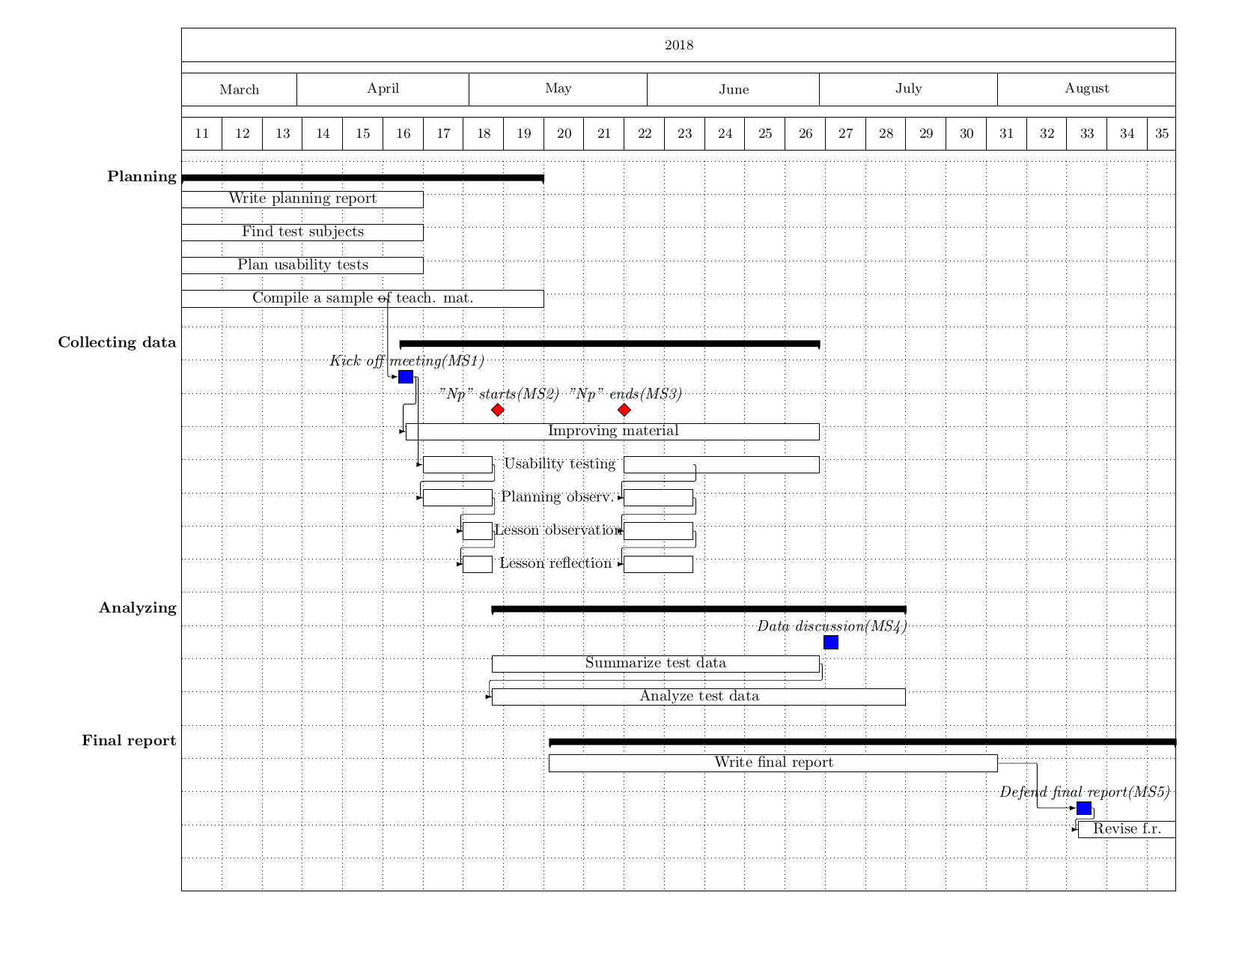
//Should we also set aside time on for example opposing another master thesis or making changes after defending the thesis? Or is this time expected to be in excess of 800 hrs?
// Schedule. Gantt n stuff. More detailed than the small project plan, obviously.
//defend report sometime in August...
// 30 hp motsvarar 800 h per person

Method // Håkan
// Describe our strategy: Create a suggestion for every school that is interested in doing and participating in tests. Also describe our two test types, the usability test and the lesson observation, or whatever we want to call them. Check the separate suggestion document for details.
// Also describe how we will test the obtainability aspect of accessibility.
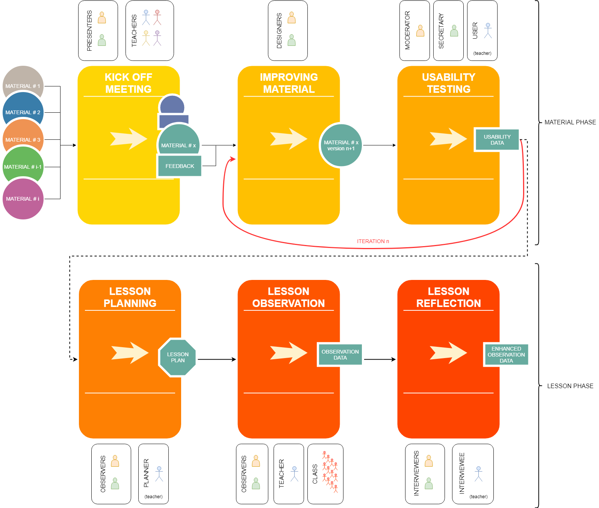

Test subject anonymity // Håkan

