Exploring efficient design of teaching materials / Usability-testing teacher accessibility (in design) of shareable teaching materials // Håkan
Master's thesis planning report

Introduction // Seb

Background
While many studies focus on how teaching materials can be designed to improve student learning, few have tackled how teaching materials can be designed for teachers to find them accessible. Teacher accessibility is a cornerstone of effective education, in that student learning suffers if a teacher can’t create efficient lessons from the given or chosen material. In a world where content creation is thriving, accessibility becomes more crucial as availability becomes more trivial.
// Check the background that I saved in a side document when I cleaned up. There are several sources there that can be used in the background to describe and motivate the study. For example, I know there is one source that explains that teachers lack knowledge of where to find materials. If unclear, we should write the background last, since it's very dependent on what we write below it. /Seb

Purpose
The aim of the thesis is to study how design of teaching materials affect their accessibility from a teacher's perspective. Accessibility in this study is defined as the following description in the Oxford dictionary [KÄLLA: https://en.oxforddictionaries.com/definition/accessibility]
“The quality of being easy to obtain or use.”
With this definition, there is both a use aspect and an obtainability aspect to accessibility. Since this thesis aims to study the design of teaching materials, the use aspect is prioritized over the obtainability aspect. However, if relevant for certain cases, obtainability of a material might be studied as well.
Studying accessibility from a teacher's perspective means to study how a teaching material's design affects its accessibility for a teacher, not for the teacher's students or others actor involved in the teaching process. The reason for picking this focus is because the teacher is in a position where accessibility is very important: They need to take into consideration factors such as the students' previous knowledge, the school curriculum, time management, classroom leadership, and more. This also means that the material's accessibility is, hypothetically, tested against several factors at once.
Summarized:
- The aim of the thesis is to study how the design of teaching materials affect their accessibility from a teacher's perspective, where accessibility is defined as the quality of being easy to obtain or use.

Goals
The goals of the thesis are described in the form of multiple deliverables which connect to an overall goal. The deliverables are as follows.

Target groups and how to share the deliverables // Ska vi flytta denna del till metodkapitlet?
While the final report and presentation are technically open to the public, many of our target groups will not likely take part of these resources. To make our results more accessible to the public we propose a few ways to share them with the following audiences:
- Swedish school teachers: There are multiple social media groups where resources like ours are shared, where it’s easy to upload files and show a summary of our findings to teachers who might be interested. The schools and teachers that we cooperate with might also want to take part of our results and should therefore be handed the deliverables in an accessible format.
- Students and alumni at Lärande och Ledarskap. These may partake in the presentation, and they have multiple social media groups and similar places where we can share the deliverables that they might be interested in.
- Engineers that work with Knowledge Management or similar subjects: [uh, actually, how do we reach these?]
- [Kleindagarna? Studion? Chalmers-institutioner?]

Testing methods
With our testing methods we hope to develop a simple yet effective way of studying the accessibility of teaching materials. Inspired by Steve Krug’s usability testing script, we want to make our methods similarly accessible to those who are interested in making effective teaching materials.
- A Steve Krug-like script for doing usability testing of teaching materials.
- An evaluation of the testing methods from several perspectives: Its time and resource requirements, its reliability and validity, what kind of information it gives, and eventual other things that we discover with it.

Models that facilitate the making of teaching materials
During our testing we expect to create and think about new models that describe the process of making teaching materials. We hope that some of these will be useful for understanding the process and for finding new ways of improving one’s ways of creating materials. In that case, making them accessible to the public might be advantageous.
- A description of each model and how it’s thought to be used.
- And evaluation of each model that describes eventual areas of improvement and what the model might be useful for.

Teaching materials
While we expect to use a lot of existing teaching materials for testing instead of spending a lot of time making it from scratch, there’s also the possibility of improving these materials as part of the testing process. For example, we might try to “patch” one of the shortcomings of one material, and test how this patch changes its quality. Similarly, we might create instructions to increase the accessibility of some materials to the test subjects. In such cases, sharing the improved materials might give something of value to teachers that they may be relevant to.
- The materials themselves in the form of digital copies or blueprints.
- A summarized evaluation of each material according to the test results in the final report.
- Instructions for how each material can be used, and how one can take part of its benefits.

Testing results
[The testing results are practically our final report, and I was unsure whether this deliverables chapter would be a “non-final report chapter” or “everything we will deliver chapter.” I’m leaning toward the latter.]

Ethical implications
While it's easy to assume that the gained knowledge from the study will be used to improve how teaching materials are designed, there are a couple of other possible outcomes to consider. For example, do shared teaching materials increase or decrease teacher workload, and how does access to these materials affect segregation in schools? While the thesis doesn't aim to answer these questions directly, they are discussed below to make room for future decisions and discussions.

Possible effects on teachers' work load
Teaching materials may hypothetically be used to decrease teachers' work load by shifting the responsibility for lesson design somewhere else. Decisions such as how to divide the students into groups can be delegated to the material designer, who can share the material practically infinite times through the use of digital tools. Compared to letting every teacher create their own material without sharing it, shareable materials would decrease the work load overall. However, this assumes optimal conditions, such as the material not needing any adaptation that depend on specific needs. Furthermore, long-term effects such as the teacher-per-student ratio changing might leave the workload of every teacher unaffected.

Possible effects on segregation
Shared teaching materials can hypothetically be used to decrease segregation, by providing access to knowledge and resources to schools that lacked them before. For example, teachers who have less time to spend on designing materials might delegate the design process to teachers who have more time. [LÄGG IN KÄLLA OM SEGREGATION OCH LÄRARNAS FOKUS] However, this also assumes that the material is easily shared between teachers without too much work required on adapting it. It also assumes that teachers in schools that need the materials actually gain access to it. Even if it would be possible for every teacher to download a material from a public website, it's possible that not every teacher knows about the website and the material, which is especially important to consider in this study when analyzing how obtainable certain teaching materials are.

Teaching materials as a technology
Since it's not obvious what the implications of shared teaching materials could be, it's important to stay critical and discuss the effects of certain material designs during the study. [WEB OF TECHNOLOGY: URSULA FRANKLIN]. A certain perspective that can be used is one by U. Franklin, in the book and lecture series The Real World of Technology [KÄLLA: RWoT]. In it, she discusses technology as a complex system:
“Technology is not the sum of the artifacts, of the wheels and gears, of the rails and electronic transmitters Technology is a system. It entails far more than its individual material components. Technology involves organization, procedures, symbols, new words, equations, and, most of all, a mindset.” - The Real World of Technology
“Personally, I much prefer to think in terms not of systems but of a web of interactions. This allows me to see how stresses on one thread affect all others. The image also acknowledges the inherent strength of a web and recognizes the existence of patterns and designs.”- RWoT, p.95
Teaching materials can be viewed as a technology. As such, it affects how a teacher does their work in complex ways. For example, as Franklin also notes, materials can be used both to assist teachers in their lesson design, or to make them comply to certain standards and control structures. Therefore, it becomes important to consider effects on the teacher's work as a whole, instead of limiting the analysis to a specific lesson.
Applied to our study, seeing teaching materials as a technology means considering the teacher's work holistically when discussing design decisions and test results. Here are some examples of considerations to include:
- How the design of the material limits as well as enables the teacher to work in certain ways,
- What kinds of schools and institutions the material will be available to,
- How the material affects the teacher's workload,
- If the material affects how the teacher's institution works, for example if it involves other teachers.
// “Any tasks that require caring, whether for people or nature, any tasks that require immediate feedback and adjustment, are best done holistically. Such tasks cannot be planned, coordinated, and controlled the way prescriptive tasks must be.” - RWoT
// “The web of technology can indeed be woven differently, but even to discuss such intentional changes of pattern requires an examination of the features of the current pattern and an understanding of the origins and the purpose of the present design.” - RWoT // Teaching materials can easily be seen as simply documents or objects, but they're part of a complex teaching process, a technology. This process is better described as a web, which the teaching material is part of. According to Franklin, we need to examine how the teaching materials relate to the teaching process as a whole to understand how it is designed effectively. Thus, part of this study lies in examining how the materials relate to the teacher's work in general – not just in the context of one particular lesson.
// “[...] the success and spread of a particular tool — and this tool can be organizational or administrative as well as mechanical — has another consequence. Any task tends to be structured by the available tools. It can appear that the available tools represent the best or even the only way to deal with a situation. […] Thus it may be wise, when communities are faced with new technological solutions to existing problems, to ask what these techniques may prevent and not only to check what the techniques promise to do.” - RWoT, p.89
- Segregation in schools and how the study affects it: obtainability, usability
// Duality: availability of the knowledge gained from the thesis vs. positive effects of sharing materials.
- Teacher stress and materials
// Duality: more or less work for teachers?

Strategy, method and time plan

Risks and bottlenecks // Seb
- We are unable to find generally applicable guidelines for designing accessible teaching materials, possibly due to teachers having different needs and desires, therefore wanting very different material. // Well we're not necessarily looking for generally applicable guidelines.
- A simple question we are trying to answer turns out to be more complex than thought. If for example teaching material accessibility turns out to be extremely dependent on its medium (PowerPoint, text document, video etc.) or the receiver (if different teachers interpret the material differently etc.).
- Our scope changes, possibly due to personal desires of answering questions not thought of in the beginning of the project.
- General lack of test subjects… (see examples below)
- Lack of test subjects for particular kinds of tests, forcing the project to change methods and possibly answering a different question than.
- Results vary depending on who conducts the testing.
- Data won’t be comparable. If for example multiple test subjects deliver vastly different data to the same teaching material and there is no logical explanation to this deviation.
- Our focus on accessibility for teachers may lower the overall quality when it comes to student learning. Although this aspect is outside the realm of this study, it’s a possible point for discussion.
- Teachers stop working in the middle of the project due to the summer holidays. This creates several challenges. It gives us limited time to contact the teachers and plan the tests together with them. It might also make it more difficult to convince them to participate. Our main method for dealing with this is to focus on one whole school at a time, meaning we don't have to adapt to too many teachers' structures and methods, especially if the teachers cooperate in teams. We'll also work actively on contacting schools and teachers even while the planning report is being written.
- After schools close for summer, we can't do any more testing. This means we need to find a way to contribute to the project without the schools. Suggestions are to continue developing the teaching materials without tests, working on sharing/discussing the results online, or finding a summer school or study circle to do tests with.
- [Lärarna har inte tid?]
- [Vi tolkar testmetoderna olika?]
- [Risk: Vi gör materialet bra på usability test, men inte bra på lektionen!]

Schedule // Håkan
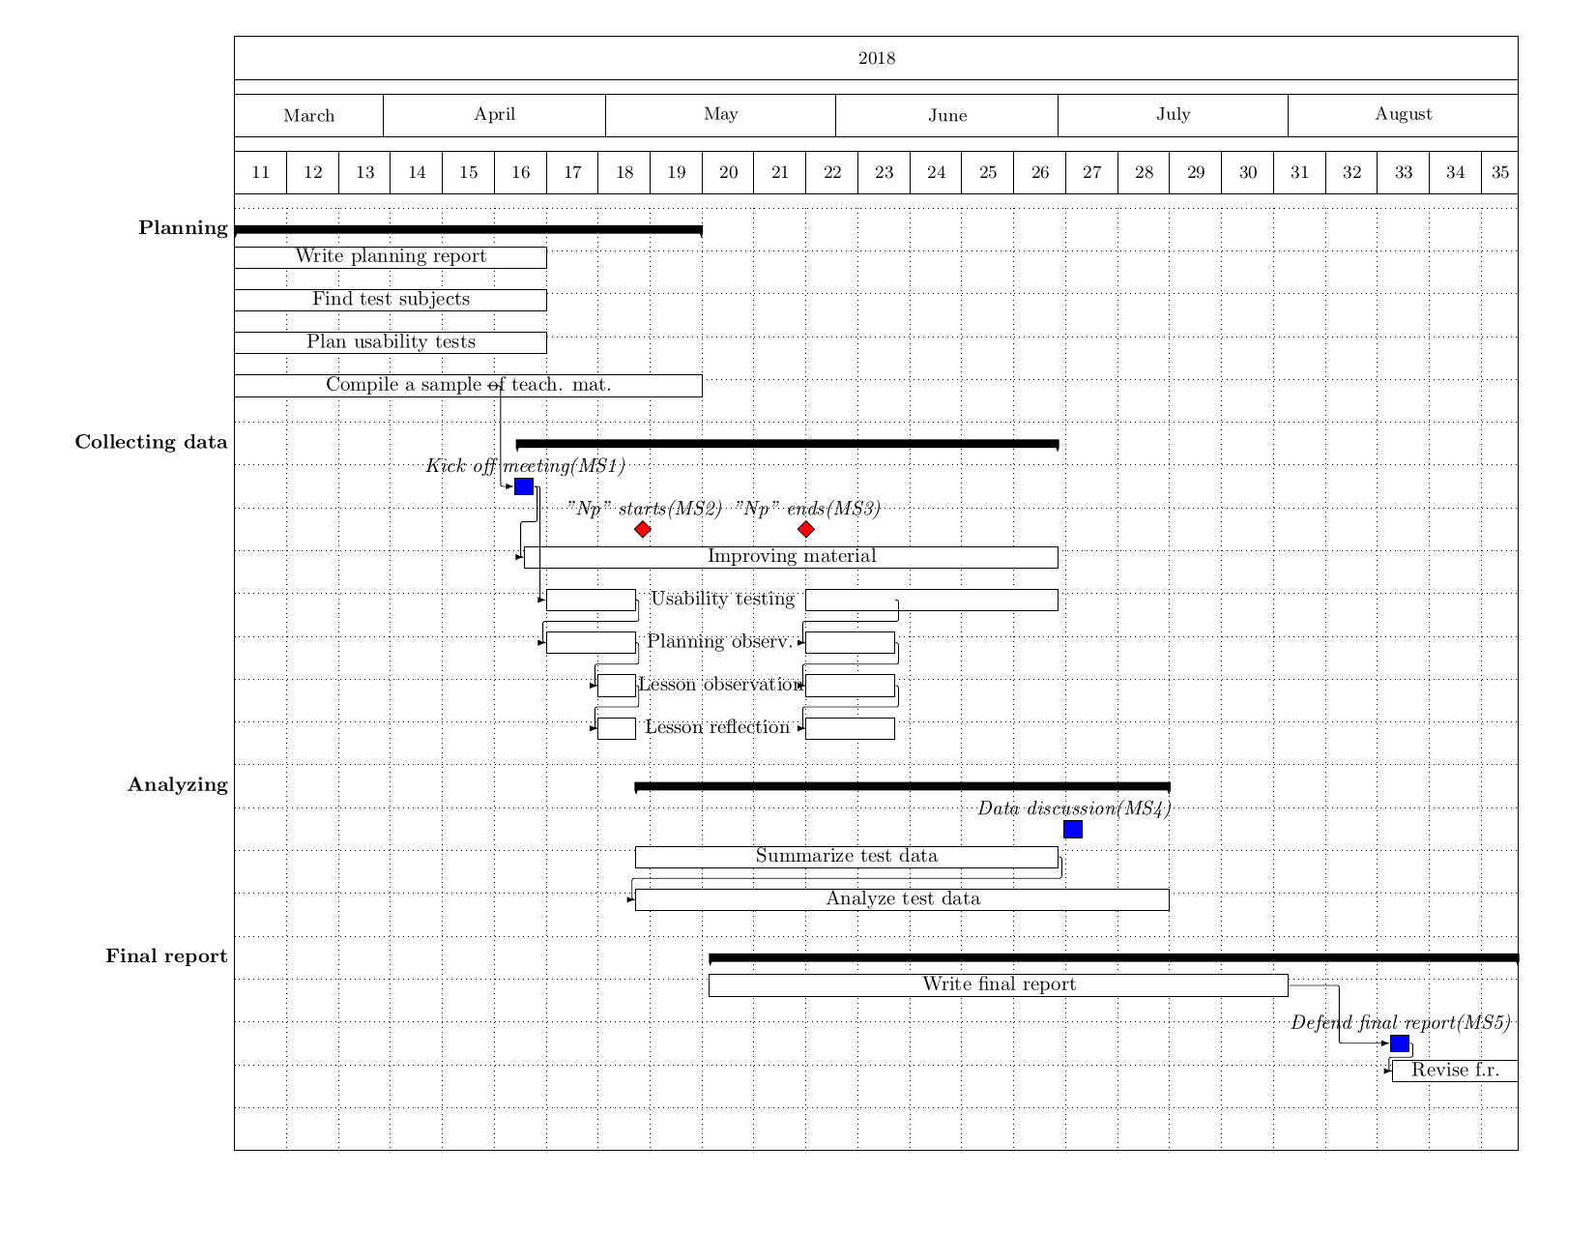
//Should we also set aside time on for example opposing another master thesis or making changes after defending the thesis? Or is this time expected to be in excess of 800 hrs?
// Schedule. Gantt n stuff. More detailed than the small project plan, obviously.
//defend report sometime in August...
// 30 hp motsvarar 800 h per person

Method // Håkan
// Describe our strategy: Create a suggestion for every school that is interested in doing and participating in tests. Also describe our two test types, the usability test and the lesson observation, or whatever we want to call them. Check the separate suggestion document for details.
// Also describe how we will test the obtainability aspect of accessibility.
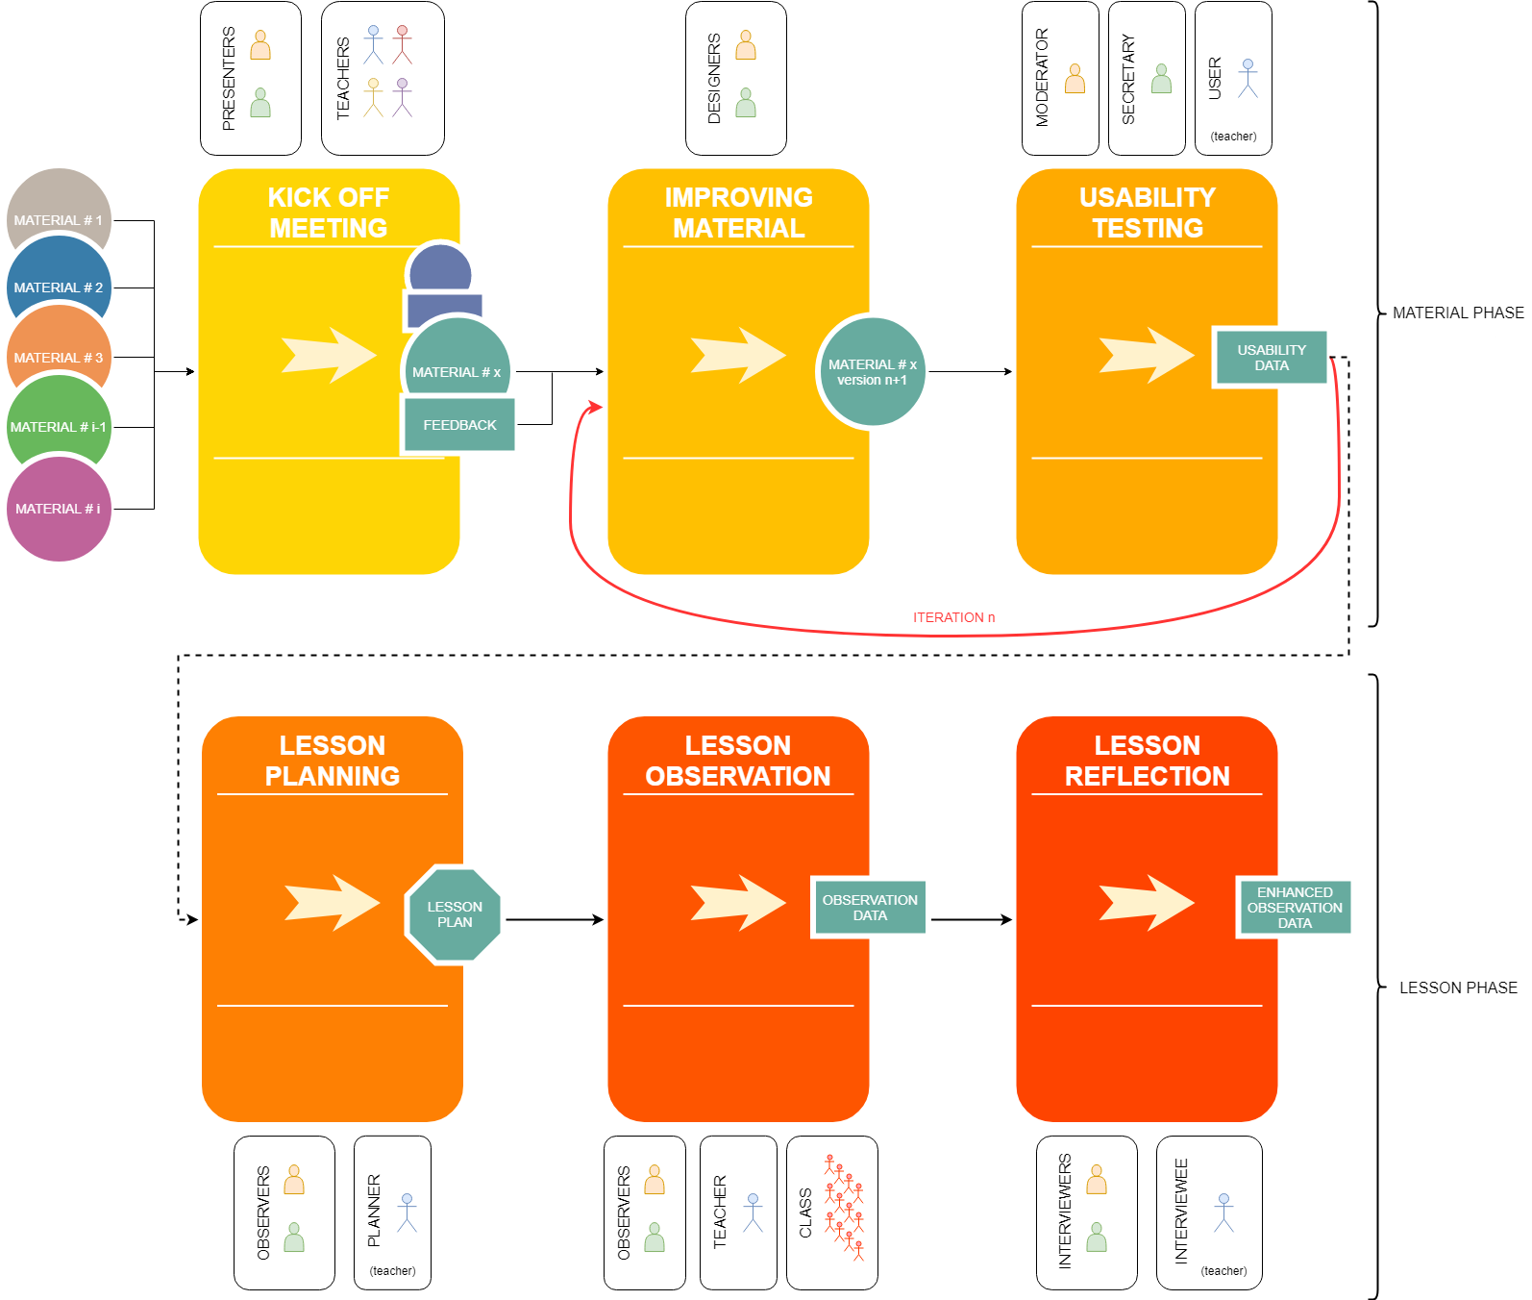

Test subject anonymity // Håkan

