**Gunicorn**

1. predict_io_bounded

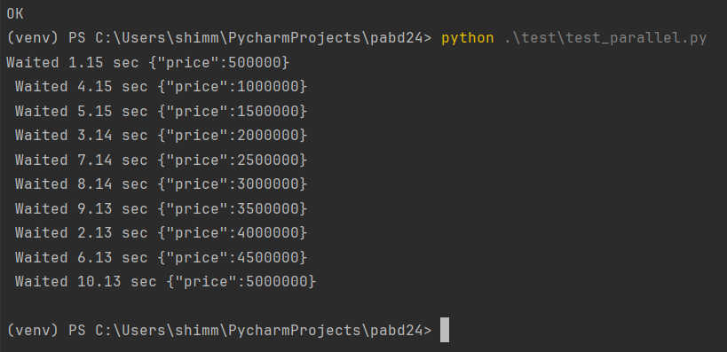

1. predict_cpu_bounded

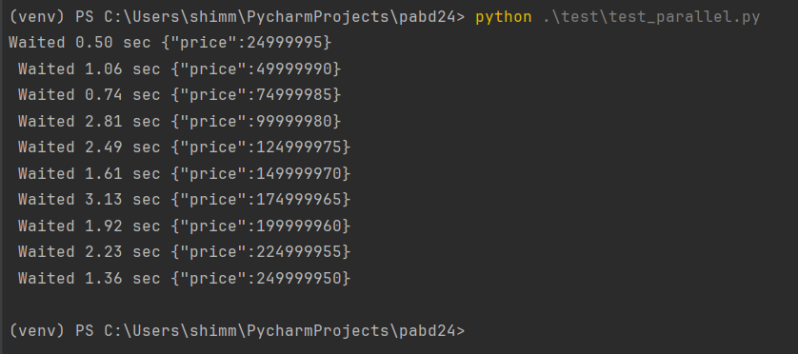

1. predict_cpu_multithread

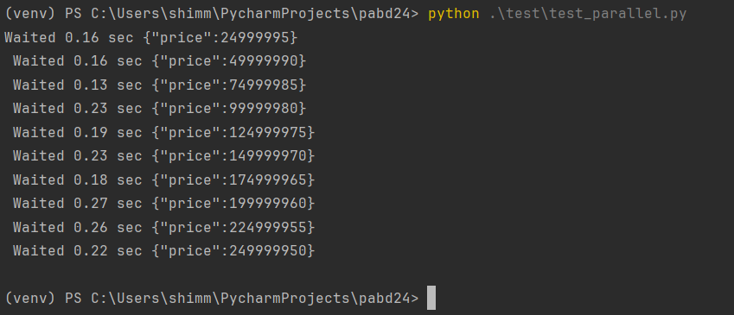

**Flask**

1. predict_io_bounded

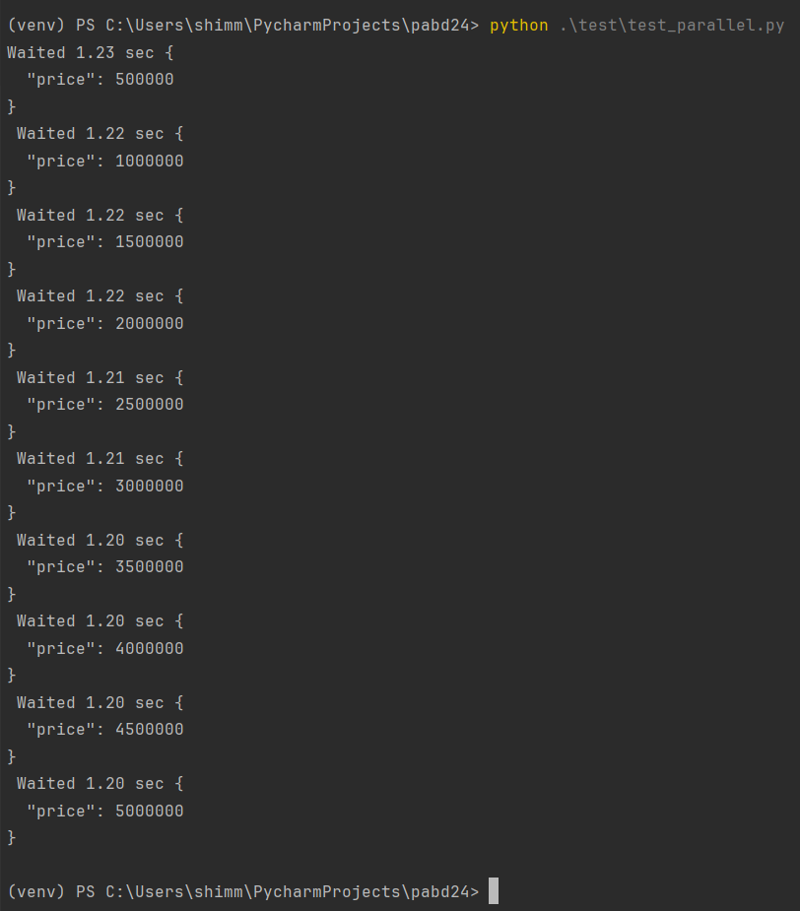

1. predict_cpu_bounded

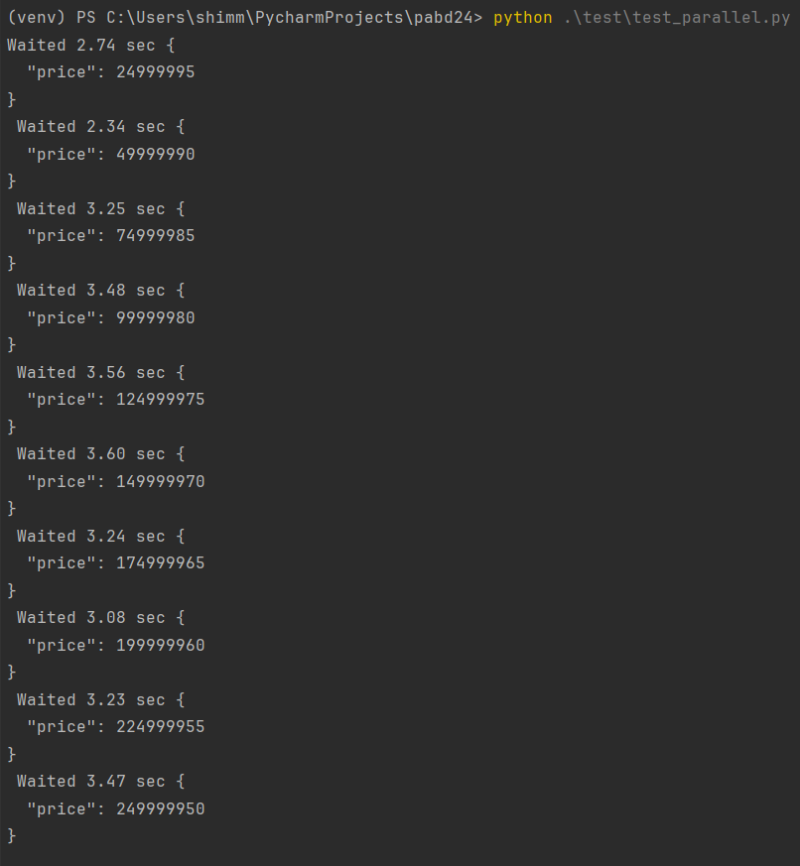

1. predict_cpu_multithread

