
THE UNIVERSITY OF ZAMBIA
SCHOOL OF NATURAL AND APPLIED SCIENCES
DEPARTMENT OF COMPUTING AND INFORMATICS

FINAL YEAR PROJECT REPORT
ACADEMIC YEAR 2026

Tranz-Algo: Explainable Landed-Cost Inventory Orchestration with Dual Cost Modes for Import-Dependent SMEs

A Final Year Project Report Submitted to the
Department of Computing and Informatics
in partial fulfilment of the requirements for the award of
Bachelor of Science in Computer Science

Student Name: Nixon Shibuchi
Computer Number: 2021437361
Group project with: Musonda Katongo (2020583969)
Supervisor: Mrs. Leena Kumar
Date of Submission: October 2026
Source code repository: https://github.com/Nixon-Shibuchi/Tranz-Algo

DECLARATION
I declare that this final year project report is my own work and has been prepared in accordance with the academic requirements of the University of Zambia. All sources of information, ideas, data, software, images, and other material that are not my own have been appropriately acknowledged and referenced.
Where this project was undertaken as a group, I have clearly identified my individual contributions and have not presented the work of other group members as my own. Tranz-Algo was developed with Musonda Katongo. Design and technology decisions were made jointly. My primary role was implementation lead: FastAPI backend, costing engine, most frontend wiring, FX service, evaluation scenarios/oracles, literature lead drafts, and majority of commits. See Appendix A.
Student Name: Nixon Shibuchi
Computer Number: 2021437361
Signature: ______________________
Date: October 2026

APPROVAL
This final year project report has been submitted for examination with the approval of the project supervisor.
Supervisor Name: Mrs. Leena Kumar
Signature: ______________________
Date: ______________________
Departmental/Examiner Approval (if applicable): ______________________

ABSTRACT
Import-dependent retailers often know supplier invoices and clearing documents yet still cannot state a defensible per-item true cost. Shared freight and tax, mixed foreign and local paperwork, and exchange-rate movement undermine cost-plus pricing. This project presents Tranz-Algo, a web-based decision-support system that computes explainable landed costs for import shipment batches, suggests retail prices, and records an auditable Cost history.
Tranz-Algo implements dual cost-entry modes (Auto FX and Already-Local), quantity and weight allocation with a comparator, a True Cost pricing studio with a safety floor, batch-linked stock, and a lightweight Record sale that reduces stock without becoming a POS. The system uses FastAPI, a React (Vite) administrative UI, PostgreSQL with SQLite fallback, and free Frankfurter exchange rates with cache and manual override. Evaluation against spreadsheet oracles for two demo shipments (Already-Local grocery; Auto FX phone parts) passed within ±0.01 ZMW. The contribution is explainable import-batch costing under mixed paperwork, not another inventory CRUD or full ERP.
This individual report is prepared by Nixon Shibuchi for the group project developed with Musonda Katongo. Only this individual report is submitted for examination; the shared implementation is available at https://github.com/Nixon-Shibuchi/Tranz-Algo.
Keywords: landed cost; dual cost modes; import SME; allocation; True-Cost Ledger; FastAPI; React

ACKNOWLEDGEMENTS
I thank my supervisor, Mrs. Leena Kumar, for guidance throughout this final year project. I also thank the Department of Computing and Informatics, University of Zambia, for providing the academic framework and assessment standards that shaped this work. Finally, I acknowledge Musonda Katongo for joint design discussions and complementary implementation effort that produced the working Tranz-Algo MVP.

NOTE ON GROUP PROJECTS
This is an individual report for a two-member group project. The shared system is Tranz-Algo. The co-author is Musonda Katongo. Each student submits only their own individual report (not a joint Word document). The shared source code and documentation live in the project Git repository: https://github.com/Nixon-Shibuchi/Tranz-Algo. Individual responsibilities for Nixon Shibuchi are stated in Chapter 5 and Appendix A. Each student remains responsible for understanding the full system and for the honesty of their contribution claims.

TABLE OF CONTENTS
DECLARATION
APPROVAL
ABSTRACT
ACKNOWLEDGEMENTS
NOTE ON GROUP PROJECTS
LIST OF ABBREVIATIONS AND ACRONYMS
Chapter 1 Introduction
1.1 Background and Context
1.2 Problem Statement
1.3 Project Aim
1.4 Project Objectives
1.5 Research Questions
1.6 Scope of the Project
1.7 Significance of the Project
1.8 Limitations
1.9 Organisation of the Report
Chapter 2 Literature Review
2.1 Introduction
2.2 Key Concepts and Theories
2.3 Existing Systems / Related Work
2.4 Comparative Analysis
2.5 Research / Knowledge Gap
2.6 Conceptual Framework
2.7 Chapter Summary
Chapter 3 Methodology
3.1 Introduction
3.2 Research / Development Approach
3.3 Requirements / Data Collection
3.4 System Architecture / Research Workflow
3.5 Tools and Technologies
3.6 Ethical and Legal Considerations
3.7 Evaluation Method
3.8 Chapter Summary
Chapter 4 System Analysis and Design
4.1 Introduction
4.2 Stakeholder and User Analysis
4.3 Functional Requirements
4.4 Non-Functional Requirements
4.5 Use Cases / User Stories
4.6 System / Solution Architecture
4.7 Database / Data Design
4.8 Interface / Interaction Design
4.9 Algorithms / Models / Technical Design
4.10 Chapter Summary
Chapter 5 Implementation / Development
5.1 Introduction
5.2 Development Environment
5.3 System Components / Modules
5.4 Key Implementation Details
5.5 Integration
5.6 Challenges and Solutions
5.7 Individual Contribution (group projects)
5.8 Chapter Summary
Chapter 6 Testing, Results and Evaluation
6.1 Introduction
6.2 Testing Strategy
6.3 Test Cases and Results
6.4 Experimental Results
6.5 User Evaluation
6.6 Analysis of Results
6.7 Objective-by-Objective Evaluation
6.8 Individual Results
6.9 Chapter Summary
Chapter 7 Discussion
7.1 Introduction
7.2 Interpretation of Findings
7.3 Comparison with Existing Work
7.4 Contributions of the Project
7.5 Limitations and Implications
7.6 Chapter Summary
Chapter 8 Conclusion and Recommendations
8.1 Introduction
8.2 Summary of the Project
8.3 Conclusions
8.4 Achievement of Objectives
8.5 Recommendations
8.6 Future Work
REFERENCES
Appendix A Individual Contribution Statement
A.1 Project and Group Information
A.2 Overall Group Project
A.3 Individual Role and Responsibilities
A.4 Collaboration and Co-author Work
Appendix B User Manual / Installation Guide (summary)

LIST OF ABBREVIATIONS AND ACRONYMS
Abbreviation | Meaning
API | Application Programming Interface
CSV | Comma-Separated Values
ERP | Enterprise Resource Planning
FX | Foreign Exchange
JWT | JSON Web Token
MVP | Minimum Viable Product
POS | Point of Sale
SME | Small and Medium-sized Enterprise
UI | User Interface
VAT | Value Added Tax
ZMW | Zambian Kwacha

Chapter 1 Introduction

1.1 Background and Context
Zambian and other import-dependent SMEs buy goods in shipment batches. Supplier invoices may be in foreign currency, while freight, duty, and VAT arrive as local clearing totals. Retailers must recover these shared costs per SKU before setting a selling price. Spreadsheets are common but fragile; POS tools sell well but rarely explain import true cost; ERP landed-cost modules are powerful but heavy for small shops.
Tranz-Algo targets the decision-support niche between clearing paperwork and the retail catalogue: compute landed cost transparently, suggest a safe retail price, commit an audit trail, and update stock by batch.

1.2 Problem Statement
Import retailers frequently cannot defend a per-item true cost when freight and tax are shared, paperwork mixes foreign and local amounts, and exchange rates move after prices are set. Existing tools either omit explainable allocation, hide formulas in spreadsheets, or require full ERP complexity. The problem addressed is therefore explainable import-batch costing and price suggestion under mixed real-world paperwork.

1.3 Project Aim
To design, implement, and evaluate a free-to-run web system that turns import shipment paperwork into per-item landed cost, suggested retail price, auditable Cost history, and batch-linked inventory for SME administrators.

1.4 Project Objectives
- Analyse import costing needs and freeze dual-mode formulas (Auto FX and Already-Local).
- Design a three-tier architecture, data model, and True Cost workflow with allocation comparison.
- Implement FastAPI services, React admin UI, PostgreSQL persistence, and FX integration.
- Evaluate correctness against spreadsheet oracles (tolerance ≤ 0.01 ZMW) using demo scenarios.
- Document technology deviations from the proposal and produce operator / demo guidance.

1.5 Research Questions
- How can dual entry modes accept mixed foreign/local import paperwork without forcing one workflow?
- How can allocation of shared shipping/duty/VAT be made explainable to an SME user?
- Can automated landed-cost and price suggestion match a spreadsheet oracle within ±0.01 ZMW?

1.6 Scope of the Project

1.6.1 In Scope
- Admin authentication (JWT); product catalogue; shipment batches and lines.
- Dual modes, allocation (quantity/weight), True Cost studio, safety floor, Cost history.
- CSV import for demos; stock board; Record sale (stock-out only).
- Frankfurter FX with cache/manual; PostgreSQL primary and SQLite fallback.

1.6.2 Out of Scope
- Full POS checkout (payments, customers, receipts).
- Legal ZRA/customs duty assessment APIs.
- React Native companion app (deferred; web admin delivered).
- Multi-tenant SaaS billing; barcode camera as a core path.

1.7 Significance of the Project
Practically, Tranz-Algo helps import SMEs defend prices with explainable costs. Academically, it demonstrates that the gap is not inventory CRUD but explainability under mixed paperwork. Institutionally, it provides a complete design–build–evaluate cycle with reproducible demos.

1.8 Limitations
Auto FX seeds the rate at **20** (or the last fetched cache) until the user clicks Fetch FX or types a rate. Demo B spreadsheet/pytest oracles use the same **20** so the UI starter and evaluation rate match. Live Fetch FX may differ; keep 20 for the frozen demo. Value-based allocation exists in the engine but is not primary in the UI. The MVP assumes honest paperwork totals and does not replace clearing agents.

1.9 Organisation of the Report
Chapter 2 reviews literature. Chapter 3 describes methodology. Chapter 4 presents analysis and design. Chapter 5 covers implementation. Chapter 6 reports testing and evaluation. Chapter 7 discusses findings. Chapter 8 concludes. Appendices include the contribution statement and installation notes.

Chapter 2 Literature Review

2.1 Introduction
This chapter reviews landed-cost concepts, FX risk for SMEs, competing tool classes, and the knowledge gap that Tranz-Algo addresses. Sources are listed in the References.

2.2 Key Concepts and Theories
Landed cost is broader than supplier invoice price: product, freight, customs, and related charges jointly determine unit economics (Mangan & Lalwani, 2016; Bonanni, 2011; NetSuite). Allocation bases commonly include quantity, weight, or value. Cost-plus pricing remains a practical SME posture: Suggested RP = Landed × (1 + margin) (Nagle & Müller). Exchange-rate volatility can erase margins for import-dependent firms that do not hedge (DiVA study; IJRISS, 2025 on Zambian MSMEs).

2.3 Existing Systems / Related Work
POS applications optimise selling but rarely allocate shared import charges with an audit trail. Basic inventory tools track counts more than explainable landed cost. Spreadsheets can encode any formula yet are opaque and fragile. Shipping/clearing systems produce paperwork but do not price a retail catalogue. ERP suites (for example Odoo landed costs) can implement sophisticated costing but are heavy for many small importers.

2.4 Comparative Analysis
System type | Import batch true cost? | Dual modes? | Explainable allocation? | Fit for small importer
POS / shop apps | Rarely | No | No | Selling-focused
Basic inventory | Weak / manual | Usually no | Usually no | Quantity-focused
Spreadsheets | Possible, fragile | Manual | Opaque | Common but error-prone
Clearing / shipping | Paperwork only | Partial | No retail pricing | Logistics partner
ERP (Odoo/SAP-class) | Often yes | Varies | Possible, heavy | Often too complex
Tranz-Algo | Yes (core) | Yes | Yes (comparator + ledger) | Built for this niche
Table 2.1: Comparison of tool classes against Tranz-Algo’s niche

2.5 Research / Knowledge Gap
The gap is not another inventory app. It is explainable import-batch costing and price suggestion under mixed real-world paperwork. Dual modes accept foreign invoices and already-local shipper amounts. An Allocation Comparator and Cost history / True-Cost Ledger make methods visible and auditable.

2.6 Conceptual Framework
Tranz-Algo follows a three-tier decision-support framing: capture paperwork → apply frozen costing strategies → persist explainable outcomes to stock and ledger. Engineering guidance emphasises verifying critical financial logic (Pressman & Maxim, 2020).
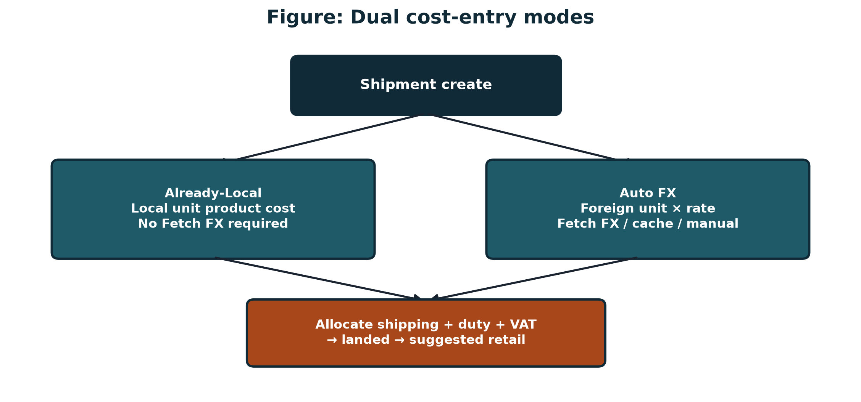
Figure 2.1: Dual cost-entry modes conceptual framework

2.7 Chapter Summary
Literature supports multi-component landed cost, FX-aware SME pricing, and a niche between paperwork and POS/ERP. Tranz-Algo is positioned to fill that niche with dual modes and auditability.

Chapter 3 Methodology

3.1 Introduction
The project combined requirements freeze for costing formulas with incremental vertical delivery of working software, followed by oracle-based evaluation.

3.2 Research / Development Approach
The proposal named Waterfall for early clarity on financial formulas. In practice, formulas were frozen first, then modules were delivered in slices: auth → products → shipments → True Cost → stock. This preserved correctness discipline while allowing feedback on UX.

3.3 Requirements / Data Collection
Requirements came from the approved proposal, joint design discussions, and review of import paperwork patterns (foreign invoices vs local clearing totals). Evaluation data are synthetic but realistic demo shipments (grocery Already-Local; phone-parts Auto FX) with spreadsheet oracles in docs/scenarios/.

3.4 System Architecture / Research Workflow
Architecture is three-tier: React frontend → FastAPI /api/v1 → PostgreSQL (SQLite fallback), with optional FX providers. The True Cost workflow is allocate → suggest/adjust → commit → Cost history.
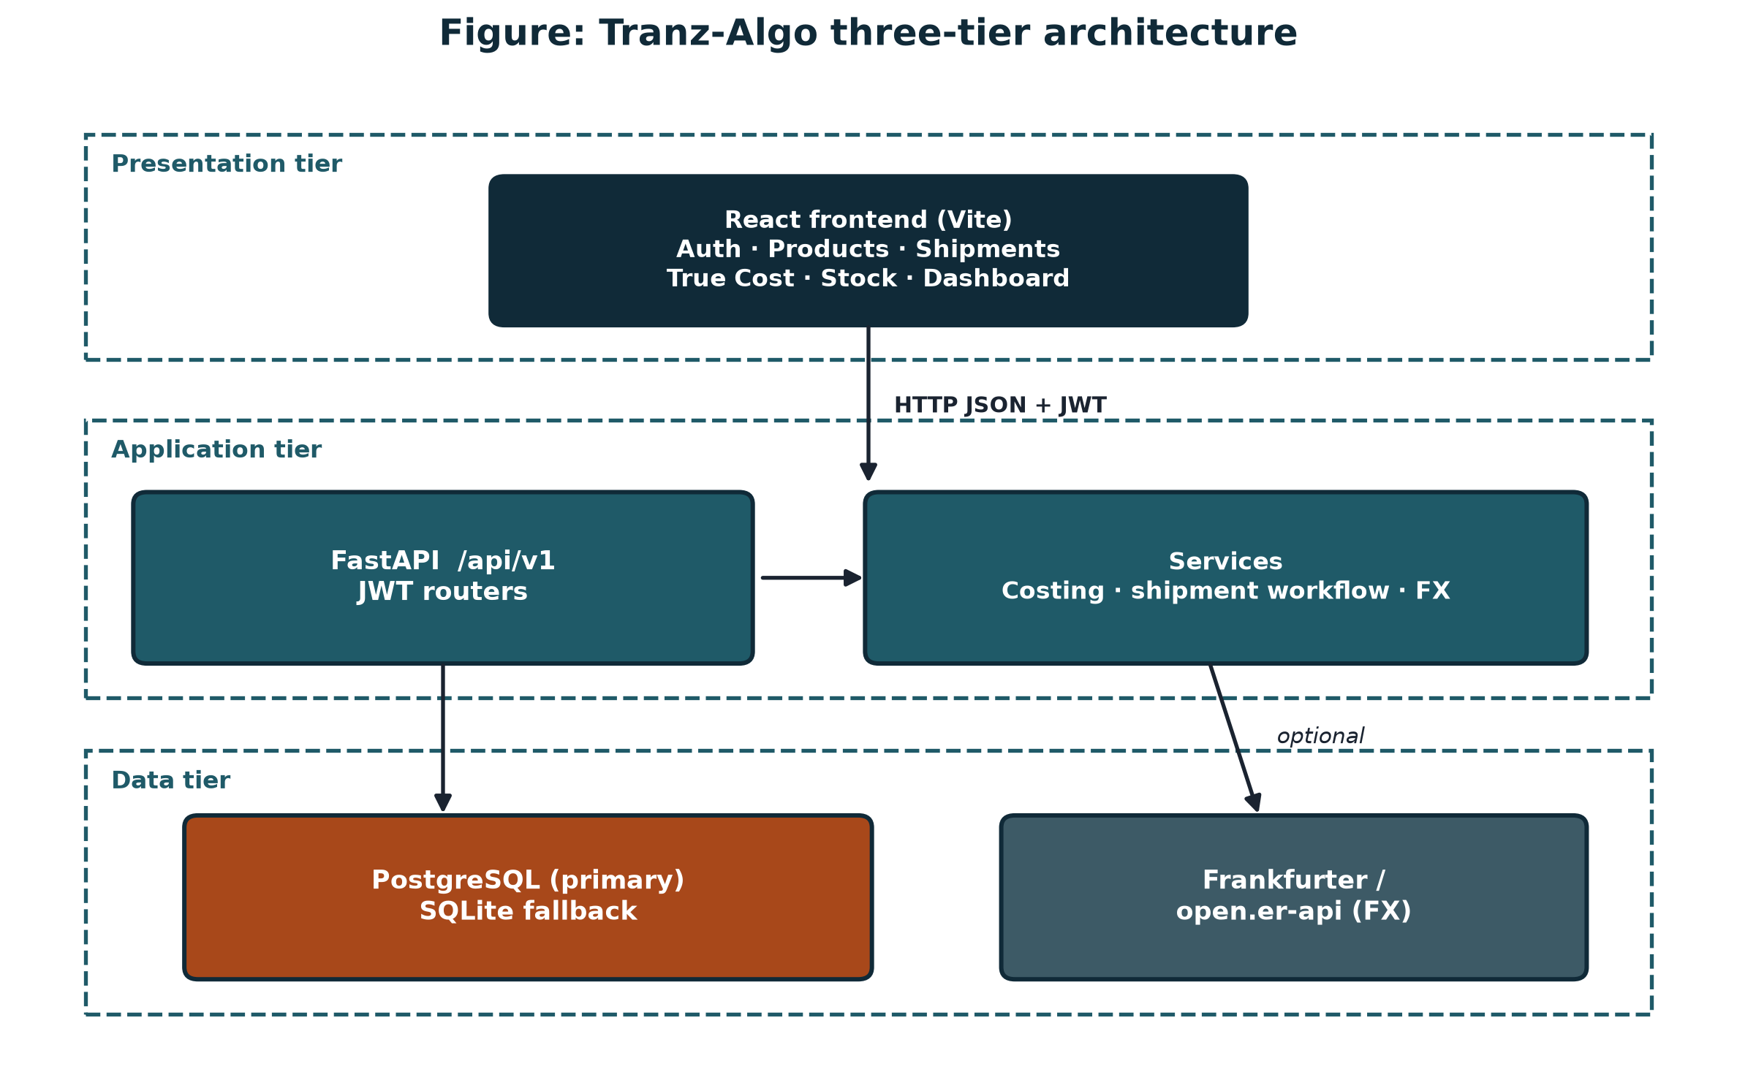
Figure 3.1: System architecture used in the methodology

3.5 Tools and Technologies
Area | Choice
Languages | Python 3, JavaScript (React)
Backend | FastAPI, SQLAlchemy 2, Pydantic, JWT/bcrypt
Frontend | React (Vite), CSS themes
Database | PostgreSQL primary; SQLite fallback
FX | Frankfurter / open.er-api + cache/manual
Tests | pytest costing oracles
VCS | Git / GitHub
OS (dev) | Windows 10/11
Table 3.1: Tools and technologies

3.6 Ethical and Legal Considerations
User passwords are hashed (bcrypt). The system does not claim legal customs assessment. Demo data are synthetic. Free FX APIs are used under their published terms. Group contribution is declared honestly.

3.7 Evaluation Method
Success is measured by (1) formula agreement with spreadsheet oracles within ±0.01 ZMW, (2) scenario coverage of dual modes, allocation comparison, safety floor, and UI CSV path, and (3) demonstration that Record sale is stock-out only (not POS).

3.8 Chapter Summary
Methodology froze costing rules, implemented a three-tier MVP, and evaluated against reproducible oracles.

Chapter 4 System Analysis and Design

4.1 Introduction
This chapter presents stakeholders, requirements, architecture, data design, interfaces, and algorithms.

4.2 Stakeholder and User Analysis
- Primary user: import SME administrator (desk workflow).
- Indirect: shop staff who rely on defended retail prices and stock levels.
- Out of scope users: end customers at till; customs officers.

4.3 Functional Requirements
- FR1 Register/sign in with JWT.
- FR2 Manage products (including CSV import and optional auto SKU).
- FR3 Create shipments in Already-Local or Auto FX mode; enter lines and paperwork totals.
- FR4 Fetch/cache/manual FX for Auto FX.
- FR5 Allocate by quantity or weight; compare methods.
- FR6 Suggest retail prices; apply safety floor while adjusting; commit with Cost history.
- FR7 Update stock on commit; Record sale reduces stock only.
- FR8 Admin Start fresh / Clear drafts for demos.

4.4 Non-Functional Requirements
- NFR1 Correctness: money calculations within ±0.01 ZMW of oracle.
- NFR2 Security: bcrypt hashes; JWT on protected routes.
- NFR3 Usability: clear True Cost stages; Create account (not create admin).
- NFR4 Deployability: PostgreSQL via DATABASE_URL; SQLite fallback.
- NFR5 Maintainability: Strategy/Facade patterns for modes and commit.

4.5 Use Cases / User Stories
- As an admin, I import Demo A CSV and cost an Already-Local grocery batch.
- As an admin, I open Auto FX at rate 20 (CSV / UI starter), allocate by weight, and cost Demo B.
- As an admin, I review Cost history after commit and record a sale that reduces stock.

4.6 System / Solution Architecture
Figure 4.1 shows the as-built architecture. Proposal deltas: React web instead of React Native; PostgreSQL local/Docker instead of mandatory Supabase; on-demand FX instead of continuous streaming.
Figure 4.1: Tranz-Algo system architecture (as built)

4.7 Database / Data Design
Core entities: users, products, shipment_batches, batch_items, cost_entries, ledger_entries, sales, fx_rate_cache. Tax profiles were removed; duty/VAT live as batch paperwork totals. Primary keys are integer serials.
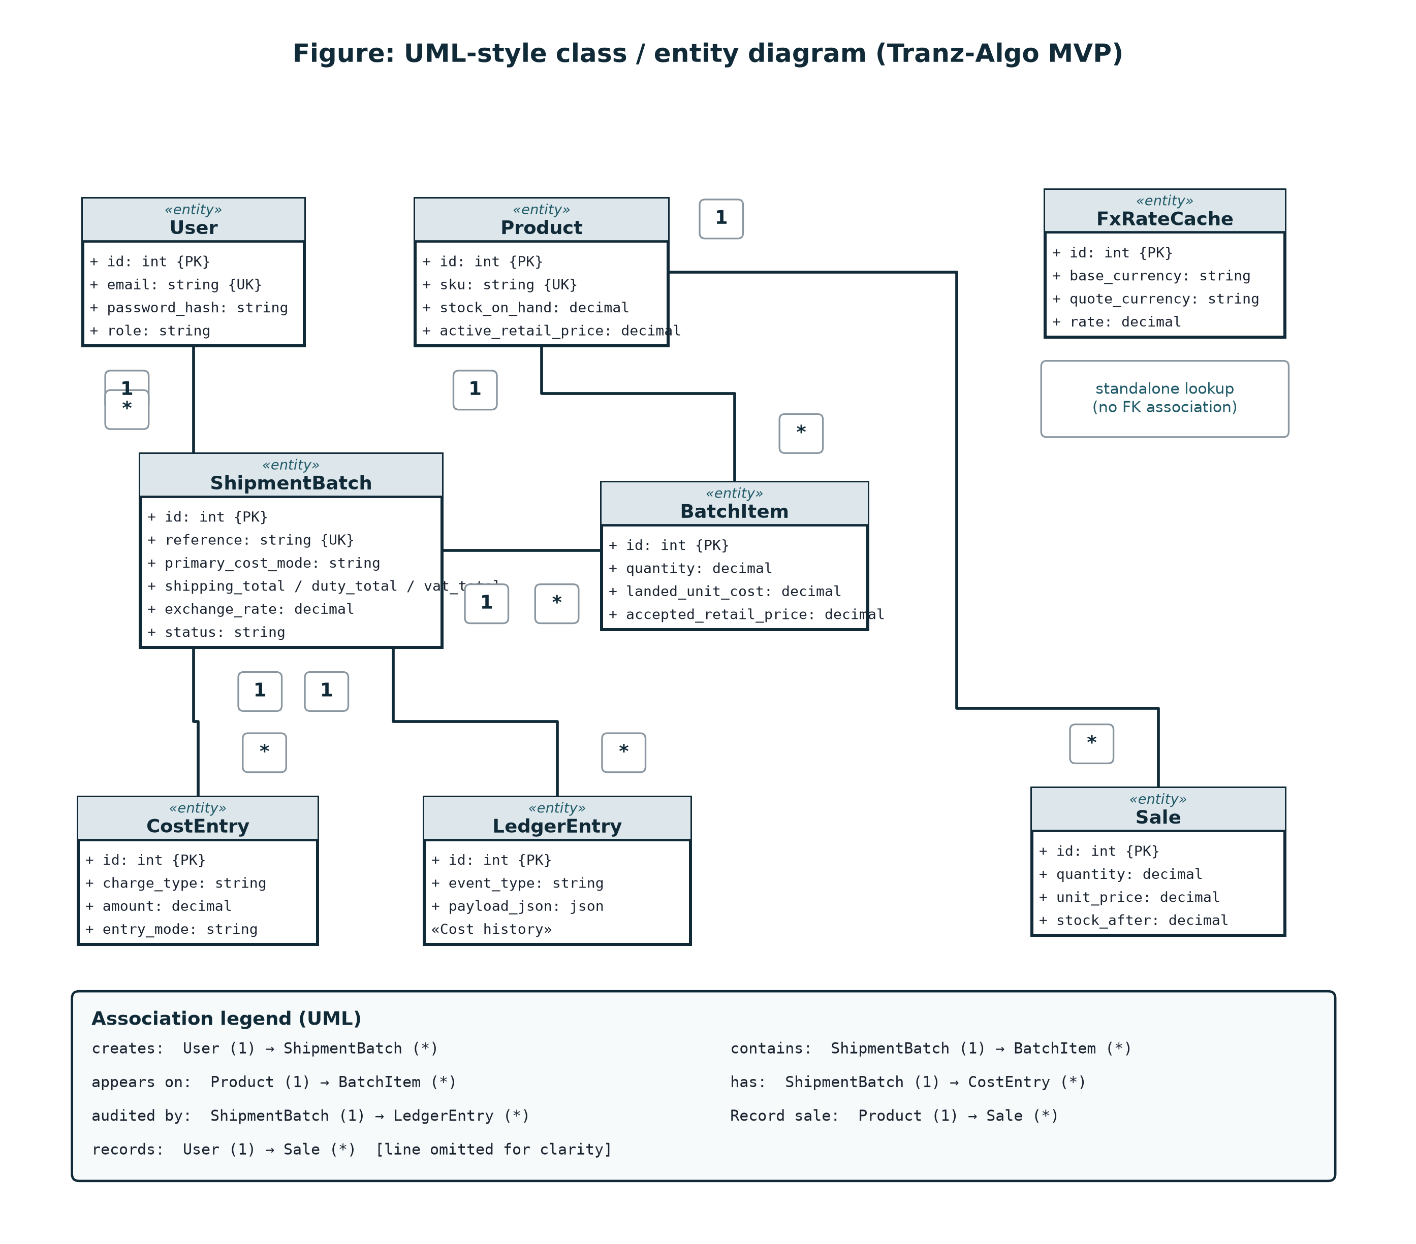
Figure 4.2: UML-style class / entity diagram (MVP)

4.8 Interface / Interaction Design
The UI is a React frontend with Welcome, Login/Create account, Dashboard, Products, Shipments (CSV import, Clear drafts), Shipment detail (Fetch FX), True Cost studio (Lines → Allocate → Price → Commit), Stock, and Cost history (When / What). Themes and a closable sidebar support desk use. Figures 4.4–4.8 are as-built screenshots of the working MVP.
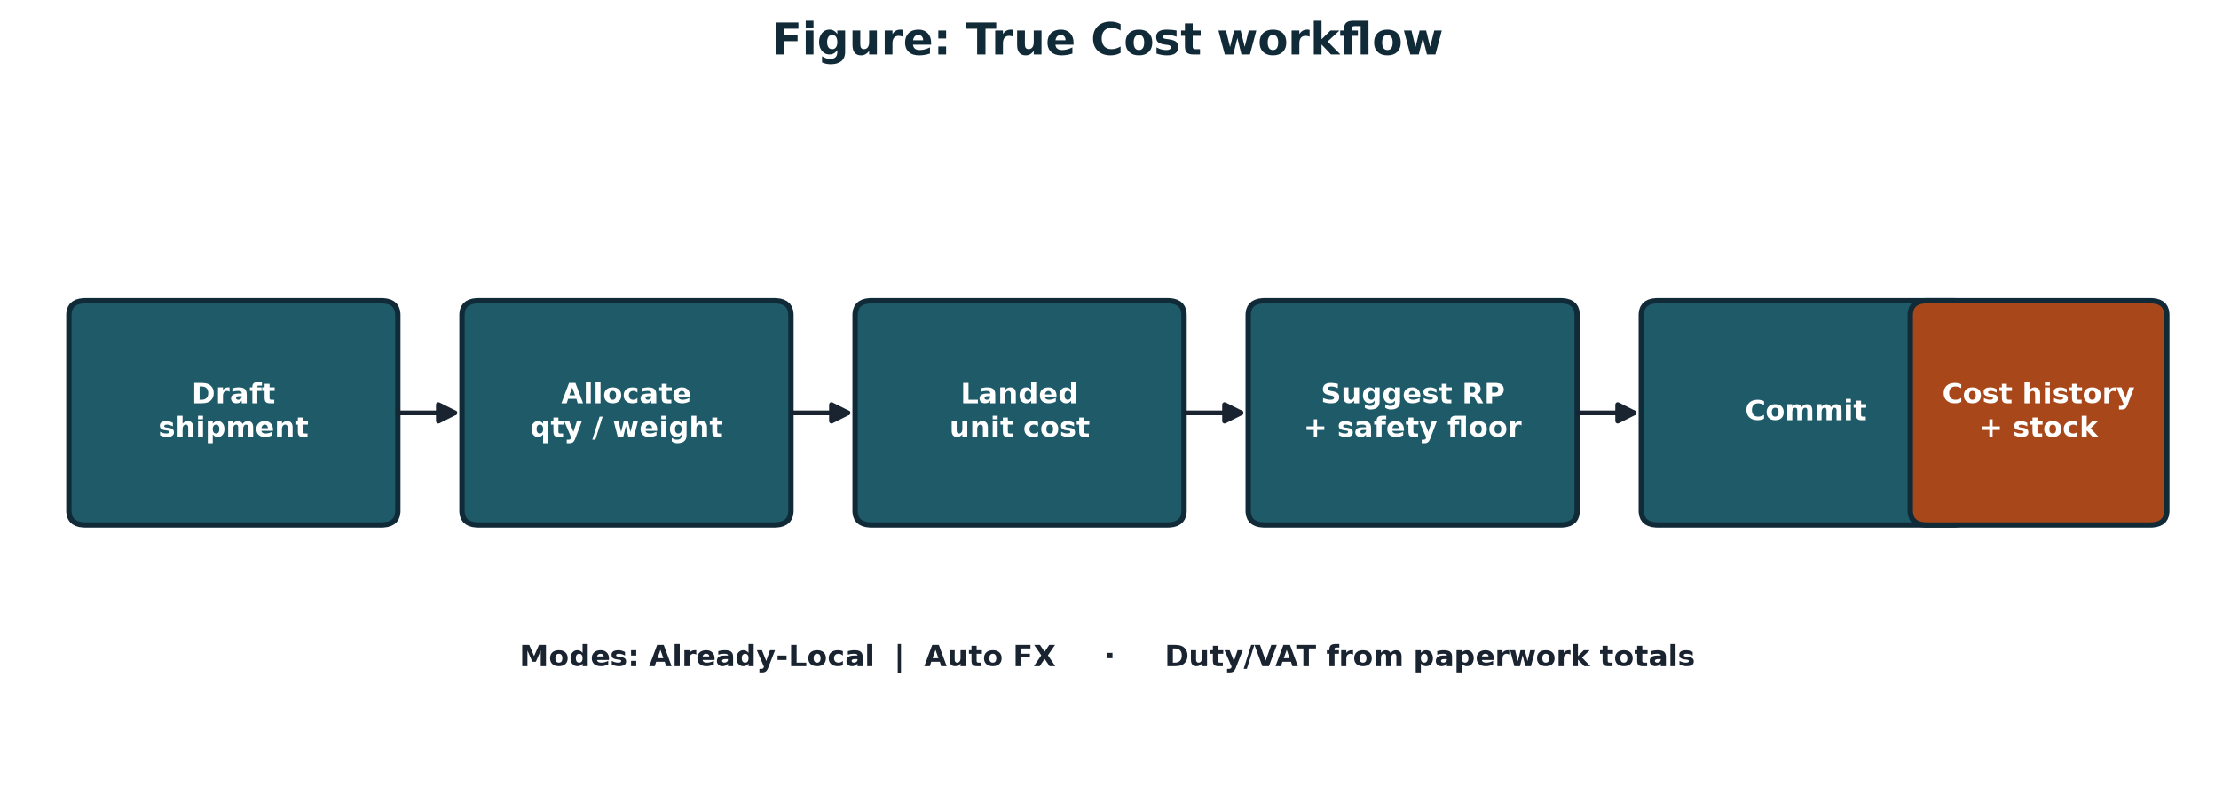
Figure 4.3: True Cost interaction flow
The Dashboard summarises units available, low/out counts, draft versus committed batches, and a short on-the-shelf list so the administrator can see status before opening True Cost.
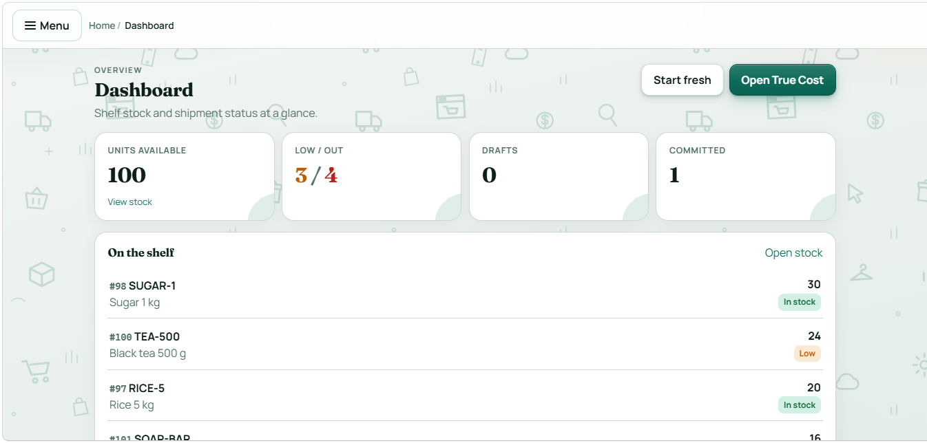
Figure 4.4: Dashboard — stock and shipment overview with Start fresh and Open True Cost
Products supports manual create (optional auto SKU) and Import CSV for demo catalogues. Optional details are folded away to keep the primary form short.
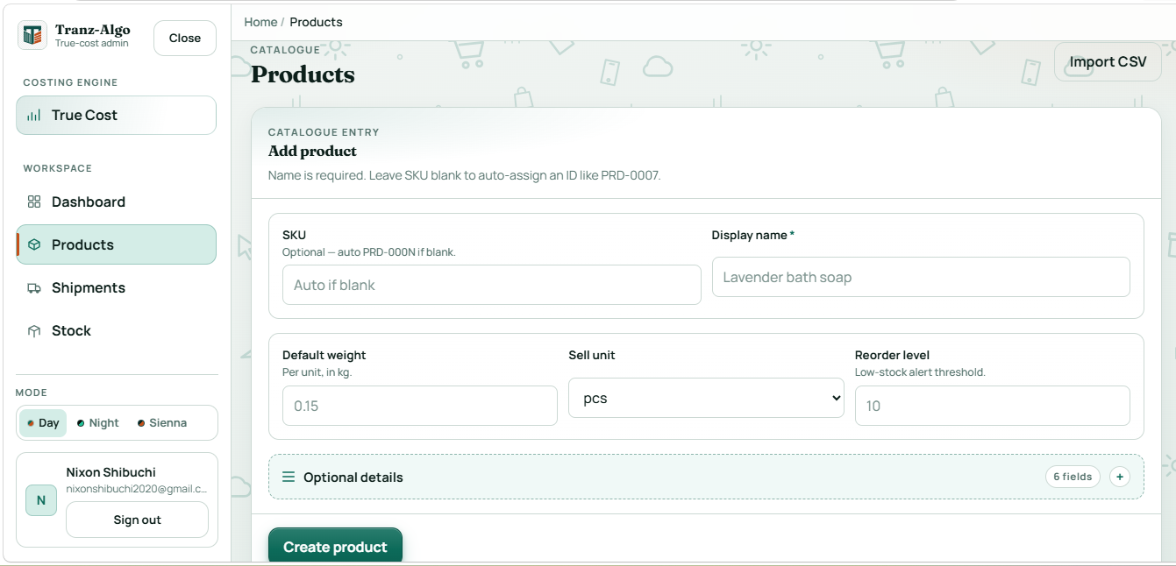
Figure 4.5: Products — catalogue entry form and CSV import
Primary cost mode is chosen once when the shipment is created; later lines and CSV imports follow that mode. Clear drafts and Import shipment CSV sit in the page actions.
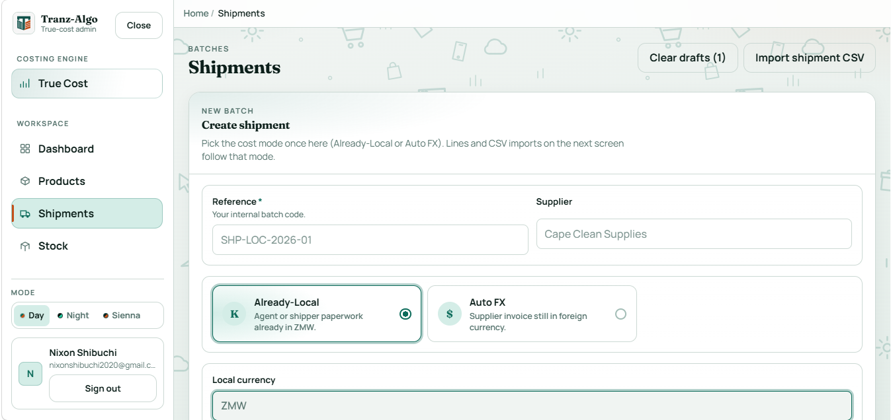
Figure 4.6: Shipments — create batch with dual cost mode (Already-Local / Auto FX)
After allocation, the administrator drags profit margin; suggested retail prices update live. The red mark is the safety floor (10% above landed unit cost).
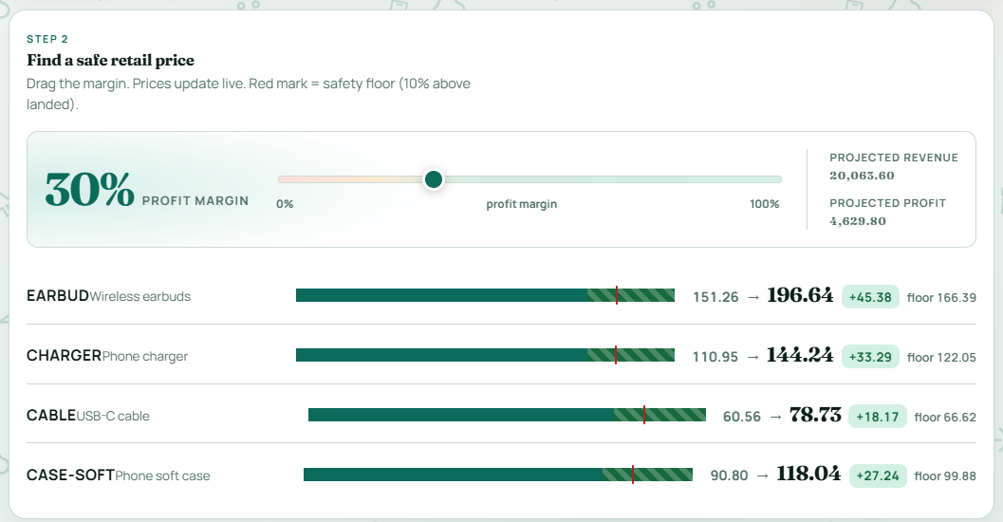
Figure 4.7: True Cost — Step 2 retail suggestion with margin slider and safety floor
Stock shows units on hand by SKU with retail context and a Record sale action that reduces quantity without becoming a full POS.
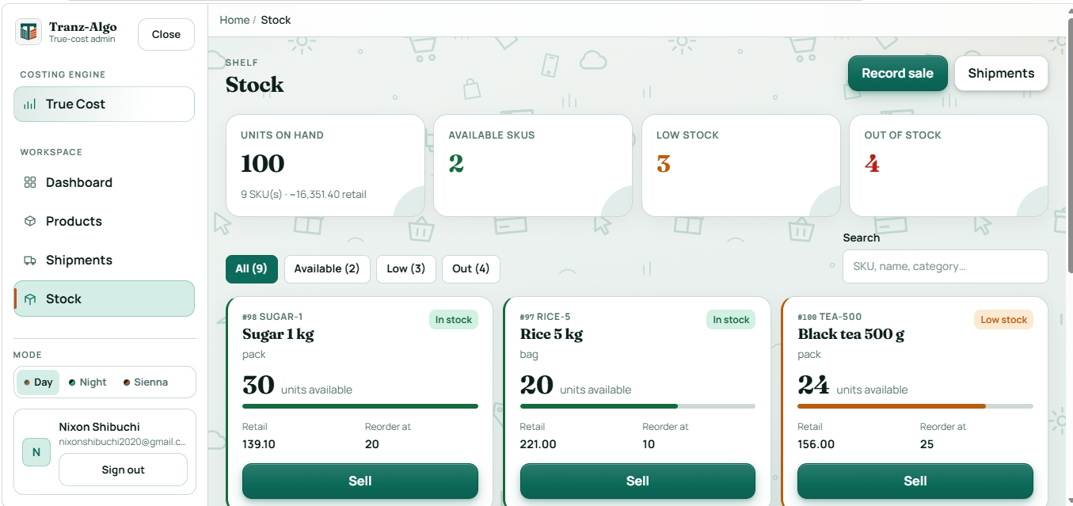
Figure 4.8: Stock — available / low / out board with Record sale

4.9 Algorithms / Models / Technical Design
Auto FX product local = foreign_unit_price × exchange_rate.
Already-Local product local = local_unit_product_cost.
Shared shipping/duty/VAT shares use quantity or weight proportions. Landed_unit = (product_local_line + shares) / qty. Suggested_RP = Landed_unit × (1 + margin). Safety floor = Landed_unit × (1.10) on live True Cost adjust (no post-commit recheck UI).
Design patterns: Strategy for cost modes/allocation; Facade for allocate/suggest/commit; Chain of Responsibility for FX providers.

4.10 Chapter Summary
Analysis and design freeze dual modes, three-tier architecture, ERD, and True Cost algorithms for implementation.

Chapter 5 Implementation / Development

5.1 Introduction
This chapter describes the working MVP, environment, modules, key decisions, integration, challenges, and individual contributions.

5.2 Development Environment
Development used Windows with Python virtualenv, Node/Vite for the frontend, PostgreSQL (Docker or local install) via DATABASE_URL, and Git. Backend runs on port 8000; frontend on 5173.

5.3 System Components / Modules
Module | Backend | Frontend
Auth | api/v1/auth.py | LoginPage / Create account
Products | api/v1/products.py | ProductsPage + CSV
Shipments | api/v1/shipments.py | Shipments / Detail + CSV
True Cost | shipment_workflow.py, costing.py | TrueCostPage
FX | fx.py, fx_providers.py | Fetch FX on costs
Stock | inventory.py | InventoryPage / Record sale
Admin | admin.py | Dashboard Start fresh
Table 5.1: Implemented modules

5.4 Key Implementation Details
PRIMARY_COST_MODES exposes Already-Local and Auto FX only. Duty/VAT are paperwork totals on the batch. Auto FX seeds rate from last cache or starter 20 until Fetch FX/manual. Commit writes ledger payloads for Cost history and increments stock. Record sale decrements stock without payments or receipts.

5.5 Integration
The React frontend calls JSON APIs with Bearer JWT. SQLAlchemy maps models to PostgreSQL/SQLite. FX providers are chained with fallback. CSV import parses demo samples into products and shipments.

5.6 Challenges and Solutions
- Challenge: mixed paperwork. Solution: dual modes chosen at shipment create.
- Challenge: React Native scope risk. Solution: deliver React web admin; defer RN.
- Challenge: FX API downtime. Solution: cache, starter rate, manual override.
- Challenge: opaque spreadsheets. Solution: comparator + Cost history When/What.

5.7 Individual Contribution (group projects)
Almost all architecture, technology, and formula decisions were discussed jointly before coding. This author’s role (Nixon Shibuchi) was implementation lead: FastAPI backend, costing engine, most frontend wiring, FX service, evaluation scenarios/oracles, literature lead drafts, and majority of commits. The co-author (Musonda Katongo) contributed complementary work as described in Appendix A. Neither member claims the other’s exclusive deliverables as sole personal work.

5.8 Chapter Summary
The MVP realises the designed dual-mode True Cost system on FastAPI + React + PostgreSQL.

Chapter 6 Testing, Results and Evaluation

6.1 Introduction
Evaluation verifies that Tranz-Algo’s costing matches spreadsheet oracles and that demo UI paths work.

6.2 Testing Strategy
- Unit/engine tests: pytest fixtures for Demo A/B oracles.
- Scenario scripts 01–05: modes, comparator, safety floor, UI CSV path.
- Manual system demo: Start fresh → import CSV → True Cost → commit → Cost history → Record sale.

6.3 Test Cases and Results
ID | Test case | Expected | Status
TC-01 | Already-Local Demo A qty oracles | Landed/RP within ±0.01 | PASS
TC-02 | Auto FX Demo B (rate 20) | Landed/RP within ±0.01 | PASS
TC-03 | Allocation compare Demo A | Qty vs weight deltas match arithmetic | PASS
TC-04 | Safety floor on True Cost | RICE floor 187; warn if below | PASS
TC-05 | CSV UI path (Scenario 05) | Same batches via import | PASS
TC-06 | Record sale stock-out | Stock decreases; no POS artefacts | PASS
Table 6.1: Representative test cases and results

6.4 Experimental Results
Demo A (SHP-DEMO-LOCAL-ZMW) locks grocery landed costs such as 170 / 107 / 160 / 120 / 93 with 30% suggested retail. Demo B (SHP-DEMO-AUTO-FX) uses FX rate **20** (UI starter = oracle) and locks weight-based landed costs 136.25 / 145 / 46.25 / 92.50 (earbud suggested retail 170.31). CI fixtures in backend/tests/test_costing.py encode these oracles.

6.5 User Evaluation
Formal large-scale user surveys were out of scope. Evaluation focused on reproducible correctness and a classroom demo path documented under docs/scenarios/.

6.6 Analysis of Results
Passing oracles shows the costing engine is faithful to the frozen formulas. Dual-mode scenarios show both paperwork styles are supported. The safety-floor test confirms pre-commit margin protection without claiming automated post-commit recheck.

6.7 Objective-by-Objective Evaluation
- Formulas/analysis: reflected in design docs and tests — achieved.
- Architecture/design: Figures 4.1–4.3 — achieved.
- Implementation: running MVP — achieved.
- Evaluation ≤0.01 ZMW — achieved for demos.
- Operator and demo documentation — achieved.

6.8 Individual Results
Oracle tests and core engine results are primarily attributable to this author’s implementation work. Design ownership remains joint with the co-author.

6.9 Chapter Summary
Against demo spreadsheet baselines, core true-cost and suggestion calculations are accurate within tolerance.

Chapter 7 Discussion

7.1 Introduction
This chapter interprets results relative to the problem, literature, and contributions.

7.2 Interpretation of Findings
Results indicate that a narrow, explainable costing system can match spreadsheet accuracy while improving auditability. Dual modes address the real paperwork split that single-workflow tools ignore.

7.3 Comparison with Existing Work
Unlike POS or basic inventory apps, Tranz-Algo centres import batch true cost. Unlike ERP, it stays SME-scoped. Unlike spreadsheets, it freezes formulas and stores Cost history.

7.4 Contributions of the Project
- Working dual-mode True Cost MVP with comparator and ledger.
- Justified technology refinements (web admin; Postgres + SQLite fallback; on-demand FX).
- Reproducible evaluation artefacts and operator documentation.

7.5 Limitations and Implications
The system trusts user-entered paperwork; it does not assess duty legally. Live FX must be pinned for reproducible demos. Broader SME field trials would strengthen usability claims.

7.6 Chapter Summary
Findings support the niche claim: explainable import costing under mixed paperwork.

Chapter 8 Conclusion and Recommendations

8.1 Introduction
This chapter summarises the project, conclusions, objective achievement, recommendations, and future work.

8.2 Summary of the Project
Tranz-Algo was designed and built to convert import paperwork into per-item landed cost, suggested retail, Cost history, and stock. Dual modes, allocation comparison, and a safety floor address SME pricing under mixed documents and FX pressure.

8.3 Conclusions
A focused three-tier web system can deliver explainable landed-cost decision support without becoming POS or ERP. Oracle evaluation confirms formula fidelity for the demo shipments.

8.4 Achievement of Objectives
All stated objectives in Section 1.4 were achieved for the MVP scope.

8.5 Recommendations
- Keep demo rates pinned when presenting Auto FX publicly.
- Train users that duty/VAT are paperwork totals, not legal assessments.
- Use Cost history in disputes about how a retail price was derived.

8.6 Future Work
- Optional React Native companion; cloud-hosted Postgres for off-campus demos.
- Richer value-based allocation UI; scheduled margin alerts.
- One-click demo seed and structured SME usability study.

REFERENCES
[1] Bonanni, A. (2011). Total Landed Cost for Tactical Supply Chain Decisions. M.Sc. thesis, Politecnico di Milano.
[2] Frankfurter API documentation (ECB reference rates). https://www.frankfurter.app/docs/
[3] IJERT (2023). Maximizing Profitability through Landed Cost Optimization with SAP Transportation Management. International Journal of Engineering Research & Technology, 12(7).
[4] IJRISS (2025). Exploring the Influence of Kwacha Fluctuations on Medium Small and Micro Enterprises (MMSMEs) Profitability: A Case of Choma District, Southern Zambia. https://doi.org/10.47772/ijriss.2025.91100274
[5] IJIRMM. Effect of Exchange Rate on Pricing in Business Operations of SMEs in Enugu State. https://sadijournals.org/index.php/IJIRMM/article/view/643
[6] Lubanovic, B. (2019). Introducing Python (2nd ed.). O’Reilly Media.
[7] Mangan, J., & Lalwani, C. (2016). Global Logistics and Supply Chain Management. John Wiley & Sons.
[8] Nagle, T. T., & Müller, G. The Strategy and Tactics of Pricing. Pearson.
[9] NetSuite. Why You Need to Calculate Landed Cost. https://www.netsuite.com/portal/resource/articles/inventory-management/landed-cost.shtml
[10] Odoo Documentation — Inventory / Purchase / Landed Costs. https://www.odoo.com/documentation/
[11] Pressman, R. S., & Maxim, B. R. (2020). Software Engineering: A Practitioner’s Approach (9th ed.). McGraw-Hill.
[12] DiVA portal thesis: The Impact of Exchange Rate Volatility on Profitability and Hedging Behavior of Import Dependent Firms. https://www.diva-portal.org/smash/get/diva2:2012289/FULLTEXT01.pdf

Appendix A Individual Contribution Statement
Purpose: identify work for which Nixon Shibuchi was primarily responsible, consistent with the main report, and acknowledge the co-author’s complementary work.

A.1 Project and Group Information
Item | Details
Project Title | Tranz-Algo: Explainable Landed-Cost Inventory Orchestration with Dual Cost Modes for Import-Dependent SMEs
Student Name | Nixon Shibuchi
Computer Number | 2021437361
Group Size | 2
Co-author | Musonda Katongo (2020583969)
Supervisor | Mrs. Leena Kumar
Source repository | https://github.com/Nixon-Shibuchi/Tranz-Algo
Submission form | Individual report only (shared code via Git URL)

A.2 Overall Group Project
The group developed Tranz-Algo, an explainable landed-cost inventory orchestration system with dual cost modes, True Cost studio, Cost history, and batch-linked stock for import SMEs.

A.3 Individual Role and Responsibilities
Primary role: implementation lead.
Primary implementation: FastAPI backend; costing engine and dual-mode formulas; most frontend integration; FX service; scenarios/oracles; literature lead drafts; majority of git commits (including pending updates).

A.4 Collaboration and Co-author Work
Joint (both): problem definition; architecture; technology selection and proposal deltas; ERD direction; dual modes and formulas; evaluation approach; presentation narrative.
Co-author (Musonda Katongo): Co-design partner for architecture, technology, and formulas before coding; literature review on related-work drafts; UI redesign and True Cost workflow implementation commit; viva/demo drive role for the live walkthrough.
Estimated contribution (honest): design ownership roughly shared; implementation effort majority Nixon Shibuchi, with substantive UI/True Cost contribution from Musonda Katongo. Neither member claims the other’s exclusive code as sole personal work.
Supervisor verification: ______________________ Date: __________

Appendix B User Manual / Installation Guide (summary)
Full source, README, and demo CSVs are in the Git repository: https://github.com/Nixon-Shibuchi/Tranz-Algo. Operator and demo guidance is summarised below; CSV samples live under docs/scenarios/samples/.
- Clone: git clone https://github.com/Nixon-Shibuchi/Tranz-Algo.git
- Backend: create venv, pip install -r requirements.txt, set DATABASE_URL, uvicorn app.main:app --reload
- Frontend: npm install && npm run dev
- Demo: Import products_demo.csv, then shipment_A_full.csv / shipment_B_full.csv from docs/scenarios/samples/
- True Cost → allocate → price → commit → Cost history; optional Record sale

