**PARALLEL COMPUTING SYSTEM ASSIGNMENT**

**TOPIC: MP AND OMP**

**Submitted by:**

**S Nixon Joshwa**

# BUBBLE SORTING

**BUBBLE SORT USING MPI**

#include <stdio.h> #include <stdlib.h> #include <mpi.h> #include <sys/time.h>

#define SIZE 7

void swap(int *xp, int *yp) { int temp = *xp;

*xp = *yp;

*yp = temp;

}

void bubbleSort(int arr[], int n) { for (int i = 0; i < n-1; i++)

for (int j = 0; j < n-i-1; j++) if (arr[j] > arr[j+1])

swap(&arr[j], &arr[j+1]);

}

int main(int argc, char** argv) { int rank, size; MPI_Init(&argc, &argv);

MPI_Comm_rank(MPI_COMM_WORLD, &rank); MPI_Comm_size(MPI_COMM_WORLD, &size);

int *data;

int localSize = SIZE / size;

data = (int *)malloc(SIZE * sizeof(int));

if (rank == 0) {

// Initialize array with specified values

int initialData[SIZE] = {22, 90, 77, 55, 33, 11, 1}; for (int i = 0; i < SIZE; i++)

data[i] = initialData[i];

}

// Scatter the data to all processes

MPI_Scatter(data, localSize, MPI_INT, data, localSize, MPI_INT, 0, MPI_COMM_WORLD);

// Measure the start time double start_time;

if (rank == 0)

start_time = MPI_Wtime();

// Perform local bubble sort bubbleSort(data, localSize);

// Gather the sorted data

MPI_Gather(data, localSize, MPI_INT, data, localSize, MPI_INT, 0, MPI_COMM_WORLD);

// Measure the end time double end_time;

if (rank == 0) {

end_time = MPI_Wtime(); printf("Sorted array: ");

for (int i = 0; i < SIZE; i++) { printf("%d ", data[i]);

}

printf("\n");

printf("Execution Time: %f seconds\n", end_time - start_time);

}

MPI_Finalize(); free(data); return 0;

}

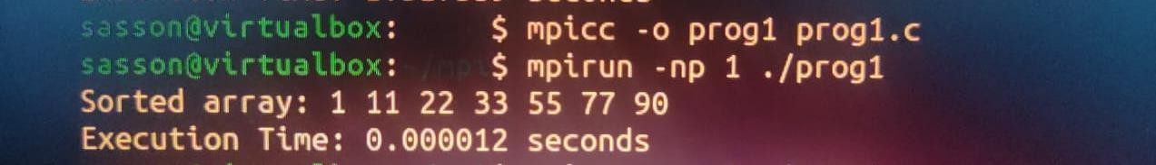

# EVEN PHASE ODD PHASE SORTING

#include <stdio.h> #include <stdlib.h> #include <mpi.h> #include <time.h>

void bubbleSort(int arr[], int n) { int temp;

for (int i = 0; i < n - 1; i++) {

for (int j = 0; j < n - i - 1; j++) { if (arr[j] > arr[j + 1]) {

temp = arr[j]; arr[j] = arr[j + 1]; arr[j + 1] = temp;

}

}

}

}

int main(int argc, char *argv[]) { MPI_Init(&argc, &argv);

int rank, size; MPI_Comm_rank(MPI_COMM_WORLD, &rank); MPI_Comm_size(MPI_COMM_WORLD, &size);

int n = 7; // Size of the array

int local_n = n / size; // Size of each process's local array int arr[n];

// Initialize the array with specific values on the root process if (rank == 0) {

int specificValues[] = {22, 90, 77, 55, 33, 11, 1}; for (int i = 0; i < n; i++) {

arr[i] = specificValues[i];

}

}

int local_arr[local_n];

// Scatter the array to all processes

MPI_Scatter(arr, local_n, MPI_INT, local_arr, local_n, MPI_INT, 0, MPI_COMM_WORLD);

// Measure execution time

double start_time = MPI_Wtime();

// Perform local bubble sort bubbleSort(local_arr, local_n);

// Gather sorted subarrays back to the root process MPI_Gather(local_arr, local_n, MPI_INT, arr, local_n, MPI_INT, 0,

MPI_COMM_WORLD);

// Measure execution time

double end_time = MPI_Wtime();

double execution_time = end_time - start_time;

if (rank == 0) {

// Print the sorted array printf("Sorted array: "); for (int i = 0; i < n; i++) {

printf("%d ", arr[i]);

}

printf("\n");

printf("Execution Time: %f seconds\n", execution_time);

}

MPI_Finalize(); return 0;

}

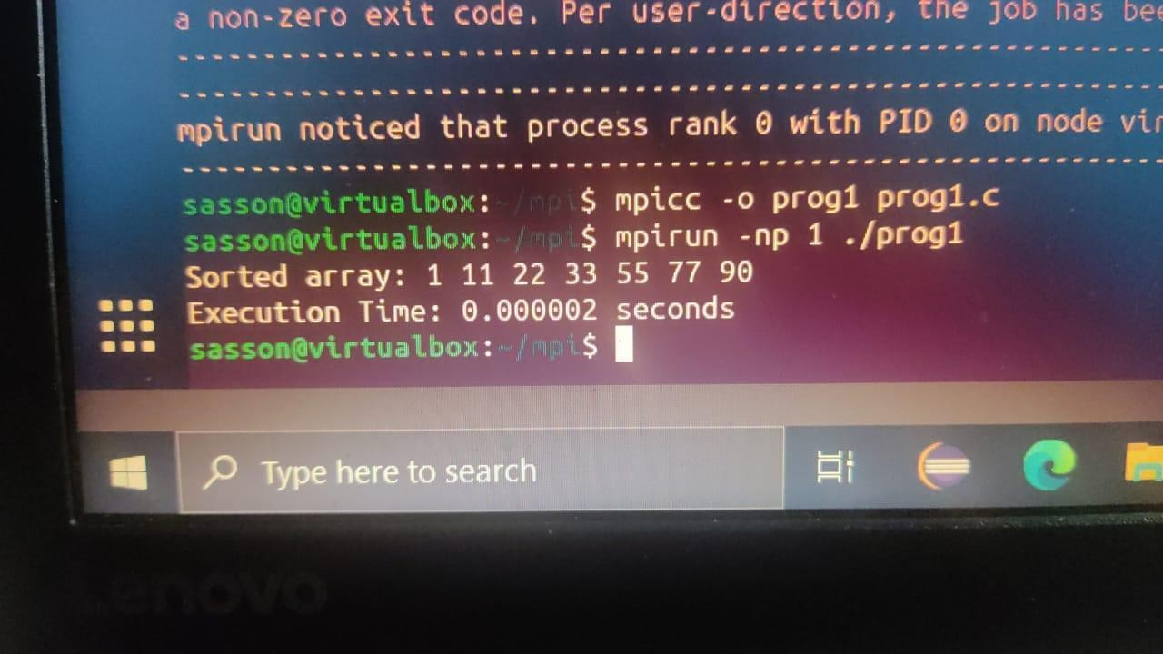

# MPI BROADCAST

#include <stdio.h> #include <stdlib.h> #include <mpi.h> #include <time.h>

void bubbleSort(int arr[], int n) { int temp;

for (int i = 0; i < n - 1; i++) {

for (int j = 0; j < n - i - 1; j++) { if (arr[j] > arr[j + 1]) {

temp = arr[j]; arr[j] = arr[j + 1]; arr[j + 1] = temp;

}

}

}

}

int main(int argc, char *argv[]) { MPI_Init(&argc, &argv);

int rank, size; MPI_Comm_rank(MPI_COMM_WORLD, &rank); MPI_Comm_size(MPI_COMM_WORLD, &size);

int n = 7; // Size of the specific values array int arr[n];

// Initialize the array with specific values on the root process if (rank == 0) {

int specificValues[] = {22, 90, 77, 55, 33, 11, 1}; for (int i = 0; i < n; i++) {

arr[i] = specificValues[i];

}

}

// Broadcast the array to all processes

MPI_Bcast(arr, n, MPI_INT, 0, MPI_COMM_WORLD);

// Measure execution time

double start_time = MPI_Wtime();

// Perform parallel bubble sort for (int i = 0; i < n; i++) {

if (i % 2 == 0) {

// Even phase

MPI_Barrier(MPI_COMM_WORLD); // Synchronize processes before even phase

bubbleSort(arr, n);

} else {

// Odd phase

MPI_Barrier(MPI_COMM_WORLD); // Synchronize processes before odd phase bubbleSort(arr, n);

}

}

// Gather sorted subarrays back to the root process

MPI_Gather(arr, n, MPI_INT, arr, n, MPI_INT, 0, MPI_COMM_WORLD);

// Measure execution time

double end_time = MPI_Wtime();

double execution_time = end_time - start_time;

if (rank == 0) {

// Print the sorted array printf("Sorted array: "); for (int i = 0; i < n; i++) {

printf("%d ", arr[i]);

}

printf("\n");

printf("Execution Time: %f seconds\n", execution_time);

}

MPI_Finalize(); return 0;

}

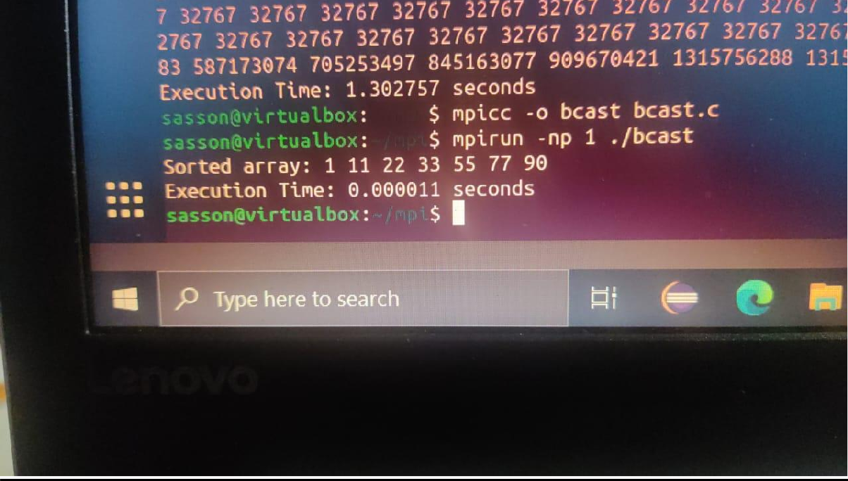

# MPI GATHER

#include <stdio.h> #include <stdlib.h> #include <mpi.h> #include <time.h>

void bubbleSort(int arr[], int n) { int temp;

for (int i = 0; i < n - 1; i++) {

for (int j = 0; j < n - i - 1; j++) { if (arr[j] > arr[j + 1]) {

temp = arr[j]; arr[j] = arr[j + 1]; arr[j + 1] = temp;

}

}

}

}

int main(int argc, char *argv[]) { MPI_Init(&argc, &argv);

int rank, size; MPI_Comm_rank(MPI_COMM_WORLD, &rank); MPI_Comm_size(MPI_COMM_WORLD, &size);

int n = 7; // Size of the array int arr[n];

// Initialize the array with specific values on the root process if (rank == 0) {

int specificValues[] = {22, 90, 77, 55, 33, 11, 1}; for (int i = 0; i < n; i++) {

arr[i] = specificValues[i];

}

}

int local_size = n / size; // Size of each local array int local_arr[local_size];

// Scatter the array to local arrays

MPI_Scatter(arr, local_size, MPI_INT, local_arr, local_size, MPI_INT, 0, MPI_COMM_WORLD);

// Measure execution time

double start_time = MPI_Wtime();

// Perform parallel bubble sort for (int i = 0; i < n; i++) {

if (i % 2 == 0) {

// Even phase bubbleSort(local_arr, local_size);

}

MPI_Barrier(MPI_COMM_WORLD); // Synchronize processes before gathering MPI_Gather(local_arr, local_size, MPI_INT, arr, local_size, MPI_INT, 0,

MPI_COMM_WORLD);

if (i % 2 == 1) {

// Odd phase bubbleSort(arr, n);

}

MPI_Barrier(MPI_COMM_WORLD); // Synchronize processes before gathering MPI_Gather(arr, local_size, MPI_INT, local_arr, local_size, MPI_INT, 0,

MPI_COMM_WORLD);

}

// Measure execution time

double end_time = MPI_Wtime();

double execution_time = end_time - start_time;

if (rank == 0) {

// Print the sorted array printf("Sorted array: "); for (int i = 0; i < n; i++) {

printf("%d ", arr[i]);

}

printf("\n");

printf("Execution Time: %f seconds\n", execution_time);

}

MPI_Finalize(); return 0;

}

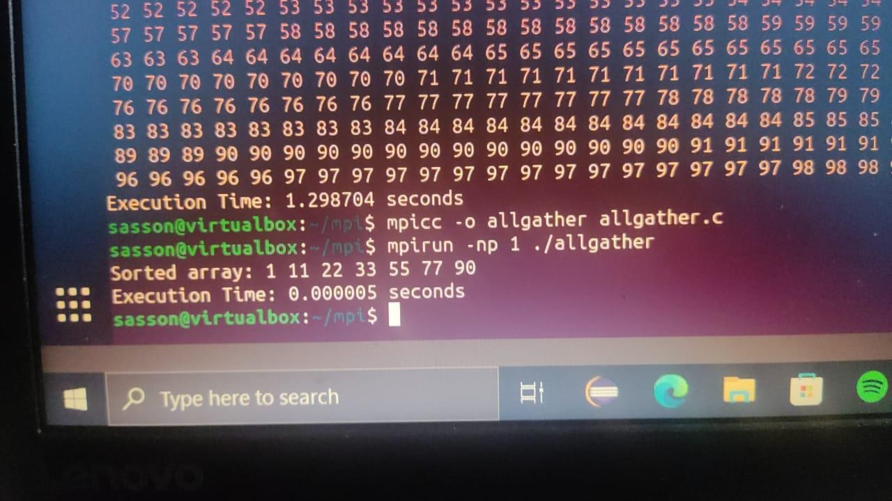

# MPI REDUCE

#include <stdio.h> #include <stdlib.h> #include <mpi.h> #include <time.h>

void bubbleSort(int arr[], int n) { int temp;

for (int i = 0; i < n - 1; i++) {

for (int j = 0; j < n - i - 1; j++) { if (arr[j] > arr[j + 1]) {

temp = arr[j]; arr[j] = arr[j + 1]; arr[j + 1] = temp;

}

}

}

}

int main(int argc, char *argv[]) { MPI_Init(&argc, &argv);

int rank, size; MPI_Comm_rank(MPI_COMM_WORLD, &rank); MPI_Comm_size(MPI_COMM_WORLD, &size);

int n = 7; // Size of the array int arr[n];

// Initialize the array with specific values on the root process if (rank == 0) {

int specificValues[] = {22, 90, 77, 55, 33, 11, 1}; for (int i = 0; i < n; i++) {

arr[i] = specificValues[i];

}

}

int local_size = n / size; // Size of each local array int local_arr[local_size];

// Scatter the array to local arrays

MPI_Scatter(arr, local_size, MPI_INT, local_arr, local_size, MPI_INT, 0, MPI_COMM_WORLD);

// Measure execution time

double start_time = MPI_Wtime();

// Perform parallel bubble sort for (int i = 0; i < n; i++) {

bubbleSort(local_arr, local_size);

MPI_Barrier(MPI_COMM_WORLD); // Synchronize processes before reducing MPI_Reduce(local_arr, arr, n, MPI_INT, MPI_MIN, 0, MPI_COMM_WORLD);

}

// Measure execution time

double end_time = MPI_Wtime();

double execution_time = end_time - start_time;

if (rank == 0) {

// Print the sorted array printf("Sorted array: "); for (int i = 0; i < n; i++) {

printf("%d ", arr[i]);

}

printf("\n");

printf("Execution Time: %f seconds\n", execution_time);

}

MPI_Finalize();

}

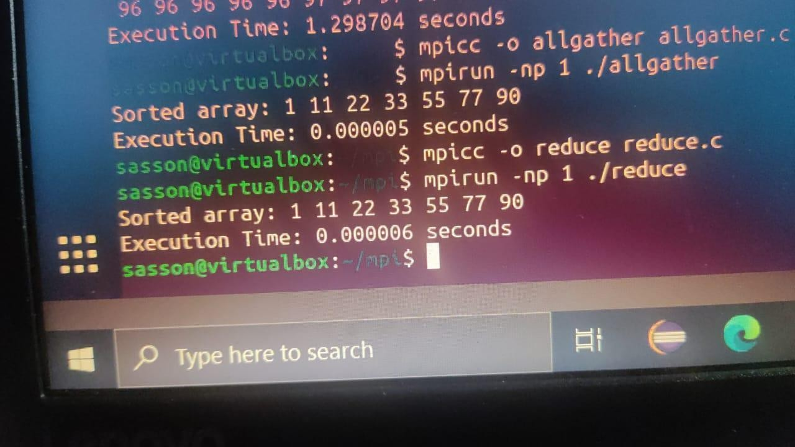

# MPI ALL REDUCE

#include <stdio.h> #include <stdlib.h> #include <mpi.h> #include <time.h>

void bubbleSort(int arr[], int n) { int temp;

for (int i = 0; i < n - 1; i++) {

for (int j = 0; j < n - i - 1; j++) { if (arr[j] > arr[j + 1]) {

temp = arr[j]; arr[j] = arr[j + 1]; arr[j + 1] = temp;

}

}

}

}

int main(int argc, char *argv[]) { MPI_Init(&argc, &argv);

int rank, size; MPI_Comm_rank(MPI_COMM_WORLD, &rank); MPI_Comm_size(MPI_COMM_WORLD, &size);

int n = 7; // Size of the array

int local_size = n / size; // Size of each local array

int local_arr[local_size]; int arr[n];

if (rank == 0) {

// Initialize the array with specific values on the root process int specificValues[] = {22, 90, 77, 55, 33, 11, 1};

for (int i = 0; i < n; i++) { arr[i] = specificValues[i];

}

}

// Broadcast the array to all processes

MPI_Bcast(arr, n, MPI_INT, 0, MPI_COMM_WORLD);

// Scatter the array to local arrays

MPI_Scatter(arr, local_size, MPI_INT, local_arr, local_size, MPI_INT, 0, MPI_COMM_WORLD);

// Measure execution time

double start_time = MPI_Wtime();

// Perform parallel bubble sort for (int i = 0; i < n; i++) {

bubbleSort(local_arr, local_size);

// Allgather to ensure correct ordering for the next iteration MPI_Allgather(local_arr, local_size, MPI_INT, arr, local_size, MPI_INT,

MPI_COMM_WORLD);

}

// Calculate local sum int local_sum = 0;

for (int i = 0; i < local_size; i++) { local_sum += local_arr[i];

}

// Allreduce local sums to find the global sum int global_sum;

MPI_Allreduce(&local_sum, &global_sum, 1, MPI_INT, MPI_SUM, MPI_COMM_WORLD);

// Measure execution time

double end_time = MPI_Wtime();

double execution_time = end_time - start_time;

if (rank == 0) {

// Print the sorted array printf("Sorted array: "); for (int i = 0; i < n; i++) {

printf("%d ", arr[i]);

}

printf("\n");

printf("Global Sum: %d\n", global_sum); printf("Execution Time: %f seconds\n", execution_time);

}

MPI_Finalize(); return 0;

}

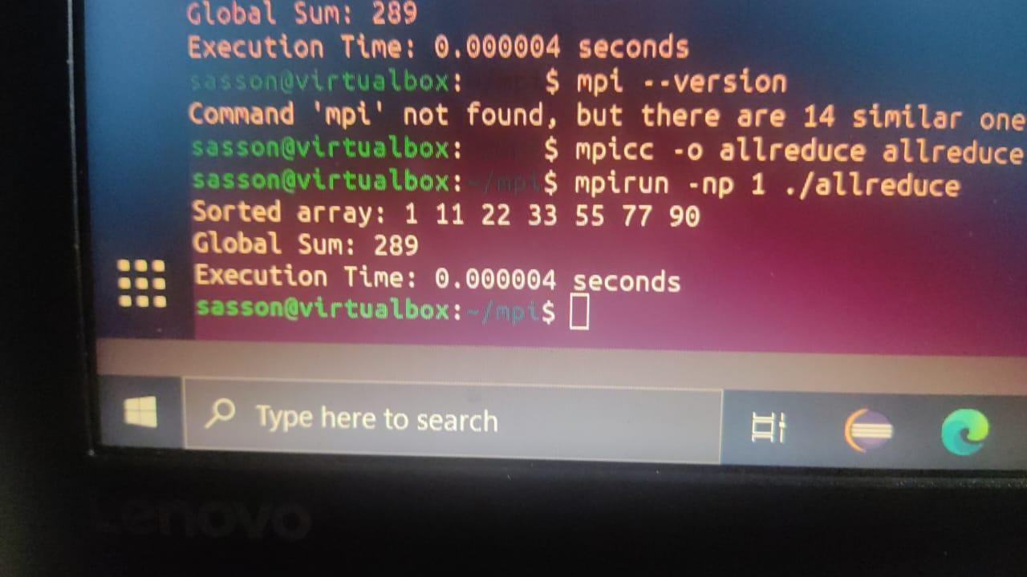

# SUMMARY

Selecting between MPI_Bcast, MPI_Scatter, MPI_Gather, MPI_Reduce, or MPI_Allreduce hinges on the particular demands and behavior of your MPI program. Each MPI collective operation serves a distinct purpose, and the optimal choice relies on the communication pattern and data distribution in your application.

**MPI_Bcast:** It's used when a single source (typically the root process) needs to broadcast data to all other processes.

Consideration for Bubble Sort: If the data for sorting is identical across all processes, MPI_Bcast can efficiently distribute the initial array to all processes before sorting.

**MPI_Scatter:** Appropriate when distributing different segments of an array to various processes is necessary.

Consideration for Bubble Sort: If dividing the initial array into segments and sending each to different processes for sorting, followed by gathering the results, is needed.

**MPI_Gather:** Useful for collecting data from multiple processes onto a single process (often the root process).

Consideration for Bubble Sort: When sorting different segments of the array on separate processes and gathering the sorted segments to a single process for further processing.

**MPI_Reduce:** Applied when a reduction operation (e.g., sum, max) across all processes is required, typically resulting in a single value.

Consideration for Bubble Sort: If seeking a global reduction operation (e.g., finding the sum of all elements in the sorted array).

**MPI_Allreduce:** Employed when performing a reduction operation across all processes, with each process receiving the result.

Consideration for Bubble Sort: When all processes should possess the result of a global reduction operation without an additional gather step.

In an MPI Bubble Sort program, the communication pattern is pivotal. Utilizing a combination of MPI_Scatter and MPI_Gather might suit scenarios where data distribution and independent local sorting are needed. For global reduction operations, MPI_Allreduce or MPI_Reduce could be more fitting choices.

# BUBBLE SORT PROGRAM IN OPEN MP

#include <stdio.h> #include <stdlib.h> #include <omp.h>

void bubbleSort(int arr[], int n) { int temp;

#pragma omp parallel for for (int i = 0; i < n - 1; i++) {

#pragma omp parallel for shared(arr) private(temp) for (int j = 0; j < n - i - 1; j++) {

if (arr[j] > arr[j + 1]) { #pragma omp critical

{

temp = arr[j];

arr[j] = arr[j + 1]; arr[j + 1] = temp;

}

}

}

}

}

int main() {

int n = 10; // Adjust the size of the array as needed int arr[] = {64, 34, 25, 12, 22, 11, 90, 88, 75, 50};

printf("Original array: "); for (int i = 0; i < n; i++) { printf("%d ", arr[i]);

}

printf("\n");

// Perform parallel bubble sort bubbleSort(arr, n);

printf("Sorted array: "); for (int i = 0; i < n; i++) {

printf("%d ", arr[i]);

}

printf("\n"); return 0;

}

OUTPUT:

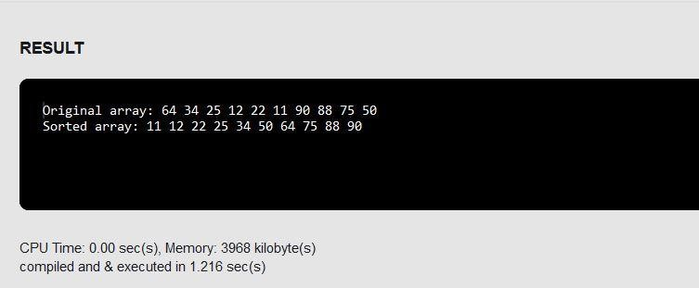

# EVEN PHASE AND ODD PHASE BUBBLE SORTING

#include <stdio.h> #include <stdlib.h> #include <omp.h>

void oddEvenBubbleSort(int arr[], int n) { int temp;

int sorted = 0;

while (!sorted) { sorted = 1;

// Odd phase

#pragma omp parallel for shared(arr) private(temp) reduction(&&:sorted) for (int i = 1; i < n - 1; i += 2) {

if (arr[i] > arr[i + 1]) { temp = arr[i];

arr[i] = arr[i + 1]; arr[i + 1] = temp;

sorted = 0; // Set sorted to false if a swap occurred

}

}

// Even phase

#pragma omp parallel for shared(arr) private(temp) reduction(&&:sorted) for (int i = 0; i < n - 1; i += 2) {

if (arr[i] > arr[i + 1]) { temp = arr[i];

arr[i] = arr[i + 1]; arr[i + 1] = temp;

sorted = 0; // Set sorted to false if a swap occurred

}

}

// Ensure all threads have finished their work before checking 'sorted' #pragma omp barrier

}

}

int main() {

int n = 10; // Adjust the size of the array as needed int arr[] = {64, 34, 25, 12, 22, 11, 90, 88, 75, 50};

printf("Original array: "); for (int i = 0; i < n; i++) { printf("%d ", arr[i]);

}

printf("\n");

// Perform odd-even phase parallel bubble sort oddEvenBubbleSort(arr, n);

printf("Sorted array: "); for (int i = 0; i < n; i++) {

printf("%d ", arr[i]);

}

printf("\n");

return 0;

}

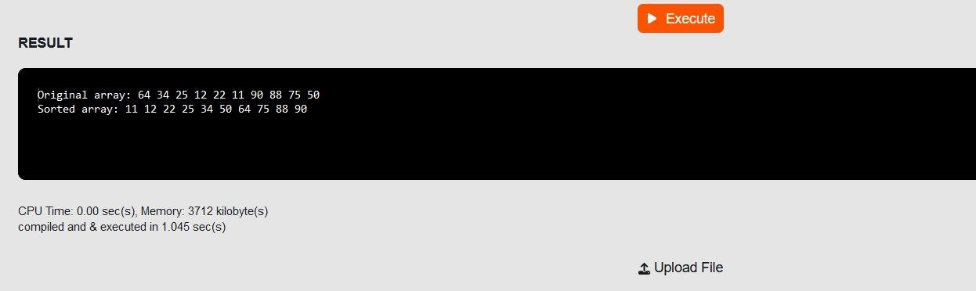

## Critical Section:

* + In Code 1, the entire sorting operation is protected by a single critical section. This ensures that only one thread at a time can execute the sorting operation, preventing race conditions.
  + In Code 2, there is a nested parallel region with a critical section inside the inner loop. This can lead to inefficiencies and might not be necessary for this specific sorting algorithm.

critical section -is a region of code that must be executed by only one thread or process at a time, in order to prevent race conditions and ensure the integrity of the shared resource.

## Barrier in Code 2:

* + Code 2 includes #pragma omp barrier after each phase of the sorting algorithm. This is not present in Code 1. The barrier ensures that all threads complete their work in the current phase before proceeding to the next phase. However, using barriers in this way might limit parallelism.

## Private Variables:

* + Both codes use private variables (temp) to avoid data races. The use of private variables is essential to ensure correctness in a parallel setting.

**Recommendation:** It's generally more efficient to use a single critical section to protect the entire sorting operation (as in Code 1) rather than introducing nested parallelism and barriers.

The critical section ensures mutual exclusion while allowing for better parallelism. You may further optimize the parallelization based on the specific requirements of your application and the characteristics of the sorting algorithm.

# PTHREAD PROGRAM TO OPEN MP:

**PTHREAD**

#include <stdio.h> #include <stdlib.h> #include <pthread.h> #include <time.h>

#define NUM_THREADS 4

#define ARRAY_SIZE 1000

int array[ARRAY_SIZE]; int sum = 0;

pthread_mutex_t mutex = PTHREAD_MUTEX_INITIALIZER; // Declare mutex

void *computeSum(void *threadID) { long id = (long)threadID;

int localSum = 0;

for (int i = id * (ARRAY_SIZE / NUM_THREADS); i < (id + 1) * (ARRAY_SIZE / NUM_THREADS); ++i) {

localSum += array[i];

}

// Critical section pthread_mutex_lock(&mutex); sum += localSum; pthread_mutex_unlock(&mutex);

pthread_exit(NULL);

}

int main() {

pthread_t threads[NUM_THREADS]; long t;

// Initialize array

for (int i = 0; i < ARRAY_SIZE; ++i) { array[i] = i + 1;

}

// Measure execution time clock_t start_time = clock();

// Create threads

for (t = 0; t < NUM_THREADS; ++t) {

pthread_create(&threads[t], NULL, computeSum, (void *)t);

}

// Join threads

for (t = 0; t < NUM_THREADS; ++t) {

pthread_join(threads[t], NULL);

}

// Measure execution time clock_t end_time = clock();

double execution_time = ((double)(end_time - start_time)) / CLOCKS_PER_SEC;

printf("Sum: %d\n", sum);

printf("Execution Time: %f seconds\n", execution_time);

pthread_exit(NULL);

}

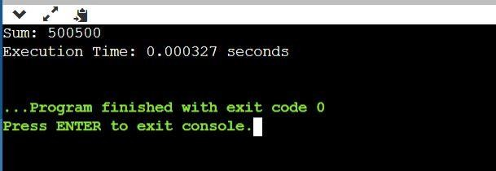

# OPEN MP

#include <stdio.h> #include <stdlib.h> #include <omp.h>

#define NUM_THREADS 4

#define ARRAY_SIZE 1000

int array[ARRAY_SIZE]; int sum = 0;

int main() { long t;

// Initialize array

for (int i = 0; i < ARRAY_SIZE; ++i) { array[i] = i + 1;

}

// Parallel region with OpenMP

#pragma omp parallel num_threads(NUM_THREADS) private(t)

{

int localSum = 0;

// Each thread computes its local sum #pragma omp for

for (int i = 0; i < ARRAY_SIZE; ++i) { localSum += array[i];

}

// Critical section to update the global sum #pragma omp critical

{

sum += localSum;

}

}

printf("Sum: %d\n", sum);

return 0;

}

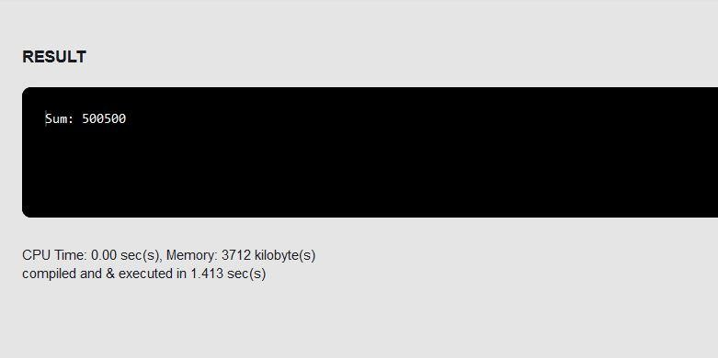

## Replace Pthreads functions with OpenMP directives:

* + The pthread_create and pthread_join functions are replaced with OpenMP directives for parallel regions and loops (#pragma omp parallel and #pragma omp for).
  + The pthread_exit call at the end of the Pthreads version is not needed in the OpenMP version.

## Private variables:

* + In the OpenMP version, the private variable t is explicitly declared within the parallel directive.

## Critical section:

* + The critical section, where the global sum is updated, is achieved using #pragma omp critical in OpenMP.