# Design

## 3.1. Introduction

Design is an important phase in a software development. Design Phase defines the physical specification of the system. The key problems in the project are identified in this phase. The design phase helps in developing the overall architecture of the system. The defined scope and purpose of the project are illustrated in this phase. This stage helps to identifies all the user interaction and the functions required to meet the requirements are fulfilled.

## 3.2. Tools

Following tools are used to develop Online Laundry Service

* Sublime text
* MySQL for database.
* StarUML for Class diagram, Activity diagram and Sequence Diagram
* Visual Paradigm for Entity Relationship Diagram

## 3.3. Structural Model

The static view of the system is captured in Structural Model. It is a systematic approach for developing a software design. It is the static structure which defines the interaction, attributes and relationship of the objects. Class diagram, Entity Relationship, Dataflow Diagram and Concept Diagram etc. falls under structural Diagram. The have designed the Class diagram and Entity Relationship diagram which is given below.

### 3.3.1. Class diagram

The class diagram is a static structure diagram in a Unified Modelling Language that demonstrates the classes, attributes, and operations of the system. The cardinality relationship between the classes are also identified in class diagram.

The class diagram of Online Laundry service is given below.

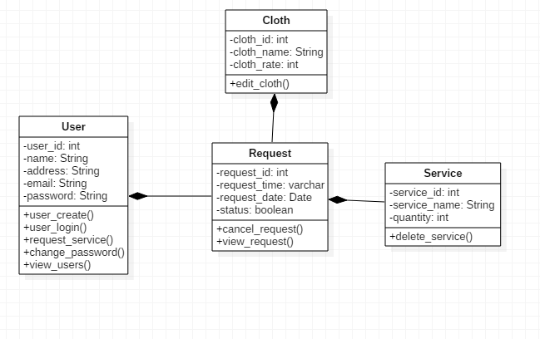

Figure 4: Class diagram

The finial class diagram consists of 4 classes. The user class, the cloth class, the request class and the service class.

### 3.3.2. Data Flow Diagram

Data Flow diagrams are used to graphically represent the flow of data in a system. It demonstrates process, data flow, entities and data stores. Formal notations are used in Data Flow diagram. Data Flow Diagram is divided into logical and physical diagram.

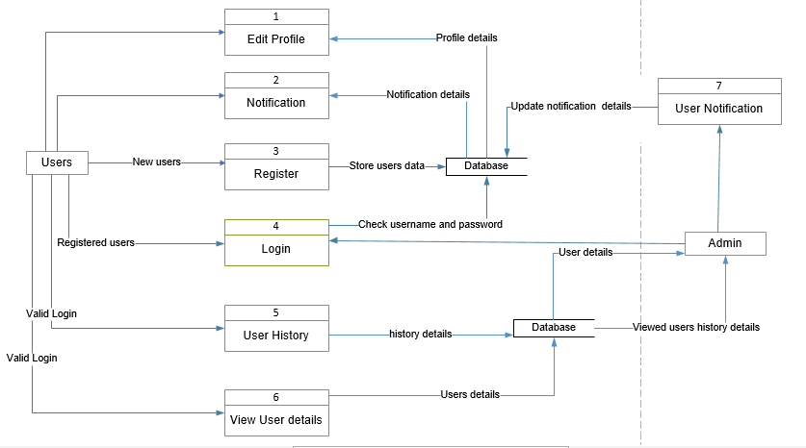

Figure 5: Data flow diagram

## 3.4. Behavioral Model

Behavioral Model defines the dynamic behavior of an executing system. They show the flow of operation, and interactions of the objects. The interaction within the system is explained in the behavioral model. It confers the real behavior of the system and describes the controller structure and help overcome the desired needs of the it.

The activity diagram and sequence diagram fall under the behavioral models. The activity diagrams shows the flow of activity to activity in the system. The sequence diagram shows the collaboration of the object.

### 3.4.1. Activity Diagram

Activity Diagram shows the dynamic behavior showing the flow of control from its activity to activity. It shows the diagrammatic outline of work process. It characterizes all the internal process. It gives the flow of the diagram within the use case. The activity diagram of Online laundry service is given below:

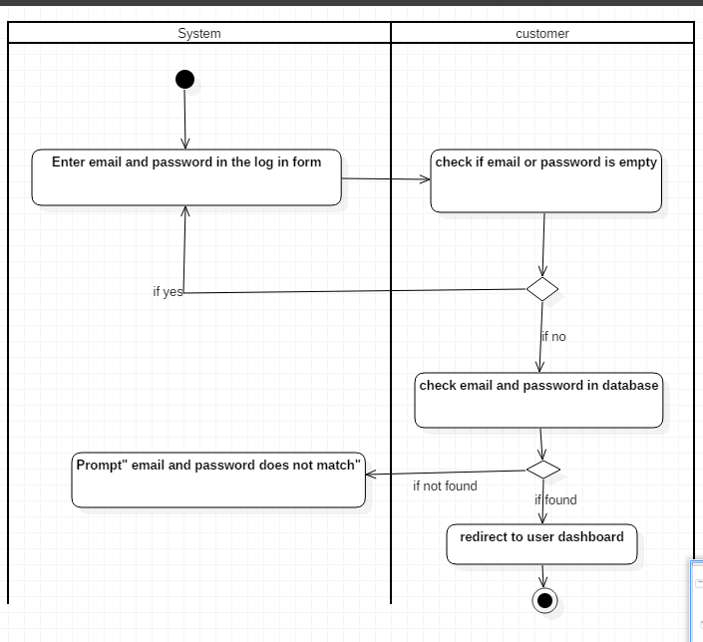

Figure 6:Activity Diagram for Login

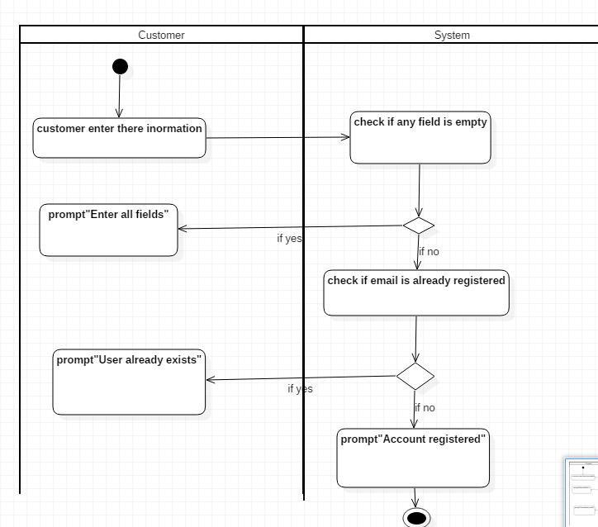

Figure 7:Activity Diagram for register

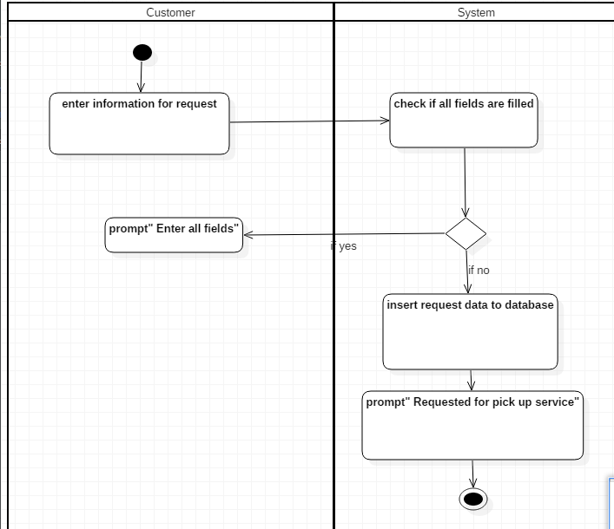

Figure 8:Activity Diagram for Request

### 

### 3.4.2. Sequence diagram

Sequence diagram are interaction diagrams that detail how operations are carried out. It captures the interactions between the objects and communication. Sequence diagrams are time focused and shows the time interactions. It is also known as event diagram and can guess how the system will behave and perform.

The Sequence diagram of Online Laundry Service is given below.

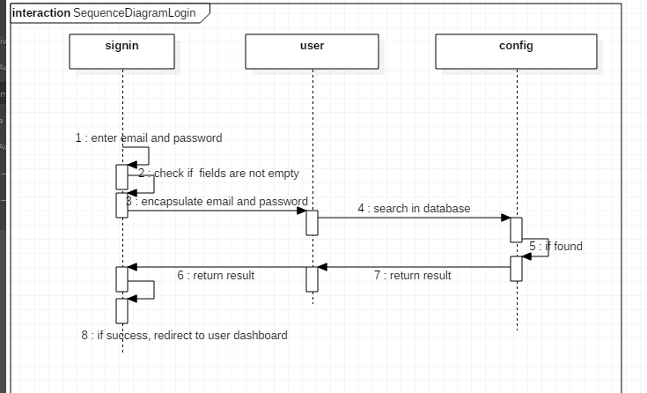

Figure 9:Sequence diagram for login

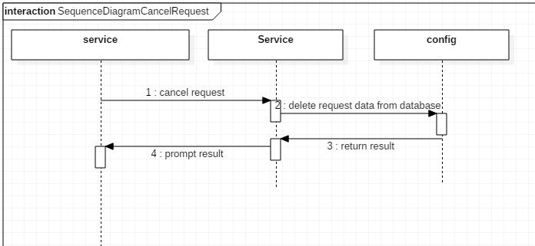

Figure 10:Sequence diagram for login

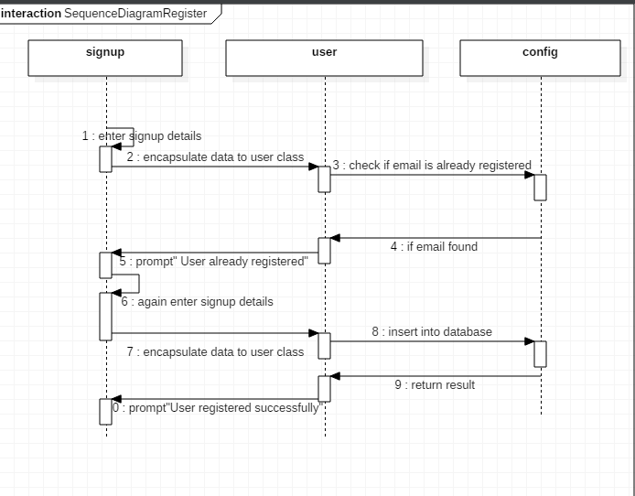

Figure 11:Sequence diagram for register

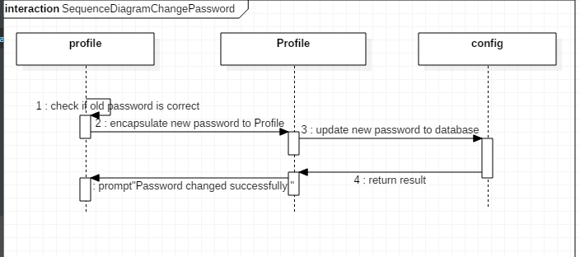

Figure 12:Sequence diagram for Change password

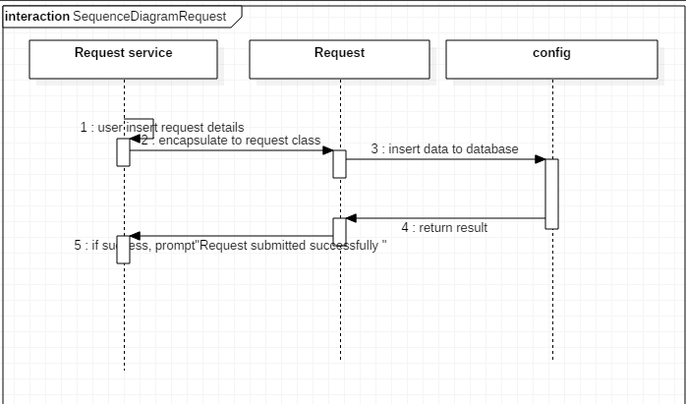

Figure 13:Sequence diagram for register

## 3.5 Database Design

It is the standardized form that makes data model flexible and makes working with data much easier. It identifies entities and relationships. It determines the data that needs to be stored in database.

## 3.6 Data dictionary

Data dictionary is the collection of description of data objects. It describes database and its objects. Data dictionary carries the information of database and the data inside it.

## 3.7. Entity Relationship Diagram

The pictorial representation of the entities and their relationship is shown in an Entity Relationship Diagram. It represents the conceptual and logical structure of the database.

An Entity Relationship Diagram of Online Laundry Service is given below.

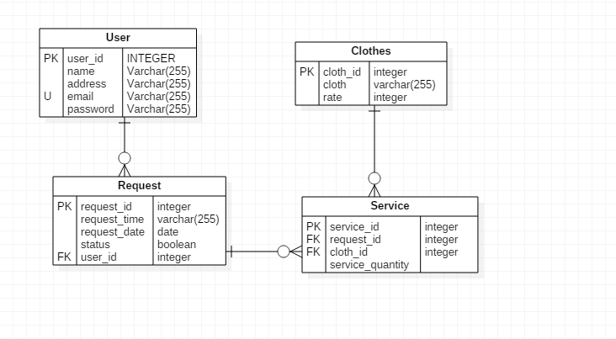

Figure 14: Entity diagram

## 3.8. UI Design

User Interface is everything designed into an information device. It is a way through user interacts with an application or a website. The Ui designs of Online Laundry Service is given below:



Home page

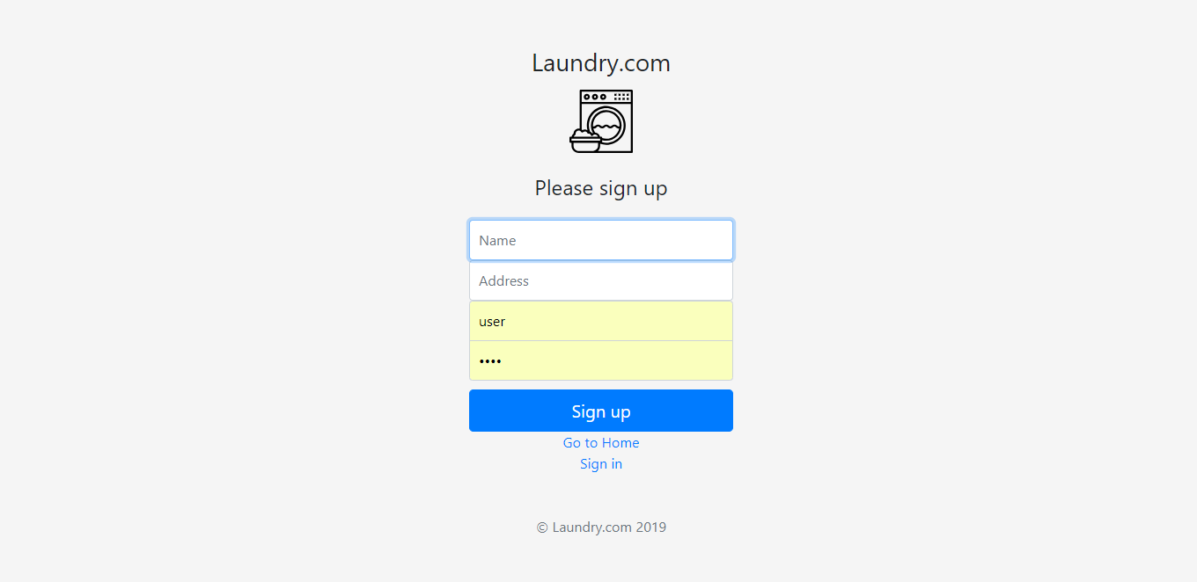

Sign up page

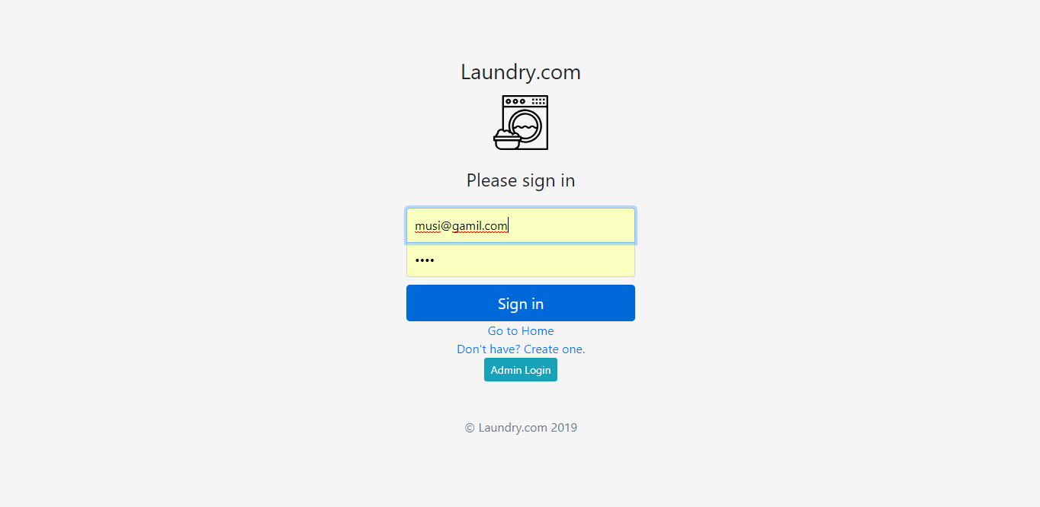

After sign up

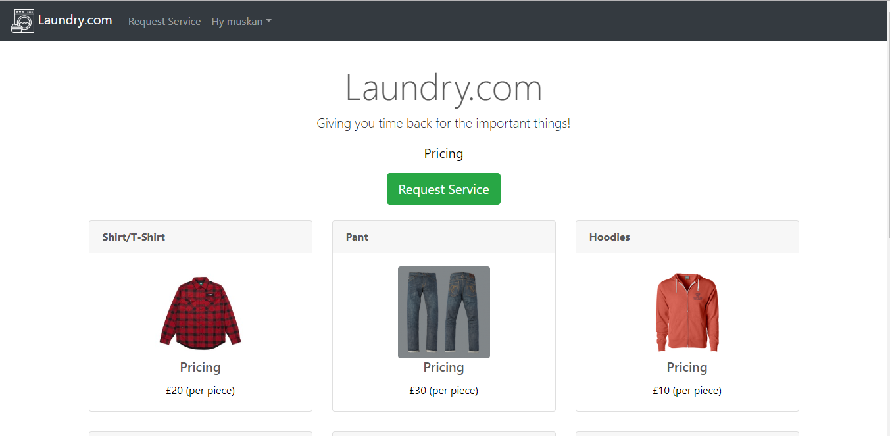 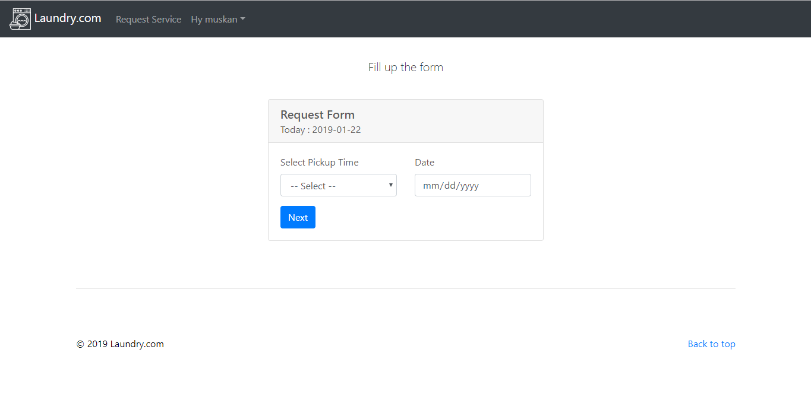

After user sign up

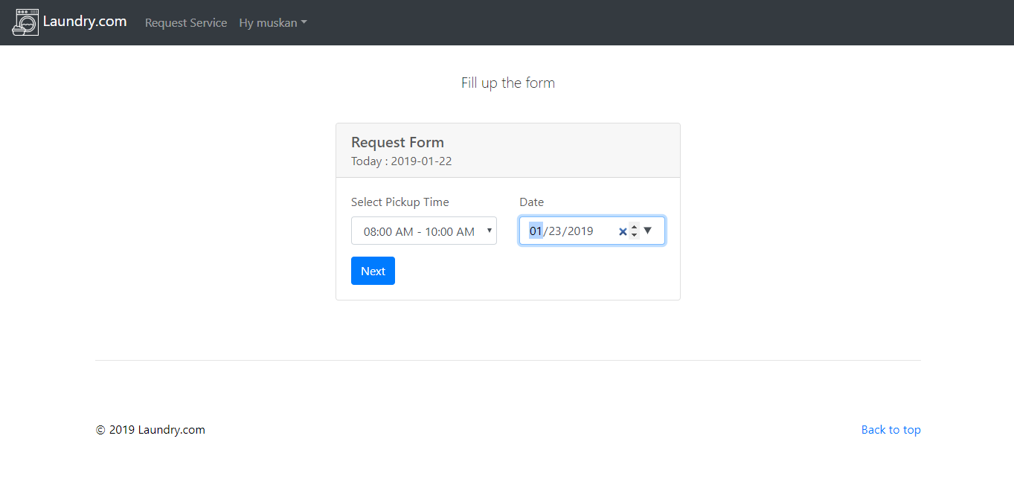

User Filling request form

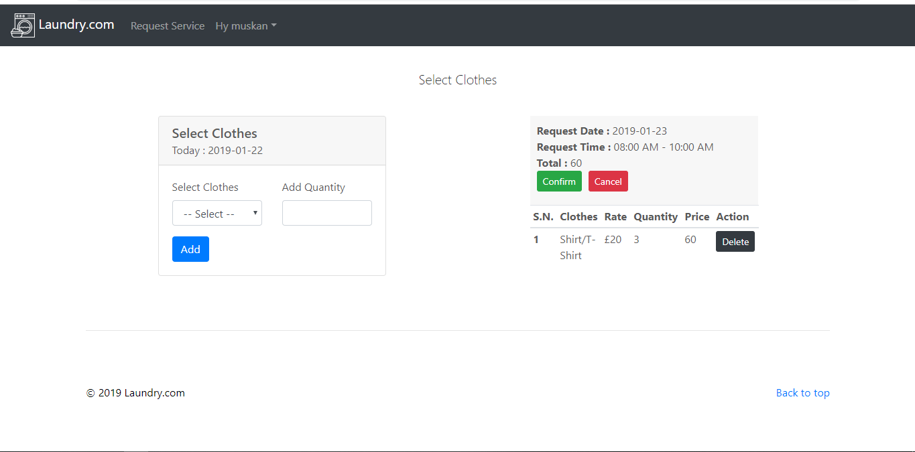

User filling the request form

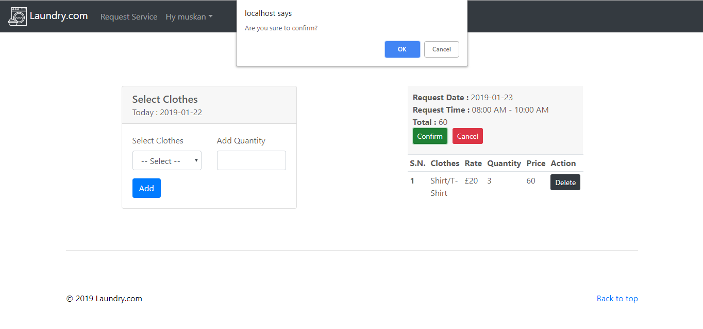

After the request form notification is given

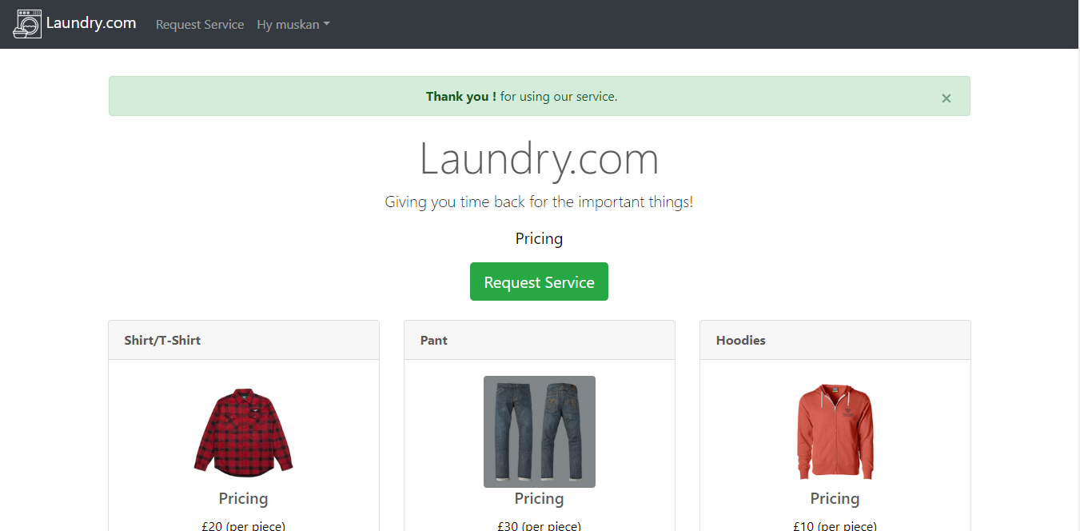

The request form page

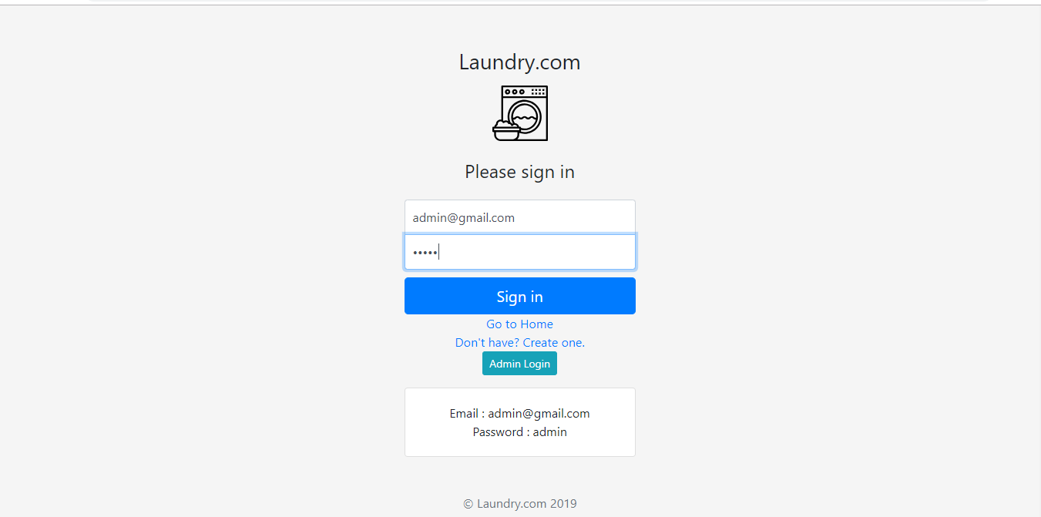

Signing in for Admin

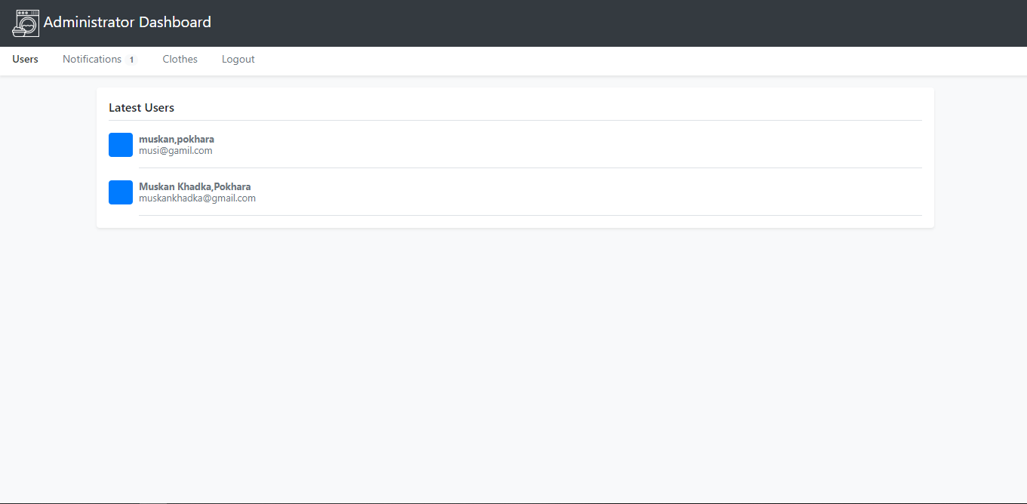

Showing the notification of the users to the admin

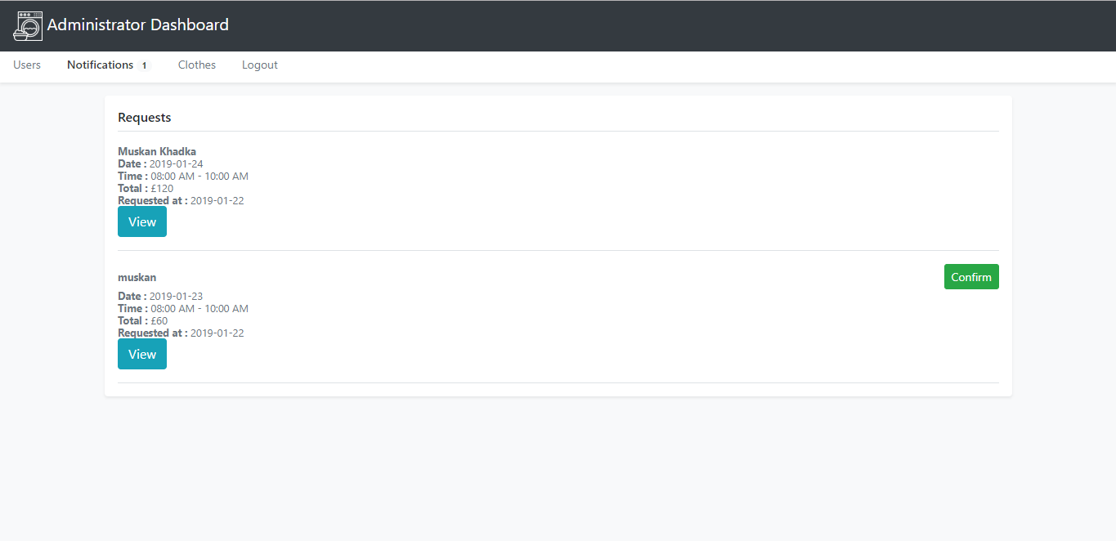

Request can be edited

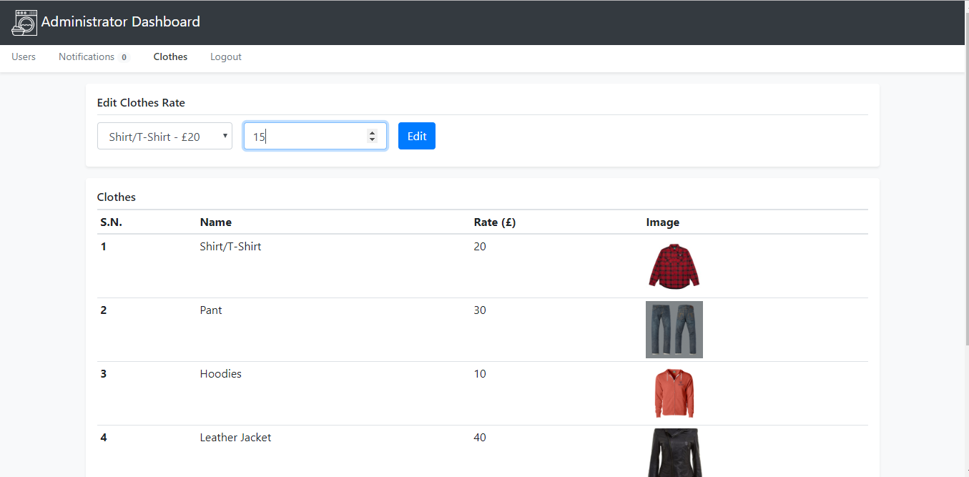

Rate can be changed

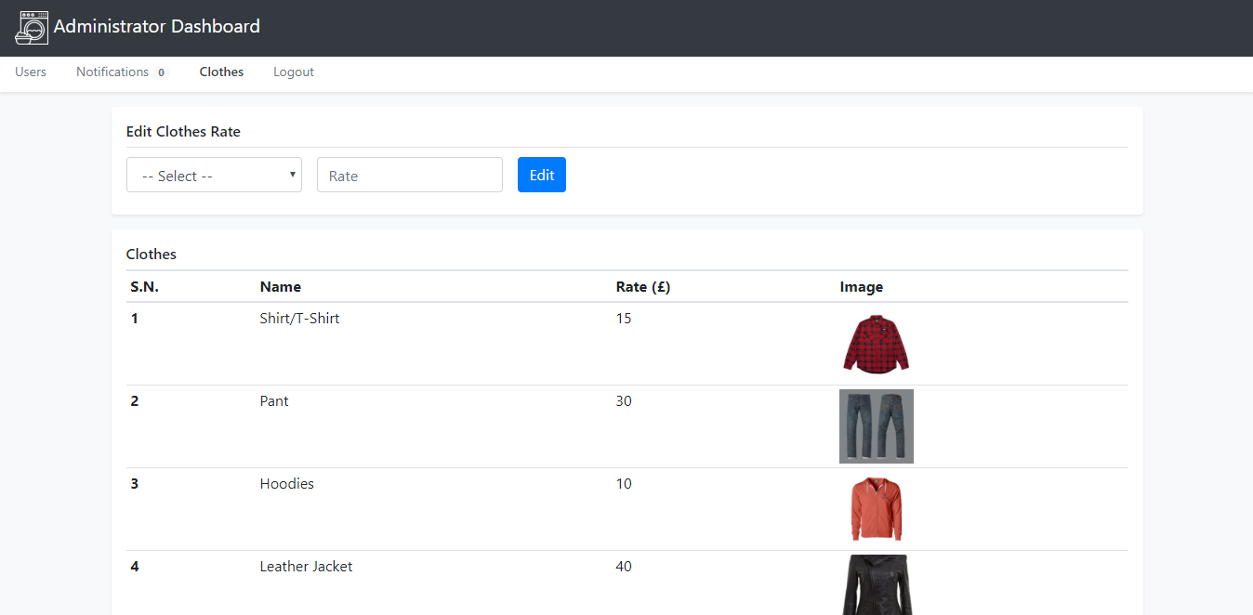

Request can be edited by the admin

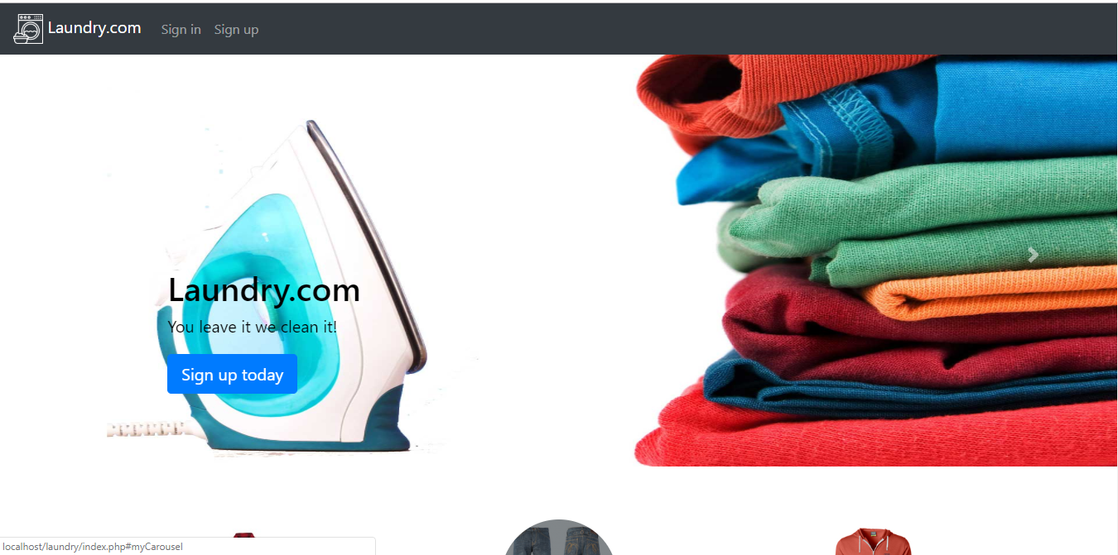

Back to the home page