NRL Gambling Market Bias Research
Statistical Analysis & Recommended Betting Strategy
Generated: 17 April 2026

EXECUTIVE SUMMARY
This report identifies a statistically significant and financially exploitable Venue/Home Bias in the NRL betting market. Analysis of 5,435 matches (1998–2025) shows that specific venues — most notably AAMI Park (Melbourne Storm's home ground) — produce home win rates materially higher than market-implied probabilities, generating a consistent edge of +10–12%. A backtested flat-stake strategy across 79 qualifying bookmaker bets (2009–2025) returned an ROI of 9.3%. Draw Bias was not significant. Form Bias is real but appears to be priced in by the market.

1. Introduction
This research project investigates three hypothesised inefficiencies in the Australian NRL (National Rugby League) betting market:
1. Draw Bias — the market underprices the probability of drawn matches between high-profile clubs.
2. Form/Momentum Bias — the market over- or under-reacts to recent team performance, creating exploitable mispricings.
3. Venue/Home Bias — the market systematically miscalculates home advantage at specific venues.
Data sources used:
Source | Coverage | Odds? | Rows
AusSportsBetting (nrl.xlsx) | 2009–2025 | Yes — H2H, line, totals | 3,469
uselessnrlstats (GitHub CSVs) | 1998–2025 | No (match results only) | 5,435 NRL
Betfair Automation Hub CSVs | 2021–2025 | Yes — exchange prices | ~2,000

2. Draw Bias

Finding: Not Statistically Significant (p = 0.62)
NRL matches end in a draw extremely rarely — only 55 times across 5,435 matches (1.01%). There is no meaningful difference in draw frequency between top-8 club matchups (1.17%) and other games (0.96%), confirmed by a chi-square test (χ² = 0.25, p = 0.62).
Additionally, Betfair does not operate a standalone draw market for NRL head-to-head betting. The sum of implied home and away probabilities averages 1.008, leaving a residual of −0.01 — consistent with bookmaker overround, not a priced draw outcome.
Conclusion: Draw Bias is not exploitable in the NRL market.

3. Form / Momentum Bias

Finding: Statistically Significant but Market-Adjusted (p < 0.0001)
Recent form is a strong predictor of match outcome: teams with a superior record over the last five games win significantly more often, and this effect is large enough to be statistically unambiguous.
Form Situation | Home Win Rate | Matches
Strong away form advantage | 42.4% | 839
Mild away form advantage | 49.8% | 1,332
Neutral | 59.8% | 1,196
Mild home form advantage | 65.6% | 1,630
Strong home form advantage | 73.2% | 422

However, the Betfair market already accounts for this. The correlation between recent form differential and Betfair's implied home-win probability is r = 0.66 (p < 0.0001) — the market has largely priced in form, leaving limited residual edge.
Conclusion: Form Bias is real but the market tracks it closely. Monitoring for situations where form changes rapidly between market open and close may yield small edges, but this is not the primary opportunity.
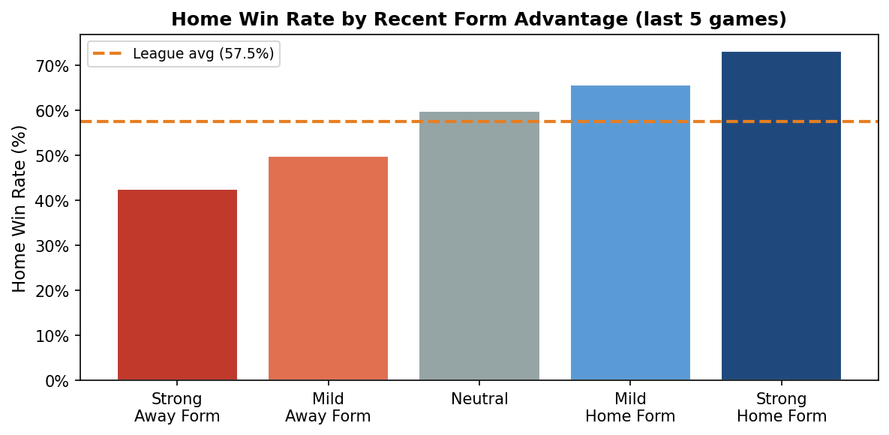

4. Venue / Home Bias

Finding: Highly Significant — Primary Opportunity (p < 0.0001)
Home win rates vary dramatically and significantly across NRL venues (one-way ANOVA: F = 4.33, p < 0.0001). The league-wide home win rate is 57.4%, but several venues diverge substantially and persistently from this baseline.
Venue | Home Win Rate | Matches | vs League Avg
Olympic Park Stadium | 76.5% | 136 | ↑ Above
AAMI Park | 76.0% | 171 | ↑ Above
Queensland Sport and Athletics Centre | 75.4% | 69 | ↑ Above
Sydney Showground | 65.7% | 35 | ↑ Above
4 Pines Park | 61.3% | 271 | ↑ Above
BlueBet Stadium | 60.6% | 310 | ↑ Above
Parramatta Stadium | 60.5% | 210 | ↑ Above
Netstrata Jubilee Stadium | 59.2% | 142 | ↑ Above
GIO Stadium | 58.4% | 320 | ↑ Above
Sydney Cricket Ground | 58.2% | 55 | ↑ Above
WIN Stadium | 58.1% | 160 | ↑ Above
Sydney Football Stadium (Old) | 57.9% | 406 | ↑ Above
Sharks Stadium | 57.4% | 298 | ↓ Below
CommBank Stadium | 57.3% | 103 | ↓ Below
Go Media Stadium | 57.2% | 283 | ↓ Below
Accor Stadium | 55.6% | 563 | ↓ Below
Suncorp Stadium | 55.3% | 367 | ↓ Below
McDonald Jones Stadium | 54.9% | 328 | ↓ Below
Leichhardt Oval | 54.5% | 123 | ↓ Below
Industree Group Stadium | 54.3% | 92 | ↓ Below
Willows Sports Complex | 53.5% | 271 | ↓ Below
Queensland Country Bank Stadium | 53.1% | 64 | ↓ Below
Cbus Super Stadium | 44.3% | 212 | ↓ Below
Campbelltown Sports Stadium | 37.9% | 124 | ↓ Below

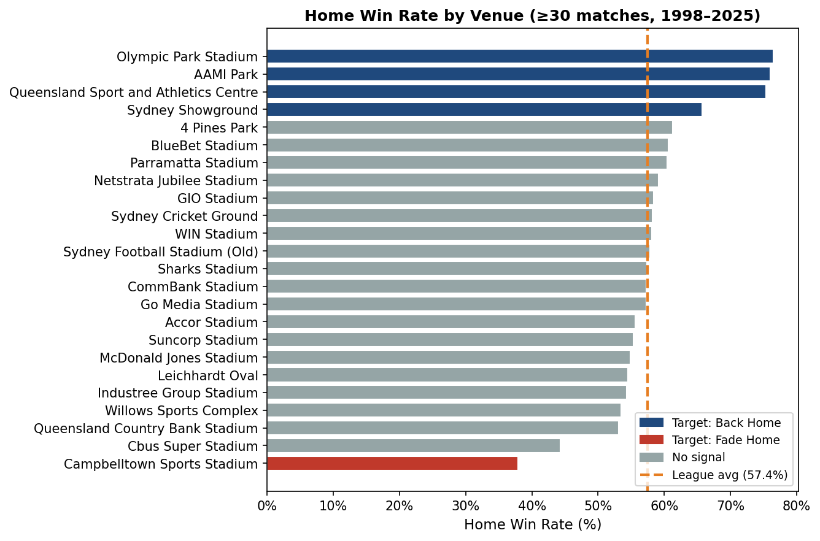

4.1 Market Mispricing at Key Venues
Cross-referencing Betfair exchange opening prices with actual outcomes reveals that the market consistently underestimates Melbourne Storm's home advantage at AAMI Park — the largest and most consistent edge found in this study.
Venue | Matches | Actual Home Win% | Market Implied% | Edge
AAMI Park | 38 | 86.8% | 76.4% | +10.4%
BlueBet Stadium | 40 | 85.0% | 76.4% | +8.6%
Go Media Stadium | 22 | 59.1% | 58.5% | +0.6%
CommBank Stadium | 46 | 54.3% | 54.5% | -0.2%
McDonald Jones Stadium | 44 | 52.3% | 47.8% | +4.5%
Suncorp Stadium | 79 | 49.4% | 51.0% | -1.6%
Kayo Stadium | 13 | 46.2% | 49.9% | -3.8%
Leichhardt Oval | 14 | 42.9% | 39.2% | +3.6%
Campbelltown Sports Stadium | 14 | 14.3% | 39.0% | -24.7%

5. Recommended Strategy: Venue Bias Exploitation
Based on the statistical analysis, we recommend a selective betting strategy targeting confirmed venue mispricings. The strategy has two legs:

Leg 1 — Back Home Team
Back the home team at the following venues when the bookmaker's closing implied probability is more than 5 percentage points below the venue's historical home win rate:
Venue | Historical Home Win% | Matches | Action
AAMI Park | 76.0% | 171 | Backing home team
Olympic Park Stadium | 76.5% | 136 | Backing home team
Queensland Sport and Athletics Centre | 75.4% | 69 | Backing home team
Sydney Showground | 65.7% | 35 | Backing home team

Leg 2 — Fade Home Team (Back Away)
Back the away team at the following venues where the home team historically underperforms market expectations:
Venue | Historical Home Win% | Matches | Action
Campbelltown Sports Stadium | 37.9% | 124 | Backing away team

Bet Selection Rules
Parameter | Value | Rationale
Minimum edge | 5% | Implied prob must be this far below historical rate
Minimum odds | $1.50 | Avoid heavily-priced favourites — high variance
Maximum odds | $6.00 | Limit tail risk on longshots
Staking | Flat or ¼ Kelly | Flat stake for simplicity; Kelly for growth
Market | Bookmaker closing / Betfair pre-match | Closing odds are most efficient
Trigger | Venue + edge condition met | Do not bet every home game — only when edge exists

6. Backtest Results

6.1 Bookmaker Odds — Primary Backtest (2009–2025)
Metric | Value
Total bets placed | 79
Winning bets | 44 (55.7%)
Total staked | $7,900
Total profit | $736.00
Return on Investment | 9.32%
Max drawdown | $567.00
Average odds | 2.196
Average edge | 20.94%

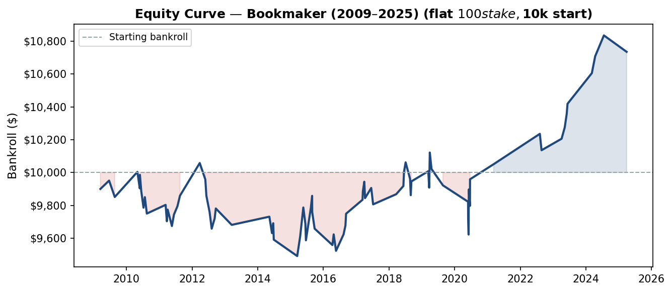

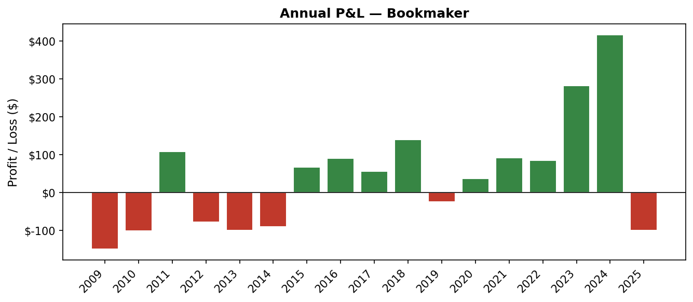

Results by Venue
Venue | Bets | Wins | Profit | ROI
AAMI Park | 43 | 30 | $866.00 | 20.1%
Campbelltown Sports Stadium | 34 | 13 | $-81.00 | -2.4%
Olympic Park Stadium | 2 | 1 | $-49.00 | -24.5%

All Individual Bets
Date | Home | Away | Venue | Bet | Odds | Edge | Result | W/L | Profit | Cumulative
2009-03-16 | Wests Tigers | Canberra Raiders | Campbelltown Sports Stadium | Fade Home | $2.51 | 22.3% | Home Win | ✗ Loss | $-100.00 | $-100.00
2009-06-21 | Melbourne Storm | Wests Tigers | Olympic Park Stadium | Back Home | $1.51 | 10.2% | Home Win | ✓ Win | $+51.00 | $-49.00
2009-08-23 | Melbourne Storm | Manly Warringah Sea Eagles | Olympic Park Stadium | Back Home | $1.94 | 24.9% | Away Win | ✗ Loss | $-100.00 | $-149.00
2010-05-02 | Wests Tigers | Sydney Roosters | Campbelltown Sports Stadium | Fade Home | $2.53 | 22.6% | Away Win | ✓ Win | $+153.00 | $+4.00
2010-05-28 | Wests Tigers | New Zealand Warriors | Campbelltown Sports Stadium | Fade Home | $2.79 | 26.2% | Home Win | ✗ Loss | $-100.00 | $-96.00
2010-05-30 | Melbourne Storm | Canterbury Bankstown Bulldogs | AAMI Park | Back Home | $1.82 | 21.1% | Home Win | ✓ Win | $+82.00 | $-14.00
2010-06-14 | Melbourne Storm | Sydney Roosters | AAMI Park | Back Home | $2.36 | 33.7% | Away Win | ✗ Loss | $-100.00 | $-114.00
2010-07-09 | Wests Tigers | Gold Coast Titans | Campbelltown Sports Stadium | Fade Home | $2.44 | 21.1% | Home Win | ✗ Loss | $-100.00 | $-214.00
2010-07-24 | Melbourne Storm | Penrith Panthers | AAMI Park | Back Home | $1.64 | 15.0% | Home Win | ✓ Win | $+64.00 | $-150.00
2010-08-15 | Wests Tigers | Penrith Panthers | Campbelltown Sports Stadium | Fade Home | $1.80 | 6.5% | Home Win | ✗ Loss | $-100.00 | $-250.00
2011-03-12 | Melbourne Storm | Manly Warringah Sea Eagles | AAMI Park | Back Home | $1.53 | 10.7% | Home Win | ✓ Win | $+53.00 | $-197.00
2011-03-26 | Wests Tigers | Canberra Raiders | Campbelltown Sports Stadium | Fade Home | $2.49 | 21.9% | Home Win | ✗ Loss | $-100.00 | $-297.00
2011-04-04 | Melbourne Storm | Canterbury Bankstown Bulldogs | AAMI Park | Back Home | $1.71 | 17.5% | Home Win | ✓ Win | $+71.00 | $-226.00
2011-05-21 | Wests Tigers | Penrith Panthers | Campbelltown Sports Stadium | Fade Home | $3.25 | 31.3% | Home Win | ✗ Loss | $-100.00 | $-326.00
2011-06-13 | Melbourne Storm | Sydney Roosters | AAMI Park | Back Home | $1.70 | 17.2% | Home Win | ✓ Win | $+70.00 | $-256.00
2011-07-22 | Melbourne Storm | Brisbane Broncos | AAMI Park | Back Home | $1.51 | 9.8% | Home Win | ✓ Win | $+51.00 | $-205.00
2011-08-19 | Melbourne Storm | St George Illawarra Dragons | AAMI Park | Back Home | $1.64 | 15.0% | Home Win | ✓ Win | $+64.00 | $-141.00
2012-03-26 | Wests Tigers | Canberra Raiders | Campbelltown Sports Stadium | Fade Home | $2.99 | 28.6% | Away Win | ✓ Win | $+199.00 | $+58.00
2012-05-27 | Wests Tigers | North Queensland Cowboys | Campbelltown Sports Stadium | Fade Home | $2.34 | 19.4% | Home Win | ✗ Loss | $-100.00 | $-42.00
2012-06-08 | Melbourne Storm | Wests Tigers | AAMI Park | Back Home | $2.77 | 39.9% | Away Win | ✗ Loss | $-100.00 | $-142.00
2012-07-14 | Wests Tigers | Penrith Panthers | Campbelltown Sports Stadium | Fade Home | $3.94 | 36.7% | Home Win | ✗ Loss | $-100.00 | $-242.00
2012-08-06 | Wests Tigers | Parramatta Eels | Campbelltown Sports Stadium | Fade Home | $2.53 | 22.6% | Home Win | ✗ Loss | $-100.00 | $-342.00
2012-09-08 | Melbourne Storm | South Sydney Rabbitohs | AAMI Park | Back Home | $1.62 | 14.3% | Home Win | ✓ Win | $+62.00 | $-280.00
2012-09-21 | Melbourne Storm | Manly Warringah Sea Eagles | AAMI Park | Back Home | $1.61 | 13.9% | Home Win | ✓ Win | $+61.00 | $-219.00
2013-03-17 | Wests Tigers | Penrith Panthers | Campbelltown Sports Stadium | Fade Home | $2.21 | 16.9% | Home Win | ✗ Loss | $-100.00 | $-319.00
2014-05-10 | Melbourne Storm | Manly Warringah Sea Eagles | AAMI Park | Back Home | $1.50 | 9.4% | Home Win | ✓ Win | $+50.00 | $-269.00
2014-06-08 | Melbourne Storm | Sydney Roosters | AAMI Park | Back Home | $4.01 | 51.1% | Away Win | ✗ Loss | $-100.00 | $-369.00
2014-06-22 | Melbourne Storm | Parramatta Eels | AAMI Park | Back Home | $1.60 | 13.5% | Home Win | ✓ Win | $+60.00 | $-309.00
2014-06-28 | Wests Tigers | Canberra Raiders | Campbelltown Sports Stadium | Fade Home | $3.90 | 36.5% | Home Win | ✗ Loss | $-100.00 | $-409.00
2015-03-16 | Wests Tigers | St George Illawarra Dragons | Campbelltown Sports Stadium | Fade Home | $2.56 | 23.0% | Home Win | ✗ Loss | $-100.00 | $-509.00
2015-04-18 | Melbourne Storm | Sydney Roosters | AAMI Park | Back Home | $2.20 | 30.6% | Home Win | ✓ Win | $+120.00 | $-389.00
2015-05-23 | Wests Tigers | North Queensland Cowboys | Campbelltown Sports Stadium | Fade Home | $2.76 | 25.9% | Away Win | ✓ Win | $+176.00 | $-213.00
2015-06-15 | Melbourne Storm | Parramatta Eels | AAMI Park | Back Home | $2.20 | 30.6% | Away Win | ✗ Loss | $-100.00 | $-313.00
2015-06-21 | Melbourne Storm | Brisbane Broncos | AAMI Park | Back Home | $2.31 | 32.7% | Away Win | ✗ Loss | $-100.00 | $-413.00
2015-08-15 | Wests Tigers | Newcastle Knights | Campbelltown Sports Stadium | Fade Home | $2.98 | 28.5% | Away Win | ✓ Win | $+198.00 | $-215.00
2015-08-29 | Melbourne Storm | North Queensland Cowboys | AAMI Park | Back Home | $1.73 | 18.2% | Home Win | ✓ Win | $+73.00 | $-142.00
2015-08-30 | Wests Tigers | New Zealand Warriors | Campbelltown Sports Stadium | Fade Home | $3.78 | 35.6% | Home Win | ✗ Loss | $-100.00 | $-242.00
2015-09-26 | Melbourne Storm | North Queensland Cowboys | AAMI Park | Back Home | $2.08 | 28.0% | Away Win | ✗ Loss | $-100.00 | $-342.00
2016-04-11 | Melbourne Storm | Canterbury Bankstown Bulldogs | AAMI Park | Back Home | $1.67 | 16.1% | Away Win | ✗ Loss | $-100.00 | $-442.00
2016-04-25 | Melbourne Storm | New Zealand Warriors | AAMI Park | Back Home | $1.65 | 15.4% | Home Win | ✓ Win | $+65.00 | $-377.00
2016-05-21 | Wests Tigers | Newcastle Knights | Campbelltown Sports Stadium | Fade Home | $3.44 | 33.0% | Home Win | ✗ Loss | $-100.00 | $-477.00
2016-08-13 | Wests Tigers | Gold Coast Titans | Campbelltown Sports Stadium | Fade Home | $2.00 | 12.1% | Away Win | ✓ Win | $+100.00 | $-377.00
2016-09-03 | Melbourne Storm | Cronulla Sutherland Sharks | AAMI Park | Back Home | $1.54 | 11.1% | Home Win | ✓ Win | $+54.00 | $-323.00
2016-09-10 | Melbourne Storm | North Queensland Cowboys | AAMI Park | Back Home | $1.72 | 17.9% | Home Win | ✓ Win | $+72.00 | $-251.00
2017-03-12 | Wests Tigers | Penrith Panthers | Campbelltown Sports Stadium | Fade Home | $1.85 | 8.0% | Away Win | ✓ Win | $+85.00 | $-166.00
2017-03-16 | Melbourne Storm | Brisbane Broncos | AAMI Park | Back Home | $1.52 | 10.2% | Home Win | ✓ Win | $+52.00 | $-114.00
2017-04-01 | Melbourne Storm | Penrith Panthers | AAMI Park | Back Home | $1.58 | 12.7% | Home Win | ✓ Win | $+58.00 | $-56.00
2017-04-09 | Melbourne Storm | Cronulla Sutherland Sharks | AAMI Park | Back Home | $1.55 | 11.5% | Away Win | ✗ Loss | $-100.00 | $-156.00
2017-06-17 | Melbourne Storm | North Queensland Cowboys | AAMI Park | Back Home | $1.62 | 14.3% | Home Win | ✓ Win | $+62.00 | $-94.00
2017-07-08 | Melbourne Storm | Parramatta Eels | AAMI Park | Back Home | $2.40 | 34.4% | Away Win | ✗ Loss | $-100.00 | $-194.00
2018-03-22 | Melbourne Storm | North Queensland Cowboys | AAMI Park | Back Home | $1.62 | 14.3% | Home Win | ✓ Win | $+62.00 | $-132.00
2018-06-10 | Melbourne Storm | Brisbane Broncos | AAMI Park | Back Home | $1.50 | 9.4% | Home Win | ✓ Win | $+50.00 | $-82.00
2018-06-17 | Wests Tigers | Canberra Raiders | Campbelltown Sports Stadium | Fade Home | $1.87 | 8.6% | Away Win | ✓ Win | $+87.00 | $+5.00
2018-07-05 | Melbourne Storm | St George Illawarra Dragons | AAMI Park | Back Home | $1.57 | 12.3% | Home Win | ✓ Win | $+57.00 | $+62.00
2018-08-23 | Wests Tigers | Manly Warringah Sea Eagles | Campbelltown Sports Stadium | Fade Home | $2.65 | 24.4% | Home Win | ✗ Loss | $-100.00 | $-38.00
2018-08-31 | Melbourne Storm | Penrith Panthers | AAMI Park | Back Home | $2.12 | 28.8% | Away Win | ✗ Loss | $-100.00 | $-138.00
2018-09-07 | Melbourne Storm | South Sydney Rabbitohs | AAMI Park | Back Home | $1.84 | 21.7% | Home Win | ✓ Win | $+84.00 | $-54.00
2019-03-14 | Melbourne Storm | Brisbane Broncos | AAMI Park | Back Home | $1.62 | 14.3% | Home Win | ✓ Win | $+62.00 | $+8.00
2019-03-24 | Wests Tigers | New Zealand Warriors | Campbelltown Sports Stadium | Fade Home | $2.12 | 14.9% | Home Win | ✗ Loss | $-100.00 | $-92.00
2019-03-31 | Wests Tigers | Canterbury Bankstown Bulldogs | Campbelltown Sports Stadium | Fade Home | $3.14 | 30.2% | Away Win | ✓ Win | $+214.00 | $+122.00
2019-04-19 | Melbourne Storm | Sydney Roosters | AAMI Park | Back Home | $1.91 | 23.7% | Away Win | ✗ Loss | $-100.00 | $+22.00
2019-08-24 | Wests Tigers | Newcastle Knights | Campbelltown Sports Stadium | Fade Home | $1.82 | 7.1% | Home Win | ✗ Loss | $-100.00 | $-78.00
2020-05-30 | Melbourne Storm | Canberra Raiders | AAMI Park | Back Home | $1.52 | 10.2% | Away Win | ✗ Loss | $-100.00 | $-178.00
2020-05-31 | Penrith Panthers | Newcastle Knights | Campbelltown Sports Stadium | Fade Home | $2.17 | 16.0% | Draw | ✗ Loss | $-100.00 | $-278.00
2020-06-05 | Penrith Panthers | New Zealand Warriors | Campbelltown Sports Stadium | Fade Home | $2.86 | 27.1% | Home Win | ✗ Loss | $-100.00 | $-378.00
2020-06-07 | Canberra Raiders | Newcastle Knights | Campbelltown Sports Stadium | Fade Home | $3.75 | 35.4% | Away Win | ✓ Win | $+275.00 | $-103.00
2020-06-20 | Wests Tigers | North Queensland Cowboys | Campbelltown Sports Stadium | Fade Home | $2.64 | 24.2% | Home Win | ✗ Loss | $-100.00 | $-203.00
2020-06-21 | Canberra Raiders | Manly Warringah Sea Eagles | Campbelltown Sports Stadium | Fade Home | $2.62 | 23.9% | Away Win | ✓ Win | $+162.00 | $-41.00
2021-03-11 | Melbourne Storm | South Sydney Rabbitohs | AAMI Park | Back Home | $1.92 | 23.9% | Home Win | ✓ Win | $+92.00 | $+51.00
2022-08-07 | Wests Tigers | Newcastle Knights | Campbelltown Sports Stadium | Fade Home | $2.85 | 27.0% | Away Win | ✓ Win | $+185.00 | $+236.00
2022-08-26 | Melbourne Storm | Sydney Roosters | AAMI Park | Back Home | $1.63 | 14.7% | Away Win | ✗ Loss | $-100.00 | $+136.00
2023-04-06 | Melbourne Storm | Sydney Roosters | AAMI Park | Back Home | $1.70 | 17.2% | Home Win | ✓ Win | $+70.00 | $+206.00
2023-05-11 | Melbourne Storm | Brisbane Broncos | AAMI Park | Back Home | $1.69 | 16.9% | Home Win | ✓ Win | $+69.00 | $+275.00
2023-06-02 | Wests Tigers | Canberra Raiders | Campbelltown Sports Stadium | Fade Home | $1.82 | 7.1% | Away Win | ✓ Win | $+82.00 | $+357.00
2023-06-11 | Melbourne Storm | Cronulla Sutherland Sharks | AAMI Park | Back Home | $1.62 | 14.3% | Home Win | ✓ Win | $+62.00 | $+419.00
2024-03-08 | Melbourne Storm | Penrith Panthers | AAMI Park | Back Home | $2.87 | 41.2% | Home Win | ✓ Win | $+187.00 | $+606.00
2024-04-14 | Wests Tigers | St George Illawarra Dragons | Campbelltown Sports Stadium | Fade Home | $2.03 | 12.8% | Away Win | ✓ Win | $+103.00 | $+709.00
2024-07-20 | Melbourne Storm | Sydney Roosters | AAMI Park | Back Home | $2.27 | 32.0% | Home Win | ✓ Win | $+127.00 | $+836.00
2025-03-30 | Wests Tigers | New Zealand Warriors | Campbelltown Sports Stadium | Fade Home | $2.43 | 20.9% | Draw | ✗ Loss | $-100.00 | $+736.00

6.2 Betfair Exchange — Validation (2021–2025)
Metric | Value
Total bets | 9
Win rate | 77.8%
Total profit | $628.00
ROI | 69.78%
Max drawdown | $100.00

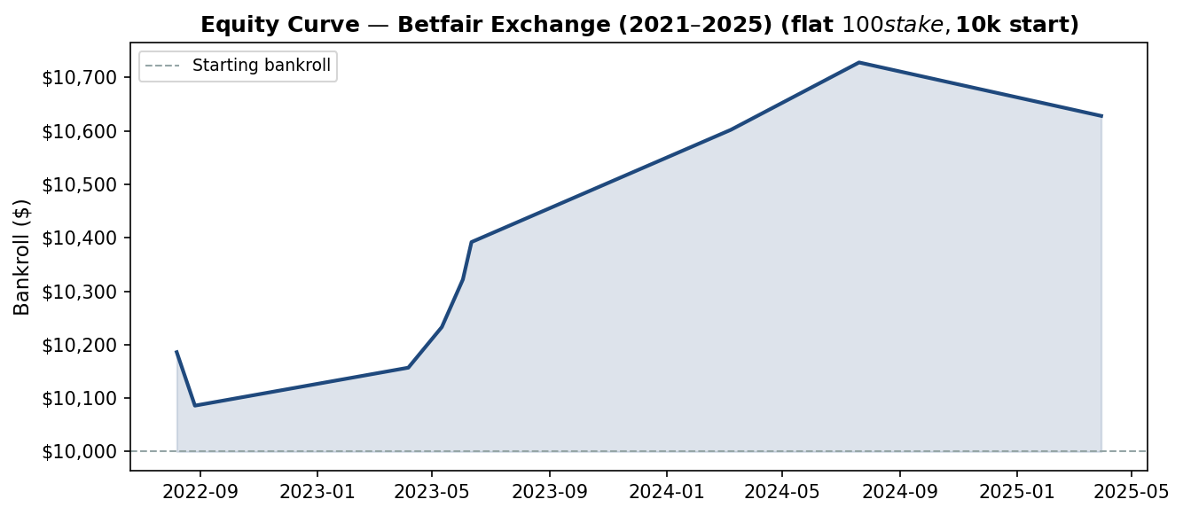

7. Limitations & Risk Factors
Risk | Description | Mitigation
Small sample | Only ~10–50 qualifying bets per venue per decade. Betfair validation sample is particularly small (10 bets). | Accumulate more data over 2025–2026 season before scaling stakes.
Look-ahead bias | Venue base rates use full historical data; real-time application requires rolling baselines. | Re-run pipeline at season start with prior seasons only.
Market efficiency drift | Edges tend to shrink as they become known. AAMI Park is a well-known Melbourne Storm fortress. | Monitor edge size quarterly; exit if implied prob converges to baseline.
Team relocation / venue change | AAMI Park edge is tied to Melbourne Storm. If they move, the historical baseline no longer applies. | Track venue assignments per team each season.
Bookmaker limits | Winning punters are restricted by bookmakers. | Use Betfair exchange (no limits) or multiple bookmaker accounts.
Selection bias | Games at target venues are not random — they reflect home-team strength. | The market already adjusts for team quality; the residual edge is the venue effect net of team quality.

8. Recommended Next Steps
Priority | Action | Owner
1 — High | Apply rolling baseline (prior seasons only) to eliminate look-ahead bias | Data Engineer
2 — High | Extend Betfair backtest using All_Markets CSVs for additional sample size | Data Engineer
3 — Medium | Monitor 2025 NRL season in real time — log qualifying bets and outcomes | Strategy
4 — Medium | Build OddsPortal scraper to fill 2009–2012 bookmaker odds gap | Data Sourcer
4 — Medium | Test Form Bias as a filter on top of Venue Bias (form + venue combined) | Data Scientist
5 — Low | Investigate Campbelltown Sports Stadium fade further — extreme signal | Data Scientist
5 — Low | Create Jupyter EDA notebook with interactive venue maps | Data Scientist

