**1. Introduction**

1.1 Problem Definition

The problem definition of a photo editor is a clear and concise description of the challenges and objectives that the software or application aims to address. It outlines the specific issues or needs that photo editing software is designed to solve and the goals it intends to achieve. The problem definition for a photo editor typically includes the following components:

1. Purpose: Explain the primary purpose of the photo editor, such as enhancing or retouching digital images, creating digital artwork, or adjusting photos for various uses.

2. User Needs: Describe the target audience and their specific needs. This could include amateur photographers, professional graphic designers, social media enthusiasts, or any other user group.

3. Features and Functionality: Enumerate the key features and functions the photo editor must provide to meet user requirements. This may include tools for cropping, resizing, color correction, filters, text overlays, and more.

4. Technical Requirements: Specify the technical requirements, including supported file formats, platform compatibility (e.g., web-based, desktop, mobile), and hardware specifications.

5. Challenges and Limitations: Identify any challenges or limitations the photo editor may face, such as processing speed, resource constraints, or compatibility issues with certain devices or operating systems.

6. Competitor Analysis: Analyze existing photo editing software in the market to understand the competitive landscape and identify opportunities for differentiation.

7. User Experience: Consider the user interface and overall user experience, ensuring that it is intuitive and user-friendly.

8. Performance: Define the expected performance standards, such as response time for editing actions, rendering quality, and stability.

9. Integration: If the photo editor is part of a larger ecosystem or needs to integrate with other software or services, outline the integration requirements.

10. Security and Privacy: Address security and privacy concerns, such as data protection and user privacy when working with images.

11. Testing and Quality Assurance: Specify the testing methodologies and quality assurance measures to ensure the software functions correctly and reliably.

12. Cost and Business Model: Define the pricing strategy, revenue model, and potential monetization methods, such as subscription fees, one-time purchases, or freemium offerings.

13. Market Research: Include insights from market research regarding the demand for photo editing software, potential niches, and emerging trends.

1.2 Need for New System

The need for a new photo editor system or project can arise from various factors and considerations. Here are some common reasons for developing a new photo editor:

1. Technological Advancements: As technology evolves, new hardware and software capabilities become available. A new photo editor may be needed to take advantage of these advancements, such as improved processing power, better graphics rendering, or support for new file formats.

2. Changing User Demands: User preferences and requirements change over time. A new photo editor can address the evolving needs of users, providing features and capabilities that older software may lack.

3. Innovative Features: Innovation can drive the development of a new photo editor with unique and advanced features.

4. Improved User Experience: User interface design and user experience (UX) play a crucial role in the success of photo editing software. A new system may be developed to offer a more intuitive and user-friendly interface, making photo editing more accessible to a broader audience.

5. Mobile and Cross-Platform Compatibility: With the increasing use of mobile devices for photography and image editing, a new photo editor may need to be developed with a strong focus on mobile and cross-platform compatibility to cater to a wider user base.

6. Market Gaps and Niches: Identifying gaps in the existing market for photo editing software can provide a strong incentive to develop a new system. This could involve targeting a specific niche or underserved user group with tailored features and functionalities.

7. Customization and Extensibility: A new photo editor may be designed to allow for extensive customization and extensibility, enabling users to adapt the software to their specific needs.

8. Security and Privacy: Increasing concerns about data security and privacy may lead to the development of a new photo editor with enhanced privacy controls and data protection features.

1.3 Project Scope

The project scope of a photo editor outlines the specific objectives, deliverables, features, and limitations of the project. It defines the boundaries of what the project will encompass and is essential for project management, budgeting, and communication.

Here's a basic outline of the project scope for a photo editor:

**Project Title**: Photo Editor Software Development

**Project Description:**

The project aims to develop a photo editing software application with a focus on providing essential image manipulation features and a user-friendly interface. The software will target both amateur photographers and professionals, allowing users to enhance, retouch, and creatively edit digital images.

**Project Objectives:**

1. Develop a user-friendly and intuitive photo editing software.

2. Provide a comprehensive set of image editing tools and features.

3. Support multiple platforms, including Windows, macOS, and web-based.

4. Ensure high-quality image rendering and performance.

5. Incorporate security and privacy measures to protect user data.

**Project Deliverables:**

1. Fully functional photo editing software application.

2. User documentation and help resources.

3. Installation packages for supported platforms.

4. A project plan and timeline for development and release.

**Features and Functionalities:**

1. Image cropping, resizing, and rotation.

2. Exposure and color correction tools.

3. Filters and special effects.

4. Compatibility with common image file formats (JPEG, PNG, etc.).

**Technical Requirements:**

1. Cross-platform development using suitable technologies (e.g., Electron for desktop and HTML5 for web).

2. Compatibility with Windows 10, macOS 11, and modern web browsers.

3. Support for multi-core processors and GPUs for improved performance.

**Testing and Quality Assurance:**

1. Comprehensive testing of all features and functions.

2. Regular updates and bug fixes.

3. User feedback collection and integration.

**Project Timeline:**

1. Planning and requirements gathering: months

2. Development: months

3. Release and maintenance: Continuous updates

**2. Analysis**

2.1 Feasibility Study

A feasibility study for a photo editor project is essential to assess whether the project is viable and worth pursuing. It helps in evaluating the technical, economic, operational, and scheduling aspects of the project. Here are the key components of a feasibility study for a photo editor project:

**1. Technical Feasibility:**

**Software and Hardware Requirements**: Evaluate whether the required hardware and software resources are available or can be easily acquired for the development of the photo editor.

Technology Stack: Determine the appropriate technology stack for the project, considering factors like platform compatibility, performance, and scalability.

**2. Economic Feasibility:**

**Cost-Benefit Analysis:** Calculate the estimated costs for development, including labor, software licenses, hardware, and other expenses, and compare them to the expected benefits, which may come from sales, subscriptions, or other revenue sources.

**Revenue Projections:** Make revenue projections based on market research and potential user base.

**3. Operational Feasibility:**

**User Needs Assessment:** Determine the specific needs and preferences of the target user base for the photo editor.

2.2 Hardware and Software Requirement

The software and hardware requirements for a photo editor project depend on the project's goals, the complexity of the software, and the target platforms. Here is a general outline of the software and hardware requirements for a photo editor project:

**Software Requirements: Chrome or Any other Browser**

**Hardware Requirements: Computer / Laptop and Internet-Connection and Mouse & Keyboard (optional)**

**3. Design**

3.1 DFD Diagram

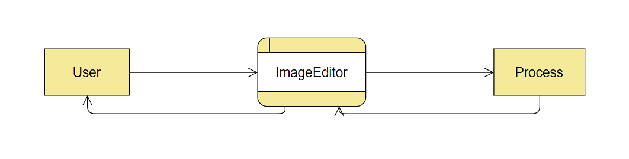**context level DFD**

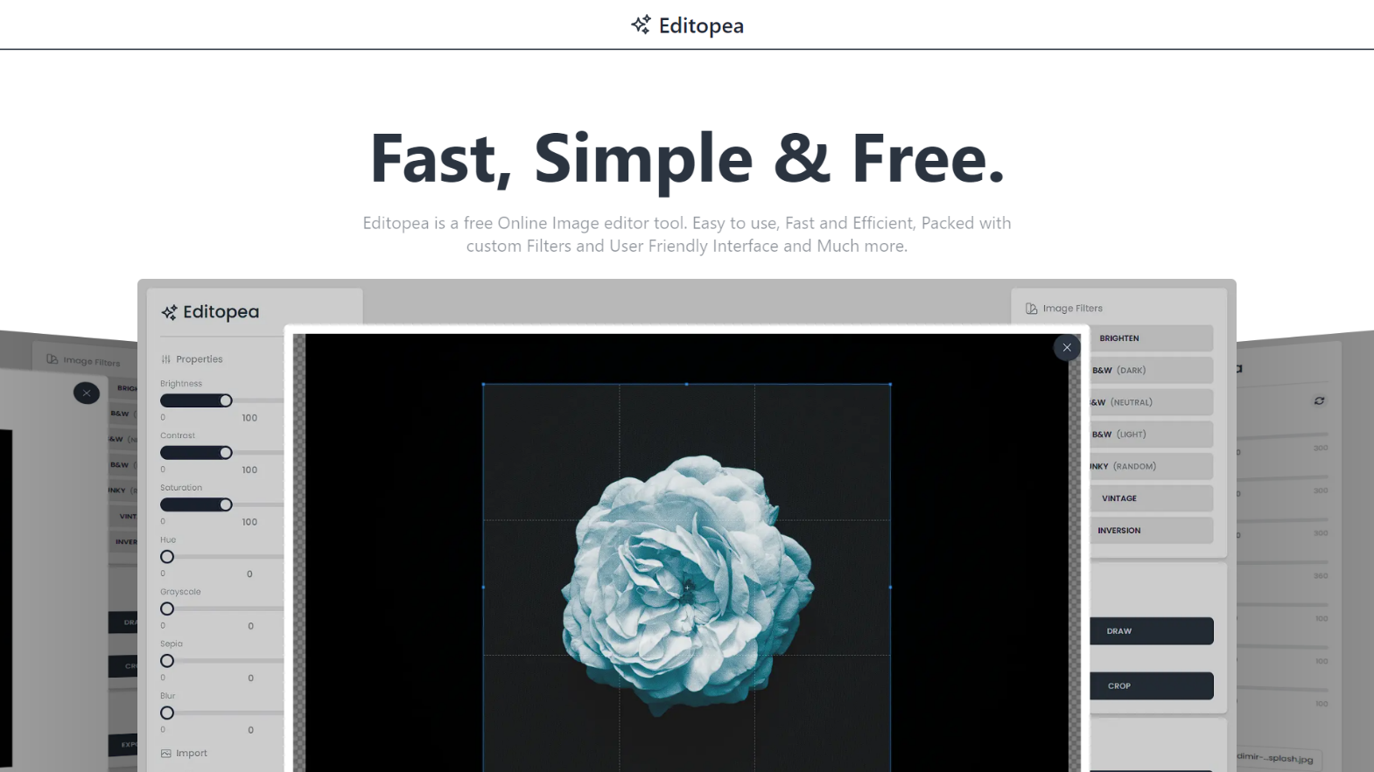**4. Screenshots**

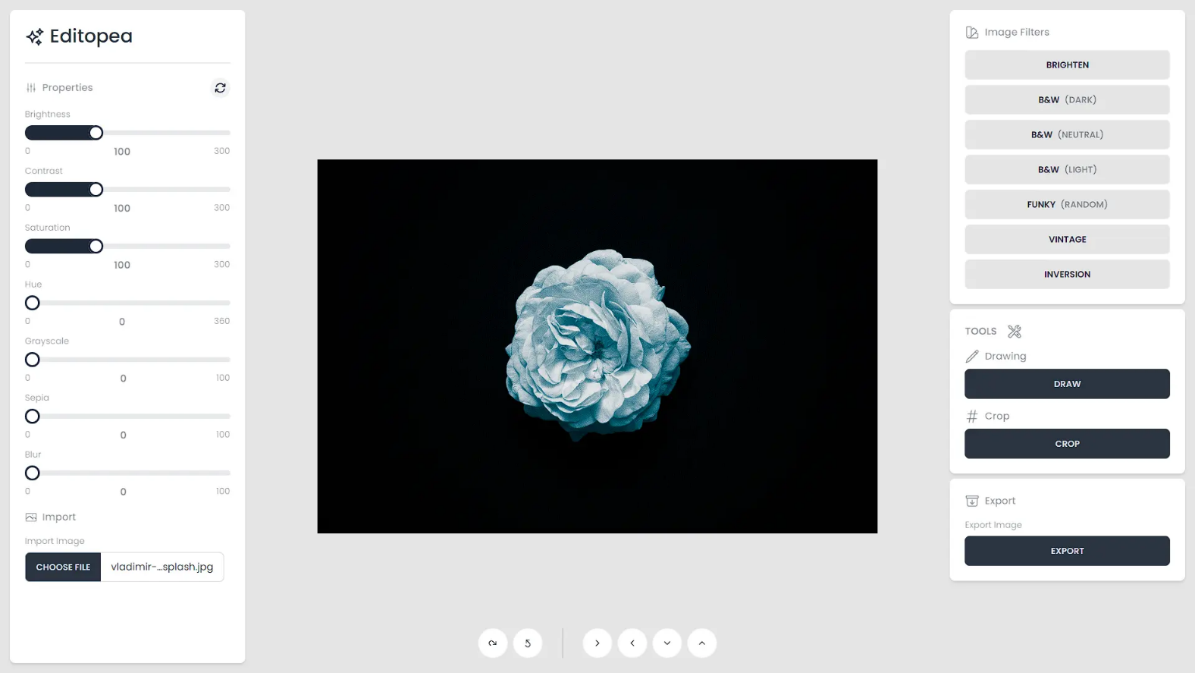

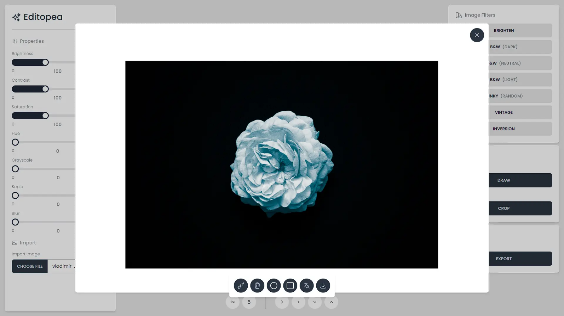

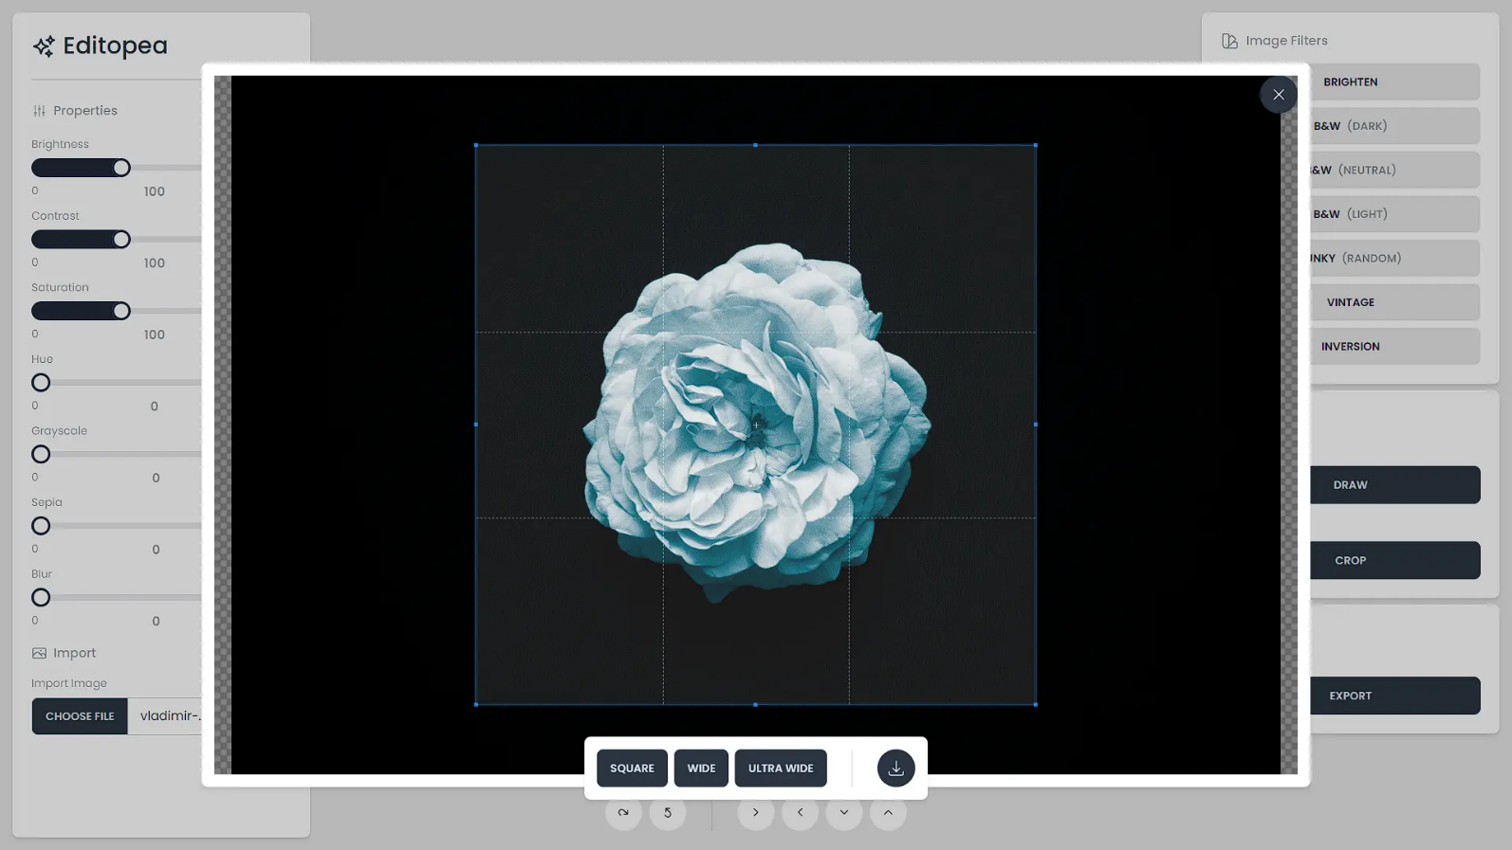

**5. Limitations**

Like any software project, a photo editor project has limitations and constraints that developers and users should be aware of. Understanding these limitations is crucial for managing expectations, planning, and making informed decisions.

Here are some common limitations of a photo editor project:

**1. Processing Power:** Photo editing can be computationally intensive, especially for high-resolution images and complex operations. Limited processing power can lead to slower performance and may restrict the software's capabilities.

**2. Memory and Storage:** Large image files can consume a significant amount of memory and storage. Users with limited resources on their devices may experience performance issues or encounter storage constraints.

**3. Compatibility:** Ensuring compatibility with a wide range of devices, operating systems, and web browsers can be challenging. The photo editor may not perform consistently or support all features on every platform.

**4. Image Formats:** While many image formats are standard, some proprietary or less common formats may not be supported, limiting the range of images that can be edited.

**5. Security and Privacy:** Protecting user data and maintaining user privacy are paramount. However, despite strong security measures, no system is entirely immune to potential breaches.

**6. Hardware Limitations:** Mobile devices, in particular, may have hardware limitations that affect the performance and functionality of the photo editor. For example, some mobile devices lack dedicated GPUs, which can limit graphic-intensive operations.

**7. File Size Constraints:** Sharing or exporting edited images may be limited by file size restrictions on certain platforms or services, affecting the final output's quality or usability.

**8. Development Resources:** Constraints on development resources, including time and budget, may limit the speed of development and the extent to which features can be implemented.

**9. Cross-Platform Limitations:** Developing a consistent and feature-rich experience across multiple platforms (web, desktop, mobile) can be complex, and certain features may not be available on all platforms.

**14. Legacy System Compatibility:** Ensuring that the photo editor works well with older hardware and software versions can be challenging. Some features may not be supported on legacy systems.

**6. Future enhancement**

Enhancing a photo editor project can be an ongoing process to meet evolving user demands, technological advancements, and market trends. Here are some potential future enhancements for a photo editor project:

**1. AI-Powered Tools:** Implement artificial intelligence (AI) and machine learning algorithms to offer automated image enhancements, facial recognition, and content-aware adjustments. This can significantly improve the editing process.

**2. Advanced Filters and Effects:** Continuously expand the library of filters, effects, and artistic overlays to provide users with creative options for their photos.

**3. 3D Editing:** Support 3D modeling and editing for more advanced users, allowing for creative three-dimensional effects and designs.

**4. Integration with Social Media:** Integrate with popular social media platforms, allowing users to easily share edited images directly to their accounts.

**5. Cross-Platform Compatibility:** Ensure seamless cross-platform compatibility by offering consistent user experiences on web, desktop, and mobile platforms.

**6. Mobile Augmented Photography:** Implement features that make use of mobile device capabilities like GPS, gyroscope, and accelerometer to enhance photography experiences.

**7. Environmental Awareness:** Integrate features that assess the environmental impact of photo editing, such as energy consumption, and suggest eco-friendly editing options.

**8. Data Privacy and Security Enhancements:** Stay up to date with evolving data privacy regulations and continuously improve data security measures to protect user information.

**7. References and Biliography**

**Biliography: Youtube (For Drawing Board)** [**https://www.youtube.com/watch?v=y84tBZo8GFo&t=1374s&pp=ygUSaHRtbCBkcmF3aW5kIGJvYXJk**](https://www.youtube.com/watch?v=y84tBZo8GFo&t=1374s&pp=ygUSaHRtbCBkcmF3aW5kIGJvYXJk)

**CropperJs (For Cropping Feature) “https://fengyuanchen.github.io/cropperjs/”**