Advanced Topics in Machine Learning (ATML) - Research Paper Replication
Replicating RikoNet
A deep-autoencoder and spectral-clustering hybrid recommender for anime

Original paper: Badal Soni, Debangan Thakuria, Nilutpal Nath, Navarun Das, Bhaskarananda Boro, “RikoNet: A Novel Anime Recommendation Engine”, Multimedia Tools and Applications, vol. 82, pp. 32329-32348 (2023), Springer. DOI 10.1007/s11042-023-14710-9

Student: ______________________ Roll no.: ______________ Supervisor: ______________________
Implementation: Python 3.12, TensorFlow/Keras, scikit-learn - developed in VS Code on Windows

Abstract
This report replicates RikoNet (Soni et al., Multimedia Tools and Applications, 2023), a hybrid anime recommender that predicts ratings with a deep autoencoder, learns anime embeddings with three stacked autoencoders, groups them with spectral clustering, and merges the two signals in a 'hybrid filter' that outputs a Similar Anime list and an Anime You May Like list. The authors' MyAnimeList dataset and code repository are not publicly available, so this is a simplified replication: the paper's own benchmark (MovieLens-100K, Table 4) is reproduced with the paper's evaluation protocol, and the full pipeline is rebuilt on the public Kaggle Anime Recommendations Database as an alternative dataset. On MovieLens-100K our RikoNet autoencoder reaches test RMSE 0.942 (mean of 3 seeds), about equal to the best classical baseline we trained on the same split (Biased MF (ALS, f=32), 0.942), and far from the 0.591 reported in the paper. On the anime data the autoencoder reaches RMSE 1.174 on a 1-10 scale. We could not reproduce the paper's headline improvement; we discuss protocol differences, unreported hyper-parameters and inconsistencies in the published table that may explain the gap.

1. Introduction and objective
The objective of this ATML project is to select a closed-access (subscription) Springer journal article whose data is publicly available, re-implement its method from the paper alone, and test whether the reported results hold. Recommender systems are a natural ATML topic because they combine representation learning (autoencoders, embeddings), unsupervised learning (clustering) and careful evaluation design (sparse data, leakage, ranking metrics).
Every number in this report is produced by the code in the accompanying project folder and read automatically from outputs/results.json; no result has been typed in by hand except the numbers quoted from the original paper, which are always labelled as such.

2. Paper selection and verification
Table 1. Verification of the selected article
Item | Finding
Title | RikoNet: A Novel Anime Recommendation Engine
Authors | Badal Soni, Debangan Thakuria, Nilutpal Nath, Navarun Das, Bhaskarananda Boro
Journal | Multimedia Tools and Applications, vol. 82, pp. 32329-32348 (2023), Springer
DOI | 10.1007/s11042-023-14710-9
Received / accepted / online | 31 May 2021 / 4 Feb 2023 / 3 Mar 2023
Access model | Subscription. Springer page metadata: "Open Access": "N", isAccessibleForFree: false; copyright © under exclusive licence to Springer
Preprint | An earlier version is on arXiv (2106.12970). Mention this to your faculty: the journal article is closed-access, but a preprint of it is freely readable.
Authors' code | https://github.com/NilutpalNath/RikoNet - returns HTTP 404 (checked 14 Oct 2026); not in the author's public repository list
Original dataset | Crawled from MyAnimeList.net with the Jikan API; never released, and the paper gives no reconstruction instructions
Benchmark dataset | MovieLens-100K (GroupLens) - public, identical to the paper's Table 4

3. The RikoNet method (as described in the paper)

3.1 Primary autoencoder (rating prediction)
RikoNet follows the deep autoencoder of Kuchaiev & Ginsburg (2017). Each user is a vector of ratings over all titles (0 = not rated). The encoder compresses it to a d-dimensional code and the decoder reconstructs a dense vector; the reconstruction at unrated positions is the predicted rating. Hidden layers use SELU, the output layer ReLU (ratings cannot be negative). Training minimises masked MSE, where only observed ratings contribute:
MSE = Σ mᵢ (rᵢ − yᵢ)² / Σ mᵢ, RMSE = √MSE, mᵢ = 0 if rᵢ = 0 else 1

3.2 Anime embeddings (three autoencoders)
- Stage 1 - every anime is represented by its ratings from the 'top raters' (users with more than t ratings); a masked autoencoder maps this m-dimensional vector to d dimensions.
- Stage 2 - the 43-dimensional one-hot genre vector is appended (d' = d + g), adding content knowledge.
- Stage 3 - an unmasked autoencoder with no output activation compresses d' back to d; its code is the final hybrid embedding.

3.3 Spectral clustering and logically opposite clusters
Embeddings are clustered with spectral clustering on a nearest-neighbour affinity graph. The number of clusters is chosen with Zelnik-Manor & Perona's self-tuning method (paper Table 1); the authors hand-picked 222 clusters with 'minimum elements' 4. Algorithm 1 then finds, for each title a₀, the title that is 'logically opposite': at a similar distance from the global centroid M but pointing the opposite way. It minimises (1 − d-ratio) + (cos∠(aᵢ−M, a₀−M) + 1), with ε = 1e-9.

3.4 Hybrid filter
Let S be the unrated titles with their predicted ratings and C the union of the clusters of the user's last three rated titles - the title's own cluster if it was liked, its opposite cluster if it was disliked (the threshold is not given). Similar Anime = top-10 of S ∩ C; Anime You May Like = top-10 of S − C, both sorted by predicted rating.

3.5 Evaluation in the paper
The paper hides 5 % of each user's ratings, predicts them and reports masked MSE/RMSE. The comparison (Table 4) is on MovieLens-100K; competitor numbers are copied from Kiran et al. (2020). A 20-person user study reports list ratings rising from 7.2 to 8.97 over about 10 iterations.

4. Exact reproduction versus simplified replication
This project is a simplified replication. The table states, for every component, what the paper specifies and what we did. 'Faithful' means implemented as described; 'Our choice' means the paper leaves it unspecified; 'Substituted' means the original was unavailable.
Table 2. Exact versus simplified replication
Component | Paper | This replication
Primary AE: SELU hidden, ReLU output, masked MSE | Specified | Faithful
Primary AE: layer sizes, dropout, optimiser, epochs | Not reported | Our choice, tuned on validation only. MovieLens: [256, 128], dropout 0.8, re-feeding True, L2 0.0001. Anime: [512, 512, 1024], dropout 0.5, re-feeding False (best of 5 anime configurations tried). Adam, lr 1e-3, batch 128, early stopping
Demographic inputs (gender, 5 age groups) | Used | Faithful on MovieLens (u.user); not possible on Kaggle anime (no demographics)
5 % per-user hold-out, masked MSE/RMSE | Specified | Faithful (+ a separate 5 % validation split)
Anime dataset (MyAnimeList, 6,668 titles, 16,384 users) | Private | Substituted: Kaggle CooperUnion data reduced to the same 6,668 titles x 16,384 users
Cleaning: unknown studio/source, plan-to-watch, dropped->1 | Specified | Approximated: unknown genre/type removed, -1 'watched but unscored' removed; no status column
Embedding size d, top-rater threshold t | Not reported | Our choice: d = 64, t = 500 ratings
Self-tuning cluster count (Table 1) | Zelnik-Manor & Perona | Approximated with the eigengap criterion
Spectral clustering, k-NN affinity, 222 clusters | Specified | Faithful (222 clusters, 4 neighbours)
Algorithm 1 (opposite cluster) | Specified | Faithful
Hybrid filter, last 3 titles, top-10 lists | Specified | Faithful; like threshold 7/10 is our choice; Kaggle has no timestamps so 3 random known titles stand in for 'last 3'
Baselines | Copied from other papers | Re-trained by us on the same split (fairer)
Top-K metrics (Precision/Recall/NDCG@10) | Not used | Added
20-person user study | Reported | Not replicated (needs human participants)

5. Datasets
MovieLens-100K. MovieLens-100K: 943 users, 1682 movies, 100,000 ratings on a 1-5 scale (density 6.30 %). This is the same public dataset the paper uses in Table 4.
Anime (Kaggle) - alternative dataset. The Kaggle 'Anime Recommendations Database' (CooperUnion, data from MyAnimeList) contains 12,294 anime and 7,813,737 user-anime rows. 1,476,496 rows are -1 (watched, no score) and were removed. Keeping the 6,668 most-rated titles and the 16,384 most active users (each has at least 121 ratings) gives 4,355,489 ratings (density 3.99 %, mean 7.67/10). It has exactly 43 genres, the same count as the paper. IMPORTANT: this is an alternative dataset, not the one used by the authors.
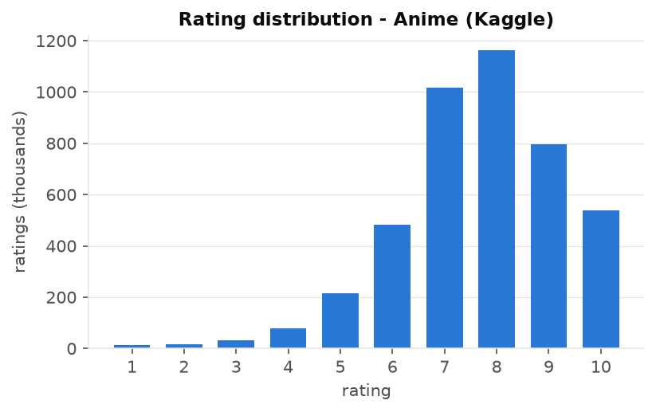
Figure 1. Rating distribution of the cleaned Kaggle anime data.

6. Implementation
The code is split into small modules so that each part of the paper maps to one file:
- config.py - every setting, tagged [PAPER], [K&G] or [OURS] so the origin of each choice is visible.
- data_prep.py - loads both datasets, applies the cleaning rules, builds sparse user x item matrices and performs the per-user split (test 5 %, validation 5 %, train 90 %).
- model.py - the deep autoencoder in TensorFlow/Keras with a custom training step implementing masked MSE and dense re-feeding, early stopping on validation MSE and batched prediction.
- baselines.py - global/user/item averages, a regularised bias model, user- and item-KNN on baseline residuals, biased matrix factorisation (ALS), popularity and random rankers.
- recommend.py - three-stage embeddings, the self-tuning table, spectral clustering, Algorithm 1 and the hybrid filter; also a command-line recommender.
- evaluate.py - MSE/RMSE/MAE, Precision/Recall/NDCG/HitRate@10, coverage, and all figures.
- tune.py / main.py - validation-only hyper-parameter search and the end-to-end experiment runner.

6.1 Avoiding data leakage
- Held-out test ratings are removed from the input matrix before training; the model never sees them.
- Hyper-parameters are chosen with a separate validation split; the test split is read only once, by the final evaluation.
- Anime embeddings and clusters are built from training ratings only.
- In ranking evaluation every title the user already rated is excluded from the candidate list.

7. Results

7.1 E1 - MovieLens-100K with the paper's protocol (reproduces Table 4)
Table 3. MovieLens-100K test error, 5 % hold-out per user. RikoNet rows: mean of 3 seeds (± std).
Model | MSE | RMSE | MAE
RikoNet AE (tuned on validation) | 0.887 | 0.942 ± 0.002 | 0.742
Biased MF (ALS, f=32) | 0.888 | 0.942 | 0.741
Bias baseline (mu+b_u+b_i) | 0.904 | 0.951 | 0.756
Item KNN (cosine, k=40) | 0.934 | 0.966 | 0.749
User KNN (cosine, k=40) | 0.967 | 0.983 | 0.769
RikoNet AE (K&G default config) | 0.997 | 0.999 ± 0.002 | 0.780
Item average | 1.069 | 1.034 | 0.827
User average | 1.085 | 1.042 | 0.839
Global average | 1.269 | 1.127 | 0.951

Our tuned RikoNet autoencoder obtains RMSE 0.942 ± 0.002, which is about equal to the best baseline trained on the same split (Biased MF (ALS, f=32): 0.942). The configuration recommended by Kuchaiev & Ginsburg reaches 0.999. The paper reports 0.591; our result is 0.351 higher.
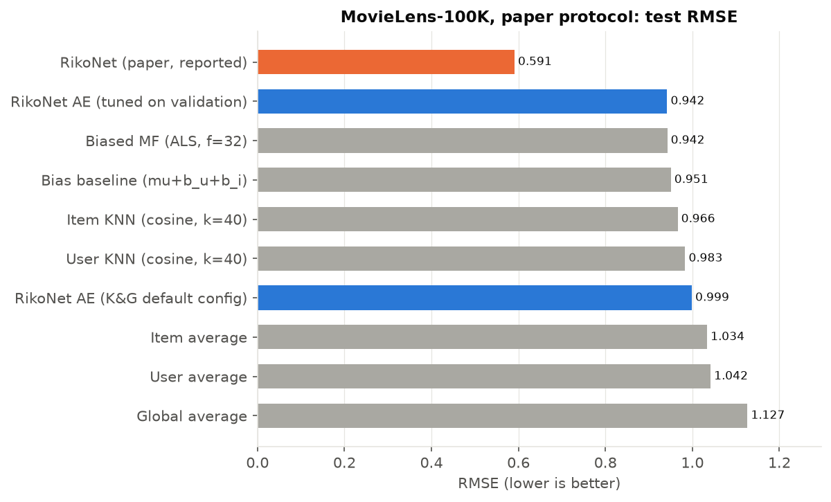
Figure 2. Test RMSE on MovieLens-100K (paper protocol). Blue: our RikoNet autoencoder; grey: baselines trained on the same split; orange: value reported in the paper.
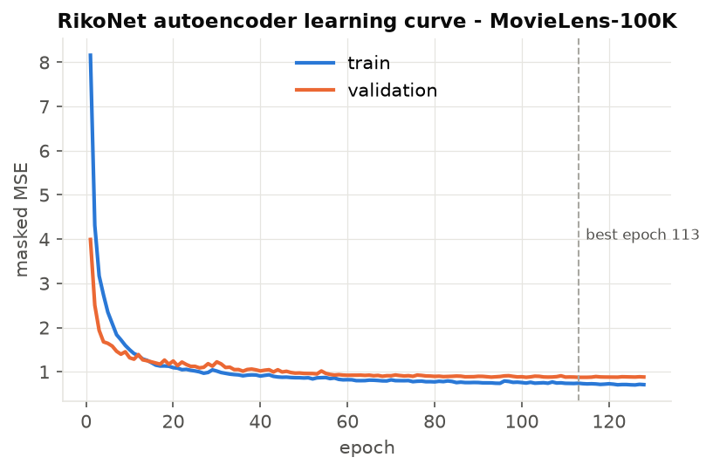
Figure 3. Learning curve of the tuned RikoNet autoencoder (MovieLens-100K).
Table 4. Numbers published in the paper (Table 4) and an internal-consistency check (RMSE should equal √MSE).
Method (paper Table 4) | MSE | RMSE | √MSE | Consistent
Global Average | 1.129 | 1.062 | 1.063 | yes
User Average | 0.929 | 0.964 | 0.964 | yes
User KNN - Cosine | 0.813 | 0.813 | 0.902 | NO
Item KNN - Cosine | 0.854 | 0.862 | 0.924 | NO
User KNN - Pearson | 0.814 | 0.902 | 0.902 | yes
Item KNN - Pearson | 0.796 | 0.892 | 0.892 | yes
SVD | 0.879 | 0.937 | 0.938 | yes
Biased MF | 0.768 | 0.877 | 0.876 | yes
SVD++ | 0.756 | 0.869 | 0.869 | yes
DNNRec | 0.747 | 0.864 | 0.864 | yes
UBP | 0.724 | 0.851 | 0.851 | yes
PDMF-post 50D | 0.427 | 0.654 | 0.653 | yes
Proposed Model: RikoNet | 0.349 | 0.591 | 0.591 | yes

Two rows of the published table (User KNN-Cosine and Item KNN-Cosine) are internally inconsistent: their RMSE is not the square root of their MSE. The competitor numbers were copied from another paper rather than re-run, so they were not necessarily measured with the same 5 % protocol as RikoNet.

7.2 E2 - MovieLens-100K with a standard 80/20 split
Table 5. MovieLens-100K test error with 20 % of each user's ratings held out.
Model | MSE | RMSE | MAE
Biased MF (ALS, f=32) | 0.865 | 0.930 | 0.729
Bias baseline (mu+b_u+b_i) | 0.893 | 0.945 | 0.749
RikoNet AE (tuned on validation) | 0.897 | 0.947 ± 0.001 | 0.746
Item KNN (cosine, k=40) | 0.974 | 0.987 | 0.763
User KNN (cosine, k=40) | 0.999 | 1.000 | 0.780
Item average | 1.056 | 1.027 | 0.819
User average | 1.079 | 1.039 | 0.833
Global average | 1.255 | 1.120 | 0.943

With the more common 80/20 protocol the autoencoder scores 0.947 against 0.930 for Biased MF (ALS, f=32), so the ranking of methods is different under both protocols.

7.3 E3 - Effect of the activation function (reproduces Fig. 3)
Table 6. Activation study on MovieLens-100K (same architecture, only the activation changes).
Activation | Best validation MSE | Epoch
SELU | 1.013 | 36
TANH | 1.114 | 40
ELU | 1.229 | 34
RELU | 2.883 | 4

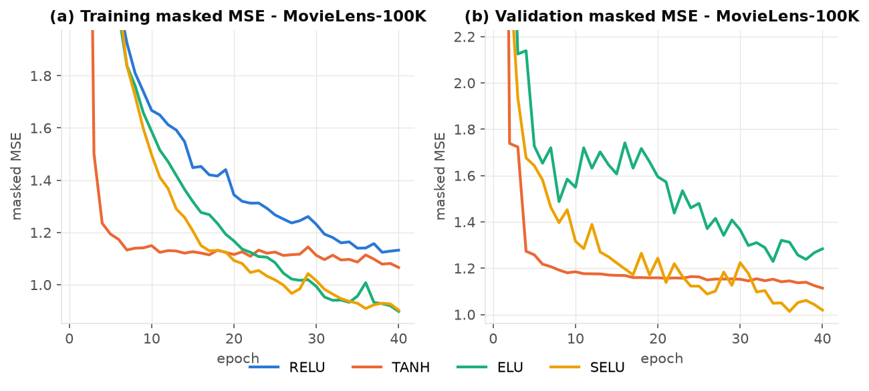
Figure 4. Training and validation masked MSE per activation function - MovieLens-100K.
On MovieLens-100K, SELU reaches the lowest validation MSE; SELU ranks 1 of 4. The paper reports SELU as the best activation - confirmed here.

7.4 E4 - Rating prediction and top-10 recommendation on the anime data
Table 7. Anime (Kaggle) test error, 5 % hold-out per user, ratings 1-10.
Model | MSE | RMSE | MAE
Item KNN (cosine, k=40) | 1.137 | 1.066 | 0.775
Biased MF (ALS, f=32) | 1.210 | 1.100 | 0.815
RikoNet AE (tuned on validation) | 1.377 | 1.174 | 0.892
Bias baseline (mu+b_u+b_i) | 1.401 | 1.184 | 0.895
User KNN (cosine, k=40) | 1.435 | 1.198 | 0.899
User average | 1.843 | 1.358 | 1.039
Item average | 2.039 | 1.428 | 1.098
Global average | 2.452 | 1.566 | 1.236

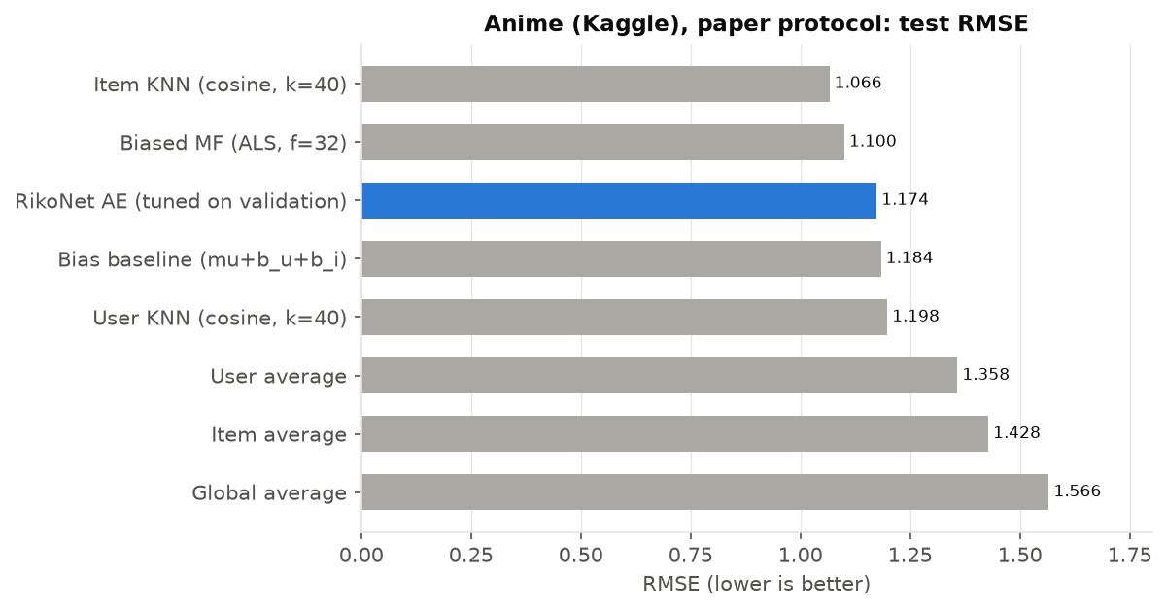
Figure 5. Test RMSE on the anime data (1-10 scale).
Table 8. Top-10 recommendation quality on anime test users. Relevant = held-out rating ≥ 8/10; already-rated titles excluded.
Model | Precision@10 | Recall@10 | NDCG@10 | HitRate@10 | Coverage
Most popular | 0.062 | 0.087 | 0.092 | 0.435 | 0.021
Biased MF (ALS, f=32) | 0.024 | 0.034 | 0.032 | 0.197 | 0.231
Item average | 0.015 | 0.023 | 0.018 | 0.136 | 0.008
Bias baseline (mu+b_u+b_i) | 0.012 | 0.019 | 0.015 | 0.113 | 0.010
RikoNet AE (tuned on validation) | 0.011 | 0.018 | 0.014 | 0.098 | 0.091
Item KNN (cosine, k=40) | 0.004 | 0.006 | 0.005 | 0.040 | 0.683
Global average | 0.004 | 0.006 | 0.005 | 0.039 | 0.123
User average | 0.004 | 0.006 | 0.005 | 0.039 | 0.123
User KNN (cosine, k=40) | 0.002 | 0.003 | 0.003 | 0.023 | 0.610
Random | 0.001 | 0.002 | 0.001 | 0.012 | 0.955

The autoencoder achieves RMSE 1.174 (best baseline Item KNN (cosine, k=40): 1.066). For top-10 recommendation the strongest model by NDCG@10 is Most popular (0.092); the autoencoder scores 0.014. Low RMSE does not guarantee good top-N lists: rating-prediction models tend to rank rarely rated, highly scored titles first, while users mostly rate popular titles.

7.5 E5 - Embeddings, clusters and logically opposite clusters
Table 9. Analogue of paper Table 1: candidate numbers of clusters (largest eigengaps) for neighbourhood size K in {1, 2, 3, 4, 5, 7, 10, 15} (paper: 1-15), plus the number of connected components of the k-NN graph.
 | K=1 | K=2 | K=3 | K=4 | K=5 | K=7 | K=10 | K=15
rank 1 | 2 | 47 | 9 | 26 | 47 | 20 | 14 | 9
rank 2 | 7 | 50 | 37 | 40 | 28 | 17 | 10 | 4
rank 3 | 4 | 64 | 15 | 35 | 32 | 5 | 5 | 24
connected components | 1195 | 47 | 9 | 1 | 1 | 1 | 1 | 1

Table 10. Clustering diagnostics on the anime embeddings.
Quantity | Value
Top raters used for stage-1 vectors (m) | 1025
Embedding dimension d | 64
Clusters / neighbours | 222 / 4
Cluster size min / median / max | 4 / 20 / 224
Clusters with fewer than 4 titles | 0
Silhouette - spectral vs K-Means (222) | -0.007 vs 0.034
Genre Jaccard within cluster - spectral | 0.294
Genre Jaccard within cluster - K-Means | 0.272
Genre Jaccard of random pairs | 0.106
Genre Jaccard title vs its opposite title | 0.034
Genre Jaccard title vs a random title | 0.106

Titles in the same spectral cluster share far more genres (Jaccard 0.294) than random pairs (0.106), so the embeddings capture content similarity. The logically opposite title shares fewer genres with the original title than a random title does (0.034 vs 0.106), which is the behaviour Algorithm 1 is meant to produce.
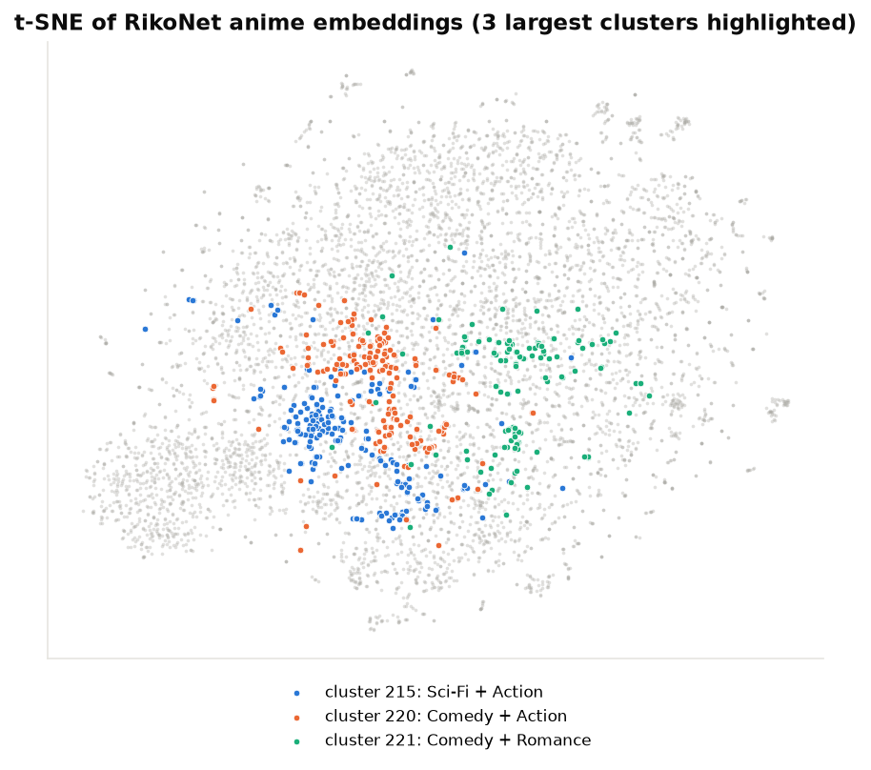
Figure 6. t-SNE projection of the 6,668 anime embeddings; the three largest spectral clusters are coloured and labelled with their two most frequent genres.
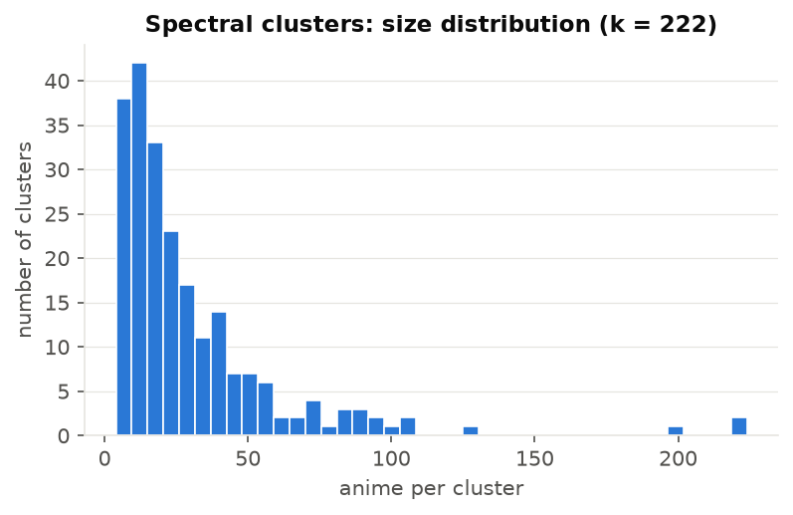
Figure 7. Distribution of spectral-cluster sizes.

7.6 Hybrid filter evaluation
Table 11. Hybrid-filter lists for anime test users (K = 10, or 20 for both lists together).
List | Precision@K | Recall@K | HitRate@K | Genre Jaccard to context
Autoencoder top-10 (no filter) | 0.011 | 0.019 | 0.101 | 0.130
Hybrid: Similar Anime | 0.020 | 0.029 | 0.172 | 0.161
Hybrid: Anime You May Like | 0.011 | 0.018 | 0.097 | 0.129
Hybrid: both lists (20 titles) | 0.015 | 0.047 | 0.251 | -

The Similar Anime list is restricted to on average 121 candidate titles (the union of three clusters) and contains 10.0 titles on average. Its genre overlap with the user's context titles is 0.161 versus 0.130 for the unfiltered autoencoder list, i.e. the filter does make the list more similar in content. Its precision is 0.0196 versus 0.0113 for the unfiltered list.
Table 12. Example output for one real Kaggle test user (user_id 7).
List | Anime | Rating / predicted | Cluster
context (last 3 known ratings) | Nisekoi: OVA | 5.000 | 221
context (last 3 known ratings) | Planetarian: Chiisana Hoshi no Yume | 8.000 | 202
context (last 3 known ratings) | Time Travel Shoujo: Mari Waka to 8-nin no Kagakusha-tachi | 7.000 | 214
Similar Anime | Little Busters!: Sekai no Saitou wa Ore ga Mamoru! | 9.080 | 201
Similar Anime | Gosick Recap | 8.720 | 201
Similar Anime | Kaiba | 8.540 | 202
Similar Anime | Noir | 8.540 | 202
Similar Anime | Anime Tenchou x Touhou Project | 8.480 | 201
Similar Anime | Nijuu Mensou no Musume | 8.390 | 202
Similar Anime | Juushin Enbu: Hero Tales | 8.320 | 214
Similar Anime | Ima, Soko ni Iru Boku | 8.310 | 202
Similar Anime | Byousoku 5 Centimeter | 8.280 | 202
Similar Anime | Taiyou no Ko Esteban | 8.270 | 214
Anime You May Like | Kenzen Robo Daimidaler Specials | 10.000 | 220
Anime You May Like | Dragon Ball Z: Summer Vacation Special | 9.640 | 217
Anime You May Like | Uchuu Senkan Yamato: Fukkatsu-hen | 9.610 | 133
Anime You May Like | Jigoku Sensei Nube OVA | 9.500 | 167
Anime You May Like | Rance 01: Hikari wo Motomete The Animation | 9.490 | 212
Anime You May Like | Gintama° | 9.440 | 31
Anime You May Like | Tezuka Osamu no Buddha: Akai Sabaku yo! Utsukushiku | 9.390 | 137
Anime You May Like | Bakuman.: Deraman. | 9.360 | 88
Anime You May Like | Ginga Eiyuu Densetsu | 9.330 | 55
Anime You May Like | Saiyuuki | 9.330 | 195

8. Discussion: why the headline result was not reproduced
- Protocol of the competitors. The paper's competitor numbers come from other papers that used different splits (often 80/20). Comparing them with a 5 % hold-out result is not like-for-like. Re-training all baselines on the same split, as we did, removes this problem.
- Unreported hyper-parameters. Layer sizes, dropout, optimiser, epochs, d and t are not given. We searched a reasonable grid on validation data, but the authors may have used something else.
- Inconsistent table. Two rows of Table 4 have RMSE ≠ √MSE, suggesting transcription errors.
- Size of the gain. In the paper's own Table 4 every method except PDMF lies between 0.851 and 1.062 RMSE; every method we trained lies between 0.942 and 1.127. A drop to 0.591 is an exceptionally large jump that the paper does not explain in detail.
- Different anime data. Our anime results come from the Kaggle data, not the authors' crawl, and lack demographics and timestamps, so they cannot be compared numerically with the paper's (unreported) anime results.
- Limitations of this replication. Single-seed anime runs; anime tuning stopped after 5 of 8 grid points and anime training capped at 60 epochs (patience 6) because of the CPU time budget; the activation study was run on MovieLens only; eigengap approximation of the self-tuning method; no human evaluation.

9. Conclusion
We re-implemented every component of RikoNet - the masked deep autoencoder with SELU and dense re-feeding, the three-stage hybrid embeddings, spectral clustering into 222 clusters, the logically opposite cluster algorithm and the hybrid filter - and evaluated it on the paper's public benchmark and on a public anime dataset. The pipeline works end to end and produces sensible, genre-coherent recommendations. However, the reported MovieLens-100K RMSE of 0.591 could not be reproduced: our best configuration reaches 0.942, about equal to a simple well-tuned baseline. Future work: obtain the original code or data from the authors, try item-based autoencoders (which usually work better on small datasets), and run a small user study to test the hybrid filter's perceived quality.

References
- B. Soni, D. Thakuria, N. Nath, N. Das, B. Boro. RikoNet: A novel anime recommendation engine. Multimedia Tools and Applications 82, 32329-32348 (2023). doi:10.1007/s11042-023-14710-9
- O. Kuchaiev, B. Ginsburg. Training deep autoencoders for collaborative filtering. arXiv:1708.01715 (2017).
- L. Zelnik-Manor, P. Perona. Self-tuning spectral clustering. NIPS 17 (2004).
- G. Klambauer, T. Unterthiner, A. Mayr, S. Hochreiter. Self-normalizing neural networks. NIPS (2017).
- R. Kiran, P. Kumar, B. Bhasker. DNNRec: a novel deep learning based hybrid recommender system. Expert Systems with Applications 144, 113054 (2020).
- F. M. Harper, J. A. Konstan. The MovieLens datasets: history and context. ACM TiiS 5(4) (2015).
- CooperUnion. Anime Recommendations Database. Kaggle. https://www.kaggle.com/datasets/CooperUnion/anime-recommendations-database
- Y. Koren. Factorization meets the neighborhood. KDD (2008).

Appendix A - Hyper-parameter search (validation only)
Table 13. Best 8 configurations on the movielens validation split (sorted by validation MSE).
hidden | dropout | refeed | l2 | best_epoch | val_rmse
256-128 | 0.800 | True | 0.000 | 130 | 0.933
256-256-512 | 0.800 | False | 0.000 | 40 | 0.940
256-128 | 0.800 | True | 0.000 | 101 | 0.946
256-128 | 0.500 | False | 0.000 | 27 | 0.947
256-256-512 | 0.500 | False | 0.000 | 20 | 0.952
256-128 | 0.500 | False | 0.000 | 41 | 0.957
256-256-512 | 0.800 | False | 0.000 | 43 | 0.961
512-512-1024 | 0.800 | False | 0.000 | 31 | 0.962

Table 14. Best 8 configurations on the anime validation split (sorted by validation MSE).
hidden | dropout | refeed | l2 | best_epoch | val_rmse
512-512-1024 | 0.500 | False | 0.000 | 33 | 1.170
512-512-1024 | 0.800 | False | 0.000 | 23 | 1.188
512-512-1024 | 0.500 | True | 0.000 | 29 | 1.578
256-256-512 | 0.800 | True | 0.000 | 63 | 1.721
512-512-1024 | 0.800 | True | 0.000 | 6 | 1.935

Appendix B - How to run
- py -3.12 -m venv .venv then .venv\Scripts\Activate.ps1
- python -m pip install pandas numpy scikit-learn matplotlib seaborn tensorflow python-docx python-pptx
- python tune.py movielens ; python tune.py anime (optional, results included)
- python main.py (all experiments)
- python recommend.py --rate "Death Note=9" "Clannad=4" (interactive recommendations)
- python make_report.py ; python make_ppt.py
Total experiment runtime: 18.3 minutes on an Intel Core i5-12500H CPU (no GPU).

