

CpE-371: Software Engineering

**Project Name: Content Blocker App**

**Team Name: Tri-Vision**

*By:*

Mahmoud Mazouz Younis (2221189759)

Fatema Ahmad Taleb (2221190733)

Mohamed Khaled Elmaghraby (2221188920)

*Supervised by:*

Dr. Mehmet Karaata

Eng. Ahmad Hammad

Department of Computer Engineering

College of Engineering and Petroleum

Kuwait University

2024-2025

Signature Page

Guidelines

* *Students can decline to sign, or teams can refuse to let a member or members sign.*
* *Students who do not sign receive a grade of zero on the document*.

- ***I declare that I read the new instructions and guidelines of CpE-371 and accept them.***

- I did my share of the work, and I have a general understanding of the contents of the assignment

- I declare that this assignment is my own original work, except where the original source is cited.

Name Signature

Mahmoud Mazouz Younis 

Mohammed Khaled Elmaghraby Mohammed

Credits

|  |  |
| --- | --- |
| **Member** | **Task** |
| Mahmoud | Introduction + persona B& persona C +solution ideation+ the scenarios+ appendices+ Low-fidelity Prototype+ user testing. |
| Fatema | Vision statement and problem statement + user research & interview summary +scenario c + user stories and proposed solutions+ UI+ software design. |
| Mohamad | Potential users and project impact + users and personas & persona A + scenario a + scenario b+ UI+ version control repository. |

Table of Contents

Signature Page ii

Credits iii

List of Figures vi

List of Tables vii

List of Abbreviations viii

Phase 1: Problem Exploration and User Discovery (Iterative & Agile) 1

1. Introduction 1

1.1 Vision Statement 1

1.2 Problem Statement 2

1.3 Potential Users 2

1.4 Project Impact 3

2. User Research 4

2.1 Interview Summary 4

2.2 Users and Personas 9

2.2.1 Persona A 9

2.2.2 Persona B 10

2.2.3 Persona C 10

3. Solution Ideation 11

3.1 The scenarios 11

3.1.1 Scenario A 12

3.1.2 Scenario B 13

3.1.3 Scenario C 14

3.2 The User Stories and Proposed Solutions 16

4. Low-fidelity Prototype 19

5. User Testing 28

Phase 2: Design and Development 30

(Modular & Collaborative) 30

1. Software Design 30

Appendices 35

Appendix A: Conducted Surveys 35

Appendix B: Meeting Minutes 37

Appendix C: Team Formation Document 45

Appendix D: Source Codes 49

List of Figures

Figure 1: Primary occupation. 4

Figure 2: Frequency of encountering unwanted content. 5

Figure 3: Content blocking type. (multiple selection choices) 6

Figure 4: Control over blocked content. 6

Figure 5: Time based content restrictions. 7

Figure 6: Scheduling options. 8

Figure 7: Beta version of app. 8

Figure 8:Cba flowchart. 21

Figure 9: Welcome page. 22

Figure 10: Dashboards. 23

Figure 11: AI filtering. 23

Figure 12:Manual blocking. 24

Figure 13:Study mode. 24

Figure 14:Kids’ mode. 25

Figure 15:Blocking choices. 25

Figure 16:Blocked lists. 26

Figure 17: Kids' lists. 26

Figure 18:Study lists. 27

Figure 19:Class diagram. 31

Figure 20:User use case. 32

Figure 21:AI use case. 33

Figure 22:Parents use case. 33

Figure 23:Students use case. 34

List of Tables

Table 1: user stories 16

Table 2:Feature–Persona Mapping. 20

List of Abbreviations

|  |  |
| --- | --- |
| NLP | Natural Language Processing |
| AI | Artificial Intelligence |

Phase 1: Problem Exploration and User Discovery (Iterative & Agile)

1. Introduction

People nowadays encounter content that they don’t want or find unwanted content while browsing the internet or using applications. The purpose of our project is to provide users with a solution to block specific content of their choice. **For** individuals who want greater control over their online experience, including general users, parents, and professionals, **who** frequently come across distracting, inappropriate, or unnecessary content, **the Content Blocker App** is an AI-powered content filtering application **that** allows users to block specific content, create custom block lists, set category-based restrictions, and receive real-time filtering while browsing. It will be an advanced app that not only filters content; instead, it will be enhanced with AI to offer advanced features such as smarter filtering, parental controls, and workplace productivity tools. **Unlike** traditional content filtering apps that rely solely on basic keyword blocking, **our product** leverages AI to provide a more intelligent and adaptive approach, ensuring a personalized and effective digital experience through an intuitive and user-friendly interface. By giving users control over their digital environment, this project aims to promote digital well-being, improve productivity, and create a safer and more customizable online space.

* 1. Vision Statement

Our goal is to create a cutting-edge, artificial intelligence (AI)-powered content-filtering tool that gives users complete control over their online space. Our solution leverages Natural Language Processing (NLP) and Computer Vision to provide context-aware and customized filtering across diverse platforms (web browsers, mobile apps, desktops), including web browsers, mobile applications, and desktop environments, in contrast to standard content blockers that rely on simple keyword filtering. Our goal is to improve productivity, online safety, and digital well-being by letting users specify what information they wish to restrict while utilizing AI-driven recommendations. This program is intended for use by professionals, parents, educators, and anyone looking for a practical method to reduce exposure to hazardous content, filter distractions, and customize browsing.

* 1. Problem Statement

Unwanted, annoying, and occasionally dangerous content is abundant online and can have a detrimental effect on user experience, productivity, and mental health. The static keyword filtering used by many content-blocking solutions today causes overblocking or underblocking because it ignores the contextual meaning of media and language.  
  
By developing an AI-powered content blocker that can:

• Accurately assess and filter information based on context rather than just keywords, our initiative seeks to address this problem.

• Tailor filtering choices to users’ specific requirements, whether they be content moderation, parental control, or productivity.

• Provide smooth content control across a variety of platforms, including desktops, mobile apps, and browsers.

• Boost security and privacy by making sure user data is managed effectively and securely.

By resolving these problems, our solution will provide a more intelligent, flexible, and intuitive content filtering experience, lowering interruptions and undesired exposure while enhancing online interaction.

* 1. Potential Users

Our Content Blocker App can be used by a variety of people, anyone who desires a more controlled digital experience. The main target audiences include:

* + Students who want to block distractions such as social media and entertainment sites so they can focus better.
  + Professionals and remote workers aim to avoid online distractions and boost productivity.
  + Individuals who want to improve their digital well-being by reducing exposure to unpleasant content that they don’t want to see.
  + Parents who try to filter out inappropriate and harmful content for their children can browse safely.
  + Educational Institutions & Organizations need to enforce content restrictions according to their policies.

The app offers a flexible and customizable solution for content filtering and blocking that almost all users will need.

* 1. Project Impact

Our app improves productivity, online well-being, and safety by using AI based filtering which benefits students, professionals, parents, and general users, allowing them to have more control over what content they see and giving them a better digital experience.

**Increased Productivity**

Distractions like social media or entertainment websites reduce attention. By filtering unnecessary content, users are more productive and time efficient.

**Improved Digital Well-Being**

Looking at harmful or distressing content isn’t the best for mental health. The app helps users create a positive online space by filtering toxic discussions, disturbing news, or offensive material.

**Safer Internet for Children**

It is extremely difficult for parents to monitor what their children see online. The app has parental settings that block harmful or inappropriate content, ensuring a safer browsing experience for the young users.

**Personalized Content Filtering**

Unlike basic blockers that rely on keywords, the app’s AI understands context and allows the users to set filtering preferences. It improves over time for greater accuracy and a more personalized experience.

**Cross-Platform Support**

The app guarantees smooth and consistent user experience across all platforms like web browsers, mobile devices for example. Its smart and customizable filtering features help users build a safer, more efficient, and less distracting online environment.

1. User Research

This section aimed to deeply understand user needs, preferences, and challenges concerning content filtering and online content blocking. Our research included comprehensive survey distributed digitally and informally interviewing friends and family members to gather data. We collected a total of 60 responses, mostly from students, supplemented by professionals, parents, and educators.

* 1. Interview Summary

Forms response chart. Question title: What is your primary occupation?
. Number of responses: 60 responses.We conducted comprehensive research involving 60 individuals, mostly within the 18-24 age range, to better understand their needs and expectations from a smart content-blocking app. Through an online survey, we identified key findings regarding user preferences and requirements. As shown in Figure 1, most respondents identified as students, making up 91.7% of the participants.

Number of Respondents

Figure : Primary occupation.

This variety in respondents shows our app could be beneficial to multiple user groups.

**Relevant Features:**

* **Smart Scheduling & Productivity Mode:** Students can set specific times to block distracting content, significantly improving their study habits.
* **Cross-Platform Support:** Ensures consistent distraction management across all devices students typically use.

1 = Very often,

2 = Sometimes

3 = Rarely

4 = Never

This indicates a strong need for a reliable solution, such as AI-powered filtering, to effectively manage online distractions and harmful content.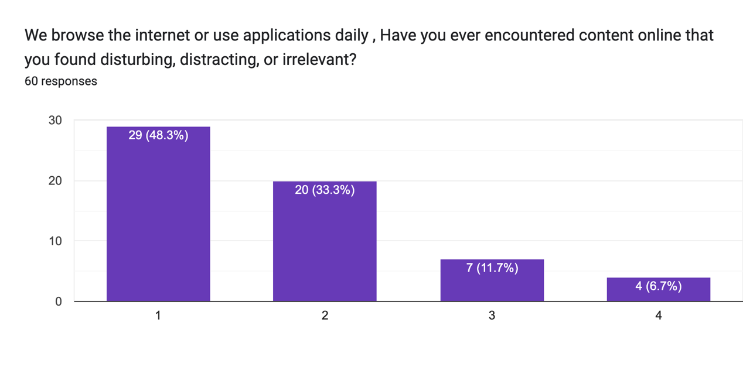

Figure : Frequency of encountering unwanted content.

* **AI-Powered Filtering (NLP-based):** Accurately detects and filters unwanted content contextually, effectively addressing frequent encounters.
* Forms response chart. Question title: What type of content would you like to block or filter? (Select all that apply)
  . Number of responses: 60 responses.**Real-time Context-Aware Filtering:** Immediately removes unwanted elements from webpages without disrupting the overall browsing experience.

Number of Respondents

Figure : Content blocking type. (multiple selection choices)

Users desire strong protection against various forms of inappropriate or irrelevant online content.

* **Smart Image Recognition:** Automatically blocks or blurs harmful images, directly addressing concerns about inappropriate visual content.
* **Customizable Filters:** Allows users to specify precisely what types of content they want to block, offering personalized protection.
* **AI-Powered Filtering:** Enhances accuracy in filtering inappropriate and irrelevant content based on context, rather than simple keyword matches.

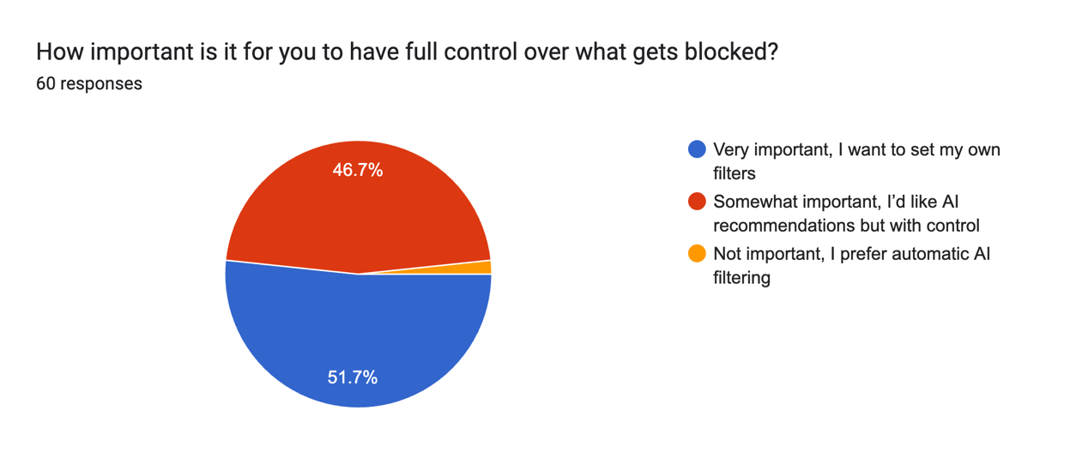

Figure : Control over blocked content.

Users highly value customization and control over their filtering preferences

* **Customizable Filters:** Provides manual control, allowing users to create personalized blocking rules.
* **User-Friendly Interface:** Offers easy access and clear control settings, simplifying user interactions with the app.

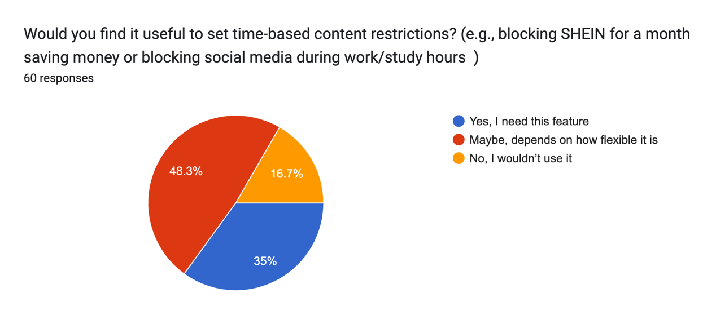

Figure : Time based content restrictions.

This Users want productivity features that help manage distractions effectively during specific periods.

* **Smart Scheduling & Productivity Mode:** Offers flexibility and ease of use, allowing users to schedule content blocking during study or work hours.

Forms response chart. Question title: How do you currently manage unwanted content while browsing and What kind of scheduling options would be most useful for you? (Select all that apply)
. Number of responses: 60 responses.

Number of Respondents

Figure : Scheduling options.

Current methods are inefficient and often manual, highlighting the need for automated, effective solutions.

* **Real-time Context-Aware Filtering:** Automatically manages unwanted content, eliminating the need for manual avoidance.
* **Cross-Platform Support:** Ensures automatic and effective blocking across all platforms, improving convenience and user experience.

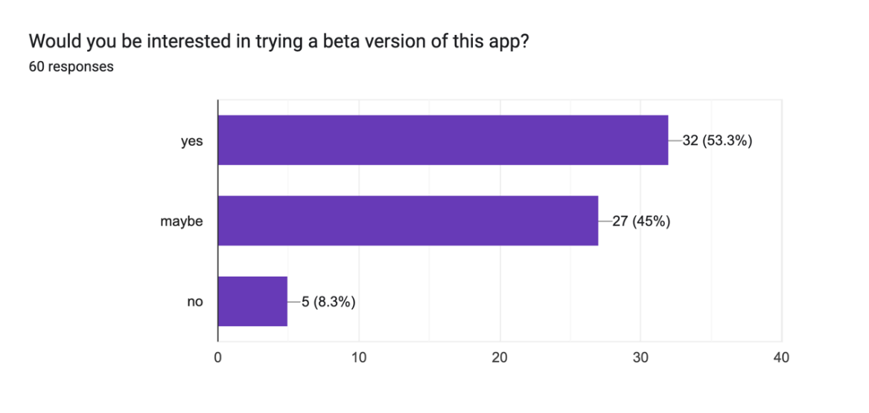

Number of Respondents

Figure : Beta version of app.

This positive response highlights users' openness to adopting our solution if it meets their expectations.

* 1. Users and Personas

The users we identified include students, professional workers, educators, and general internet users. These personas, based on real survey responses, reflect a range of needs and behaviors, from students aiming to reduce distractions, to professionals looking for better focus during work hours.

Each persona highlights different motivations, such as avoiding online distractions to boost productivity, protecting children from culturally inappropriate content, or managing impulse shopping habits to promote financial self-control.

These insights help us design features that are relevant, usable, and personalized. By addressing these varied needs, our app aims to deliver a flexible and effective content-filtering solution suitable for diverse user groups.

In the next sections, we describe these personas in more detail, starting with Persona A, which represents the largest group of respondents.

* + 1. Persona A

Ali, age 22, is an undergraduate business student living in a shared apartment with 2 other students in Amman. He spends most of his time studying, researching, and attending online lectures, but often finds himself distracted by social media, entertainment sites, and pop-up ads while browsing. These distractions are impacting on his productivity, especially during exam season. He is comfortable with digital tools and he uses his laptop and phone daily for academic and personal tasks. He uses productivity apps, note-taking tools, and ad blockers but finds that most basic blockers lack customization. He is seeking an advanced solution that lets him filter specific content based on his needs. He prefers a user-friendly interface where he can set filters and schedules without too much technical configuration. He is interested in having custom block lists, smart scheduling, and AI recommendations to help reduce distractions without overblocking useful content. This persona reflects most users from our survey, particularly students aged 18–24 who reported similar struggles with online distractions and expressed interest in personalized content filtering.

* + 1. Persona B

Fatima is a 54 -year -old mother of four and is a respected woman in her community. She upholds her family traditions and is concerned about the increasing amount of online material that conflicts with her cultural and religious values, especially the way her children can come when browsing the Internet. From inappropriate language, violence, and romantic materials to misleading stories about culture or religion, she constantly worries about what her children can be exposed to, especially when she is not around looking after them. Fatima is not a very technical-lover, so it requires a material-filtering solution that is both smart and easy to use. The content blocker app fully aligns with its needs. It provides AI-powered filtering that goes beyond the basic keyword blocking-to use nature language processing and computer vision and identify the materials that are relevant, inappropriate, or culturally insensitive. With custom ancestral control, Fatima can set separate filtering levels for each child depending on her age. She also appreciates real-time alert, which informs her whether her children try to reach a blocked material. The cross-platform support of the app ensures that its restrictions are continuously applied to all their devices- phones, tablets, and laptops. With this app, Fatima feels stronger to protect her children from content that does not align with their values, while still allows them to safely detect and learn from the Internet. This vision of a safe, culturally respectable digital space gives her peace of mind that she is looking at.

2.2.3 Persona C

Sara is a 25-year-old fashion enthusiast and freelancer, who prefers to be up to date with the latest trends and scroll through her favorite shopping app. While online shopping gives her pleasure, she admits that it often leads to impulse buying, especially when she looks at flash sales, advertising, or limited time proposals. Over time, this habit has affected her budget and productivity. She often browses shopping sites during work hours. Sara is now seeking to gain control over her expenses without leaving the online experience completely online. The content blocker app offers her an ideal solution. With its AI-powered reference-segment filtering, the app can identify access to shopping sites during work hours and temporarily block, when she is unsafe for impulse to buy. It can also limit the number of shopping apps and block targeted shopping advertisements per day, which is one of its largest temptations. Custom scheduling features of the app allows her to create a specific "safe shopping window", so she can still enjoy browsing but in a controlled and desired way. Its cross-platform support ensures that filters may apply whether she is using her phone, laptop, or tablet. Sara also benefits from a soft reminder and spends alerts that pop up before purchasing, which helps her to stop and rethinks her decisions. With this vision of a personal, self-control digital accessory, the whole is finally capable of enjoying online shopping without regrets in a healthy, more responsible manner.

1. Solution Ideation

To start shaping the content blocker app, we adopted a user-centric and iterative approach to ensure that our solution has been aligned with relevant, practical, and real user needs. Our ideation process started with analyzing survey results, which helped us identify general concerns and behavioral patterns among a variety of users - such as distracted students, parents are concerned about cultural risk, and professionals struggling with impulse control. Using these insights, we developed personas A, B, and C to represent our primary user groups. These individuals lay the groundwork for user story creation in the next phase. Each user will be implicated the story from a persona, which will focus on their goals and challenges. For example, a user can be a user story for a related parent: "As a parent, I want to block culturally inappropriate material so that I can protect my children online." This process will help us define specific, target-oriented scenarios which guide our feature development. Based on these user stories, we will recognize the app facilities and prefer that directly address the user's needs. These features may include **AI-powered context aware filtering**, **Adaptable Block Lists** **and Ban Settings**, **Parents Control and Material Categories**, **Time-based blocked and used monitoring** and a **cross-platform integration and real time alert**. By following a recurring and agile method, we aim to constantly refine our ideas, validate them through feedback and develop our design in response to user input. This approach ensures that the final solution is adaptive, user friendly and meaningful, addressing a wide range of cases of use with Precision and care.

* 1. The scenarios

To better understand the needs of our targeted users, we developed three major scenarios, each of which corresponds to our personas. These scenarios are designed to reflect real-life conditions in which users will benefit from using the inhibitory app. They serve as a foundation to make user stories and identify the most relevant and impressive features for app.

Scenario A - Focused Student (Ali):

This scenario explains how a student struggles with being distracted during the time of study and how the app can help him focus by filtering the non-educational material wisely. It highlights the need for smart scheduling and relevant blocking that supports productivity without limiting access to accessory resources.

Scenario B - Culturally aware mother (Fatima):

This scenario focuses on a mother who is concerned about meeting her children's culturally inappropriate or aggressive materials. It emphasizes the importance of AI-operated parents’ control, cultural sensitivity, and the importance of adaptable filtering for the protection of young users while maintaining access to educational and safe materials.

Scenario C - impulsive shopper (Sara):

This scenario presents a young woman who enjoys online shopping but struggles with buying impulse. This indicates how the app can assist in self-control and financial discipline by limiting access to shopping platforms, reducing advertising exposure and sending an alert or reminder to help him make more oriented purchasing decisions. These scenarios are important because they represent the needs of various users- productivity, safety and self-regulations- each of which contributes to the overall vision of the blocker app: a smart, user-friendly manner to promote digital welfare and personal material control.

* + 1. Scenario A

Ali is a 22-year-old university student studying business and lives in a shared apartment with two roommates. With final exams around the corner, Ali is feeling overwhelmed. He sits up at his desk, ready to revise for his accounting exam, but every few minutes he gets pulled into distractions, YouTube suggestions related to his hobbies, his friends sending him reels on Instagram, or any messages from group chats. Despite having good study intentions, Ali often ends up wasting hours online. He is aware of the issue and has tried regular browser extensions, but they either block too much or are too easy to bypass. Ali needs something smarter, something that understands what to block and when. He launches the Content Blocker App on his laptop and phone. He selects his preset “Study Mode” a profile he created earlier that block social media apps, and entertainment websites. The app allows him to choose a 4-hour session with AI filtering turned on. Unlike traditional blockers, the app uses Natural Language Processing (NLP) to avoid overblocking, so websites like online textbooks and research articles remain accessible. As he begins his session, Ali gets a small notification that the mode is active. Every time he attempts to open Instagram or YouTube; the app gently reminds him that it is part of his blocked list. He ignores the urge and goes back to studying. By the end of the session, he managed to finish two full chapters of his revision material without falling into his usual distraction loops. Afterward, the app displays a summary: total focused time, blocked distraction attempts, and progress. Ali feels accomplished and motivated. For the first time in weeks, he was able to study efficiently without manually trying to avoid distractions.

Connection to User Research:

This scenario is based on the 55 out of 60 student respondents in our survey who reported frequent distractions from social media and entertainment platforms. Many of them expressed the need for customizable, intelligent filtering with minimal disruption to useful resources. The scenario helped us identify features like AI-powered content recognition, time-based blocking, user-defined filtering profiles, and progress tracking as essential components of the app.

* + 1. Scenario B

Fatima is a 54-year-old mother of four living in a quiet suburban neighborhood. She is deeply connected to her cultural and religious values and takes pride in raising her children with care and discipline. While she encourages her kids to learn and explore using technology, she is constantly worried about what they might come across online especially on platforms like YouTube, social media, or random websites during homework time. Her youngest son, Omar, is 9 years old and uses a tablet for school research and watching cartoons. One day, Fatima overhears him repeating a phrase he heard in a video, a phrase that was inappropriate and offensive in their cultural context. Concerned and frustrated, she realizes the regular parental settings on the device are not enough. Her older daughter recommends trying the Content Blocker App. Fatima installs the app and is immediately surprised by how simple the setup is. The interface offers a Parental Mode, specifically designed for parents like her. Using easy step-by-step options, she sets up user profiles for each of her children, selecting different restriction levels based on their age. Unlike traditional blockers that rely only on basic keyword filtering, this app uses AI-powered content analysis. It can detect contextual meaning in videos, images, and articles using Natural Language Processing and Computer Vision, which helps filter out content that might seem harmless to a machine but is culturally inappropriate. She also enables real-time alerts so if one of her children tries to access a blocked site or content, she gets a notification on her phone. The app works across all the devices in the house tablets, phones, and laptops thanks to cross-platform synchronization. Most importantly, it does not interfere with educational tools, so her kids can still access school websites and online learning platforms. After a week of using the app, Fatima feels significantly more at ease. She notices her children engaging more with educational content and appreciates not having to constantly oversee what they’re watching or reading. The app empowers her to keep her children safe while respecting her values, without needing technical expertise.

Connection to User Research:

Fatima’s scenario reflects responses from parents in our survey who expressed concerns about their children’s exposure to content conflicts with their culture or beliefs. They highlighted the need for culturally sensitive filtering, child-specific control settings, ease of use, and multi-device protection. This scenario directly informed our decisions to include features like custom content categories, AI filtering beyond keywords, real-time alerts, and parental control profiles.

* + 1. Scenario C

Sara is a 25-year-old freelance graphic designer who lives alone in a busy city and is passion for fashion. She enjoys being up to date with the latest trends and often scrolls herself through shopping apps such as Zara, Shin, and Instagram during her break. While online shopping gives her pleasure, she has noticed its negative effects - it becomes a distraction during the work hours, and she often makes impulse purchasing, especially during flash sales and targeted advertisements. One afternoon, after remembering a customer's deadline because she got browsing, she realizes that her habit is affecting both her productivity and her budget. In search of how to achieve control, Sara installs material blocked app recommended by a friend. For her surprise, the setup is comfortable and analog. The interface of the app offers a smart self-control mode, which is specifically designed for users like her, which they enjoy fully want to help manage online habits without disconnecting. Using the adaptation features of the app, she creates a routine that suits her lifestyle. She activates a "work mode" from 9 am to 5 pm, which automatically blocks shopping websites and apps during its focus hours. She also sets the "safe purchasing window" from 6 pm to 7 pm, allowing herself to browse crime-free. To reduce the temptation, she limits her risk by only two purchasing advertisements per day, and she enables the "spending alert" feature, which informs her whether she is overspending or deciding. A specialty she especially appreciates, if she ever feels the need to reset her habits, then she can completely block all shopping apps for the whole month.

The next day, when Sara easily opened a shopping app during working hours, the app gently intervened with a friendly message: "Now, Sara. Shopping can wait till 6 pm." She smiles, puts her phone down, and returns to her design project. Later in the evening, she gets a subtle notification: "Your shopping window is now open. Happy browsing- Mindful!" She browses some objects, adds a jacket to her cart, but as she goes out, a pop-up message appears: "You have already spent $ 140 this month. Are you sure you want to buy it?" She stops, rethinks the purchase, and decides to save it later. By the end of the week, she feels more focused, spends less impulsively, and still enjoys shopping - but with healthy boundaries.

Connection to User Research:

Sara's scenario is based on the reactions of young adult freelancers and online shopkeepers, who highlighted advertising effects in the form of productivity issues and common challenges. Survey participants expressed interest in features such as AI-operated impulse control, customized browsing window, shopping boundaries and purchase reminder. This scenario shapes features such as direct smart time-based access, financial awareness alerts and cross-platform content control, designed to support all digital welfare, while allowing users to maintain their lifestyle in a balanced way.

* 1. The User Stories and Proposed Solutions

Table : user stories

|  |  |  |  |
| --- | --- | --- | --- |
| **Persona** | **User Story** | **Proposed Solution** | **Why This Solution Works** |
| **Ali** | As a student, I want to block distracting websites during study time so I can focus better. | Provide a “Study Mode” with a custom schedule and AI filtering that blocks entertainment and social media websites. | Helps Ali avoid distractions during key study hours while still allowing access to useful academic resources. |
| As a student, I want a smart contextual filtering to avoid overblocking academic resources. | Use NLP-powered filtering to understand the context and avoid overblocking important academic content. | Ensures essential study tools like online textbooks and research platforms remain accessible. |
| As a multitasker, I want to use the app on all my devices, so I don’t have to set it up multiple times. | Include cross-platform syncing between laptop and phone. | Prevents Ali from bypassing the block by switching devices. |
| As a productivity tracker, I want to see how well I stayed focused after each study session. | Add a session summary that shows focused time, blocked distractions, and progress. | Encourages better habits through feedback and self-monitoring. |
| As someone who uses night sessions, I want to enable dark mode to reduce eye strain. | Provide a dark mode UI option in the app settings. | Enhances comfort and usability for late-night study sessions. |

|  |  |  |  |
| --- | --- | --- | --- |
| **Fatima** | As a parent, I want to protect my children from harmful and culturally inappropriate content. | Offer Parental Mode with culturally sensitive AI filtering using Natural Language Processing and Computer Vision. | Gives Fatima peace of mind by filtering based on meaning, not just keywords. |
| As a non-technical user, I want an easy-to-use interface so I can set up filters without difficulty. | Design a simple and user-friendly setup with visual steps and language options. | Fatima can set up content filters confidently without needing technical skills. |
| As a mother of kids with different ages, I want to set different filter levels for each child. | Allow custom user profiles per device/child with age-appropriate filter settings. | Make filtering more accurate and respectful of each child’s maturity level. |
| As a concerned parent, I want to be notified if my kids try to open blocked content. | Enable real-time alerts when blocked content is accessed. | Keeps Fatima aware and involved in her children’s online behavior. |
| As a family with many devices, I want filters to apply to all our phones, tablets, and laptops. | Support cross-platform filtering on all household devices. | Ensures consistent filtering regardless of the device being used. |
| As someone who speaks Arabic, I want to use the app in my native language. | Add multilingual support, including Arabic interface options. | Makes the app more accessible and usable for non-English speakers like Fatima. |

|  |  |  |  |
| --- | --- | --- | --- |
| **Sara** | As a freelancer, I want to avoid shopping distractions during work hours so that I can stay focused. | Add a Work Mode that blocks all shopping apps and websites during 9 AM–5 PM using AI-based filters. | Prevents Sara from losing productivity due to impulse browsing. |
| As an impulsive shopper, I want to receive a reminder before buying so that I can think twice before spending. | Include a Spend Alert pop-up just before checkout, showing monthly spending and asking for confirmation. | Helps her reconsider purchases and reduce unnecessary spending. |
| As a budget-conscious user, I want to reduce my exposure to shopping ads so that I can control my spending. | Limit the number of shopping-related ads shown per day using smart ad-blocking. | Reduces temptation caused by frequent targeted advertisements. |
| As someone who still loves fashion, I want to shop in a controlled way without quitting completely. | Offer a Safe Shopping Window from 6 PM–7 PM where shopping is allowed freely. | Allows Sara to enjoy shopping at a time that doesn’t affect work or productivity. |
| Given my challenges with self-discipline, I want to stop shopping completely for a while when I need a break. | Include a feature to block all shopping content/apps for a full month with one click. | Gives Sara a strong reset option to help manage her impulse shopping urges. |
| As a multi-device user, I want the same rules to apply on all my devices. | Use cross-platform syncing so that filters apply to her phone, tablet, and laptop. | Ensures Sara can’t bypass filters by switching devices. |

1. Low-fidelity Prototype

To visualize our solution for the content blocker app, we developed a low-fidelity prototype using uizard.io, an AI-powered design platform that allows us to quickly and efficiently create interactive prototypes. This prototype focuses on structure, layout and core user interactions without diving in refined scenes. The goal was to design a functional representation of the major features of the app, based on the main points and requirements known in our personas, survey findings and problem statement. The Prototype design follows a modular layout where users can easily navigate between various core functions such as material filtering, scheduling, parental controls and productivity equipment. The interface is minimal, spontaneous and accessible. It is particularly important to ensure that the application remains accessible and easy to use for individuals with comfort and experience.

**Our solution addresses three major challenges:**

* Digital distraction and loss of productivity (Ali and Sara).
* Impulse control and financial discipline (Sara).
* Cultural sensitivity and child safety online (Fatema).

**Each feature of the prototype is directly connected to solve these problems:**

* Smart AI-powered content blocking.
* Custom block lists for websites, apps, and keywords.
* Time-based restrictions with flexible scheduling.
* Parental profiles and culturally sensitive filtering.

**Feature–Persona Relationship Table**

Table :Feature–Persona Mapping.

|  |  |  |
| --- | --- | --- |
| **Feature (from UI Prototype)** | **Related Persona(s)** | **Purpose / Relevance to Persona** |
| AI-Powered Smart Filtering | Ali, Fatima, Sara | Adapts content blocking based on behavior and context—helps Ali focus, Fatima filter culturally inappropriate content, and Sara manages distractions. |
| Manual Blocking (Websites, Apps, Keywords) | Sara | Allows Sara to block shopping apps and websites during work hours, promoting better focus and spending control. |
| Time-Based Scheduling | Ali, Sara, Fatima | Supports scheduled blocking during study time for Ali, shopping windows for Sara, and controlled screen time for Fatima’s children. |
| Study Mode | Ali | Blocks distracting apps/websites during focus hours, helping Ali improve academic concentration. |
| Kids Mode | Fatima | Provides a child-safe browsing environment by allowing content restriction by category and screen time scheduling. |
| Category Filtering (Blocked Categories) | Fatima, Sara | Enables Fatima to block culturally inappropriate content and Sara to filter out shopping or ad-related distractions. |
| Spend Alerts / Reminder Prompts | Sara | Notifies Sara before a purchase is completed, encouraging her to reconsider and reduce impulse spending. |
| Mode Suggestions (Focus, Relax, Room) | Ali, Sara | Suggests behavior-based modes to help Ali stay focused and Sara maintains balance between productivity and downtime. |

**User Flow & Interaction Model**

This flowchart illustrates the overall interaction flow of the app. It covers all major user pathways, including Study Mode, Kids Mode, and Manual Blocking. Each branch shows how users configure filters, apply scheduling, activate sessions, and access mode-specific dashboards. The diagram represents the full functionality of the prototype and reflects the main screens implemented in the UI.

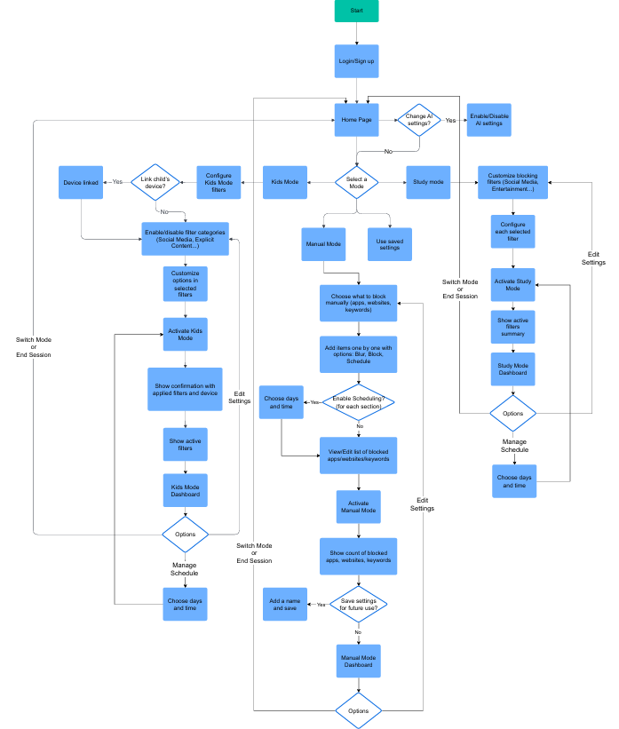

Figure : Cba flowchart.

* 1. Welcome screen

This is the entry point of the app, from which users get a clean and friendly interface to start their journey. This includes options for signing up or logging in, installing ease of access to all user types. It addresses the requirement of a simple, invited entry point, especially for users such as Fatema, who give importance to clarity and simplicity.

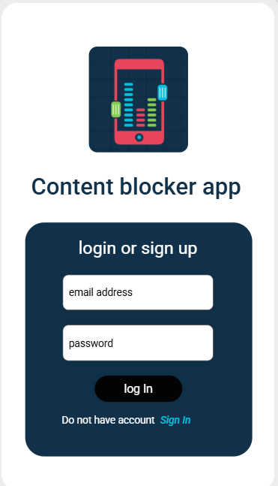 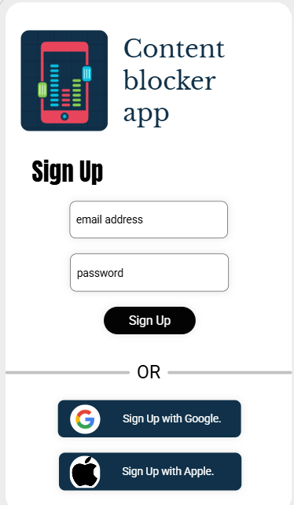 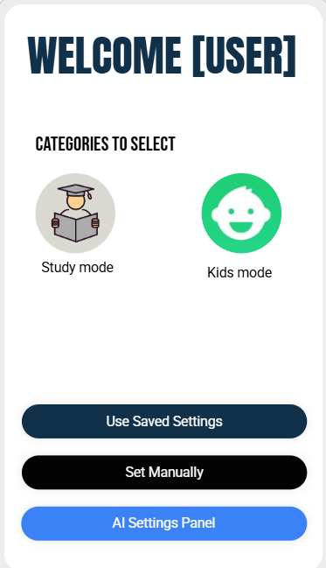

Figure : Welcome page.

* 1. Home / Dashboard

The dashboard acts as a central control panel, which shows quick access to facilities such as blocking categories, timer, alert and recent use insight. It supports users like Ali and Sara by providing an observation of its digital wellness status and quick toggle to enable or disable blocking features.

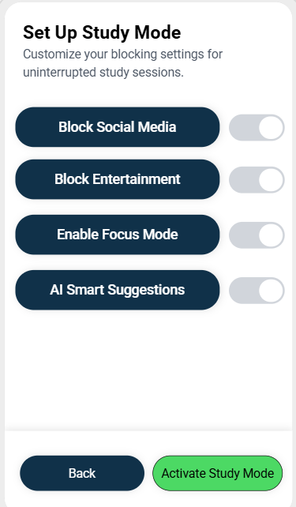 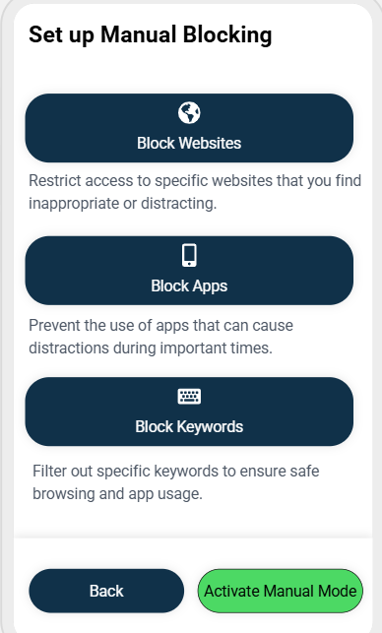

Figure : Dashboards.

* 1. AI-Powered Smart Filtering

Enables to block intelligent based on reference and behavior. Essential for all users - especially Fatema (cultural filtering) and Sara (shopping temptation).

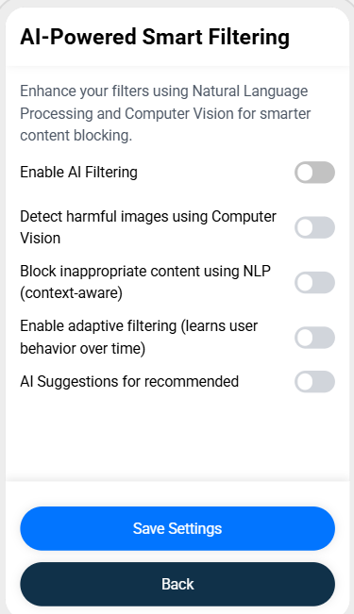

Figure : AI filtering.

* 1. Manual Blocking Setup

Gives complete control to users such as Sara, who wants to block materials during work hours, or Ali, who wants to block distractions while studying.

Figure :Manual blocking.

* 1. Study Mode

Automatically provides time to focus by blocking distractions. This feature directly supports Ali's scenario and productivity goals.

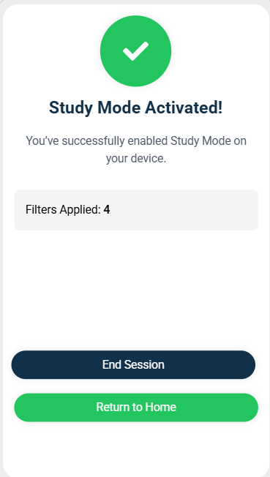

Figure :Study mode.

* 1. kids’ mode

It allows users such as a category-based blocked (inappropriate or culturally sensitive material…etc.), in the management of safe digital places for their children such as Fatema.

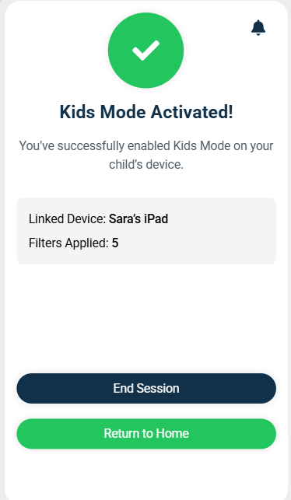

Figure :Kids’ mode.

* 1. Add Blocked Websites / Apps / Keywords

Users make their own blocks. A flexible solution for diverse requirements- Sara block shopping apps, Fatema blocks YouTube content.

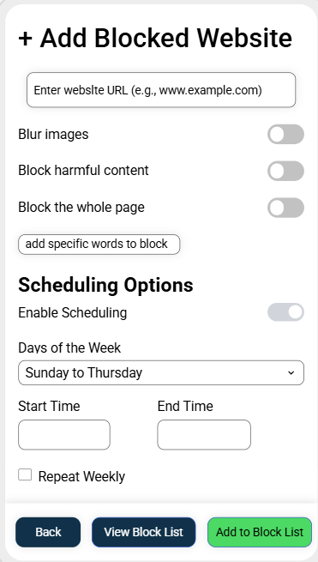

Figure :Blocking choices.

* 1. Block Management lists

Easy management interfaces to edit or remove entries. Promotes continuous adaptation and privatization.

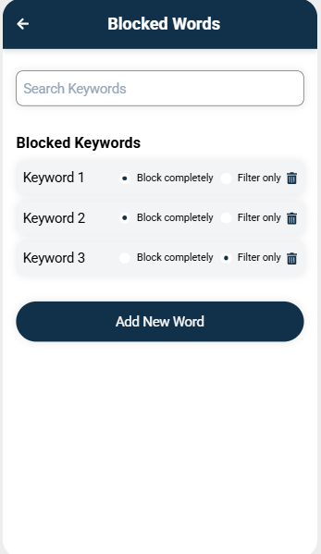 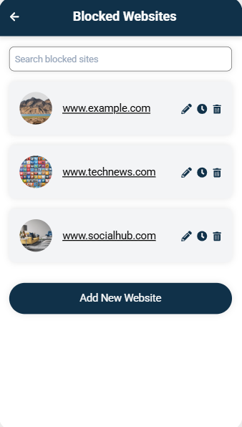

Figure :Blocked lists.

* 1. Kids Mode Choices

It contains harmful or culturally inappropriate materials such as clear media, aggressive language, or symbolically sensitive words. The lists support Fatema requirements to ensure a safe and respectable digital environment for her children.

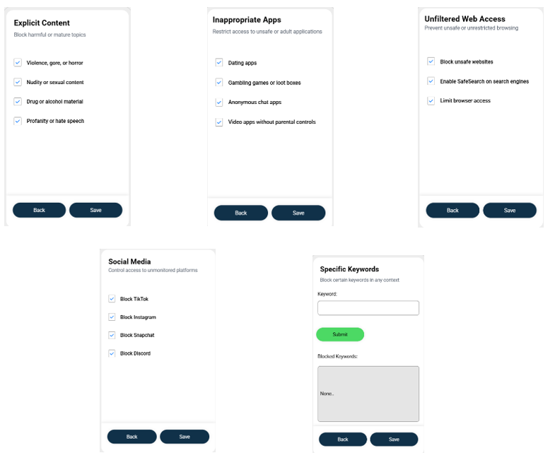

Figure : Kids' lists.

* 1. Study mode choices

Ideal for users like Ali who require a structured digital environment to support productivity. Custom schedules and time limitations help to create discipline and improve educational concentration.

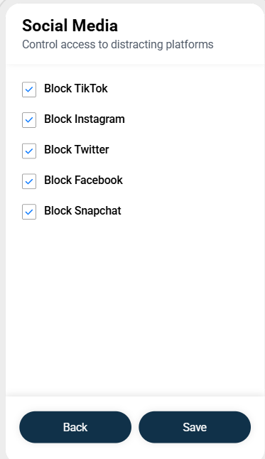 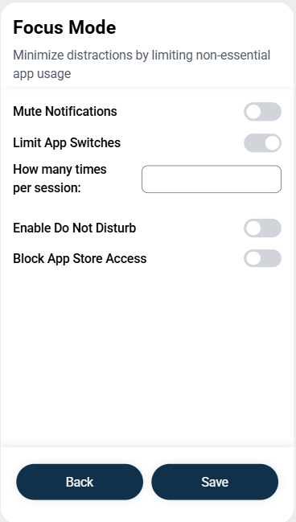 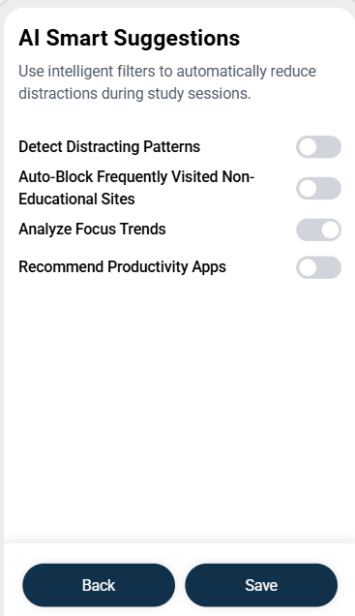

Figure :Study lists.

**Conclusion**

The low-fidelity prototype effectively translates our proposed solution to a functional, user-friendly design that addresses the major problems identified in our research. By focusing on ease -rich navigation, flexible filtering options and analog user mode, such as manual, study and kids’ mode, the prototype shows how the app will meet the diverse requirements of users looking for digital welfare, productivity and safe browsing environment. Each screen and convenience was designed with purpose, ensuring that the interface is clear, accessible and aligned with the expectations of the user. This prototype gives a solid foundation for the next step: refining interactions and preparing for high-loyal development and testing.

1. User Testing

We conducted a user test with participants representing our three persons: Ali (student), Fatema (parent), and Sara (impulse shopper). Each user discovered the low-loyal prototype and provided the reaction based on their experience using relevant features for their needs.

**Response from Ali – (the focused student):**

What did he like:

* Study mode found helpful to stay focused during the hours of study.
* Liked the simple scheduling setup and how it matches its routine.
* Focused on the 'Study Mode Active' message which confirmed his action.

What he did not like:

* He felt that the list of blocked apps and websites in Study Mode was too limited and wanted more control over what gets blocked.

Suggestions:

* Enable syncing with recent usage data
* Include a simple timer to show how long the study mode is active.
* Provide a “suggested distractions” list powered by AI, based on typical student behavior, with options to toggle on/off.

**Response from Fatema – (Culturally aware mother):**

What did she like:

* Kids mode was easy to use.
* Liked the ability to block improper and clear material.
* Appreciated to be able to set screen time hours for her children.

What she did not like:

* Some labels were misleading, such as 'symbolic keywords'.
* Uncertain if settings apply to all devices or just one.

Suggestions:

* Add short explanation or tooltips to explain filter names.
* clearly show whether the settings apply to all devices.

**Sara response – (the impulse shopper):**

What did she like:

* Manual blocking and shopping window features were very helpful.
* loved the spend alert.

helped her think and stop before purchasing.

What she did not like:

* She felt overwhelmed by the number of setup steps before activating Manual Blocking.
* She found it difficult to track how much she had already spent during the month within the app.

Suggestions:

* Allow users to save favorite setups so they can activate them with one click in the future.
* Add a monthly spending summary screen that shows total blocked attempts and estimated saved purchases.

Overall, users found the app easy and easy to use. However, they suggested some changes to improve the experience, such as clear navigation, tooltips for unclear words, and more flexibility with blocking settings. These suggestions will be considered in the next stage to make the app more user friendly and effective.

Phase 2: Design and Development

(Modular & Collaborative)

In phase 1, we discovered the main problems that users encounter with unwanted and disturbing online content. Through survey and user research, we identified major user groups, including students, parents and professionals, who expressed the need for more intelligent and adaptable material-filtering solutions. We developed three user individuals- Ali, Fatima, and Sara that reflect the needs of the real world such as improving focus, ensuring child safety and managing online shopping behavior. This research laid the foundation of a user-centric solution focused on smart filtering, scheduling and cross-platform control. With these insights, phase 2 transition design and development phase, where modular implementation and collaborative input will guide the creation of a functional and intuitive app experience.

1. Software Design

This section presents a high-level architecture and modular structure of the **content blocker app**. It explains how the system is arranged, how different components interact, and how each module contributes to the overall functionality of the application. These diagrams serve as a blueprint for development and ensure that all team members have a common understanding of the implementation plan. The system follows a modular and collaborative structure, supporting several **modes** (kids mode, study mode and manual mode) with smart filtering capabilities operated by AI.

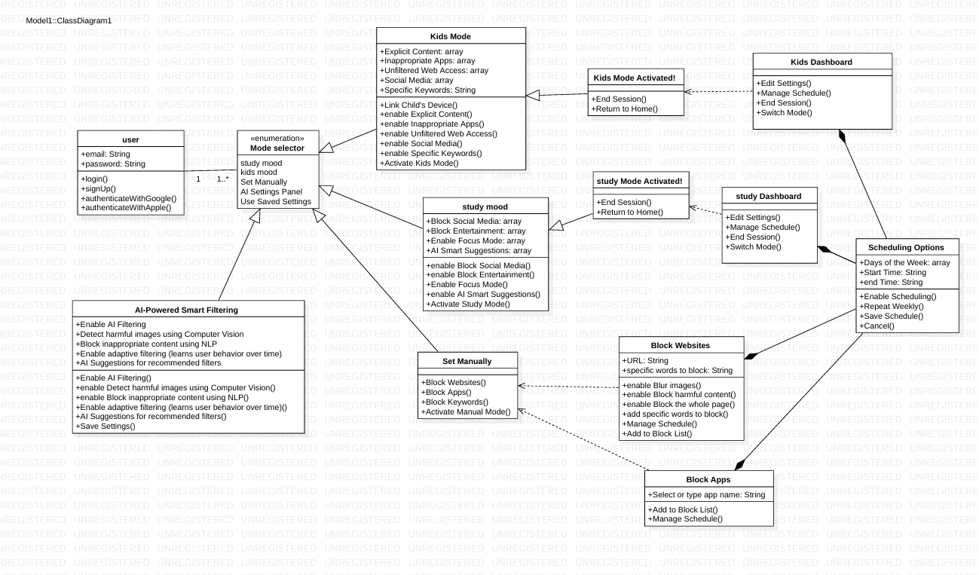

Figure :Class diagram.

The class diagram shows the overall architecture of the application. Its center has a user class, which interacts with all available modes including study mode, kids mode, manual mode and AI settings. Each mode has its own characteristics such as activation, material filtering, scheduling and block management. The AI-powered smart filtering module is notable for the integration of computer vision and natural language processing, allowing it to detect relevant or harmful material rather than relying on basic keyword filtering. The scheduling is managed through a shared module that adds all dashboards, allowing users to define the weekly routine, set time intervals and manage the recurring program. The structure ensures a clear separation between interface, behavioral engine and privatization control, which enables flexibility and scalability.

Figure :User use case.

The main use case maps user interactions in the case diagram application. From home dashboard, users can reach kids mode, study mode, AI settings, or manually configure filter. Each of these options provides specific functionality, such as blocking the website, app and keywords or setting behavioral modes. Main activities such as scheduling and viewing block lists are shared using relationships in these modules. This design provides clarity in navigation and displays how modular components work together through shared services.

Figure :AI use case.

A more detailed use case diagram focuses on AI-operated smart filtering. In this module, users can enable adaptive filtering, detect harmful images, and block improper material using advanced AI techniques. The system provides suggestions based on learned behavior, and users can choose to save their configuration for future use. This layout highlights how intelligent material management is considered as an independent and adaptation facility.

Figure :Parents use case.

Another user case diagram center around kids’ mode. This feature is designed for the parents who want to filter the material according to the category - such as clear materials, inappropriate apps, or unsafe websites - and apply restrictions based on the needs of each child. The setup process to accommodate non-technical users is deliberately straight. Parents can manage device-specific restrictions, enable real-time alerts, and activate the mode in all devices in the house. This ensures cultural safety and age-appropriate access to online materials.

Figure :Students use case.

Finally, the study mode use case diagram emphasizes productivity and focus. Targeting users such as students, it allows them to block entertainment and social media platforms during study hours. The mode supports AI-based smart tips to customize focus, and users can activate the pre-determined routine. The study mode encourages a distraction-free digital environment and helps users to build healthy digital habits through automation and custom settings.

1. Version Control Repository

Code hosted on platforms like Git with clear versioning and commit messages.

[This section abstracts the significance of using Git Flow or GitHub for structured development, emphasizing the benefits of parallel development and smooth integration. It should also highlight the need to integrate CI/CD tools to automate critical processes, streamline workflows, and reduce errors. Key practices such as frequent commits, adherence to a consistent branching model, and thorough code reviews are essential for maintaining an organized, efficient, and collaborative development environment.]

Appendices

Appendix A: Conducted Surveys

<https://docs.google.com/forms/d/e/1FAIpQLSesd8Mr5m8u68tx33bsxuq8PozqmuiHe-mXaFSzNy73vI1w4g/viewform?usp=header>

Forms response chart. Question title: What is your primary occupation?
. Number of responses: 60 responses.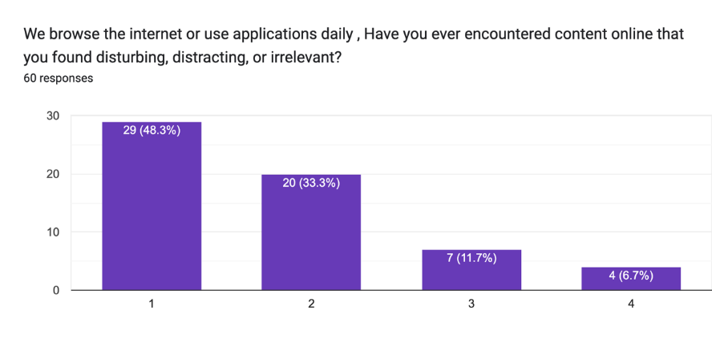

Forms response chart. Question title: What type of content would you like to block or filter? (Select all that apply)
. Number of responses: 60 responses.

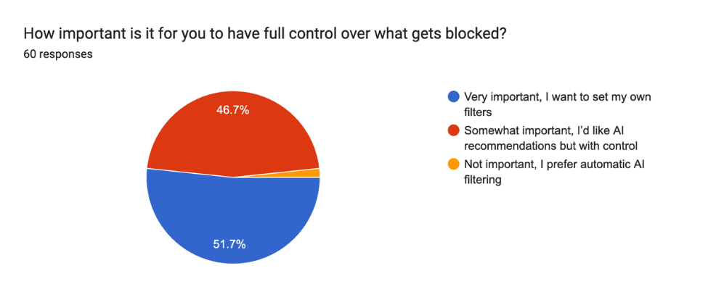

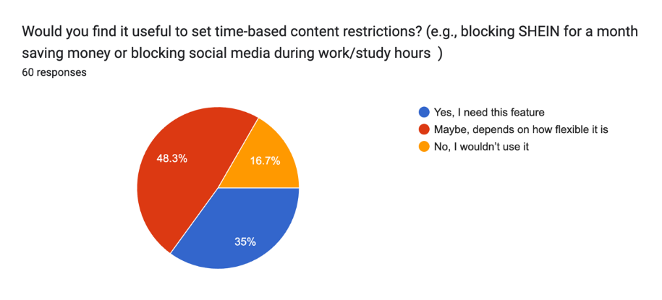

Forms response chart. Question title: How do you currently manage unwanted content while browsing and What kind of scheduling options would be most useful for you? (Select all that apply)
. Number of responses: 60 responses.

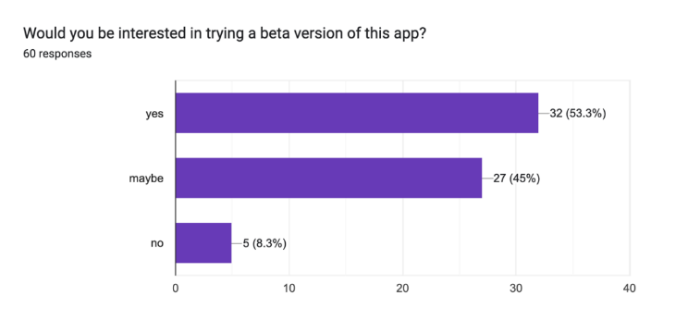

Appendix B: Meeting Minutes

**Kuwait University**

**College of Engineering and Petroleum**

**Computer Engineering Department**

**Team Meeting Minutes 1**

|  |  |  |  |
| --- | --- | --- | --- |
| **Team Name:** | **Tri-vision** | **Date:** | 18/2/2025 |
| **Start Time:** | **7:00 pm** | **Finish Time:** | **8:30 pm** |

|  |  |
| --- | --- |
| **Members Present:** | **All members** |
| **Members Excused:** | **None** |
| **Members Tardy:** | **None** |
| **Members Absent:** | **None** |

**Summary of meeting**

In our meeting, we divided the work for the content blocker app to ensure efficiency. I will handle the Introduction, outlining the app’s purpose and development goals. The Project Impact section will be covered by Mohamad, focusing on how the app enhances digital well-being and user control. For User Potentials, Mohamad also will research and define the target audience, including individuals, parents, and professionals. The Vision Statement will be done by Fatema. Lastly, the Problem Statement will be also done by Fatema, addressing the need for a flexible and user-friendly content-blocking solution. Regular check-ins will be held to ensure consistency and alignment before finalizing the presentation.

**Task list:**

|  |  |  |  |
| --- | --- | --- | --- |
| **Team Member** | **Assigned Tasks** | **Start Date** | **Due Date** |
| Mahmoud | Introduction | 19/2/2025 | 22/2/2025 |
| Fatema | Vision & problem statement | 19/2/2025 | 22/2/2025 |
| Mohamad | User potentials & project impact | 19/2/2025 | 22/2/2025 |

**Next meeting will be held on**

24/2/2025

**Kuwait University**

**College of Engineering and Petroleum**

**Computer Engineering Department**

**Team Meeting Minutes 2**

|  |  |  |  |
| --- | --- | --- | --- |
| **Team Name:** | **Tri-vision** | **Date:** | 24/2/2025 |
| **Start Time:** | **5:00 pm** | **Finish Time:** | **6:00 pm** |

|  |  |
| --- | --- |
| **Members Present:** | **All members** |
| **Members Excused:** | **None** |
| **Members Tardy:** | **None** |
| **Members Absent:** | **None** |

**Summary of meeting**

In our latest meeting, we underlined the next stage of the Content Blocker App Project and divided the work to ensure efficiency and clarity in execution. Each team member is assigned a specific task to focus Mahmoud will take persona B and C. Mohammed will be responsible for discussing user manuals and persona A. Fatema will handle the survey summary, compile the major findings and present them in a clear and structured format. We agreed to keep regular check-in to ensure that all sections align in tones and materials. Once the individual work is completed, we will review and refine the final delivery before going to the next stage.

**Task list:**

|  |  |  |  |
| --- | --- | --- | --- |
| **Team Member** | **Assigned Tasks** | **Start Date** | **Due Date** |
| Mahmoud | Persona B,C | 1/3/2025 | 6/3/2025 |
| Fatema | Interview summary | 1/3/2025 | 6/3/2025 |
| Mohamad | Users & persona A | 1/3/2025 | 6/3/2025 |

**Next meeting will be held on**

9/3/2025

**Kuwait University**

**College of Engineering and Petroleum**

**Computer Engineering Department**

**Team Meeting Minutes 3**

|  |  |  |  |
| --- | --- | --- | --- |
| **Team Name:** | **Tri-vision** | **Date:** | 9/3/2025 |
| **Start Time:** | **9:00 am** | **Finish Time:** | **9:30 am** |

|  |  |
| --- | --- |
| **Members Present:** | **All members** |
| **Members Excused:** | **None** |
| **Members Tardy:** | **None** |
| **Members Absent:** | **None** |

**Summary of meeting**

In our latest meeting, we gathered to finalize all sections of the content blocker app project and apply the final touch before completion. Each team member reviewed its scheduled parts, which ensure stability, clarity and alignment with our project goals. We went through personas, user manual and survey summary, where the need was a minor purification.

**Task list:**

|  |  |  |  |
| --- | --- | --- | --- |
| **Team Member** | **Assigned Tasks** | **Start Date** | **Due Date** |
| Mahmoud | Persona B,C | 7/3/2025 | 12/3/2025 |
| Fatema | Interview summary | 7/3/2025 | 12/3/2025 |
| Mohamad | Users & persona A | 7/3/2025 | 12/3/2025 |

**Next meeting will be held on**

20/3/2025

**Kuwait University**

**College of Engineering and Petroleum**

**Computer Engineering Department**

**Team Meeting Minutes 4**

|  |  |  |  |
| --- | --- | --- | --- |
| **Team Name:** | **Tri-vision** | **Date:** | 20/3/2025 |
| **Start Time:** | **6:00 pm** | **Finish Time:** | **7:00 am** |

|  |  |
| --- | --- |
| **Members Present:** | **All members** |
| **Members Excused:** | **None** |
| **Members Tardy:** | **None** |
| **Members Absent:** | **None** |

**Summary of meeting**

In this week’s meeting, we reviewed and finalized the sections related to Solution Ideation and Scenarios for the Content Blocker App project, discussing the approach used to generate ideas from user personas and survey insights, and how we would proceed with user stories and proposed solutions. Mahmoud will do the Solution Ideation, Scenarios overview, and updated the Appendices, Mohammad will work on Scenario A and B, and Fatema will handle Scenario C along with the User Stories and Proposed Solutions. All content is now aligned and ready for the next phase.

**Task list:**

|  |  |  |  |
| --- | --- | --- | --- |
| **Team Member** | **Assigned Tasks** | **Start Date** | **Due Date** |
| Mahmoud | Solution ideation & the scenarios & updating the appendices | 23/3/2025 | 25/3/2025 |
| Fatema | Scenario A,B | 23/3/2025 | 25/3/2025 |
| Mohamad | Scenario C & user stories and the proposed solutions | 23/3/2025 | 25/3/2025 |

**Next meeting will be held on**

27/3/2025

**Kuwait University**

**College of Engineering and Petroleum**

**Computer Engineering Department**

**Team Meeting Minutes 5**

|  |  |  |  |
| --- | --- | --- | --- |
| **Team Name:** | **Tri-vision** | **Date:** | 25/3/2025 |
| **Start Time:** | **10:00 am** | **Finish Time:** | **11:00 am** |

|  |  |
| --- | --- |
| **Members Present:** | **All members** |
| **Members Excused:** | **None** |
| **Members Tardy:** | **None** |
| **Members Absent:** | **None** |

**Summary of meeting**

In this week’s meeting, we planned the upcoming phase of the Content Blocker App project, which focuses on the User Interface design and Low-Fidelity Prototype. We discussed the layout, user flow, and features that should be included to align with the identified user needs. Mohamad and Fatema will begin working on the UI design, while Mahmoud will focus on completing the written report.

**Task list:**

|  |  |  |  |
| --- | --- | --- | --- |
| **Team Member** | **Assigned Tasks** | **Start Date** | **Due Date** |
| Mahmoud | Low fidelity prototype | 25/3/2025 | 3/4/2025 |
| Fatema | UI | 25/3/2025 | 3/4/2025 |
| Mohamad | UI | 25/3/2025 | 3/4/2025 |

**Next meeting will be held on**

3/4/2025

**Kuwait University**

**College of Engineering and Petroleum**

**Computer Engineering Department**

**Team Meeting Minutes 6**

|  |  |  |  |
| --- | --- | --- | --- |
| **Team Name:** | **Tri-vision** | **Date:** | 3/4/2025 |
| **Start Time:** | **3:00 pm** | **Finish Time:** | **4:30 pm** |

|  |  |
| --- | --- |
| **Members Present:** | **All members** |
| **Members Excused:** | **None** |
| **Members Tardy:** | **None** |
| **Members Absent:** | **None** |

**Summary of meeting**

12In this week’s meeting, we reviewed the progress made on the User Interface and Low-Fidelity Prototype for the Content Blocker App project. Mohamad and Fatema worked on designing the UI screens, focusing on layout, screen structure, and representing key features like Manual Mode, Study Mode, and Kids Mode. Meanwhile, Mahmoud continued developing the written report, including detailed descriptions for each screen and feature. The prototype now visually reflects the core functionalities of the app, and both the design and documentation are progressing as planned.

**Task list:**

|  |  |  |  |
| --- | --- | --- | --- |
| **Team Member** | **Assigned Tasks** | **Start Date** | **Due Date** |
| Mahmoud | Low fidelity prototype | 3/4/2025 | 5/4/2025 |
| Fatema | UI | 3/4/2025 | 5/4/2025 |
| Mohamad | UI | 3/4/2025 | 5/4/2025 |

**Next meeting will be held on**

12/4/2025

**Kuwait University**

**College of Engineering and Petroleum**

**Computer Engineering Department**

**Team Meeting Minutes 7**

|  |  |  |  |
| --- | --- | --- | --- |
| **Team Name:** | **Tri-vision** | **Date:** | 12/4/2025 |
| **Start Time:** | **10:00 pm** | **Finish Time:** | **10:30 pm** |

|  |  |
| --- | --- |
| **Members Present:** | **All members** |
| **Members Excused:** | **None** |
| **Members Tardy:** | **None** |
| **Members Absent:** | **None** |

**Summary of meeting**

In this meeting, the team gathered to divide responsibilities for the upcoming project tasks. Mahmoud will handle the **User Testing** section, focusing on analyzing feedback and identifying usability improvements. Fatema will work on the **Software Design**, documenting the architecture, modules, and system diagrams. Mohamad will be responsible for setting up and managing the **Version Control Repository**, ensuring all project files are organized and accessible. This division aims to maintain efficiency and ensure that each member is focused on their assigned component.

**Task list:**

|  |  |  |  |
| --- | --- | --- | --- |
| **Team Member** | **Assigned Tasks** | **Start Date** | **Due Date** |
| Mahmoud | User testing | 3/4/2025 | 5/4/2025 |
| Fatema | Software design | 3/4/2025 | 5/4/2025 |
| Mohamad | Version Control Repository | 3/4/2025 | 5/4/2025 |

**Next meeting will be held on**

19/4/2025

**Kuwait University**

**College of Engineering and Petroleum**

**Computer Engineering Department**

**Team Meeting Minutes 8**

|  |  |  |  |
| --- | --- | --- | --- |
| **Team Name:** | **Tri-vision** | **Date:** | 19/4/2025 |
| **Start Time:** | **10:00 am** | **Finish Time:** | **11:00 am** |

|  |  |
| --- | --- |
| **Members Present:** | **All members** |
| **Members Excused:** | **None** |
| **Members Tardy:** | **None** |
| **Members Absent:** | **None** |

**Summary of meeting**

In this follow-up meeting, the team reviewed progress on the tasks previously divided. Mahmoud has begun working on the **User Testing** section, focusing on compiling feedback and analyzing user experience. Fatema is currently developing the **Software Design**, working on the system architecture and module descriptions. Mohamad is yet to begin work on the **Version Control Repository**, which will be set up in the coming days. The team agreed to continue with regular check-ins to ensure alignment and timely completion of all sections.

**Task list:**

|  |  |  |  |
| --- | --- | --- | --- |
| **Team Member** | **Assigned Tasks** | **Start Date** | **Due Date** |
| Mahmoud | User testing | 3/4/2025 | 5/4/2025 |
| Fatema | Software design | 3/4/2025 | 5/4/2025 |
| Mohamad | Version Control Repository | 3/4/2025 | 5/4/2025 |

**Next meeting will be held on**

27/4/2025

Appendix C: Team Formation Document

**Team Name: Tri-vision**

**Member Name: Mohammed Khaled Elmaghraby**

**Date: 15/2/2025**

|  |  |  |  |
| --- | --- | --- | --- |
| Criterion | Weight [Max10] | Candidate 1: Mahmoud | Candidate 2:  Fatema |
| Vision | 10 | 7 | 8 |
| Presentation Skills | 10 | 9 | 8 |
| One-2-one and group Communication Skills | 10 | 10 | 9 |
| Energy | 10 | 8 | 9 |
| Problem Solving Skills | 10 | 9 | 8 |
| Stress management Skills | 10 | 8 | 7 |
| Conflict Resolution Skills [listening skills, fairness, etc] | 10 | 9 | 9 |
| Technical Skills | 10 | 8 | 8 |
| Professional CV | 10 | 8 | 7 |
| Ethical standards | 10 | 10 | 10 |
| Other Skills | 10 | 8 | 8 |
| Total | 110 | 93 | 91 |

Member Recommendation & Reasoning:  
average scores:  
Mahmoud: 92  
Fatema: 91.5  
Mohammed: 86

I recommend Mahmoud as the group leader as he has the highest average skills and based on previous interactions in past courses. From my experience, I see that he has the qualities that make him a suitable leader.

Signature & Date  
Mohammed Elmaghraby, 15/2/2025

**Team Name: Tri-vision**

**Member Name: Fatema Ahmad Taleb**

**Date: 12/2/2025**

|  |  |  |  |
| --- | --- | --- | --- |
| Criterion | Weight [Max10] | Candidate 1:mahmoud | Candidate 2:Mohamad |
| Vision | 10 | 9 | 8 |
| Presentation Skills | 10 | 7 | 6 |
| One-2-one and group Communication Skills | 10 | 8 | 7 |
| Energy | 10 | 8 | 7 |
| Problem Solving Skills | 10 | 8 | 8 |
| Stress management Skills | 10 | 9 | 8 |
| Conflict Resolution Skills [listening skills, fairness, etc] | 10 | 9 | 8 |
| Technical Skills | 10 | 7 | 8 |
| Professional CV | 10 | 8 | 7 |
| Ethical standards | 10 | 9 | 9 |
| Other Skills | 10 | 9 | 9 |
| Total | 110 | 91 | 85 |

Member Recommendation & Reasoning:

we calculated the average of the results and we obtained that _

Mahmoud: 92

Fatema: 91.5

Mohamed : 86

I see myself as the leader of this group because I am committed to guiding us with vision, teamwork, and responsibility. I believe in listening to every voice, making strong decisions, and ensuring we succeed together. With dedication and collaboration, I will lead us to achieve our goals.

**Team Name: Tri-vision**

**Member Name: Mahmoud Younis**

**Date: 12/2/2025**



|  |  |  |  |
| --- | --- | --- | --- |
| Criterion | Weight [Max10] | Candidate 1:fatema | Candidatem 2:Mohamed |
| Vision | 10 | 8 | 7 |
| Presentation Skills | 10 | 9 | 5 |
| One-2-one and group Communication Skills | 10 | 10 | 9 |
| Energy | 10 | 10 | 8 |
| Problem Solving Skills | 10 | 8 | 8 |
| Stress management Skills | 10 | 7 | 8 |
| Conflict Resolution Skills [listening skills, fairness, etc] | 10 | 9 | 9 |
| Technical Skills | 10 | 7 | 7 |
| Professional CV | 10 | 6 | 8 |
| Ethical standards | 10 | 10 | 10 |
| Other Skills | 10 | 8 | 8 |
| Total | 100 | 92 | 87 |

Member Recommendation & Reasoning:

_we calculated the average of the results and we obtained that

_Mahmoud: 92

_Fatema: 91.5

_Mohamed : 86 ____________________________________________________________________________ I see myself as the leader of this group because I am confident, proactive, and dedicated to our success. I will support and guide our team with clear direction and teamwork. Together, we will overcome challenges and achieve our goals.

12/2/2025



Signature & Date

After calculating the average, we found that Mahmoud had the highest score, and we have agreed to make him the leader. This decision reflects our trust in his ability to guide us and keep us focused on our goals. With teamwork and dedication, we are confident that we will achieve great things together.

Appendix D: Source Codes

<https://app.uizard.io/p/ee199d13>