**RECIPE RECOMMENDATION**

**SYSTEM**

Niya Justine

Roll no – 61

Programming in C

15/07/2024

Create a system that recommends recipes based on user preferences, dietary restrictions and available ingredients.

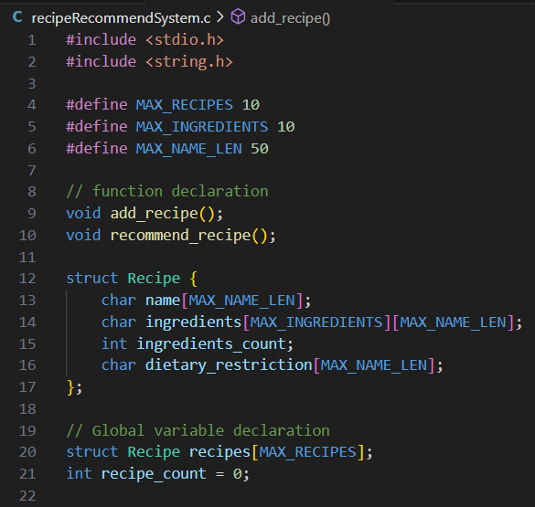

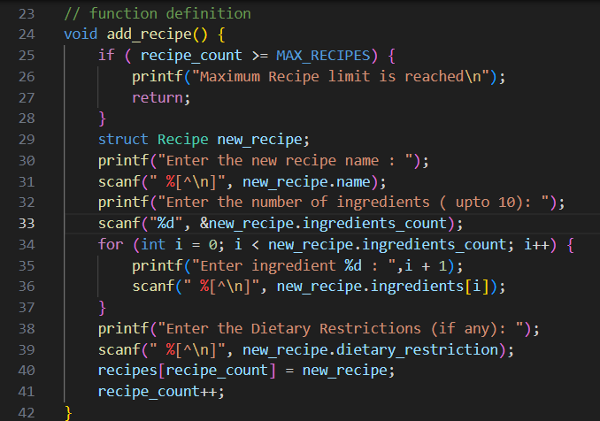

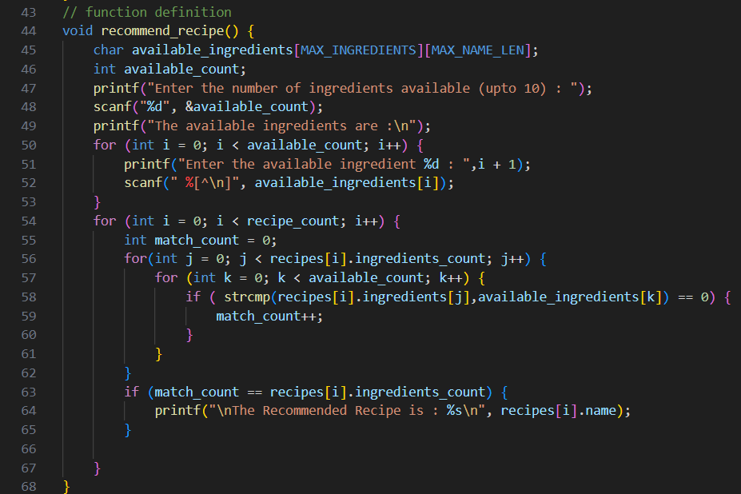

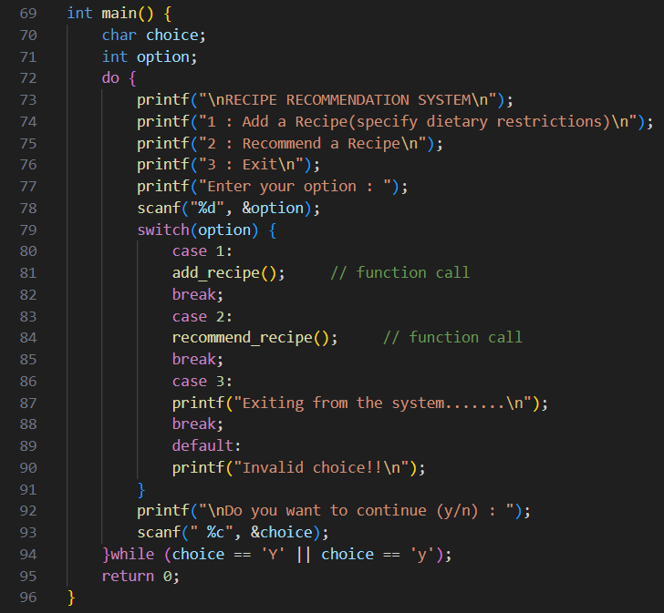

Output:

