**CHAPTER 1**

**INTRODUCTION**

To-Do List project is an application specially built to keep track of errands or tasks that need to be done. This application will be like a task keeper where the user would be able to enter the tasks that they need to do. Once they are done with their tasks they can also remove them from the list. A To Do List Android App lets you write, organize, and change the order of your tasks more quickly. In addition, many of them let you see when someone else is done with a task. They also let you add notes, links, and files to a task. In many ways, a good to-do app is the best way to be more efficient at work.

A simple Android project called Todo List makes it easy to keep track of things to do It lets the user keep track of their daily tasks. If you want to run the project, you will need Android Studio to do so. It’s important that you have Android Studio on your computer before you run the project. So, it’s very important to keep a to-do list. It helps you to make big and overwhelming projects easier. When you do things that are important, things get done faster. Once you have a list of things you need to do, it’s much easier to put them in order. If you do this, it will make sure you always work on the right things at the right time.

One of the main reasons to keep a to-do list is to keep things in order. Putting your tasks on a list can make them easier to do and make you feel more stable. Seeing a clear picture of your completed and unfinished tasks will help you feel more organized and stay focused on the things you need to do.

**CHAPTER 2**

**IMPLEMENTATION**

**DETAILS :**

This application will be like a task keeper where the user would be able to enter the tasks that they need to do. Once they are done with their tasks they can also remove them from the list. Let us see what is there in the application:

* You can add the tasks that are to be done in a descriptive way.
* You will be able to add as many tasks as you have.
* Once the task is completed, you will be able to remove it by clicking on “delete” icon.

**Following are the user interface components that will be shown in our application :**

* There will be an add task button.
* There will be a button “delete” for each task added, so you will be able to delete it.
* The tasks that will be added by the users are stored in the list view.
* There will be a button “update” for each task added, so you will able to update the task.
* There will be a “reset” button, so you will able to delete all task simultaneously.

**Steps to use the application :**

1. Run it on the Android Virtual Machine.
2. After running the application.
3. Now begin working on the app.
4. Now, here you can type the task that you want to add.
5. You can write the tasks and then click on add.
6. Similarly add few more
7. There will be a button “update” for each task added, so you will able to update the task.
8. Now, to remove the completed task from the task list, simply click on the “delete” icon for single task Or click on the “reset” button to delete all task simultaneously.

So this is how the project will function and help us keep a well-maintained track of the tasks or the meetings that we need to complete.

**Details about the files :**

1. activity_main.xml: This file is responsible for the layout and the interface of the project. We have added a textview and the buttons through this file.

2. MainActivity.java: This file is responsible for the working of the application. We have used this file in this project for the functioning of buttons.

3. colors.xml file: In this file, we have mentioned the color names that we have used in the project.

4. strings.xml file: In this file, we have mentioned the words that are used in our project and also its description.

**CHAPTER 3**

**SYSTEM REQUIREMENT**

**3.1 HARDWARE REQUIREMENTS :**

* Processor : Intel core i3 or above
* RAM : 2GB or more
* Hard Disk : 5GB or above
* Monitor : 1024 x 768 display resolution

**3.2 SOFTWARE REQUIREMENTS :**

* Operating System : Windows
* Language : Java
* Category : Android, Mobile computing
* IDE : Android Studio
* Front End : XML, Java
* Prerequisites : Java, XML, Android studio

**CHAPTER 4**

**RESULT & SCREENSHOTS**

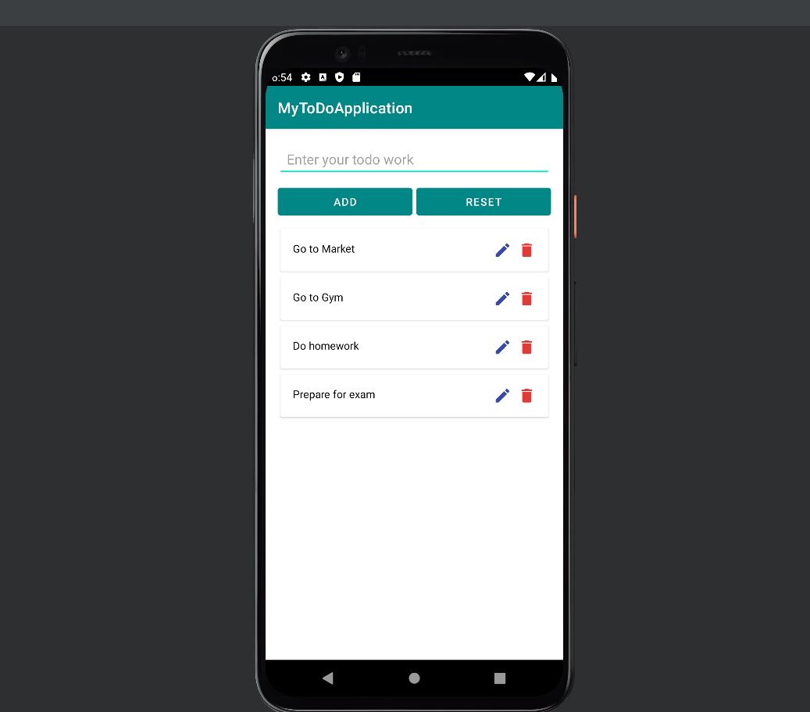

Fig 4.1 The basic layout of To Do application

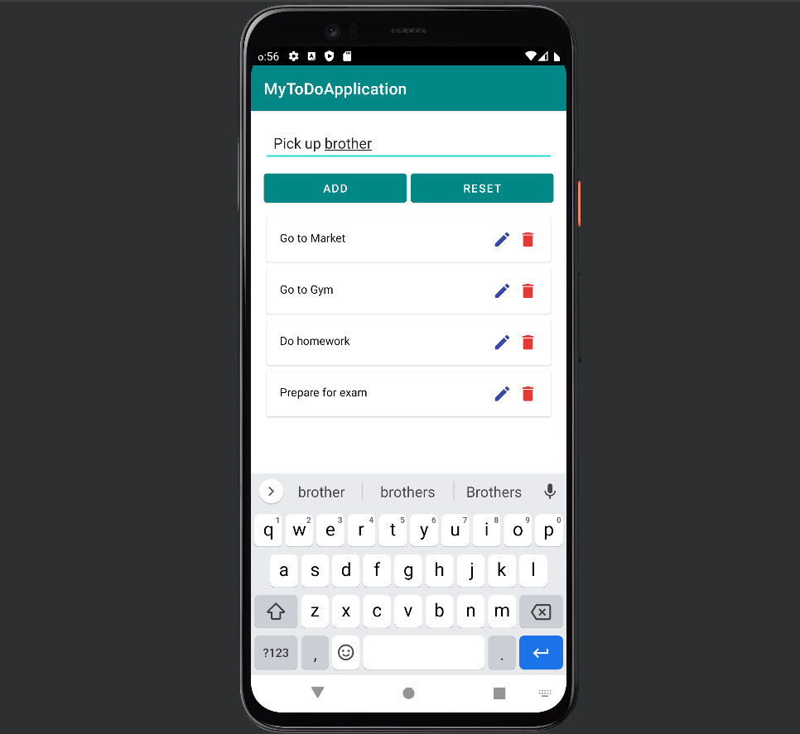

Fig 4.2 Adding a task to the application

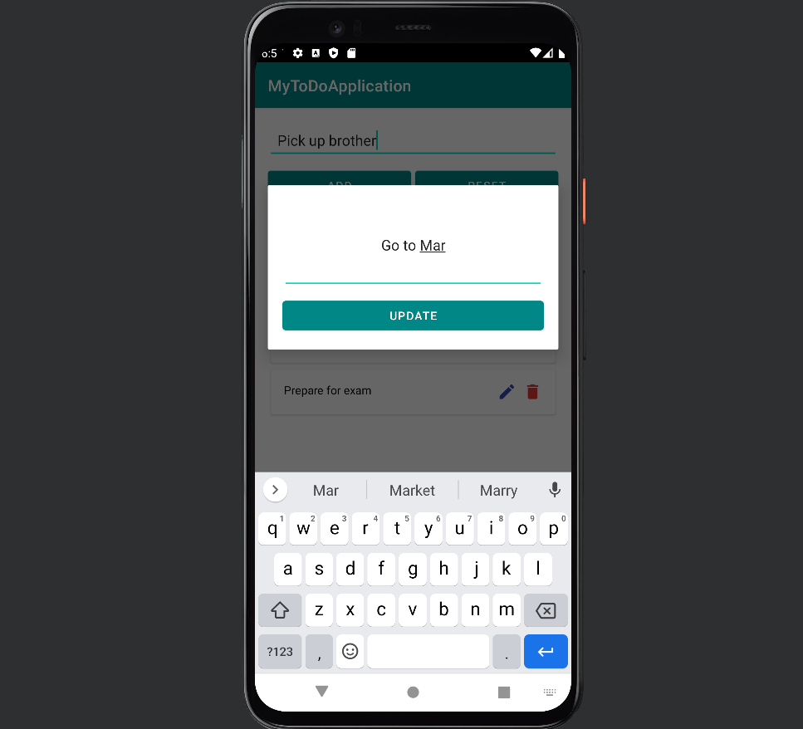

Fig 4.3 Updating the task in application

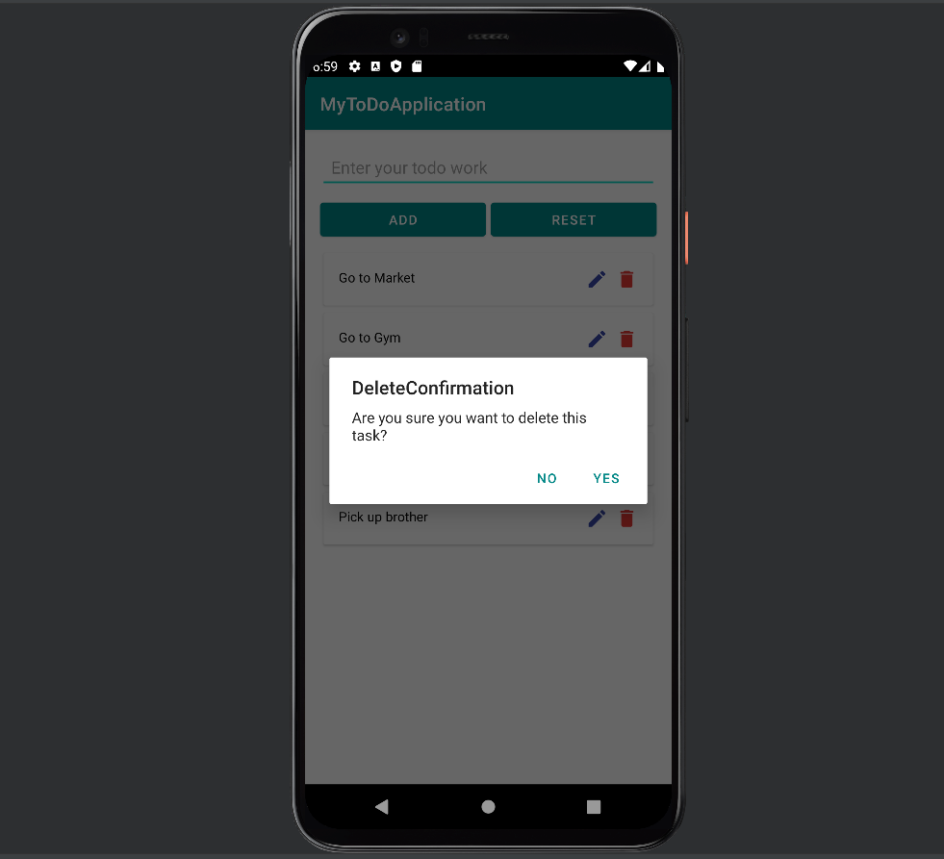

Fig 4.4 Deleting an task from application

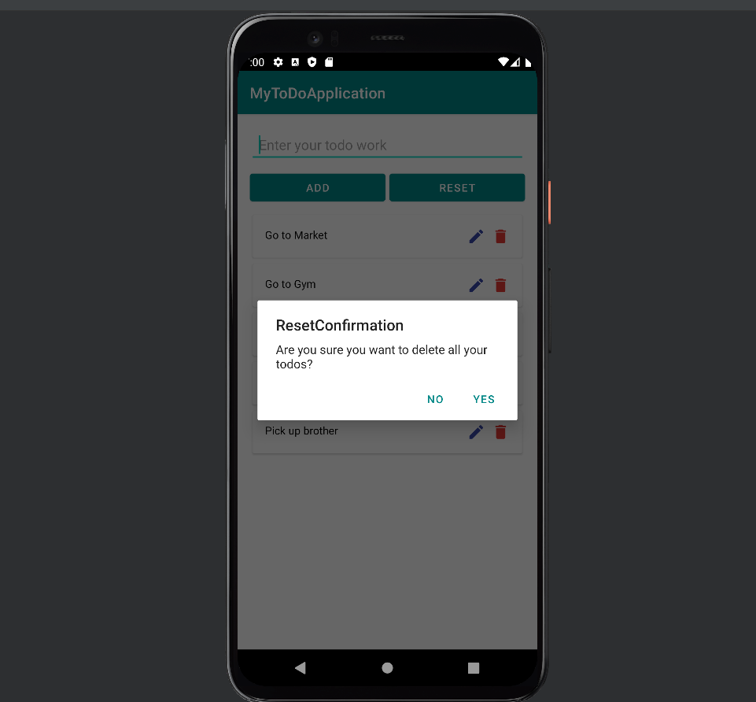

Fig 4.5 Deleting or Reseting all task in the application

**CHAPTER 5**

**ADVANTAGES**

* Increases productivity
* Provides motivation
* Improves memory
* Reduces stress
* Allows for more personal time
* Reduces anxiety and improves mental health
* Provides a sense of accomplishment
* Set deadlines for each goal
* Divide larger tasks
* Prioritize your goals

**CONCLUSION**

The ToDo List Application performs very efficient comparing to competitor. There is a space for further developments with regards of keeping app small and quick. ToDo App can be developed as a sole application as well as a very efficient module to be combined in a larger project. One of the key challenges is to chose appropriate storage solution,

**REFERENCES**

**Books :**

1. To-Do List Formula: A Stress-Free Guide To Creating To-Do Lists That Work! By Damon Zahariades
2. Android Programming: The Big Nerd Ranch Guide
3. Java Programming for Android Developers for Dummies

**List of Websites :**

1. <https://www.wikihow.com/Make-a-To-Do-List>
2. <https://todoist.com/>
3. <https://developer.android.com/codelabs/build-your-first-android-app#0>
4. <https://code.tutsplus.com/tutorials/how-to-use-android-studio--cms-37378>
5. https://www.geeksforgeeks.org/a-complete-guide-to-learn-xml-for-android-app-development/