C Practical file

Session 24 - 25



**Submitted to: Submitted by:**

**Mr. Abhay Singh Rudra Guleria**

**Computer and application Class – BA 1st year**

**department Roll no - 2415595**

# INDEX

|  |  |  |
| --- | --- | --- |
|  | **List Of Practicals** |  |
| **S.NO** | **TOPIC** | **DATE** |
| 1 | Hello World | 1/3/25 |
| 2 | Area & Perimeter of Rectangle | 3/3/25 |
| 3 | Marksheet | 5/3/25 |
| 4 | Triangle | 7/3/25 |
| 5 | Temperature in Centigrade | 10/3/35 |
| 6 | Print Gross & Salary | 12/3/25 |
| 7 | Example - if else | 15/3/25 |
| 8 | Pass & Fail | 19/3/25 |
| 9 | Prime Number | 20/3/25 |
| 10 | Table | 23/3/25 |
| 11 | Pattern Printing | 26/3/25 |
| 12 | Average of given N numbers | 27/3/25 |
| 13 | Number is prime or not | 29/3/25 |
| 14 | 50 prime numbers | 30/3/25 |
| 15 | Fibonacci series | 31/3/25 |
| 16 | Factorial | 1/4/25 |
| 17 | Reverse a number to state whether it is a Palindrome | 2/4/25 |
| 18 | Largest, second largest and smallest of 3 numbers | 3/4/25 |
| 19 | Largest of 3 numbers | 4/4/25 |
| 20 | Find even and odd | 5/4/25 |

**Practical – 1**

**Objective:**

Program:

#include<stdio.h> void main()

{printf(" hello world");

}

Output:

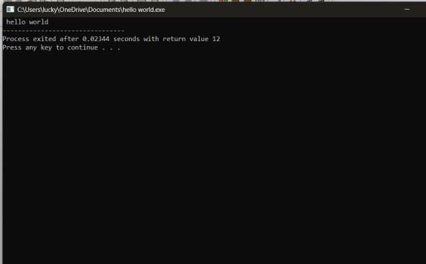

**Practical-2**

**Objective:**

Program:

// program to print area and perimeter of rectangle

#include<stdio.h> void main()

{float len,bre,area,perimeter; printf("\n enter the length"); scanf("%f, &len"); printf("\n enter the breath"); scanf("%f,bre"); area= len*bre; perimeter= 2.0*(len+bre); printf("\n area and perimeter of rectangle"); printf("\n--------------------------------");

printf("\n given length is = %f \n given breath is = %f",len,bre); printf("\n area is = %f \n perimeter is = %f",area,perimeter);

}

Output:

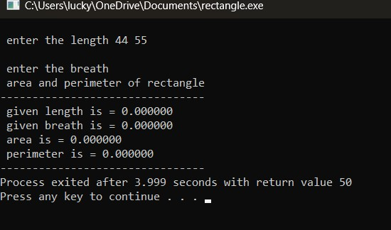

**Practical-3**

**Objective:**

Program

#include<stdio.h> void main()

{float m1,m2,m3,m4,m5,total,percentage; printf("\n enter marks in eng"); scanf("%f", &m1); printf("\n enter marks in hcp"); scanf("%f", &m2); printf("\n enter marks in csa"); scanf("%f",&m3); printf("\n enter marks in his"); scanf("%f",&m4); printf("\n enter marks in geo"); scanf("%f",&m5); total = m1+m2+m3+m4+m5; percentage = total/5,0; printf("\n marksheet ba (csa) sem 2"); printf("\n--------------------------"); printf("\n eng %f/100",m1); printf("\n hcp %f/100",m2); printf("\n csa %f/100",m3); printf("\n his %f/100",m4); printf("\n geo %f/100",m5); printf("\n grad total= %f",total);

printf("\n percentage= %f",percentage);

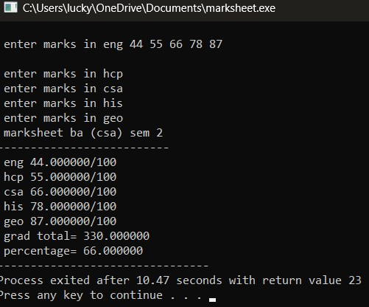}

Output:

**Practical-4**

**Objective:**

Program

#include<math.h> #include<stdio.h> void main()

{float a,b,c,s,area;

printf("\n enter three sides of triangle"); scanf("%f,%f,%f",a,b,c); s = (a+b+c)/2.0; area = sqrt(s*(s-a)*(s-b)*(s-c)); printf("\n------------------");

printf("\n givn sides are sides 1 = %f side 2 = %f side 3 = %f",a,b,c); printf("\n area is = %f,area"); printf("\n------------------");

}

Output:

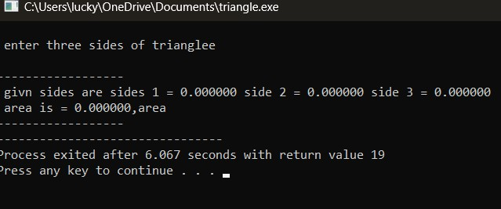

**Practical-5**

**Objective:**

Program

#include<stdio.h> void main ()

{float c,f;

printf("\n enter temp in centigrade"); scanf("%f",&f); c= (5/9.0) * (f - 32);

printf("\n given temp in height is %f",f); printf("\n temp converted in centigrade is %f",c);

}

Output:

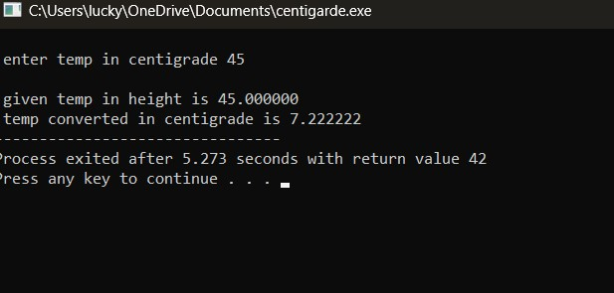

## Practical – 6

**Objective:**

Program

#include<stdio.h> void main ()

{float basic,da,hra,gross; printf("\n enter basic salary"); scanf("%f",&basic); da= 0.4*basic; hra= 0.2*basic; gross= basic +da + hra;

printf("\n the basic salary is %f \n da %f \n hra %f \n gross salary %f",basic,da,hra,gross);

}

Output:

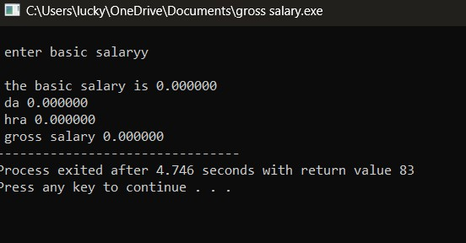

**Practical-7**

Program

#include<stdio.h> void main () {int a,b,c;

printf("\n enter three numbers");

scanf("%d %d %d",&a,&b,&c);

if (a>b); {if(a>c);

printf("\n %d is the largest",a);

} if (b>c); printf("\n %d is the largest",b);

printf("\n %d is the largest",c);

}

Output:

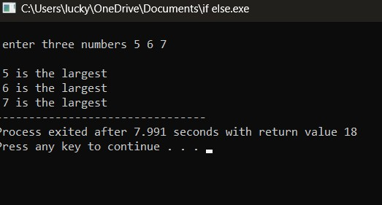

**Practical-8**

Program

#include<stdio.h> void main()

{int a; printf("\n enter a number"); scanf("%d",&a); if(a>=9&& a<=10)

{printf("\n grade = a");

}

else if (a>7&& a<=8) {printf("\n grade=b");

}

else if (a>4&& a<=5) {printf("\n grade=c");

}

else if (a>3&& a<=4) {printf("\n grade=d");

}

else if (a>2&& a<=3) {printf("\n grade=e");

}

else {printf("\n pass");

}

}

Output:

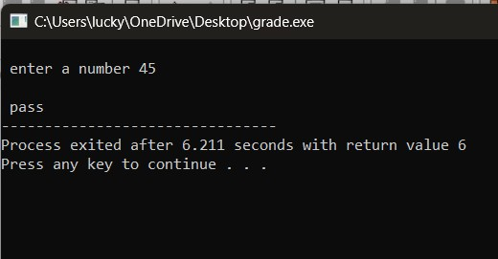

**Practical-9**

Program

#include<stdio.h>

void main()

{int n,i; printf("\n enter a no ?"); scanf("%d",&n); for(i=2; i<n; i++)

{if(n% i==0) {printf("\n not prime"); break;

}

}

if(i==n)

printf("\n %d is a prime no",n);

}

Output:

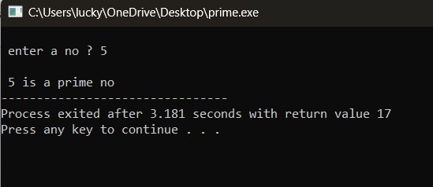

**Practical – 10**

**Objective:**

Program

#include<stdio.h>

void main()

{int i,p; for(i=10; i>0; i--) {p=3*i;

printf("\n 3*%d=%d",i,p);

}

}

Output:

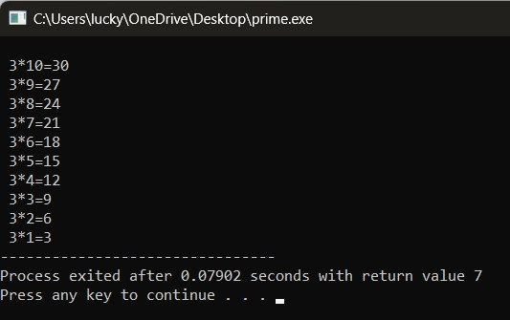

## Practical – 11

**Objective:**

Program

#include<stdio.h>

Void main()

{ int I,j;

For(j=1;j<=I;j++)

{printf(“ * “);

}

Printf(“\n”);

}

}

Output:

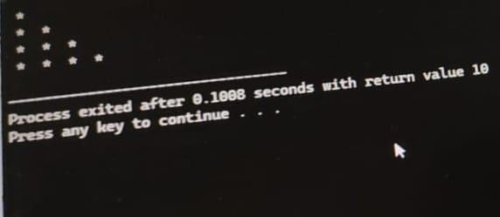

**Practical-12**

**Objective- Program to calculate average of given N numbers**

**Program**

**#include <stdio.h>**

**int main() {**

**int n, i;**

**float num, sum = 0.0, average;**

**printf("Enter the number of elements (n): ");**

**scanf("%d", &n);**

**if (n <= 0) {**

**printf("Please enter a positive value for n.\n");**

**return 1; // Indicate an error**

**}**

**printf("Enter %d numbers:\n", n);**

**for (i = 1; i <= n; ++i) {**

**printf("Enter number %d: ", i);**

**scanf("%f", &num);**

**sum += num; // Accumulate the sum**

**}**

**average = sum / n;**

**printf("Sum = %.2f\n", sum);**

**printf("Average = %.2f\n", average);**

**return 0;**

**}**

**Output:**

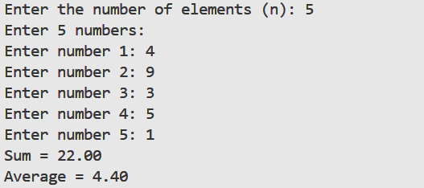

**Practical-13**

Objective- Program to check if a number is prime or not

Program

#include <stdio.h>

int main() {

int num, i, flag = 1;

printf("Enter a number: ");

scanf("%d", &num);

if (num <= 1) {

flag = 0;

} else

{

for (i = 2; i <= num / 2; i++) {

if (num % i == 0) {

flag = 0;

break;

}

}

}

if (flag)

printf("%d is a prime number.\n", num);

else

printf("%d is not a prime number.\n", num);

return 0;

}

Output:

**Practical-14**

Objective- Program to print first 50 prime numbers

Program

#include <stdio.h>

#include <stdbool.h>

bool isPrime(int num) {

if (num <= 1) return false;

for (int i = 2; i * i <= num; i++) {

if (num % i == 0) return false;

}

return true;

}

int main() {

int count = 0;

int number = 2;

printf("The first 50 prime numbers are:\n");

while (count < 50) {

if (isPrime(number)) {

printf("%d ", number);

count++;

}

number++;

}

printf("\n");

return 0;

Output







**Practical-15**

AIM: WAP to print Fibonacci series

#include <stdio.h>

int main() {

int n, i;

long long first = 0, second = 1, next;

printf("Enter the number of terms: ");

scanf("%d", &n);

printf("Fibonacci Series:\n");

for (i = 1; i <= n; ++i) {

printf("%lld, ", first);

next = first + second;

first = second;

second = next;

}

printf("\n"); // Add a newline at the end

return 0;

}

Output:

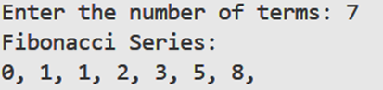

**Practical-16**

AIM: WAP to print factorial

#include <stdio.h>

int main() {

int n;

long long factorial = 1;

printf("Enter a non-negative integer: ");

scanf("%d", &n);

// Error handling for negative input

if (n < 0) {

printf("Factorial is not defined for negative numbers.\n");

} else {

for (int i = 1; i <= n; i++) {

factorial *= i; // factorial = factorial * i;

}

printf("Factorial of %d = %lld\n", n, factorial);

}

return 0;

}

Output:



**Practical-17**

AIM: WAP to reverse a number and state whether it is a palindrome

#include <stdio.h>

#include <stdbool.h>

int reverseNumber(int num) {

int reversedNum = 0;

while (num != 0) {

reversedNum = reversedNum * 10 + num % 10;

num /= 10;

}

return reversedNum;

}

bool isPalindrome(int num, int reversedNum) {

return num == reversedNum;

}

int main() {

int number, reversed;

printf("Enter an integer: ");

scanf("%d", &number);

reversed = reverseNumber(number);

printf("Reversed number: %d\n", reversed);

if (isPalindrome(number, reversed)) {

printf("%d is a palindrome.\n", number);

} else {

printf("%d is not a palindrome.\n", number);

}

return 0;

}

Output:

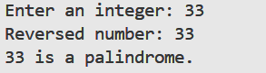

**Practical-18**

AIM: WAP to print largest, second largest and smallest of three numbers

#include <stdio.h>

int main() {

int num1, num2, num3;

int largest, secondLargest, smallest;

printf("Enter three distinct integers: ");

scanf("%d %d %d", &num1, &num2, &num3);

if (num1 >= num2 && num1 >= num3) {

largest = num1;

if (num2 >= num3) {

secondLargest = num2;

smallest = num3;

} else {

secondLargest = num3;

smallest = num2;

}

} else if (num2 >= num1 && num2 >= num3) {

largest = num2;

if (num1 >= num3) {

secondLargest = num1;

smallest = num3;

} else {

secondLargest = num3;

smallest = num1;

}

} else {

largest = num3;

if (num1 >= num2) {

secondLargest = num1;

smallest = num2;

} else {

secondLargest = num2;

smallest = num1;

}

}

printf("Largest: %d\n", largest);

printf("Second Largest: %d\n", secondLargest);

printf("Smallest: %d\n", smallest);

return 0;

}

Output:

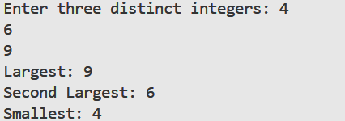

**Practical-19**

AIM: WAP to print the largest of 3 numbers

#include <stdio.h>

int main() {

int num1, num2, num3;

printf("Enter three integers: ");

scanf("%d %d %d", &num1, &num2, &num3);

if (num1 >= num2 && num1 >= num3) {

printf("%d is the largest number.\n", num1);

} else if (num2 >= num1 && num2 >= num3) {

printf("%d is the largest number.\n", num2);

} else {

printf("%d is the largest number.\n", num3);

}

return 0;

}

Output:

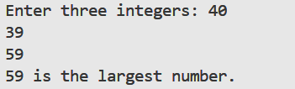

**Practical-20**

AIM: WAP to find even or odd

#include <stdio.h>

int main() {

int number;

printf("Enter an integer: ");

scanf("%d", &number);

if (number % 2 == 0) {

printf("%d is even.\n", number);

} else {

printf("%d is odd.\n", number);

}

return 0;

}

Output:

