SMART AI PARKING & SECURITY SYSTEM
An Intelligent, Automated, and Secure Parking Ecosystem
1. Title of the Project
Smart AI Parking and Security System using ESP32-CAM and Web-Based Monitoring Platform
2. Problem Statement
With the rapid growth of urbanization and increasing number of vehicles, parking management has become a major challenge. Traditional parking systems are inefficient, time-consuming, and lack proper security mechanisms. Users often struggle to find available parking spaces, leading to traffic congestion and frustration.
Additionally, existing systems do not provide real-time monitoring or verification of vehicles, allowing unauthorized access and increasing the risk of security breaches. There is also a lack of integration between booking systems and physical entry control mechanisms.
Therefore, there is a critical need for an intelligent system that can automate parking management, ensure security, and provide a seamless user experience.
3. Objective
The primary objective of this project is to design and develop a smart, automated, and secure parking system that integrates modern web technologies, artificial intelligence, and IoT hardware.
The key objectives include:
- To develop a user-friendly web platform for parking slot booking
- To implement AI-based number plate recognition for vehicle verification
- To automate gate control using a servo motor
- To ensure that only authorized vehicles can enter the parking area
- To provide a centralized admin panel for monitoring and control
- To simulate a real-world payment system using a credit-based model
- To enhance efficiency, security, and scalability of parking systems
4. Existing Work
Several parking management solutions have been developed, including:
- Manual parking systems with human supervision
- RFID-based access control systems
- Camera-based number plate recognition systems such as those developed by Circuit Digest
While these systems address certain aspects of parking, they are limited in scope. Most existing solutions operate independently and do not provide a fully integrated platform combining booking, verification, and monitoring.
5. Gap Analysis
Despite advancements in technology, current systems have several limitations:
- Lack of integration between web platforms and hardware systems
- Absence of real-time vehicle verification
- Limited or no centralized monitoring system
- Poor user interface and experience
- No intelligent automation or analytics
- Security vulnerabilities due to unauthorized access
This project aims to bridge these gaps by providing a unified and intelligent system.
6. Novelty
The uniqueness of this project lies in its complete system integration. Unlike existing solutions, this project combines multiple technologies into a single platform.
Key innovative features include:
- Integration of web application, AI, and IoT hardware
- Real-time number plate recognition and verification
- Automated gate control system
- Credit-based booking system instead of real payments
- Security alert system with image capture
- Comprehensive admin dashboard with full control
This makes the system highly scalable and suitable for real-world applications.
7. Project Description
The Smart AI Parking System is designed as a complete solution for efficient and secure parking management.
Users interact with the system through a web-based platform where they can view available parking slots, select their vehicle type, and enter their number plate details. The system provides a visual 2D parking layout that allows users to easily identify and select available slots.
Once a booking is confirmed, the system stores the vehicle details, including the number plate, in the database. When the vehicle arrives at the parking entrance, an ESP32-CAM captures the image of the vehicle.
The captured image is processed using AI-based Optical Character Recognition (OCR) to extract the number plate. The system then compares the extracted number with the stored booking data.
- If the vehicle is authorized, the system sends a signal to the servo motor to open the gate.
- If the vehicle is unauthorized, the system blocks entry and generates an alert for the admin.
This ensures a seamless and secure parking experience.
8. List of Components and Software Used
Hardware Components:
- ESP32-CAM module
- Servo Motor
- Power Supply
- Jumper Wires
Software Used:
- Frontend: React.js with Tailwind CSS
- Backend: Python Flask / Node.js
- AI Processing: OpenCV and EasyOCR
- Database: SQLite
- PCB Design: KiCad
9. Methodology
The system follows a structured approach:
- User accesses the web platform
- Selects parking slot and enters vehicle details
- Booking information is stored in the database
- ESP32-CAM captures vehicle image at entry
- Image is sent to backend for processing
- OCR extracts number plate
- System verifies the number plate with database
- Gate is controlled based on verification result
- Alerts are generated if unauthorized access is detected
10. Workflow
User → Web Interface → Database → ESP32-CAM → AI Processing → Verification → Gate Control → Admin Alert
11. Picture of the Project / Prototype
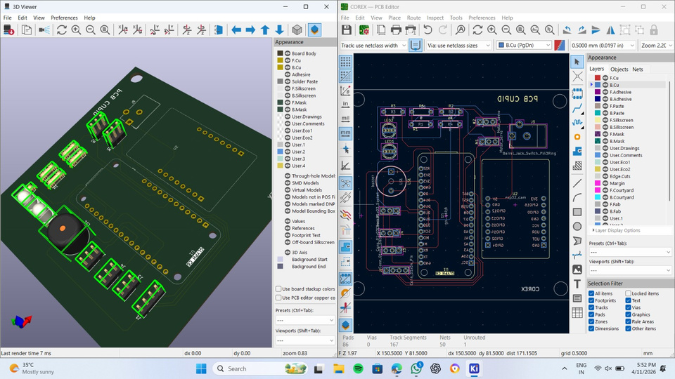
fig: 1.1, 3D and layout view of the custom PCB design
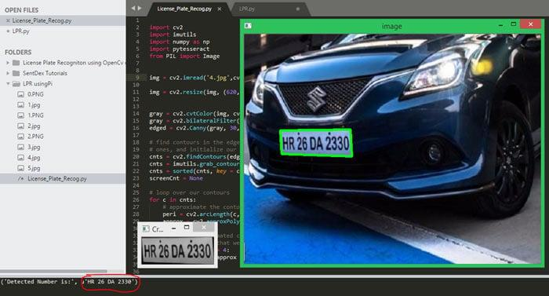
fig:1.2, AI-based OCR system detecting
13. GitHub Repository
Github-Smart Parking
The repository includes:
- Schematics and circuit design
- PCB layout (KiCad project files)
- Gerber files
- Source code (frontend and backend)
- 3D models with specifications
14. Team Details
Team Name: CODEX
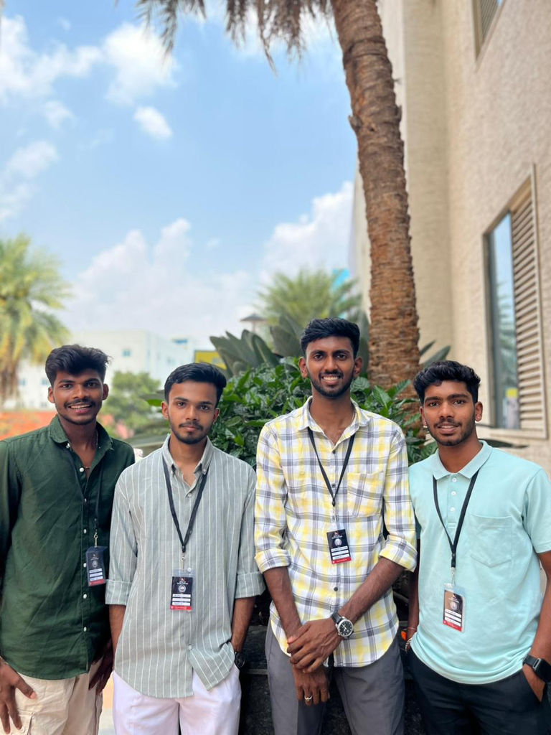
Fig:1.3, Team Members
Team Members:
- Niyas J
- Ashlesh K D
- Bharathesh
- Bharath Bhushan K
15. Contact Details
- Email: niyas@kvgce.ac.in
- Phone: 8217469646
16. Conclusion
The Smart AI Parking and Security System presents an innovative approach to modern parking challenges by integrating web technologies, artificial intelligence, and IoT hardware. The system enhances efficiency, improves security, and provides a scalable solution suitable for smart city applications.
By automating the entire process from booking to verification and entry control, this project demonstrates the potential of intelligent systems in transforming traditional infrastructure into smart and efficient ecosystems.

