SKILL(WEEK-1)
- Database Setup
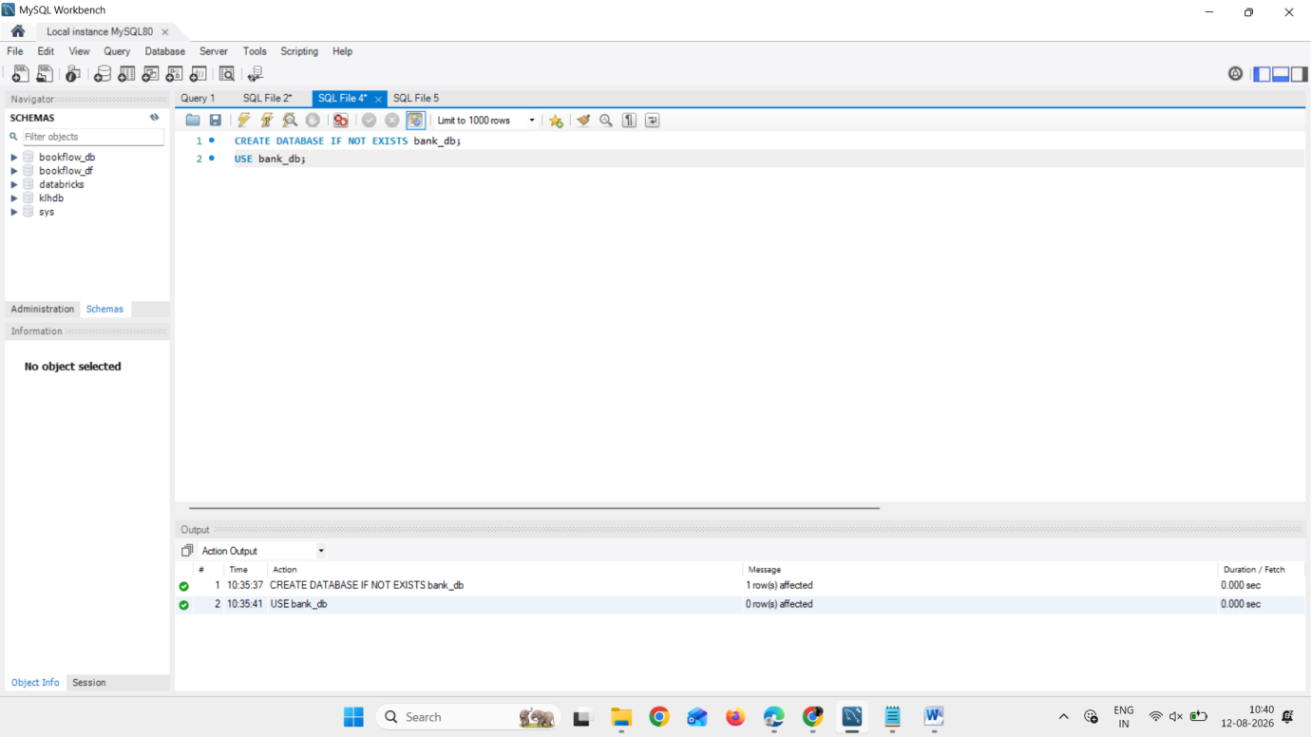
- Create Table
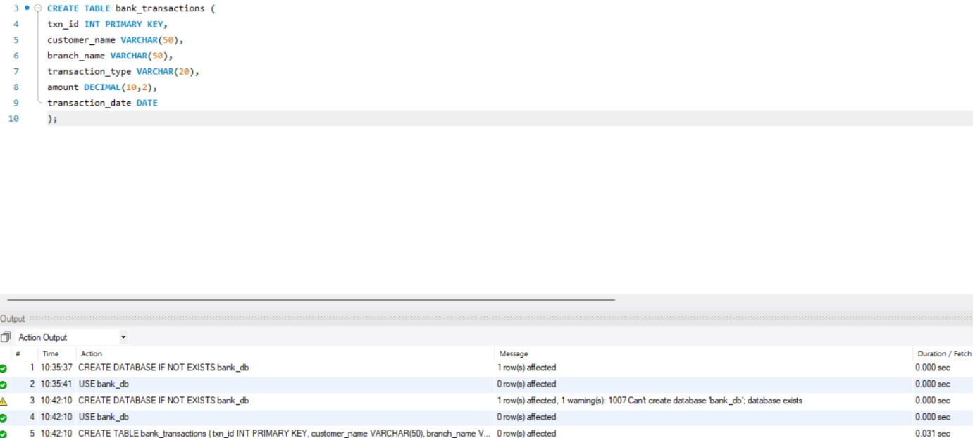
- Add Column
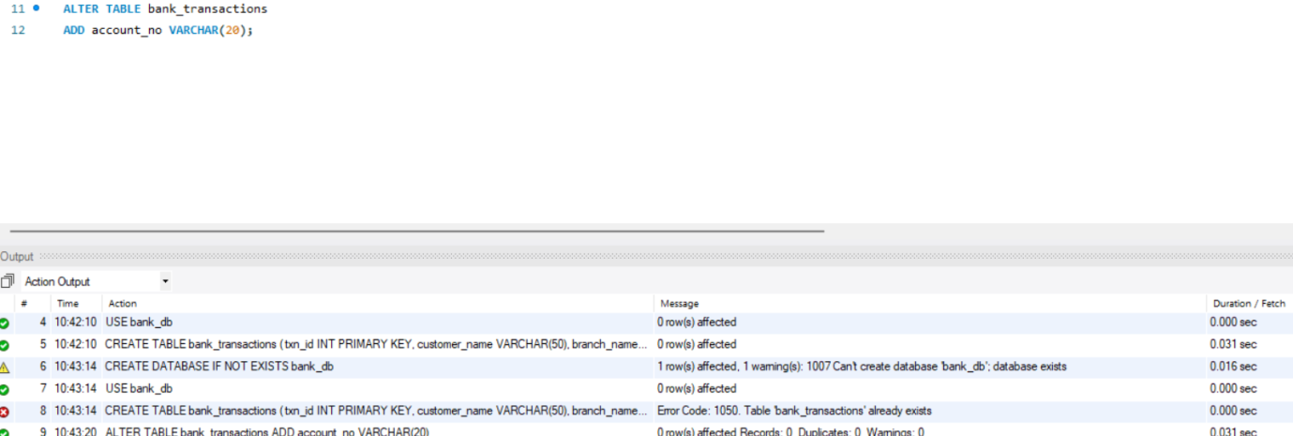
- Modify Column
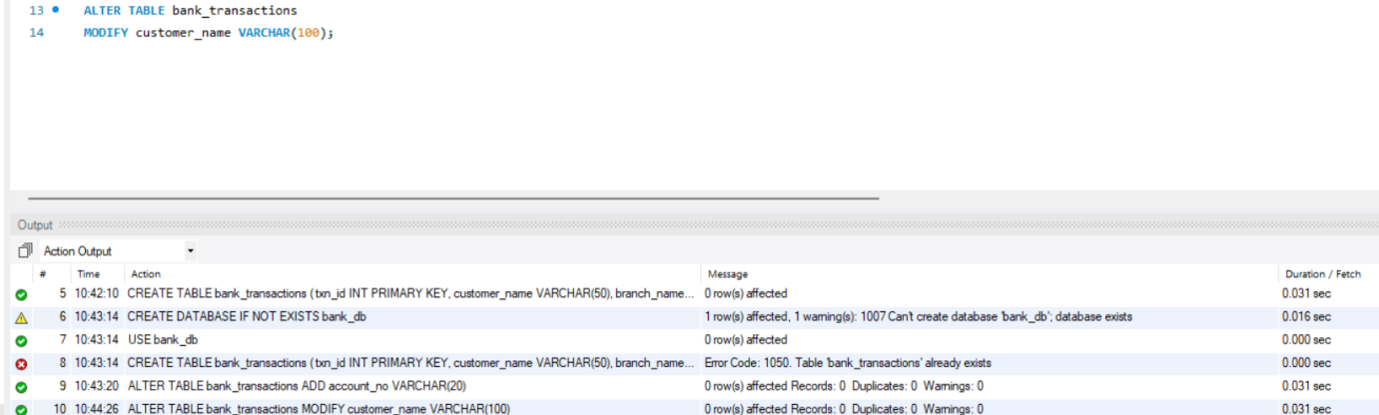
- Rename Table
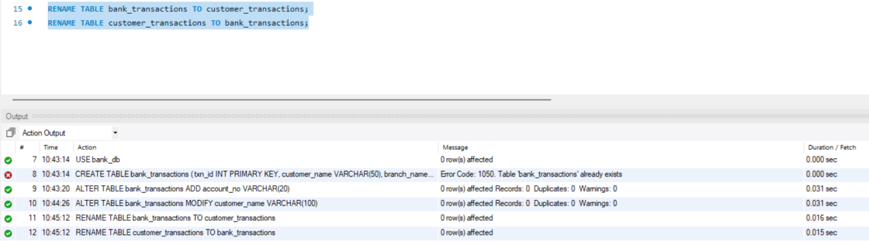
- Truncate Table
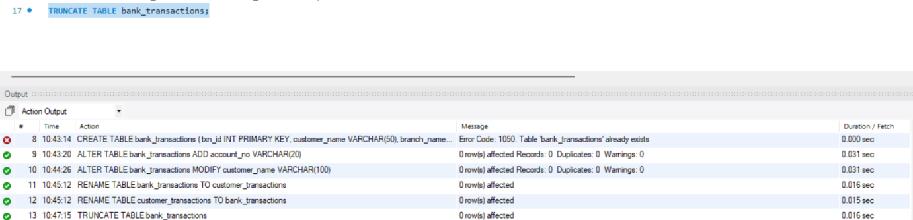
- Drop Table
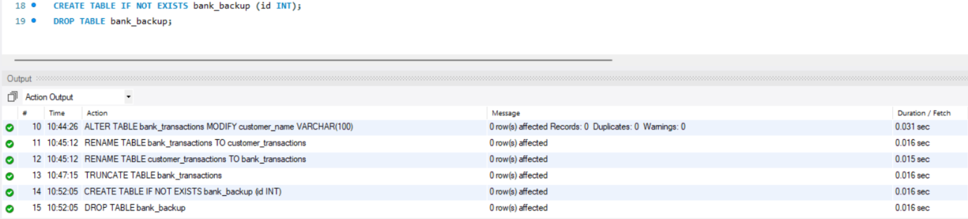
- Insert Bulk Data
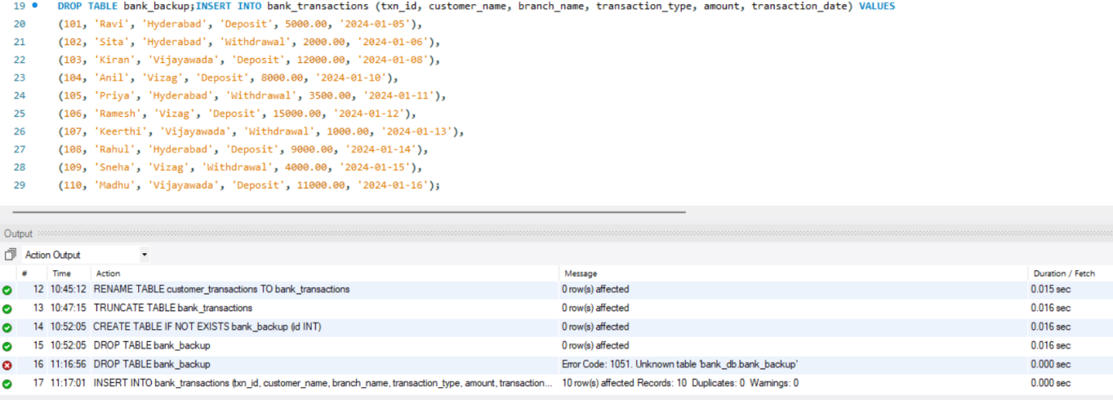
- Insert Single Record
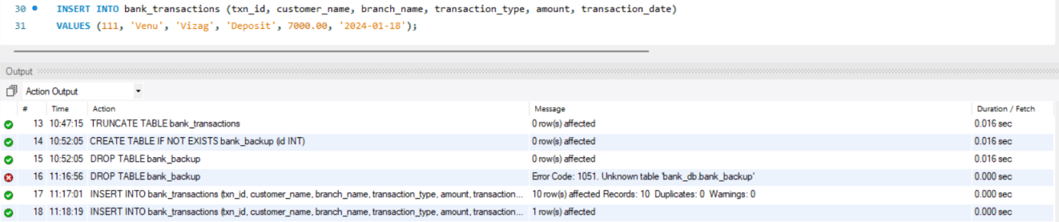
- Update Data
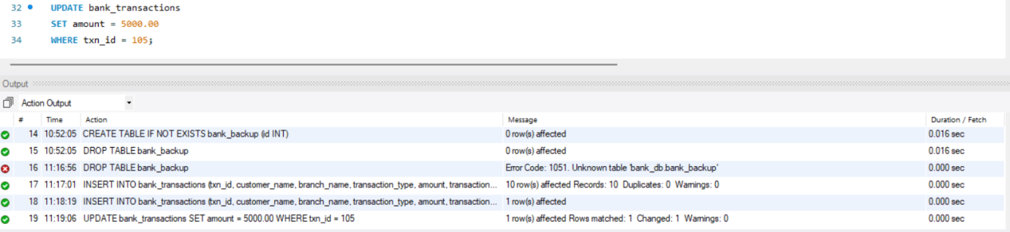
- Delete Data
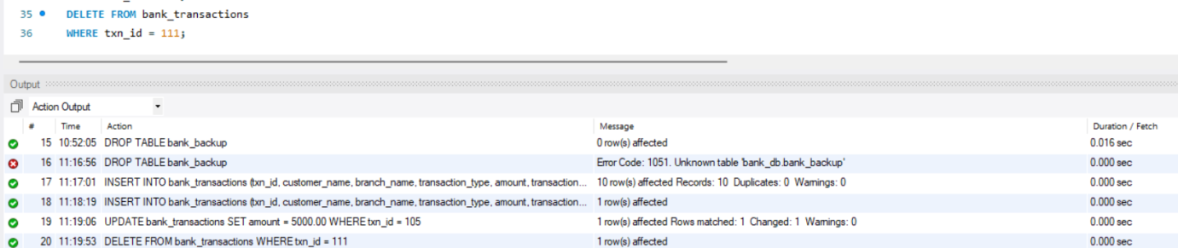
- Select All Records
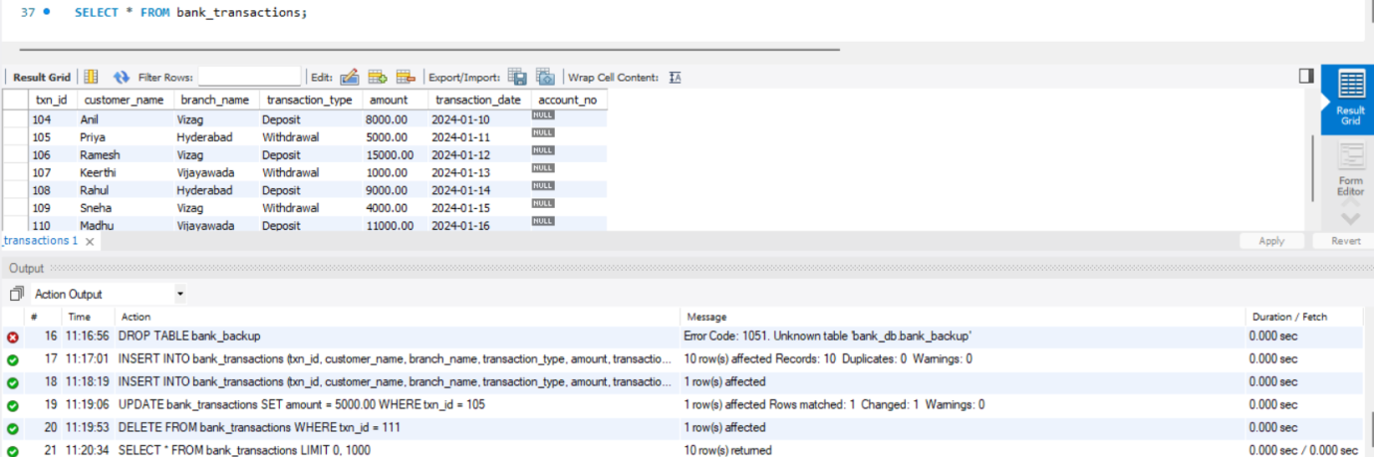
- Select With Where Filter
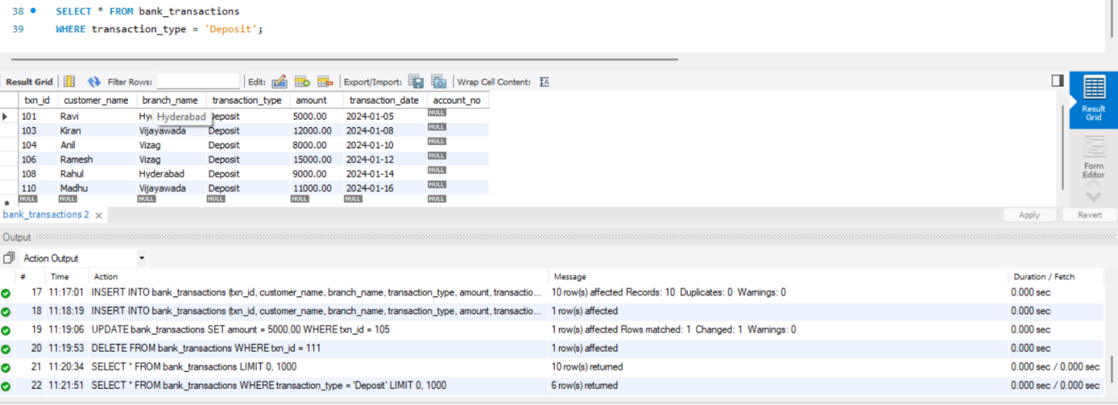
- Select With Order By
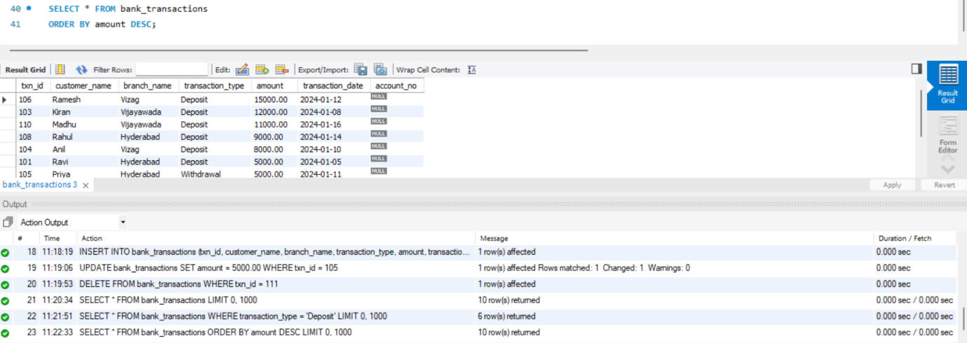
- Create Users
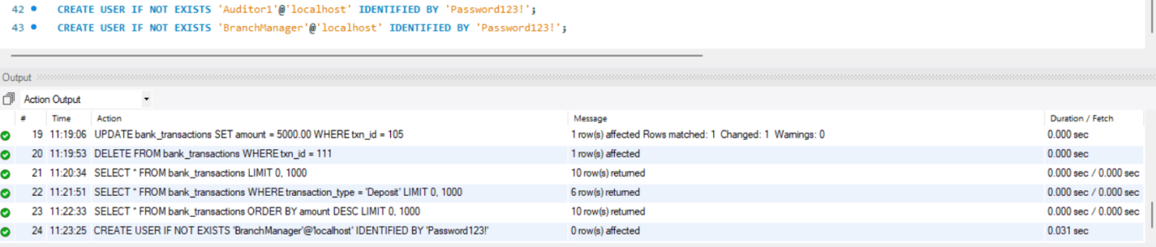

- GRANT SELECT
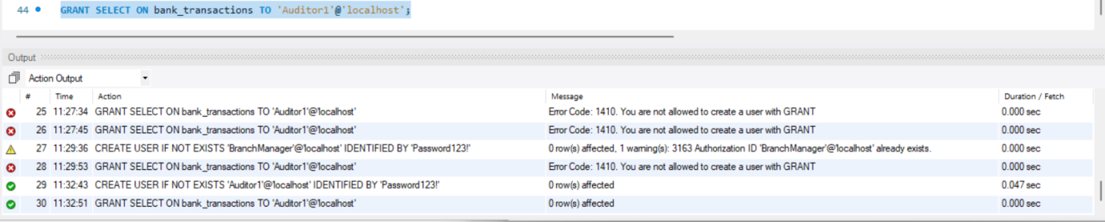
- Grant All Permissions
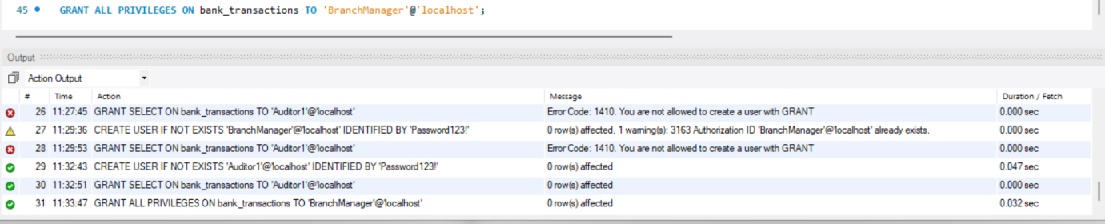
- Revoke Select Permission
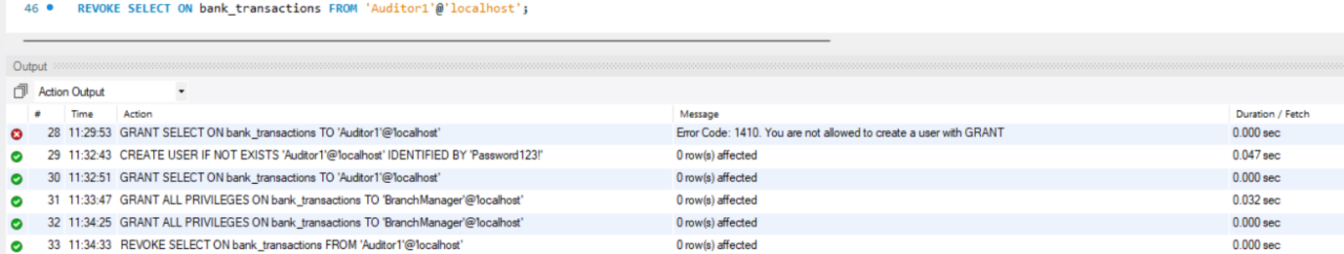
- Revoke All Permissions
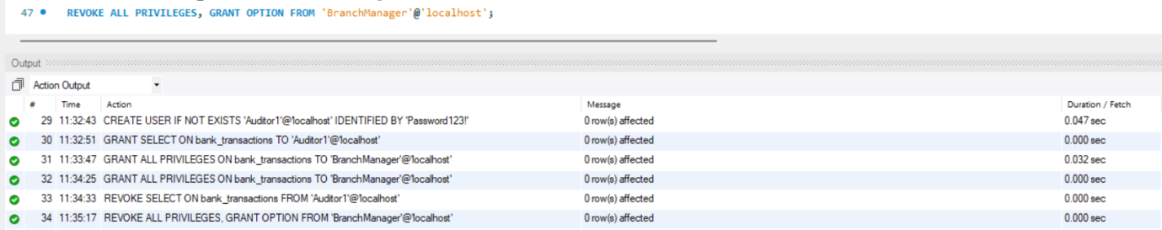
- Disable Autocommit
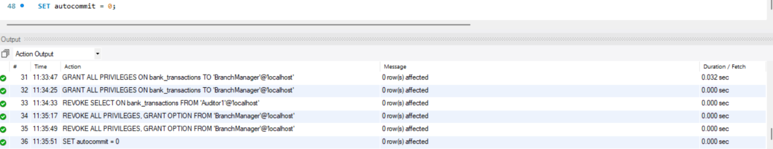
- Commit Transaction
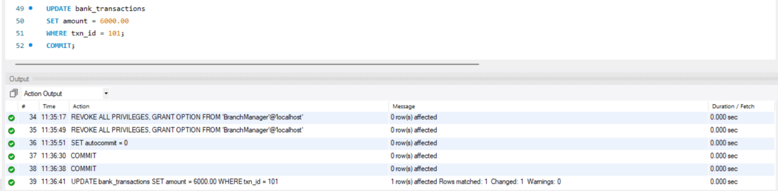
- Savepoint and Rollback
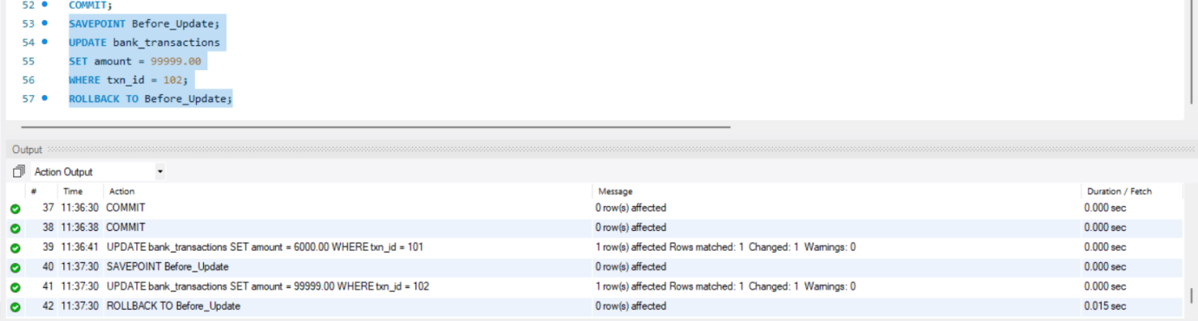
- Full Transaction Workflow
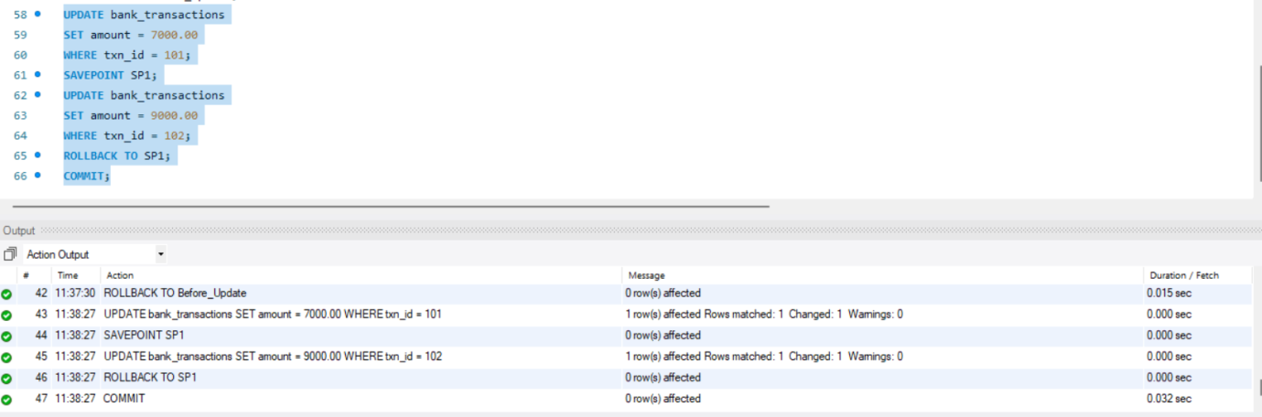
- Enable Autocommit
