Game Design Document

Fill up the Following document

1. Write the title of your project.

- The Bottle Flip Challenge

1. What is the goal of the game?

* The goal of the game is to overcome all the obstacles and not to fall on the ground.

1. Write a brief story of your game?

* There was a girl named Niyathi and she was bored because everything was closed because of the pandemic. So, during the free time she tried flipping a bottle and pass time. Every time the bottle stood properly, it made her happy. But at times when the bottle fell down, she was irritated. So, she thought she could create a game where the bottle flipped every time properly. Please help her create the game with your own creativity.

1. Which are the playing characters of this game?

* Playing characters are the ones which respond to the user based on the input from the user
* Cars, monkeys, dinos, wizards etc, are the playing characters in the game.

|  |  |  |
| --- | --- | --- |
| Number | Character Name | What can this character do? |
| 1 | Bottle | It is controlled by the player and tries to overcome the below given obstacles. |
| 2 |  |  |
| 3 |  |  |
| 4 |  |  |
| 5 |  |  |
| 6 |  |  |
| 7 |  |  |
| 8 |  |  |

1. Which are the Non Playing Characters of this game?

* Non Playing characters are the ones which don't have an action or a behavior when the user interacts with the game.
* Hurdles, stones, bananas, coins, etc. are non playing characters in the game.

|  |  |  |
| --- | --- | --- |
| Number | Character Name | What can this character do? |
| 1 | Sofa | It acts as an obstacle for the bottle. |
| 2 | Table and chair | It acts as obstacles  for the bottle. |
| 3 | Fridge | It acts as an obstacle for the bottle. |
| 4 | Shelf | It acts as an obstacle for the bottle. |
| 5 | Lamp | It acts as an obstacle for the bottle. |
| 6 | Cupboard | It acts as an obstacle for the bottle. |
| 7 |  |  |
| 8 |  |  |

Draw your imagination of this game. What does this game look like?

* Draw the game either on your computer or on paper,
* Add images of scenes of the game to show each of the playing and non-playing characters at least once.

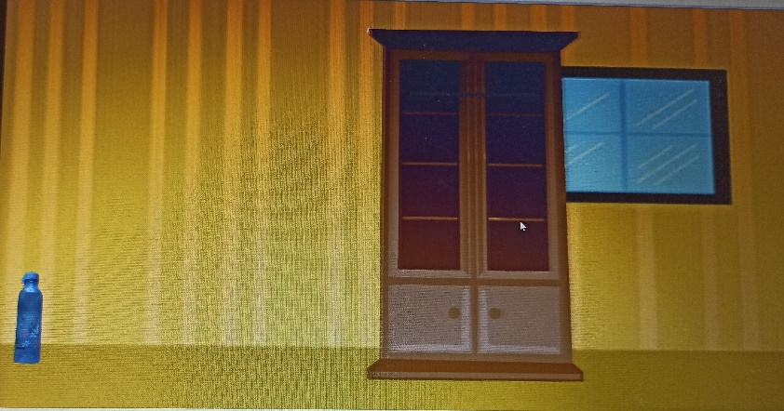

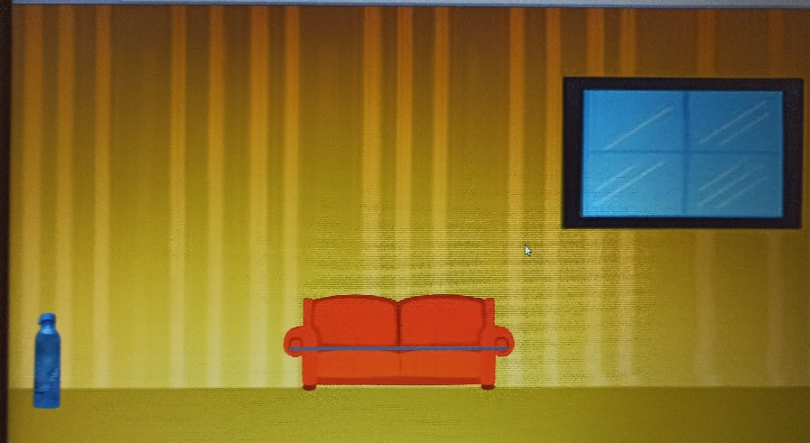

How do you plan to make your game engaging?

To make the game addictive, I will try to make different levels. Tasks and obstacles will start increasing. I will give the game an attractive title and give funky sounds which can attract the players.