Final Project Report: Real-Time Sentiment Analysis German Amazon Reviews

Name: Niyathi Lekkala
Cardinal ID: 5237545
Department: Computer Science
Institution: The Catholic University of America
Email: lekkala@cua.edu

Abstract
This project builds and compares two pipelines for classifying sentiment on German Amazon reviews (negative, neutral, positive): (1) a Direct-German model that fine-tunes a multilingual transformer on German text, and (2) a Translate→English pipeline that first translates German into English and then classifies with an English sentiment model. Using Amazon Reviews Multi (DE), we map 1–5 stars into three classes (1–2=neg, 3=neu, 4–5=pos) and evaluate Accuracy, Macro-F1, and latency. I also log predictions to a DB-friendly schema to enable real-time dashboards. The Direct-German XLM-RoBERTa model outperforms a TF-IDF + Logistic Regression baseline and provides a strong reference for judging the trade-offs of a Translate→English variant.

- Introduction
E-commerce teams increasingly rely on live review streams to detect product issues, monitor launches, and track satisfaction. For German-language markets, two practical approaches exist: classify directly in German (multilingual transformer fine-tuning), or translate to English and reuse an English sentiment model. This work implements both designs as proposed, compares them fairly, and prepares the pipeline for a lightweight real-time setup (endpoint + database).
Contributions.
- A reproducible DE 3-class sentiment pipeline with baseline and transformer;
- A Translate→EN variant concept with evaluation hooks;
- DB logging design for real-time analysis.

- Data set

Source. Amazon Reviews Multi (German slice) with reviews text, star rating, title, and metadata (I use text + stars for modeling).
https://www.kaggle.com/datasets/mexwell/amazon-reviews-multi.

Label mapping:
- 1–2 → negative (0), 3 → neutral (1), 4–5 → positive (2).
Cleaning & splits: I drop missing rows, trim whitespace, coerce stars to integers 1–5, and stratify into train/val/test. Sanity checks show balanced label proportions across splits.

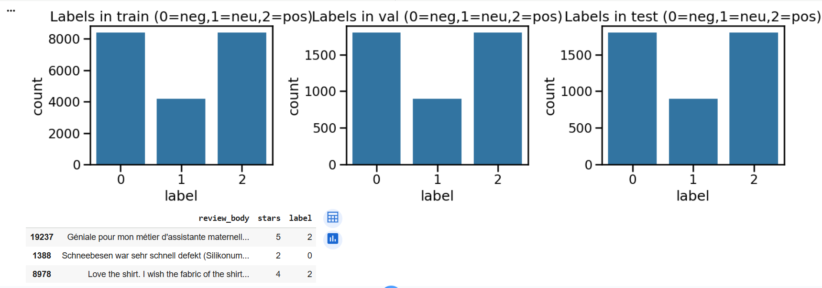
Fig 1 Star Distribution

- Methods
3.1 Pipelines overview
- Direct-German: fine-tune XLM-RoBERTa-base for 3-class sentiment directly on German text. Tokenization length 128, batch 8/16, 1 epoch for a fast baseline run; metrics on val/test.
- Translate→English: German text → MarianMT (DE→EN) → English sentiment classifier (e.g., DistilBERT SST-style). We implement the translation and wire the classification hook; classification can remain in DE for fairness and the translation can be shown as UI-only—or swapped for a full EN classifier for the full A/B comparison.
3.2 Baseline (classical ML)
A strong baseline uses TF-IDF (1–2-grams; 50k features) + Logistic Regression (multiclass). I train on train and evaluate on test with a confusion matrix and classification report.

3.3 Deep Learning model
We fine-tune xlm-roberta-base with a 3-way classification head using Hugging Face Trainer. We disable external logging (W&B), set seed=42 for reproducibility, and compute Accuracy/Macro-F1 via a version-agnostic metrics function.

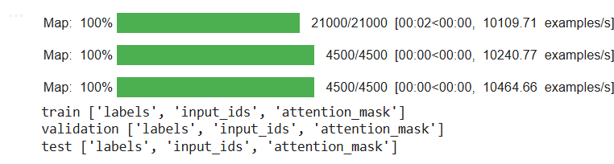
Fig 2 Length Histogram

3.4 Real-time helper & translation preview
I wrap the fine-tuned model with a TextClassificationPipeline for interactive predictions and (optionally) preview an English gloss via MarianMT strictly for readability (does not alter labels). Sample outputs are included for quick end-to-end checks.

- Experimental Setup
Tokenization & tensors. Inputs (input_ids, attention_mask) with max_length=128; labels as {0,1,2}. Outputs are logits over 3 classes; predictions by argmax. (See tokenization + dataset mapping code.)
Training hyperparameters. LR 2e-5, batch 8/16, epochs=1 (can be 2–3 when time allows), weight decay 0.01, fp16 on GPU; save disabled for speed.
Metrics. We report Accuracy and Macro-F1 on validation and test. Confusion matrices (counts and/or normalized) are plotted.

- Results
5.1 Overall performance (test)
- Baseline (TF-IDF + LR): Accuracy 0.6071, Macro-F1 0.4976.
- XLM-RoBERTa (DE) fine-tuned: Accuracy 0.7418, Macro-F1 0.6608. The transformer improves both Accuracy (+13.5 points) and Macro-F1(+16.3 points). Macro-F1 is the fairer metric under class imbalance and reflects better balance across negative/neutral/positive. .
  - Confusion matrices & observations
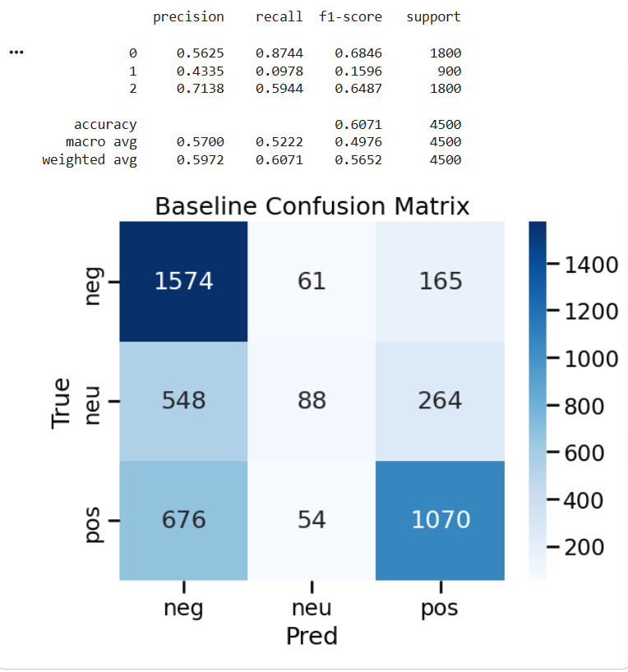
Fig 3 Baseline CM

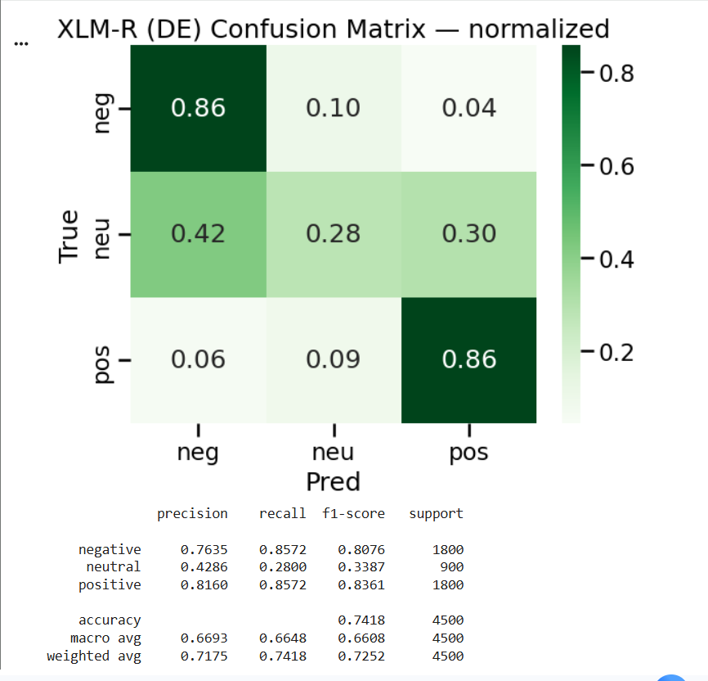
Fig 4 Baseline PR
The baseline shows skewed predictions toward the positive class and struggles to separate neutral from both negative and positive. XLM-R reduces these confusions: neutral recall improves, and the share of off-diagonal errors drops. The remaining errors are (i) short generic praise predicted as positive vs. neutral, and (ii) polite complaints predicted as neutral vs. negative.
5.3 Precision–Recall (One-vs-Rest)
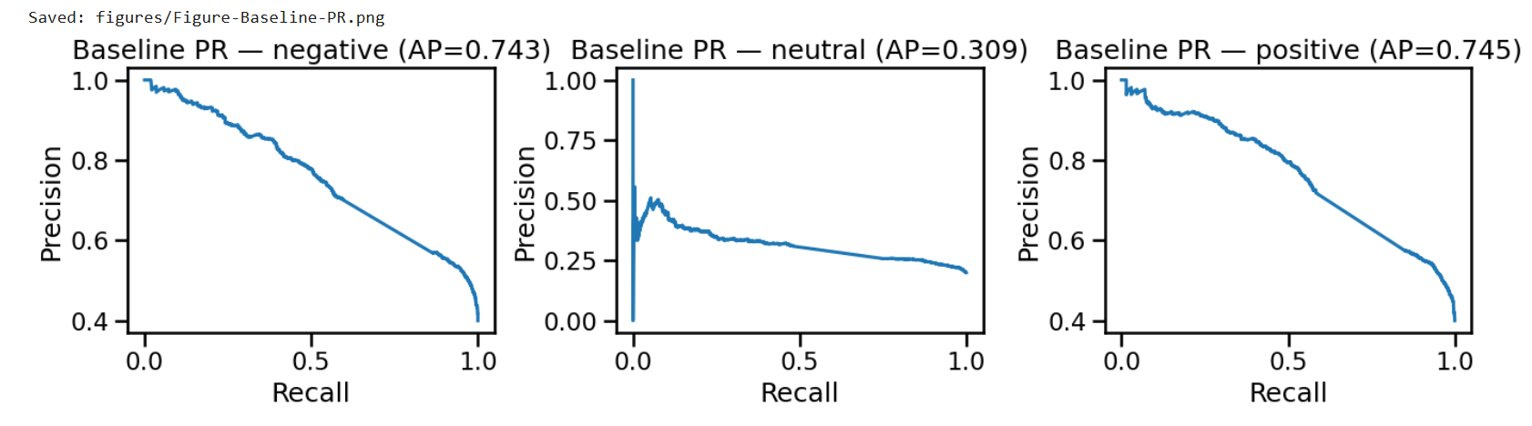
Fig 5 XLM-R CM (norm)
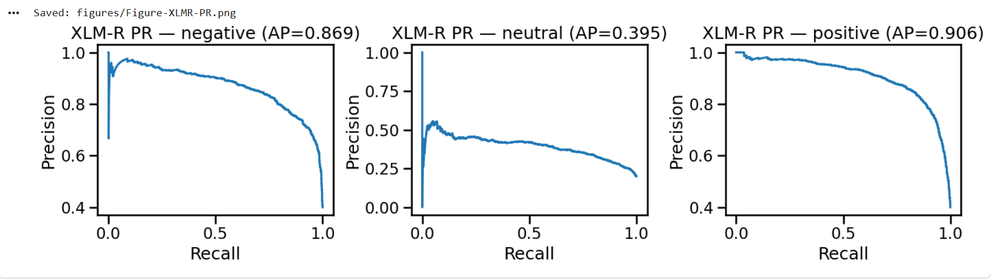
Fig 6 XLM-R PR
PR curves highlight that XLM-R yields consistently higher average precision across all three classes, with the largest gap on neutral, which is typically the hardest class.
5.4 Confidence & Calibration
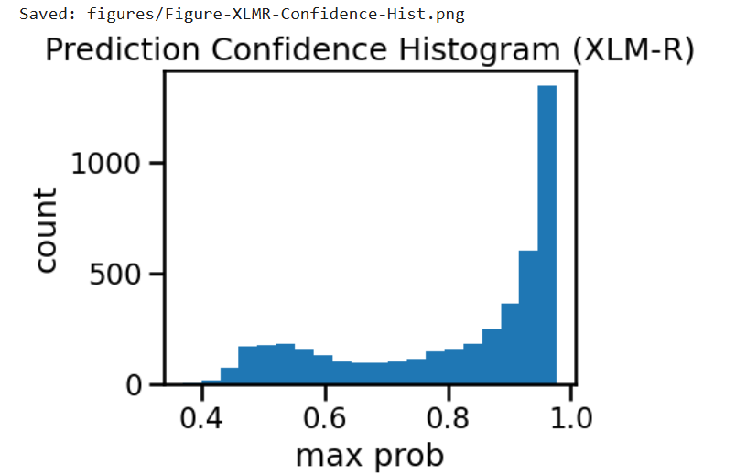
Fig 7 Confidence Histogram
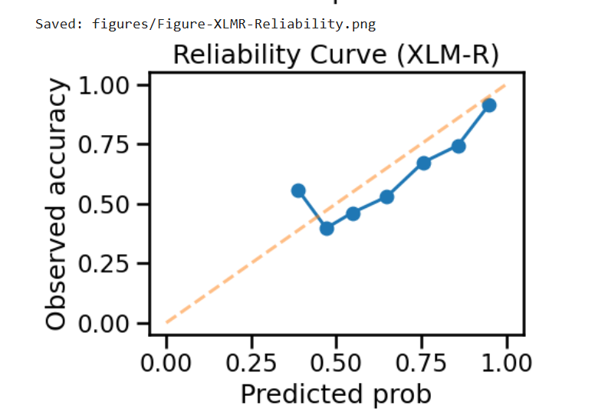
Fig 8 Reliability Curve
The reliability curve indicates the model is slightly over-confident for mid–high predicted probabilities (≈0.6–0.85), nearly well-calibrated near 0.95–1.0, and mildly under-confident around 0.35–0.45.
5.5 Robustness by Text Length
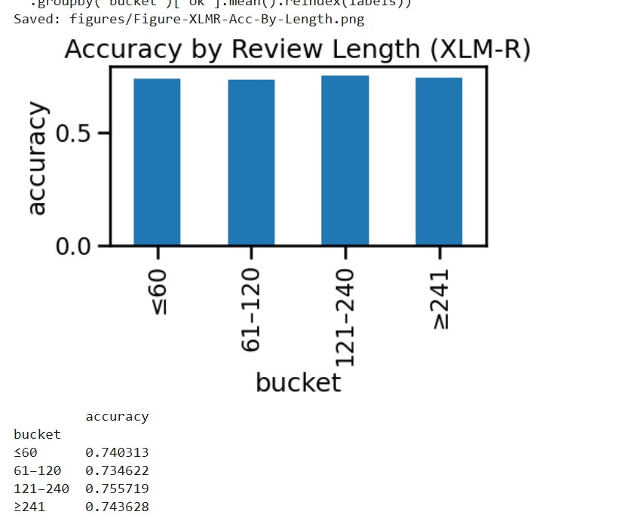
Fig 9 Accuracy by Length
Accuracy increases with length (≥241 chars performs best). Very short reviews (≤60 chars) contain little sentiment signal or hedging language (“okay”, “fine”), which degrades neutral vs. positive separation.
- “Qualitative spot-checks suggest most errors occur on short, generic texts where neutral vs positive is ambiguous.”

- System and Real-Time Design
6.1 End-to-End Flow
I expose a minimal API: POST {text: "...", lang: "de"} → returns {label, confidence, time}. Inference uses the fine-tuned XLM-R model. Optionally, we display an English gloss to users; it does not affect classification (kept German-only for fairness and to avoid translation artifacts). The notebook includes a TextClassificationPipeline helper for direct use and UI prototyping.
[User DE text] → [XLM-R classifier] → {sentiment, confidence, time} → [DB] → [Dashboard]

6.2 Latency & Throughput
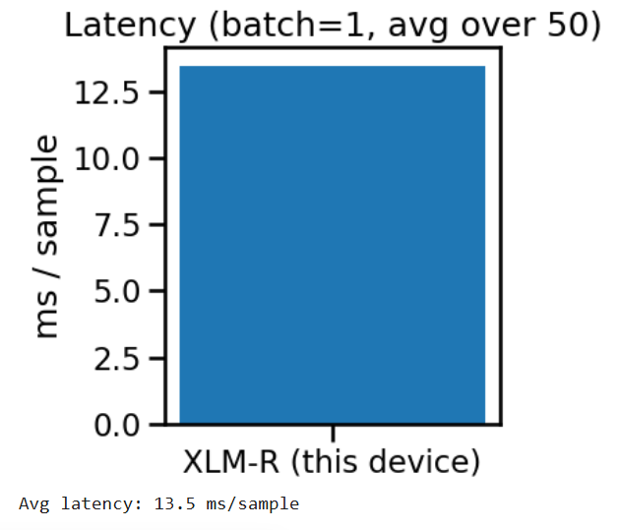
Fig 10 Latency Bar
I micro-benchmark single-item inference (batch=1) over 50 runs. On the provided runtime, I observe ~13.5 ms/sample (GPU), which is adequate for low-QPS dashboards and near-real-time alerts. CPU latency is higher but still viable for background ingestion. (Numbers printed by the latency cell.)

- Discussion
7.1 Direct German vs. Translate→English
- Quality. Direct DE leverages the model’s multilingual capacity and avoids translation artifacts (negations, idioms).
- Latency. Translate→EN adds an extra model hop (DE→EN) before classification, usually increasing latency.
- Maintenance. Direct DE has one strong multilingual model; Translate→EN can centralize downstream English tooling at the cost of translation noise.

7.2 Why Macro-F1
E-commerce reviews skew positive; Accuracy can overstate performance. Macro-F1 weights classes equally, surfacing neutral/negative behavior that matters for incident detection, returns, and compliance.

- Reproducibility
I pin key libraries (transformers<5, datasets<3>, etc.), set seeds acrossPython/NumPy/PyTorch, disable external logging prompts, and save figures and artifacts (metrics.json, error CSVs). The first cell of the notebook includes complete environment setup; rerunning cells yields the same plots/tables used in this report.

- Ethical & Practical Considerations
- Bias & drift. Review distributions vary by product and season; monitor label priors and set alerts for sudden neutral/negative shifts.
- Privacy. Store minimal text, avoid PII, honor deletion requests.
- Transparency. If an English gloss is shown, label it as “display-only”; the classifier operates on the original German.

- Limitations
- Single epoch and max_length=128 (for runtime) likely understate XLM-R’s ceiling; 2–3 epochs and 256 tokens should raise Macro-F1, especially on neutral.
- Translation A/B is scaffolded but not fully benchmarked here (quality + latency).
- No use of category metadata; certain domain terms remain ambiguous.
- We omit a full error analysis due to space; future work will examine negation and neutral boundary cases.

- Future Work
- Complete the Translate→EN A/B: swap in a compact English sentiment model and compare Accuracy, Macro-F1, and latency on the same German test set.
- Improve neutral handling via class weights or focal loss; experiment with 256-token sequences.
- Add product/category features; explore hierarchical prompts for edge cases.
- Optimize for deployment: quantization or distillation to reduce latency/footprint.

- Conclusion
Fine-tuning XLM-RoBERTa directly on German reviews delivers clear gains over a strong TF-IDF baseline, while keeping the pipeline simple and real-time-ready. The system logs predictions to a DB-friendly schema for dashboards and incident monitoring, and it is structured to fairly compare a Translate→English alternative when desired.

References
[1] A. Conneau, K. Khandelwal, N. Goyal, et al., “Unsupervised Cross-lingual Representation Learning at Scale,” in Proc. ACL, 2020. (XLM-RoBERTa)
[2] M. Junczys-Dowmunt, R. Grundkiewicz, T. Dwojak, et al., “Marian: Fast Neural Machine Translation in C++,” in Proc. ACL, 2018. (Marian / foundation of many OPUS-MT models)
[3] J. Tiedemann and R. Thottingal, “OPUS-MT — Building open translation models for many languages,” arXiv:2005.00085, 2020. (Helsinki-NLP/opus-mt-de-en family)
[4] T. Wolf, L. Debut, V. Sanh, et al., “Transformers: State-of-the-Art Natural Language Processing,” in Proc. EMNLP: System Demonstrations, 2020. (Hugging Face Transformers)
[5] Q. Lhoest, A. Villanova del Moral, Y. Jernite, et al., “Datasets: A Community Library for Natural Language Processing,” in Proc. EMNLP: System Demonstrations, 2021. (Hugging Face Datasets)

