**GIT-HOL 2**

The following steps were followed to complete this exercise:

1. Creating a working Directory

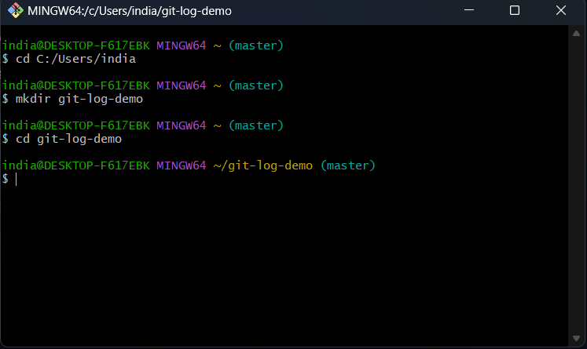

1. Initializing git repository

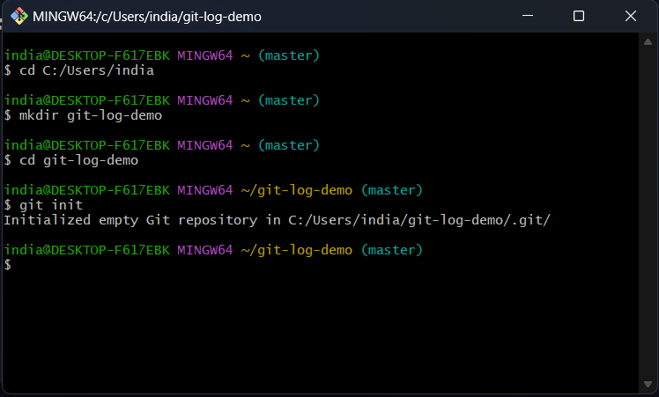

1. 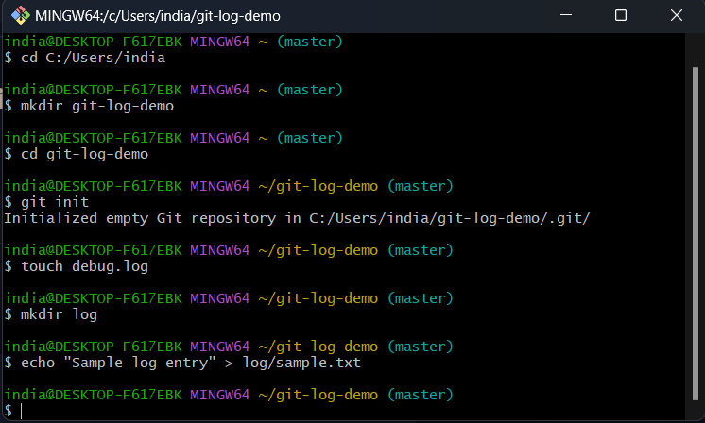Creating .log file and /log folder
2. Create gitignore file

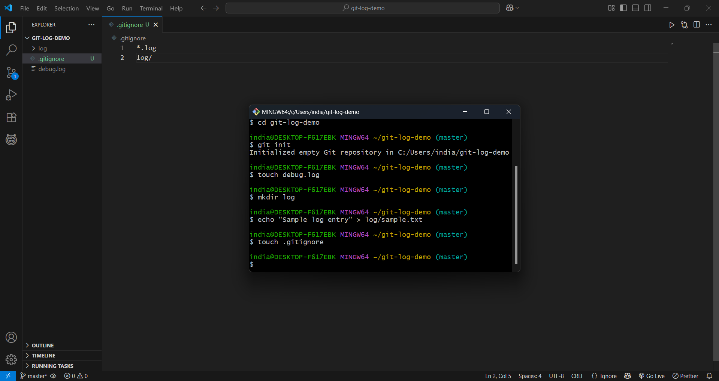The code written inside gitignore file will tell git to ignore these files and folders.

1. 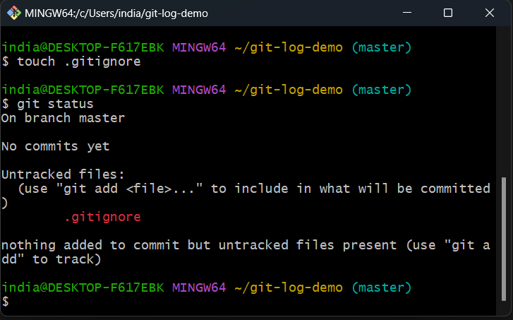As we can see debug.log and /log is not displayed.