**GIT-HOL 3**

The following steps were followed to complete this exercise:

Branching

1. 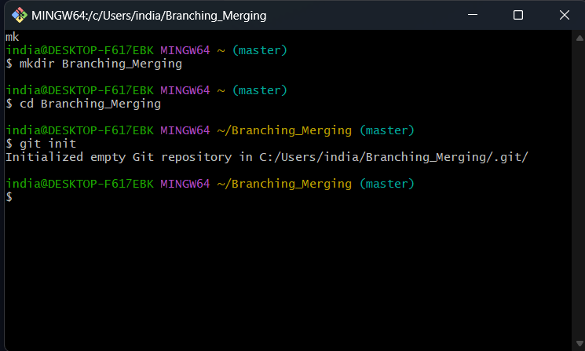Making a directory to work with
2. 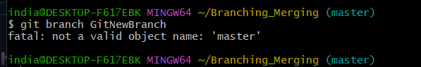Since the repo was empty therefore, I was not able to create a branch
3. 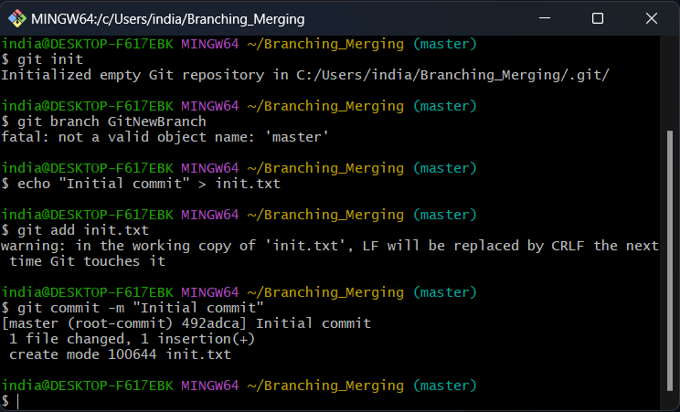Adding an initial file to solve the problem
4. Creating the branch and listing all local and remote branches

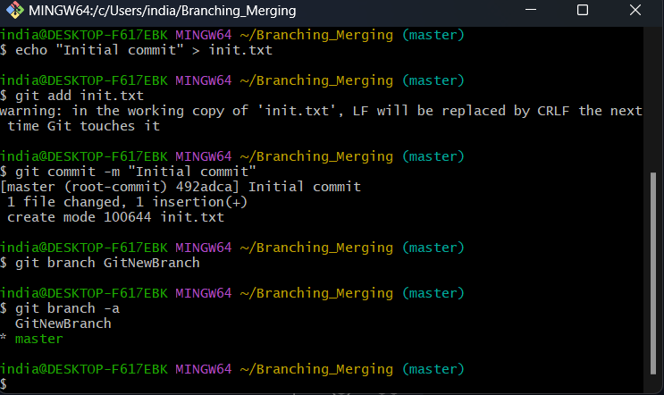The star (*) symbol indicates currently active branch.

1. 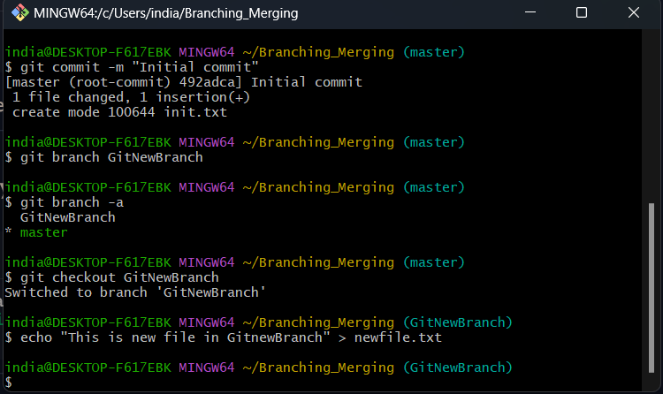Switching to newly Created branch and adding files.
2. Commit changes to the file

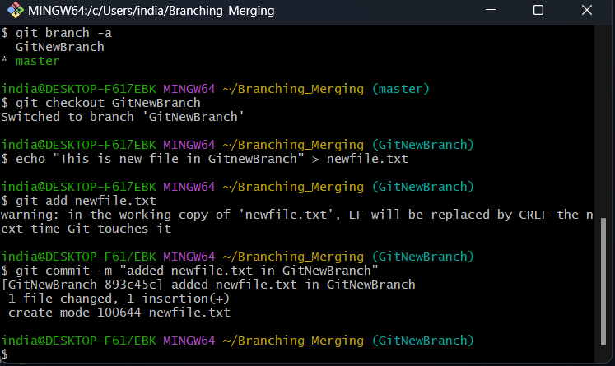

1. Checking the status

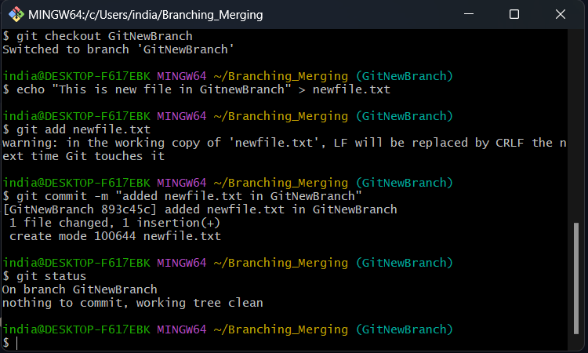

**Merging**

1. Switching to master branch

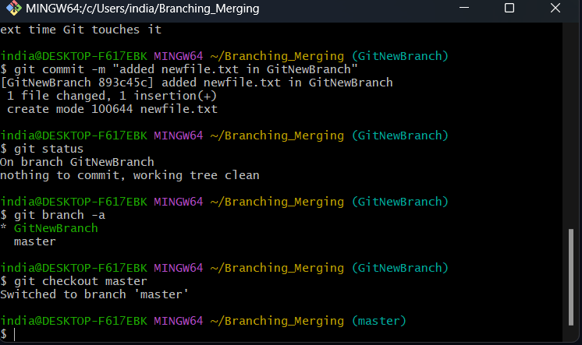

1. 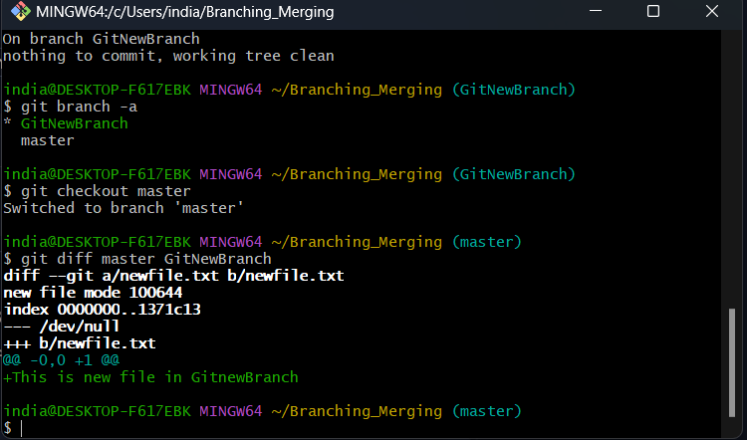List Difference between master and GitNewBranch
2. Listing difference using P4Merge tool.

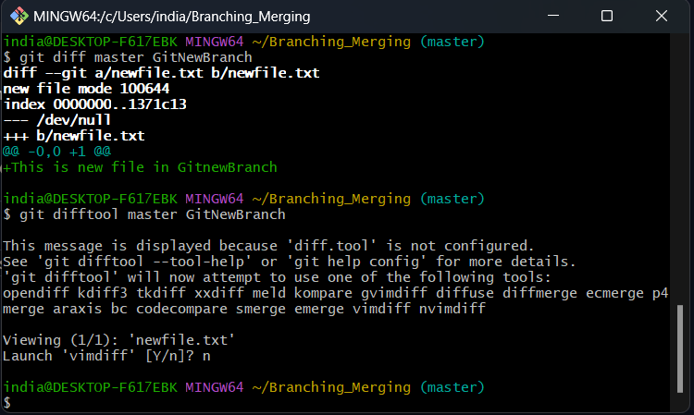p4Merge tool is not installed and setup in my system.

1. 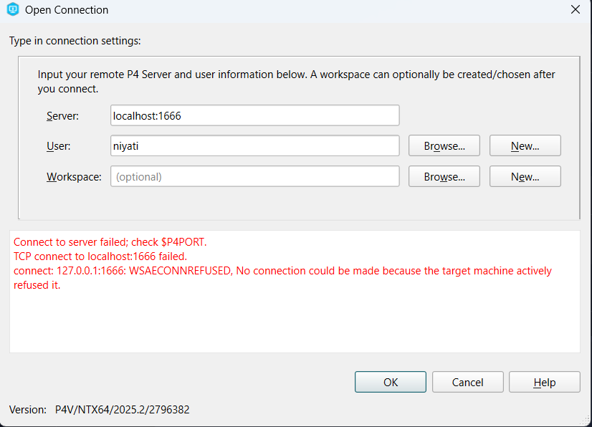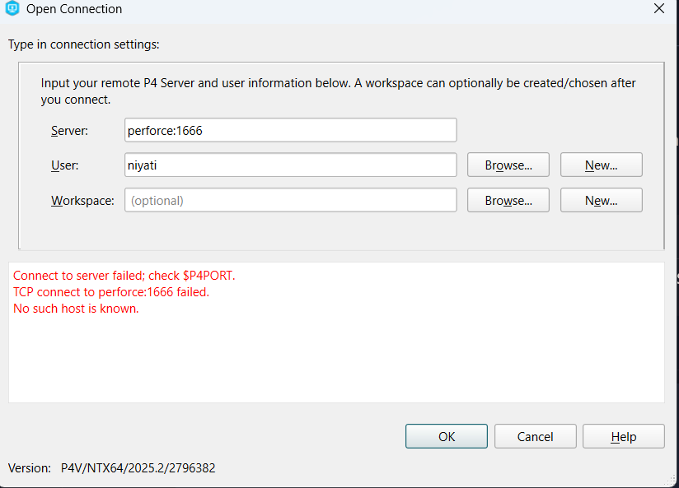Tried to setup the P4Merge tool but getting this error repeatedly.
2. Merging GitNewBranch into master

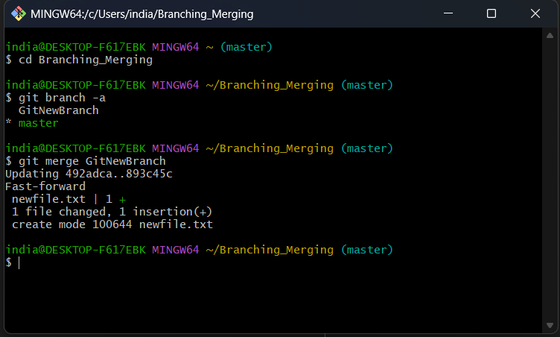

1. To view merge log

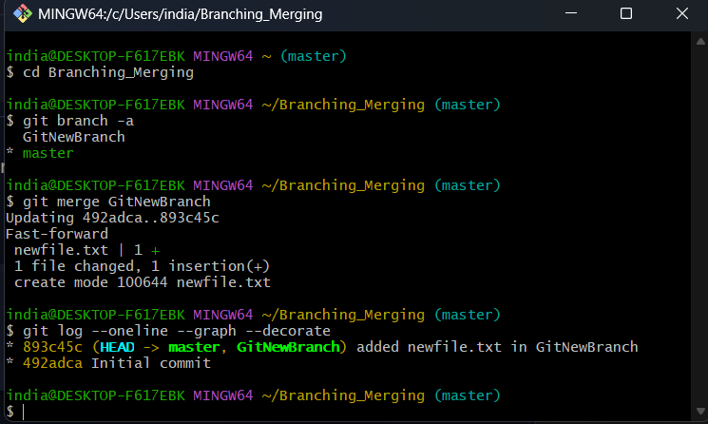

1. Deleting branch and checking status

