**GIT-HOL 4**

The following steps were followed to complete this exercise:

Using the same Branching_Merging repository that we used in the 3rd hands-on

1. 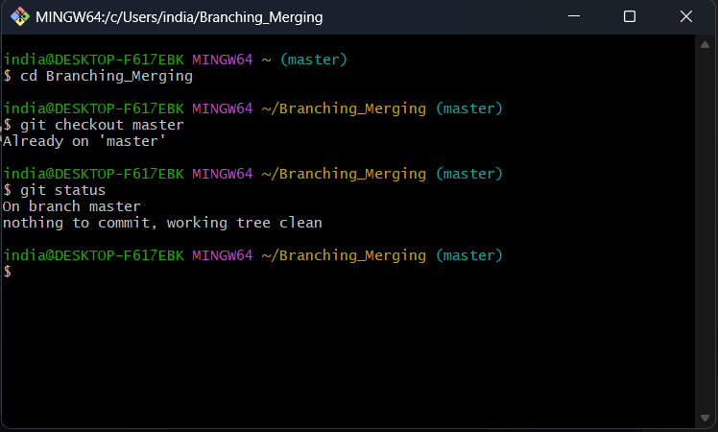Verifying if master is in clean state
2. 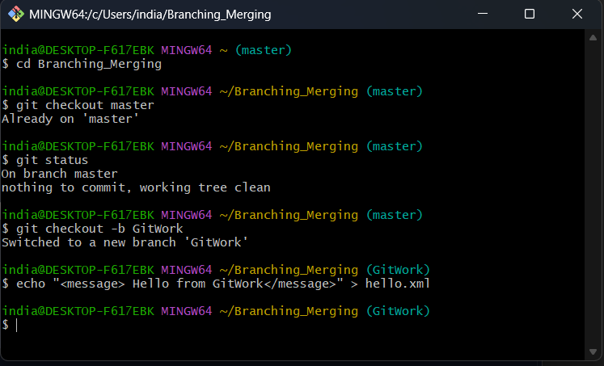Creating a branch GitWork and adding hello.xml
3. 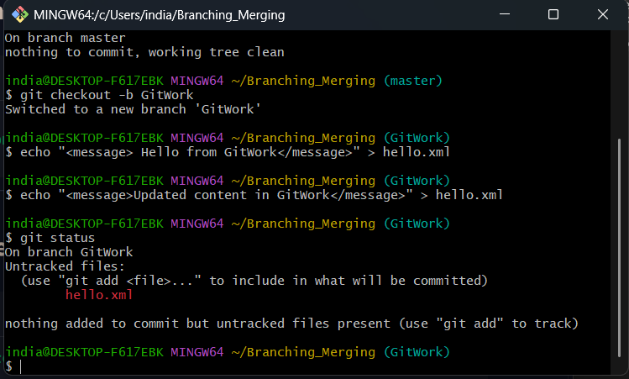Updating content of hello.xml and checking status
4. 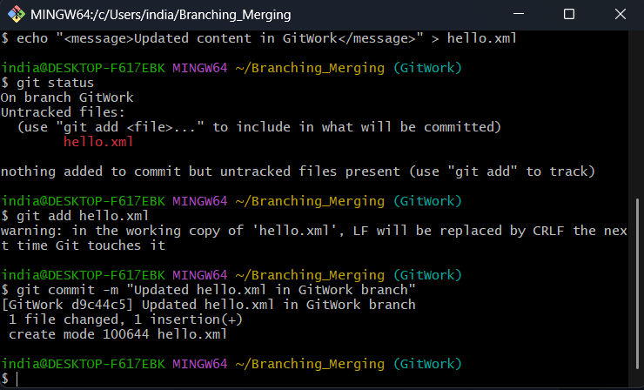Committing the changes in GitWork
5. 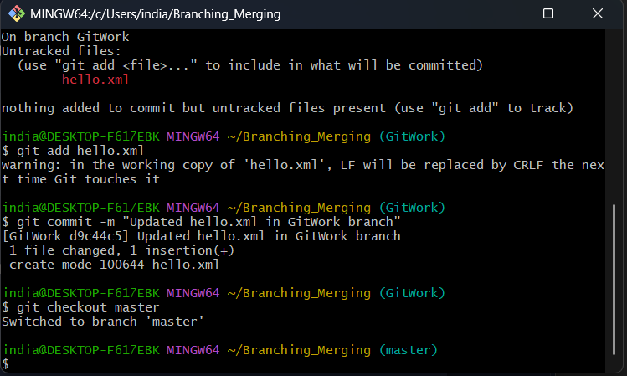Switching back to master
6. 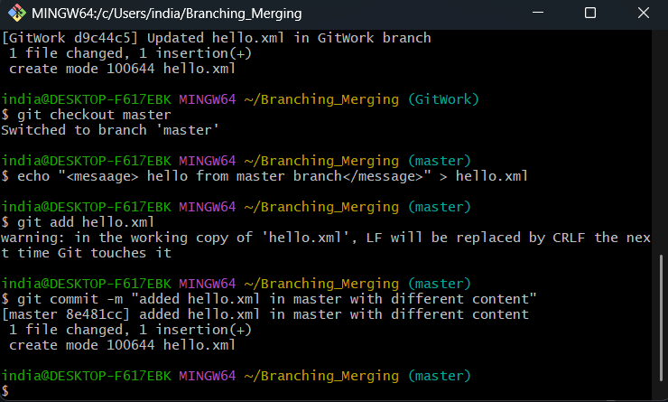Add a different hello.xml in master branch and committing changes
7. 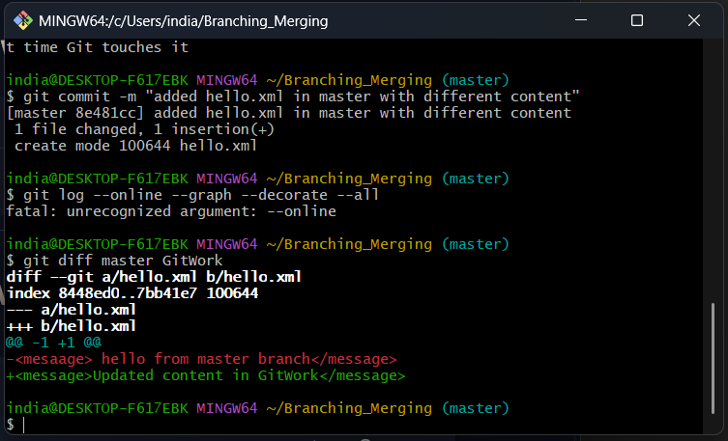Checking Differences
8. 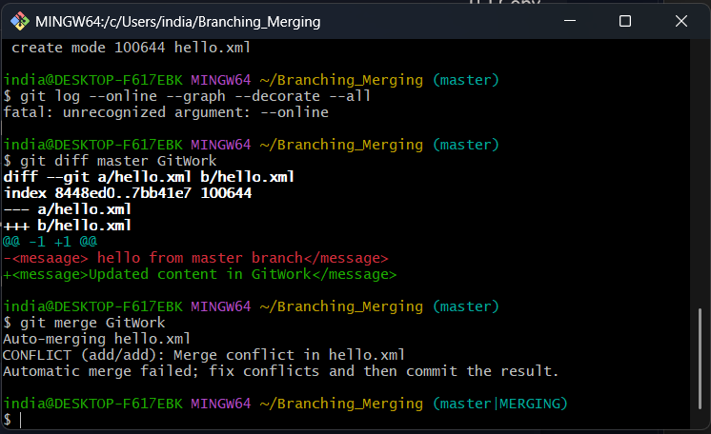Merging GitWork into master branch. Git is notifying us about the conflict.
9. 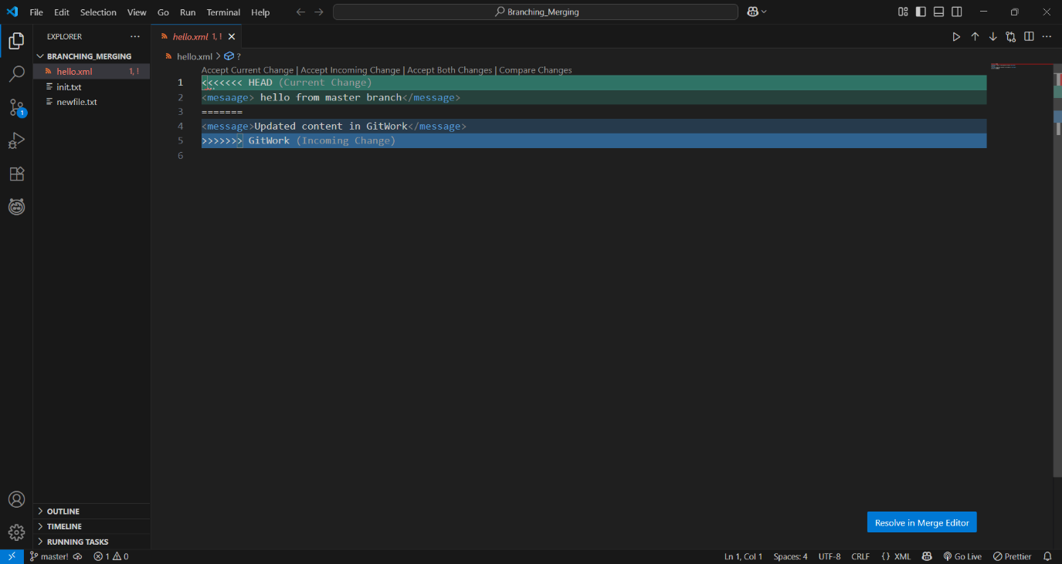 Resolving the conflict manually. Conflict indicators are being displayed on VS code.
10. 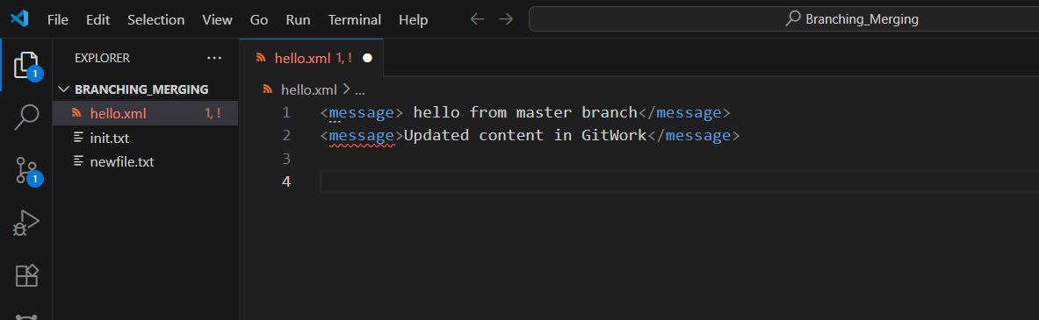 Conflict resolved
11. 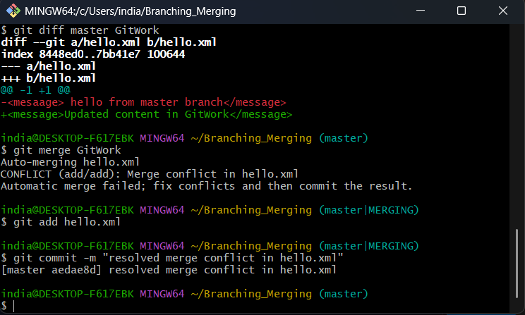 Committing the resolved merge
12. 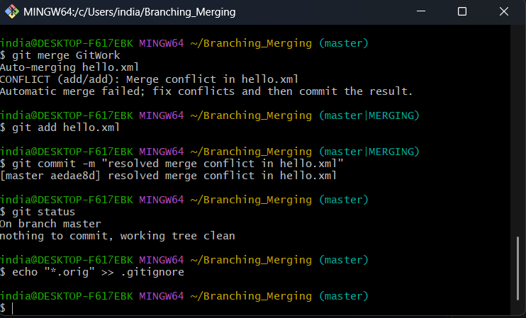Observing git status and adding backup files to gitignore
13. Commiting gitignore changes

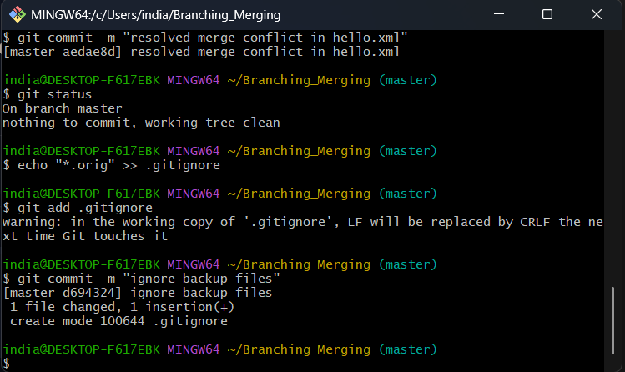

1. 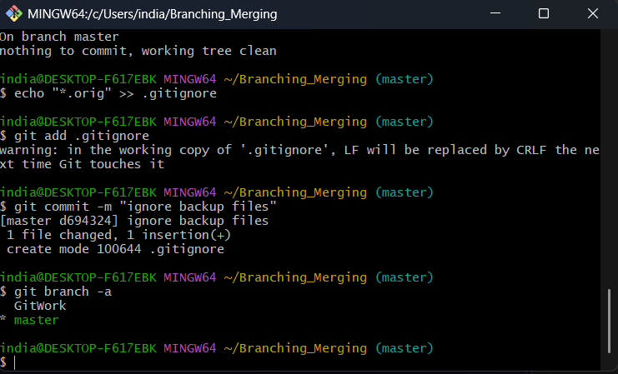 Listing all available branches
2. 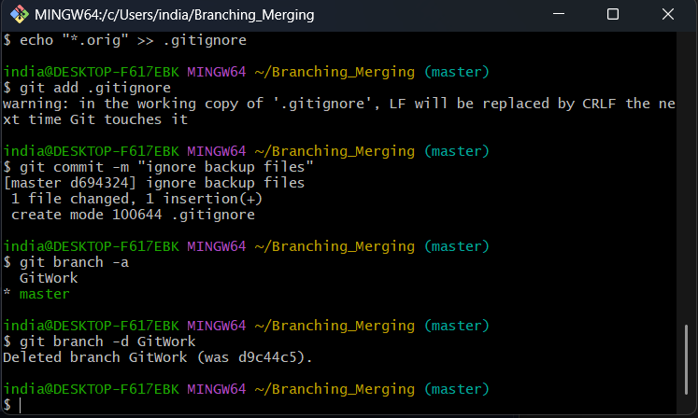 Deleting merged branch GitWork
3. Viewing final git log

