DEPARTMENT OF COMPUTER SCIENCE & ENGINEERING
<NAME OF INSTITUTE / UNIVERSITY, CITY>
SOFTWARE REQUIREMENTS
SPECIFICATION (SRS)
Project Title: Personalized Movie Recommendation System using Collaborative Filtering
Standard Academic Compliance: IEEE Std 830-1998
————————————————————————————
SUBMITTED BY:  1. Student Name (Roll No: XXXXXX)  2. Student Name (Roll No: XXXXXX)  3. Student Name (Roll No: XXXXXX)  Degree: Bachelor of Technology (B.Tech)  Academic Year: 2026 - 2027 | UNDER THE GUIDANCE OF:  Prof. / Dr. <Supervisor Name>  <Designation / Title>  Department of Computer Science & Engg.  Status: 3rd Year Project Specification  Date of Submission: <DD-MM-YYYY>

Document Revision & Approval History
Version | Date | Description / Major Changes | Prepared By | Reviewed By
0.1 | 30-Sep-2026 | Initial draft derived from PRD v1.1 | Project Team | Project Guide
1.0 | 01-Oct-2026 | SRS baseline for review and sign-off | Project Team | HOD / Committee

Guidance Note: This Software Requirements Specification document conforms to the IEEE 830-1998 standard recommended practice. All sections are strictly designed for 3rd-year university lab evaluation, project reviews, and system design baselines.

1. Introduction
1.1 Purpose
The purpose of this Software Requirements Specification (SRS) document is to provide a complete, clear, and unambiguous definition of the functionality, external interfaces, performance targets, and constraints of the proposed system: 'Personalized Movie Recommendation System using Collaborative Filtering'. It is derived from the approved Product Requirements Document (PRD v1.1, 30 September 2026) and serves as the reference agreement between the student developers, project evaluators, the academic supervisor, and prospective users during the 3rd-year engineering curriculum.
1.2 Scope of the System
The proposed system solves the problem of choice overload on streaming platforms. Users face a very large catalogue, are shown the same generic lists regardless of taste, and struggle to find movies they will enjoy, which reduces engagement and satisfaction. Using historical user ratings from the MovieLens dataset, the system identifies users with similar preferences and movies with similar rating patterns, predicts ratings for movies a user has not watched, and recommends the top N most relevant titles. Key boundary guidelines include:
- In-Scope Capabilities: Loading, cleaning and exploring the MovieLens ratings and movies data; user-based and item-based collaborative filtering with cosine similarity; rating prediction and top-N recommendation; popularity-aware ranking; cold-start fallback for new users; reasons for recommendations; evaluation using RMSE, MAE and Precision@K with baseline comparison; an interactive demonstration interface; and a PDF report.
- Out-of-Scope Boundaries: A production website, mobile app or streaming service; real-time (streaming) model updates; matrix factorization (SVD/ALS) and deep learning models; recommendations that use content features such as genre, cast or plot; implicit feedback such as clicks and watch time; live deployment, APIs and A/B testing; payment, subscription or advertising features.
- Expected Benefits: Accurate rating prediction (target RMSE of 0.95 or lower), recommendation lists that are evaluated against a popularity baseline, a list for every user including new ones (100% coverage through the cold-start fallback), an explanation for each recommendation, and a reproducible, documented workflow.
1.3 Definitions, Acronyms, and Abbreviations
Category | Term / Acronym | Definition / Standard Context
Standard | SRS | Software Requirements Specification (IEEE Std 830-1998 format).
Standard | PRD | Product Requirements Document v1.1 from which this SRS is derived.
Algorithm | CF | Collaborative Filtering: recommending items using the rating behaviour of many users.
Algorithm | User-based CF | Predicts a rating from the ratings of the k users most similar to the target user.
Algorithm | Item-based CF | Predicts a rating from the user's own ratings of the k movies most similar to the target movie.
Algorithm | Cosine similarity | Similarity of two rating vectors measured by the cosine of the angle between them (range -1 to 1).
Algorithm | Mean-centring | Subtracting each user's average rating so that strict and generous raters are comparable.
Algorithm | k | Number of nearest neighbours used when predicting a rating.
Algorithm | Popularity-aware ranking | Ranking score that blends the personalised CF score with movie popularity using a weight alpha.
Metric | RMSE / MAE | Root Mean Squared Error and Mean Absolute Error between actual and predicted ratings.
Metric | Precision@K | Share of the top K recommended movies that the user later rated 4 or higher.
Data | MovieLens | Public movie rating dataset from GroupLens Research, University of Minnesota.
Data | Sparsity | Share of the user x movie matrix that contains no rating.
Data | Cold start | A new user or movie has too little data for personalised recommendation.
Data | Popularity baseline | Non-personalised ranking by popularity, used for comparison and as the cold-start fallback.
Tool | EDA | Exploratory Data Analysis: summarising data with statistics and charts.
Tool | Gradio | Python library used to build the interactive web interface inside the notebook.

1.4 References
- IEEE Std 830-1998: IEEE Recommended Practice for Software Requirements Specifications.
- Software Engineering (10th Edition): Ian Sommerville, Pearson Education.
- Movie_Recommender_PRD.docx: Product Requirements Document, Personalized Movie Recommendation System, version 1.1, 30 September 2026.
- MovieLens dataset: F. M. Harper and J. A. Konstan, "The MovieLens Datasets: History and Context," ACM Transactions on Interactive Intelligent Systems, 5(4), Article 19, 2015. https://grouplens.org/datasets/movielens/
- Item-based CF: B. Sarwar, G. Karypis, J. Konstan and J. Riedl, "Item-based collaborative filtering recommendation algorithms," Proceedings of the 10th International Conference on World Wide Web (WWW '01), 2001.
- Recommender Systems Handbook (2nd Edition): F. Ricci, L. Rokach and B. Shapira (Eds.), Springer, 2015.
- Library documentation: pandas, NumPy, scikit-learn and Gradio official documentation.
1.5 Document Overview
The remainder of this SRS is partitioned into structural sections: Section 2 outlines the product perspective, user classes, operating environment, and constraints. Section 3 itemizes the functional requirements in six software modules and traces them to the PRD. Section 4 specifies external interfaces (user interface, hardware, software, communication). Section 5 defines non-functional attributes (performance, model quality, reliability, privacy). Section 6 provides the analysis models: use case diagram, data flow diagrams, entity-relationship diagram, and sequence diagram. Section 7 contains the academic review and sign-off.
2. Overall Description
2.1 Product Perspective
The product is a self-contained analytics system implemented as a Python notebook pipeline with a lightweight web interface. It has no separate database or application server: ratings and movie data are read from CSV files into in-memory tables, similarity tables are computed in memory, and results are shown in the interface or exported as a PDF report. The only external dependency at run time is the source of the MovieLens files, which are downloaded over HTTPS from GroupLens or a GitHub copy.
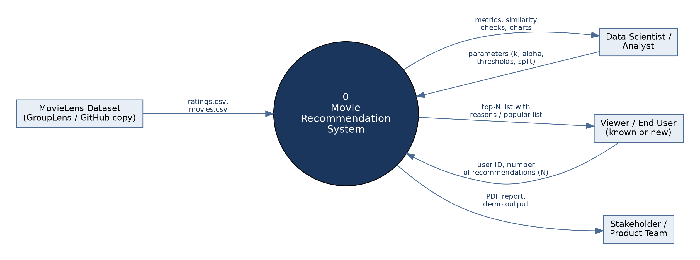
Figure 1: System context diagram (DFD Level 0)
Internally the system is organised in layers, from the data layer through preparation, modelling, prediction and ranking, to presentation. An evaluation component measures model quality using held-out ratings.
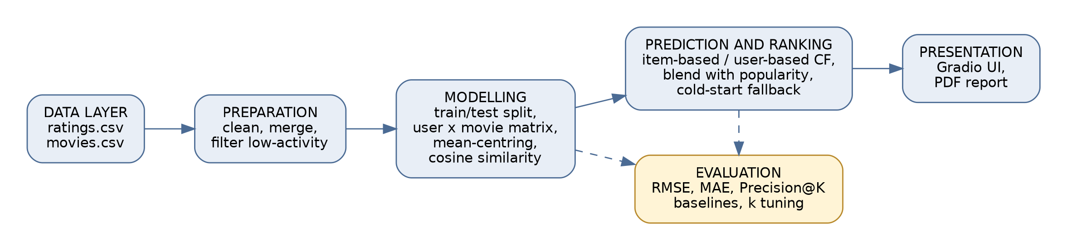
Figure 2: Logical architecture and processing pipeline
2.2 User Classes and Characteristics
The system supports the following user classes:
User Role / Persona | Technical Proficiency | Core Responsibilities & Rights
Viewer (known user) | Basic | Enters a user ID and the number of recommendations, views personalised recommendations with reasons and their own top-rated movies, and looks up similar movies.
New / Unknown Viewer | Basic | Receives the popular-movies list (cold-start fallback) until enough ratings exist for personalisation.
Data Scientist / Analyst | High (Python, machine learning) | Runs the pipeline, sets thresholds, k and alpha, evaluates and tunes models, records the selected model and exports the report.
Product Manager / Stakeholder | Intermediate | Reviews metrics, the PDF report and the demonstration, and approves the model for the next phase.

2.3 Operating Environment
The application operates within the following software and hardware environments:
- Client Requirements: Any modern web browser (Google Chrome v110 or later, Mozilla Firefox v108 or later, Microsoft Edge, Safari) to use the interface; display resolution of 1366x768 or higher.
- Execution Environment: Google Colab or Jupyter Notebook with Python 3.10 or later and the libraries pandas, NumPy, scikit-learn, matplotlib, seaborn and Gradio. A CPU runtime is sufficient; no GPU is required.
- Hardware Resources: 8 GB RAM or more is recommended because user-user and item-item similarity tables are held in memory; about 100 MB of free disk space for data and outputs.
- Data Storage Tier: CSV files (ratings.csv, movies.csv). No database management system is used.
2.4 Design and Implementation Constraints
- Academic Budget Constraint: Only free-tier resources (Google Colab, GitHub) are used.
- Method Constraint: Collaborative filtering with cosine similarity. Matrix factorization, deep learning and content-based features are excluded from version 1.
- Memory Constraint: Dense user x movie matrices are practical only for small and medium datasets such as MovieLens small; larger data requires sparse matrices or factorization.
- Reproducibility Constraint: Fixed random seeds and documented library versions so that results can be repeated.
- Data Licence and Privacy: MovieLens is used for research and learning under the GroupLens terms: the source is cited, endorsement by the University of Minnesota or GroupLens is not implied, and only anonymous user identifiers are used.
- Modularity Standard: Separate, commented functions for loading, fitting, predicting, recommending and evaluating.
2.5 Assumptions and Dependencies
- Assumptions: The MovieLens ratings are representative of the target audience's rating behaviour; explicit ratings are available, and each user has at least 20 ratings; the project is delivered as a notebook, report and demonstration, not as a live service; users have internet access to download the dataset or a local copy of the files exists.
- Dependencies: Availability of the MovieLens files (GroupLens or a GitHub copy); availability of the Python libraries and the Colab or Jupyter runtime; agreement on the success metrics and thresholds during the planning sprint (SID_1).
3. System Features and Functional Requirements
Requirements are categorized by functional subsystem modules with unique requirement identifiers (FR-x.x). Section 3.7 maps each requirement to the PRD and to the sprint backlog.
3.1 Module 1: Data Acquisition and Preparation
Req ID | Feature Description | Input / Validation Rule | Priority
FR-1.1 | Load ratings and movies files | ratings.csv (userId, movieId, rating, timestamp) and movies.csv (movieId, title, genres) from a URL or local path; print the record counts | High
FR-1.2 | Validate input schema | Required columns present with numeric IDs and ratings; stop with a clear message if not | Medium
FR-1.3 | Remove duplicates and invalid ratings | One rating per user-movie pair (latest kept); reject ratings outside 0.5 to 5.0 | High
FR-1.4 | Handle missing values and merge | Drop records missing userId, movieId or rating; join ratings with titles on movieId; row count after the merge equals the count before | High
FR-1.5 | Report dataset statistics | Number of ratings, users and movies, and matrix sparsity (%) | High
FR-1.6 | Filter low-activity users and movies | Configurable minimums (default 20 ratings per user, 5 per movie); report sizes and sparsity before and after | High

3.2 Module 2: Exploratory Data Analysis
Req ID | Feature Description | Input / Validation Rule | Priority
FR-2.1 | Rating distribution | Bar chart of rating values with summary statistics (count, mean, standard deviation, quartiles) | High
FR-2.2 | Activity distributions | Ratings per user and ratings per movie, with summary statistics; log scale allowed for the long tail | High
FR-2.3 | Most rated and highest rated movies | Top 10 by rating count; top 10 by mean rating among movies with at least 50 ratings | High
FR-2.4 | Genre analysis | Number of ratings per genre (a multi-genre movie counts once per genre) | Medium

3.3 Module 3: Modelling and Rating Prediction
Req ID | Feature Description | Input / Validation Rule | Priority
FR-3.1 | Train/test split | Random 80/20 split of ratings with a fixed seed (42); report how many test users and movies are absent from training | High
FR-3.2 | User x movie matrix | Built from training data only; absent cells mean unrated | High
FR-3.3 | Mean-centring | Subtract each user's mean rating; set missing entries to 0 after centring | High
FR-3.4 | Cosine similarity | User-user and item-item similarity tables from the centred matrix; values within -1 to 1 | High
FR-3.5 | Item-based prediction | User mean plus similarity-weighted average of the user's centred ratings on the k most similar rated movies; default k = 30, configurable | High
FR-3.6 | User-based prediction | User mean plus similarity-weighted average of centred ratings from the k most similar users who rated the movie; k configurable | High
FR-3.7 | Range limit and fallbacks | Clip predictions to 0.5 to 5.0; use the user's mean when no neighbours exist; use the global mean for an unknown user or movie | High

3.4 Module 4: Recommendation Engine
Req ID | Feature Description | Input / Validation Rule | Priority
FR-4.1 | Top-N recommendations | User ID and N (default 10, range 3 to 20); returns N movies with title, average rating and score | Medium
FR-4.2 | Exclude watched movies | No movie already rated by the user appears in the list | Medium
FR-4.3 | Popularity-aware ranking | Score = alpha x z(personalised score) + (1 - alpha) x z(log popularity); alpha configurable (default 0.6); candidates need a minimum rating count (default 20); predictions damped by a shrink constant (default 10) | Medium
FR-4.4 | Cold-start fallback | A user who is unknown or has fewer than 5 ratings receives the movies with the highest mean rating among those with at least 50 ratings | Medium
FR-4.5 | Recommendation reasons | Each personalised item names the user-liked movie (rated 4 or higher) most similar to it; a generic reason if none exists | Low
FR-4.6 | Similar movies lookup | Given a movie, return N movies with the highest item similarity, with similarity score and rating count | Low

3.5 Module 5: Evaluation and Model Selection
Req ID | Feature Description | Input / Validation Rule | Priority
FR-5.1 | RMSE and MAE | Computed on held-out test ratings for the user-based and item-based models | High
FR-5.2 | Baseline comparison | Compare with the global-average and user-average baselines on the same test ratings | High
FR-5.3 | Precision@K | K = 10; a movie is relevant if the user's test rating is 4 or higher; compared with the popularity baseline on the same users | High
FR-5.4 | Hyperparameter tuning | Tune k (10, 20, 30, 50, 100) and alpha on data separate from the data used to report final results | High
FR-5.5 | Record the selected model | Store the chosen method, k, alpha and thresholds together with the results | High
FR-5.6 | Paired comparison | Report the mean per-user difference against the popularity baseline with its standard error | Medium

3.6 Module 6: User Interface and Reporting
Req ID | Feature Description | Input / Validation Rule | Priority
FR-6.1 | Recommendation screen | Inputs: user ID (integer) and N (slider 3 to 20). Output: table with rank, title, average rating and reason | Medium
FR-6.2 | User context display | Show a status message (personalised or cold start) and the user's five highest-rated movies | Medium
FR-6.3 | Similar-movies screen | Searchable movie dropdown and count slider (3 to 15); output: similarity table | Low
FR-6.4 | Report generation | Data summary, method, results, charts and sample recommendations for at least two different users | Low
FR-6.5 | PDF export | The report is exported to PDF | Low

3.7 Requirements Traceability Matrix
Module | SRS Requirements | PRD Requirements | User Story / Sprint | PRD Goals
Planning and requirements | This SRS | PRD | SID_1 (TASK1) | G-01 to G-05
M1 Data Acquisition and Preparation | FR-1.1 to FR-1.6 | FR-01 to FR-05 | SID_2 (TASK2) | G-05
M2 Exploratory Data Analysis | FR-2.1 to FR-2.4 | FR-10, FR-11 | SID_2 (TASK2) | G-05
M3 Modelling and Rating Prediction | FR-3.1 to FR-3.7 | FR-20 to FR-25 | SID_3 (TASK3) | G-01, G-02
M4 Recommendation Engine | FR-4.1 to FR-4.6 | FR-30 to FR-33 | SID_5 (TASK5) | G-02, G-03, G-04
M5 Evaluation and Model Selection | FR-5.1 to FR-5.6 | FR-40 to FR-43 | SID_4 (TASK4) | G-01, G-02
M6 User Interface and Reporting | FR-6.1 to FR-6.5 | FR-50, FR-51 | SID_5, SID_6 (TASK6) | G-03, G-04, G-05

Requirements that refine the PRD: FR-1.2 (schema validation), FR-2.4 (genre analysis), FR-4.3 (popularity-aware ranking, introduced because Precision@10 is compared with a popularity baseline), FR-4.6 and FR-6.1 to FR-6.3 (demonstration interface) and FR-5.6 (statistical comparison). They stay within the PRD scope of a demonstration, not a production service.
4. External Interface Requirements
4.1 User Interfaces (UI)
The interface is a two-screen web page served inside the notebook. It follows basic usability practice: labelled inputs with defaults, a single primary action button per screen, plain-language titles and reasons, and immediate visual feedback. Invalid input (for example an empty or non-numeric user ID) shows a message and never produces an empty or broken table. An unknown or new user ID shows an explicit notice that popular movies are being displayed.
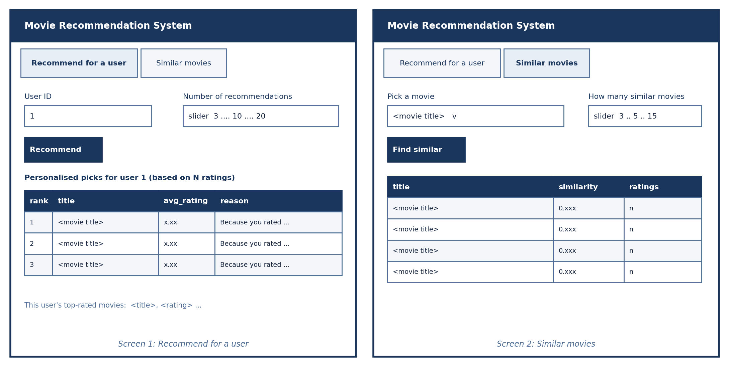
Figure 3: User interface wireframes (Screen 1: Recommend for a user; Screen 2: Similar movies)
4.2 Hardware Interfaces
- Standard Deployment: A PC or laptop with keyboard, mouse and a display of at least 720p, running a modern browser; the notebook runs locally or on a Google Colab cloud virtual machine (CPU runtime).
- Embedded / IoT Variants: Not applicable. The system has no embedded or sensor components.
4.3 Software Interfaces
- Runtime and Libraries: Python 3.10 or later; pandas and NumPy for data handling; scikit-learn (cosine_similarity) for similarity; matplotlib and seaborn for charts; Gradio for the interface.
- Data Source: CSV files read through pandas from an HTTPS URL (GroupLens or a GitHub copy) or from a local path. No relational database or ORM is used.
- Notebook Platform: Google Colab or Jupyter Notebook for execution and for exporting the report to PDF.
4.4 Communication Interfaces
- Web Traffic Protocol: HTTPS (TLS, port 443) for downloading the dataset. The Gradio interface is served on the notebook host; an optional temporary public share link (HTTPS) may be enabled for demonstrations only.
- Data Serialization: Input data as UTF-8 CSV; JSON between the browser and the Gradio backend; the final report as PDF.
5. Non-Functional Requirements (NFRs)
Attribute | Target Metric / Standard | Verification & Testing Method
5.1 Performance | Top-10 recommendations for one user generated in under 2 seconds on the MovieLens small dataset; interface response under 3 seconds. | Time the recommend function over 100 users with the time module; observe interface latency.
5.2 Model Accuracy | RMSE of 0.95 or lower on held-out ratings and lower than the user-average baseline; MAE reported. | Evaluation on a report slice that was not used for tuning (FR-5.1, FR-5.2, FR-5.4).
5.3 Ranking Quality | Precision@10 of the final recommender reported on users not used for tuning; target is not lower than the popularity baseline, with standard error. | Paired per-user comparison (FR-5.3, FR-5.6).
5.4 Reliability | No crash and no empty list for an unknown user ID, a user with no ratings, or a movie absent from training; fallbacks apply (FR-3.7, FR-4.4). | Test cases: unknown ID, zero-rating user, movie missing from training.
5.5 Reproducibility | Fixed random seeds; library versions documented; the notebook runs end to end without errors. | Fresh Colab runtime, Run all, compare outputs.
5.6 Scalability | Design allows migration to sparse matrices or matrix factorization for larger data. | Design review; record memory use of the similarity tables.
5.7 Maintainability | Modular, commented functions for load, fit, predict, recommend and evaluate. | Code review checklist.
5.8 Privacy and Security | Only anonymous user IDs; no personal data; public share link enabled only during demonstrations. | Data inspection; review of interface launch settings.
5.9 Fairness | Monitor popularity bias so niche movies are not always ranked below popular ones. | Report the rating counts of recommended movies against the catalogue.
5.10 Usability | Outputs readable by non-technical users: plain titles, reasons and status messages. | Walkthrough with two non-technical reviewers.
5.11 Portability | Runs in Colab or Jupyter on Windows, Linux and macOS; interface works in Chrome, Firefox, Edge and Safari. | Run on two environments and two browsers.

6. System Design and Analysis Models
University evaluation rubrics require standard graphical analysis models illustrating the dynamic and static behavior of the application. The models for this project are listed below and presented in Sections 6.1 to 6.4.
Diagram Type | Objective & Scope | Deliverable Format
Use Case Diagram | Maps the actors (Viewer, New Viewer, Data Scientist, Stakeholder) to the functional interactions. | UML diagram (Figure 4) and use case specification table.
Data Flow Diagram (DFD) | Information flow: Level 0 context (Figure 1) and Level 1 decomposition into six processes (Figure 5). | Yourdon style diagrams with process table.
Entity-Relationship (ERD) | Entities, keys, attributes and relationships for ratings, movies, users and recommendations. | Crow's foot diagram (Figure 6) with data dictionary.
Sequence Diagram | Message sequence between viewer, interface, recommender engine and data store for the core feature. | UML sequence diagram (Figure 7) with both paths.

6.1 Use Case Diagram and Specifications
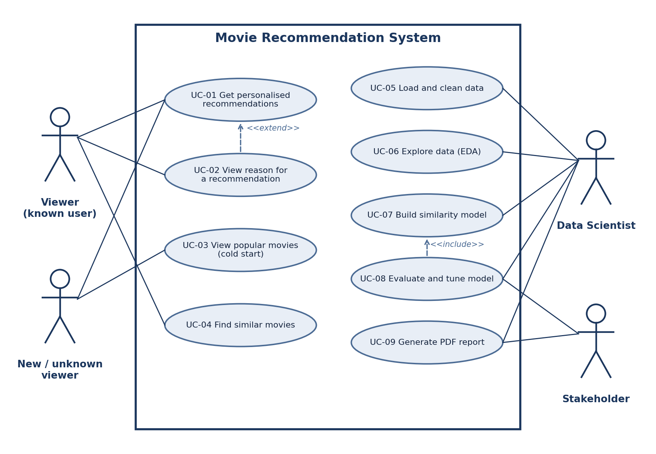
Figure 4: Use case diagram
ID | Use Case / Actor | Main Flow | Outcome
UC-01 | Get personalised recommendations  Viewer | Enter user ID and N; the system finds the user has 5 or more ratings, scores unseen movies and returns the top N. | List of N unseen movies.
UC-02 | View reason for a recommendation  Viewer | The system attaches to each movie a reason naming a liked movie that is similar to it. | Each item explained.
UC-03 | View popular movies (cold start)  New / unknown viewer | Alternative flow of UC-01: the user is unknown or has fewer than 5 ratings; the system returns top mean-rated movies with at least 50 ratings and shows a notice. | Non-empty list.
UC-04 | Find similar movies  Viewer | Select a movie and a count; the system returns the most similar movies with similarity scores. | Similarity table.
UC-05 | Load and clean data  Data Scientist | Load files, validate schema, remove duplicates and invalid ratings, merge, filter low-activity users and movies. | Clean dataset and size report.
UC-06 | Explore data  Data Scientist | Produce distributions, top movie lists, genre chart and sparsity figure. | Insight charts.
UC-07 | Build similarity model  Data Scientist | Split data, build the matrix from training data, mean-centre and compute similarity tables. | Model tables.
UC-08 | Evaluate and tune model  Data Scientist, Stakeholder | Compute RMSE, MAE and Precision@10, compare with baselines, tune k and alpha on separate data, record the model. Includes UC-07. | Selected model with metrics.
UC-09 | Generate PDF report  Data Scientist, Stakeholder | Compile data summary, method, results, charts and sample recommendations; export to PDF. | PDF report.

6.2 Data Flow Diagrams
The Level 0 context diagram is shown in Figure 1. Figure 5 decomposes the system into six processes and four data stores.
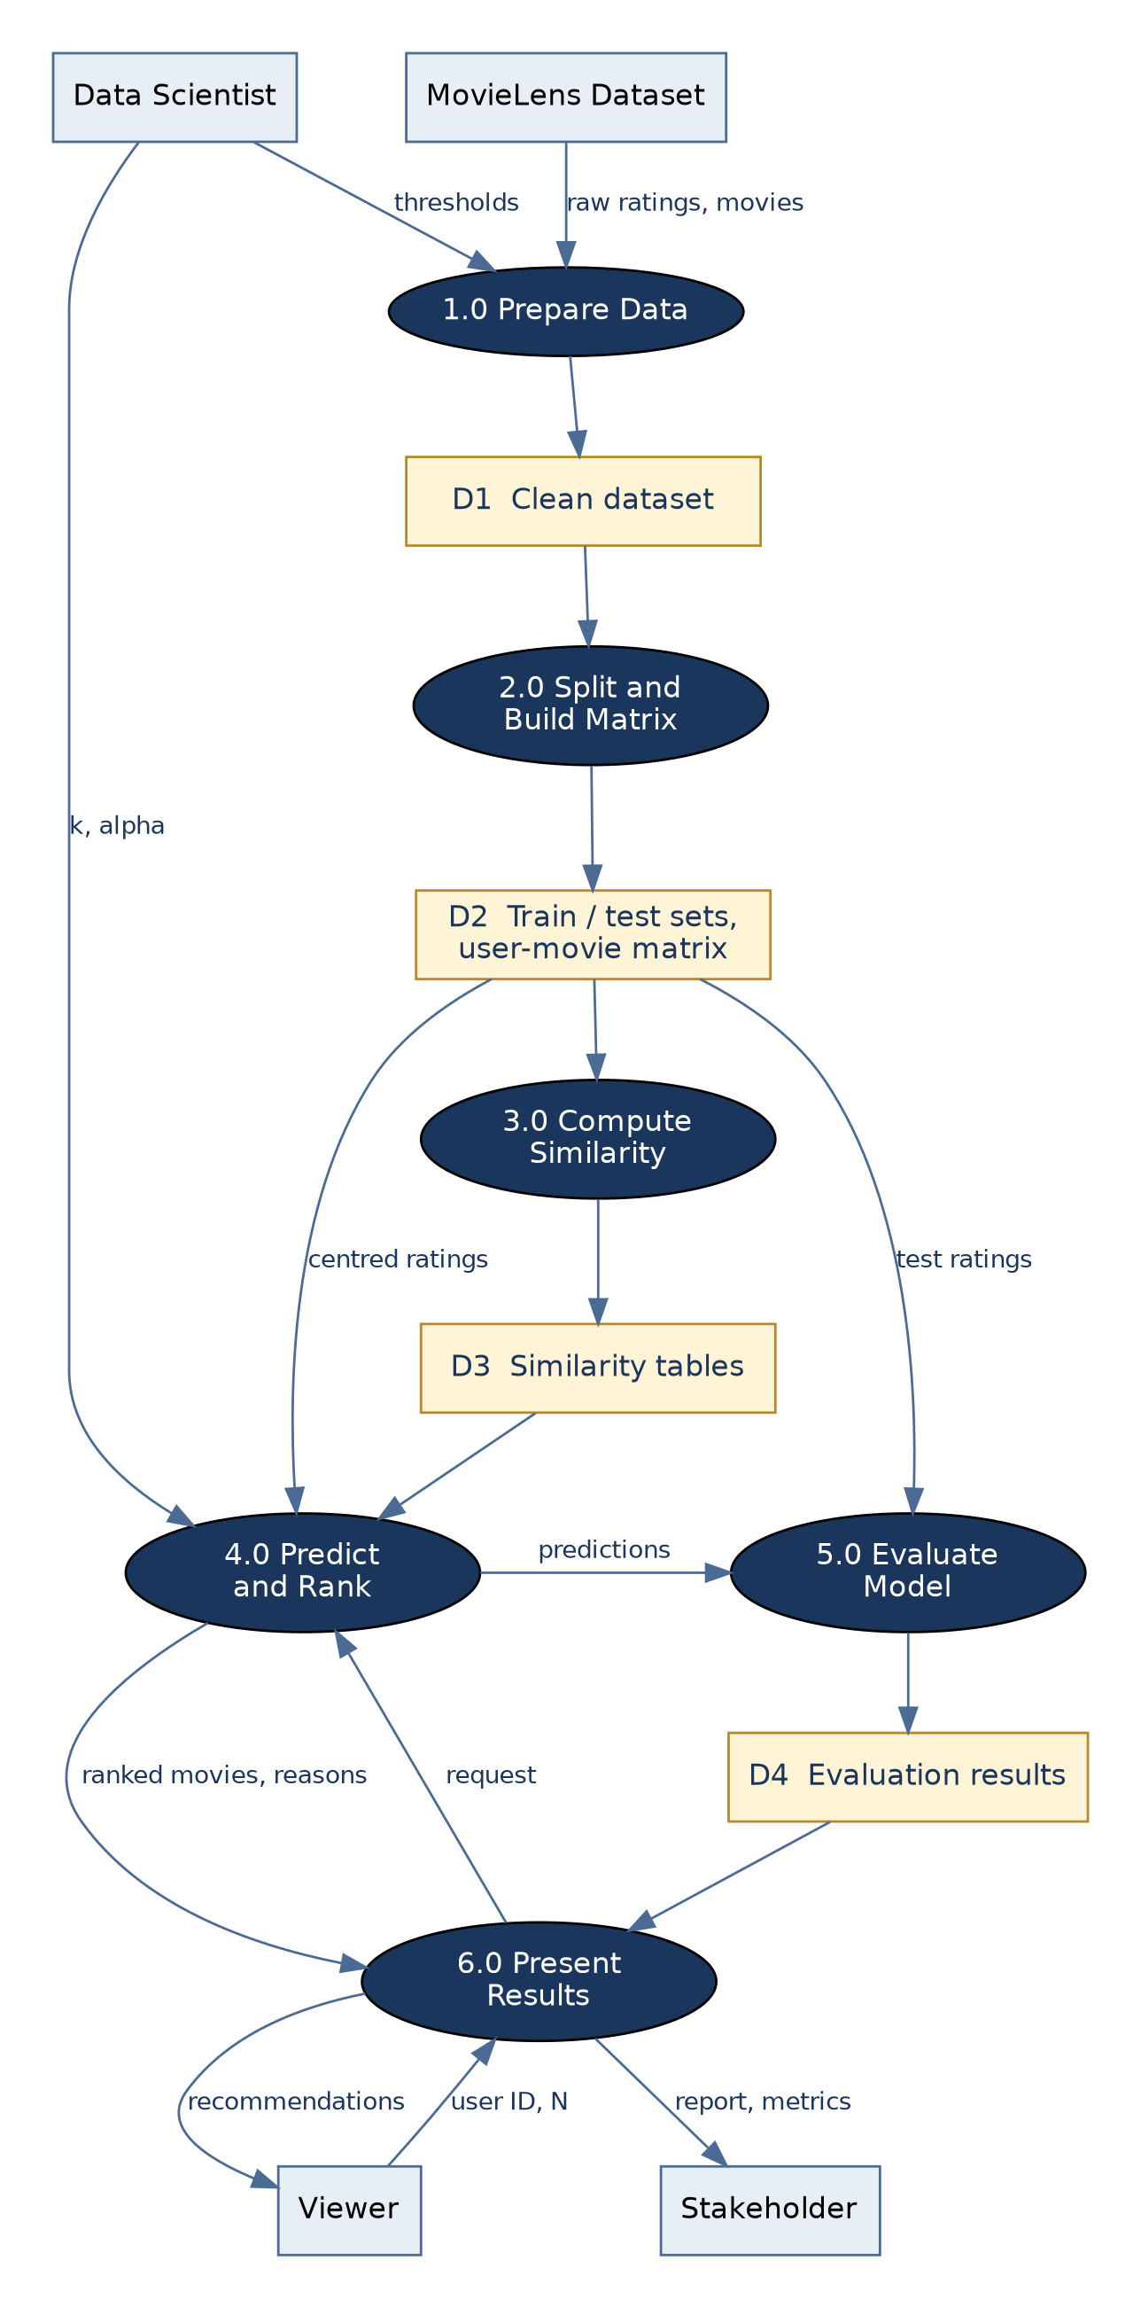
Figure 5: Data flow diagram, Level 1
Process / Store | Description | SRS Requirements
1.0 Prepare Data | Validates, cleans, merges and filters the raw ratings and movies into the clean dataset (D1). | FR-1.1 to FR-1.6
2.0 Split and Build Matrix | Splits ratings into training and test sets and builds the user x movie matrix from training data (D2). | FR-3.1 to FR-3.3
3.0 Compute Similarity | Computes user-user and item-item cosine similarity tables (D3). | FR-3.4
4.0 Predict and Rank | Predicts ratings, applies popularity-aware ranking, excludes watched movies, adds reasons, and applies the cold-start fallback. | FR-3.5 to FR-3.7, FR-4.1 to FR-4.6
5.0 Evaluate Model | Compares predictions with test ratings and baselines; tunes parameters; stores results (D4). | FR-5.1 to FR-5.6
6.0 Present Results | Serves the interface, produces charts and the PDF report. | FR-2.1 to FR-2.4, FR-6.1 to FR-6.5

6.3 Entity-Relationship Diagram and Data Dictionary
The entities are conceptual. In the implementation they are held as CSV files and in-memory tables, with no relational database. RATING is the associative entity that resolves the many-to-many relationship between USER and MOVIE (third normal form: every non-key attribute depends on the whole key).
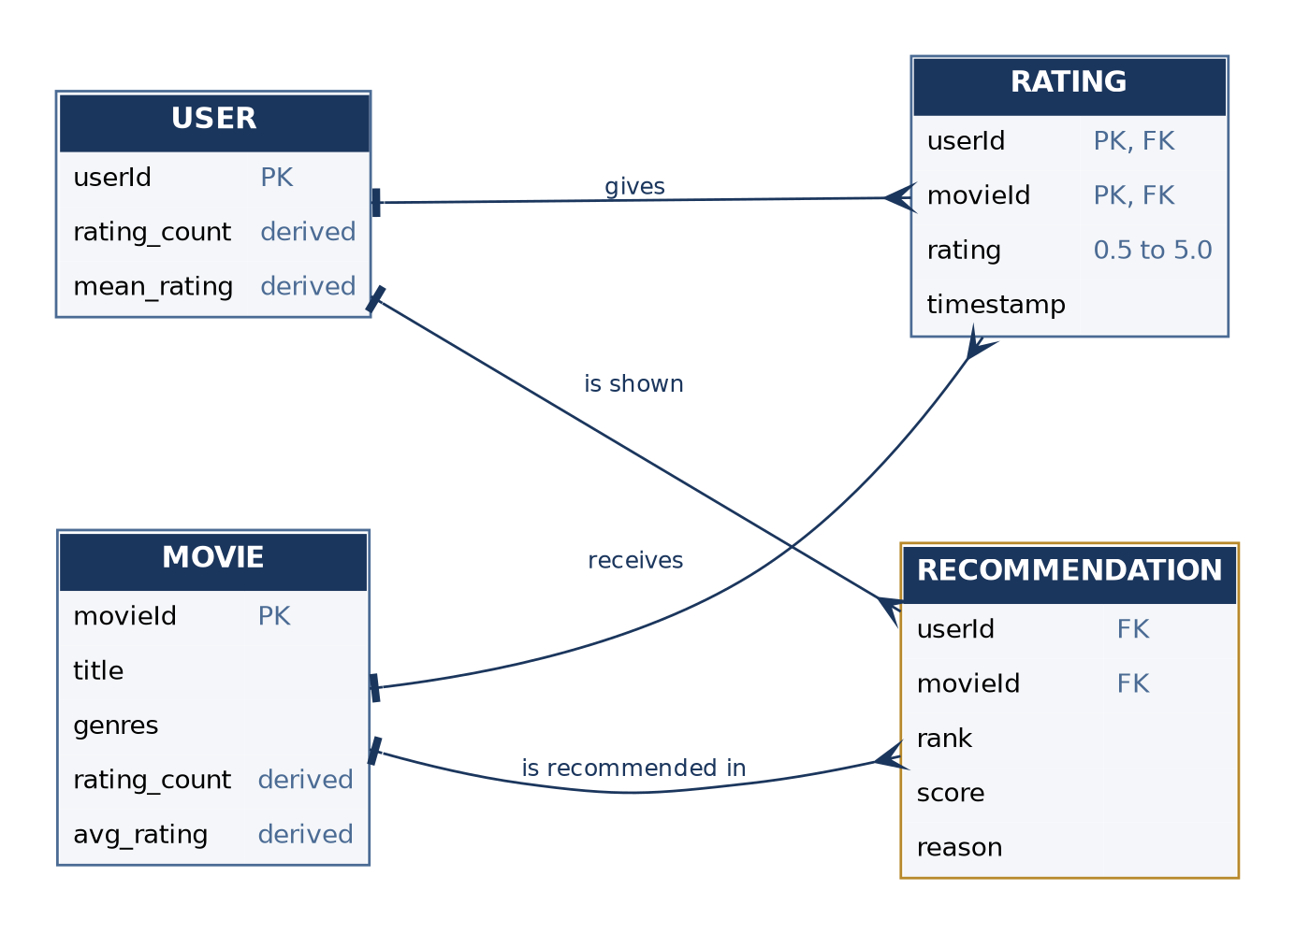
Figure 6: Entity-relationship diagram (crow's foot notation)
Entity | Attribute | Type | Description
RATING | userId | Integer | Foreign key to USER; part of the primary key
RATING | movieId | Integer | Foreign key to MOVIE; part of the primary key
RATING | rating | Decimal | Rating from 0.5 to 5.0 in steps of 0.5
RATING | timestamp | Integer | Time of the rating (Unix time)
USER | userId | Integer | Unique, anonymous user identifier (primary key)
USER | rating_count, mean_rating | Derived | Number of ratings and average rating of the user
MOVIE | movieId | Integer | Unique movie identifier (primary key)
MOVIE | title | String | Movie title with release year
MOVIE | genres | String | Pipe-separated genres (not used by the model in version 1)
MOVIE | rating_count, avg_rating | Derived | Number of ratings and average rating of the movie (training data)
RECOMMENDATION | userId, movieId | Integer | Foreign keys: the user shown and the movie recommended
RECOMMENDATION | rank, score, reason | Integer, Decimal, String | Position, ranking score and explanation; generated at run time, not stored

6.4 Sequence Diagram
Figure 7 shows the message sequence for the core feature, requesting recommendations, with both the personalised path and the cold-start path.
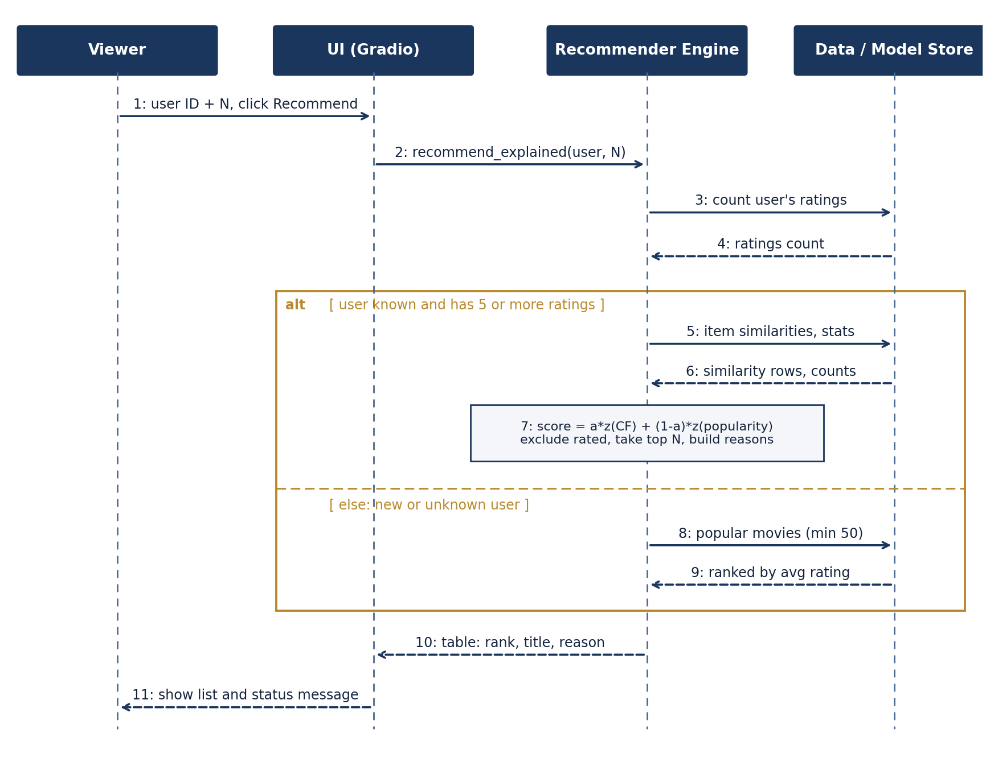
Figure 7: Sequence diagram for UC-01 / UC-03 (get recommendations)
7. Academic Review & Sign-Off
This Software Requirements Specification document has been submitted and reviewed by the academic supervisory panel:
Project Coordinator / Guide | Internal Examiner | Head of Department (HOD)
Signature: __________________  Date: __________________ | Signature: __________________  Date: __________________ | Signature: __________________  Date: __________________

