Cricket Data Analytics

|  |  |  |
| --- | --- | --- |
| Niyati Pandya (20IT077)  *KDPIT, CSPIT, CHARUSAT*  Email: [20it077@charusat.edu.in](mailto:20it077@charusat.edu.in) |  | Yash Dalia (20IT020)  *KDPIT, CSPIT, CHARUSAT*  Email: 20it020@charusat.edu.in |

***Abstract***

**This system is created with the purpose of getting more and more information about the data regarding cricket.**

**This end-to-end data analytics project focuses on analysing cricket data to gain insights into team performance, player statistics, and match outcomes. The project involves collecting and cleaning data from web scraping tools. The data is then processed and analysed using statistical models and visualization techniques to identify trends and patterns.**

1. **INTRODUCTION**

The project includes several stages, including data collection, data cleaning and pre-processing, exploratory data analysis, feature engineering, modelling, and evaluation. During the exploratory data analysis phase, the data is visualized using charts, graphs, and other tools to identify correlations and patterns.

The feature engineering phase involves creating new features from existing data, such as calculating batting averages or bowler economy rates. These features are used to build predictive models, which are evaluated using performance metrics such as accuracy, precision, and recall.

The project aims to provide insights into cricket performance, including factors such as player selection, team strategy, and match conditions. By analysing historical data, the project also aims to predict future outcomes, such as the likelihood of a team winning a particular match or tournament.

1. **COMPARATIVE ANALYSIS**

Techniques used: Data analytics projects on cricket may use a range of techniques, such as exploratory data analysis, regression analysis, machine learning, and data visualization. The choice of technique may depend on the specific research questions being addressed, the quality of the data, and the resources available.

Goal of the project: Some data analytics projects on cricket may focus on predicting match outcomes or player performance, while others may aim to identify trends and patterns in historical data. The ultimate goal of the project can affect the choice of data sources and techniques used.

Scope and complexity: Some data analytics projects on cricket may focus on a specific aspect of the game, such as player performance or team strategy, while others may aim to provide a comprehensive analysis of all aspects of the game. The scope and complexity of the project can affect the time and resources required to complete it, as well as the quality and reliability of the insights generated.

# SCOPE

# Player performance analysis: A project focused on player performance could analyse individual player statistics such as batting averages, strike rates, bowling economy rates, and fielding performances. Insights could be generated by comparing individual player statistics across different formats of the game (e.g. test cricket, one-day internationals, T20s), or by analysing the impact of specific players on team performance.

# Match outcome prediction: A project focused on predicting match outcomes could use machine learning algorithms to analyse historical data and identify factors that contribute to team success or failure. These factors could include team composition, match location, weather conditions, and other variables.

# OBJECTIVE

Identify trends and patterns: By analysing historical data on cricket, a data analytics project can identify trends and patterns in team and player performance over time. This can help identify areas of strength and weakness for individual players and teams, as well as inform strategies for future matches.

Improve player performance: By analysing individual player statistics such as batting averages, strike rates, bowling economy rates, and fielding performances, a data analytics project can identify areas where individual players can improve their performance. This can help inform training and development strategies for individual players, as well as inform selection decisions for future matches.

**V. FUNCTIONALITIES OF THE APP**

Data collection and management: The project should have a robust data collection and management system to ensure that the data used is accurate, complete, and up-to-date. This could include sourcing data from various online databases and APIs, web scraping tools, or crowdsourced data, and storing the data in a structured and organized manner.

Data visualization: Data visualization is a powerful tool for communicating complex data insights to stakeholders. The project should include various visualization techniques such as charts, graphs, and heat maps to help users understand the insights generated by the project.

**VI.** **IMPLEMENTATION**

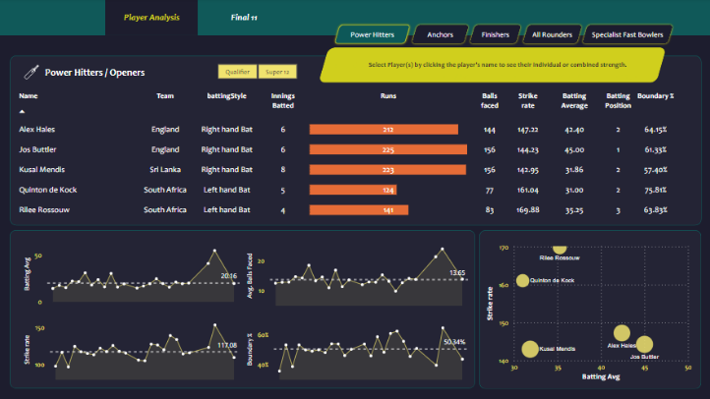

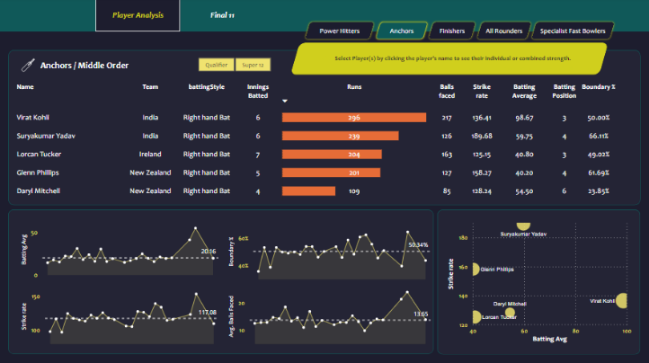

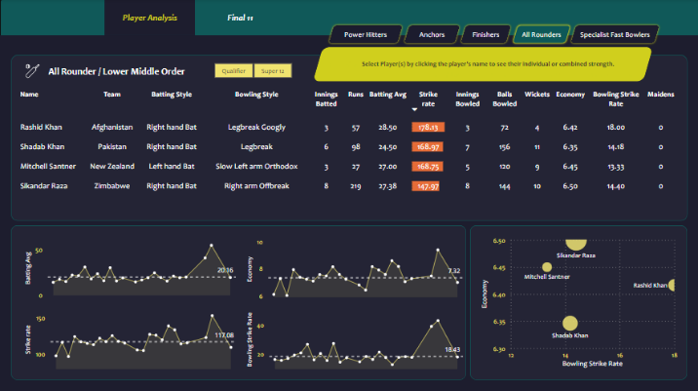

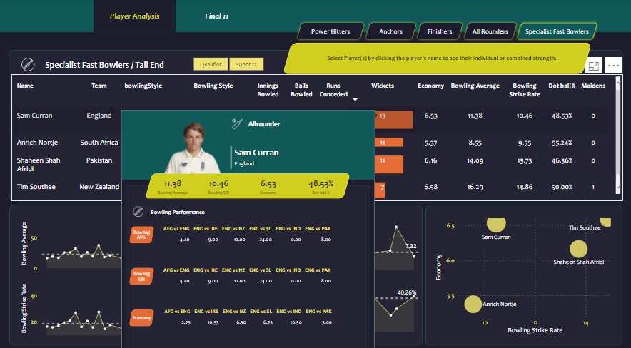

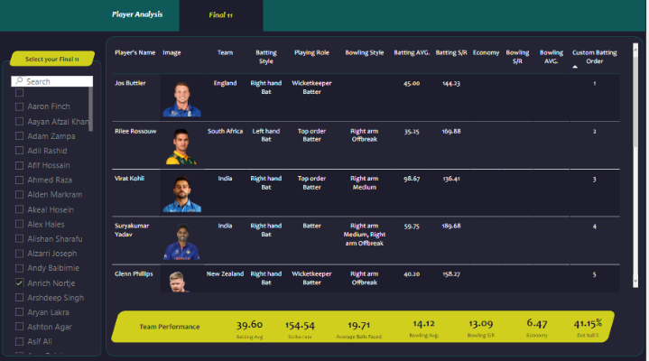

**VII. TOOLS AND TECHNOLOGIES:**

**Language:** Python

**Language:** JavaScript

**Editor:** VS Code

**Data Visualization:** Power BI

**Python: -**

Python is high level programming language that is object oriented. It is designed in such a way that the user can read and understand it easily. The design philosophy of python emphasizes on code readability with the use of indentation. It incorporates modules, exceptions, dynamic typing, high level data types and classes. Any version above Python 3.10 will work.

**JavaScript: -**

**VS Code: -**

**Power BI: -**

**VIII. FUTURE ENHANCEMENTS:**

* Adding motion detection in the night time with night vision capabilities.
* The security system can be further upgraded by integrating a advanced face recognition database to detect specific faces which will raise red flags.
* We can also provide a feature that would detect multiple humans at a same time.
* A mobile application can also be created that will give alerts on the phone also which would make the system more effective.
* By creating our own algorithm we can detect specific body parts by creating specific modules which can be very efficient.

**IX. CONCLUSION**

The project that we are creating can bring a change into the existing security systems by removing the expensive setups and replacing it with a simple software solution. This security camera application uses OpenCV that can detect motion using its image processing. These system helps to detect threats and culprits and take immediate action on it.

**X. REFERENCES**

1. OpenCV: OpenCV Tutorials
2. OpenCV Tutorial | OpenCV using Python - javatpoint
3. Python Tutorial (w3schools.com)
4. Python Dates (w3schools.com)
5. Python Time Module - GeeksforGeeks
6. OpenCV haar Cascade | Guide to OpenCV haar Cascade (educba.com)
7. <https://techvidvan.com/tutorials/face-recognition-project-python-opencv/>
8. https://towardsdatascience.com/face-detection-in-2-minutes-using-opencv-python-90f89d7c0f81