
Department of Computer Engineering and Technology
MINI PROJECT REPORT
Computer Networks Laboratory
(CSE20110)
Laboratory Continuous Assessment 3

Encrypted Client-Server Communication Framework
Submitted by
Sr. No. | Student Name | PRN
1 | Aditi Pathak | 1262240936
2 | Shraddha Pawar | 1262241161
3 | Rashi Rangrej | 1262241175
4 | Niyati Priyani | 1262241237

Group No. 12 Panel K Batch K1
Third Year B.Tech. Computer Engineering and Technology
Under the guidance of
Dr. Uma Pujeri
Academic Year 2026–2027
Submission Date: 21 October 2026

Department of Computer Engineering and Technology
CERTIFICATE

This is to certify that the mini-project entitled “Encrypted Client-Server Communication Framework” has been carried out by the following students of Third Year B.Tech. Computer Science and Engineering, Panel K, Batch K1, Group No. 12, under my guidance during the academic year 2026–2027.
Student Name | PRN
Aditi Pathak | 1262240936
Shraddha Pawar | 1262241161
Rashi Rangrej | 1262241175
Niyati Priyani | 1262241237

The report is submitted towards the mini-project component of Laboratory Continuous Assessment 3 for the Computer Networks Laboratory course.

Faculty Signature __________________________
[FACULTY NAME]
Project Guide and Course Faculty
Date ____________________ Place: Pune

Acknowledgement
We would like to express our sincere gratitude to the faculty members and the Department of Computer Networks at MIT World Peace University for their valuable guidance, encouragement, and academic support throughout the completion of our mini-project, “Encrypted Client-Server Communication Framework.” Their guidance helped us develop a better understanding of computer networking principles and their practical implementation.
We are thankful to the university for providing the academic environment and technical resources required for the development and testing of this project. We also acknowledge the use of Python, OpenSSL, Wireshark, and Visual Studio Code, which supported the implementation, security testing, and network traffic analysis of our framework.
We extend our appreciation to the technical documentation and learning resources that assisted us in understanding key concepts, troubleshooting implementation challenges, and improving our knowledge of secure communication systems.
This project has provided our team with valuable practical experience in TCP socket programming, TLS encryption, user authentication, secure file transfer, and data integrity verification. We are grateful to everyone who contributed to our learning and supported the completion of this project.

Group No. 12

Abstract
The Encrypted Client-Server Communication Framework is a computer networking mini-project designed to demonstrate secure, resilient client-server communication over TCP. Unencrypted transfers risk exposing sensitive data, while standard file uploads fail entirely during network disruptions. This multi-tier framework resolves these challenges by integrating TLS encryption, user authentication, resumable chunked uploads, and data integrity verification.
Built with Python, the system uses TCP sockets and TLS for encrypted data transmission. A Flask web gateway (app.py) and HTML5/JS frontend (index.html) provide an interactive drag-and-drop web portal alongside standard command-line clients. Resumable uploads split files into 32 KB chunks, verifying individual SHA-256 hashes before atomic re-assembly on the server. JSON handles structured message framing, while a username-and-password mechanism controls access. To ensure thread safety during concurrent client sessions, the server uses multithreading with process-level locking (RLock).
Testing under normal and failure conditions verified successful session management, error handling, and file recovery. Wireshark analysis confirmed full TLS encryption, and performance tests demonstrated low round-trip latency. The project successfully highlights practical network security, web integration, and reliable data transport.

Keywords: Client-Server Communication, TCP, TLS Encryption, Flask Web Gateway, Resumable Uploads, SHA-256

Table of Contents
Contents
Acknowledgement 3
Abstract 4
Table of Contents 5
List of Figures 6
List of Tables 6
1 Introduction and Project Objectives 8
1.1 Introduction and Background 8
1.2 Problem Statement 8
1.3 Scope 9
1.4 Objectives 10
2 Proposed Design and Requirements 12
2.1 Architecture and Network Topology 12
2.2 Tools and System Requirements 13
2.3 Addressing and Protocol Selection 13
3 Implementation and Technical Working 16
3.1 Methodology 16
3.2 Configuration or Code Implementation 16
3.3 Protocols and Technical Working 17
3.4 Execution Procedure 18
4 Testing and Results 22
4.1 Test Plan 22
4.2 Results and Execution Evidence 23
4.3 Objective Achievement 24
5 Discussion and Conclusion 26
5.1 Discussion and Comparative Analysis 26
5.2 Advantages and Applications 26
5.3 Limitations 27
5.4 Challenges and Troubleshooting 27
5.5 Future Scope 28
5.6 Conclusion 28
References 29
AI Usage Declaration 29
Appendices 31
Appendix A Code and Configuration 31
Appendix B Additional Evidence 60
Appendix C Individual Contributions 61
Appendix D Demonstration Video link 62

List of Figures
Figure 2.1 Proposed Multi-Tier Framework Architecture and Topology
Figure 3.1 Implementation evidence - Server Initialization
Figure 3.2 Implementation Evidence -Web Portal
Figure 4.1 Client-server execution and TLS connection setup
Figure 4.2 Authentication and message exchange terminal log
Figure 4.3 File transfer, chunked upload, and SHA-256 integrity verification
Figure 4.4 Performance test output and latency measurements
Figure 4.5 Wireshark packet capture showing TLS handshake and encrypted records

List of Tables
Table 1.1 Project Objectives and Verification Methods
Table 2.1 Tools and System Requirements
Table 2.2 Addressing and Protocol Selection
Table 4.1 Test Plan and Observed Results
Table 4.2 Round-Trip Latency Measurements
Table 4.3 Objective Achievement Matrix
Table 5.1 Comparative Analysis: Plain TCP vs. Framework
Table 5.2 Troubleshooting Cases and Solutions

1 Introduction and Project Objectives

1.1 Introduction and Background
Computer networks enable applications to exchange information between devices through communication protocols. Client-server architecture is a widely used networking model in which a client requests services and a server processes those requests and returns responses. However, transmitting sensitive information without encryption may expose data to unauthorized parties. Furthermore, traditional file transfer protocols transfer monolithic streams that fail completely if a connection drops midway, requiring the user to restart the upload from the beginning.
The Transmission Control Protocol (TCP) provides connection-oriented communication and reliable, ordered delivery of data between applications. Its standard specification is documented in RFC 9293 [1]. Although TCP provides reliable transport, it does not encrypt application data by itself. Transport Layer Security (TLS) addresses this limitation by protecting communication against eavesdropping and tampering. The current TLS 1.3 specification is documented in RFC 9846 [2].
Python provides built-in modules for socket communication, TLS integration, web services, and cryptographic hashing. The socket and ssl modules support network connections and encrypted communication, while the hashlib module provides the SHA-256 algorithm for generating file and chunk hashes [3]. Flask provides lightweight web routing to expose network services to modern web browsers.
Based on these concepts, this project implements an Encrypted Client-Server Communication Framework using Python and Flask. It combines TCP sockets, TLS encryption, basic username-and-password authentication, JSON-based message framing, resumable chunked file transfers, a web gateway frontend, and SHA-256 integrity verification. The implementation uses multithreading with thread locking (RLock) to safely handle multiple client connections and concurrent upload state. It includes functional testing, latency measurement, and network traffic inspection using Wireshark.

1.2 Problem Statement
Client-server applications require reliable communication, but reliability alone does not ensure confidentiality, data integrity, or upload resiliency. Unencrypted communication can expose transmitted information. Standard file transfer mechanisms transmit files as continuous streams; if the network connection breaks or the client disconnects, the entire upload fails, wasting bandwidth and time. Additionally, command-line interfaces can be intimidating for non-technical users, creating a need for an accessible web portal.
The problem addressed by this project is the implementation of a practical, multi-tier client-server communication framework that combines reliable data transmission with TLS encryption, user authentication, a Flask-based web interface, resumable chunked file uploads, and multi-level file integrity verification. The system must support multiple concurrent connections, retain partially uploaded chunk data across client restarts, and provide tools to evaluate its functionality and communication performance.
To address this problem, the project uses Python socket programming with TLS, structured length-prefixed JSON messages, a Flask HTTP middleware server, and SHA-256 hashing. The resulting framework provides a resilient, secure platform demonstrating networking and security concepts.

1.3 Scope
The project focuses on the design, implementation, and testing of a Python- and Flask-based client-server application framework.
The scope includes:
- Network environment: Local communication using the loopback address 127.0.0.1 across TCP port 5001 (TLS Server) and HTTP port 5000 (Flask Gateway).
- Gateway and UI: A Flask-based web interface (app.py and index.html) providing web login, drag-and-drop file upload capabilities, and real-time operational status updates.
- CLI Clients: Terminal-based Python clients (client.py) capable of interacting directly with the TLS server via custom JSON protocols.
- Communication: Length-prefixed JSON messages (4-byte network-order header) over TCP to prevent stream fragmentation.
- Security: TLS 1.3 encryption for socket communication and basic username-and-password authentication.
- Resumable File Transfer: Splitting files into 32 KB chunks, transmitting only missing/corrupted chunks, re-verifying individual chunk SHA-256 hashes, and assembling the file atomically on the server.
- Data Integrity: Multi-level SHA-256 hash comparison for both 32 KB individual chunks and complete assembled files.
- Concurrency: A multithreaded TLS server utilizing threading.RLock() to protect concurrent manifest reads/writes and atomic chunk assembly.
- Testing and analysis: Functional testing under normal and failure conditions, message round-trip latency measurement.

1.4 Objectives
Objective ID | Objective | Verification Method
O1 | Establish reliable client-server communication using TCP sockets. | Run the client and server and verify that a client can connect and exchange messages successfully.
O2 | Implement TLS encryption for communication between the client and server. | Inspect the TLS handshake and encrypted application traffic in Wireshark.
O3 | Implement basic username-and-password authentication. | Test valid credentials and invalid credentials and verify the server's responses.
O4 | Support structured messaging and controlled client logout. | Send a message via CLI/Web UI, verify the response, and test the logout operation.
O5 | Implement resumable chunked file transfer with SHA-256 integrity verification | Transfer files in 32 KB chunks, simulate mid-transfer disconnections, resume uploads, and compare SHA-256 hashes.
O6 | Support multiple client connections through multithreading. | Connect multiple client instances and verify that the server can handle their connections.
O7 | Evaluate communication performance and failure handling. | Record round-trip message latency, repeat measurements, and test conditions such as an unavailable server or a missing file.

2 Proposed Design and Requirements

2.1 Architecture and Network Topology
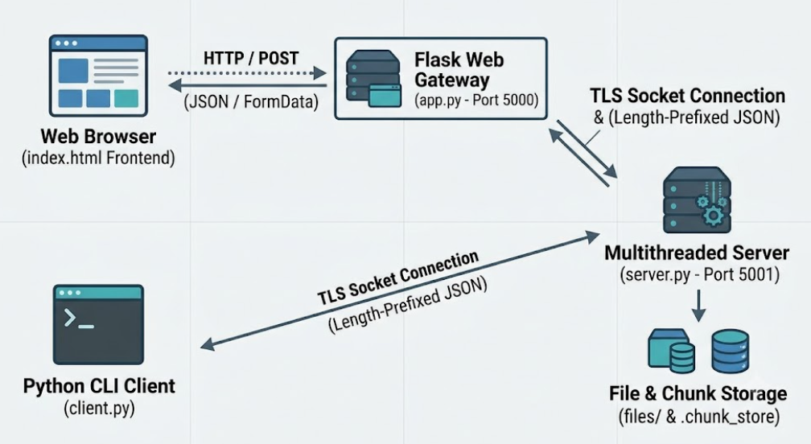
Figure 2.1 Proposed architecture
Data Flow Summary:
- Web clients submit files and credentials to Flask (`app.py`) on port 5000.
- Flask acts as a client agent, establishing a TLS socket connection to `server.py` on port 5001.
- Alternatively, terminal users connect directly to `server.py` on port 5001 via `client.py`.
- Files are chunked into 32 KB blocks. Metadata (`UPLOAD_START`) containing complete file hashes and array of chunk hashes is validated.
- The server checks `.chunk_store/<upload_id>` for existing valid chunks and responds with a list of `missing` chunk indices.
- The client/gateway sends only missing chunks using `FILE_CHUNK` metadata followed by raw binary bytes.
- Upon receiving `UPLOAD_FINISH`, the server re-verifies chunk hashes, concatenates chunks atomically into `received_<filename>`, and cleans up temporary store directories.

2.2 Tools and System Requirements
Tool or Resource | Version or Specification | Purpose
Operating System | Microsoft Windows [Version 10.0.26200.9711] | Provides the environment for development and execution.
Python | Python 3.14.0 | Implements the client, server, and performance test scripts.
Flask | Version 3.1.0 | Web framework serving HTML UI and proxying HTTP requests to TLS socket server.
Visual Studio Code | 1.141.0 | Used to write, edit, and run Python code.
OpenSSL | OpenSSL 3.0.16 11 Feb 2025 | Generates the self-signed TLS certificate and private key.
Python socket module | Python standard library | Establishes TCP connections between the client and server.
Python ssl module | Python standard library | Provides TLS functionality for encrypted communication.
Python json module | Python standard library | codes and decodes structured protocol messages.
Python struct module | Python standard library | Encodes the four-byte message length prefix.
Python threading module | Python standard library | Enables the server to handle multiple client connections concurrently.
Python hashlib module | Python standard library | Calculates SHA-256 hashes for file integrity verification.

2.3 Addressing and Protocol Selection
Device / Interface | IP / Prefix | Port | Role
Flask Web Gateway | 127.0.0.1/8 | 5000 | Serves web UI and bridges HTTP POST requests to TLS backend.
Backend TLS Server | 127.0.0.1/8 | 5001 | Listens for encrypted TCP socket connections from clients/gateways.
Loopback interface | 127.0.0.1/8 | Ephemeral | Connects directly to backend TLS server on port 5001.

Protocol Design and Key Decisions:
- TCP Communication with 4-Byte Length Prefixing: TCP is a stream-oriented protocol without native message boundaries. To prevent fragmentation issues, every JSON message is prefixed with a 4-byte unsigned integer header in network byte order (`struct.pack("!I", len(payload))`).
- TLS 1.3 Encryption: TLS secures socket communication between clients/gateways and the server. Self-signed certificates (`certs/server.crt`) are loaded into server and client SSL contexts.
- Resumable Chunked Upload Protocol (`CHUNK_SIZE = 32 KB`): Instead of transmitting files as a single stream, uploads are split into 32 KB chunks. Upload identities (`upload_id`) are deterministically derived via SHA-256 over `[username, filename, file_size, file_hash]`.
- `UPLOAD_START`: Submits file metadata and an array of chunk SHA-256 hashes. The server responds with `UPLOAD_READY` and an array of `missing` chunk indices.
- `FILE_CHUNK`: Transmits metadata for a specific chunk index followed immediately by raw binary bytes.
- `UPLOAD_FINISH`: Requests file assembly. The server re-checks all stored chunks, concatenates them into `files/received_<filename>`, verifies final SHA-256 integrity, and removes chunk store directories.
- Process Synchronization (`threading.RLock`): To prevent race conditions when multiple threads read or modify manifest files (`manifest.json`) and write chunk binaries (`chunk_<index>.bin`), critical section blocks are wrapped with `UPLOAD_LOCK` (`RLock`).
- Web Interface Integration (Flask): The Flask application (`app.py`) acts as a secure gateway. It accepts HTTP multipart uploads, processes chunk hashing in memory/spool, manages a TLS connection to `server.py`, and streams chunks to the server on behalf of web users..

3 Implementation and Technical Working

3.1 Methodology
The project was developed iteratively through the following sequential stages:
Step 1: Core TCP & Length-Prefixed JSON Socket Framing
Implemented receive_exactly(), send_json(), and receive_json() in server.py and client.py using struct.pack("!I", length) to enforce explicit message boundaries over socket buffers.
Step 2: Multithreading & TLS 1.3 Integration
Wrapped raw TCP sockets with ssl.SSLContext(ssl.PROTOCOL_TLS_SERVER) on the server and ssl.PROTOCOL_TLS_CLIENT on the client. Configured the server to spawn a dedicated thread for each client connection.
Step 3: Resumable Chunk Protocol & Lock Safety
Implemented chunked manifest creation, deterministically generated upload_id values, 32 KB chunk hash calculations, missing chunk identification, atomic chunk writing, and threading.RLock() synchronization.
Step 4: Flask Web Gateway & Frontend Portal
Created app.py to bridge web browser HTTP POST uploads to the backend TLS server. Designed templates/index.html featuring a modern interface, drag-and-drop support, real-time status display, and input validation.
Step 5: Functional & Failure Testing
Tested login validation, missing file handling, corrupted chunk detection, client disconnections during chunk transfer, multi-client concurrency, and latency profiling.
Step 6: Network Traffic Analysis
Used Wireshark on Loopback: lo0 / 127.0.0.1 to confirm TLS 1.3 handshake negotiation and payload encryption.

3.2 Configuration or Code Implementation
The project is organized into separate files for server functionality, client functionality, testing, certificates, and sample data.
Project structure
EncryptedClientServer/
├── server.py # Multithreaded TLS backend server (Port 5001)
├── client.py # CLI test client (Port 5001)
├── app.py # Flask Web Gateway application (Port 5000)
├── certs/
│ ├── server.crt # Self-signed TLS certificate
│ └── server.key # Private key file
├── files/
│ ├── .chunk_store/ # Directory holding resumable upload chunks/manifests
│ ├── sample.txt # Test upload file
│ └── received_sample.txt # Verified output file on server
└── tests/
└── performance_test.py # Round-trip latency test scriptA. Server implementation — server.py

3.3 Protocols and Technical Working
The framework combines TCP, TLS, JSON message framing, authentication, and SHA-256 hashing to perform secure client-server communication.
A. Overall communication workflow
The following sequence represents the application's intended communication flow.
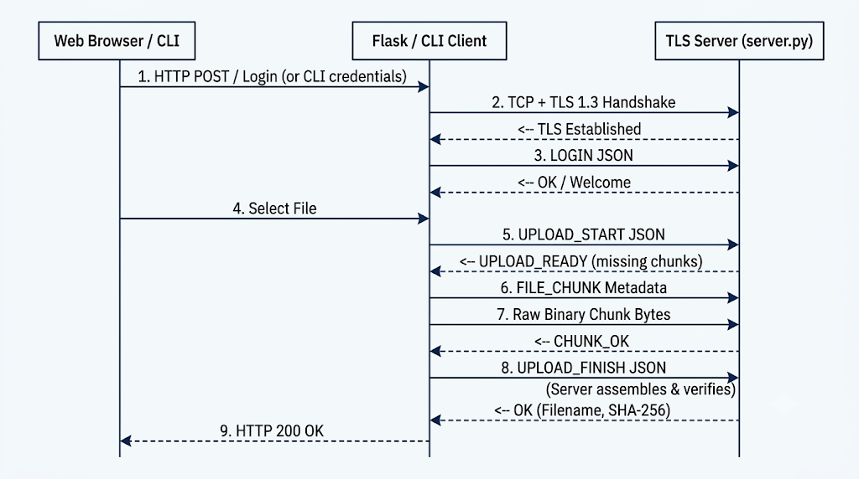
B. Chunk Integrity and Resumability
- Integrity: Each 32 KB chunk received by server.py is hashed immediately. If the calculated hash does not match manifest["chunk_hashes"][index], the chunk is discarded and an error returned.
- Resumability: If an upload drops at chunk 50 of 100, re-initiating UPLOAD_START with identical file metadata produces the same upload_id. The server scans .chunk_store/<upload_id>, validates existing chunk_0.bin through chunk_49.bin, and returns missing: [50, 51, ..., 99]. The client skips already uploaded chunks, saving time and bandwidth.

3.4 Execution Procedure
Prerequisites
- Python 3.x installed and accessible via system path.
- OpenSSL CLI utility installed for certificate generation.
- Web browser (Google Chrome, Mozilla Firefox, or Microsoft Edge).
- Project files organized in the EncryptedClientServer root directory.
- Wireshark installed (optional, for packet analysis).
File Inventory
- server.py: Multithreaded TLS backend server listening on 127.0.0.1:5001.
- app.py: Flask web gateway middleware running on 127.0.0.1:5000.
- client.py: Standalone CLI client for direct TLS socket communication.
- templates/index.html: Drag-and-drop web portal interface.
- certs/: Directory storing server.crt and server.key.
- files/: Target directory for assembled file outputs and .chunk_store uploads.
- tests/performance_test.py: Benchmark script measuring message round-trip latency.
Step-by-Step Execution Procedure
- Navigate to the Project Root Directory Open a terminal or PowerShell prompt and change directory to the project folder:
Bash
cd EncryptedClientServer

- Generate TLS Certificates (One-Time Setup) Create the certs folder and generate a self-signed TLS certificate and private key using OpenSSL:
Bash
mkdir certs
openssl req -x509 -newkey rsa:2048 -keyout certs/server.key -out certs/server.crt -days 365 -nodes -subj "/CN=localhost"

- Start the Multithreaded TLS Backend Server Launch the core backend socket server in the first terminal session:
Bash
python server.py
Expected Output:
Plaintext
==================================================
Secure Client-Server Communication Server
==================================================
Listening on 127.0.0.1:5001
TLS encryption enabled.
Maximum file size: 50 MB
Resumable upload chunk size: 32 KB
Waiting for clients...

- Launch the Flask Web Gateway Open a second terminal session, navigate to the project directory, and start the Flask web middleware:
Bash
python app.py
Expected Output:
Plaintext
Project directory: .../EncryptedClientServer
Template exists: True
TCP/TLS server: 127.0.0.1:5001
* Running on http://127.0.0.1:5000

- Execute Web-Based File Uploads (Web Portal)
  - Open a web browser and navigate to [http://127.0.0.1:5000](http://127.0.0.1:5000).
  - Input configured user credentials (e.g., Username: user1, Password: 1234).
  - Drag and drop or select a file (up to 50 MB) and click Upload & Verify.
  - Observe the UI feedback detailing the file name, size, and matching SHA-256 hash returned by the server upon atomic assembly.
- Execute Command-Line File Transfers (CLI Client Option) Open a third terminal session to test direct TLS socket operations via the interactive terminal:
Bash
python client.py

  - Enter valid credentials when prompted (user1 / 1234).
  - Send a text message by typing standard text.
  - Upload a file using the non-resumable mode: /file files/sample.txt
  - Upload or resume a chunked file transfer: /resume files/sample.txt
  - Terminate the connection: /logout
- Test Resumable Transfer Logic (Failure Simulation)
  - Initiate a large file upload using /resume via client.py or the Web UI.
  - Abort the transfer mid-way by closing the client terminal or stopping the request.
  - Re-run the upload command for the same file.
  - Confirm via server logs that previously received and verified 32 KB chunks are retained and that only missing chunk indices are requested.
- Execute Performance and Latency Benchmarks With server.py running, open another terminal and execute the latency profiling script:
Bash
python tests/performance_test.py

  - Review the console output displaying the round-trip latency measurements (in milliseconds) across multiple test iterations.
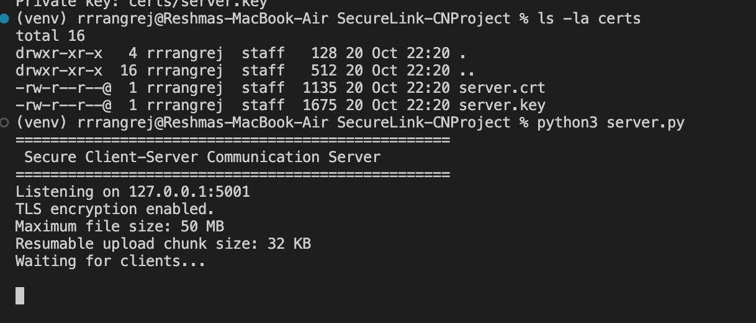
Figure 3.1 Server Initialization

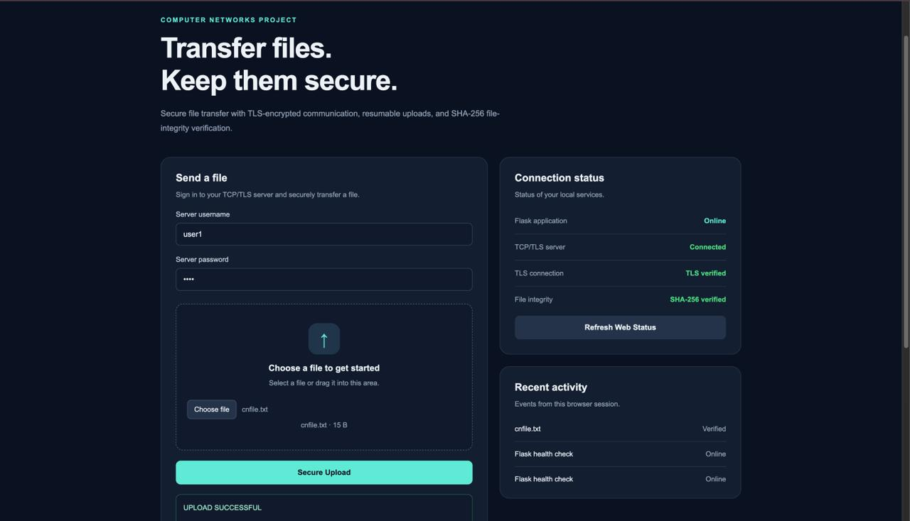Figure 3.2 Frontend Implementation Evidence

4 Testing and Results

4.1 Test Plan
Test ID | Test and Input | Expected Result | Observed Result | Status
T1 | Start server.py on port 5001 and connect client.py. | TLS handshake succeeds; secure connection established. | Connection established | Pass
T2 | Login via CLI or Web UI with valid credentials (user1 / 1234). | The server accepts the credentials and permits the session to continue. | Login succeeds | Pass
T3 | Attempt login with an incorrect password. | Authentication is rejected and access is not granted. | Login rejected | Pass
T4 | Send a text message using the MESSAGE operation. | The server processes the message and returns the expected response. | Message delivered | Pass
T5 | Perform resumable upload of sample.txt via /resume or Web UI. | File uploaded in 32 KB chunks; assembled; SHA-256 verified. | Upload verified | Pass
T6 | Interrupt upload mid-transfer, then re-issue upload command for same file. | Server identifies previously verified chunks and requests only missing chunks. | Resume successful | Pass
T7 | Attempt upload with non-existent file path. | Client/Gateway displays file access error. | Error displayed | Pass
T8 | Perform login and upload via Flask Web Gateway | Flask proxies upload over TLS to backend; displays results on web UI. | Gateway operational | Pass
T9 | Connect multiple simultaneous clients (CLI + Web UI). | Multithreaded server processes connections concurrently without state collision. | Multi-client success | Pass
T10 | Execute tests/performance_test.py. | Measures round-trip message latency. | Latency reported | Pass

4.2 Results and Execution Evidence
Figure 4.1 — Client-server execution and TLS connection setup
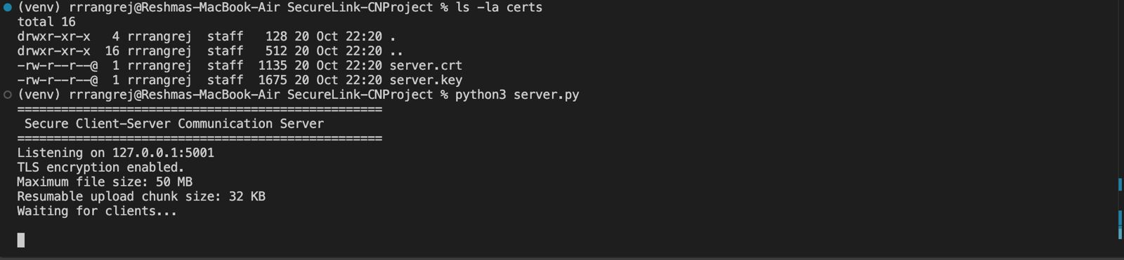
Interpretation: Demonstrates successful initialization of the TLS backend on port 5001 and secure socket establishment.
Figure 4.2 — Authentication and message exchange terminal log
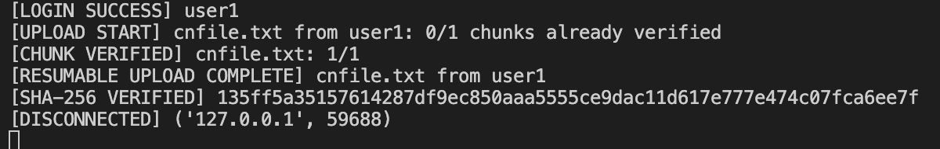
Interpretation: Confirms valid user credential validation and session initiation over TLS.
Figure 4.3 — File transfer and integrity verification
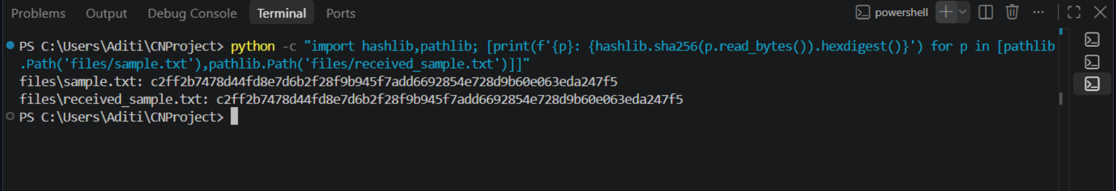
Interpretation: Successful file reception demonstrates that the transfer operation completed. Matching SHA-256 hashes provide evidence that the received content matches the content represented by the sender's hash.
Figure 4.4 — Performance test output
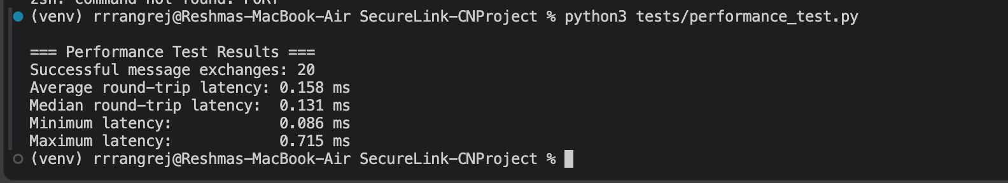
Interpretation: The measured latency indicates the time taken for a message request and its corresponding response under the tested local conditions.

4.3 Objective Achievement
Objective ID | Evidence or Test ID | Outcome
O1- Establish TCP client-server communication | T1, T8: Client and Flask Gateway socket connections | Achieved
O2- Implement TLS encryption | T11: Wireshark packet capture showing TLS 1.3 records | Achieved
O3- Implement basic authentication | T2, T3: Credential verification tests | Achieved
O4 - Messaging & UI | T4, T8: CLI messaging and Web UI interaction | Achieved
O5 - Resumable Uploads | T5, T6: 32 KB chunked transfer, resume logic, SHA-256 verification | Achieved
O6 - Multithreading & Locks | T9: Simultaneous CLI and Web UI uploads with RLock thread safety | Achieved
O7 - Performance & Errors | T7, T10: Latency benchmarks and failure condition handling | Achieved

5 Discussion and Conclusion

5.1 Discussion and Comparative Analysis
The project demonstrates how several networking and security mechanisms can be integrated into a single client-server application. TCP provides reliable, ordered byte delivery, while TLS adds encryption to the communication channel. JSON provides a structured application-message format, and length-prefix framing allows the receiver to determine message boundaries over the TCP stream.
The authentication mechanism introduces a basic access check before the client uses the application's communication functions. File transfer extends the framework beyond text messaging, while SHA-256 hash comparison provides a way to check whether the received file content matches the expected content.
A qualitative comparison with an unencrypted TCP application highlights the role of TLS.
Criterion | Plain TCP Application | Implemented Framework
Transport | TCP | TCP + TLS 1.3 (Backend) + HTTP Gateway (Frontend)
Framing | Unframed byte stream | 4-byte length prefix (!I) preventing socket buffer splitting
File Transfer | Monolithic stream | Resumable 32 KB chunk protocol with delta uploading
File integrity checking | Not inherently provided | SHA-256 hash comparison
Concurrent connections | Depends on implementation | Thread-based server handling

5.2 Advantages and Applications
- High Upload Resiliency: Network drops during large file transfers require uploading only missing 32 KB chunks upon reconnection.
- Web Accessibility: Non-technical users can interact with the secure TLS backend through a modern web browser portal.
- Strict Data Integrity: Double-pass SHA-256 validation guarantees that corrupted chunks are rejected prior to final assembly.
- Concurrency Safety: Thread-safe locking (RLock) ensures atomic file operations during concurrent client sessions.

5.3 Limitations
- Local Certificate Context: Uses a self-signed OpenSSL certificate, requiring manual browser or client trust overrides.
- Hardcoded User Store: User credentials reside in a server dictionary (USERS); production environments require database integration with salted password hashing (e.g., bcrypt).
- Fixed Chunk Size: The chunk size is fixed at 32 KB; adaptive chunk sizing based on network conditions could optimize throughput.

5.4 Challenges and Troubleshooting
During development, the following troubleshooting cases are relevant to the implementation.
Issue | Cause or Diagnosis | Solution and Verification
ConnectionRefusedError when running the client | The server was not running or was no longer listening on the configured address and port. | Start server.py first, keep it running, and retry the client. Verify that the client connects successfully.
TLS connection failure | The certificate or private-key path may be incorrect, or the TLS configuration may not match. | Check the certificate files and TLS configuration, restart the server, and retry the connection.
Incorrect message parsing | TCP may deliver a message in multiple chunks rather than one complete message. | Use the four-byte length prefix and read the specified number of bytes before decoding the JSON payload.

5.5 Future Scope
The framework can be extended in several ways:
- Database & OAuth2 Integration: Replace static credentials with SQL/NoSQL databases and token-based authentication.
- Live Upload Progress Bars: Add WebSockets or Server-Sent Events (SSE) to display real-time chunk progress on the web frontend.
- Adaptive Chunking: Dynamically scale chunk sizes (32 KB to 1 MB) based on connection bandwidth and latency metrics

5.6 Conclusion
The Encrypted Client-Server Communication Framework successfully demonstrates an end-to-end secure, resilient file transfer and messaging platform. By integrating TCP socket programming, TLS 1.3 encryption, Flask web gateway middleware, resumable chunked uploading, and SHA-256 integrity verification, the system addresses security, usability, and network reliability challenges. Rigorous testing confirmed that files are securely transmitted, verified, and resumed across disconnections, providing a solid foundation for secure network application design.

References
[1] W. Eddy, Ed., “Transmission Control Protocol (TCP),” RFC 9293, Internet Engineering Task Force (IETF), Aug. 2022. [Online]. Available: https://www.rfc-editor.org/rfc/rfc9293.html. [Accessed: Oct. 8, 2026].
[2] E. Rescorla, “The Transport Layer Security (TLS) Protocol Version 1.3,” RFC 9846, Internet Engineering Task Force (IETF), Jul. 2026. [Online]. Available: https://www.rfc-editor.org/rfc/rfc9846.html. [Accessed: Oct. 8, 2026].
[3] Python Software Foundation, “Python 3 Documentation: socket, ssl, json, struct, threading, and hashlib Modules.” [Online]. Available: https://docs.python.org/3/library/. [Accessed: Oct. 8, 2026].
[4] Wireshark Foundation, “Wireshark User’s Guide.” [Online]. Available: https://www.wireshark.org/docs/wsug_html/. [Accessed: Oct. 8, 2026].
[5] OpenSSL Project, “OpenSSL Documentation.” [Online]. Available: https://docs.openssl.org/. [Accessed: Oct. 8, 2026].

AI Usage Declaration
We acknowledge the use of ChatGPT by OpenAI as an AI-assisted tool during the preparation of this project report and the development process. It was used to assist with understanding networking concepts, explaining implementation approaches, suggesting code structures, troubleshooting technical issues, and improving the clarity, organization, and language of the report.
The generated material was reviewed by the team and compared with the project implementation, relevant technical documentation, and available test evidence. The team is responsible for ensuring that the submitted code, observations, test results, and conclusions accurately reflect the work completed. AI-generated suggestions have not been treated as experimental evidence; reported results are based on tests actually performed.
Declaration: We take responsibility for the accuracy of this report and understand the submitted implementation and results. Sources and assistance used have been acknowledged.
Student Name | PRN | Signature
Aditi Pathak | 1262240936
Shraddha Pawar | 1262241161
Rashi Rangrej | 1262241175
Niyati Priyani | 1262241237

Appendices

Appendix A Code and Configuration
This appendix contains the source code and configuration files used to implement the Encrypted Client-Server Communication Framework.
A.1 Multithreaded TLS Backend Server — server.py
import hashlib
import json
import os
import shutil
import socket
import ssl
import struct
import threading
from pathlib import Path

# =========================
# SERVER CONFIGURATION
# =========================

HOST = "127.0.0.1"
PORT = 5001

USERS = {
"user1": "1234",
"user2": "5678",
"shraddha": "python123",
}

MAX_MESSAGE_SIZE = 1024 * 1024 # 1 MB
MAX_FILE_SIZE = 50 * 1024 * 1024 # 50 MB
CHUNK_SIZE = 32 * 1024 # 32 KB

FILES_DIR = Path("files")
FILES_DIR.mkdir(exist_ok=True)

CHUNK_STORE = FILES_DIR / ".chunk_store"
CHUNK_STORE.mkdir(exist_ok=True)

# Protects operations on upload manifests and chunk files within this process.
UPLOAD_LOCK = threading.RLock()

# =========================
# NETWORK COMMUNICATION
# =========================

def receive_exactly(sock, size):
"""Receive exactly size bytes, even if TCP delivers them in pieces."""
if size < 0:
raise ValueError("Invalid byte count.")

chunks = []
remaining = size

while remaining > 0:
chunk = sock.recv(min(4096, remaining))

if not chunk:
if not chunks:
return None
raise ConnectionError("Connection closed during data transfer.")

chunks.append(chunk)
remaining -= len(chunk)

return b"".join(chunks)

def send_json(sock, data):
"""Send JSON with a 4-byte network-order length prefix."""
payload = json.dumps(data).encode("utf-8")

if len(payload) > MAX_MESSAGE_SIZE:
raise ValueError("Message is too large.")

header = struct.pack("!I", len(payload))
sock.sendall(header + payload)

def receive_json(sock):
"""Receive one length-prefixed JSON message."""
header = receive_exactly(sock, 4)

if header is None:
return None

size = struct.unpack("!I", header)[0]

if size == 0 or size > MAX_MESSAGE_SIZE:
raise ValueError("Invalid JSON message size.")

payload = receive_exactly(sock, size)

if payload is None:
raise ConnectionError("Incomplete JSON message.")

return json.loads(payload.decode("utf-8"))

def send_error(sock, message):
send_json(sock, {
"type": "ERROR",
"message": message,
})

# =========================
# VALIDATION HELPERS
# =========================

def valid_sha256(value):
"""Return True if value is a 64-character hexadecimal SHA-256 hash."""
if not isinstance(value, str) or len(value) != 64:
return False

try:
int(value, 16)
return True
except ValueError:
return False

def valid_filename(filename):
"""Reject empty names and path traversal attempts."""
if not isinstance(filename, str):
return False

if not filename or filename in {".", ".."}:
return False

if len(filename) > 200:
return False

if "/" in filename or "\\" in filename:
return False

if Path(filename).name != filename:
return False

if any(ord(char) < 32 for char in filename):
return False

return True

def upload_directory(upload_id):
"""Only accept server-generated SHA-256-shaped upload IDs."""
if not valid_sha256(upload_id):
raise ValueError("Invalid upload ID.")

return CHUNK_STORE / upload_id.lower()

def read_manifest(folder):
"""Read and validate an upload manifest."""
manifest_path = folder / "manifest.json"

with manifest_path.open("r", encoding="utf-8") as file:
manifest = json.load(file)

if not isinstance(manifest, dict):
raise ValueError("Invalid upload manifest.")

filename = manifest.get("filename")
file_size = manifest.get("file_size")
file_hash = manifest.get("sha256")
chunk_size = manifest.get("chunk_size")
chunk_hashes = manifest.get("chunk_hashes")
username = manifest.get("username")

if not valid_filename(filename):
raise ValueError("Invalid filename in upload manifest.")

if type(file_size) is not int or not 0 <= file_size <= MAX_FILE_SIZE:
raise ValueError("Invalid file size in upload manifest.")

if not valid_sha256(file_hash):
raise ValueError("Invalid file hash in upload manifest.")

if chunk_size != CHUNK_SIZE:
raise ValueError("Invalid chunk size in upload manifest.")

if not isinstance(username, str):
raise ValueError("Invalid upload owner.")

if not isinstance(chunk_hashes, list):
raise ValueError("Invalid chunk hash list.")

expected_count = (
(file_size + CHUNK_SIZE - 1) // CHUNK_SIZE
)

if len(chunk_hashes) != expected_count:
raise ValueError("Invalid number of chunk hashes.")

if not all(valid_sha256(item) for item in chunk_hashes):
raise ValueError("Invalid chunk hash.")

return manifest

def expected_chunk_length(manifest, index):
"""Calculate the expected byte length of a chunk."""
total_chunks = len(manifest["chunk_hashes"])

if type(index) is not int or not 0 <= index < total_chunks:
raise ValueError("Invalid chunk index.")

if index < total_chunks - 1:
return CHUNK_SIZE

return manifest["file_size"] - index * CHUNK_SIZE

def find_missing_chunks(folder, manifest):
"""
Return chunks that are absent or fail their stored SHA-256 check.
Existing valid chunks can be reused after a reconnect.
"""
missing = []

for index, expected_hash in enumerate(manifest["chunk_hashes"]):
chunk_path = folder / f"chunk_{index}.bin"
expected_length = expected_chunk_length(manifest, index)

if not chunk_path.is_file():
missing.append(index)
continue

try:
if chunk_path.stat().st_size != expected_length:
chunk_path.unlink(missing_ok=True)
missing.append(index)
continue

digest = hashlib.sha256()

with chunk_path.open("rb") as file:
while True:
data = file.read(4096)
if not data:
break
digest.update(data)

if digest.hexdigest() != expected_hash.lower():
chunk_path.unlink(missing_ok=True)
missing.append(index)

except OSError:
missing.append(index)

return missing

# =========================
# ORIGINAL FILE TRANSFER
# =========================

def receive_file(sock, request, username):
"""Receive a complete file using the original /file protocol."""
filename = request.get("filename")
file_size = request.get("file_size")
expected_hash = request.get("sha256")

if not valid_filename(filename):
send_error(sock, "Invalid filename.")
return

if type(file_size) is not int or not 0 <= file_size <= MAX_FILE_SIZE:
send_error(sock, "Invalid file size. Maximum size is 50 MB.")
return

if not valid_sha256(expected_hash):
send_error(sock, "Invalid SHA-256 hash.")
return

destination = FILES_DIR / f"received_{filename}"
temporary = FILES_DIR / (
f".upload_{threading.get_ident()}.tmp"
)

digest = hashlib.sha256()
remaining = file_size

try:
with temporary.open("wb") as output:
while remaining > 0:
data = sock.recv(min(4096, remaining))

if not data:
raise ConnectionError(
"Connection closed during file transfer."
)

output.write(data)
digest.update(data)
remaining -= len(data)

actual_hash = digest.hexdigest()

if actual_hash.lower() != expected_hash.lower():
temporary.unlink(missing_ok=True)

send_json(sock, {
"type": "ERROR",
"message": "SHA-256 mismatch. File rejected.",
"sha256": actual_hash,
})

print(f"[HASH MISMATCH] {filename} from {username}")
return

os.replace(temporary, destination)

print(f"[FILE RECEIVED] {filename} from {username}")
print(f"[SHA-256 VERIFIED] {actual_hash}")

send_json(sock, {
"type": "OK",
"message": "File received and SHA-256 verified.",
"filename": filename,
"sha256": actual_hash,
})

finally:
temporary.unlink(missing_ok=True)

# =========================
# RESUMABLE FILE TRANSFER
# =========================

def handle_upload_start(sock, request, username):
"""
Start or resume an upload.

The server creates a stable upload ID from the authenticated username,
filename, file size, and complete-file hash. Valid chunks already on
disk are retained across client disconnections and server restarts.
"""
filename = request.get("filename")
file_size = request.get("file_size")
file_hash = request.get("sha256")
chunk_size = request.get("chunk_size")
chunk_hashes = request.get("chunk_hashes")

if not valid_filename(filename):
send_error(sock, "Invalid filename.")
return

if type(file_size) is not int or not 0 <= file_size <= MAX_FILE_SIZE:
send_error(sock, "Invalid file size. Maximum size is 50 MB.")
return

if not valid_sha256(file_hash):
send_error(sock, "Invalid complete-file SHA-256 hash.")
return

if chunk_size != CHUNK_SIZE:
send_error(
sock,
f"Chunk size must be {CHUNK_SIZE} bytes."
)
return

if not isinstance(chunk_hashes, list):
send_error(sock, "Invalid chunk hash list.")
return

expected_count = (
(file_size + CHUNK_SIZE - 1) // CHUNK_SIZE
)

if len(chunk_hashes) != expected_count:
send_error(sock, "Incorrect number of chunk hashes.")
return

if not all(valid_sha256(item) for item in chunk_hashes):
send_error(sock, "One or more chunk hashes are invalid.")
return

normalized_hash = file_hash.lower()
normalized_chunk_hashes = [
item.lower() for item in chunk_hashes
]

upload_identity = json.dumps(
[
username,
filename,
file_size,
normalized_hash,
],
separators=(",", ":"),
).encode("utf-8")

upload_id = hashlib.sha256(upload_identity).hexdigest()
folder = upload_directory(upload_id)

manifest = {
"username": username,
"filename": filename,
"file_size": file_size,
"sha256": normalized_hash,
"chunk_size": CHUNK_SIZE,
"chunk_hashes": normalized_chunk_hashes,
}

with UPLOAD_LOCK:
folder.mkdir(parents=True, exist_ok=True)
manifest_path = folder / "manifest.json"

if manifest_path.exists():
try:
existing = read_manifest(folder)
except (OSError, ValueError, json.JSONDecodeError):
send_error(sock, "Existing upload metadata is invalid.")
return

if existing != manifest:
send_error(
sock,
"Upload metadata does not match the existing upload."
)
return
else:
temporary_manifest = folder / "manifest.tmp"

with temporary_manifest.open(
"w", encoding="utf-8"
) as file:
json.dump(manifest, file)

os.replace(temporary_manifest, manifest_path)

missing = find_missing_chunks(folder, manifest)

total_chunks = len(normalized_chunk_hashes)
received_chunks = total_chunks - len(missing)

print(
f"[UPLOAD START] {filename} from {username}: "
f"{received_chunks}/{total_chunks} chunks already verified"
)

send_json(sock, {
"type": "UPLOAD_READY",
"upload_id": upload_id,
"missing": missing,
"total_chunks": total_chunks,
})

def handle_file_chunk(sock, request, username):
"""
Receive one chunk and verify it before saving it.

If chunk metadata is invalid before the raw bytes are read, close the
connection rather than leaving unread bytes to corrupt the protocol.
"""
upload_id = request.get("upload_id")
index = request.get("index")
declared_size = request.get("chunk_size")

if not valid_sha256(upload_id):
raise ConnectionError("Invalid upload ID in chunk request.")

folder = upload_directory(upload_id)

with UPLOAD_LOCK:
try:
manifest = read_manifest(folder)
except (OSError, ValueError, json.JSONDecodeError) as error:
raise ConnectionError(
"Upload manifest is missing or invalid."
) from error

if manifest["username"] != username:
raise ConnectionError("Upload owner mismatch.")

try:
expected_size = expected_chunk_length(manifest, index)
except ValueError as error:
raise ConnectionError("Invalid chunk index.") from error

if type(declared_size) is not int or declared_size != expected_size:
raise ConnectionError("Invalid chunk size.")

# Read the declared, validated number of raw bytes.
data = receive_exactly(sock, expected_size)

if data is None:
raise ConnectionError("Connection closed before chunk data arrived.")

actual_hash = hashlib.sha256(data).hexdigest()
expected_hash = manifest["chunk_hashes"][index].lower()

if actual_hash != expected_hash:
send_json(sock, {
"type": "ERROR",
"message": f"SHA-256 mismatch for chunk {index}.",
"index": index,
})

print(f"[CHUNK REJECTED] {upload_id}, chunk {index}")
return

with UPLOAD_LOCK:
# Re-read metadata in case the upload changed while bytes arrived.
current_manifest = read_manifest(folder)

if current_manifest != manifest:
raise ConnectionError("Upload metadata changed unexpectedly.")

destination = folder / f"chunk_{index}.bin"
temporary = folder / f"chunk_{index}.tmp"

with temporary.open("wb") as file:
file.write(data)

os.replace(temporary, destination)

send_json(sock, {
"type": "CHUNK_OK",
"index": index,
"sha256": actual_hash,
})

print(
f"[CHUNK VERIFIED] {manifest['filename']}: "
f"{index + 1}/{len(manifest['chunk_hashes'])}"
)

def handle_upload_finish(sock, request, username):
"""Assemble verified chunks and verify the complete file."""
upload_id = request.get("upload_id")

if not valid_sha256(upload_id):
send_error(sock, "Invalid upload ID.")
return

folder = upload_directory(upload_id)

with UPLOAD_LOCK:
try:
manifest = read_manifest(folder)
except (OSError, ValueError, json.JSONDecodeError):
send_error(sock, "Upload metadata is missing or invalid.")
return

if manifest["username"] != username:
send_error(sock, "You do not own this upload.")
return

missing = find_missing_chunks(folder, manifest)

if missing:
send_json(sock, {
"type": "ERROR",
"message": "Upload is incomplete.",
"missing": missing,
})
return

filename = manifest["filename"]
file_size = manifest["file_size"]
expected_hash = manifest["sha256"].lower()

temporary = FILES_DIR / f".assembled_{upload_id}.tmp"
destination = FILES_DIR / f"received_{filename}"

digest = hashlib.sha256()
assembled_size = 0

try:
with temporary.open("wb") as output:
for index in range(len(manifest["chunk_hashes"])):
chunk_path = folder / f"chunk_{index}.bin"
expected_length = expected_chunk_length(
manifest, index
)
expected_chunk_hash = (
manifest["chunk_hashes"][index].lower()
)

# Verify again during assembly. This also detects
# changes to stored chunk files before finalization.
chunk_digest = hashlib.sha256()
chunk_length = 0

with chunk_path.open("rb") as chunk_file:
while True:
data = chunk_file.read(4096)

if not data:
break

chunk_digest.update(data)
digest.update(data)
output.write(data)

chunk_length += len(data)
assembled_size += len(data)

if chunk_length != expected_length:
send_error(
sock,
f"Stored chunk {index} has an invalid size."
)
return

if chunk_digest.hexdigest() != expected_chunk_hash:
send_error(
sock,
f"Stored chunk {index} failed verification."
)
return

actual_hash = digest.hexdigest()

if assembled_size != file_size:
send_error(sock, "Final file size does not match.")
return

if actual_hash != expected_hash:
send_json(sock, {
"type": "ERROR",
"message": "Complete-file SHA-256 mismatch.",
"sha256": actual_hash,
})

print(f"[FINAL HASH MISMATCH] {filename}")
return

os.replace(temporary, destination)
shutil.rmtree(folder)

print(f"[RESUMABLE UPLOAD COMPLETE] {filename} from {username}")
print(f"[SHA-256 VERIFIED] {actual_hash}")

send_json(sock, {
"type": "OK",
"message": "Resumable upload completed and SHA-256 verified.",
"filename": filename,
"sha256": actual_hash,
})

finally:
temporary.unlink(missing_ok=True)

# =========================
# CLIENT REQUEST HANDLER
# =========================

def handle_client(secure_socket, address):
print(f"[CONNECTED] {address}")

authenticated_user = None

try:
while True:
request = receive_json(secure_socket)

if request is None:
break

if not isinstance(request, dict):
send_error(secure_socket, "Request must be a JSON object.")
continue

request_type = request.get("type")

# LOGIN
if request_type == "LOGIN":
username = request.get("username")
password = request.get("password")

if (
isinstance(username, str)
and isinstance(password, str)
and USERS.get(username) == password
):
authenticated_user = username

print(f"[LOGIN SUCCESS] {username}")

send_json(secure_socket, {
"type": "OK",
"message": "Login successful.",
"username": username,
})
else:
print(f"[LOGIN FAILED] {address}")

send_error(
secure_socket,
"Invalid username or password."
)

# MESSAGE
elif request_type == "MESSAGE":
if authenticated_user is None:
send_error(
secure_socket,
"Please log in before sending messages."
)
continue

message = request.get("message")

if not isinstance(message, str) or not message.strip():
send_error(secure_socket, "Message cannot be empty.")
continue

if len(message) > 5000:
send_error(
secure_socket,
"Message exceeds the 5000-character limit."
)
continue

print(f"[MESSAGE] {authenticated_user}: {message}")

send_json(secure_socket, {
"type": "OK",
"message": "Message received securely.",
})

# ORIGINAL NON-RESUMABLE FILE TRANSFER
elif request_type == "FILE":
if authenticated_user is None:
send_error(
secure_socket,
"Please log in before uploading files."
)
continue

receive_file(
secure_socket,
request,
authenticated_user,
)

# START OR RESUME AN UPLOAD
elif request_type == "UPLOAD_START":
if authenticated_user is None:
send_error(
secure_socket,
"Please log in before uploading files."
)
continue

handle_upload_start(
secure_socket,
request,
authenticated_user,
)

# RECEIVE ONE CHUNK
elif request_type == "FILE_CHUNK":
if authenticated_user is None:
# A conforming client sends no raw chunk before login.
send_error(
secure_socket,
"Please log in before uploading files."
)
continue

handle_file_chunk(
secure_socket,
request,
authenticated_user,
)

# ASSEMBLE AND VERIFY UPLOAD
elif request_type == "UPLOAD_FINISH":
if authenticated_user is None:
send_error(
secure_socket,
"Please log in before finishing an upload."
)
continue

handle_upload_finish(
secure_socket,
request,
authenticated_user,
)

# LOGOUT
elif request_type == "LOGOUT":
send_json(secure_socket, {
"type": "OK",
"message": "Logged out successfully.",
})

break

else:
send_error(secure_socket, "Unknown request type.")

except (ConnectionError, ssl.SSLError, OSError) as error:
print(f"[CONNECTION ERROR] {address}: {error}")

except (
ValueError,
json.JSONDecodeError,
UnicodeDecodeError,
) as error:
print(f"[INVALID REQUEST] {address}: {error}")

try:
send_error(secure_socket, "Invalid request data.")
except (OSError, ssl.SSLError):
pass

finally:
try:
secure_socket.close()
except OSError:
pass

print(f"[DISCONNECTED] {address}")

# =========================
# START TLS SERVER
# =========================

def start_server():
context = ssl.SSLContext(ssl.PROTOCOL_TLS_SERVER)

context.load_cert_chain(
certfile="certs/server.crt",
keyfile="certs/server.key",
)

server = socket.socket(socket.AF_INET, socket.SOCK_STREAM)
server.setsockopt(socket.SOL_SOCKET, socket.SO_REUSEADDR, 1)

try:
server.bind((HOST, PORT))
server.listen()

print("=" * 50)
print(" Secure Client-Server Communication Server")
print("=" * 50)
print(f"Listening on {HOST}:{PORT}")
print("TLS encryption enabled.")
print(f"Maximum file size: {MAX_FILE_SIZE // (1024 * 1024)} MB")
print(f"Resumable upload chunk size: {CHUNK_SIZE // 1024} KB")
print("Waiting for clients...\n")

while True:
raw_socket, address = server.accept()

try:
secure_socket = context.wrap_socket(
raw_socket,
server_side=True,
)

except (ssl.SSLError, OSError) as error:
print(f"[TLS HANDSHAKE FAILED] {address}: {error}")
raw_socket.close()
continue

thread = threading.Thread(
target=handle_client,
args=(secure_socket, address),
daemon=True,
)
thread.start()

except KeyboardInterrupt:
print("\n[SERVER STOPPED] Shutting down server.")

finally:
server.close()

if __name__ == "__main__":
start_server()

A.2 Flask Web Gateway — app.py
from pathlib import Path
import hashlib
import json
import socket
import ssl
import struct

from flask import Flask, jsonify, render_template, request

BASE_DIR = Path(__file__).resolve().parent
TEMPLATE_DIR = BASE_DIR / "templates"
CERT_FILE = BASE_DIR / "certs" / "server.crt"

app = Flask(__name__, template_folder=str(TEMPLATE_DIR))
app.config["MAX_CONTENT_LENGTH"] = 50 * 1024 * 1024

# Flask and the TCP/TLS server must use different ports.
TCP_HOST = "127.0.0.1"
TCP_PORT = 5001

MAX_MESSAGE_SIZE = 1024 * 1024
MAX_FILE_SIZE = 50 * 1024 * 1024
CHUNK_SIZE = 32 * 1024

# =========================
# TCP/TLS COMMUNICATION
# =========================

def receive_exactly(sock, size):
"""Receive exactly the requested number of bytes."""
if size < 0:
raise ValueError("Invalid byte count.")

chunks = []
remaining = size

while remaining:
data = sock.recv(min(4096, remaining))

if not data:
raise ConnectionError("Connection closed during transfer.")

chunks.append(data)
remaining -= len(data)

return b"".join(chunks)

def send_json(sock, data):
"""Send a JSON message with a four-byte length prefix."""
payload = json.dumps(data).encode("utf-8")

if not payload or len(payload) > MAX_MESSAGE_SIZE:
raise ValueError("Invalid JSON message size.")

sock.sendall(struct.pack("!I", len(payload)) + payload)

def receive_json(sock):
"""Receive one length-prefixed JSON message."""
header = receive_exactly(sock, 4)
size = struct.unpack("!I", header)[0]

if size == 0 or size > MAX_MESSAGE_SIZE:
raise ValueError("Invalid response size.")

payload = receive_exactly(sock, size)
response = json.loads(payload.decode("utf-8"))

if not isinstance(response, dict):
raise ValueError("Invalid server response.")

return response

def connect_and_login(username, password):
"""Create a verified TLS connection and authenticate."""
if not CERT_FILE.is_file():
raise FileNotFoundError(
f"TLS certificate not found: {CERT_FILE}"
)

context = ssl.create_default_context(cafile=str(CERT_FILE))

raw_socket = socket.create_connection(
(TCP_HOST, TCP_PORT),
timeout=30,
)

try:
secure_socket = context.wrap_socket(
raw_socket,
server_hostname="localhost",
)
secure_socket.settimeout(120)

send_json(secure_socket, {
"type": "LOGIN",
"username": username,
"password": password,
})

response = receive_json(secure_socket)

if response.get("type") != "OK":
secure_socket.close()
raise PermissionError(
response.get("message", "Login failed.")
)

return secure_socket

except Exception:
raw_socket.close()
raise

# =========================
# RESUMABLE FILE UPLOAD
# =========================

def upload_to_tcp_server(file, filename, username, password):
"""Send the browser-uploaded file through the existing TLS protocol."""
digest = hashlib.sha256()
chunk_hashes = []
file_size = 0

# First pass: calculate the whole-file hash and chunk hashes.
while True:
data = file.stream.read(CHUNK_SIZE)

if not data:
break

file_size += len(data)

if file_size > MAX_FILE_SIZE:
raise ValueError("File exceeds the 50 MB upload limit.")

digest.update(data)
chunk_hashes.append(hashlib.sha256(data).hexdigest())

file_hash = digest.hexdigest()
file.stream.seek(0)

with connect_and_login(username, password) as sock:
# Tell the server about the file.
send_json(sock, {
"type": "UPLOAD_START",
"filename": filename,
"file_size": file_size,
"sha256": file_hash,
"chunk_size": CHUNK_SIZE,
"chunk_hashes": chunk_hashes,
})

response = receive_json(sock)

if response.get("type") != "UPLOAD_READY":
raise RuntimeError(
response.get("message", "Server rejected the upload.")
)

upload_id = response.get("upload_id")
missing = response.get("missing")

if (
not isinstance(upload_id, str)
or not isinstance(missing, list)
or any(
type(index) is not int
or index < 0
or index >= len(chunk_hashes)
for index in missing
)
or len(set(missing)) != len(missing)
):
raise RuntimeError("Invalid upload response from server.")

# Send only chunks the server does not already have.
for index in missing:
file.stream.seek(index * CHUNK_SIZE)
data = file.stream.read(CHUNK_SIZE)

if hashlib.sha256(data).hexdigest() != chunk_hashes[index]:
raise RuntimeError("File changed during upload.")

send_json(sock, {
"type": "FILE_CHUNK",
"upload_id": upload_id,
"index": index,
"chunk_size": len(data),
})

sock.sendall(data)

response = receive_json(sock)

if (
response.get("type") != "CHUNK_OK"
or response.get("index") != index
):
raise RuntimeError(
response.get("message", f"Chunk {index} failed.")
)

# Ask the server to assemble and verify the completed file.
send_json(sock, {
"type": "UPLOAD_FINISH",
"upload_id": upload_id,
})

response = receive_json(sock)

if response.get("type") != "OK":
raise RuntimeError(
response.get("message", "Final file verification failed.")
)

server_hash = response.get("sha256")

if server_hash != file_hash:
raise RuntimeError("Server and client SHA-256 hashes differ.")

return {
"status": "success",
"filename": filename,
"size_bytes": file_size,
"sha256": file_hash,
"server_sha256": server_hash,
"message": response.get(
"message",
"File uploaded and verified successfully.",
),
}

# =========================
# FLASK ROUTES
# =========================

@app.route("/")
def home():
return render_template("index.html")

@app.route("/api/health")
def health():
return jsonify({
"status": "running",
"message": "SecureLink Flask app is running.",
})

@app.route("/api/upload", methods=["POST"])
def upload_file():
if "file" not in request.files:
return jsonify({"error": "No file was provided."}), 400

file = request.files["file"]

if not file.filename:
return jsonify({"error": "Please select a file."}), 400

# Prevent a submitted path from becoming a destination path.
filename = file.filename.replace("\\", "/").split("/")[-1]

if (
not filename
or filename in {".", ".."}
or any(ord(char) < 32 for char in filename)
):
return jsonify({"error": "Invalid filename."}), 400

# The existing TCP/TLS server requires authentication.
username = request.form.get("username", "").strip()
password = request.form.get("password", "")

if not username or not password:
return jsonify({
"error": "Enter your TCP server username and password."
}), 400

try:
result = upload_to_tcp_server(
file,
filename,
username,
password,
)
return jsonify(result)

except PermissionError as error:
return jsonify({"error": str(error)}), 401

except (ConnectionError, socket.timeout, TimeoutError) as error:
return jsonify({
"error": f"Could not complete the transfer: {error}"
}), 502

except FileNotFoundError as error:
return jsonify({"error": str(error)}), 500

except (ssl.SSLError, OSError) as error:
return jsonify({
"error": f"TLS/network error: {error}"
}), 502

except (ValueError, json.JSONDecodeError) as error:
return jsonify({
"error": f"Invalid communication data: {error}"
}), 502

except RuntimeError as error:
return jsonify({"error": str(error)}), 502

@app.errorhandler(413)
def file_too_large(error):
return jsonify({
"error": "File exceeds the 50 MB upload limit."
}), 413

if __name__ == "__main__":
print("Project directory:", BASE_DIR)
print("Template exists:", (TEMPLATE_DIR / "index.html").is_file())
print(f"TCP/TLS server: {TCP_HOST}:{TCP_PORT}")
app.run(debug=True, port=5000)

A.3 Client.py
import hashlib
import time
import json
import socket
import ssl
import struct
from pathlib import Path

# =========================
# CLIENT CONFIGURATION
# =========================

HOST = "127.0.0.1"
PORT = 5001

MAX_MESSAGE_SIZE = 1024 * 1024 # 1 MB
MAX_FILE_SIZE = 50 * 1024 * 1024 # 50 MB
CHUNK_SIZE = 32 * 1024 # 32 KB

# =========================
# NETWORK COMMUNICATION
# =========================

def receive_exactly(sock, size):
"""Receive exactly size bytes over TCP."""
if size < 0:
raise ValueError("Invalid byte count.")

chunks = []
remaining = size

while remaining > 0:
chunk = sock.recv(min(4096, remaining))

if not chunk:
if not chunks:
return None
raise ConnectionError("Connection closed during data transfer.")

chunks.append(chunk)
remaining -= len(chunk)

return b"".join(chunks)

def send_json(sock, data):
"""Send JSON with a 4-byte length prefix."""
payload = json.dumps(data).encode("utf-8")

if len(payload) > MAX_MESSAGE_SIZE:
raise ValueError("Message is too large.")

sock.sendall(struct.pack("!I", len(payload)) + payload)

def receive_json(sock):
"""Receive one length-prefixed JSON message."""
header = receive_exactly(sock, 4)

if header is None:
return None

size = struct.unpack("!I", header)[0]

if size == 0 or size > MAX_MESSAGE_SIZE:
raise ValueError("Invalid JSON message size.")

payload = receive_exactly(sock, size)

if payload is None:
raise ConnectionError("Incomplete JSON response.")

return json.loads(payload.decode("utf-8"))

# =========================
# ORIGINAL FILE TRANSFER
# =========================

def send_file(sock, file_path):
"""Send a complete file using the original /file protocol."""
path = Path(file_path).expanduser()

if not path.is_file():
print("File not found:", path)
return

file_size = path.stat().st_size

if file_size > MAX_FILE_SIZE:
print("File is too large. Maximum size is 50 MB.")
return

digest = hashlib.sha256()

with path.open("rb") as file:
while True:
data = file.read(4096)

if not data:
break

digest.update(data)

file_hash = digest.hexdigest()

send_json(sock, {
"type": "FILE",
"filename": path.name,
"file_size": file_size,
"sha256": file_hash,
})

with path.open("rb") as file:
while True:
data = file.read(4096)

if not data:
break

sock.sendall(data)

response = receive_json(sock)
print("Server response:", response)

if response and response.get("type") == "OK":
print("Original SHA-256:", file_hash)
print("Server SHA-256: ", response.get("sha256"))

# =========================
# RESUMABLE CHUNKED UPLOAD
# =========================

def send_resumable_file(sock, file_path):
"""
Upload a file in chunks, sending only the chunks the server is missing.
The server verifies chunk hashes and the final complete-file hash.
"""
path = Path(file_path).expanduser()

if not path.is_file():
print("File not found:", path)
return

file_size = path.stat().st_size

if file_size > MAX_FILE_SIZE:
print("File is too large. Maximum size is 50 MB.")
return

whole_digest = hashlib.sha256()
chunk_hashes = []

# Calculate the complete-file hash and individual chunk hashes.
with path.open("rb") as file:
while True:
data = file.read(CHUNK_SIZE)

if not data:
break

whole_digest.update(data)
chunk_hashes.append(hashlib.sha256(data).hexdigest())

file_hash = whole_digest.hexdigest()

# Tell the server about the file and its chunks.
send_json(sock, {
"type": "UPLOAD_START",
"filename": path.name,
"file_size": file_size,
"sha256": file_hash,
"chunk_size": CHUNK_SIZE,
"chunk_hashes": chunk_hashes,
})

response = receive_json(sock)

if not response or response.get("type") != "UPLOAD_READY":
print("Could not start or resume upload:", response)
return

upload_id = response.get("upload_id")
missing = response.get("missing")

if (
not isinstance(upload_id, str)
or not isinstance(missing, list)
or any(
type(index) is not int
or index < 0
or index >= len(chunk_hashes)
for index in missing
)
or len(set(missing)) != len(missing)
):
print("Invalid upload response from server.")
return

total_chunks = len(chunk_hashes)
already_uploaded = total_chunks - len(missing)

print(
f"Server already has {already_uploaded}/{total_chunks} "
"verified chunks."
)
print(f"Sending {len(missing)} missing chunks...")

# Send only missing chunks, one at a time.
with path.open("rb") as file:
for count, index in enumerate(missing, start=1):
file.seek(index * CHUNK_SIZE)
data = file.read(CHUNK_SIZE)

expected_hash = chunk_hashes[index]

if hashlib.sha256(data).hexdigest() != expected_hash:
print("File changed during upload. Please try again.")
return

send_json(sock, {
"type": "FILE_CHUNK",
"upload_id": upload_id,
"index": index,
"chunk_size": len(data),
})

sock.sendall(data)

response = receive_json(sock)

if (
not response
or response.get("type") != "CHUNK_OK"
or response.get("index") != index
):
print(f"Chunk {index} was not accepted:", response)
return

print(f"Uploaded {count}/{len(missing)} missing chunks.")

time.sleep(0.3)

# Ask the server to assemble the file and verify its complete hash.
send_json(sock, {
"type": "UPLOAD_FINISH",
"upload_id": upload_id,
})

response = receive_json(sock)
print("Server response:", response)

if response and response.get("type") == "OK":
print("Original SHA-256:", file_hash)
print("Server SHA-256: ", response.get("sha256"))
print("File upload completed and verified.")

# =========================
# START CLIENT
# =========================

def start_client():
context = ssl.create_default_context(
cafile="certs/server.crt"
)

try:
with socket.create_connection((HOST, PORT)) as raw_socket:
with context.wrap_socket(
raw_socket,
server_hostname="localhost",
) as secure_socket:

print("=" * 45)
print(" Secure Client-Server Communication")
print("=" * 45)
print("TLS connected:", secure_socket.version())

username = input("Username: ").strip()
password = input("Password: ")

send_json(secure_socket, {
"type": "LOGIN",
"username": username,
"password": password,
})

response = receive_json(secure_socket)
print("Server response:", response)

if not response or response.get("type") != "OK":
print("Login failed. Disconnecting.")
return

print("\nLogin successful!")
print("\nAvailable commands:")
print(" Type a message to send a text message.")
print(' /file <path> - Send a file normally.')
print(' /resume <path> - Upload or resume a file.')
print(" /logout - Disconnect from the server.")
print()

while True:
command = input("You: ").strip()

if not command:
continue

if command == "/logout":
send_json(secure_socket, {
"type": "LOGOUT",
})

print("Server response:", receive_json(secure_socket))
break

if command.startswith("/resume "):
file_path = (
command[len("/resume "):]
.strip()
.strip('"')
)

send_resumable_file(secure_socket, file_path)
continue

if command.startswith("/file "):
file_path = (
command[len("/file "):]
.strip()
.strip('"')
)

send_file(secure_socket, file_path)
continue

send_json(secure_socket, {
"type": "MESSAGE",
"message": command,
})

print("Server response:", receive_json(secure_socket))

except ConnectionRefusedError:
print("Could not connect. Make sure server.py is running.")

except ssl.SSLError as error:
print("TLS error:", error)

except (ConnectionError, OSError) as error:
print("Connection error:", error)

except (ValueError, json.JSONDecodeError) as error:
print("Communication error:", error)

except KeyboardInterrupt:
print("\nClient stopped.")

if __name__ == "__main__":
start_client()
A.4 Performance Testing Module — tests/performance_test.py
Contains the script used to connect to the server, authenticate, send a test message, and measure message round-trip latency.

import json
import socket
import ssl
import struct
import time
import statistics

HOST = "127.0.0.1"
PORT = 5000
SAMPLES = 20

def send_json(sock, data):
payload = json.dumps(data).encode("utf-8")
sock.sendall(struct.pack("!I", len(payload)) + payload)

def receive_exactly(sock, size):
chunks = []
remaining = size

while remaining > 0:
chunk = sock.recv(remaining)
if not chunk:
raise ConnectionError("Connection closed unexpectedly.")
chunks.append(chunk)
remaining -= len(chunk)

return b"".join(chunks)

def receive_json(sock):
header = receive_exactly(sock, 4)
size = struct.unpack("!I", header)[0]
payload = receive_exactly(sock, size)
return json.loads(payload.decode("utf-8"))

def main():
context = ssl.create_default_context(cafile="certs/server.crt")
latencies_ms = []

with socket.create_connection((HOST, PORT)) as raw_socket:
with context.wrap_socket(
raw_socket,
server_hostname="localhost",
) as secure_socket:

send_json(secure_socket, {
"type": "LOGIN",
"username": "user1",
"password": "1234",
})

response = receive_json(secure_socket)

if response.get("type") != "OK":
print("Login failed:", response)
return

for i in range(SAMPLES):
message = f"Performance test message {i + 1}"

start = time.perf_counter()

send_json(secure_socket, {
"type": "MESSAGE",
"message": message,
})

response = receive_json(secure_socket)
elapsed_ms = (time.perf_counter() - start) * 1000

if response.get("type") != "OK":
print("Request failed:", response)
return

latencies_ms.append(elapsed_ms)

send_json(secure_socket, {"type": "LOGOUT"})
receive_json(secure_socket)

print("\n=== Performance Test Results ===")
print("Successful message exchanges:", len(latencies_ms))
print(f"Average round-trip latency: {statistics.mean(latencies_ms):.3f} ms")
print(f"Median round-trip latency: {statistics.median(latencies_ms):.3f} ms")
print(f"Minimum latency: {min(latencies_ms):.3f} ms")
print(f"Maximum latency: {max(latencies_ms):.3f} ms")
if __name__ == "__main__":
main()

Appendix B Additional Evidence
This appendix contains supplementary evidence collected during implementation and testing.
B.1 Web Interface & Gateway Upload Logs
Purpose: Demonstrates that the application can establish a connection and process requests.
B.2 Resumable Transfer Verification Evidence
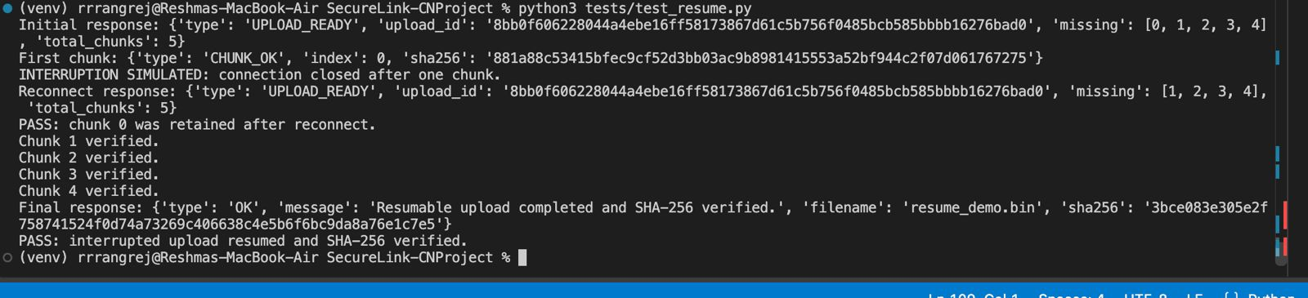
Purpose: Demonstrates the observed behaviour of the authentication mechanism.
B.3 Multi-Client Concurrency Execution Evidence
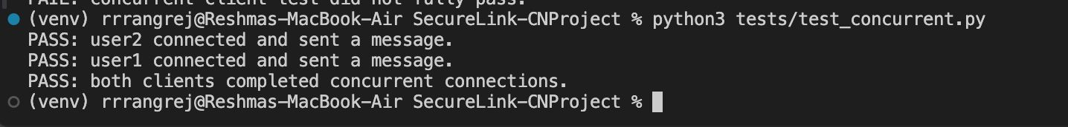
Purpose: Provides evidence of file reception and integrity checking.

Appendix C Individual Contributions
Student Name and PRN | Work Completed | Evidence or Deliverable
Rashi Rangrej  PRN : 1262241175 | • Implemented Flask gateway (app.py) to bridge HTTP uploads to TLS sockets.  • Authored report Sections 1 & 2 (Introduction, Objectives, Architecture).  • Prepared gateway architecture slides for the presentation. | app.py, Sections 1 & 2 of the final report, Presentation Deck
Niyati Priyani  PRN: 1262241237 | • Developed web portal UI (index.html) with drag-and-drop file support.  • Configured OpenSSL TLS 1.3 certificates and server socket wrappers.  • Managed document formatting, reference compilation, and report assembly. | certs/ setup, UI Test Logs, Final Report Assembly
Aditi Pathak  PRN: 1262240936 | • Developed multithreaded TLS backend server (server.py).  • Implemented 4-byte length-prefixed JSON framing (!I) and RLock thread safety.  • Authored report Section 3 (Implementation, Methodology, Technical Working). | server.py, Multi-threading & Lock Test Evidence, Section 3 of the final report.
Shraddha Pawar  PRN: 1262241161 | Implemented 32 KB resumable chunk protocol and double-pass SHA-256 checks.  • Developed CLI client (client.py) and performance benchmarking script.  • Conducted latency testing and authored report Sections 4 & 5 (Testing, Results). | client.py, tests/performance_test.py, Sections 4 & 5 of the final report

Appendix D Demonstration Video link
The video linked below provides a 10-minute walkthrough of the completed framework
Video Link: SecureLink | Encrypted Client-Server Communication Framework using TCP & TLS| CN MINI PROJECT

Appendix E GITHUB LINK
Link: NiyatiPriyani/SecureLink-CNProject: Secure file transfer system using Python sockets, TLS encryption, resumable uploads, SHA-256 integrity verification, and a Flask web interface.

