Practical – 2
Static Page :-
Home :-
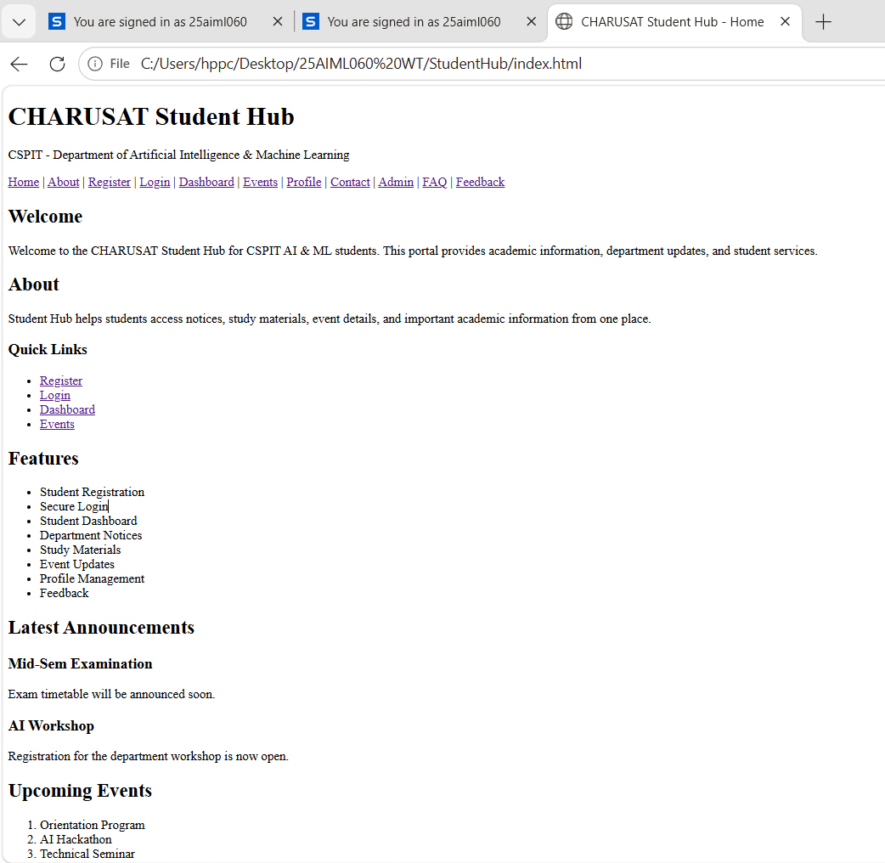


About :-
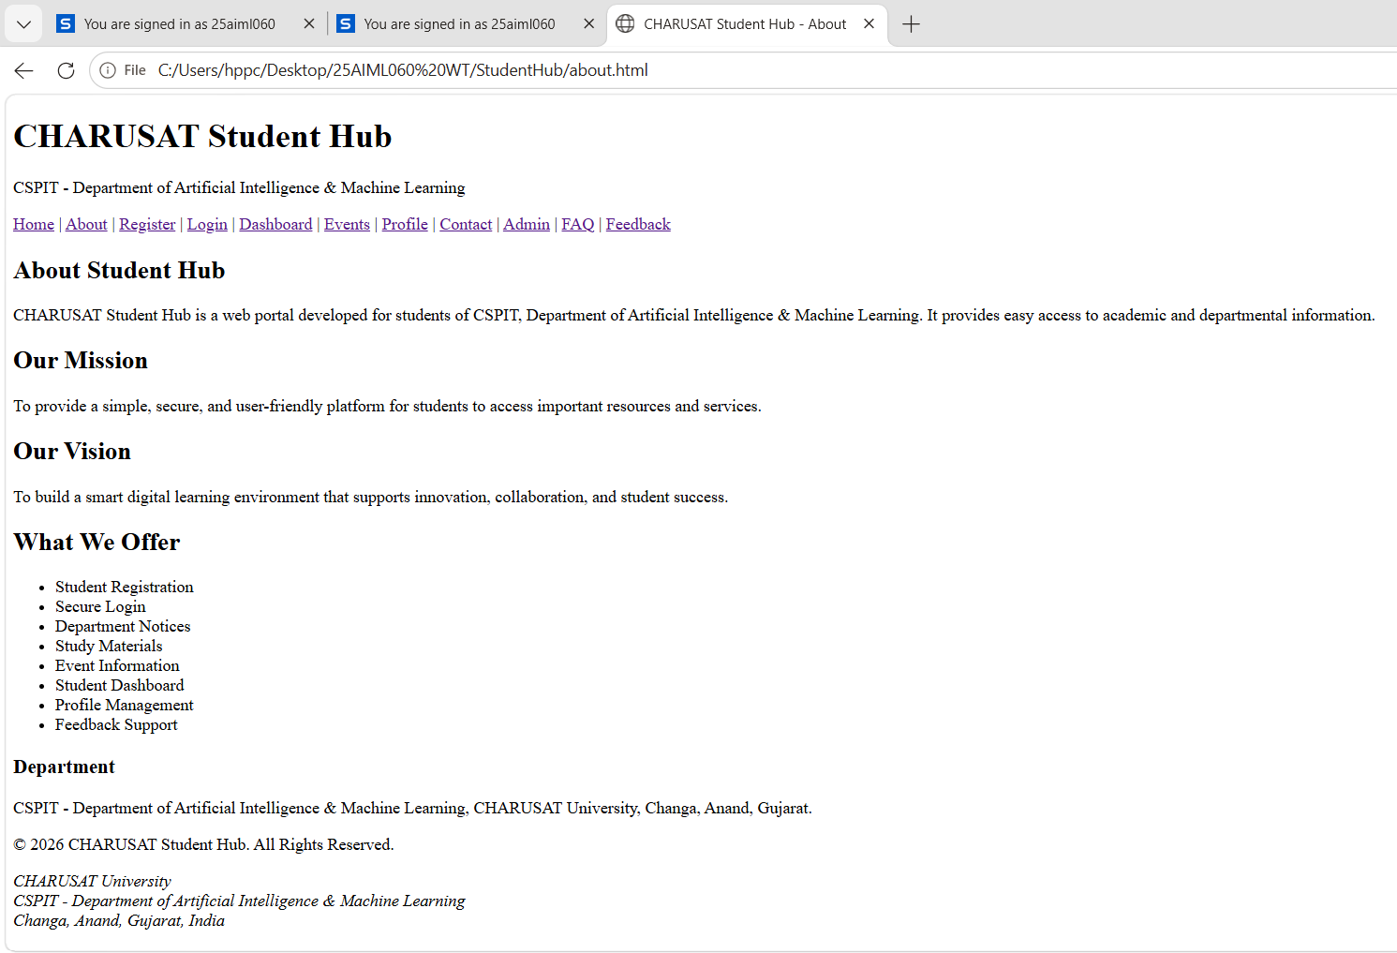

Register :-
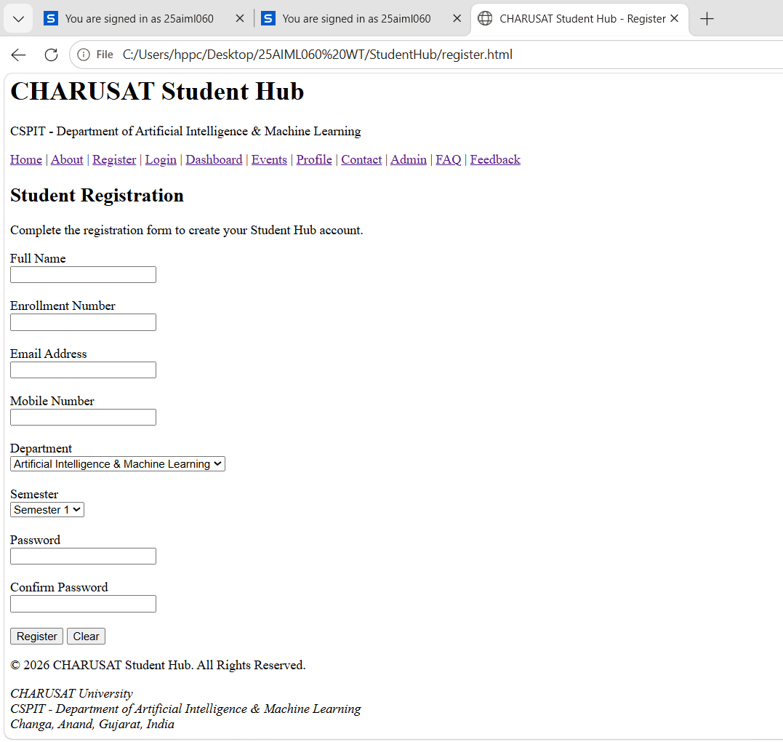

Login :-
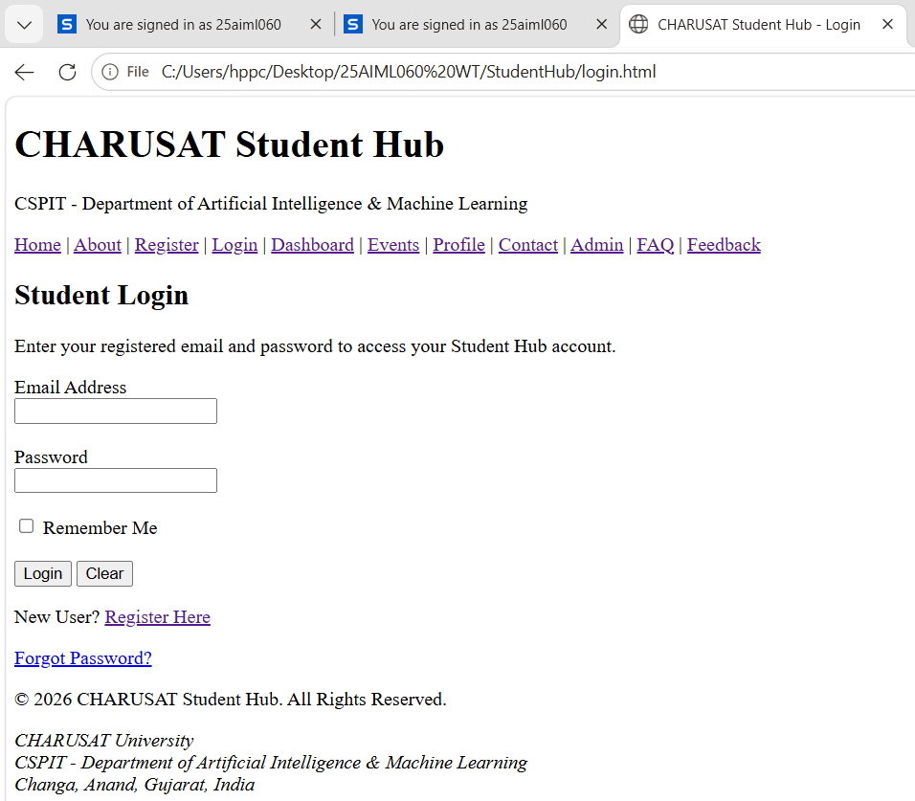

Dashboard :-
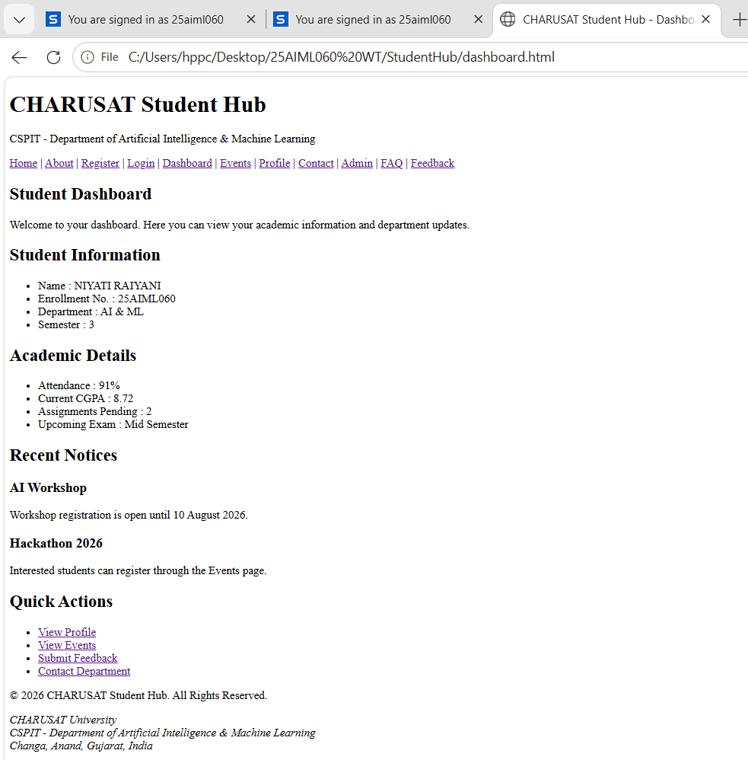

Events :-
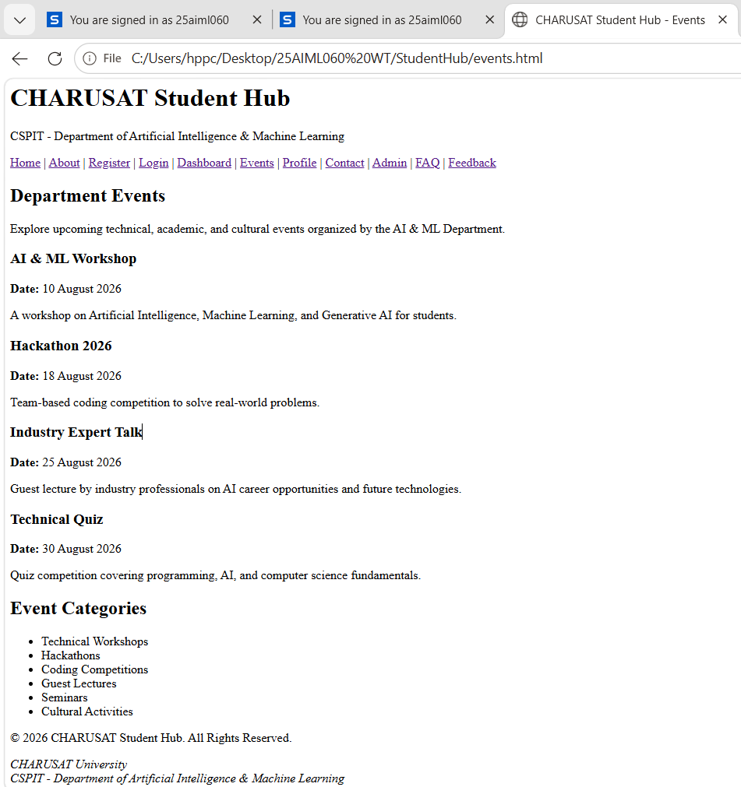

Profile :-
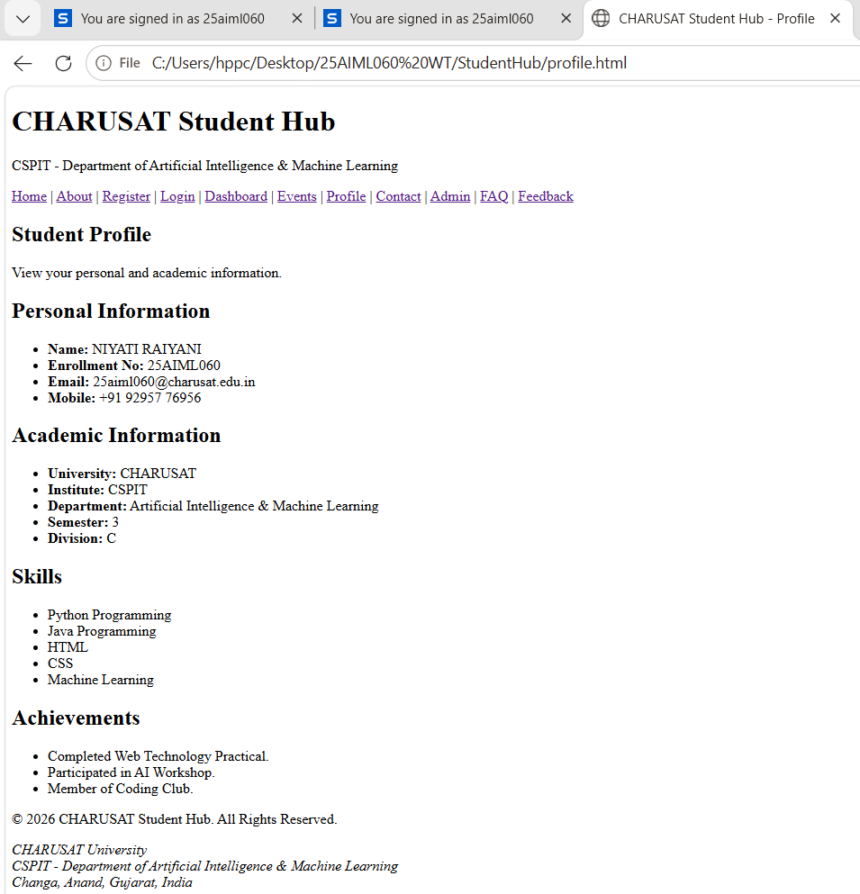

Contact :-
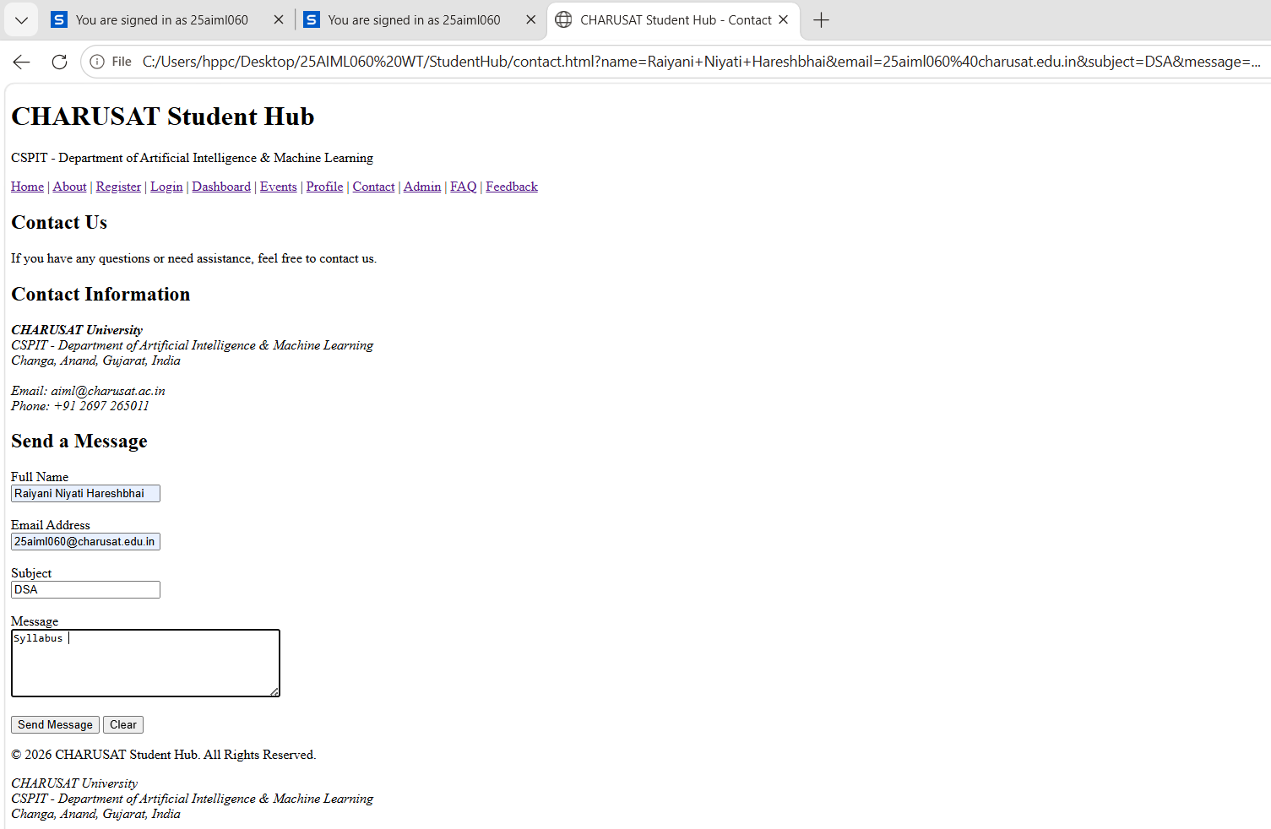

Admin :-
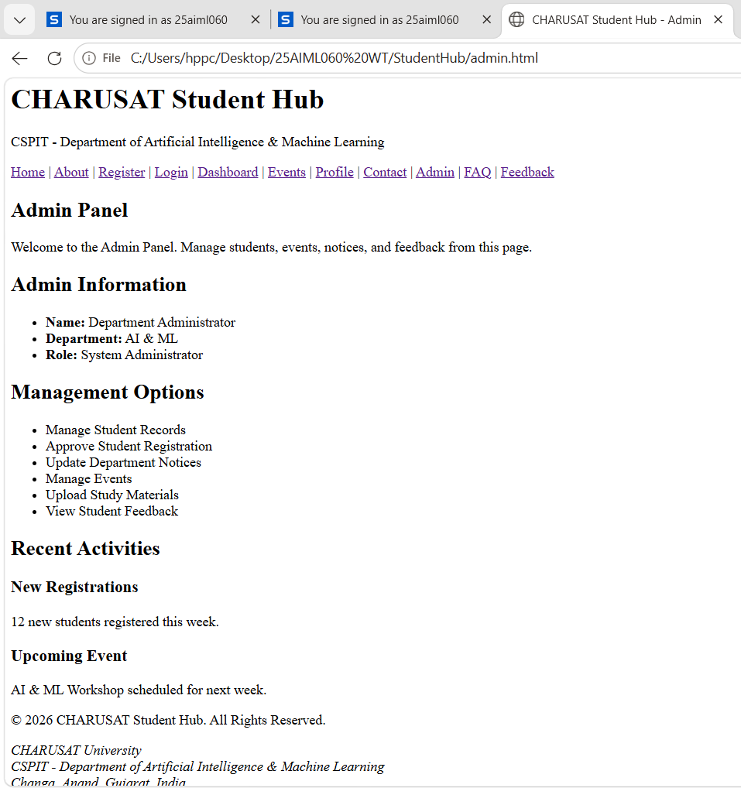

FAQ :-
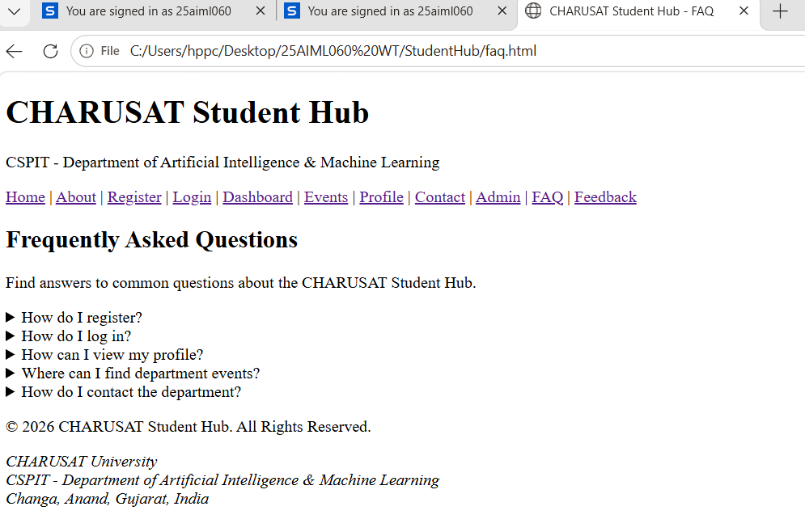

Feedback :-
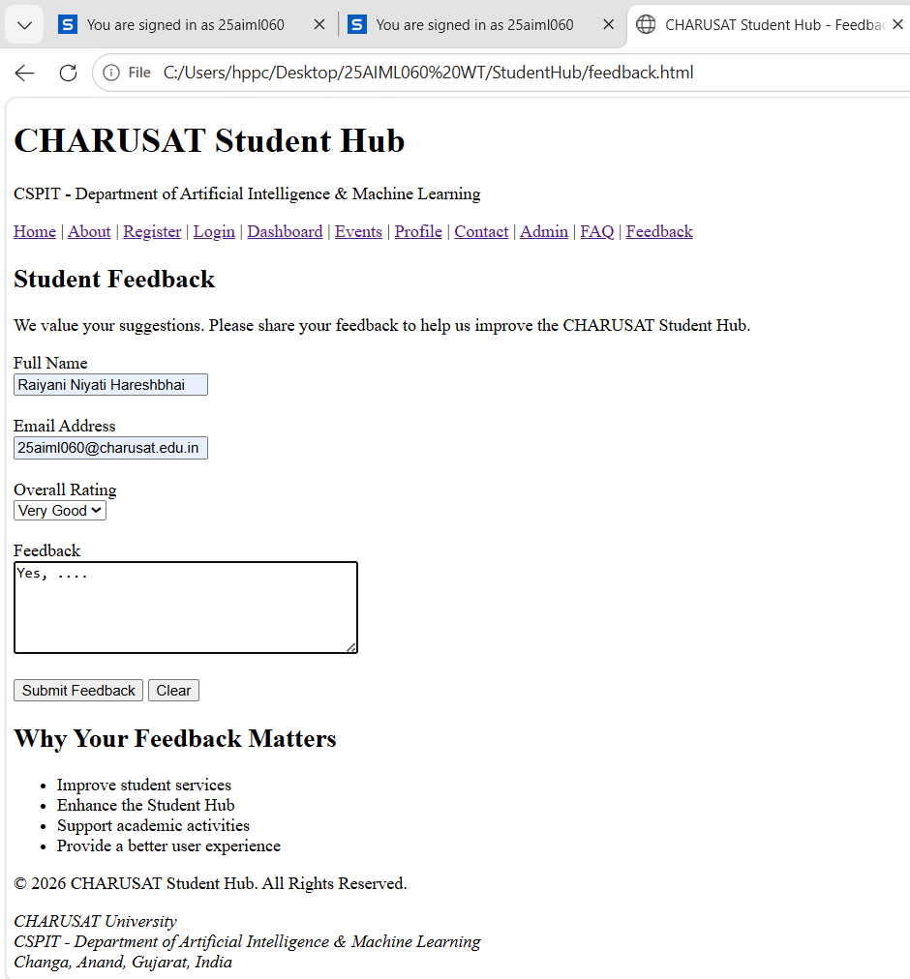

Accessibility checklist :-
Sr No. | Accessibility Requirement | Status
1 | HTML5 semantic tags are used correctly | Yes
2 | Every page has a proper <title> element | Yes
3 | Proper heading hierarchy is maintained | Yes
4 | Navigation menu is available on all pages | Yes
5 | Navigation links are working correctly | Yes
6 | Forms use proper <label> elements | Yes
7 | Images contain meaningful alt text | No
8 | Viewport meta tag is included | Yes
9 | Page structure is consistent across all pages | Yes
10 | Keyboard navigation is supported | Yes
11 | Skip-to-content link | No
12 | Breadcrumb navigation | No

