Practical 5
Registration Form with Frontend Validation and User-Friendly Error Handling

Student Name | Niyati Raiyani
Enrollment No | 25AIML060
Program | B.Tech – Artificial Intelligence and Machine Learning
Subject | Web Technology
Faculty Name | Deep Mendha

Aim
To design and develop a student registration form using HTML5, CSS, and JavaScript with robust client-side validation, Regular Expressions, password strength checking, real-time validation, and user-friendly error handling.

Problem Definition
The objective of this practical is to create a user-friendly and accessible Student Registration Form that collects student information such as Full Name, Email Address, Mobile Number, Password, Confirm Password, Course, Academic Year, Gender, and Terms & Conditions acceptance.
JavaScript is used to validate the entered information before form submission. Regular Expressions are implemented for validating the name, email address, mobile number, and password. The form also provides a password strength indicator, real-time validation, and meaningful error messages near the corresponding fields.
The system prevents form submission when invalid or incomplete information is entered and displays a successful registration message when all required inputs are valid.

Validation Test Cases
The registration form was tested using both valid and invalid input data to verify the accuracy of the implemented validation rules.
Test Case ID | Validation Scenario | Test Input | Expected Result | Status
1 | Valid Registration | All fields entered with valid data | Registration Successful message is displayed | Pass
2 | Empty Name | Name left blank | "Name is required." error is displayed | Pass
3 | Invalid Name | Niyati123 | Invalid name error is displayed | Pass
4 | Invalid Email | niyati@gmail | Invalid email error is displayed | Pass
5 | Invalid Mobile | 98765 | Mobile number validation error is displayed | Pass
6 | Invalid Mobile Characters | 98765abc10 | Non-numeric characters are removed/rejected | Pass
7 | Weak Password | 12345 | Weak password error is displayed | Pass
8 | Medium Password | Niyati123 | Medium password indication is displayed | Pass
9 | Strong Password | Niyati@123 | Strong password indication is displayed | Pass
10 | Password Mismatch | Password: Niyati@123, Confirm: Niyati@456 | Password mismatch error is displayed | Pass
11 | Course Not Selected | Course left blank | Course selection error is displayed | Pass
12 | Year Not Selected | Year left blank | Academic year error is displayed | Pass
13 | Gender Not Selected | No gender selected | Gender validation error is displayed | Pass
14 | Terms Not Accepted | Checkbox unchecked | Terms & Conditions error is displayed | Pass
15 | Complete Valid Form | All valid details and terms accepted | Registration is completed successfully | Pass

Valid Test Data
The following valid data was used to verify successful registration:
Field | Valid Test Data
Full Name | Niyati Raiyani
Email | niyati@gmail.com
Mobile Number | 9876543210
Password | Niyati@123
Confirm Password | Niyati@123
Course | B.Tech AIML
Academic Year | Second Year
Gender | Female
Terms & Conditions | Accepted
Invalid Test Data
The following invalid inputs were used to verify error handling:
Field | Invalid Test Data | Validation Message
Full Name | Niyati123 | Enter a valid name using letters and spaces only.
Email | niyati@gmail | Enter a valid email address.
Mobile | 98765 | Enter a valid 10-digit mobile number.
Password | 12345 | Password is too weak.
Confirm Password | Niyati@456 | Passwords do not match.
Course | Not selected | Please select a course.
Academic Year | Not selected | Please select your academic year.
Gender | Not selected | Please select your gender.
Terms & Conditions | Not accepted | You must accept the Terms and Conditions.

Screenshots of Validation Testing
Screenshot 1 – Valid Registration Form
Test: All required fields are entered with valid information.
Expected Result: All fields are accepted and the registration is completed successfully.
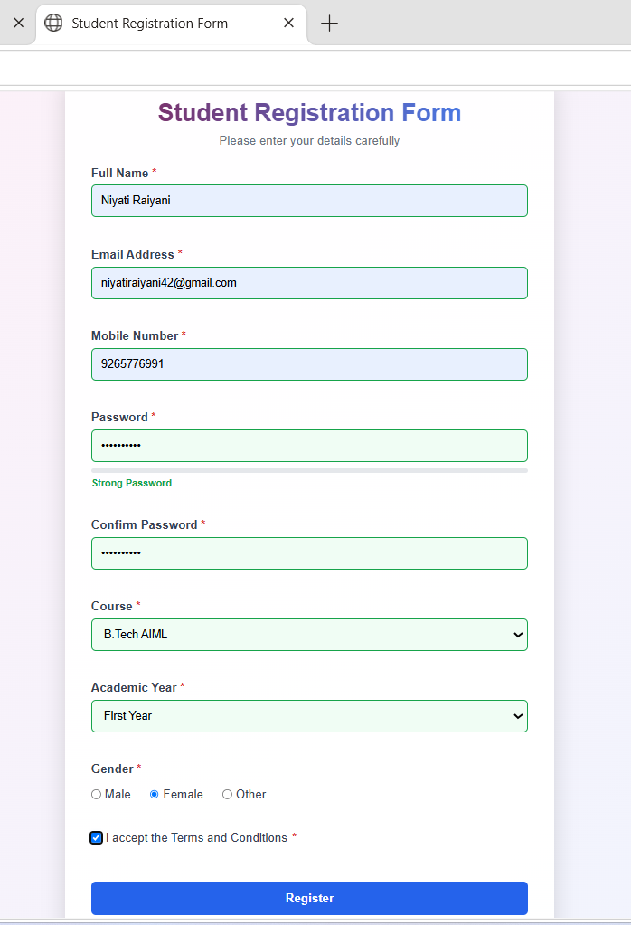
Figure 1: Valid student registration form with successful validation.

Screenshot 2 – Invalid Email and Mobile Number
Test: An invalid email address and mobile number are entered.
Expected Result: Appropriate validation messages are displayed below the respective fields.
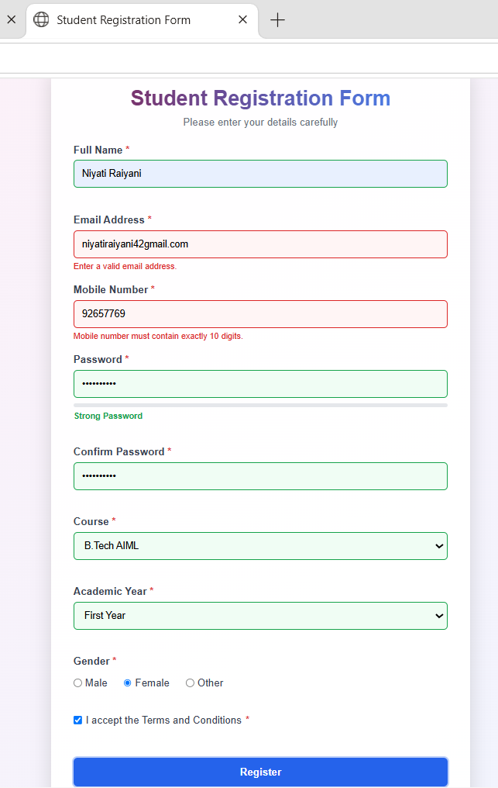
Figure 2: Email and mobile number validation errors.

Screenshot 3 – Password Strength Validation
Test: A weak or medium-strength password is entered.
Expected Result: The password strength meter displays the corresponding password strength and an appropriate validation message.
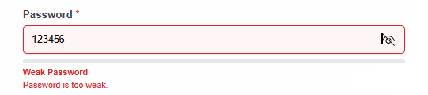
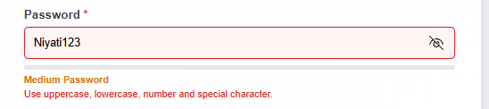
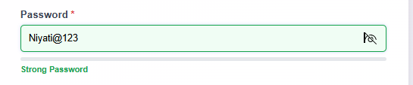
Figure 3: Password strength validation.
Screenshot 4 – Confirm Password Validation
Test: Password and Confirm Password fields contain different values.
Expected Result: "Passwords do not match." error message is displayed.
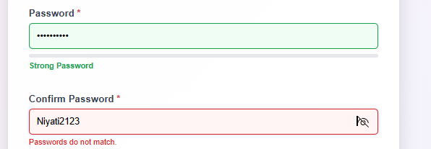
Figure 4: Confirm password validation error.

Screenshot 5 – Required Field Validation
Test: The form is submitted without entering required information.
Expected Result: Validation messages are displayed for the empty required fields.
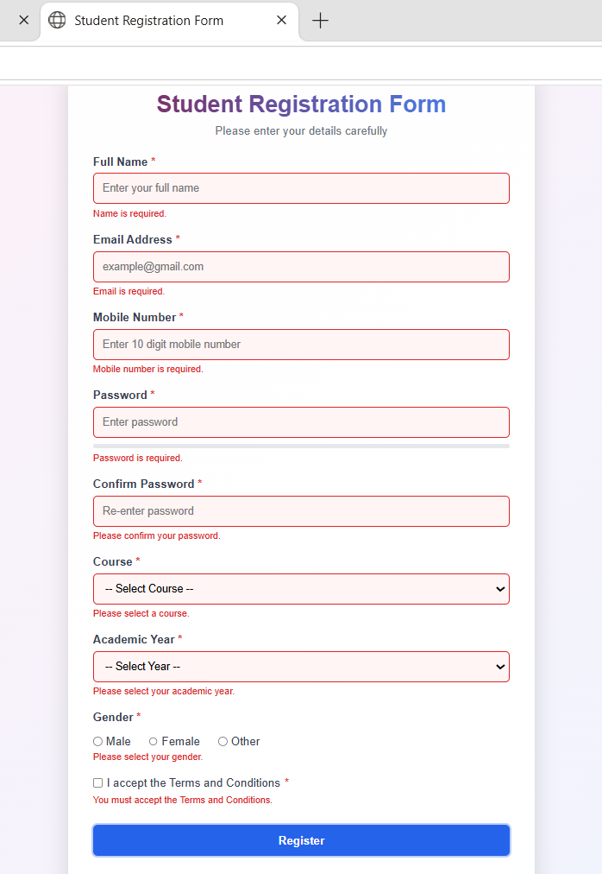
Figure 5: Required field validation errors.

Screenshot 6 – Successful Registration
Test: All fields contain valid information and Terms & Conditions are accepted.
Expected Result: "Registration Successful!" message is displayed.
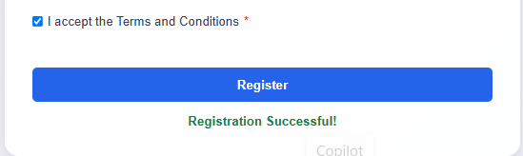
Figure 6: Successful registration message.

Conclusion
The Student Registration Form was successfully developed using HTML5, CSS, and JavaScript. Client-side validation was implemented for all major input fields using Regular Expressions and JavaScript event handling.
The practical successfully demonstrates password strength checking, confirm-password validation, real-time validation, user-friendly error messages, and Terms & Conditions validation. Both valid and invalid test cases were executed to verify the correctness and reliability of the form.
Overall, this practical provided practical knowledge of developing accessible, interactive, and user-friendly registration forms suitable for real-world web applications.

