

# Natural Language Processing

# *Hands on readable.com*

Under the guidance of

Prof. Sharmila ma’am

Submited By-

Niyati Sahni

17BCE0506

A readability score is a computer-calculated index which can tell you what level of education someone will need to be able to read a piece of text easily.

**Readable.com** uses tried and tested [readability formulas](https://readable.com/features/readability-formulas/), as well as our own proprietary scoring systems, to analyse the readability of your website or text and recommend ways to improve upon it.

To ensure your content is readable by 85% of the general public, you should aim for a readability score of Grade 8 or better.

Typical factors used for readability scoring include:

* Average sentence length
* Syllable count
* Percentage of multi-syllable words
* Average word length
* Familiarity of words
* Complexity of sentences

The formula used to calculate readability score-

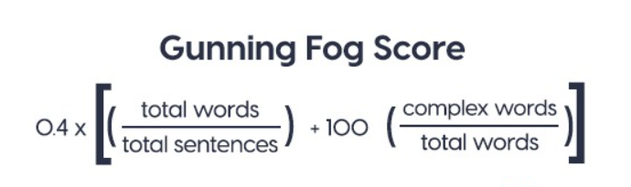

The formula for Gunning Fog is 0.4 [(words/sentences) + 100 (complex words/words)], where complex words are defined as those containing three or more syllables.

The Fog Index has served as an effective warning system against drifting into needless complexity in the mechanics of writing. Beginning writers need such warning. So do business men, engineers, scientists and all others who have to write as part of their jobs but are not primarily writers.

Consistent with Gunning’s original aim, the Gunning Fog index is principally used as a tool to help writers keep their texts clear and simple.

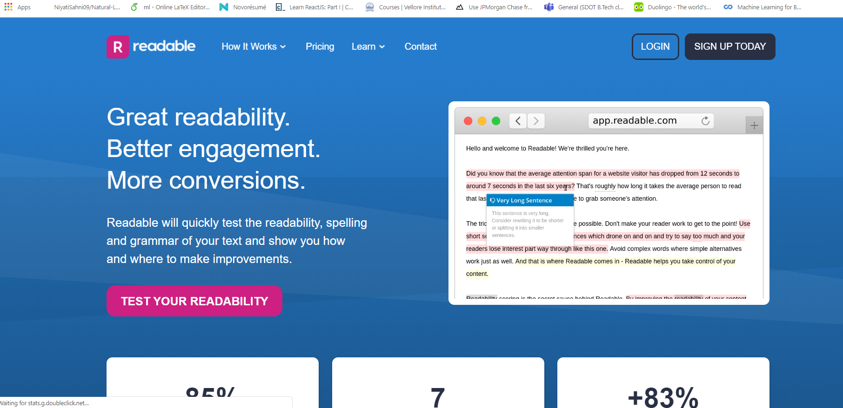

This is how the site looks. The site helps in finding the readability score based on which an article can be rated.