Unit - 7 | Social Analytics Assignment – Distinguishing Sentiments

News Mood

27th Mar, 2018

# Task

In this assignment, you'll create a Python script to perform a sentiment analysis of the Twitter activity of various news outlets, and to present your findings visually.

Your final output should provide a visualized summary of the sentiments expressed in Tweets sent out by the following news organizations: **BBC, CBS, CNN, Fox, and New York times**.

Tools used:

* Pandas
* Numpy
* Matlpoltlib
* Seaborn
* Json
* Datetime
* Time
* Vader

Observations:

1. Scatter Plot helps us visualize the spread of tweet sentiments for all the news channels for a compound score range of -1 to +1.

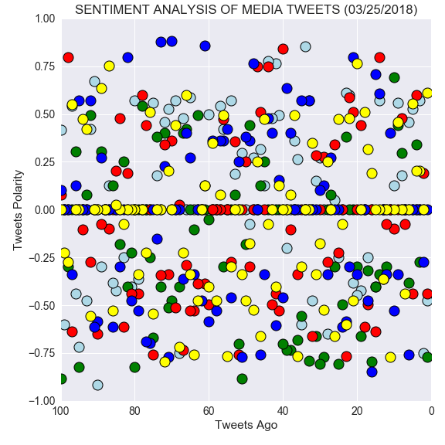

**Figure 1**

1. As we can observe in Figure 2, BBC news had positive 0.06 compound score on average and all others had a negative score. This implies that there was more positive discussion on BBC. Comparing it to the Vader classification of Positive, neutral and negative sentiment, BBC’s score still falls under neutral.

**positive sentiment**: compound score >= 0.5

**neutral sentiment**: (compound score > -0.5) and (compound score < 0.5)

**negative sentiment**: compound score <= -0.5

1. One explanation to this result may suggest that BBC being a British channel might be heavily affected by topics discussed on it’s twitter account. Whereas, CNN, FoxNews and Nytimes are all American channels and thus might have some similarity in their tweets which were more inclined towards negative score.

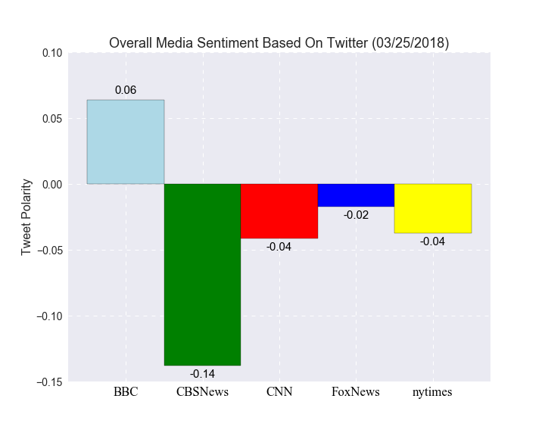

**Figure 2**