Howard University
College of Engineering and Architecture
Department of Electrical Engineering & Computer Science

Large Scale Programming
Fall 2024

Midterm Exam – Part I
October 17, 2024

Part I: 50 pts. (essay questions)

Instructions:
- Submit completed exam to your github repository under package org.howard.edu.lsp.midterm

Verify that the commit(s) completed successfully

- OPEN BOOK, OPEN NOTES. THERE IS NO COLLABORATION ON THIS EXAM
- Site any and ALL references for anything obtained off the internet.

Question 1. (10 pts.)

You are reviewing the following class in a Fitness Tracking System. The class is intended to manage various aspects of a user’s fitness activities.

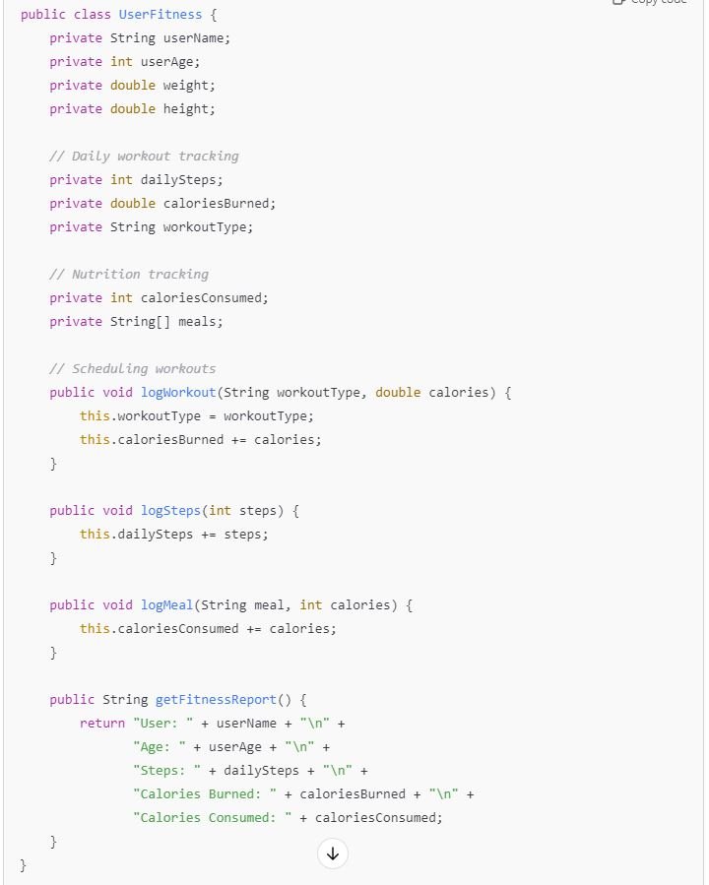

Tasks:
- Analyze the UserFitness class. Explain why this class has low cohesion. (5 pts.)
The UserFitness class manage multiple tasks, this includes user information, daily workout tracking, nutrition tracking, and fitness reporting. All the tasks are different meaning it is trying to do multiple things at one time. Cohesion suggest that a class should have a single well-defined responsibility and because it is doing many things at once each with different concerns it leads to a low cohesion.

- Describe, in general, how you would split the UserFitness class into more cohesive classes. Your answer should not be a complete design. (5 pts.)

To make this more cohesive, and smaller, there should be additional classes each focusing on a specific area. Some examples are:

- A user_profile class this would be specific for managing user information and details such as age, weight, name, height, gender, ect.
- A workout_tracking class this would be specific for managing work-out related things/tracking such as calories burned, steps counted, heart rate, logging workout, mile tracking, ect.
- A meal_tracking class this would be specific for managing meals, and calories, as well as keeping track of what you have eaten or drank.
- A fitness_report class this would be specific for managing the generation of fitness reports from other classes by using aggregation of data.

dividing the responsibilities, allows for each class to become more cohesive making the overall system easier to maintain and understand.

Question 2. (5 pts.)
Given the following, answer the below questions.

A university manages its students using a program that has a class Student with subclasses FirstYear, SecondYear, and ThirdYear for year-specific state and behaviors. The program has a List that contains all Students.

Should Student be a class, an abstract class or an interface? Explain your answer

The student class should be an abstract class because of a few reasons. The first is the fact that there can be specific behaviors, the subclasses (firstyear, secondyear, thirdyear) all represent specific versions of the student class. Each year can consist of different characteristics or actions that are specific to that year, however they all represent a student. The next is that the student class likely has behaviors shared such as name, GPA, age, ect that are shared across the students, regardless of the year they are in. Using an abstract class gives the advantage of providing shared method implementations allowing the reuse of code. This is useful if some behaviors like calculating gpa or student information are common to all students but might need minor modifications in the subclasses. An interface won’t be useful if we are dealing with shared state and method implementations.

- At the end of each year, the third-year students graduate and must be removed. This is done by passing the list to the following method:

void removeThirdYears(List<Students> students) {
for (Student student : students) {
try {
ThirdYear = (ThirdYear) student;
students.remove(thirdyear);
}
}
}

Why is the above method flawed? Hint: Another Arthur Riel heuristic (5 pts.)

The problems are:

Google was used

- Modifying the list while iterating because it is trying to remove items from a list while iterating over it which can lead to a concurrentModificationException. This is because the lost struct is being removing items while the for-each loop is still iterating causing the iteration state to become inconsistent.
- Avoiding object-oriented casting designs. Heuristic suggests that excessive casting can indicate poor design, the downcast to 3rd year in this method is unnecessary and can be avoided by using instance of checks.

Question 3. (5 pts.)
Given the following, answer the below questions.

public class BankAccount {
public String accountHolderName;
public String accountNumber;
public double balance;
public double interestRate;

public BankAccount(
String accountHolderName,
String accountNumber,
double initialDeposit,
double interestRate) {
this.accountHolderName = accountHolderName;
this.accountNumber = accountNumber;
this.balance = initialDeposit;
this.interestRate = interestRate;
}

// Exposed implementation for adding interest
public void addInterest() {
double interest = balance * (interestRate / 100);
balance += interest;
}

// Exposed implementation for deposits
public void deposit(double amount) {
balance += amount;
}

// Exposed implementation for withdrawals
public void withdraw(double amount) {
balance -= amount;
}
}

- Is BankAccount well-encapsulated? Why or why not? If so, describe what changes you would make to the class. Otherwise, state nothing. (5 pts.)

No, the reason why is because the fields accountHolderName, accountNumber, balance, and interstate are all public meaning they can be directly accessed and modified by any other class. This breaks encapsulation, as it exposes the internal state of the object to the outside code. Encapsulation is meant to restrict access to an object’s internal data ensuring that is can only be accessed or modified in controlled ways. To improve we should make the fields private by restricting direct access and creating controlled access by use getter and setter methods.

Question 4. (10 pts.)
Given the following, answer the below questions.

Given:
A car manufacturer uses Java software to track current vehicles being built. The UML diagram below shows an excerpt of the current software structure. You should assume the presence of other appropriate fields and methods
Car
getTrimLevel()
Engine
accelerate()
getFuelLevel()
Base
Sports
Luxury
Electric
Petrol

Each car can be built to one of three trim levels: Base, Luxury or Sport. They can also be configured with an electric or petrol engine. At various points in the manufacturing process the customer can choose to change the trim level.

Task:
- Explain in detail why the current structure does not support this. (5 pts.)

The current structure does not support this because it relies on inheritance, with each car being tightly coupled to its specific subclass. As a result, if a user wants to change the trim level of a car later in the manufacturing process, it cannot be done dynamically after the car has been instantiated; instead, a new car object must be created.

- Describe how to refactor the structure to allow trim-level change for a car to dynamically change. Hint: How would you modify Car to use composition to solve the problem? (5 pts.)

Using composition to enable dynamic changes to a car's trim level. To o this you create a `TrimLevel` interface that defines the common methods for various trim levels, and then implement concrete classes for the `Base`, `Sports`, and `Luxury` that aline to this interface. The `Car` class would hold a reference to a `TrimLevel` object, allowing different instances of trim levels to be assigned as needed.

Question 5. (5 pts.)
Suppose you are about to code a particular class and find that you have written another class with nearly the functionality that you now are developing. This means that the two classes in large parts contain the same code, but in smaller parts have different code. Explain in detail why this may be a problem and how to solve it. Give your answer in terms of Arthur Riel’s design heuristics.

The problem with this is one it does not follow the rules of not repeat yourself. There are 2 classes that share a large portion of code but differ in small parts which tell us that there is duplicate logic, and this is a violation of DRY. This can lead to maintenance problems like changing code and error issues, as well as code bloating which leads to unnecessary complexity. The next is Arthur Riel heuristic which say to avoid unnecessary duplication code duplication is considered a sign that the current structure is flawed and needs to be refactored for better maintainability and extensibility. Lastly, low cohesion having two classes that perform the same core functionality but slightly differ tells us that each class might be trying to do too much. This reduces cohesion, a key design principle that ensures that a class should have a single, well-defined responsibility. In order to fix this you can use Inheritance, if the two classes share a lot of behavior but differ in small parts, you can extract the common functionality into a base (parent) class.

Question 6. (5 pts.)
Suppose we need to store instances of the classes Car and BankAccount in a database. To obtain low coupling it may seem as if the functionality to save an instance should be in precisely those classes, since they have the information that shall be saved. Why is it unwise to place the database calls there?

This is unwise because to place a database call directly inside the car and bankaccount classes will lead to high coupling in the business logic and the persistence logic. The first is the high coupling if the car and bankaccount contain database calls, they become tightly couples to a specific persistence framework, making it harder to change the persistence mechanism or unit test without having to involve the database. Next is code reusability if we embed the database calls within the car and bankaccount any class that needs to interact with the database will have to duplicate their logic, leading to code duplication and violating DRY. Lastly, separation of concerns such as ensuring that the logic related to business operations and data persistence remains independent, making each easier to manage and modify.

Question 7. (5 pts.)
Given a set of requirements, what conditions must be met to make it appropriate to create a new class hierarchy using inheritance? Neither superclass nor subclass exist before, the question is about designing a new class hierarchy.

Google was used

- Shared behavior or state: Inheritance is appropriate when multiple classes share common behavior or state that can be placed in a superclass. This reduces code duplication and centralizes the shared behavior in one place.
- The superclass should define the common attributes and methods that all subclasses will inherit. Subclasses can then override or extend the behavior when necessary.
- “Is-a” relationship Inheritance should be used when there is a clear "is-a" relationship between the superclass and the subclass. This means that the subclass should represent a specialized version of the superclass and should be able to substitute the superclass without affecting the correctness of the program.
- Encapsulation of behavior in superclass Inheritance allows you to encapsulate shared behavior in the superclass and provides a clear extension mechanism for subclasses. This ensures that the implementation details of the common behavior are hidden from the subclasses, promoting better maintainability and modularity.

Question 8. (2.5 pts.)
Describe the difference between inheritance and composition why would you choose one over the other.
Google was used
Inheritance is an "is-a" relationship where a subclass extends the behavior of a superclass, whereas composition is an "has-a" relationship where one class contains and delegates responsibilities to another. A person would choose inheritance when the objects naturally share behavior and state, whereas a person would choose composition when you want flexibility to change components without affecting the overall class structure.

Question 9. (2.5 pts.)
Explain the meaning of cohesion and describe whether low or high cohesion is better.
Google was used
Cohesion is how closely related and focused the responsibilities of a class/module are. High cohesion is better because it ensures that a class has a single, well-defined purpose, making the code easier to understand, maintain, and reuse.

