**Project Outputs**

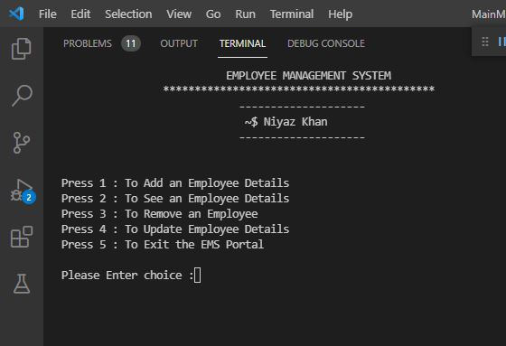

Fig 1 :- Enter Choices…

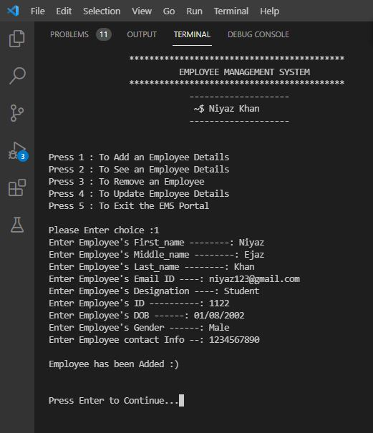

Fig 2 :- Add Employee Details..

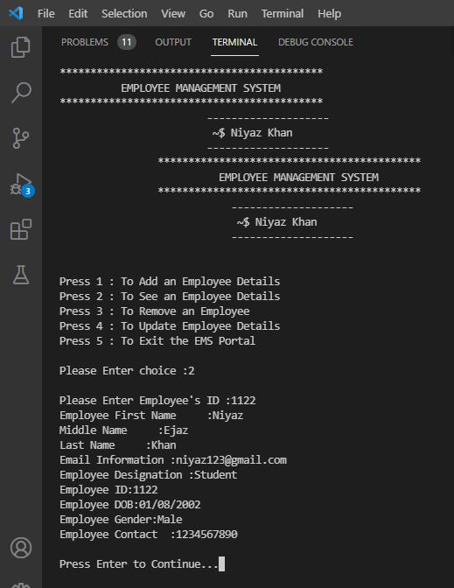

Fig 3 :- See Employees Details..

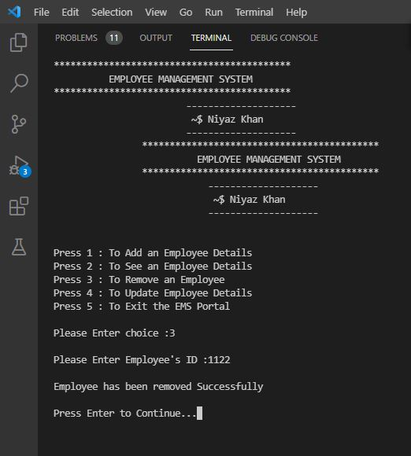

Fig 4 :- Remove Employees Details..

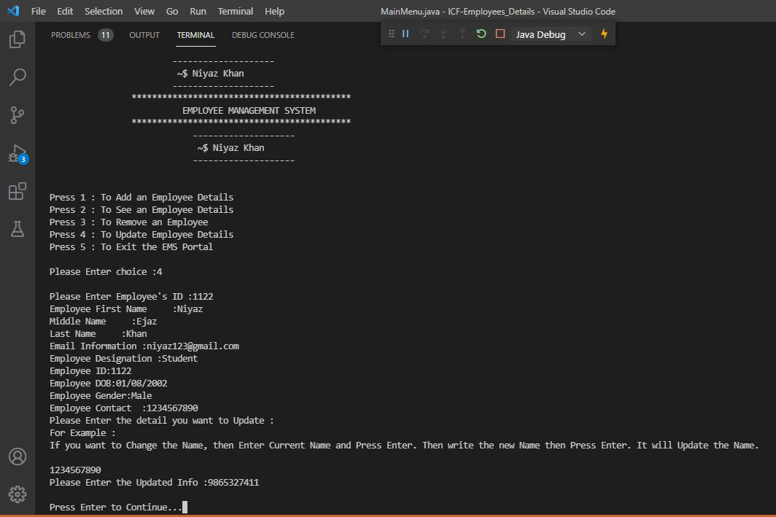

Fig 5 :- Update Employees Details..

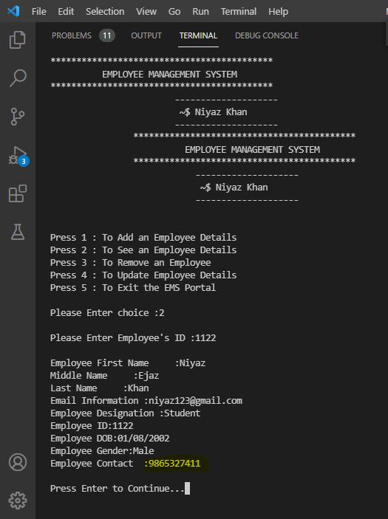

Fig 6 :- Updated Result…

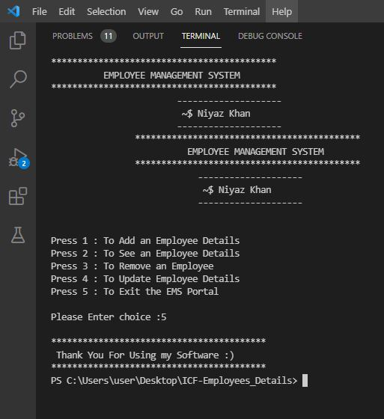

Fig 7 :- Exit Project..