CIPHERLOCK
A Python-Based Encryption and Decryption System Using the Vigenère Cipher
PROJECT DOCUMENTATION REPORT

Field | Detail
Project Title | CipherLock
Developer | Adeniyi Ojedele
Submitted To | DecodeLab
Category | Cybersecurity / Applied Cryptography
Language and Tools | Python 3, Visual Studio Code, Git, GitHub
Date | July 2026

Table of Contents
Table of Contents
1. Abstract 3
2. Introduction 3
3. Problem Statement 3
4. Aim and Objectives 4
4.1 Aim 4
4.2 Objectives 4
5. Scope of the Project 4
6. Tools and Technologies 4 - 5
7. Methodology 5
8. System Workflow 5
9. System Design and Algorithm 6
9.1 Core Modules 6
10. Implementation 6 - 7
11. Testing 8
12. Results 8
13. Challenges 8
14. Recommendation 9
15. Conclusion 9
16. References 9
17. Appendix: Screenshot Placeholders 10 - 12
17.1 Home Screen 10
17.2 Encryption Screen 10
17.3 Decryption Screen 11
17.4 Encryption and Decryption Screen 11
17.5 About Page 12

1. Abstract
CipherLock is a Python-based encryption and decryption tool that implements the classical Vigenère Cipher to demonstrate the fundamentals of symmetric-key cryptography. The system allows a user to supply plaintext and a secret key, from which it generates a corresponding ciphertext and to reverse the process to recover the original plaintext from the ciphertext and key. Beyond its immediate function, the project serves as a practical, hands-on exploration of classical cryptographic theory, secure software design, and command-line application development in Python. This report documents the problem the project addresses, the design and implementation approach adopted, the testing strategy used to validate correctness, the results obtained and the challenges encountered during development, and it concludes with recommendations for extending the system toward modern, production-grade cryptographic standards.

2. Introduction
Cryptography is the science of protecting information by transforming it into a form that is unreadable to anyone other than its intended recipient. It underpins nearly every secure digital interaction today, from online banking to private messaging. Understanding classical cryptographic techniques provides an essential foundation for appreciating how modern encryption standards, such as AES and RSA, evolved from earlier substitution and transposition ciphers.
The Vigenère Cipher, first described in the 16th century, is a polyalphabetic substitution cipher that improves upon simple substitution ciphers (such as the Caesar Cipher) by using a repeating keyword to vary the substitution alphabet applied to each letter of the plaintext. Although the Vigenère Cipher is not secure by modern standards and is vulnerable to frequency analysis and key-length detection attacks such as the Kasiski examination, it remains an excellent pedagogical tool for illustrating the core concepts of key-based encryption: confidentiality, key management, and reversible transformation.
CipherLock was developed to translate this theoretical understanding into a working, menu-driven Python application. The project demonstrates how plaintext can be transformed into ciphertext using a shared secret key, and subsequently restored to its original form through decryption, while reinforcing good software engineering practices such as input validation, modular design, and structured testing.

3. Problem Statement
Unencrypted data — whether stored on a device or transmitted across a network — is inherently vulnerable to unauthorized access, interception and tampering. Individuals and organizations that fail to apply even basic encryption techniques to sensitive text risk exposing confidential information to malicious actors. While enterprise systems typically rely on advanced encryption standards, there remains a gap in accessible tools and learning resources that help beginners understand how encryption fundamentally works before they engage with more complex cryptographic libraries.
This project addresses that gap by implementing a simple, self-contained encryption and decryption tool. It explores basic encryption techniques as a means of improving practical understanding of data confidentiality, key-based transformation, and the trade-offs between classical and modern cryptographic approaches.

4. Aim and Objectives

4.1 Aim
To design and implement a simple, functional encryption and decryption system using Python and the Vigenère Cipher, capable of securing and recovering plaintext messages using a user-supplied secret key.

4.2 Objectives
- Encrypt user-supplied plaintext using a secret key to produce ciphertext.
- Decrypt previously generated ciphertext back into its original plaintext using the same key.
- Demonstrate the principles of symmetric-key encryption in a practical, interactive application.
- Strengthen practical Python programming and cybersecurity fundamentals through hands-on implementation.
- Validate correctness of the encryption/decryption cycle through structured testing.

5. Scope of the Project
CipherLock is scoped as a command-line application intended for educational demonstration rather than production security use. Its scope includes the encryption and decryption of alphabetic text (with supporting handling of case and punctuation), key validation, and a menu-driven user interface. It does not include file-level encryption, network transmission of encrypted data, graphical user interfaces or industry-standard algorithms such as AES — these are identified as candidates for future work in Section 12.

6. Tools and Technologies
Tool / Technology | Purpose
Python 3 | The core programming language used to implement the cipher logic and CLI.
Visual Studio Code | The integrated development environment used for writing and debugging code.
Git | Version control system used to track changes throughout development.
GitHub | Remote repository hosting for source code backup and collaboration.

7. Methodology
The project followed a structured software development approach consisting of five key phases, described below.
- Requirements Analysis: Identifying the core functional needs of the system — accepting plaintext and a key, generating ciphertext, and reversing the process to recover plaintext.
- Design: Defining the algorithmic approach for key repetition, character shifting, and the overall menu-driven program flow.
- Testing: Executing the application against varied plaintexts, keys and edge cases to confirm correctness and robustness.
- Evaluation: Reviewing outcomes against the stated objectives and documenting challenges and possible improvements.

8. System Workflow
At a high level, CipherLock follows the sequence below during both encryption and decryption operations:
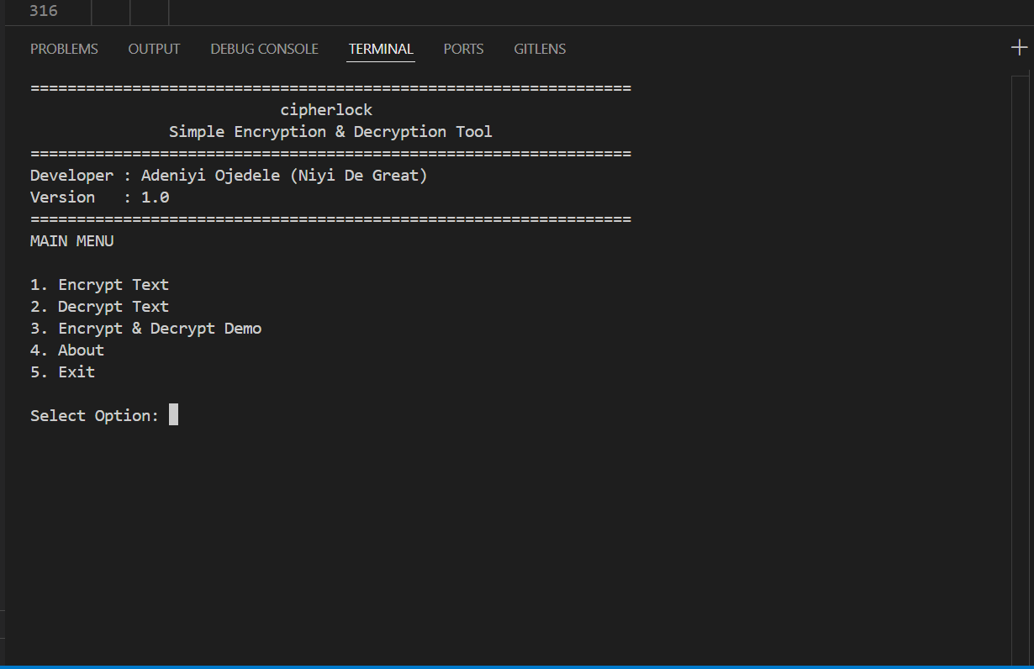

9. System Design and Algorithm
The Vigenère Cipher encrypts each letter of the plaintext by shifting it according to the corresponding letter of a repeating key, using modular arithmetic over the 26-letter alphabet. Given a plaintext letter P and key letter K (each mapped to a numeric value from 0–25, where A = 0), the ciphertext letter C is computed as follows:
Encryption: C[i] = (P[i] + K[i mod len(K)]) mod 26
Decryption: P[i] = (C[i] - K[i mod len(K)] + 26) mod 26
Non-alphabetic characters (spaces, punctuation, digits) are passed through unchanged so that message formatting is preserved, and the key index only advances on alphabetic characters. Case (upper/lower) is preserved independently of the shift operation so that the readability of the decrypted output matches the original input.

9.1 Core Modules
Module / Function | Responsibility
validate_key() | Confirms the key is non-empty and contains only alphabetic characters.
generate_key() | Repeats/truncates the key to match the length of the input message.
encrypt() | Applies the Vigenere shift formula to transform plaintext into ciphertext.
decrypt() | Reverses the shift formula to recover plaintext from ciphertext.
main() / menu loop | Presents the CLI menu and routes user input to the appropriate function.

10. Implementation
The application was implemented as a single, menu-driven Python command-line program. On startup, it validates the supplied key, repeats it to match the length of the input message, and performs the appropriate Vigenère transformation. Results are presented directly in the terminal. A simplified illustration of the encryption function is shown below:
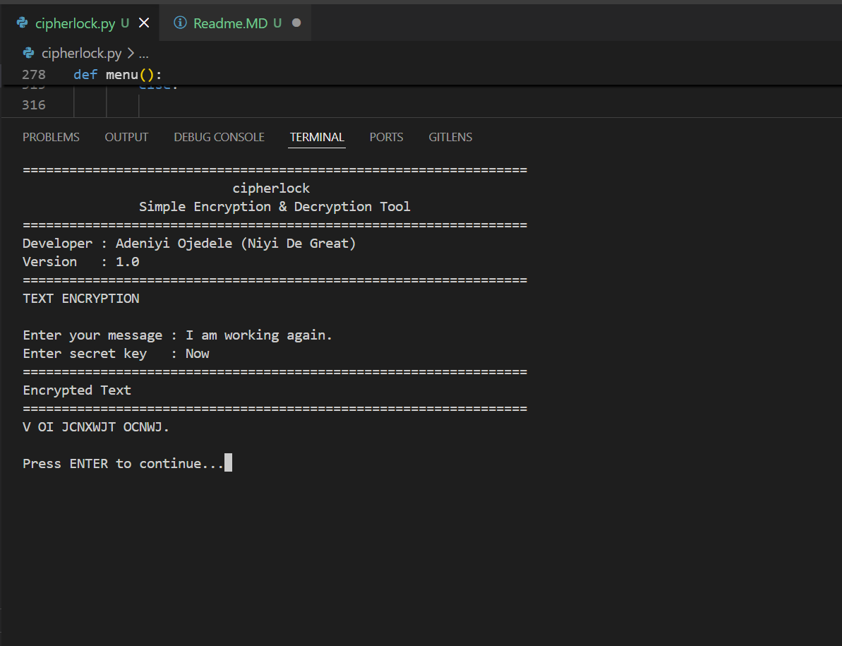
The decryption function mirrors this logic, subtracting the key shift instead of adding it. Input validation ensures the key contains only alphabetic characters and is not empty before any transformation is attempted, preventing runtime errors and undefined behaviour.
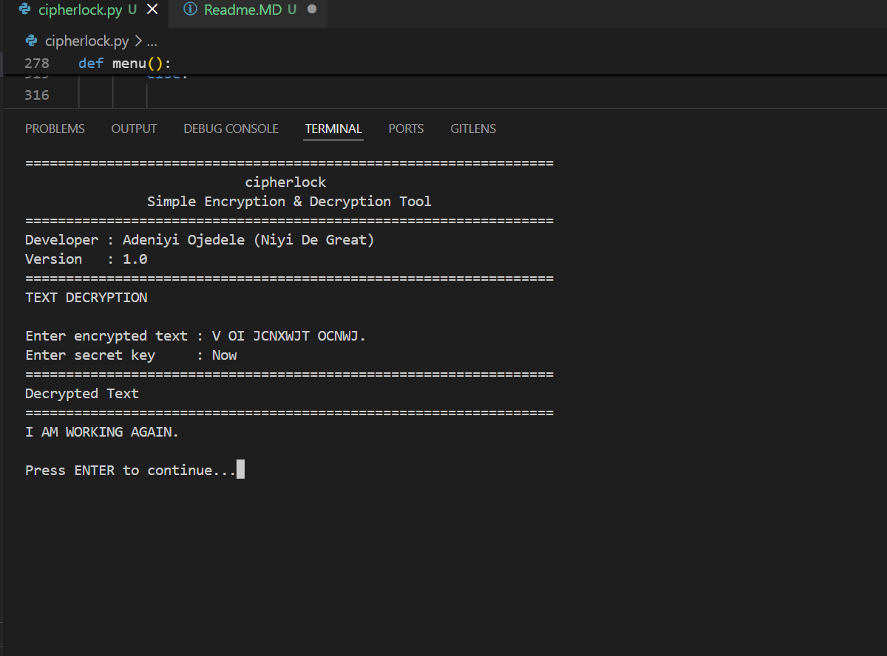

11. Testing
A structured set of test cases was designed to validate the correctness and robustness of the encryption and decryption logic across a range of inputs, including mixed case, punctuation, and invalid keys.
Test Case | Input | Expected Result | Outcome
Basic encryption | Plaintext: "HELLO", Key: "KEY" | Produces valid ciphertext | Pass
Round-trip decryption | Ciphertext from Test 1, Key: "KEY" | Recovers original plaintext "HELLO" | Pass
Mixed case handling | Plaintext: "Hello World" | Case produced in all caps output | Pass
Punctuation preservation | Plaintext: "Hi, there!" | Punctuation unchanged, letters shifted | Pass
Empty key | Key: "" | Validation error prompts re-entry | Pass
Non-alphabetic key | Key: "1234" | Validation error prompts re-entry | Pass
For each valid test case, decrypted output was compared against the original plaintext to confirm an exact match, verifying that the encryption/decryption cycle is fully reversible for well-formed inputs.

12. Results
CipherLock successfully encrypts and decrypts messages using a supplied secret key. Testing confirmed that decrypted output consistently matched the original plaintext across all valid test cases, and that the application correctly rejected invalid keys with clear, user-facing error messages. The menu-driven interface provided a smooth and predictable user experience, and the program performed reliably across varied message lengths and character compositions.

13. Challenges
- Key validation: Ensuring the key contained only valid alphabetic characters before use, without disrupting the user experience with excessive prompts.
- Preserving punctuation and spacing: Ensuring non-alphabetic characters passed through the cipher unchanged rather than being altered or stripped out.
- Ensuring reliable decryption: Confirming that the modular arithmetic used in decryption correctly reversed every case handled by encryption, including wrap-around at the boundaries of the alphabet.

14. Recommendation
While CipherLock successfully meets its educational objectives, several enhancements have been identified to extend its functionality and bring it closer to real-world applicability:
- Implementing AES (Advanced Encryption Standard) for genuinely secure, modern encryption.
- Adding file encryption support, allowing entire documents to be encrypted and decrypted.
- Developing a graphical user interface (GUI) to improve accessibility for non-technical users.
- Incorporating cryptographic hashing (e.g., SHA-256) for data integrity verification.
- Adding a secure password generator utility.
- Implementing logging for auditing encryption/decryption operations.
- Building a comprehensive automated unit test suite using a framework such as pytest.

15. Conclusion
CipherLock meets its stated objectives, successfully implementing a functional Vigenère Cipher-based encryption and decryption system in Python. Beyond its technical output, the project provided a practical introduction to core cryptographic principles, key management, and secure programming practices. It demonstrates a clear understanding of how classical ciphers operate and lays a solid foundation for future exploration of modern, industry-standard encryption techniques. The lessons learned in requirements analysis, structured testing, and iterative problem-solving during development are directly transferable to more advanced cybersecurity and software engineering work.

16. References
1. Stallings, W. Cryptography and Network Security: Principles and Practice.
2. Schneier, B. Applied Cryptography: Protocols, Algorithms, and Source Code in C.
3. Python Software Foundation. Python 3 Documentation. https://docs.python.org
4. National Institute of Standards and Technology (NIST). Cryptographic Standards and Guidelines.

17. Appendix: Screenshot Placeholders
The following application screens are referenced for inclusion in the final submitted copy. Insert the corresponding screenshot beneath each heading below.

17.1 Home Screen

17.2 Encryption Screen



17.3 Decryption Screen

17.4 Encryption And Decryption Page

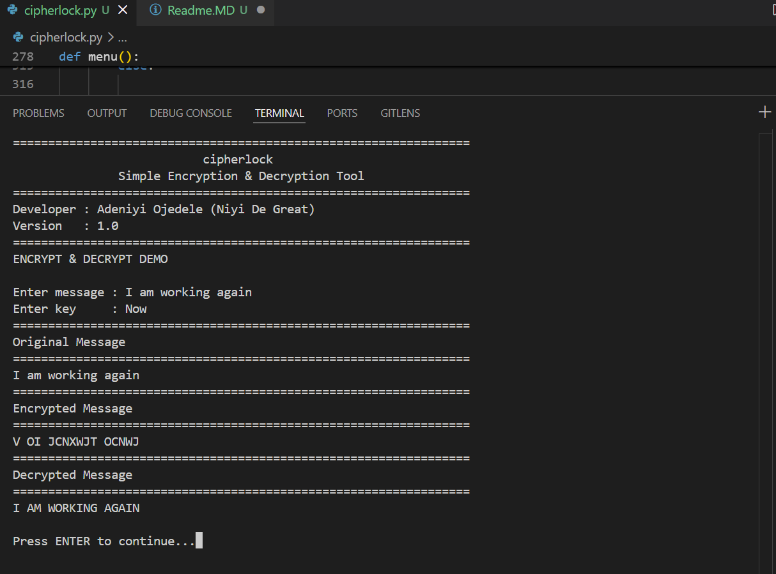
\

17.4 About Page
