1.drilling machine
Designed from concept to functional prototype, this precision drilling machine integrates adjustable depth control and ergonomic handling. Developed entirely in SolidWorks and optimized for manufacturability, it demonstrates mechanical reliability for workshop and industrial use.
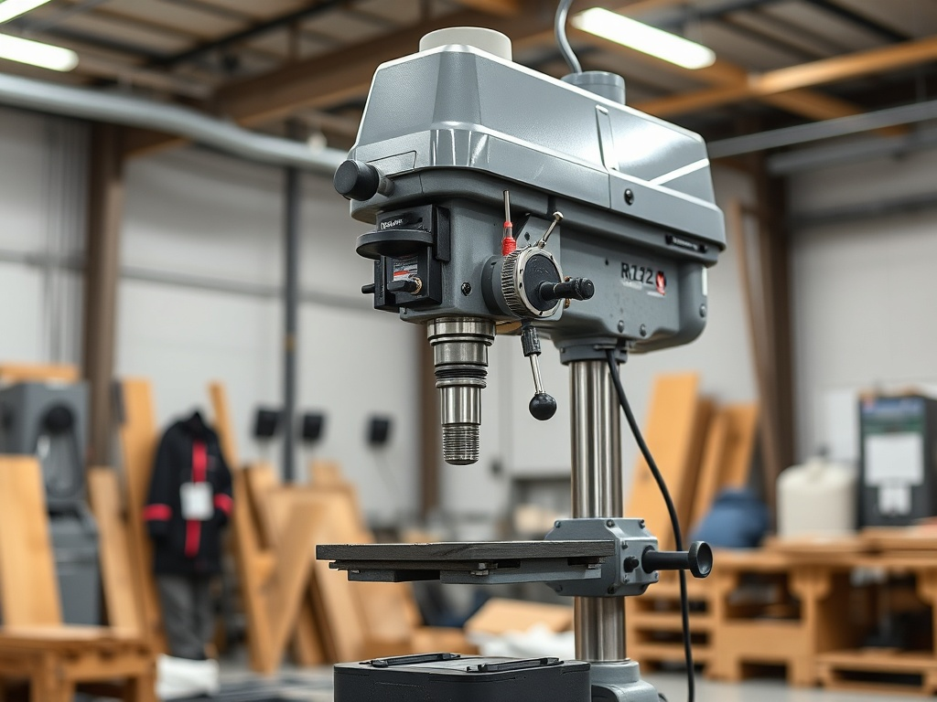

2. Customized mobile classroom bus
A reimagined school bus converted into a mobile learning space equipped with digital tools, workstations, and power systems. The design focuses on flexibility, accessibility, and modularity — enabling education to reach remote communities efficiently.
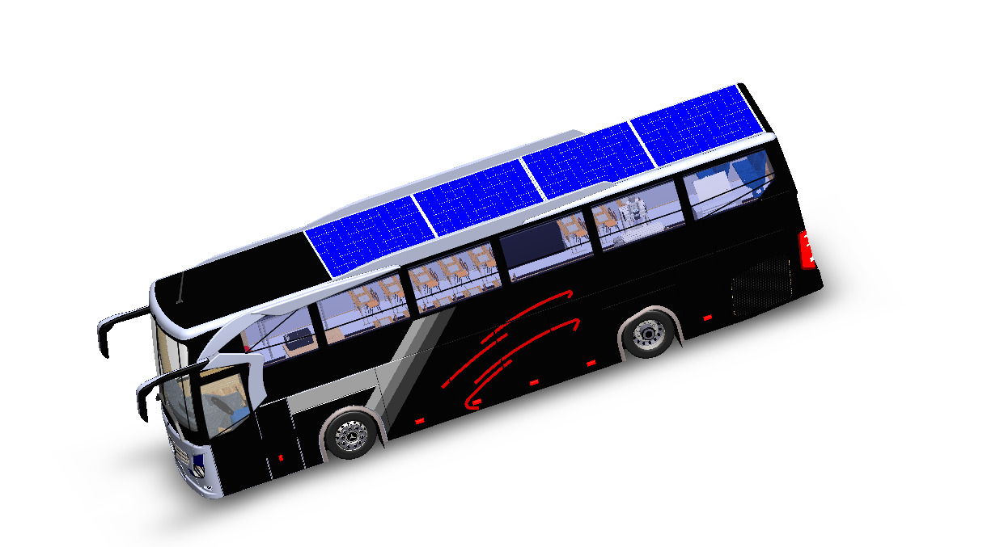
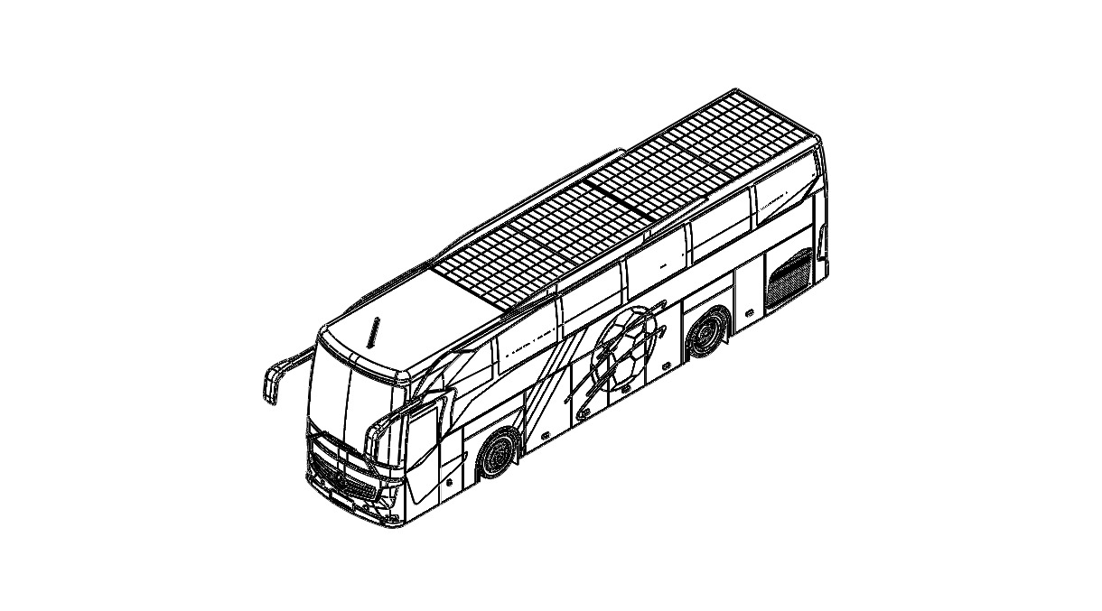
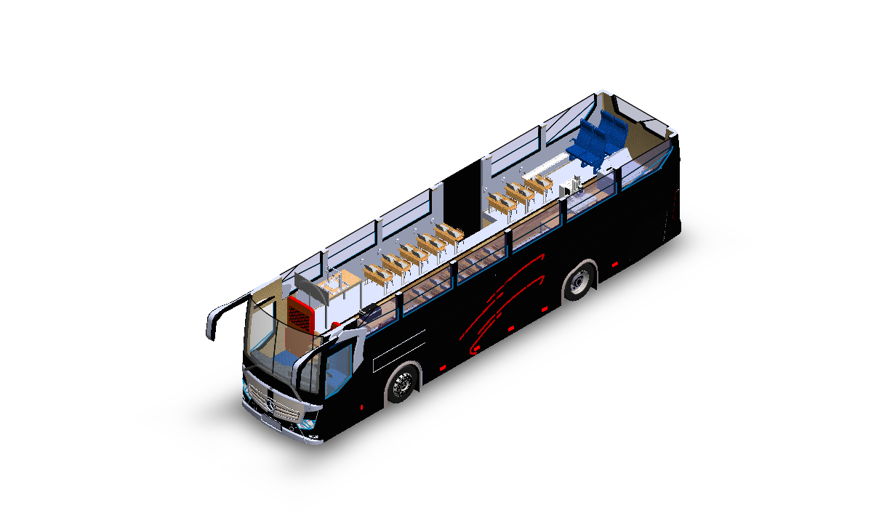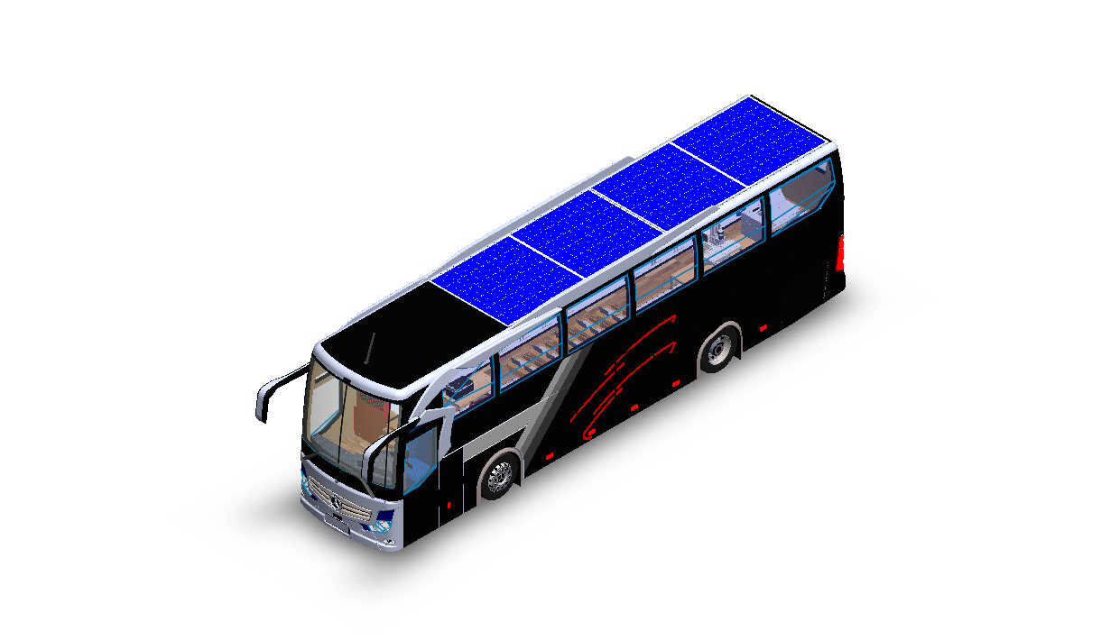
3. Rice milling machine
A compact, energy-efficient rice milling system engineered for small-scale farmers. Its design prioritizes performance, cost efficiency, and ease of maintenance, transforming traditional milling processes into modern, localized production.
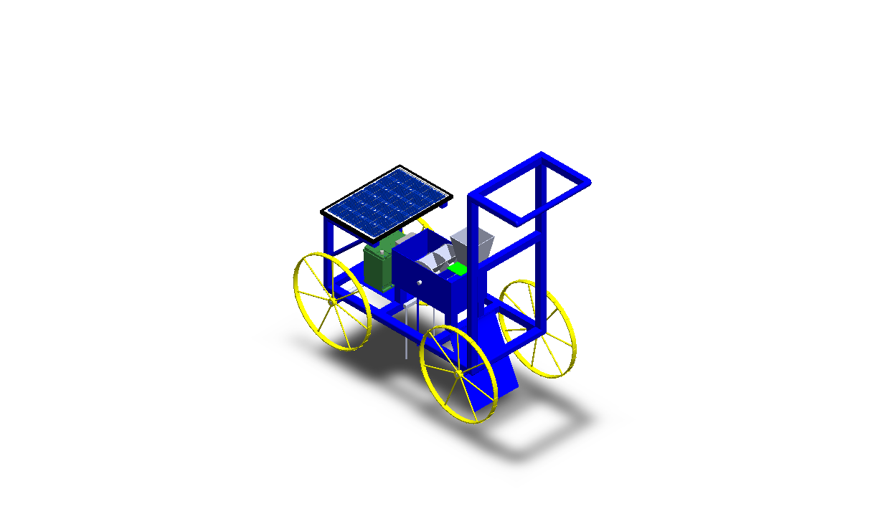

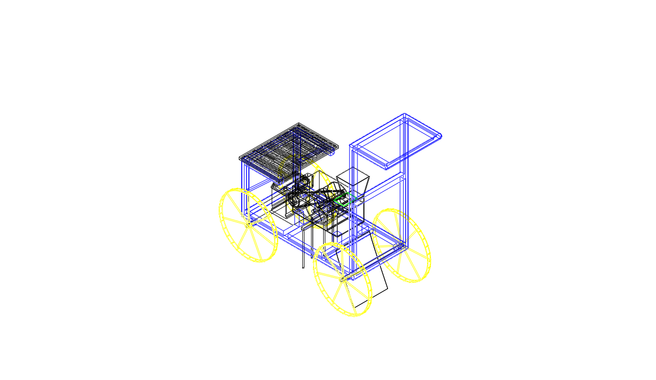
4. Tricycle (refrigerated milk transport)
An electric tricycle designed to transport cold milk safely using a built-in refrigeration system. Engineered for Rwandan terrain, it includes a lightweight chassis, battery cooling integration, and manufacturing-ready drawings for production.
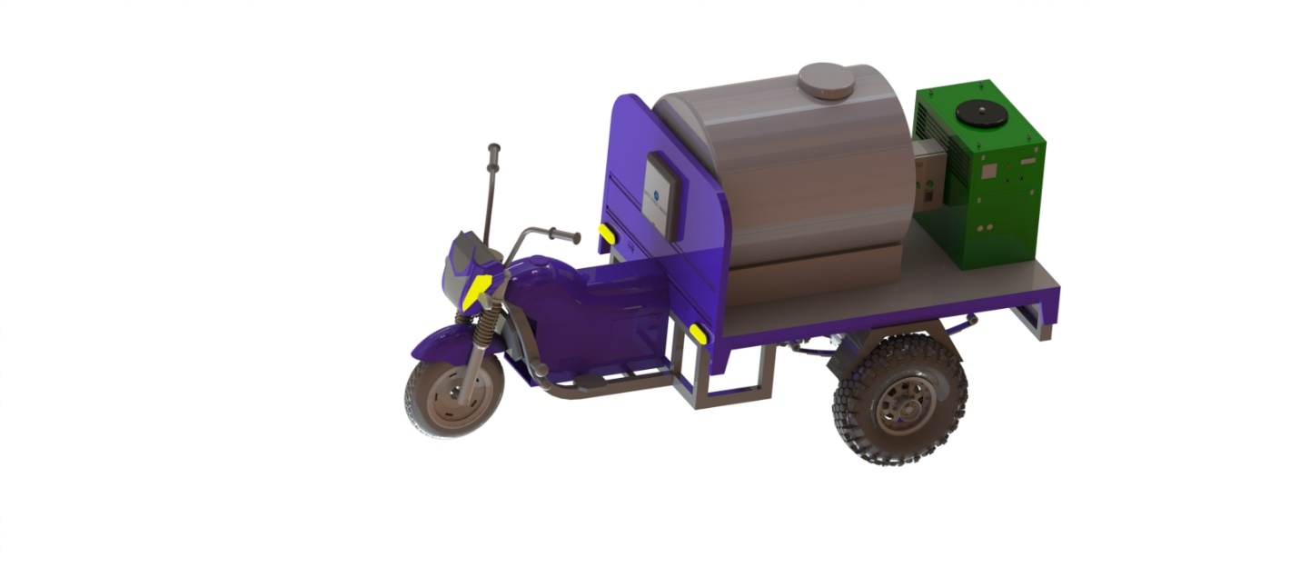
5. ISUZU customized tender truck
A tender-ready truck design tailored for industrial and logistics applications. The project involved CAD customization of chassis, bodywork, and functional compartments to meet client specifications while maintaining structural integrity and aesthetic appeal.
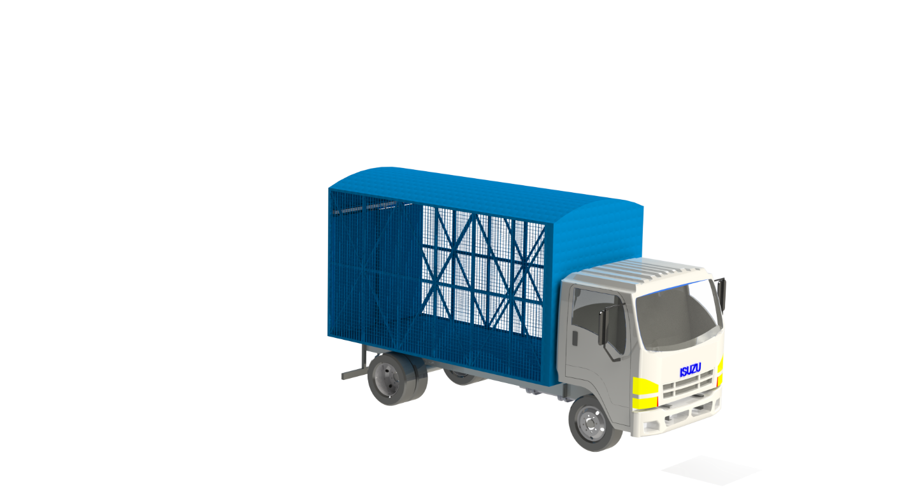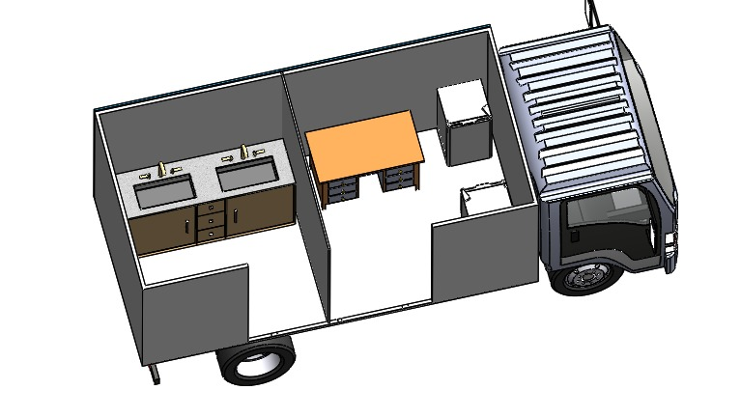
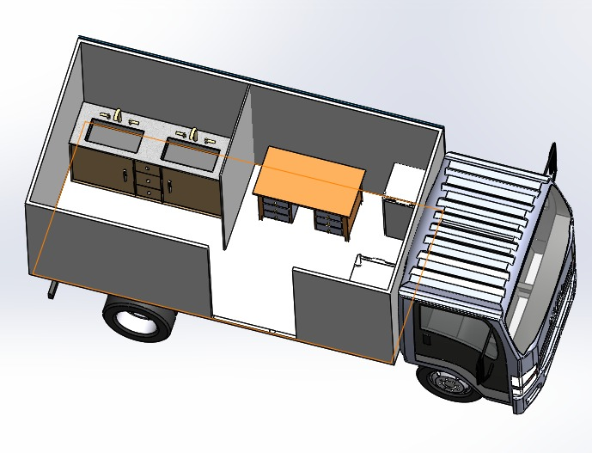
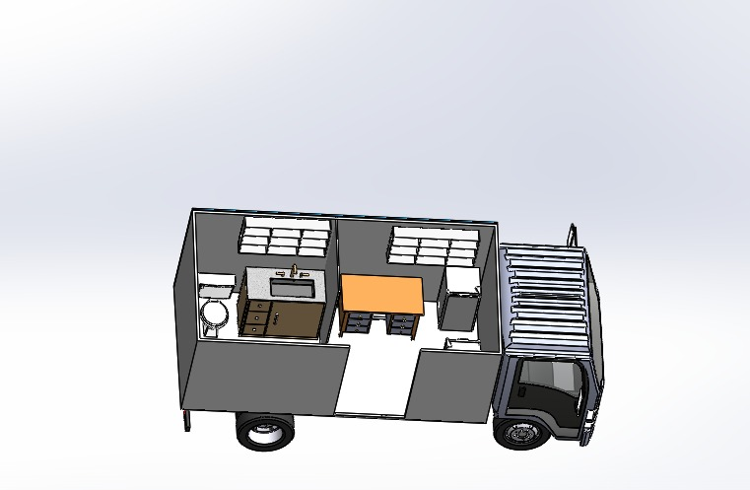

6.Wrist brace (parametric)
A parametric wrist brace that adapts dynamically to patient dimensions, ensuring personalized fit and comfort. Designed for additive manufacturing, it combines biomedical engineering principles with digital fabrication for medical rehabilitation.
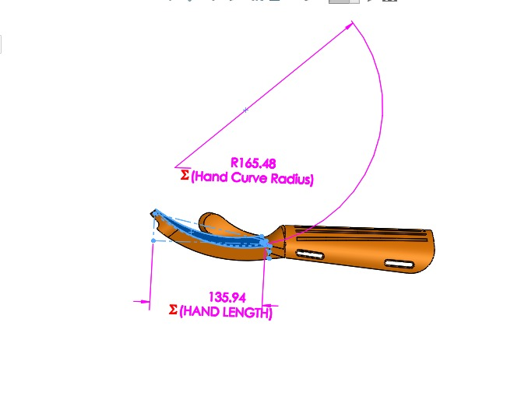
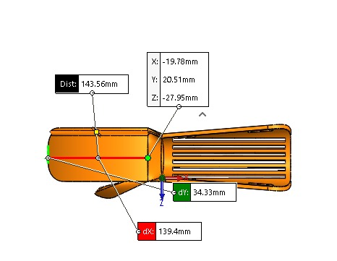

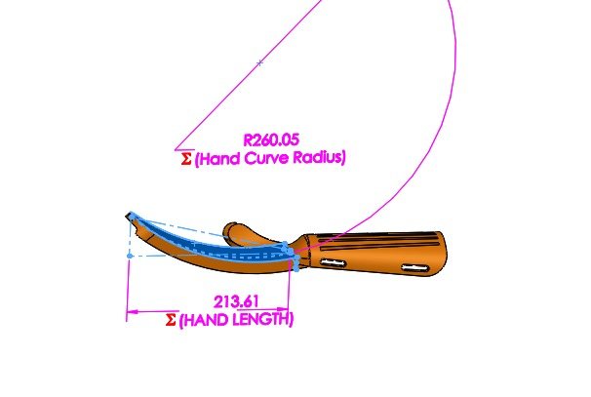

7. Wet scrubber
An industrial air-cleaning system designed to remove particulate matter and pollutants using fluid dynamics optimization. Developed in SolidWorks with a working prototype, it demonstrates environmental innovation through precision engineering.
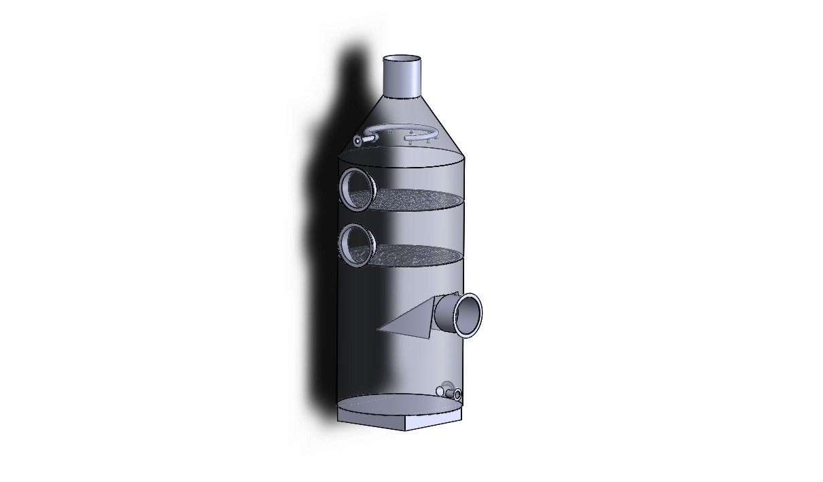
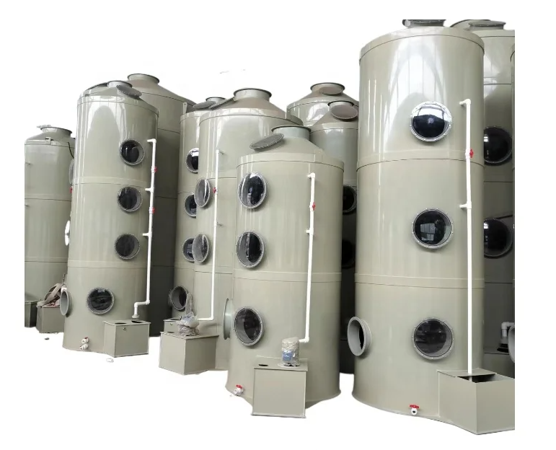

8. Travel mug
A modern, ergonomically designed travel mug combining durability, insulation, and manufacturability. Developed from concept to functional prototype, it showcases Delight Consultancy’s end-to-end product development capability — from 3D design to real product.
