Converter App

Documentation

By Nicholas Aylmore

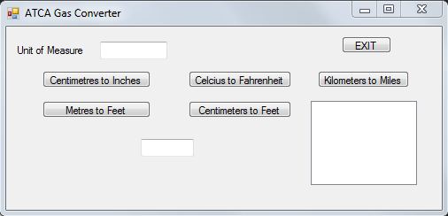

**Project Introduction**

You will be creating a converter program for ATCA Gas that converts units of measurement. This tool will be used on their intranet. Employees must be able to access this application from the office or in the field.

- ATCA Gas have a Gas tracking system where a device is taken along a gas pipeline and detects levels of gas. Five readings are taken each time. This data is then transferred into their system where any irregularities are highlighted.

Measurements are taken in metric but the company is based in America so a converter must be created to convert the readings into imperial.

**Project Specifications**

**Project Goal:**

Create a converter program that converts Metric measurements into Imperial measurements and displays 5 results.

**Purpose:**

The programs purpose is to convert measurement readings from one measurements system to another automatically.

**Functional Requirements:**

The program must convert Metric to Imperial

- Convert Centimetres to Inches

- Convert Meters to Feet

- Convert Celsius to Fahrenheit

- Convert Centimetres to Feet

- Convert Kilometres to Miles

Testing table

|  |  |  |  |  |  |  |
| --- | --- | --- | --- | --- | --- | --- |
| **Project Name:** ConverterApp | | **Tester :** Nicholas | | | **Tester ID:** 1234567 | |
| **Test Scenario:**  Testing Conversion | |  | | |  | |
| **Test Ref.** | **Description** | **Test Instructions** | **Input Data** | | **Expected** | **Actual** |
| 1.1 | Centimetres to Inches | Does the conversion for Centimetres to Inches convert correctly | Numerical | | Centimetres convert to the correct amount of Inches | 1 centimetre is converted to 0.3937 inches, which is the correct conversion |
| 1.2 | Celsius to Fahrenheit | Does the conversion for Celsius to Fahrenheit convert correctly | Numerical | | Celsius converts to the correct Fahrenheit temperature | 18 Celsius is converted to 64.4 Fahrenheit, which is the correct conversion |
| 1.3 | Centimetres to Feet | Does the conversion for Centimetres to Feet convert correctly | Numerical | | Centimetres convert to the correct number of feet | 10 centimetres are converted to 0.328084 feet, which is the correct conversion |
| 1.4 | Kilometres to Miles | Does the conversion for Kilometres to Miles convert correctly | Numerical | | Kilometres convert to the correct number of Miles | 25 kilometres are converted to 15.534275 Miles, which is the correct conversion unrounded |
| 1.5 | Meters to Feet | Does the conversion for Meters to Feet convert correctly | Numerical | | Meters convert to the correct number of Feet | 5 meters are converted to 16.4042 feet, which is the correct conversion |
| 2 | Exit application | Does the exit button work as intended | | Click | The exit button closes the application | The exit button closed the application |
| 3 | Array | Does the array display in the results box | | Numerical | After 6 conversions, the 5 results should display in the results box | After 6 conversions the 5 results display in the results box |

The measurement you wish to convert and what it is converting to

The converter application

Your unit of measure you wish to convert



This is where the array of results will display after 6 measurements are converted

The EXIT button closes the application

This is where individual results will be displayed

The working centimetre conversion:

This 1 will be the number being converted

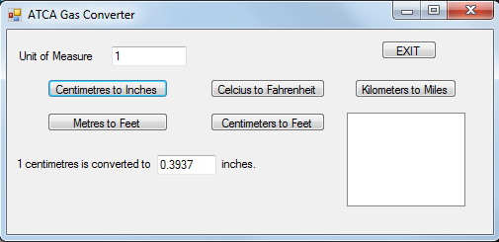

The result of converting 1 centimetre into inches

The number 1 is defined as being a centimetre and is being converted to inches

The working array with the centimetre conversion:

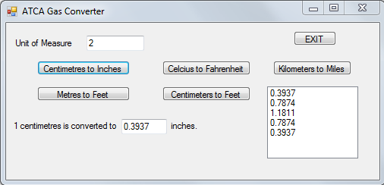

All of the measurements that have been converted

The individual results of converting multiple measurements

Debugging

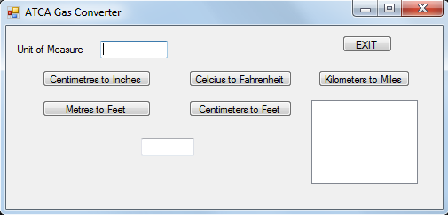

Sequential access algorithm

The applications array takes in the result numbers and counts how many results it has stored and upon counting 5 stored results the array will display in the results box.