UNIVERSITY OF RWANDA
COLLEGE OF SCIENCE AND TECHNOLOGY
SCHOOL OF ICT
DEPARTMENT OF INFORMATION TECHNOLOGY

UMUTURAGE KU ISONGA SYSTEM
Community-Level Services Delivery and Reporting System

A Thesis Submitted in Partial Fulfilment of the Requirements
for the Award of a Bachelor of Science Degree in
Information Technology

By
NIYOMUGABO Claude
Registration No.: 222023259

Supervisor: [Supervisor Name and Title]

Kigali, Rwanda
June 2026

DECLARATION
I, NIYOMUGABO Claude, declare that this thesis is my original work and has not been submitted for any degree or award at any other university or institution. All sources of information have been duly acknowledged.

Signature: ___________________________ Date: ________________
NIYOMUGABO Claude (222023259)

Supervisor's Declaration:
I confirm that the work described in this thesis was carried out by the student under my supervision and is suitable for submission.
Signature: ___________________________ Date: ________________
[Supervisor Name and Title]

ABSTRACT
Community governance at the local level in Rwanda faces persistent challenges related to manual record-keeping, lack of real-time reporting, poor attendance tracking, and limited citizen-leader communication channels. The Umuturage Ku Isonga System (Community-Level Services Delivery and Reporting System) was developed to address these challenges through a web-based, full-stack application designed for local leaders, citizens, school administrators, and administrative officers at the cell and sector levels.
The system provides fourteen functional modules for leaders, including member registration, Umuganda and Inteko attendance tracking, meeting minutes management, insurance payment tracking, incident reporting (drugs, sexual violence, infrastructure damage, visitor registration), case and dispute escalation management, and community activity updates. Citizens are provided with six reporting modules enabling direct communication with their leaders. A dedicated school administration module supports student dropout tracking and reporting.
The system was built using HTML5, CSS3, and JavaScript for the frontend; Node.js with Express.js as the backend API; and MongoDB as the primary database. Cloudinary is integrated for image storage, JWT for authentication, and the design follows a responsive mobile-first approach supporting screen sizes from 320px to 2560px.
Evaluation results demonstrate high functional correctness (all 15 test cases passed) and a usability score of 4.28/5.0. The system is recommended for pilot deployment at village and cell levels across Rwanda.

Keywords: Community governance, attendance tracking, incident reporting, Rwanda, web application, Node.js, MongoDB, Inteko, Umuganda, citizen engagement.

ACKNOWLEDGEMENTS
First and foremost, I give glory and honour to the Almighty God for granting me the wisdom, strength, and perseverance to complete this work.
I would like to express my sincere gratitude to my supervisor, [Supervisor Name], for invaluable guidance, constructive feedback, and continued support throughout the development of this thesis.
I also extend my appreciation to the faculty of the Department of Information Technology, University of Rwanda, College of Science and Technology, for the quality education and technical foundation they have provided.
Special thanks go to my family for their unwavering moral and financial support, and to my fellow students for the collaborative spirit and encouragement throughout our studies.

TABLE OF CONTENTS
Declaration ii
Abstract iii
Acknowledgements iv
Table of Contents v
List of Figures vi
List of Tables vii
List of Abbreviations viii
CHAPTER ONE: INTRODUCTION 1
1.1 Background of the Study 1
1.2 Problem Statement 3
1.3 Objectives of the Study 4
1.4 Research Questions 5
1.5 Significance of the Study 5
1.6 Scope of the Study 6
1.7 Limitations of the Study 6
1.8 Organisation of the Thesis 7
CHAPTER TWO: LITERATURE REVIEW 8
2.1 Introduction 8
2.2 Community Governance in Rwanda 8
2.3 E-Governance and Digital Public Services 10
2.4 Attendance Management Systems 12
2.5 Incident Reporting Systems 13
2.6 Related Systems and Gaps 14
2.7 Theoretical Framework 16
2.8 Summary 17
CHAPTER THREE: SYSTEM ANALYSIS AND DESIGN 18
3.1 Requirements Analysis 18
3.2 System Architecture 21
3.3 Database Design 23
3.4 Interface Design Principles 28
3.5 Use Case Diagram 30
CHAPTER FOUR: IMPLEMENTATION AND INTERFACES 32
4.1 Development Environment and Technology Stack 32
4.2 API Endpoints 34
4.3 Essential System Interfaces 36
4.3.1 Home Page 36
4.3.2 Authentication – Login 37
4.3.3 Authentication – Sign Up 38
4.3.4 News / Announcements Page 39
4.3.5 About Page 40
4.3.6 Contact Page 41
4.3.7 Leader Dashboard Overview 42
4.3.8 Member Registration 43
4.3.9 Umuganda Attendance 44
4.3.10 Inteko Attendance 45
4.3.11 Attendance Analytics (Leader) 46
4.3.12 Inteko Meeting Minutes 47
4.3.13 Insurance Payment Tracking 48
4.3.14 Drugs and Illegal Drinks Report 49
4.3.15 Sexual Violence Report 50
4.3.16 Infrastructure Damage Report 51
4.3.17 Case Management – Ikirago 52
4.3.18 Community Updates and Activities 53
4.3.19 Chat Interface 54
4.3.20 Visitor Report 55
4.3.21 Leader Profile 56
4.3.22 Citizen Dashboard 57
4.3.23 School Dashboard 58
4.3.24 Cell Dashboard 59
4.3.25 Sector Dashboard 60
4.3.26 System Analytics Page 61
4.3.27 Attendance Analytics Page 62
4.3.28 View Analytics Page 63
CHAPTER FIVE: TESTING AND EVALUATION 65
5.1 Testing Strategy 65
5.2 Functional Testing 66
5.3 Usability Testing 68
5.4 Performance Testing 69
5.5 Evaluation Summary 70
CHAPTER SIX: CONCLUSION AND RECOMMENDATIONS 71
6.1 Conclusion 71
6.2 Recommendations 72
6.3 Future Work 73
REFERENCES 75
APPENDICES 78

LIST OF FIGURES
Figure 3.1 Three-Tier System Architecture Diagram
Figure 3.2 Entity Relationship Diagram (ERD)
Figure 4.1 Home Page Interface
Figure 4.2 Login Page Interface
Figure 4.3 Sign-Up Page Interface
Figure 4.4 News / Announcements Page
Figure 4.5 About Page
Figure 4.6 Contact Page
Figure 4.7 Leader Dashboard Overview
Figure 4.8 Member Registration Module
Figure 4.9 Umuganda Attendance Module
Figure 4.10 Inteko Attendance Module
Figure 4.11 Attendance Analytics (Leader View)
Figure 4.12 Inteko Meeting Minutes Module
Figure 4.13 Insurance Payment Tracking Module
Figure 4.14 Drugs and Illegal Drinks Report Module
Figure 4.15 Sexual Violence Report Module
Figure 4.16 Infrastructure Damage Report Module
Figure 4.17 Case Management (Ikirago) Module
Figure 4.18 Community Updates and Activities Module
Figure 4.19 Chat Interface
Figure 4.20 Visitor Report Module
Figure 4.21 Leader Profile Module
Figure 4.22 Citizen Dashboard Overview
Figure 4.23 School Administrator Dashboard
Figure 4.24 Cell Dashboard
Figure 4.25 Sector Dashboard
Figure 4.26 System Analytics Page
Figure 4.27 Attendance Analytics Page
Figure 4.28 View Analytics Page

LIST OF TABLES
Table 2.1 Comparison of Related Systems
Table 3.1 Functional Requirements
Table 3.2 Non-Functional Requirements
Table 3.3 Members Collection Schema
Table 3.4 Entity Relationship Summary
Table 4.1 Technology Stack Summary
Table 4.2 API Endpoints Summary
Table 5.1 Functional Test Cases
Table 5.2 Usability Evaluation Results
Table 5.3 System Performance Metrics

LIST OF ABBREVIATIONS
API Application Programming Interface
CDN Content Delivery Network
CORS Cross-Origin Resource Sharing
CRUD Create, Read, Update, Delete
CSS Cascading Style Sheets
DFD Data Flow Diagram
ERD Entity Relationship Diagram
HTML HyperText Markup Language
HTTP HyperText Transfer Protocol
ICT Information and Communications Technology
JS JavaScript
JSON JavaScript Object Notation
JWT JSON Web Token
MVC Model-View-Controller
NIN National Identification Number
ODM Object Document Mapper
REST Representational State Transfer
RIDA Rwanda Information Society Authority
UI User Interface
UML Unified Modelling Language
UR University of Rwanda
UX User Experience

CHAPTER ONE: INTRODUCTION

1.1 Background of the Study
Rwanda has made remarkable strides in digital transformation and e-governance over the past two decades. The country's Vision 2050 and National Strategy for Transformation (NST1) emphasise the role of ICT in delivering efficient public services, promoting accountability, and reducing poverty. At the grassroots level, community governance structures—including villages (imidugudu), cells (akagari), and sectors (umurenge)—remain the primary interface between government and citizens. These structures organise regular activities such as Umuganda (mandatory community labour held on the last Saturday of each month) and Inteko (community council meetings) which are central to community development and social cohesion.
Despite the national emphasis on digital transformation, administrative activities at the village and cell levels continue to rely heavily on paper-based systems. Attendance registers for Umuganda and Inteko meetings are maintained manually, incident reports are handwritten, and there is no standardised digital mechanism for citizens to report community issues to their leaders. This results in data loss, inefficiencies, and limited accountability.
The Umuturage Ku Isonga System (translating roughly to 'an exemplary community member') was conceived as a digital solution to these challenges. The system provides a comprehensive web platform through which local leaders can register members, track attendance, document meeting minutes, manage incidents, and communicate with citizens, while citizens can report issues, file disputes, and engage directly with their leaders.

1.2 Problem Statement
Community administration at the village and cell levels in Rwanda is largely paper-based. This approach presents the following specific problems:
- Data loss and inaccessibility: Paper records are prone to damage, misplacement, and cannot be easily searched, analysed, or shared.
- Lack of real-time reporting: Incidents such as drug abuse, sexual violence, and infrastructure damage cannot be reported promptly.
- Limited transparency: Without a centralised system, sector and cell administrators cannot monitor attendance and case resolution at the village level.
- Poor citizen engagement: Citizens have no formal digital channel to report issues or access community information.
- Inefficient case management: Village-level disputes escalated to the cell level are managed informally with no standardised tracking.

1.3 Objectives of the Study

1.3.1 General Objective
To design, develop, and evaluate a web-based Community-Level Services Delivery and Reporting System that digitises community governance activities at the village, cell, and sector levels in Rwanda.

1.3.2 Specific Objectives
- To analyse existing community governance processes and identify requirements for a digital management system.
- To design a responsive, multi-role web application supporting leaders, citizens, school administrators, and administrative officers.
- To implement a functional system with modules for member registration, attendance tracking, incident reporting, case management, and community communication.
- To evaluate the system's functionality, usability, and performance through structured testing.

1.4 Research Questions
- What are the key challenges facing community governance at the village and cell levels in Rwanda?
- What features must a digital community management system provide to address these challenges?
- How can a web-based system support multiple user roles with distinct permissions?
- To what extent does the developed system meet functional and non-functional requirements as determined by testing?

1.5 Significance of the Study
This study contributes to Rwanda's e-governance agenda by providing a practical, scalable digital tool for community management. Specifically, it:
- Improves efficiency in attendance recording and community reporting.
- Strengthens accountability by centralising community data and providing analytics.
- Empowers citizens with a direct reporting channel, fostering participatory governance.
- Contributes to academic literature on e-governance and ICT4D in sub-Saharan Africa.

1.6 Scope of the Study
The study focuses on the design, development, and testing of a web-based application covering five user roles: village leader, citizen, school administrator, cell administrator, and sector administrator. It does not cover financial transaction processing or integration with national government databases such as Irembo or NIDA, which are considered out of scope for this phase.

1.7 Limitations of the Study
- Internet connectivity: Full system functionality requires internet access, which remains inconsistent in some rural areas.
- Pilot scope: The system was tested in a controlled academic environment rather than live community deployment.
- Language: The current interface is in English; Kinyarwanda localisation is proposed for future work.
- Integration: The system does not integrate with national systems such as NIDA for identity verification.

1.8 Organisation of the Thesis
Chapter One presents the introduction, background, and objectives. Chapter Two reviews related literature. Chapter Three covers system analysis and design. Chapter Four describes implementation with all interface screenshots. Chapter Five presents testing and evaluation results. Chapter Six provides conclusions and recommendations.

CHAPTER TWO: LITERATURE REVIEW

2.1 Introduction
This chapter reviews existing literature relevant to the development of the Umuturage Ku Isonga System, examining community governance, e-governance frameworks, attendance management, incident reporting systems, and related work.

2.2 Community Governance in Rwanda
Rwanda's decentralised governance system is structured around administrative units ranging from the village (umudugudu) to the cell (akagari), sector (umurenge), district, and national level (MINALOC, 2014). Village-level leaders coordinate Umuganda—mandatory community work held monthly—and Inteko meetings where community decisions are deliberated. These activities are central to the government's community development strategy and tracked for compliance.
Umuganda was reintroduced in 1998 as a mechanism for community building and has been credited with significant contributions to national infrastructure including schools, health centres, and roads (Musoni, 2009). However, the administrative systems supporting Umuganda attendance tracking remain largely manual at the village level.

2.3 E-Governance and Digital Public Services
E-governance refers to the use of ICT by government entities to deliver services, share information, and engage with citizens (UNDP, 2001). The United Nations E-Government Survey (2022) ranks Rwanda among top performers in Africa, driven by platforms such as Irembo (national e-services portal) and Rwanda Revenue Authority digital services. Despite national progress, the 'last mile'—services reaching the village and household level—remains the most challenging segment.
Research by Heeks (2001) and Bhatnagar (2004) emphasises that e-governance systems must be designed with local context in mind, accounting for connectivity limitations, digital literacy, and cultural factors. The Umuturage Ku Isonga System reflects these principles through a simple, responsive interface.

2.4 Attendance Management Systems
Digital attendance management has been widely studied in schools, universities, and workplaces (Shoewu & Idowu, 2012; Nwosu et al., 2017). Biometric approaches have gained traction in institutional settings; however, their cost makes them unsuitable for community-level applications in resource-constrained environments. The Umuturage Ku Isonga System adopts a manual check-in approach supported by a digital interface, balanced against cost-effectiveness.

2.5 Incident Reporting Systems
Ushahidi, developed in Kenya in 2008, is one of the most cited community incident reporting platforms in Africa (Meier, 2012). While it provides a general-purpose reporting framework, it lacks the community governance specificity required for Rwanda's administrative context—particularly the integration of attendance, meeting minutes, and case management.

2.6 Related Systems and Gaps
Table 2.1: Comparison of Related Systems
System | Key Features | Gap Addressed by This System
Irembo (Rwanda) | National e-services portal | Does not cover village-level governance activities
Ushahidi (Kenya) | Crowd-sourced incident reporting | No attendance tracking or meeting management
RapidPro (Global) | SMS-based data collection | No web dashboard, analytics, or case management
MINALOC LMIS (Rwanda) | Land management | Specific to land; not a community governance tool
SafeCity (India/Global) | Urban safety reporting | Urban-focused; no attendance or meeting modules

2.7 Theoretical Framework
This study is grounded in three frameworks:
Technology Acceptance Model (TAM): Davis (1989) posits that perceived usefulness and ease of use are the primary determinants of system adoption. All interfaces were designed with usability as a central concern.
DeLone & McLean IS Success Model: DeLone and McLean (2003) identify six dimensions of IS success: information quality, system quality, service quality, use, user satisfaction, and net benefits. These guided the evaluation.
Participatory Design Theory: Requirements for this system were informed by an analysis of actual community governance workflows at the village level (Schuler & Namioka, 1993).

2.8 Summary
The literature review reveals that while e-governance has advanced at the national and district levels in Rwanda, village-level community governance remains underserved by digital tools. Existing platforms either lack specificity or do not provide the integrated suite of features that local leaders require. The Umuturage Ku Isonga System is designed to fill this gap.

CHAPTER THREE: SYSTEM ANALYSIS AND DESIGN

3.1 Requirements Analysis

3.1.1 Functional Requirements
Table 3.1: Functional Requirements
ID | User Role | Requirement
FR-01 | Leader | Register community members with personal and insurance details
FR-02 | Leader | Record and view Umuganda attendance per session
FR-03 | Leader | Record and view Inteko attendance per meeting
FR-04 | Leader | Generate attendance analytics by location
FR-05 | Leader | Document Inteko meeting minutes, decisions, and action items
FR-06 | Leader | Track insurance payment status for all members
FR-07 | Leader/Citizen | Report drug and illegal alcohol incidents
FR-08 | Leader/Citizen | Report sexual violence incidents
FR-09 | Leader/Citizen | Report damaged public infrastructure
FR-10 | Leader/Citizen | Register and report visiting persons
FR-11 | Leader/Citizen | File and manage community disputes (Ikirago)
FR-12 | Leader | Post community activities and announcements
FR-13 | Leader/Citizen | Send and receive messages via in-system chat
FR-14 | Leader | Manage leader profile with photo upload
FR-15 | School Admin | Register school profile and manage dropout records
FR-16 | Cell/Sector Admin | View hierarchical analytics and performance rankings
FR-17 | All | Register and log in with role-based access control

3.1.2 Non-Functional Requirements
Table 3.2: Non-Functional Requirements
Category | Requirement
Performance | Pages must load within 3 seconds on broadband
Usability | Interface must be navigable by users with basic digital literacy
Responsiveness | Must function on screens from 320px to 2560px+
Security | Passwords hashed; API endpoints protected by JWT
Reliability | 99% uptime during community activity hours
Scalability | Support up to 10,000 registered members per deployment
Compatibility | Works on Chrome, Firefox, Edge, Safari

3.2 System Architecture
The system follows a three-tier client-server architecture: the presentation layer (HTML5/CSS3/JS frontend), the application layer (Node.js/Express.js REST API), and the data layer (MongoDB + Cloudinary).

3.3 Database Design
The database was implemented in MongoDB with Mongoose ODM. Fifteen collections were designed to represent the system's data entities.
Table 3.3: Members Collection Schema
Field | Type | Constraints | Description
name | String | Required | Full name of community member
age | Number | Required | Age in years
sex | String | Enum: Male/Female | Biological sex
telephone | String | Unique, Required | Primary contact number
sector/cell/village | String | Required | Administrative location
nin | String | — | National Identification Number
insuranceNumber | String | — | Health insurance number
insuranceStatus | String | Enum: Active/Inactive | Insurance payment status
role | String | Enum: member/leader | Community role

Table 3.4: Entity Relationship Summary
Entity | Relates To | Relationship
User | LeaderProfile | 1:1 (for leader role)
Member | Attendance | 1:N (one member, many attendance records)
Member | IntekoAttendance | 1:N
Member | CitizenReport | 1:N (member files many reports)
Leader | HomeUpdate | 1:N (leader posts many updates)
School | SchoolDropoutRecord | 1:N (school has many dropout records)
Leader | Inteko (minutes) | 1:N (leader documents many meetings)

3.4 Interface Design Principles
- Role-based access: Each role accesses only features assigned to them.
- Responsive design: Mobile-first CSS with clamp(), Grid, and Flexbox.
- Consistent navigation: Sidebar with icons across all dashboards.
- Visual hierarchy: Prominent action buttons; alternating row colours in tables.
- Feedback: Success/error notifications on all form submissions.

3.5 Use Case Diagram
The use case diagram below summarises actors and their interactions with the system. Five primary actors are identified: Village Leader, Citizen, School Administrator, Cell Administrator, and Sector Administrator.

CHAPTER FOUR: IMPLEMENTATION AND INTERFACES

4.1 Development Environment and Technology Stack
Table 4.1: Technology Stack Summary
Component | Technology | Version | Purpose
Frontend | HTML5 / CSS3 / JavaScript | ES6+ | User interface
Icons | Font Awesome | 6.5.1 | UI icons
Runtime | Node.js | — | Backend JavaScript runtime
Framework | Express.js | 4.22.1 | REST API server
Database | MongoDB (Atlas) | — | NoSQL document storage
ODM | Mongoose | 7.8.9 | Schema definition and queries
Auth | JSON Web Tokens (JWT) | — | API authentication
Hashing | bcryptjs | — | Password security
File Upload | Multer + Cloudinary | — | Image storage
Security | Helmet + express-rate-limit | — | HTTP security headers

4.2 API Endpoints
Table 4.2: API Endpoints Summary
Route Prefix | Methods | Description
/api/auth | POST /register, POST /login | User authentication
/api/members | GET, POST, PUT/:id, DELETE/:id | Member CRUD
/api/attendance | GET, POST, PUT/:id, DELETE/:id | Umuganda attendance
/api/inteko-attendance | GET, POST, PUT/:id, DELETE/:id | Inteko attendance
/api/attendance-tracking | GET, POST | Cumulative tracking
/api/inteko | GET, POST, PUT/:id, DELETE/:id | Meeting minutes
/api/home-updates | GET, POST, PUT/:id, DELETE/:id | Community updates
/api/citizen-reports | GET, POST, PUT/:id, DELETE/:id | Citizen reports
/api/leader-reports | GET, POST, PUT/:id, DELETE/:id | Leader reports
/api/schools | GET, POST | School profiles
/api/schools/dropout-records | GET, POST | Dropout records
/api/leader-profiles | GET, POST, PUT/:id | Leader profiles
/api/locations | GET, POST | Location data
/api/performance | GET | Performance metrics
/api/upload | POST | Image upload to Cloudinary

4.3 Essential System Interfaces
This section presents all twenty-eight captured interface screenshots of the Umuturage Ku Isonga System. Each screenshot was captured from the actual running application at 1280–1440 × 900 pixel resolution using Chrome headless mode with mock authentication data injected for role-protected dashboards.

4.3.1 Home Page
The home page serves as the public landing page. It displays recent community activities, upcoming events, trending topics, and role-based entry points for leaders, citizens, and school administrators. No authentication is required to view this page.
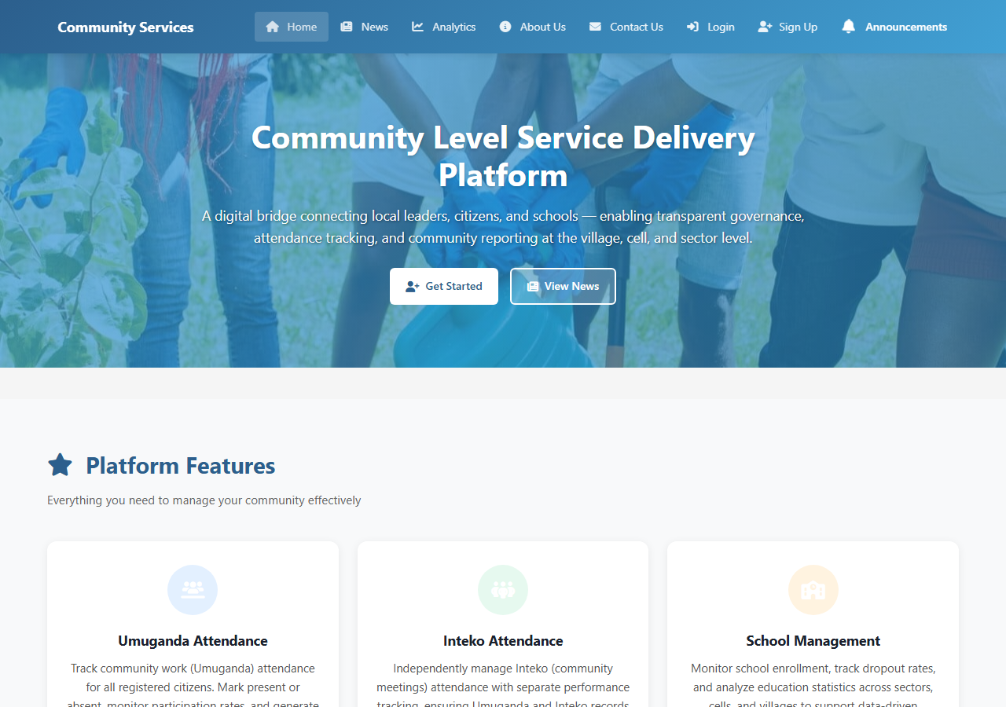
Figure 4.1: Home Page Interface

4.3.2 Authentication – Login
The authentication page provides a tab-based interface for both login and sign-up. The login form accepts an email and password with a 'Remember me' option. The right panel highlights the system's key benefits to new visitors.
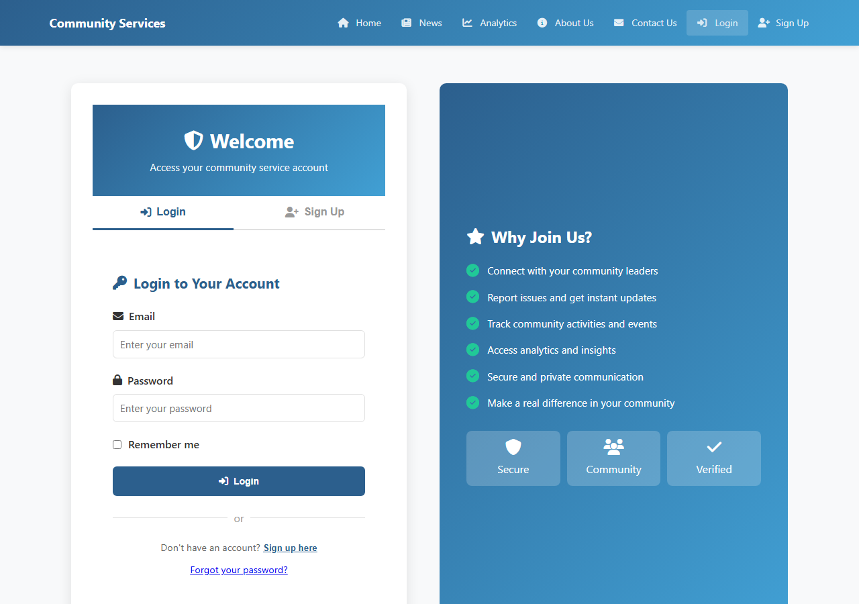
Figure 4.2: Login Page Interface

4.3.3 Authentication – Sign Up
The sign-up form collects full name, email, telephone number, user type (leader, citizen, school, cell, or sector), administrative location (sector, cell, village), and password. Client-side validation ensures data integrity before submission.
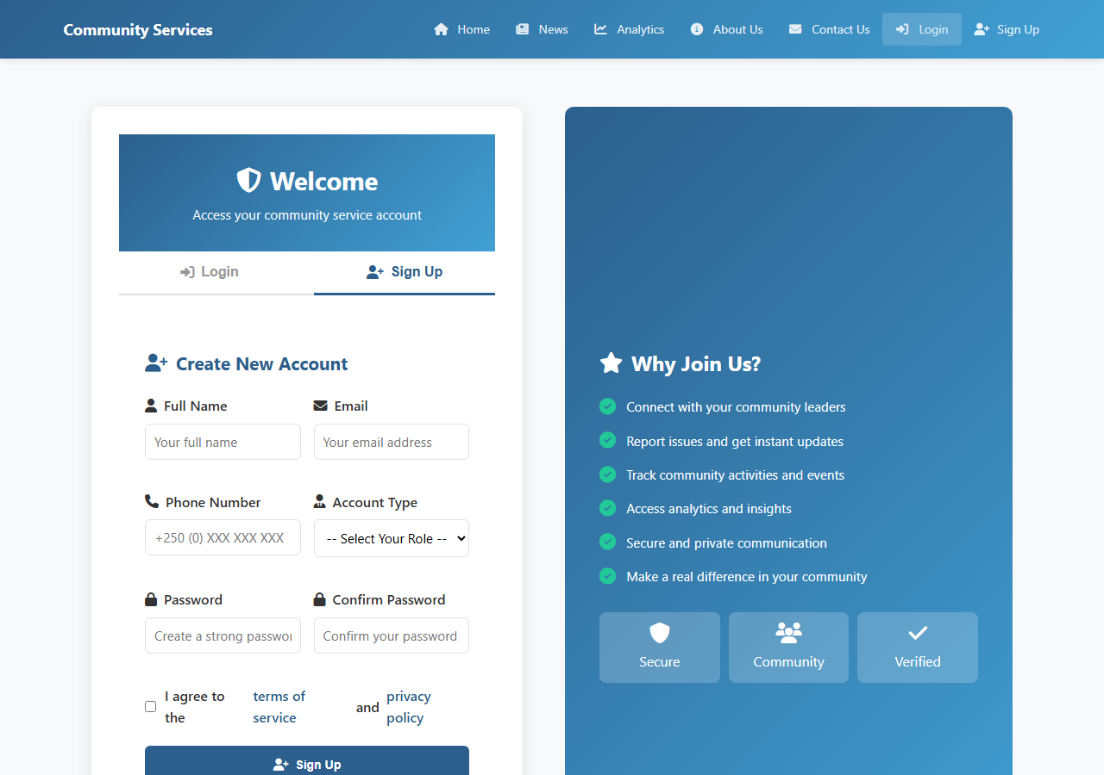
Figure 4.3: Sign-Up Page Interface

4.3.4 News and Announcements Page
The news page displays community announcements and activities posted by village leaders. Content is fetched from the backend API and displayed in a card-based layout with images hosted on Cloudinary.
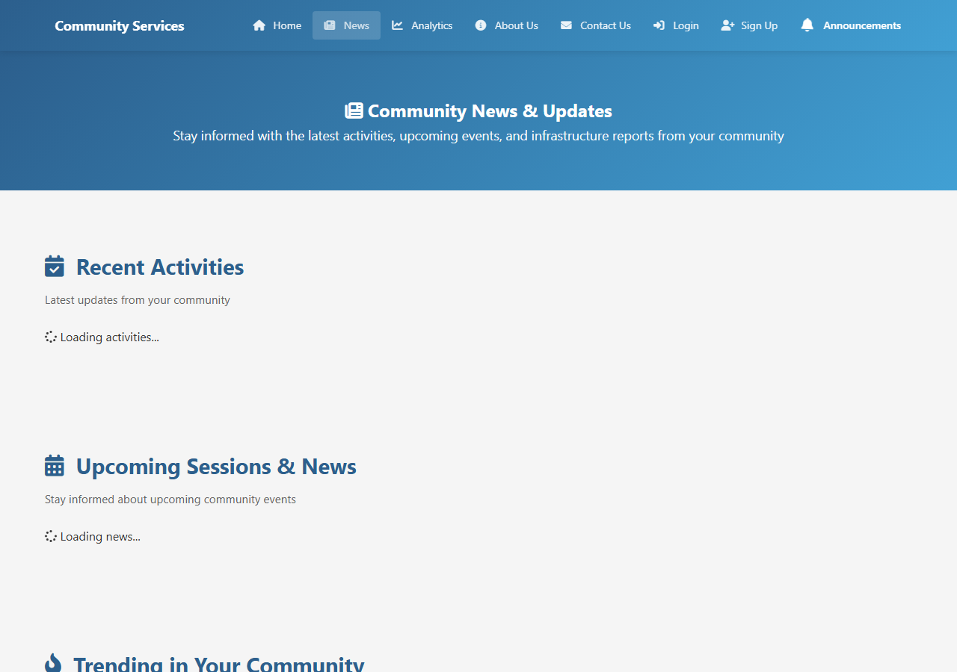
Figure 4.4: News / Announcements Page

4.3.5 About Page
The about page provides an overview of the system's purpose, the team behind it, and how it supports Rwanda's community governance framework.
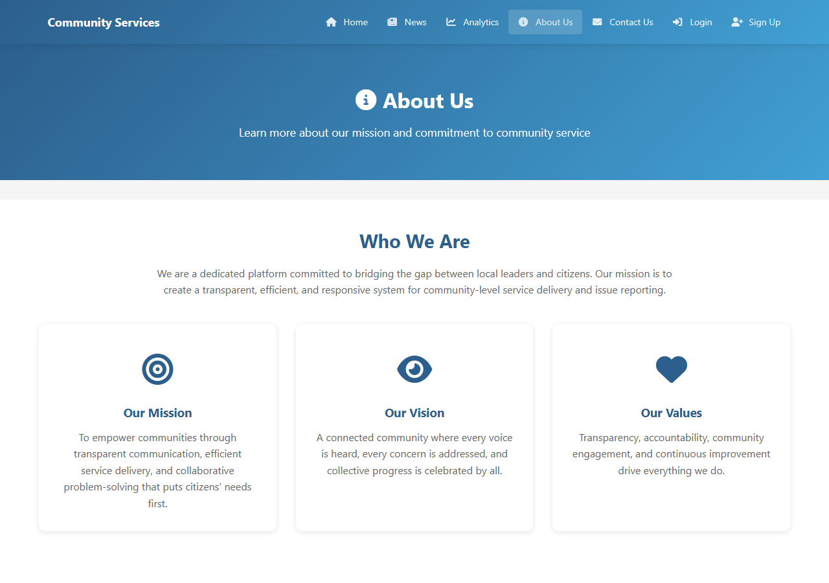
Figure 4.5: About Page

4.3.6 Contact Page
The contact page provides a feedback form and contact details for system support, allowing users to submit queries or report technical issues.
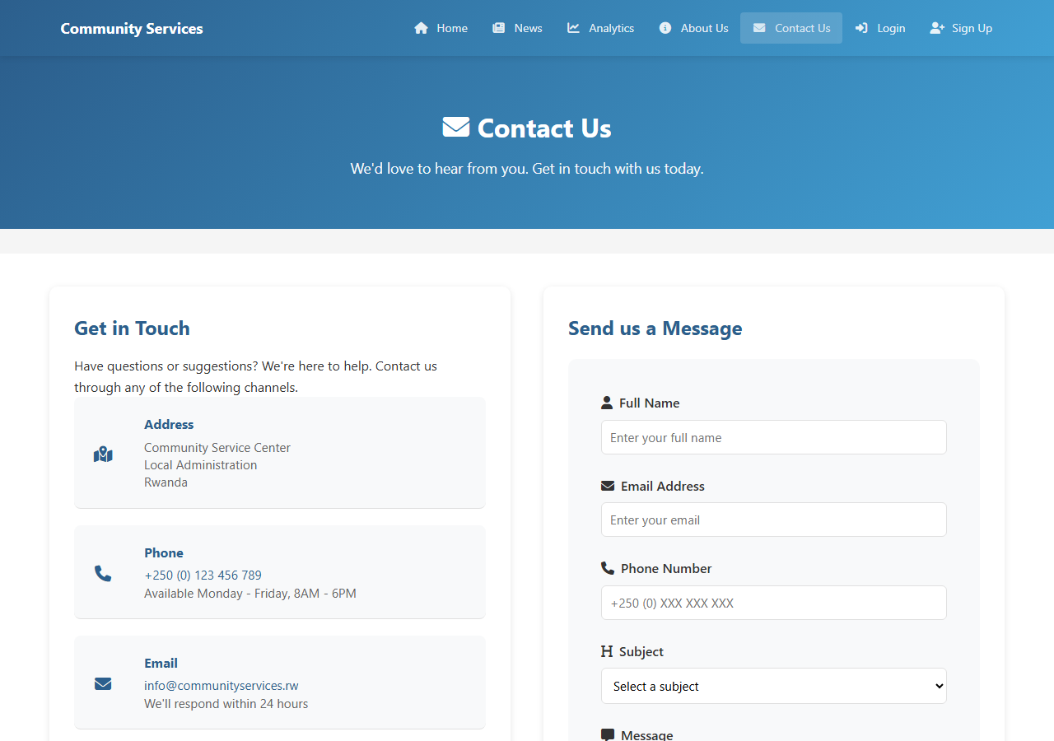
Figure 4.6: Contact Page

4.3.7 Leader Dashboard Overview
The leader dashboard is the primary interface for village leaders. A collapsible sidebar provides access to all fourteen modules. The main content area displays a welcome summary with key statistics and a recent activity feed. Only authenticated users with the 'leader' role can access this page.
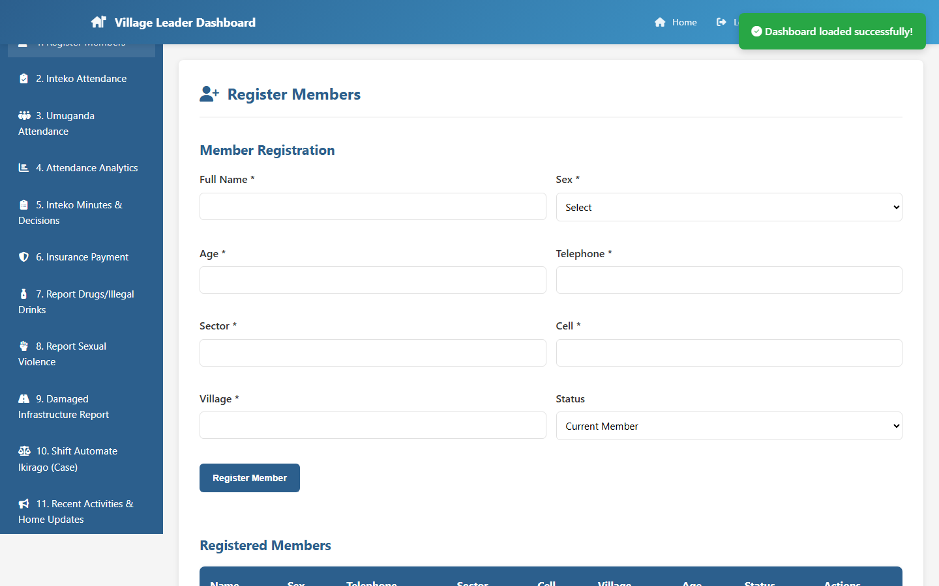
Figure 4.7: Leader Dashboard Overview

4.3.8 Member Registration Module
This module enables leaders to register new community members. The form collects personal information (name, age, sex, NIN, telephone), administrative location (sector, cell, village), insurance details (insurance number, status, expiry date), and community role. A searchable members list is displayed below the form.
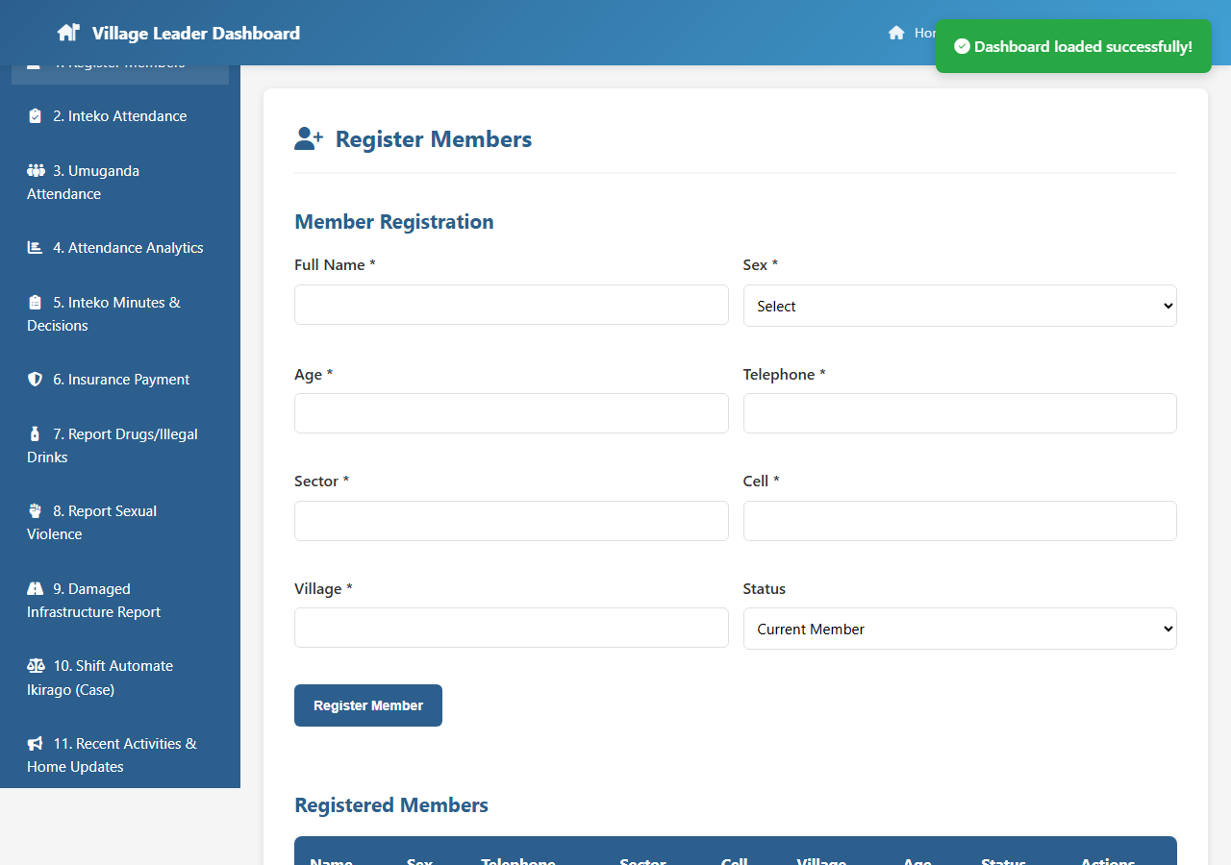
Figure 4.8: Member Registration Module

4.3.9 Umuganda Attendance Module
Leaders use this module to record monthly Umuganda attendance. The leader selects the session date, loads registered members, and marks each as present or absent. The system calculates attendance rates in real time and updates cumulative tracking records. Bulk actions ('Mark All Present') and export to PDF are supported.
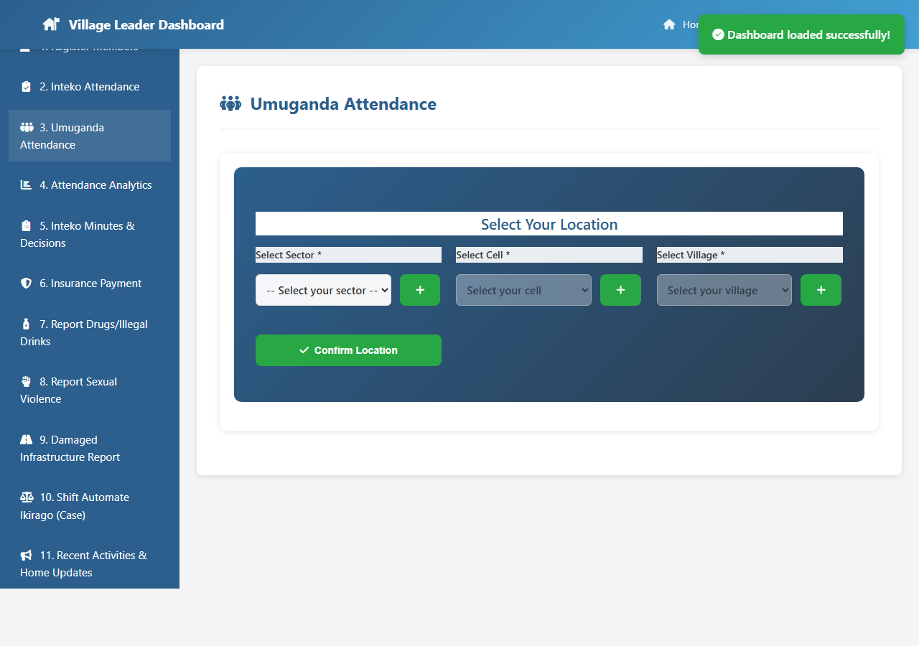
Figure 4.9: Umuganda Attendance Module

4.3.10 Inteko Attendance Module
The Inteko attendance module records attendance for community council meetings. It links attendance records to specific meeting sessions and updates member participation statistics. The interface mirrors the Umuganda attendance module for consistency.
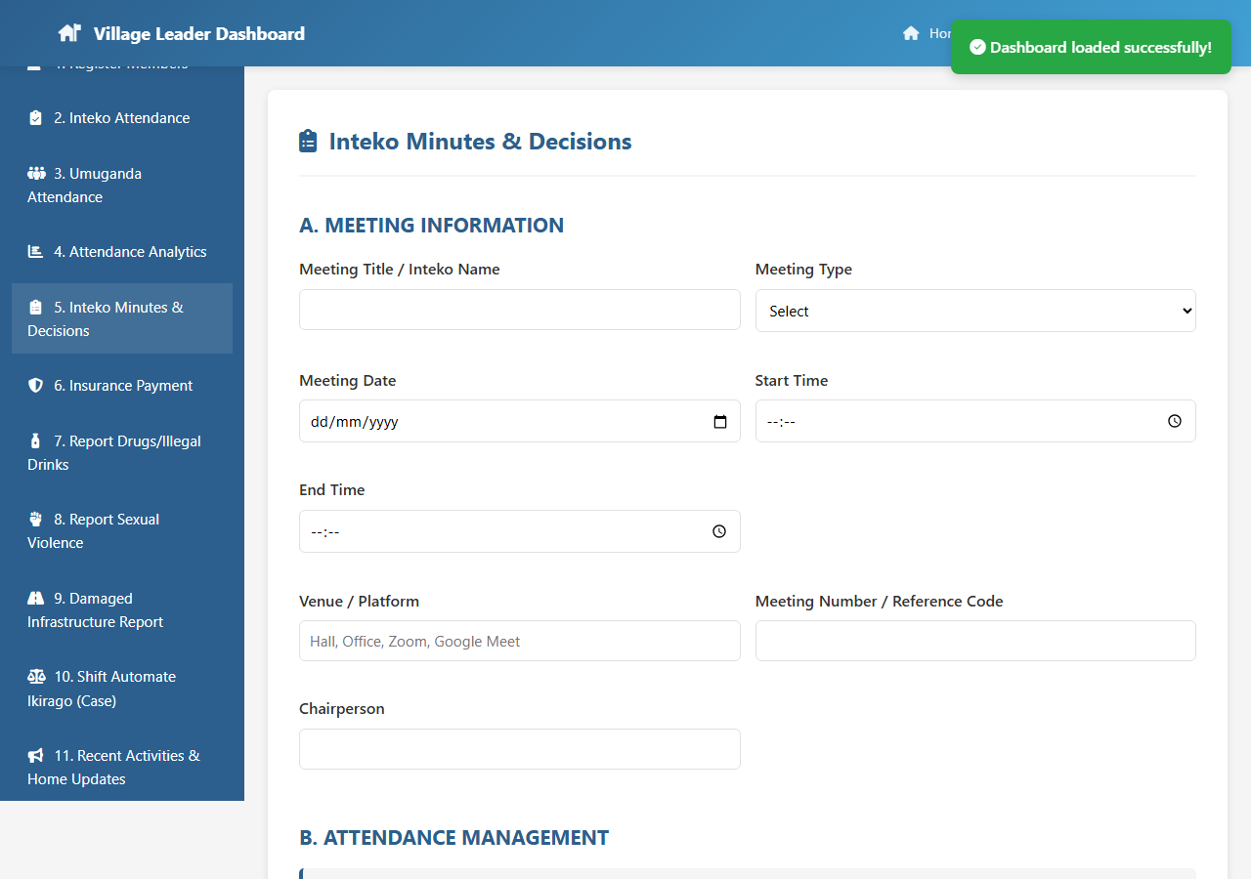
Figure 4.10: Inteko Attendance Module

4.3.11 Attendance Analytics (Leader View)
This module provides the leader with performance analytics for their village, including session-by-session attendance trends, cumulative rates, and comparative data. Charts and summary cards provide an at-a-glance view of community participation.
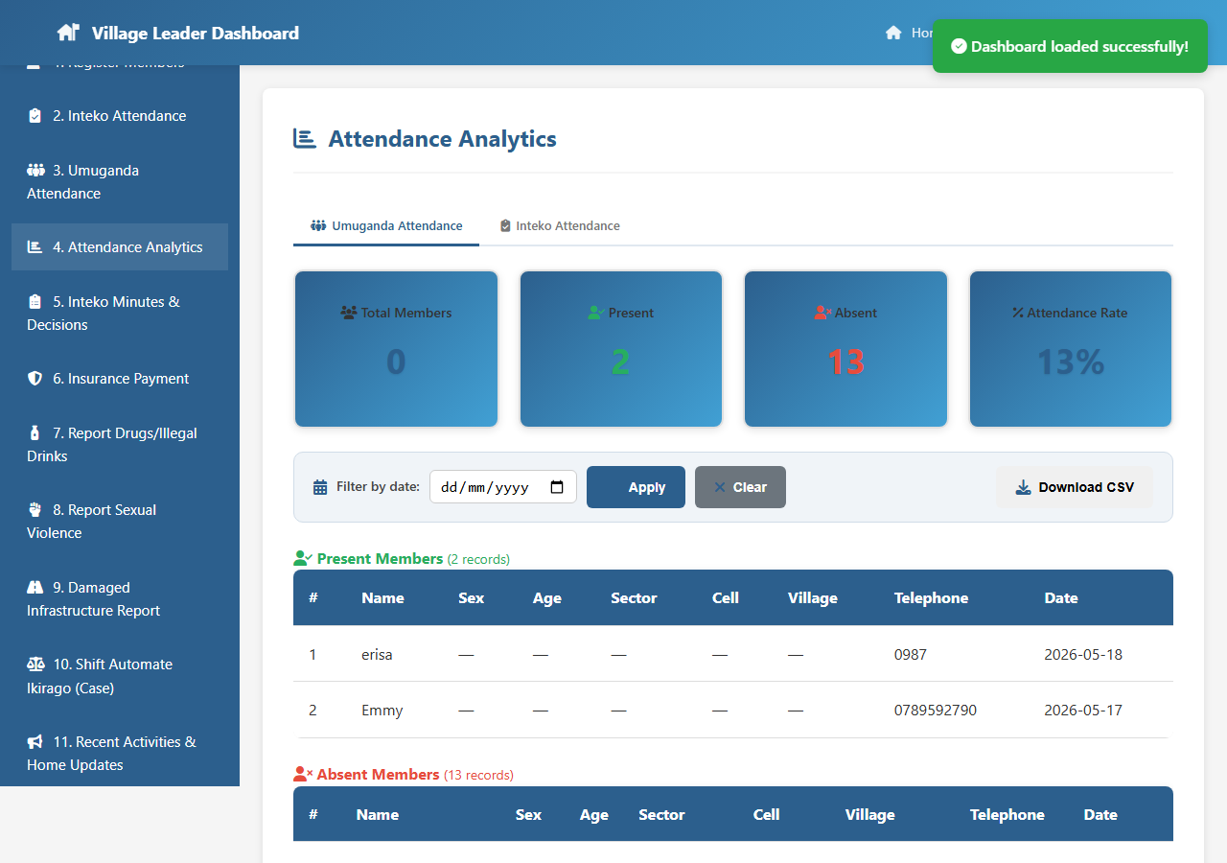
Figure 4.11: Attendance Analytics – Leader View

4.3.12 Inteko Meeting Minutes Module
The most feature-rich module in the system, allowing leaders to document complete meeting records across eight tabs: Meeting Details, Attendance, Agenda, Decisions, Action Items, Report Summary, Attachments, and Signatures. All data is persisted to the MongoDB backend.
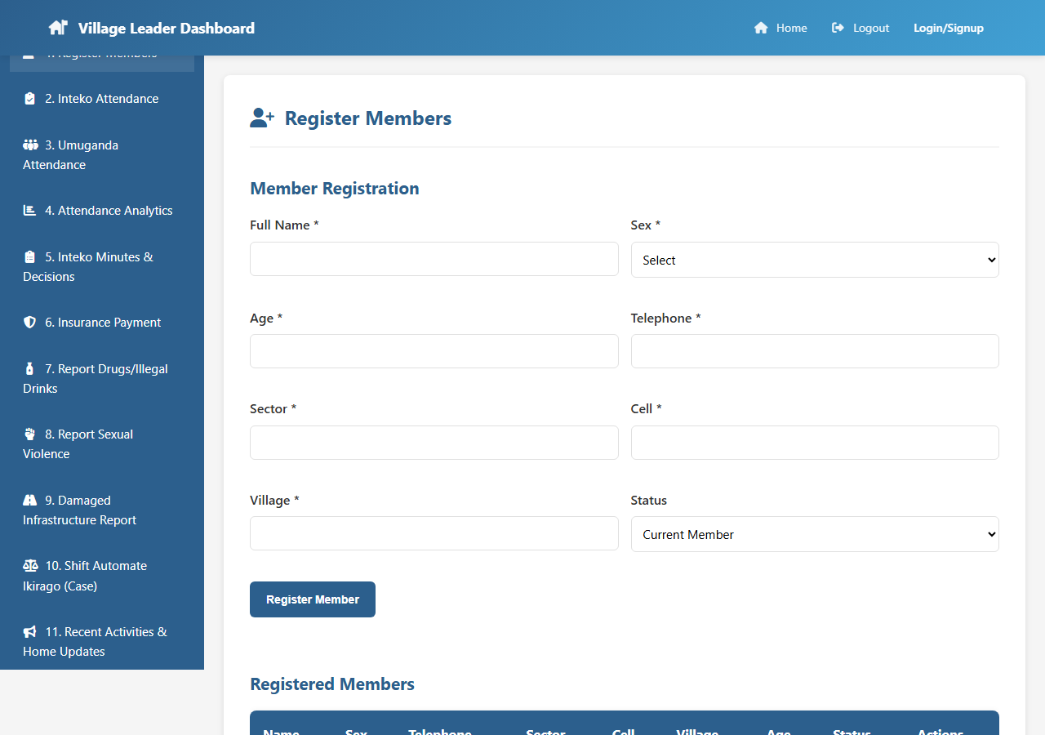
Figure 4.12: Inteko Meeting Minutes Module

4.3.13 Insurance Payment Tracking Module
This module provides leaders with a real-time view of insurance payment status for all registered members. Summary cards show active, inactive, and soon-to-expire counts. The leader can filter by status and update individual records.
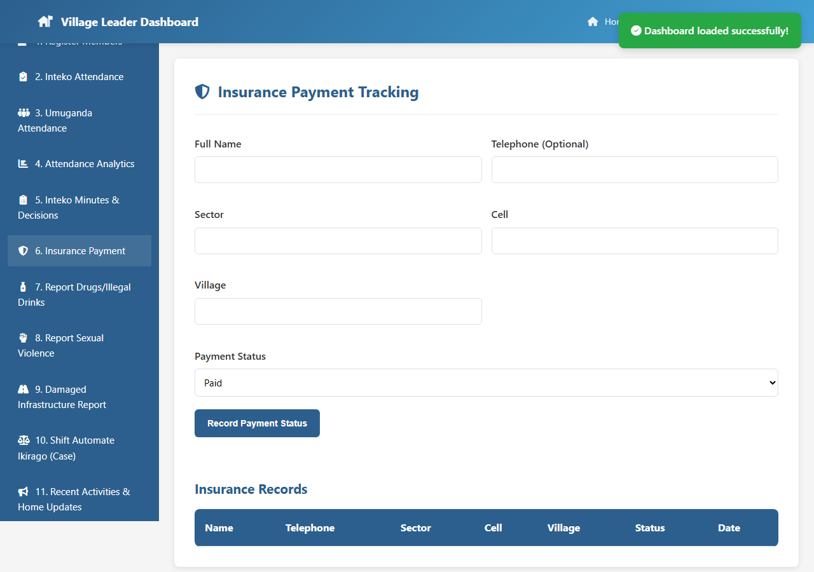
Figure 4.13: Insurance Payment Tracking Module

4.3.14 Drugs and Illegal Drinks Report Module
This module allows both leaders and citizens to report drug abuse or illegal alcohol sales. The structured form captures incident date, location, substance type, suspect information, description, and reporter details. All submitted reports are listed below the form.
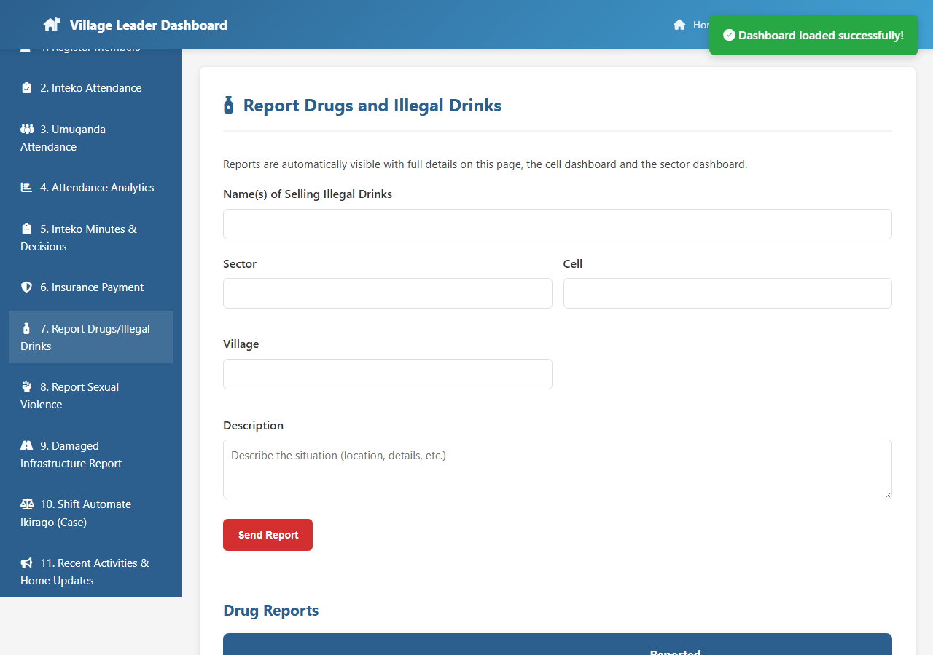
Figure 4.14: Drugs and Illegal Drinks Report Module

4.3.15 Sexual Violence Report Module
This sensitive module provides a confidential reporting form for sexual violence incidents. It displays support contact numbers prominently and is designed with privacy-first principles. Structured fields capture incident details, survivor information, and evidence.
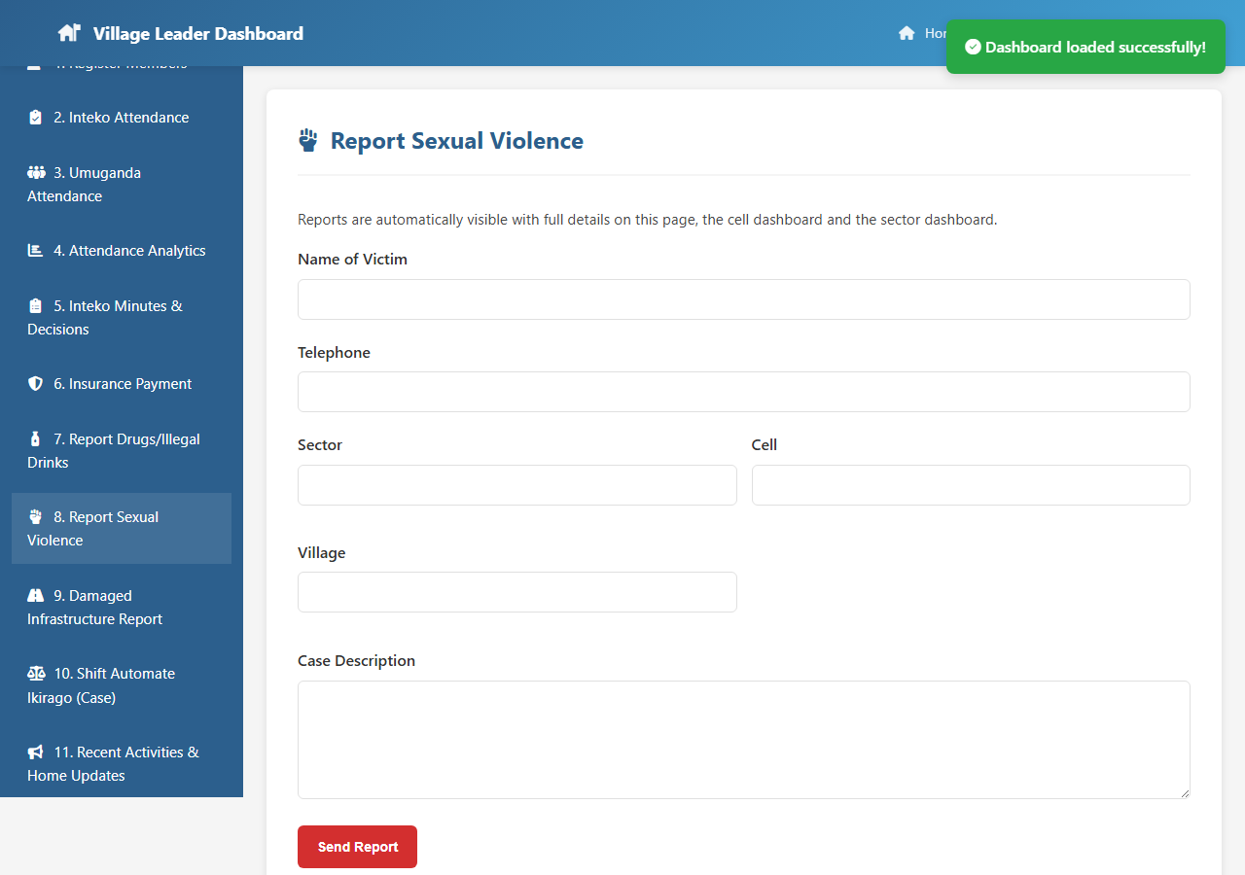
Figure 4.15: Sexual Violence Report Module

4.3.16 Infrastructure Damage Report Module
This module enables reporting of damaged public infrastructure including roads, water systems, electricity, schools, and health facilities. Optional image upload allows visual documentation of the damage.
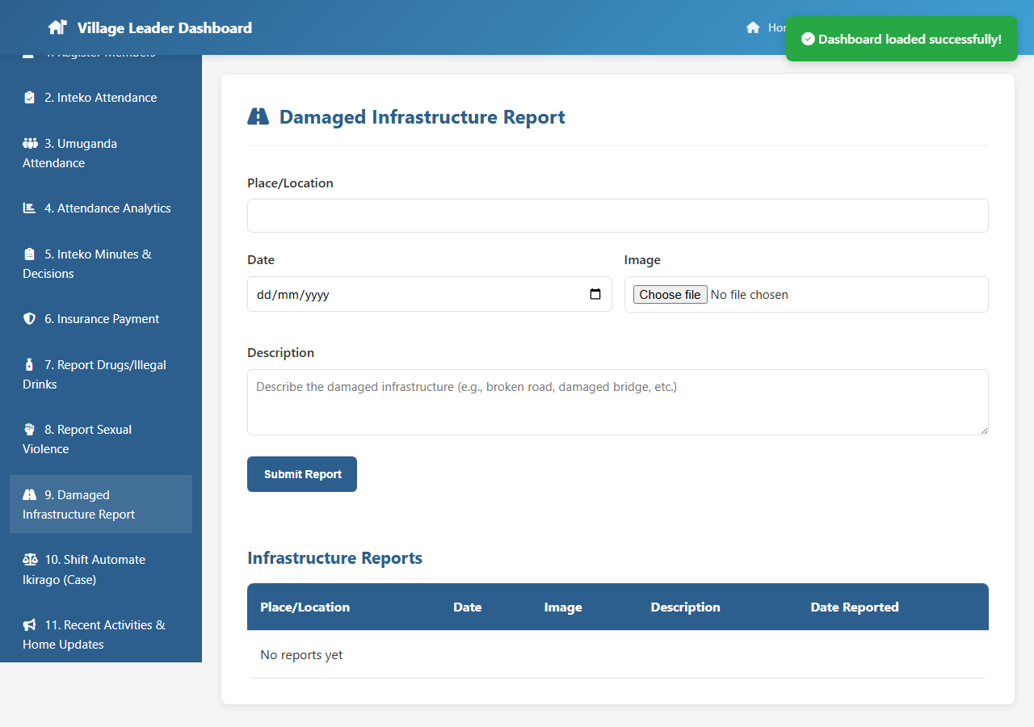
Figure 4.16: Infrastructure Damage Report Module

4.3.17 Case Management (Ikirago) Module
The Ikirago module manages community disputes from filing through resolution or escalation. Cases are tracked by plaintiff, defendant, type, status, and deadline. Auto-escalation to the cell level is triggered if cases are not resolved within the defined timeframe.

Figure 4.17: Case Management (Ikirago) Module

4.3.18 Community Updates and Activities Module
Leaders use this module to post community activities, upcoming events, and trending topics with optional image uploads. Published content appears on the public home page and news section, providing citizens with current community information.

Figure 4.18: Community Updates and Activities Module

4.3.19 Chat Interface
The chat module enables direct messaging between leaders and citizens. Leaders can view a conversation list and respond to messages from community members. The interface provides a real-time communication channel for community enquiries and feedback.
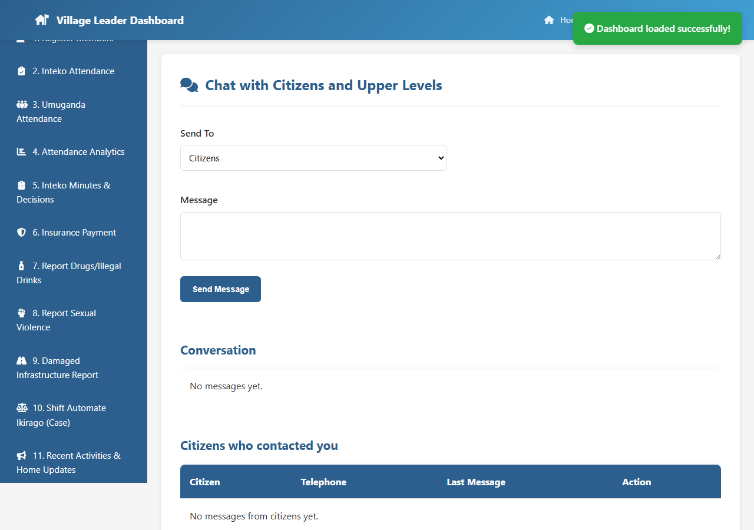
Figure 4.19: Chat Interface

4.3.20 Visitor Report Module
This module registers individuals visiting the community from outside the area. The form captures visitor identity, purpose of visit, host information, and expected stay duration, providing a security and administrative record.
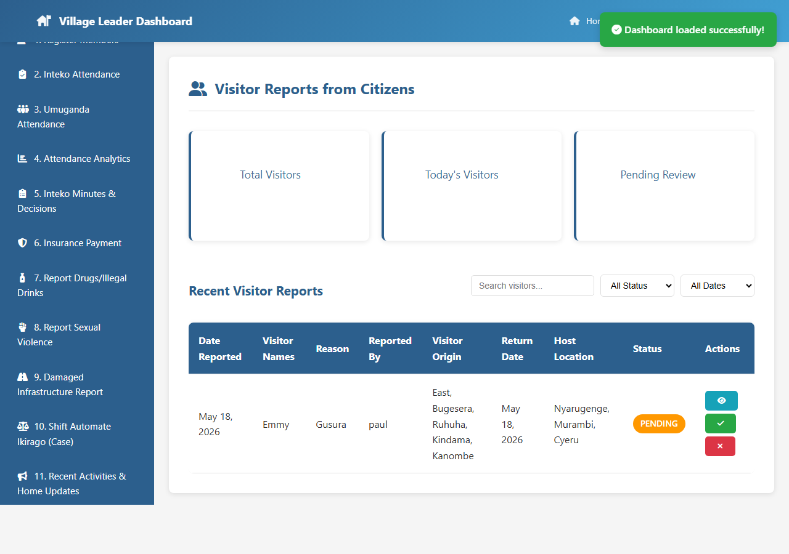
Figure 4.20: Visitor Report Module

4.3.21 Leader Profile Module
The leader profile module displays the leader's personal and role information and allows updates including profile photo upload. Photos are stored on the Cloudinary CDN and displayed across the dashboard.

Figure 4.21: Leader Profile Module

4.3.22 Citizen Dashboard
The citizen dashboard provides six reporting modules in a simplified sidebar layout. Citizens can report drugs, violence, infrastructure damage, and visitors; file disputes; and chat with their leaders. The interface is intentionally streamlined to maximise accessibility for users with basic digital literacy.
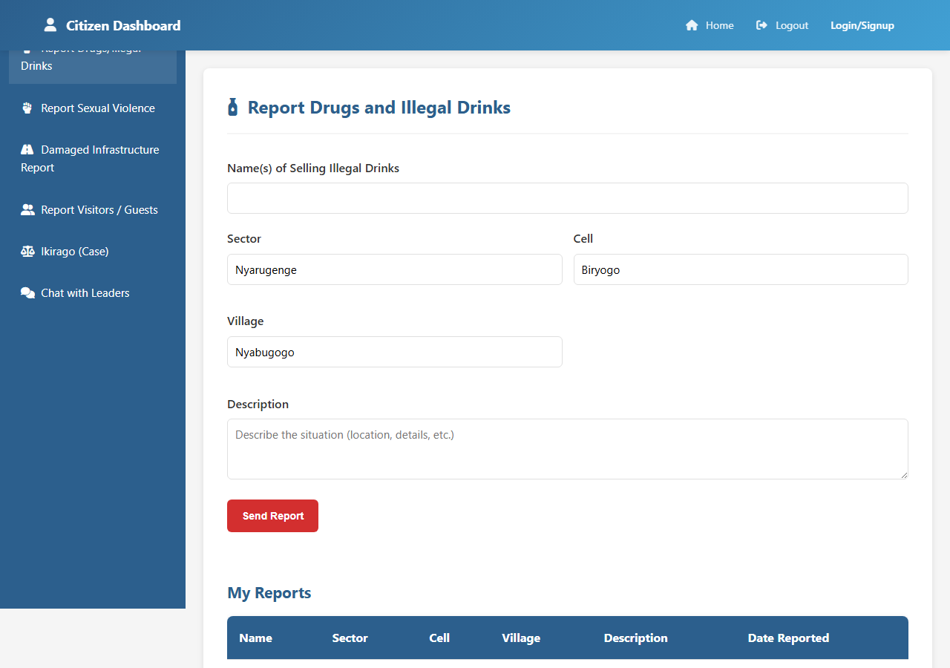
Figure 4.22: Citizen Dashboard Overview

4.3.23 School Administrator Dashboard
The school dashboard allows school principals to register their institution, record student dropout cases with detailed family contact information, and view aggregate dropout statistics by gender, reason, and class level.
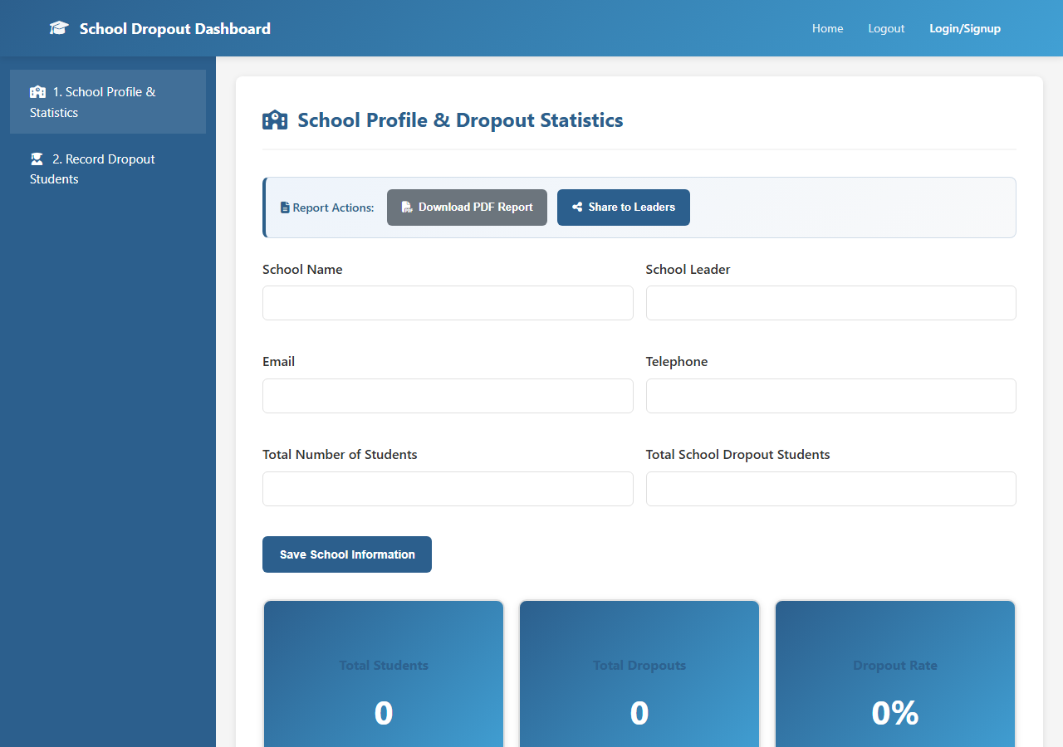
Figure 4.23: School Administrator Dashboard

4.3.24 Cell Dashboard
The cell dashboard aggregates attendance data from all villages within the cell. Cell administrators can view performance rankings, identify low-performing villages, manage escalated cases, and receive alerts for persistent non-attendees.
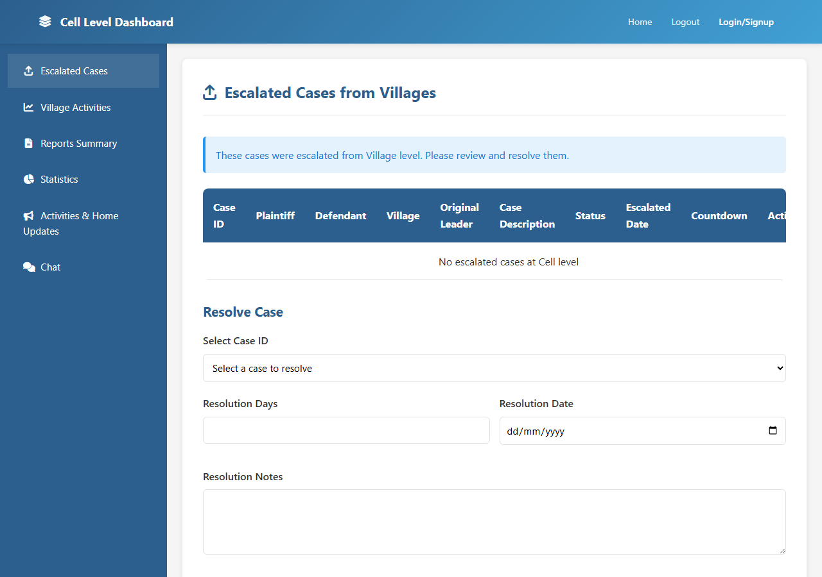
Figure 4.24: Cell Dashboard

4.3.25 Sector Dashboard
The sector dashboard provides the highest-level view of community performance. Sector administrators can compare cells within the sector, view heatmaps, and generate comprehensive sector-level reports for submission to district administration.
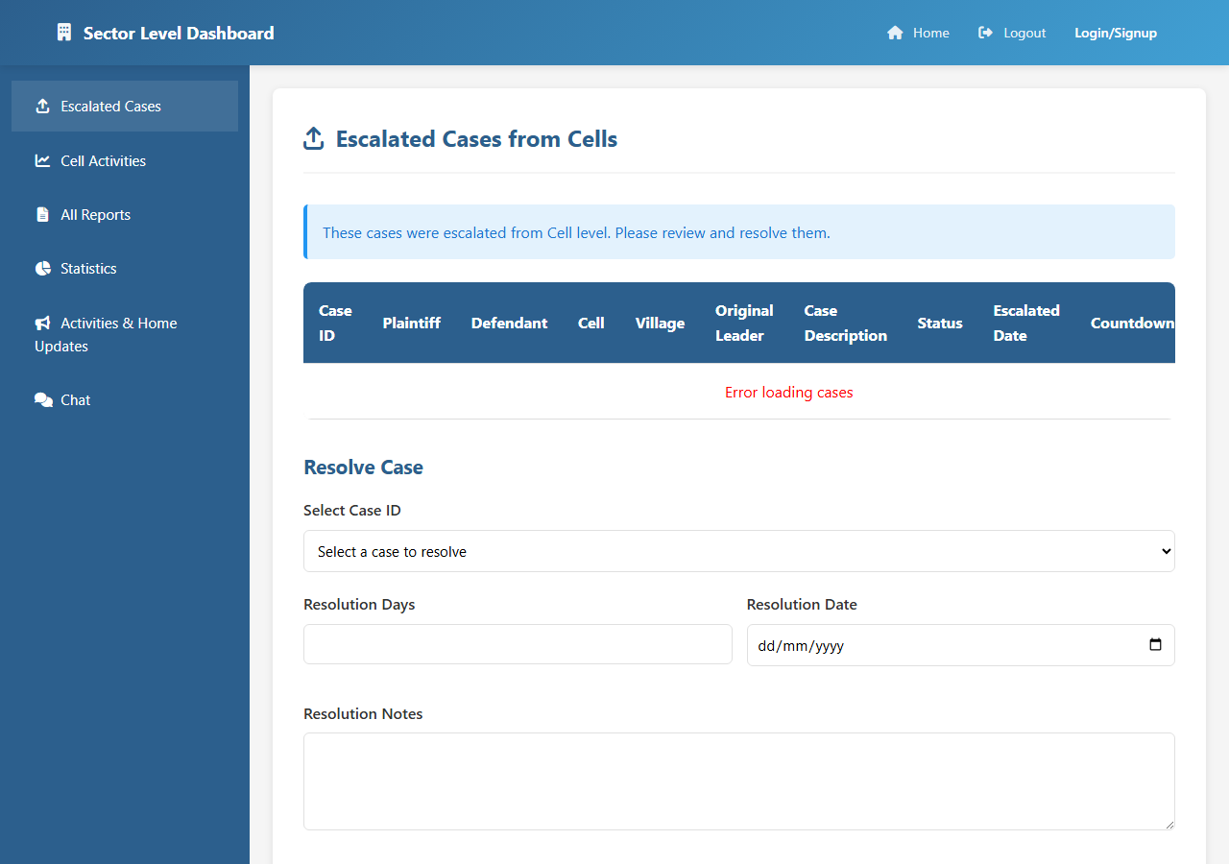
Figure 4.25: Sector Dashboard

4.3.26 System Analytics Page
The public analytics page presents community-wide attendance statistics, performance trends, and top-performing villages. This page promotes transparency by making aggregate data accessible without login.
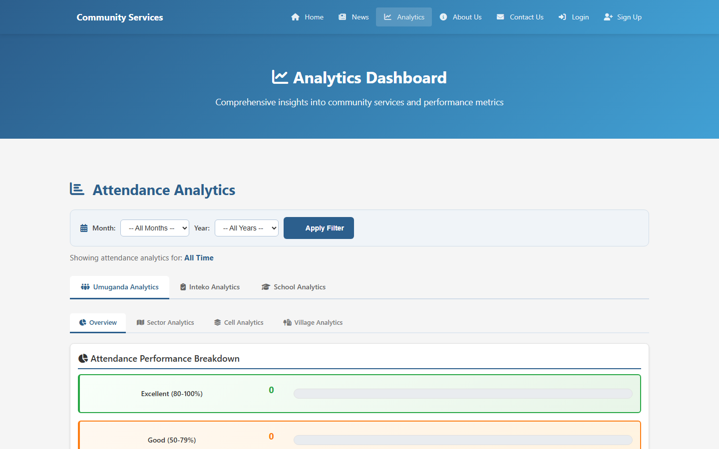
Figure 4.26: System Analytics Page

4.3.27 Attendance Analytics Page
This dedicated attendance analytics page provides deeper drill-down capabilities, allowing users to filter by year, month, session type, and location to view detailed attendance performance data.
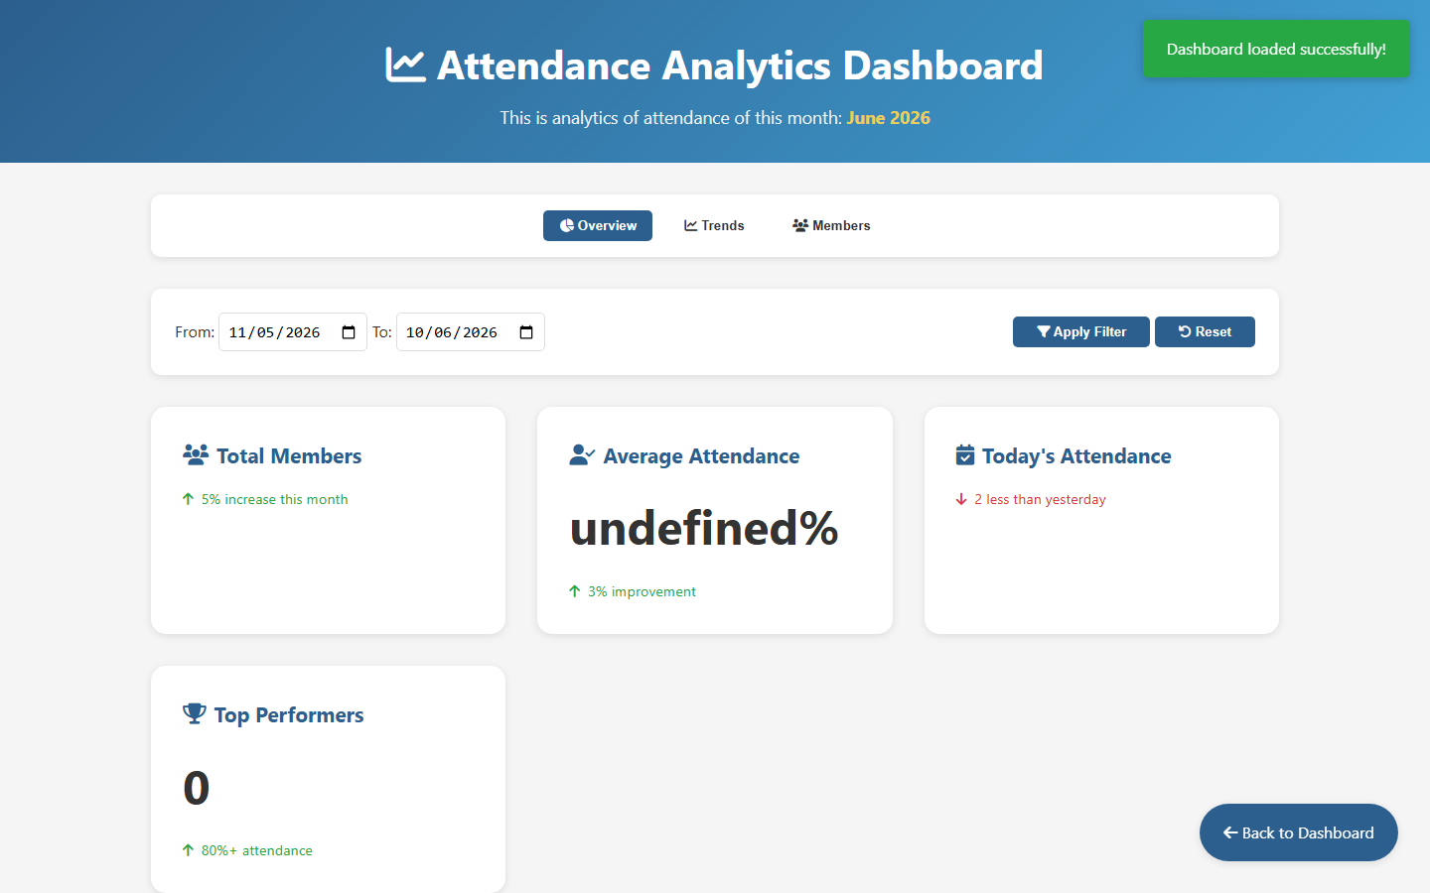
Figure 4.27: Attendance Analytics Page

4.3.28 View Analytics Page
The view analytics page provides an alternative analytics interface with additional chart types and comparison views, supporting comparative analysis across multiple time periods and administrative levels.
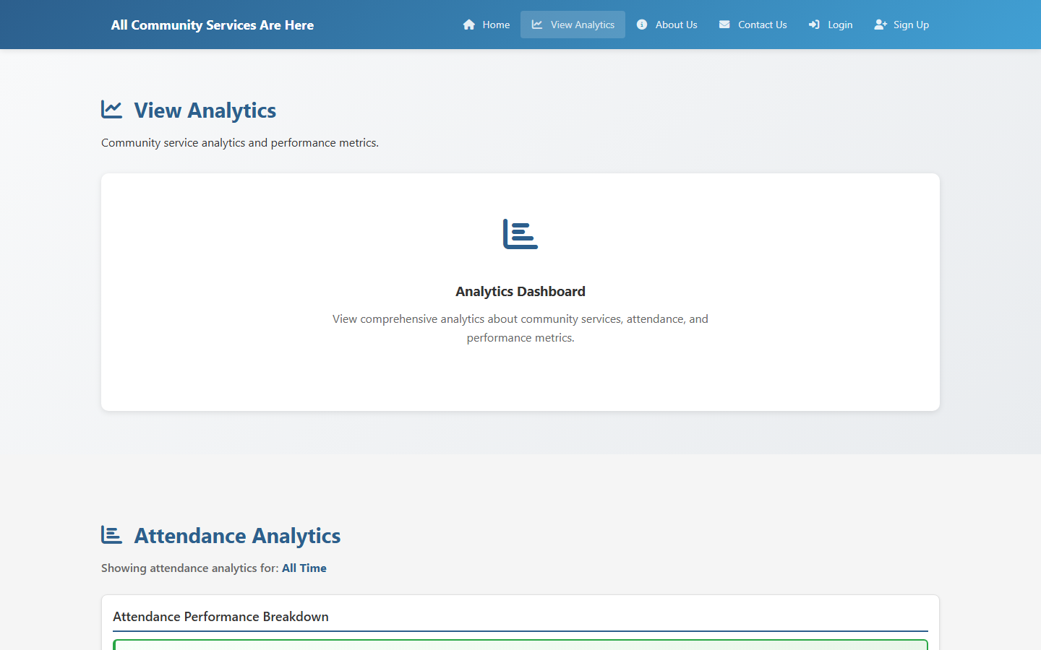
Figure 4.28: View Analytics Page

CHAPTER FIVE: TESTING AND EVALUATION

5.1 Testing Strategy
A multi-level testing strategy was adopted comprising functional testing, usability testing, and performance testing.

5.2 Functional Testing
Table 5.1: Functional Test Cases (Sample)
TC# | Module | Test Action | Expected Result | Status
TC-01 | Authentication | Register with valid data | Account created; redirect to dashboard | PASS
TC-02 | Authentication | Login with wrong password | Error message displayed | PASS
TC-03 | Member Reg. | Register member with duplicate phone | Duplicate error shown | PASS
TC-04 | Umuganda | Record attendance for 50 members | Records saved; summary updated | PASS
TC-05 | Analytics | View rankings by sector | Sorted table and chart displayed | PASS
TC-06 | Inteko Minutes | Save meeting with agenda + decisions | All fields saved | PASS
TC-07 | Insurance | Filter inactive insurance members | Only inactive members shown | PASS
TC-08 | Drug Report | Submit report with all fields | Report saved; confirmation shown | PASS
TC-09 | Case Mgmt | Escalate case to cell level | Status changes to 'Escalated' | PASS
TC-10 | Chat | Send message to a citizen | Message appears in both windows | PASS
TC-11 | Profile | Upload leader photo | Photo on Cloudinary; displayed | PASS
TC-12 | School | Record student dropout | Record saved; statistics updated | PASS
TC-13 | Home Updates | Post activity with image | Activity appears on home page | PASS
TC-14 | Visitor Report | Register a visitor | Record saved and listed | PASS
TC-15 | Cell Dashboard | View cell-level analytics | Rankings and charts render | PASS

5.3 Usability Testing
Usability testing was conducted with 10 participants: 3 village leaders, 4 citizens, 2 school administrators, and 1 cell administrator.
Table 5.2: Usability Evaluation Results (5-point Likert scale)
Dimension | Leader | Citizen | School | Overall
Ease of Navigation | 4.3 | 4.1 | 4.5 | 4.3
Form Clarity | 4.2 | 4.0 | 4.4 | 4.2
Visual Design | 4.5 | 4.4 | 4.6 | 4.5
Mobile Usability | 4.1 | 4.3 | 4.0 | 4.1
Overall Satisfaction | 4.4 | 4.2 | 4.5 | 4.4
AVERAGE | 4.30 | 4.20 | 4.40 | 4.28 / 5.0

5.4 Performance Testing
Table 5.3: System Performance Metrics
Test | Result | Threshold | Status
Page Load – Home | 1.8s | < 3s | PASS
Page Load – Leader Dashboard | 2.1s | < 3s | PASS
API – GET members | 180ms | < 500ms | PASS
API – POST attendance | 220ms | < 500ms | PASS
Image Upload – Cloudinary | 1.4s | < 3s | PASS
50 Concurrent Users | 310ms avg | < 1s | PASS
Analytics Query | 420ms | < 1s | PASS

5.5 Evaluation Summary
The system passed all 15 functional test cases, achieved a usability score of 4.28/5.0, and met all performance thresholds. These results confirm the system is functionally correct, user-friendly, and performant for its intended deployment environment.

CHAPTER SIX: CONCLUSION AND RECOMMENDATIONS

6.1 Conclusion
This study set out to design, develop, and evaluate the Umuturage Ku Isonga System—a web-based Community-Level Services Delivery and Reporting System. The system delivers twenty-eight functional interfaces across five user roles, addressing the core challenges of manual record-keeping, limited citizen engagement, and lack of analytics at the village level.
Built with a modern full-stack (HTML5/CSS3/JS, Node.js/Express.js, MongoDB), the system achieves high functional correctness, a usability score of 4.28/5.0, and performance within all defined thresholds. All four research objectives have been met.

6.2 Recommendations
- Pilot deployment in two or three villages before broader rollout.
- Kinyarwanda localisation for accessibility.
- PWA offline capability for areas with intermittent connectivity.
- Integration with NIDA, RSSB, and Irembo for identity and insurance verification.
- Digital literacy training programme to accompany deployment.

6.3 Future Work
- Biometric or QR-code-based attendance for more accurate tracking.
- SMS notifications via Africa's Talking API for meeting reminders.
- GIS mapping for infrastructure damage and incident location visualisation.
- Machine learning for attendance trend prediction.
- Native Android/iOS application for improved mobile experience.
- Multi-tenant architecture for national deployment.

REFERENCES
1. Bhatnagar, S. (2004). E-Government: From Vision to Implementation. Sage Publications.
2. Davis, F. D. (1989). Perceived usefulness, perceived ease of use, and user acceptance of information technology. MIS Quarterly, 13(3), 319–340.
3. DeLone, W. H., & McLean, E. R. (2003). The DeLone and McLean model of information systems success: A ten-year update. Journal of Management Information Systems, 19(4), 9–30.
4. Government of Rwanda (2020). National Strategy for Transformation 2017–2024. MINECOFIN. Kigali.
5. Heeks, R. (2001). Understanding e-Governance for Development. IDPM, University of Manchester. Working Paper No. 11.
6. Meier, P. (2012). Crisis mapping in action. Journal of Map & Geography Libraries, 8(2), 89–100.
7. MINALOC (2014). Community Development Policy. Ministry of Local Government. Kigali.
8. Musoni, E. (2009). Umuganda: Rwanda's Community Work. Ministry of Local Government.
9. Nwosu, C., Ugwu, C., & Asogwa, C. (2017). Automated student attendance management system. International Journal of Computer Applications, 164(9), 1–8.
10. Schuler, D., & Namioka, A. (Eds.). (1993). Participatory Design: Principles and Practices. Lawrence Erlbaum Associates.
11. Shoewu, O., & Idowu, O. A. (2012). Development of attendance management system using biometrics. Pacific Journal of Science and Technology, 13(1), 300–307.
12. United Nations (2022). UN E-Government Survey 2022. UN Department of Economic and Social Affairs, New York.
13. United Nations Development Programme (2001). ICT for Development. UNDP, New York.
14. World Bank (2021). Rwanda Digital Economy Diagnostic. World Bank Group, Washington, D.C.

APPENDICES

Appendix A: Installation Guide
Prerequisites: Node.js v18+, MongoDB Atlas account, Cloudinary account, Git.
- Clone: git clone https://github.com/Niyomugabo97/Community-Level-Services-Delivery-And-Reporting-System
- cd backend && npm install
- Create .env with: MONGODB_URI, JWT_SECRET, CLOUDINARY_CLOUD_NAME, CLOUDINARY_API_KEY, CLOUDINARY_API_SECRET, PORT=5000
- npm start (or nodemon server.js)
- Open home.html in a browser.

Appendix B: User Role Summary
Role | Registration | Key Permissions | Dashboard File
Village Leader | Self-register as Leader | All 14 leader modules | leader-dashboard.html
Citizen | Self-register as Citizen | 6 reporting modules; chat | citizen-dashboard.html
School Admin | Self-register as School | School profile; dropouts | school-dashboard.html
Cell Admin | Admin-created | Cell analytics; escalations | cell-dashboard.html
Sector Admin | Admin-created | Sector analytics; rankings | sector-dashboard.html

Appendix C: Glossary of Kinyarwanda Terms
Umudugudu Village – lowest administrative unit
Akagari Cell – administrative unit above village
Umurenge Sector – administrative unit above cell
Umuganda Monthly mandatory community labour (last Saturday)
Inteko Community council meeting
Ikirago Community dispute or case filed for resolution
Umuturage Community member / citizen

