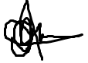

Signature

Date: 12/08/2025

Full Name

This Certificate is awarded

CERTIFICATE

0F completion

s Date: 12/08/2025 Date: 12/08/2025