BLUESTOCK MUTUAL FUND ANALYTICS CAPSTONE PROJECT
End-to-End Mutual Fund Analytics Platform for Performance Evaluation, Risk Assessment and Investor Insights

Final Project Report
Bluestock Fintech Data Analytics Internship Program

Submitted By
Niyukti D jain

Project Duration
Day 1 – Day 7

Project Components
- Data Extraction, Transformation and Loading (ETL)
- Exploratory Data Analysis (EDA)
- Performance Analytics
- Advanced Risk Analytics
- Fund Recommendation Engine
- Interactive Power BI Dashboard
- Business Insights & Recommendations

Introduction
The mutual fund industry has grown rapidly over the last few years, becoming one of the most popular investment options for individuals. With increasing awareness about financial planning and the rise of digital investment platforms, more people are investing in mutual funds through Systematic Investment Plans (SIPs) and lump-sum investments. As a result, a large amount of financial data is generated every day, making it important to analyze and interpret this information effectively.
While investors have access to a wide range of mutual fund schemes, selecting the right fund is often challenging. Many investors focus only on returns and overlook important factors such as risk, portfolio concentration, benchmark performance, and overall fund quality. Therefore, a data-driven approach is required to evaluate mutual funds more accurately and support better investment decisions.
The Bluestock Mutual Fund Analytics Capstone Project was developed with the aim of creating a complete analytics solution for the mutual fund industry. The project combines data engineering, financial analytics, and business intelligence techniques to transform raw mutual fund data into meaningful insights. It covers the entire analytics workflow, starting from data collection and cleaning to performance evaluation, advanced risk analysis, and dashboard development.
Multiple datasets were used in this project, including fund master data, historical NAV records, AUM information, SIP inflows, investor transactions, portfolio holdings, and benchmark indices. These datasets were processed using Python and stored in a structured format to ensure consistency and accuracy. Various analytical techniques were then applied to study industry trends, investor behaviour, fund performance, and risk characteristics.
To evaluate mutual funds effectively, several financial metrics such as CAGR, Sharpe Ratio, Sortino Ratio, Alpha, Beta, Maximum Drawdown, Value at Risk (VaR), and Conditional Value at Risk (CVaR) were calculated. These metrics provided a deeper understanding of both returns and risk, allowing for a more balanced assessment of fund performance.
In addition to performance analysis, advanced analytics techniques were implemented to gain further insights. Investor cohort analysis was used to understand investment patterns across different groups of investors, while SIP continuity analysis helped identify investors who may be at risk of discontinuing their investments. A simple fund recommendation engine was also developed to suggest suitable funds based on an investor's risk profile.
To present the results in an interactive and user-friendly manner, a Power BI dashboard was created. The dashboard allows users to explore industry trends, compare fund performance, analyse investor behaviour, and monitor market-related indicators through dynamic visualisations and filters.
Overall, this project demonstrates how data analytics can be applied in the financial domain to convert raw data into actionable insights. By integrating Python, SQLite, and Power BI, the project provides a comprehensive framework for mutual fund analysis and highlights the importance of data-driven decision-making in modern investment management.

Executive Summary
The Bluestock Mutual Fund Analytics Capstone Project was undertaken to develop a comprehensive analytics solution for understanding and evaluating the performance of mutual funds in the Indian financial market. The project focused on transforming raw mutual fund data into meaningful insights through data processing, financial analysis, risk assessment, and interactive visualisation techniques.
The project began with the collection and integration of multiple datasets covering different aspects of the mutual fund ecosystem, including fund master information, historical NAV records, Assets Under Management (AUM), SIP inflows, investor transactions, portfolio holdings, and benchmark indices. These datasets were cleaned, validated, and transformed using Python and Pandas to ensure data quality and consistency.
Following the ETL process, Exploratory Data Analysis (EDA) was performed to identify trends and patterns within the data. Key areas of analysis included industry AUM growth, SIP inflow trends, category-wise investment flows, investor participation through folio counts, and relationships between various financial variables. The analysis provided valuable insights into the growth of the mutual fund industry and investor behaviour over time.
To evaluate fund performance, several financial metrics were calculated, including annual returns, CAGR, Sharpe Ratio, Sortino Ratio, Alpha, Beta, Tracking Error, and Maximum Drawdown. These metrics enabled a detailed comparison of mutual funds based on both returns and risk-adjusted performance. A fund scorecard was also developed to rank funds using a combination of performance and risk indicators.
The project further incorporated advanced analytics techniques to provide deeper insights. Historical Value at Risk (VaR) and Conditional Value at Risk (CVaR) were calculated to assess downside risk. Rolling Sharpe Ratios were analysed to study changes in risk-adjusted performance over time. Investor cohort analysis and SIP continuity analysis were performed to understand investor engagement patterns and identify potential risks associated with SIP discontinuation. In addition, a simple recommendation engine was developed to suggest suitable mutual funds based on different investor risk profiles.
To make the analysis accessible and easy to interpret, an interactive Power BI dashboard was created. The dashboard consists of four pages covering Industry Overview, Fund Performance, Investor Analytics, and SIP & Market Trends. Through the use of KPI cards, charts, filters, and drill-through functionality, users can explore data dynamically and gain actionable insights.
The findings from this project indicate strong growth in industry AUM, increasing SIP participation, and significant differences in risk-adjusted performance across mutual funds. The analysis highlights the importance of considering both return and risk metrics while evaluating investment options. Overall, the project successfully demonstrates how data analytics, financial modelling, and business intelligence tools can be combined to support informed investment decisions and provide meaningful insights within the mutual fund industry.

Project Objectives
The primary objective of the Bluestock Mutual Fund Analytics Capstone Project was to develop a comprehensive analytics platform capable of transforming raw mutual fund data into meaningful insights for investors, analysts, and financial institutions. The project aimed to demonstrate the practical application of data analytics, financial analysis, and business intelligence tools within the mutual fund domain.
The specific objectives of the project were as follows:
3.1 Build a Robust Data Processing Pipeline
To design and implement an ETL (Extract, Transform, Load) pipeline capable of collecting, cleaning, validating, and transforming mutual fund data from multiple sources into a structured and analysis-ready format.
3.2 Perform Exploratory Data Analysis
To analyse historical mutual fund data and identify key trends, patterns, and relationships related to Assets Under Management (AUM), SIP inflows, investor participation, category-wise fund flows, and benchmark performance.
3.3 Evaluate Fund Performance
To assess mutual fund performance using various financial metrics such as annual returns, Compound Annual Growth Rate (CAGR), Sharpe Ratio, Sortino Ratio, Alpha, Beta, Tracking Error, and Maximum Drawdown.
3.4 Measure and Analyse Investment Risk
To calculate advanced risk metrics including Value at Risk (VaR), Conditional Value at Risk (CVaR), Rolling Sharpe Ratio, and portfolio concentration measures in order to better understand potential investment risks.
3.5 Understand Investor Behaviour
To study investor transaction patterns through cohort analysis and SIP continuity analysis, enabling a deeper understanding of investor engagement and investment habits.

3.6 Develop a Fund Recommendation System
To create a simple recommendation model capable of suggesting suitable mutual funds based on an investor’s risk appetite and risk-adjusted performance metrics.
3.7 Build an Interactive Dashboard
To design and develop a user-friendly Power BI dashboard that presents industry trends, fund performance, investor analytics, and market insights through interactive visualisations and filters.
3.8 Generate Actionable Business Insights
To derive meaningful conclusions and recommendations that can assist investors in making informed decisions and help financial institutions better understand market trends and investment behaviour.
3.9 Demonstrate End-to-End Analytics Skills
To apply the complete data analytics lifecycle, including data engineering, data analysis, financial modelling, visualisation, and reporting, in a real-world fintech use case.
In summary, the project aimed to bridge the gap between raw financial data and practical decision-making by leveraging modern analytics techniques and business intelligence tools. Through the successful completion of these objectives, the project provides a structured framework for analysing mutual fund performance, assessing risk, and supporting data-driven investment decisions.

Data Sources and Dataset Description
4.1 Overview
This project uses ten datasets covering different aspects of the mutual fund industry, including fund information, historical performance, investor transactions, portfolio holdings, industry growth metrics, and benchmark indices. These datasets were collected in CSV format and processed using Python and SQLite before being used for analysis and dashboard development.

4.2 Fund Master Data (01_fund_master.csv)
This dataset serves as the master reference table for all mutual fund schemes.
Key Columns:
- amfi_code – Unique scheme identifier
- scheme_name – Name of the mutual fund scheme
- fund_house – Asset Management Company (AMC)
- category – Fund category (Equity, Debt, Hybrid, etc.)
- plan – Direct or Regular plan
Purpose: Used for scheme identification, categorization, and dashboard filtering.

4.3 NAV History (02_nav_history.csv)
Contains historical Net Asset Value (NAV) data for mutual funds.
Key Columns:
- amfi_code – Fund identifier
- date – NAV date
- nav – Net Asset Value
Purpose: Used for return calculations, CAGR analysis, and risk metrics.

4.4 AUM by Fund House (03_aum_by_fund_house.csv)
Contains Assets Under Management (AUM) information for different fund houses.
Key Columns:
- fund_house – Fund house name
- aum_crore – Assets Under Management (₹ Crores)
- report_date – Reporting date
Purpose: Used to analyse industry size and compare fund houses.

4.5 Monthly SIP Inflows (04_monthly_sip_inflows.csv)
Tracks monthly investments made through SIPs.
Key Columns:
- month – Reporting month
- sip_inflow_crore – SIP inflows (₹ Crores)
Purpose: Used to study investor participation and SIP growth trends.

4.6 Category Inflows (05_category_inflows.csv)
Contains net inflows into different mutual fund categories.
Key Columns:
- month – Reporting month
- category – Fund category
- inflow_crore – Net inflow amount
Purpose: Used to identify investor preferences across categories.

4.7 Industry Folio Count (06_industry_folio_count.csv)
Tracks the number of mutual fund folios over time.
Key Columns:
- month – Reporting month
- folio_count_cr – Number of folios (in crores)
Purpose: Used to analyse industry growth and investor participation.

4.8 Scheme Performance (07_scheme_performance.csv)
Contains historical performance information for mutual funds.
Key Columns:
- return_1yr_pct – 1-Year Return
- return_3yr_pct – 3-Year Return
- return_5yr_pct – 5-Year Return
- benchmark_3yr_pct – Benchmark Return
Purpose: Used for performance evaluation and fund ranking.

4.9 Investor Transactions (08_investor_transactions.csv)
Records investor transaction activities.
Key Columns:
- investor_id – Investor identifier
- transaction_date – Transaction date
- transaction_type – SIP, Purchase, or Redemption
- amount – Transaction value
Purpose: Used for investor behaviour analysis, cohort analysis, and SIP continuity studies.

4.10 Portfolio Holdings (09_portfolio_holdings.csv)
Contains stock-level holdings of mutual fund portfolios.
Key Columns:
- stock_name – Company name
- sector – Industry sector
- weight_pct – Portfolio allocation percentage
- market_value_cr – Market value of holdings
Purpose: Used to analyse diversification and sector concentration risk.

4.11 Benchmark Indices (10_benchmark_indices.csv)
Contains benchmark market index data.
Key Columns:
- date – Observation date
- index_name – Benchmark index
- index_value – Index closing value
Purpose: Used for Alpha, Beta, and benchmark comparison analysis.

Summary
These datasets provide a comprehensive view of the mutual fund ecosystem, covering fund performance, investor activity, portfolio composition, industry growth, and benchmark performance. Together, they form the foundation of all analyses and visualisations developed throughout this project.

ETL Design and Data Processing
The ETL (Extract, Transform, Load) process formed the foundation of this project by converting raw mutual fund data into a structured and analysis-ready format. Data was collected from ten different CSV datasets covering fund information, NAV history, AUM data, SIP inflows, investor transactions, portfolio holdings, and benchmark indices. These datasets were imported into Python using the Pandas library for further processing.
Once the data was extracted, several cleaning techniques were applied to improve data quality and consistency. Missing values were handled appropriately, duplicate records were removed, date formats were standardized, and numerical fields were converted into suitable data types. Column names were also standardized to ensure consistency across all datasets. These steps helped eliminate inconsistencies and improve the reliability of the analysis.
After cleaning, the datasets were transformed to generate meaningful analytical outputs. Various calculations were performed, including return computations, benchmark comparisons, risk metrics, and fund performance measures. Additional processed datasets such as Sharpe Ratio values, Sortino Ratio values, Alpha-Beta analysis, Tracking Error calculations, Maximum Drawdown reports, and Fund Scorecards were created to support advanced analytics and performance evaluation.
To improve data organization and accessibility, all processed datasets were stored in a SQLite database named bluestock_mf.db. The database served as a centralized repository and enabled efficient integration with Power BI for dashboard development.
The overall ETL workflow followed a structured sequence of data extraction, cleaning, transformation, and storage. The final processed datasets and database tables became the foundation for exploratory data analysis, performance analytics, advanced risk assessment, and interactive dashboard creation.
Overall, the ETL stage played a critical role in the success of the project. By transforming raw financial data into a reliable and structured format, it enabled meaningful insights to be generated and ensured the accuracy of all subsequent analyses.

Exploratory Data Analysis (EDA) Findings
Exploratory Data Analysis (EDA) was conducted to understand industry trends, investor behaviour, and mutual fund performance. The analysis revealed a steady growth in Assets Under Management (AUM), indicating increasing investor confidence and expansion of the mutual fund industry.
Monthly SIP inflows showed a consistent upward trend, highlighting the growing adoption of disciplined investment strategies among retail investors. Similarly, the rise in folio counts reflected increasing participation in mutual funds and greater financial awareness among investors.
Category-wise analysis indicated that equity funds attracted a significant share of investor inflows, demonstrating a preference for long-term wealth creation. Historical NAV data also showed that most funds experienced positive long-term growth despite short-term market fluctuations.
Overall, the EDA phase provided valuable insights into industry growth, investment patterns, and fund behaviour. These findings served as the foundation for the performance and risk analysis conducted in the later stages of the project.
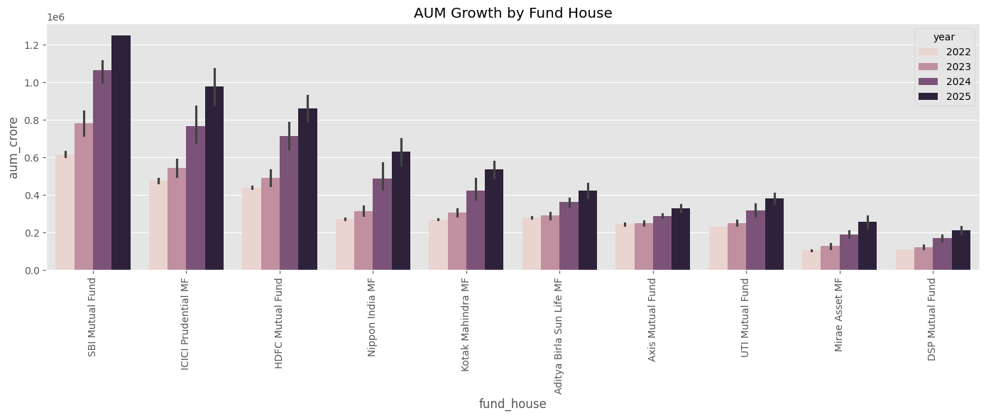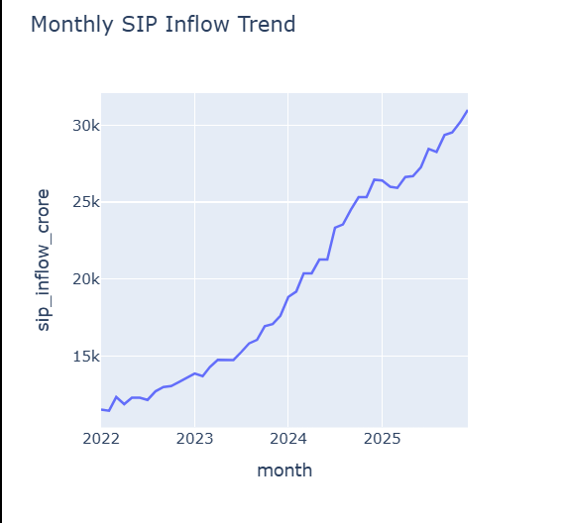
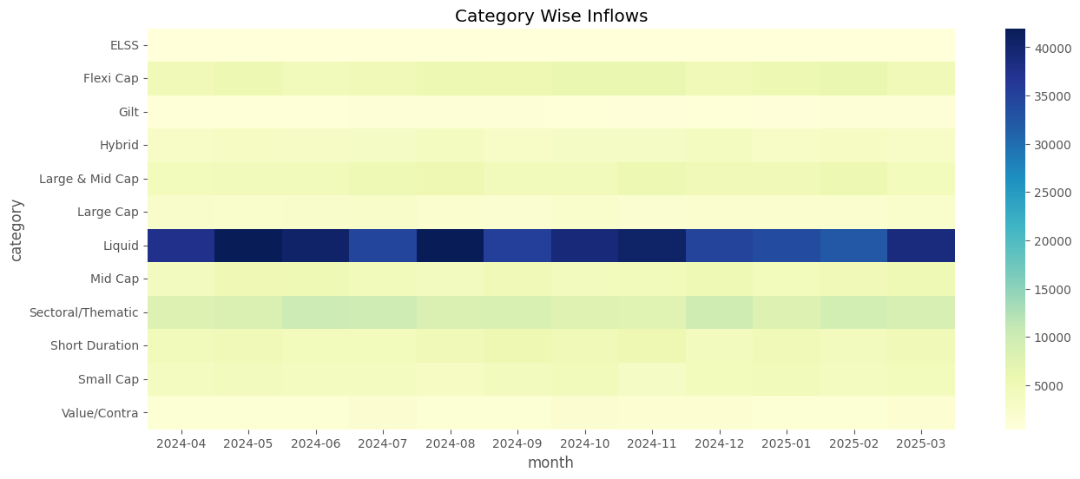
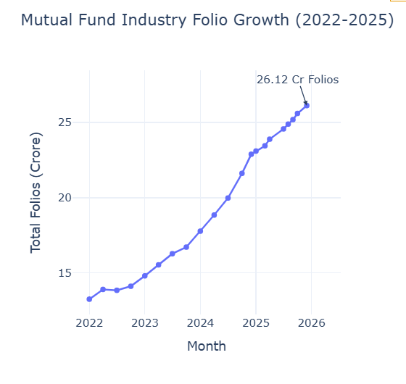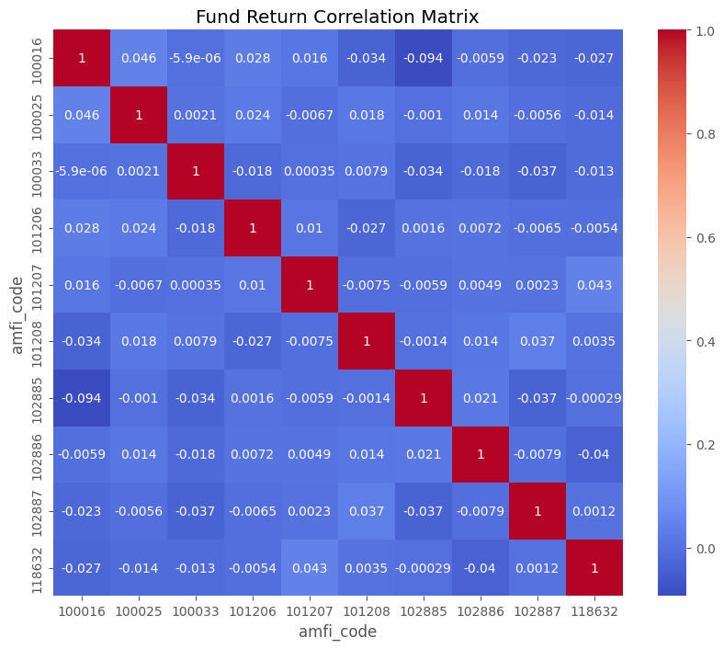
Performance Analysis
Performance analysis was conducted to evaluate the returns and risk characteristics of different mutual fund schemes. Various financial metrics were calculated to provide a comprehensive assessment of fund performance beyond simple return comparisons.
Return-based metrics such as 1-Year, 3-Year, and 5-Year returns were analysed to understand the growth potential of different funds. In addition, CAGR (Compound Annual Growth Rate) was calculated to measure the annualized growth rate of investments over time.
Risk-adjusted performance was evaluated using the Sharpe Ratio and Sortino Ratio. These metrics helped identify funds that generated higher returns relative to the level of risk taken. Funds with higher Sharpe and Sortino Ratios demonstrated better risk-adjusted performance.
Benchmark comparison metrics such as Alpha and Beta were also calculated. Alpha measured the excess return generated by a fund compared to its benchmark, while Beta indicated the sensitivity of a fund to market movements. Tracking Error was used to assess how closely a fund followed its benchmark index.
Maximum Drawdown analysis was performed to measure the largest decline experienced by a fund from its peak value. This metric provided insights into downside risk and helped identify funds with greater resilience during market fluctuations.
Finally, a fund scorecard was developed by combining multiple performance and risk indicators. This scorecard enabled the ranking of mutual funds and helped identify the top-performing schemes based on overall performance and risk management.
Overall, the analysis highlighted significant differences in fund performance and demonstrated the importance of considering both returns and risk metrics when evaluating investment opportunities.

Advanced Analytics
To gain deeper insights beyond traditional performance metrics, several advanced analytical techniques were implemented as part of this project. These analyses focused on measuring risk, understanding investor behaviour, evaluating portfolio concentration, and generating personalized fund recommendations.
Historical Value at Risk (VaR) and Conditional Value at Risk (CVaR) were calculated to assess the downside risk associated with mutual fund investments. While VaR estimates the maximum expected loss at a given confidence level, CVaR provides an estimate of the average loss that may occur beyond the VaR threshold. These metrics helped identify funds that are more vulnerable during adverse market conditions.
A Rolling 90-Day Sharpe Ratio analysis was also performed to examine how risk-adjusted returns changed over time. Unlike a static Sharpe Ratio, the rolling analysis provided a dynamic view of fund performance and highlighted periods of stronger or weaker risk-adjusted returns.
Investor behaviour was studied using cohort analysis, where investors were grouped based on the year of their first transaction. This analysis revealed differences in investment patterns, average SIP contributions, and overall participation across investor groups.
To further analyse investor engagement, SIP continuity analysis was conducted. Investors with irregular SIP contributions and longer gaps between transactions were identified as potentially at risk of discontinuing their investments. This analysis can help financial institutions design strategies to improve investor retention.
A simple fund recommendation model was developed to suggest suitable mutual funds based on an investor's risk appetite. The recommendation engine ranked funds using risk-adjusted performance metrics and provided a practical example of how analytics can support investment decision-making.
Finally, sector concentration analysis was performed using the Herfindahl-Hirschman Index (HHI). This metric measured how concentrated a fund's portfolio was within specific sectors. Funds with higher HHI values were found to have greater concentration risk, while lower values indicated better diversification.
Overall, the advanced analytics phase provided deeper insights into risk, investor behaviour, portfolio composition, and fund selection. These analyses complemented the performance evaluation stage and demonstrated how data-driven techniques can support more informed investment decisions.

Dashboard Development and Visualization
To present the analysis in an interactive format, a Power BI dashboard was developed. The dashboard combines key insights from the project and allows users to explore mutual fund data through visualizations, KPI cards, and filters.
The dashboard consists of four pages: Industry Overview, Fund Performance, Investor Analytics, and SIP & Market Trends. These pages provide insights into industry growth, fund returns, investor behaviour, and market trends.
Interactive slicers and filters were added to enable users to customize their analysis based on fund house, category, and time period. The dashboard transforms complex financial data into simple and actionable insights, making it easier to monitor performance and identify trends.
Overall, the dashboard serves as a centralized platform for analysing mutual fund performance and supporting data-driven investment decisions.

Recommendations
Based on the analysis conducted during this project, investors should evaluate mutual funds using both return and risk metrics rather than focusing solely on historical returns. Metrics such as Sharpe Ratio, Sortino Ratio, Alpha, and Maximum Drawdown provide a more comprehensive view of fund performance.
Investors are also encouraged to adopt long-term investment strategies through SIPs, as the analysis showed consistent growth in SIP participation and industry inflows. Diversification across fund categories and sectors can further help reduce portfolio risk and improve investment stability.
For fund houses and financial institutions, investor retention strategies can be developed using SIP continuity analysis to identify investors who may be at risk of discontinuing their investments. Advanced analytics and recommendation systems can also be leveraged to provide more personalized investment solutions.

Limitations
While the project successfully achieved its objectives, certain limitations were identified during the analysis. The study was conducted using a limited set of datasets and therefore may not capture all factors affecting mutual fund performance.
Some datasets contained missing values and required preprocessing, which may impact the precision of certain analyses. The recommendation model developed in this project is based on a simple rule-based approach and does not incorporate advanced machine learning techniques.
Additionally, market conditions continuously change over time, and therefore the findings and performance metrics presented in this report should be interpreted within the context of the available historical data.

Conclusion
The Bluestock Mutual Fund Analytics Capstone Project successfully demonstrated the application of data analytics, financial analysis, and business intelligence techniques in the mutual fund domain. Through the use of Python, SQLite, and Power BI, raw financial data was transformed into meaningful insights related to fund performance, investor behaviour, and industry trends.
The project covered the complete analytics lifecycle, including data extraction, cleaning, transformation, exploratory analysis, performance evaluation, advanced risk assessment, and dashboard development. Various financial metrics and analytical techniques were used to provide a comprehensive understanding of mutual fund investments.
The interactive Power BI dashboard further enhanced the accessibility of insights by presenting complex information in a simple and user-friendly manner. Overall, the project highlights the value of data-driven decision-making in the financial sector and provides a strong foundation for future enhancements such as predictive analytics, machine learning-based recommendations, and real-time market monitoring.

