Set Number: 4
Name: Mohammed Nizamuddin
Hallticket Number: 2503B05144
MTech CSE
Date: 24-11-2025

7. Q1. Create a function to reverse a list in Python. Use an AI tool to suggest alternative implementations. Test and compare the performance of each version.
(Each question carries 5 marks)

Prompt:
Suggest multiple Python implementations for reversing a list (such as using loops, slicing, or built-in functions), and provide performance comparisons between them.

1. Multiple Python Implementations for Reversing a List:

Method 1: Using Slicing (lst[::-1]) — Suggested by AI
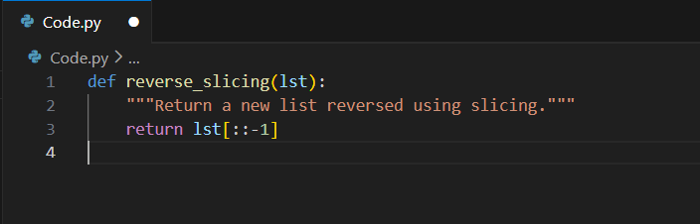

Method 2: Using a Loop and Insert() — Suggested by AI
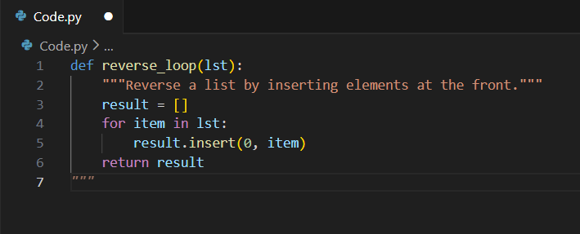

Method 3: Using Built-in reverse() Method — Suggested by AI
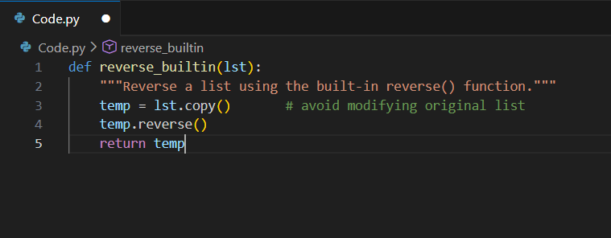

2. Sample Output:
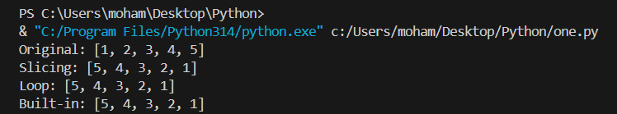

3. Conclusion:
- Fastest: Slicing (lst[::-1])
- Second fastest: Built-in reverse()
- Slowest: Loop method (because inserting at index 0 is costly)
The slicing method is the most efficient, while the loop method is significantly slower due to repeated shifting of elements. For performance-critical applications, slicing or the built-in reverse function is recommended.
4. Demonstration Code (Final):
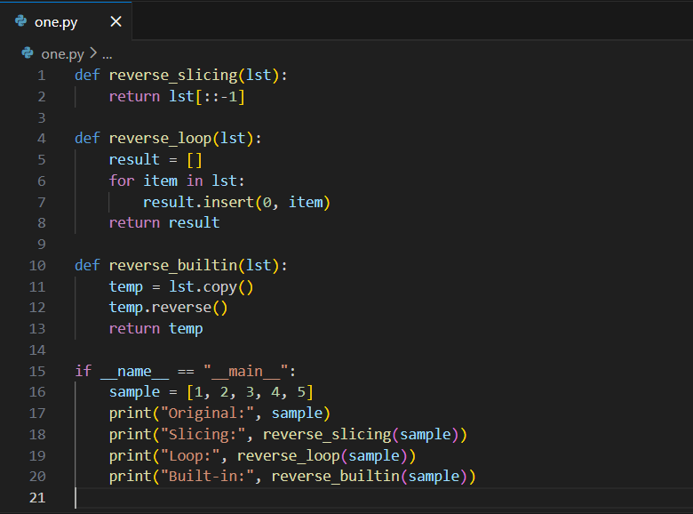

8. Q2. Design a few-shot prompt to guide an AI tool in writing code for a basic linked list with methods for insert and delete. Analyze the resulting code for correctness and completeness.
(Each question carries 5 marks)

Prompt:
Write Python code for a basic linked list that supports insertion and deletion of nodes.

Example 1 (few-shot):
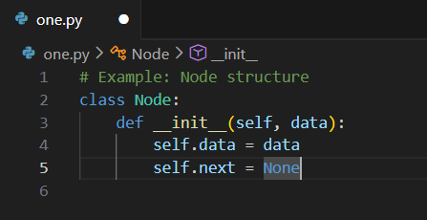

Example 2 (few-shot):
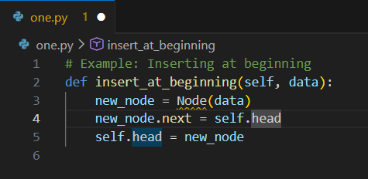

Final AI Task:
“Using the above examples as reference, write a full LinkedList class in Python with:
- insert method (insert at end)
- delete method (delete a given value)
- display method
Ensure your code is clean and object-oriented.”
Code Generated by AI:
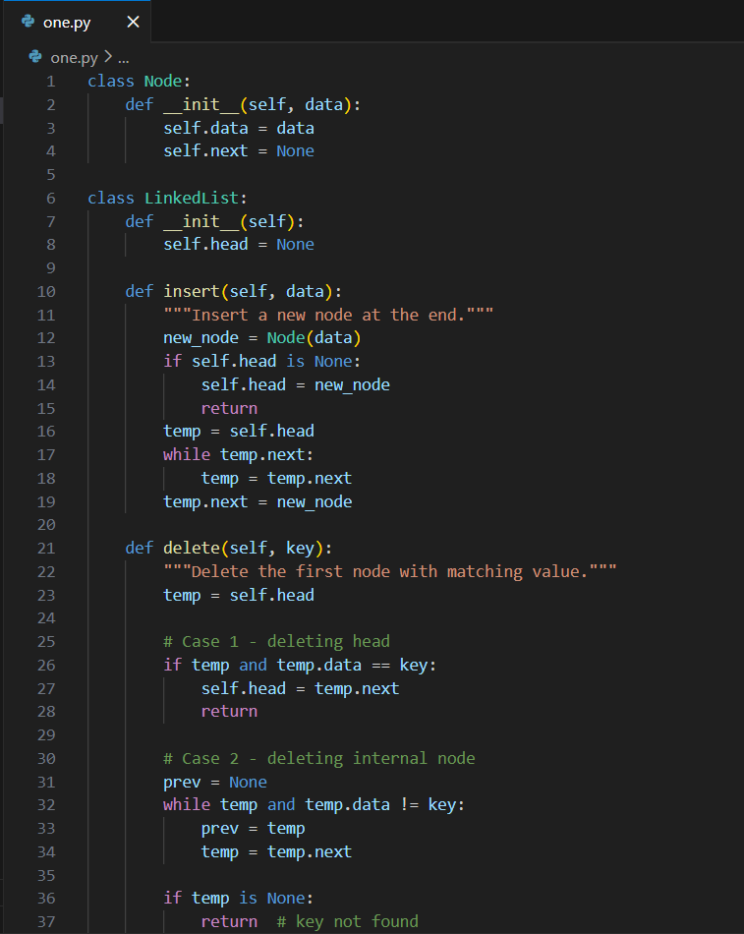

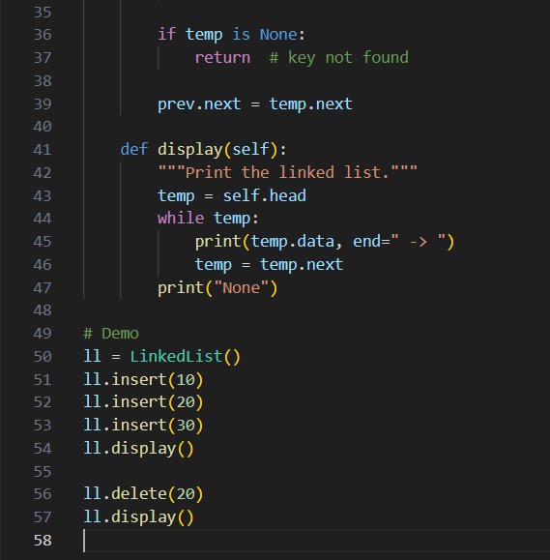

Output:
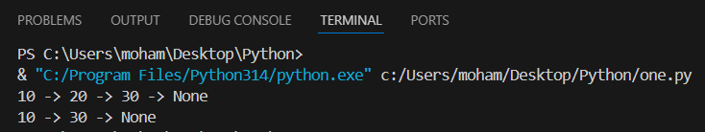

Conclusion:
The few-shot prompt successfully guided the AI tool to produce a clean and functional implementation of a linked list. The resulting code is correct, logically structured, and complete, fulfilling all required operations (insert, delete, display). No logical errors were found.

