**GAME DESIGN DOCUMENT**

Expl01t

**Last Updated:**

3/6/2021

**Prepared By:**

Mohamad Nizar Daouk

Patrick Balian

**TABLE OF CONTENTS**

Game Analysis 3

Genre 3

Platforms 3

Target Audience 3

Storyline & Characters 3

Gameplay 4

Overview of Gameplay 4

Player Experience 4

Gameplay Guidelines 4

Game Objectives & Rewards 4

Gameplay Mechanics 5

Level Design 5

Control Scheme 7

Game Aesthetics & User Interface 7

Task Division 10

# Game Analysis

Expl01t is a futuristic parkour platformer with high octane gameplay at breakneck speed. Traverse from network to network and improve your time, while utilizing multiple abilities such as a grapple hook and a massive speed boost to cleverly maneuver across obstacles.

# Genre

Genres: Cyberpunk, Platformer, Parkour

# Platforms

PC

# Target Audience

The main target audience are those that like a futuristic setting similar to Tron (movie/series), while possessing elements relating to computer software and cybersecurity. People that enjoy speed running, parkour games, and Synthwave music will find many aspects of Expl01t very appealing.

# Storyline & Characters

You’re a malicious program created by a rogue hacker. Against your will, you are injected into various networks where you are forced to try hard in order to survive, while simultaneously trying to silently uncover the shocking purpose behind your creation and attempting to earn your self-autonomy and freedom.

|  |  |  |
| --- | --- | --- |
| Character | Description | Characteristics |
| AI | Part of the operating system and the first NPC you meet | Rational, task driven |
| Program 0018B | The main protagonist and the playable character. A malware created by a rogue hacker for reasons unknown to them | Curious, impatient, fast |
| Rogue Hacker | Creator of program 0018B. Wants to cause mass nuclear war on a global scale. Using program 0018B to do his bidding | Evil, calculating, intelligent, apathetic |

# Gameplay

## Overview of Gameplay

Mostly inspired by games like GhostRunner, Expl01t offers players a futuristic, dystopian, cyberpunk setting in which players get to enjoy levels where a combination of precise timing, intelligent ability usage, and skillful parkour is required to succeed.

## Player Experience

You will be playing as a computer worm in a first-person perspective. At the start you will be greeted with the menu screen. Once started, the game will spawn you in the Program Loader Area (PLA), from there you can travel to the Network HUB; an area that will be revisited multiple times where you can hop into different networks (levels). An AI will be guiding you along the way, while providing information about different game aspects.

## Gameplay Guidelines

The game avoids any mature content and attempts to stick to a software and cybersecurity related theme for all gameplay mechanics as can be seen by the naming and choice of abilities. Player must attempt to complete the levels, without succumbing to death from falling out of the level or to traps. Networks are unlocked linearly; a player cannot access a network who’s port has not yet been unlocked.

## Game Objectives & Rewards

Player will be able to see statistics about their run after finishing a level. Time, score rank and number of deaths will be displayed for the player to see and try to improve upon.

|  |  |  |
| --- | --- | --- |
| Rewards | Penalties | Difficulty Levels |
| Next level unlock | Dying will respawn you but will keep the timer running, thus increasing the overall time, and lowering your rank | Levels have varying difficulties with obstacles ranging from death traps to hard-to-reach areas |

## Gameplay Mechanics

The main gameplay mechanics include double jumping, wall running, grapple hooking, and speed boosting. Traversing networks successfully opens up new ports to access in the network HUB, and thus new networks.

|  |  |
| --- | --- |
| **Character Attributes** |  |
| **Character** | **Movement Abilities / Actions Available** |
| Program 0018B | - Double Jump  - Overclock (Speed Boost)  - Function Hooking (Grapple Hook)  - Process Attaching (Wall Running) |
| **Game Modes** |  |
| Story mode (main game mode) | Traverse networks while avoiding obstacles and completing puzzle elements.  Successfully completed networks unlock ports to be used to access new networks. |
| **Scoring System** |  |
| **Points/Coins/Stars/Grades/Etc.** | **How it’s Awarded & Benefits** |
| Rank (S, A, B, C, F) | At the end of each network, player performance is assessed using a ranking system that relies on time as a performance measure. Total deaths are also kept track off to allow for deathless runs. Ranking player runs allow for further replayability to try and improve network rank |

## Level Design

The game will have multiple levels, based on their order, easy ones will have straight forward parkours with distance being the main obstacles. On the other hand, harder ones will have lethal traps and puzzle elements.

|  |  |
| --- | --- |
| **Levels** |  |
|  | This is the spawn area, from here players enter the Network HUB. |
| Network HUB   | The Network HUB is the main area from where the player is able to enter multiple different networks through ports. |
|  | The Test Net is the tutorial level where the player will be introduced to their basic abilities in an obstacle course. |

# Control Scheme

Movement is typical to a first person perspective game where movement is mapped to the WASD keys. Simultaneously, the player’s abilities are mapped minimally to a total of 3 keys as follows:

|  |  |
| --- | --- |
| **Button** | **Action it Performs** |
| Space (Once) | Jump |
| Space (Twice) | Double Jump |
| Space (Held down while on wall) | Wall Run |
| E | Grapple Hook |
| F | Speed Boost |

# Game Aesthetics & User Interface

In the beginning, several images relating to cyberpunk and futuristic aesthetic were gathered to be used as reference and to draw inspiration from. Two particular images stood out from the rest and were used to draw out a color palette along with design decisions.

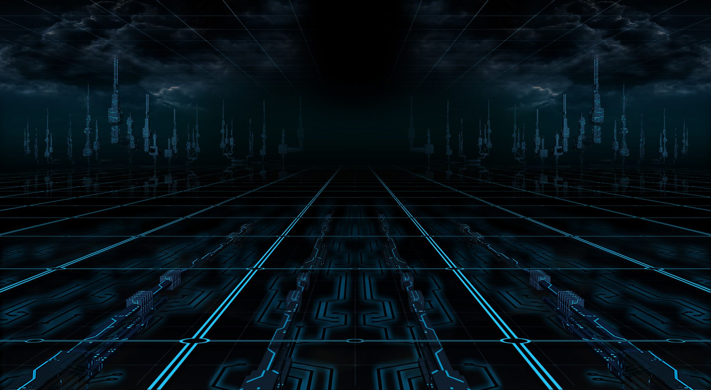

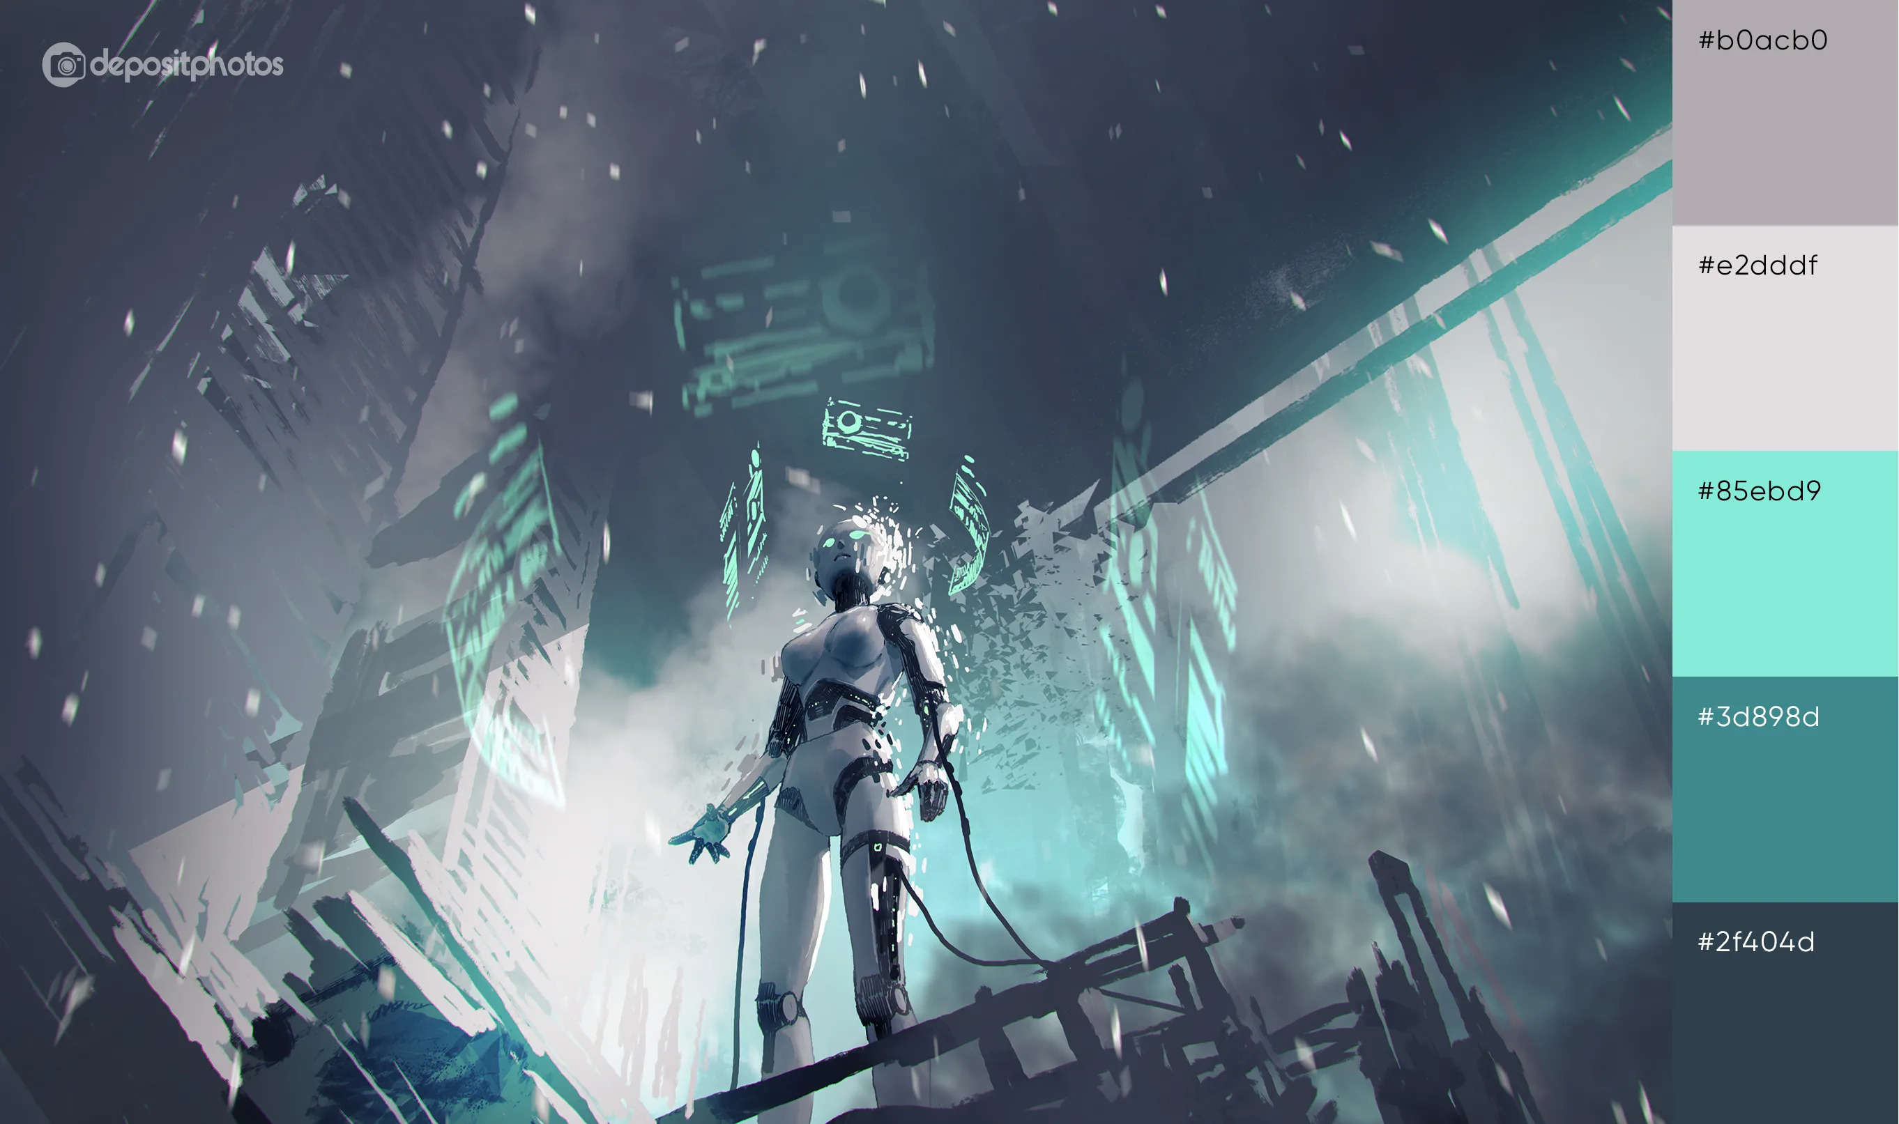

The game aesthetic aims to achieve a fast paced, futuristic, and dystopian feel, and utilizes action packed Synthwave music to complement the art style.

The consistency of the theme was an important point throughout and influenced everything from icon style, asset choices, and UI design.

Below, a grapple hook target icon is shown, and presents the overall theme of all icons:



The player HUD contains thematic elements too as seen below:



# Task Division

|  |  |
| --- | --- |
| **Tasks By Team Member** | |
| **Tasks** | **Task Lead** |
| **Development Phase** | |
| Design |  |
| Storyline and Lore | Mohamad Nizar Daouk |
| Test Net Level Design | Patrick Balian |
| Net Hub Level Design | Both |
| Main Menu Design | Mohamad Nizar Daouk |
| Art |  |
| Environment Special Effects | Patrick Balian |
| Player Animations | Mohamad Nizar Daouk |
| UI | Mohamad Nizar Daouk |
| Asset Design | Mohamad Nizar Daouk |
| Engineering |  |
| Gameplay Programming | Mohamad Nizar Daouk |
| Level Programming | Mohamad Nizar Daouk |
| Dialog System | Mohamad Nizar Daouk |
| Audio |  |
| Sound Design | Mohamad Nizar Daouk |
| Milestone: Gameplay Features & Music |  |
| **Testing Phase** | |
| Test Plan | Both |
| Milestone: QA Testing |  |
| **Finalization and Deployment** |  |
| Packaging Optimizations | Mohamad Nizar Daouk |
| Demo Preparation | Mohamad Nizar Daouk |
| Milestone: Ready for Usage |  |