Nizar Sanchez (2018-6482)

Diagrama UML:

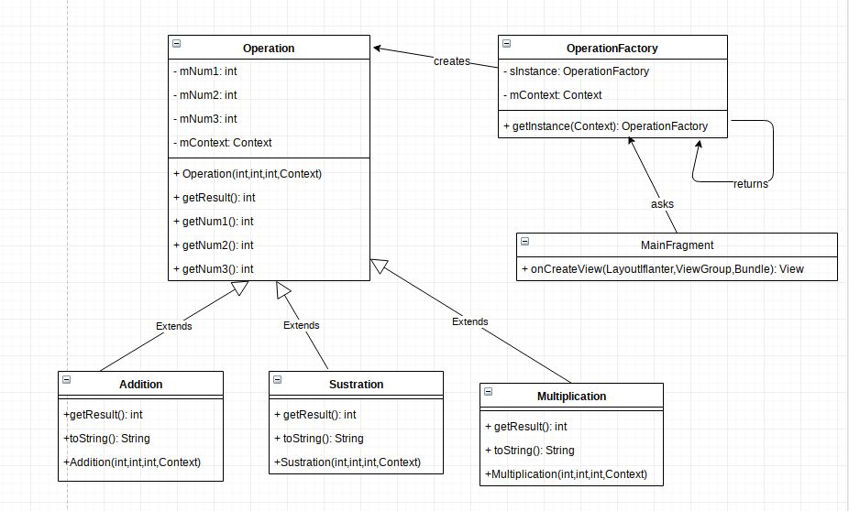

AndroidManifiest.xml
<?xml version="1.0" encoding="utf-8"?>
<manifest xmlns:android="http://schemas.android.com/apk/res/android"
package="com.example.segundoparcial">
<application
android:allowBackup="true"
android:icon="@mipmap/ic_launcher"
android:label="@string/app_name"
android:roundIcon="@mipmap/ic_launcher_round"
android:supportsRtl="true"
android:theme="@style/AppTheme">
<activity android:name=".MainActivity">
<intent-filter>
<action android:name="android.intent.action.MAIN" />
<category android:name="android.intent.category.LAUNCHER" />
</intent-filter>
</activity>
</application>
</manifest>

Operation.java
package com.example.segundoparcial.model;
import android.content.Context;
public abstract class Operation {
private int mNum1;
private int mNum2;
private int mNum3;
private Context mContext;
public Operation(int num1, int num2, int num3, Context context) {
mNum1 = num1;
mNum2 = num2;
mNum3 = num3;
mContext=context;
}
protected abstract int getResult();
protected int getNum1() {
return mNum1;
}
protected int getNum2() {
return mNum2;
}
protected int getNum3() {
return mNum3;
}
protected Context getContext() {
return mContext;
}
}

Multiplication.xml
package com.example.segundoparcial.model;
import android.content.Context;
import androidx.annotation.NonNull;
import com.example.segundoparcial.R;
public class Multiplication extends Operation {
public Multiplication(int num1, int num2, int num3, Context context) {
super(num1, num2, num3,context);
}
@Override
protected int getResult() {
return getNum1()*getNum2()*getNum3();
}
@NonNull
@Override
public String toString() {
return getContext().getString(R.string.multiplication_result,String.valueOf(getResult()));
}
}

Sustration.java
package com.example.segundoparcial.model;
import android.content.Context;
import androidx.annotation.NonNull;
import com.example.segundoparcial.R;
public class Sustration extends Operation {
public Sustration(int num1, int num2, int num3, Context context) {
super(num1, num2, num3,context);
}
@Override
protected int getResult() {
return getNum1()-getNum2()-getNum3();
}
@NonNull
@Override
public String toString() {
return getContext().getString(R.string.sustration_result,String.valueOf(getResult()));
}
}
Adition.java
package com.example.segundoparcial.model;
import android.content.Context;
import androidx.annotation.NonNull;
import com.example.segundoparcial.R;
public class Addition extends Operation {
public Addition(int num1, int num2, int num3, Context context) {
super(num1, num2, num3,context);
}
@Override
protected int getResult() {
return getNum1()+getNum2()+getNum3();
}
@NonNull
@Override
public String toString() {
return getContext().getString(R.string.addition_result,String.valueOf(getResult()));
}
}
MainActivity.java
package com.example.segundoparcial;
import android.os.Bundle;
import androidx.appcompat.app.AppCompatActivity;
import androidx.fragment.app.Fragment;
import androidx.fragment.app.FragmentManager;
public class MainActivity extends AppCompatActivity {
@Override
protected void onCreate(Bundle savedInstanceState) {
super.onCreate(savedInstanceState);
setContentView(R.layout.activity_main);
FragmentManager fm = getSupportFragmentManager();
Fragment fragment = fm.findFragmentById(R.id.fragment_container);
if(fragment==null){
fragment = new MainFragment();
fm.beginTransaction()
.add(R.id.fragment_container,fragment)
.commit();
}
}
}
MainFragment.java
package com.example.segundoparcial;
import android.os.Bundle;
import android.view.LayoutInflater;
import android.view.View;
import android.view.ViewGroup;
import android.widget.Button;
import android.widget.EditText;
import android.widget.TextView;
import android.widget.Toast;
import androidx.annotation.NonNull;
import androidx.annotation.Nullable;
import androidx.fragment.app.Fragment;
import com.example.segundoparcial.model.Addition;
import com.example.segundoparcial.model.Multiplication;
import com.example.segundoparcial.model.Sustration;
import java.util.Calendar;
import java.util.GregorianCalendar;
public class MainFragment extends Fragment {
private Button mCalculateButton;
private Button mClearBtn;
private EditText mNum1;
private EditText mNum2;
private EditText mNum3;
private TextView mResultTxt;
@Nullable
@Override
public View onCreateView(@NonNull LayoutInflater inflater, @Nullable ViewGroup container, @Nullable Bundle savedInstanceState) {
View v= inflater.inflate(R.layout.fragment_main,null,false);
mClearBtn = (Button) v.findViewById(R.id.btn_clear);
mNum1 = (EditText) v.findViewById(R.id.etxt_num1);
mNum2 = (EditText)v.findViewById(R.id.etxt_num2);
mNum3= (EditText) v.findViewById(R.id.etxt_num3);
mResultTxt = (TextView) v.findViewById(R.id.txt_result);
mCalculateButton = v.findViewById(R.id.calculate_button);
mCalculateButton.setOnClickListener(new View.OnClickListener() {
@Override
public void onClick(View v) {
String txtNum1 =mNum1.getText().toString();
String txtNum2 = mNum2.getText().toString();
String txtNum3= mNum3.getText().toString();
String [] texts={txtNum1,txtNum2,txtNum3};
if( areEmpty(texts)){
return;
}
int num1 = Integer.parseInt(txtNum1);
int num2 = Integer.parseInt(txtNum2);
int num3 = Integer.parseInt(txtNum3);
Addition addition = (Addition)
OperationFactory.getInstance(getContext()).getOperation(num1,num2,num3, OperationFactory.OperationType.ADDITION);
Sustration sustration = (Sustration)
OperationFactory.getInstance(getContext()).getOperation(num1,num2,num3, OperationFactory.OperationType.SUSTRATION);
Multiplication multiplication = (Multiplication)
OperationFactory.getInstance(getContext()).getOperation(num1,num2,num3, OperationFactory.OperationType.MULTIPLICATION);
StringBuilder stringBuilder = new StringBuilder();
stringBuilder.append(addition);
stringBuilder.append("\n");
stringBuilder.append(sustration);
stringBuilder.append("\n");
stringBuilder.append(multiplication);
mResultTxt.setText(stringBuilder.toString());
}
});
mClearBtn.setOnClickListener(new View.OnClickListener() {
@Override
public void onClick(View v) {
clearAll();
}
});
return v;
}
@Override
public void onCreate(@Nullable Bundle savedInstanceState) {
super.onCreate(savedInstanceState);
}
private int add(int num1, int num2){
return num1+num2;
}
private int substract(int num1,int num2){
return num1-num2;
}
private int multiply(int num1,int num2){
return num1*num2;
}
private void updateOuput(int result){
StringBuilder sb = new StringBuilder();
sb.append(getResources().getString(R.string.display_result));
sb.append(result);
mResultTxt.setText(sb.toString()); // Seting text to result
}
private boolean areEmpty(String [] textNum){
for (String text: textNum){
if(text.equals("")){
Toast.makeText(getContext(),R.string.field_empty,Toast.LENGTH_SHORT).show();
return true;
} else {
continue;
}
}
return false;
}
private void clearAll(){
mNum1.setText("");
mNum2.setText("");
mNum3.setText("");
mResultTxt.setText(R.string.result_default);
}
}
OperationFactory.xml
package com.example.segundoparcial;
import android.content.Context;
import com.example.segundoparcial.model.Addition;
import com.example.segundoparcial.model.Multiplication;
import com.example.segundoparcial.model.Operation;
import com.example.segundoparcial.model.Sustration;
public class OperationFactory {
private static OperationFactory sInstance;
private Context mContext;
private OperationFactory(Context context){
mContext = context;
}
public Operation getOperation(int n1, int n2, int n3, OperationType operationType){
switch (operationType){
case ADDITION:
return new Addition(n1,n2,n3,mContext);
case SUSTRATION:
return new Sustration(n1,n2,n3,mContext);
case MULTIPLICATION:
return new Multiplication(n1,n2,n3,mContext);
default:
return null;
}
}
public static OperationFactory getInstance(Context context){
if(sInstance==null){
sInstance= new OperationFactory(context);
}
return sInstance;
}
public enum OperationType{
ADDITION,SUSTRATION,MULTIPLICATION
}
}
activity_main.xml
<?xml version="1.0" encoding="utf-8"?>
<FrameLayout
xmlns:android="http://schemas.android.com/apk/res/android"
android:layout_width="match_parent"
android:layout_height="match_parent"
android:id="@+id/fragment_container"
/>
fragment_main.xml
<?xml version="1.0" encoding="utf-8"?>
<FrameLayout xmlns:android="http://schemas.android.com/apk/res/android"
android:orientation="vertical" android:layout_width="match_parent"
android:layout_height="match_parent"
android:id="@+id/fragment_container"
>
<LinearLayout
android:layout_width="match_parent"
android:layout_height="match_parent"
android:orientation="vertical">
<EditText
android:id="@+id/etxt_num1"
android:layout_width="match_parent"
android:layout_height="wrap_content"
android:ems="10"
android:hint="@string/give_number"
android:inputType="numberSigned" />
<EditText
android:id="@+id/etxt_num2"
android:layout_width="match_parent"
android:layout_height="wrap_content"
android:ems="10"
android:hint="@string/give_number1"
android:inputType="numberSigned" />
<EditText
android:id="@+id/etxt_num3"
android:layout_width="match_parent"
android:layout_height="wrap_content"
android:ems="10"
android:hint="@string/give_number1"
android:inputType="number" />
<Button
android:id="@+id/calculate_button"
android:text="@string/calculate_button"
android:layout_width="match_parent"
android:layout_height="wrap_content"
/>
<Button
android:id="@+id/btn_clear"
android:layout_width="match_parent"
android:layout_height="wrap_content"
android:drawableLeft="@drawable/clear"
android:text="@string/clear_all" />
<TextView
android:id="@+id/txt_result"
android:layout_width="match_parent"
android:layout_height="match_parent"
android:hint="@string/result_default" />
<EditText
android:id="@+id/editText"
android:layout_width="match_parent"
android:layout_height="wrap_content"
android:ems="10"
android:inputType="numberSigned" />
</LinearLayout>
</FrameLayout>
strings.xml
<resources>
<string name="app_name">Segundo Parcial</string>
<string name="clear_all">Clear all</string>
<string name="output_not_calculated">The output cannot be calculated</string>
<string name= "output_result1">Date of birth of the age</string>
<string name="output_result2">is</string>
<string name="output_default">The date will displayed here</string>
<string name="result_default">The result will displayed here</string>
<string name="give_number">Tap me and give me a number</string>
<string name="give_number1">Tap me and give another number</string>
<string name="field_empty">The fields MUST NOT be empty</string>
<string name="display_result">Result: </string>
<string name="addition_result">Addition: %1$s</string>
<string name="sustration_result">Diference: %1$s</string>
<string name="multiplication_result">Product: %1$s</string>
<string name="calculate_button">CALCULATE!!</string>
</resources>

