Project Proposal
Group ID: UG-31
Members: Nizar Omar, Muhammed Ali, Sohaib Iqbal Khokhar Muhammed
Main paper: Bakro et al. [1], https://doi.org/10.1109/ACCESS.2024.3353055
Supporting paper: Wang and Yang [2], https://doi.org/10.1109/SCECS65243.2025.11065638

1. Introduction
This project builds a scalable, cloud-hosted intrusion detection platform based on Bakro et al. [1]. The platform replays network traffic records into a cloud API and classifies each record as normal or as a specific attack type. Classification uses a random forest trained on features chosen by a hybrid Grasshopper Optimisation–Genetic Algorithm (GOA-GA), and results appear on a monitoring dashboard. Detection workers run in containers and scale automatically with incoming load. We use the UNSW-NB15 dataset [3] and measure detection quality alongside latency, throughput and cost, to show what feature selection saves in the cloud. Our deployment and evaluation approach is informed by Wang and Yang [2].

2. Problem and Motivation
Cloud networks carry large, bursty traffic, and attacks such as DDoS must be detected quickly. Models trained on every feature are slower to train and run, which raises compute cost and delays alerts. Bakro et al. [1] show that a compact feature subset keeps accuracy high while cutting processing time, but they evaluate offline and list real-world deployment as future work. Wang and Yang [2] show that production security systems must also meet latency, availability and cost targets under load.
We therefore ask whether feature selection gives measurable savings in a live cloud deployment. The cloud suits this better than a local setup:
- Autoscaling matches capacity to varying demand without paying for idle machines.
- A message queue decouples ingestion from detection, so a failed worker does not lose data.
- GOA-GA needs many fitness evaluations, which can run in parallel on pay-per-use compute.

3. Beneficiaries
Cloud tenants and small businesses that need affordable, scalable monitoring; security analysts who gain a clear view of alerts; and students and researchers who gain a reproducible, deployed implementation of a published method with an honest evaluation.

4. Planned Extension of the Research
Beyond reproducing [1], we plan:
- Leakage-free feature selection. The paper’s pipeline [1, Fig. 1] appears to select features before the train/test split. We select features using training and validation data only, keeping test data untouched.
- Parallel GOA-GA. We run fitness evaluations as parallel container tasks and report the speed-up against a single-machine run.
- Live cloud evaluation. We serve the model behind an autoscaling pipeline and compare all-features and selected-features models on latency, throughput, CPU use and cost, using the metric framing from [2].

5. Methodology and Technology Stack
Model pipeline. We use UNSW-NB15 and preprocessing methods from [1]: cleaning, label encoding and min-max scaling. We split data 75/25 before fitting preprocessing. ADASYN [5] and random under-sampling use training data only; internal validation guides GOA-GA [4] feature selection. The final random forest is evaluated on untouched test data. Tools are Python, scikit-learn and imbalanced-learn.
Cloud architecture (AWS).
- Amazon S3: stores datasets and trained models.
- API Gateway and AWS Lambda: serverless endpoint that receives traffic records and places them on the queue.
- Amazon SQS: decouples ingestion from detection.
- Amazon ECS on Fargate: runs containerised detection workers and the parallel GOA-GA training tasks.
- Amazon DynamoDB: stores classifications and alerts.
- FastAPI service and web dashboard: serve results to analysts through a load balancer.
- Amazon CloudWatch: collects metrics; ECS Service Auto Scaling adjusts workers using backlog per worker.
- DevOps: Git and GitHub, Docker, Amazon ECR for container images, GitHub Actions for CI/CD, and Terraform for infrastructure as code.
Cloud characteristics demonstrated: elasticity and scalability (queue-driven autoscaling), containers and microservices, serverless ingestion, distributed storage, load balancing, fault tolerance (retries and a dead-letter queue) and cost minimisation (small tasks, Spot capacity where possible).
Evaluation. We compare both models on identical test records using accuracy, recall, precision, F1 and false alarm rate [1]. We report latency, throughput and CPU use under matched loads, informed by [2], and estimate cost per 10,000 records.
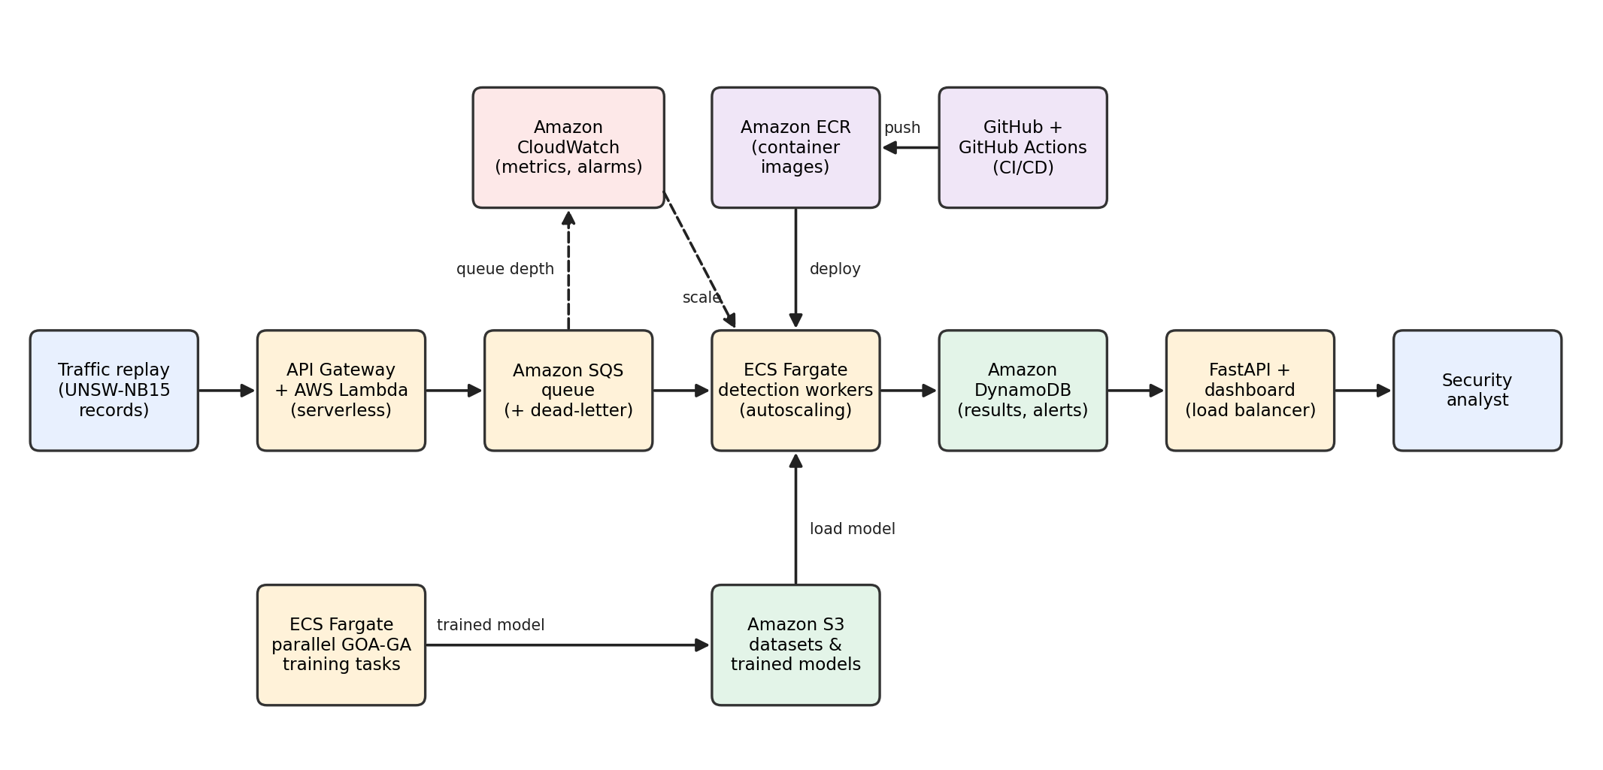
Figure 1: Proposed cloud intrusion detection platform, showing data flow from traffic replay to analyst dashboard, the parallel GOA-GA training job and CI/CD.

6. Risks and Mitigation
- Cloud cost: use the free tier, set budget alerts, use small tasks and Spot capacity, and shut down resources after each test.
- GOA-GA runtime: cap population and iterations (15 agents and 30 iterations in [1]) and search on a training subsample.
- Results differing from [1]: keep an all-features baseline, report honestly and analyse the differences.
- Scope creep: build the core pipeline with restricted access first, and treat advanced authentication and alert filtering as stretch goals.
- Team coordination: fixed roles, weekly meetings, a shared task board and Git history to document each member’s contribution.

7. Timeline
Phase | Dates | Deliverable
1 | To 2 Dec | Baseline pipeline, repository and CI set up, first container deployment
2 | To 20 Dec | Queue, workers, autoscaling, parallel GOA-GA
3 | To 3 Jan | Dashboard, integration, load tests
4 | To 10 Jan | Final evaluation, demo video, submission

Generative AI Declaration
Claude (Anthropic) was used to help find the reference papers and research for the initial papers to use as a project. Also, it helped with the grammar and vocabulary to be at a similar level to the research papers [1][2].

References
[1] M. Bakro et al., “Building a Cloud-IDS by Hybrid Bio-Inspired Feature Selection Algorithms Along With Random Forest Model,” IEEE Access, vol. 12, pp. 8846–8874, 2024, doi: 10.1109/ACCESS.2024.3353055.
[2] Y. Wang and X. Yang, “Research on Enhancing Cloud Computing Network Security using Artificial Intelligence Algorithms,” in Proc. 2025 Int. Conf. Sensor-Cloud and Edge Computing System (SCECS), 2025, pp. 237–244, doi: 10.1109/SCECS65243.2025.11065638.
[3] N. Moustafa and J. Slay, “UNSW-NB15: A comprehensive data set for network intrusion detection systems (UNSW-NB15 network data set),” in Proc. Military Communications and Information Systems Conf. (MilCIS), 2015, doi: 10.1109/MilCIS.2015.7348942.
[4] S. Saremi, S. Mirjalili, and A. Lewis, “Grasshopper optimisation algorithm: Theory and application,” Advances in Engineering Software, vol. 105, pp. 30-47, 2017, doi: 10.1016/j.advengsoft.2017.01.004.
[5] H. He, Y. Bai, E. A. Garcia, and S. Li, “ADASYN: Adaptive synthetic sampling approach for imbalanced learning,” in Proc. 2008 IEEE Int. Joint Conf. Neural Networks (IJCNN), 2008, pp. 1322-1328, doi: 10.1109/IJCNN.2008.4633969.

