Domain-Adaptive Automatic Speech Recognition for Moroccan Darija–French Code-Switched B2B Telephony
Nizar Belaatik¹, Fouzia Elazzaby¹, Abdellatif Douma²
¹ Faculty of Sciences Ben M'Sick (FSBM), Hassan II University of Casablanca, Casablanca, Morocco
² Arboris Management, Casablanca, Morocco
Emails: belaatiknizar@gmail.com, fouzia.elazzaby@fsbm.ac.ma, a.douma@bmm.ma

ABSTRACT
Moroccan Darija presents substantial challenges for Automatic Speech Recognition (ASR) because of its limited speech resources, variable orthographic conventions, linguistic variation, and frequent code-switching with French. These challenges are further amplified in business-to-business (B2B) telephone conversations, where spontaneous speech, channel conditions, domain-specific vocabulary, and short conversational turns can substantially affect recognition performance.
This paper presents a domain-adaptive ASR system for Moroccan Darija–French code-switched B2B telephony. The system is developed as the speech-recognition component of a broader real-time conversational AI voice-agent project, making both transcription accuracy and inference efficiency important design objectives. We adapt Whisper-large-v3-turbo using Low-Rank Adaptation (LoRA) and investigate the effects of training-data composition and adapter capacity through controlled ablation experiments. Specifically, we compare models trained on general Darija speech data, domain-specific B2B recordings, and their combination, while also evaluating multiple LoRA ranks under otherwise consistent training conditions.
The resulting systems are evaluated against publicly available Moroccan Darija ASR models and original multilingual Whisper baselines using a common evaluation protocol. Evaluation is performed on both a held-out general-Darija benchmark and a larger, previously unseen B2B telephone benchmark constructed independently of the training data. Recognition performance is measured using Word Error Rate (WER) and Character Error Rate (CER), while inference efficiency is assessed using Real-Time Factor (RTF) under single-utterance inference conditions.
The experiments provide a controlled analysis of how domain-specific speech data and parameter-efficient adaptation capacity affect Moroccan Darija ASR performance in conversational telephony. In addition, the study introduces a frozen, append-only evaluation protocol designed to preserve genuinely unseen data during iterative model development. An analysis of conversational utterance length further examines the limitations of conventional WER for short telephone utterances. Overall, the results demonstrate the importance of evaluating speech-recognition systems under conditions that reflect their intended deployment domain and of considering recognition accuracy, adaptation strategy, and inference efficiency jointly.
Keywords: Automatic Speech Recognition; Moroccan Darija; Code-Switching; Domain Adaptation; Whisper; LoRA; B2B Telephony; Low-Resource Languages; Parameter-Efficient Fine-Tuning; Real-Time ASR; Conversational AI.

1. INTRODUCTION
Natural Language Processing (NLP) resources for Arabic have historically focused primarily on Modern Standard Arabic (MSA), despite everyday communication relying predominantly on regional dialects. Automatic Speech Recognition (ASR) for these dialects remains challenging because of limited annotated speech resources, substantial linguistic variation, and the absence of standardized orthographic conventions. Moroccan Darija presents a particularly demanding case because it is characterized by considerable lexical and phonological variation and frequent interaction with other languages. In professional and commercial communication, speakers may alternate between Moroccan Arabic and French within the same utterance, creating additional challenges for multilingual and code-switched speech recognition.
These challenges become even more pronounced in telephone conversations, a setting long studied in ASR research through corpora such as Switchboard (Godfrey et al., 1992), though largely for high-resource languages. Compared with carefully recorded or read speech, real conversational telephony may contain spontaneous phrasing, hesitations, disfluencies, variable speaking rates, channel-related acoustic degradation, and short conversational turns. In addition, B2B interactions often contain domain-specific vocabulary, company names, product terminology, and expressions that may be poorly represented in general-purpose speech corpora. Consequently, an ASR system that performs well on a general dialect benchmark may not necessarily provide reliable performance when deployed in a specific real-world conversational domain.
This work is part of a broader engineering project at Arboris Management aimed at developing a real-time conversational AI voice agent for Moroccan Darija–French B2B telephone interactions. Such a system consists of multiple interconnected stages, including speech recognition, language generation, and speech synthesis. The latency of each component contributes to the total response time perceived by the user. Therefore, the ASR component must satisfy two requirements simultaneously: it must produce sufficiently accurate transcriptions and operate efficiently enough to leave adequate computational time for downstream processing.
Human conversational turn-taking provides useful motivation for treating latency as an important evaluation dimension. Corpus studies across multiple languages have reported a modal gap of approximately 200 ms between speaker turns (Levinson & Torreira, 2015). This observation does not imply that an automated voice agent must respond within the same time interval to remain usable, nor does it establish a universal latency threshold for conversational AI systems. Rather, it illustrates the temporal constraints inherent in natural conversation. In a multi-stage conversational pipeline, excessive ASR latency directly reduces the time available for language generation and speech synthesis. For this reason, recognition accuracy and inference efficiency should be evaluated jointly when ASR is intended for real-time conversational deployment.
The present paper deliberately focuses on the ASR component of the larger voice-agent system. The complete conversational agent involves several independent engineering challenges, including real-time audio streaming, low-latency large language model serving, speech synthesis, interruption handling, and the orchestration of multiple services. Addressing all of these problems comprehensively in a single study would limit the depth of analysis possible for each component. Accordingly, this work concentrates on the adaptation and evaluation of the speech-recognition model. The remaining components of the broader system are outside the scope of the present study and are not evaluated here.
A central question investigated in this work concerns the role of training-data composition in low-resource domain adaptation. The proposed system combines a general-purpose Moroccan Darija speech corpus with recordings collected from the target B2B telephony domain. This combination raises an important methodological question: does the addition of domain-matched conversational speech provide measurable benefits beyond training on general Darija speech alone, and how does the contribution of domain-specific data compare with training exclusively on the target-domain recordings? To address this question, we perform a controlled dataset ablation in which models are trained under comparable conditions using: (i) the general Darija corpus alone, (ii) the domain-specific B2B recordings alone, and (iii) the combined corpus.
A second question concerns the capacity of the parameter-efficient adaptation mechanism itself. The proposed system uses Low-Rank Adaptation (LoRA), which allows a large pretrained model to be adapted by training a relatively small number of additional parameters. However, the rank of the low-rank adapters controls the capacity of the adaptation and may influence the balance between model flexibility, generalization, computational cost, and inference behavior. We therefore evaluate multiple LoRA ranks under otherwise consistent experimental conditions to examine how adapter capacity affects recognition performance.
The evaluation is conducted using two complementary benchmarks. The first is a held-out general-Darija benchmark derived from the general speech corpus. The second is a larger frozen benchmark consisting of previously unseen recordings from the target B2B telephony domain. The B2B benchmark is maintained independently from the training data and is preserved as an append-only evaluation set during iterative model development. This design prevents previously unseen evaluation recordings from gradually entering the training corpus as new data are collected, thereby enabling more reliable comparisons between successive model versions.
The study also considers the limitations of conventional ASR evaluation for conversational speech. Word Error Rate (WER) remains the most widely used metric for reporting ASR performance, but its normalization by the number of reference words can disproportionately penalize short utterances. A single error in a one-word utterance produces a WER of 100%, whereas the same error in a longer utterance has a much smaller effect on the aggregate score. Since telephone conversations frequently contain short acknowledgements, confirmations, names, and brief responses, analyzing performance as a function of utterance length is important for interpreting the reported results.
The main contributions of this work are as follows:
- Domain-adaptive Moroccan Darija–French ASR: We develop and evaluate a LoRA-adapted Whisper-large-v3-turbo model for code-switched Moroccan Darija–French B2B telephony and compare it with publicly available Moroccan Darija ASR systems and original multilingual Whisper models under a common evaluation protocol.
- Controlled training-data ablation: We separately evaluate models trained on general Darija speech, domain-specific B2B recordings, and their combination, allowing the contribution of training-data composition to be examined directly rather than inferred from a single combined model.
- LoRA-capacity ablation: We investigate the effect of different LoRA adapter ranks on recognition accuracy and inference efficiency under otherwise comparable adaptation conditions.
- Frozen, append-only evaluation methodology: We introduce a benchmark protocol that permanently preserves previously unseen domain-specific evaluation recordings, supporting reliable longitudinal comparison during iterative model development.
- Joint accuracy and efficiency evaluation: We evaluate recognition quality using WER and CER while measuring inference efficiency using Real-Time Factor (RTF), reflecting the requirements of real-time conversational deployment.
- Analysis of conversational utterance length: We examine the relationship between reference utterance length and measured WER to characterize how conventional edit-distance metrics behave on short conversational telephone speech.
The remainder of this paper is organized as follows. Section 2 reviews related work on Arabic dialect ASR, low-resource speech recognition, code-switching, parameter-efficient model adaptation, and ASR evaluation methodologies. Section 3 discusses the linguistic and orthographic conventions adopted for Moroccan Darija–French transcription. Section 4 describes the speech datasets, the training corpus, and the frozen evaluation benchmarks. Section 5 presents the model adaptation and experimental methodology, including the training-data and LoRA-rank ablation experiments. Section 6 reports the experimental results, including the effects of training-data composition and LoRA rank on recognition accuracy and inference speed. Section 7 analyzes recognition errors and conversational utterance characteristics. Section 8 discusses the implications of the findings, while Section 9 presents the limitations and directions for future work. Section 10 concludes the paper.

2. RELATED WORK

2.1 Automatic Speech Recognition for Arabic Dialects and Low-Resource Languages
Automatic Speech Recognition (ASR) for Arabic dialects remains substantially more challenging than recognition of Modern Standard Arabic (MSA). Arabic dialects exhibit considerable phonological, lexical, and morphological variation, while many lack standardized writing conventions and sufficiently large, consistently annotated speech corpora. These challenges are particularly significant for dialects that are underrepresented in large-scale multilingual speech datasets. Even large crowd-sourced multilingual efforts such as Common Voice (Ardila et al., 2020) provide comparatively little coverage of spoken Arabic dialects, since such corpora are typically organized around standardized languages rather than regional dialectal varieties. Recent surveys of Arabic speech recognition identify limited annotated resources, dialectal variation, orthographic inconsistency, and the presence of code-switching as persistent challenges for the development of robust ASR systems (Haboussi et al., 2025).
The difficulty of low-resource ASR is not limited to Arabic. Research across underrepresented languages has shown that the performance of speech-recognition systems is strongly influenced by the relationship between training data and deployment conditions. Systems trained primarily on read speech or carefully controlled recordings may experience substantial degradation when applied to spontaneous speech, conversational interactions, or real-world acoustic environments. Reitmaier et al. (2022), for example, documented significant challenges in deploying ASR systems for low-resource language communities and emphasized the importance of data collection quality, transcription practices, and the interaction between dataset construction and downstream model performance.
For Arabic dialects specifically, previous work has demonstrated that training-data composition can be as important as model architecture. Menacer and Smaïli (2021), studying Algerian Arabic, showed that combining dialectal speech with linguistically related resources, including MSA and French, could improve recognition performance compared with relying exclusively on a single data source. Their results illustrate the potential benefits of combining complementary speech resources in low-resource settings. However, the optimal balance between general dialectal data and domain-specific conversational speech remains dependent on the target application. The present work investigates this question directly for Moroccan Darija–French B2B telephone speech through controlled training-data ablations.
Moroccan Darija has received increasing attention through the development of open datasets and publicly available speech-recognition models. The Darija Open Dataset (DODa) and its subsequent audio resources have contributed to the expansion of publicly accessible Moroccan Darija data (Outchakoucht & Es-Samaali, 2024; Bidry et al., 2025). Moroccan Arabic has also been the subject of dedicated broadcast-domain benchmarking through the MGB-5 challenge (Ali et al., 2019), which evaluated speech recognition and dialect identification on Moroccan YouTube content spanning several genres. These resources provide valuable general-domain speech coverage but do not necessarily reproduce the acoustic, conversational, and domain-specific characteristics of B2B telephone interactions. This distinction motivates the use of both general Darija speech and target-domain recordings in the present study.

2.2 Code-Switching and Moroccan Darija–French Speech Recognition
Code-switching introduces additional complexity into ASR because the acoustic realization of an utterance may involve multiple languages, vocabularies, phonological systems, and orthographic conventions. Code-switching has been studied extensively for other language pairs, including Mandarin-English conversational speech collected in the SEAME corpus (Lyu et al., 2010), and has been surveyed broadly across speech and language processing tasks by Sitaram et al. (2019). In the Maghreb, interactions between Arabic dialects and French are particularly common in professional, commercial, educational, and everyday contexts. A single conversational turn may therefore contain both Moroccan Darija and French lexical material, sometimes switching languages multiple times within the same utterance.
Recent work on code-switching speech recognition has increasingly emphasized that the difficulty of the task depends on the specific linguistic and acoustic characteristics of the target domain. Liu et al. (2025) argue that the effectiveness of multilingual architectures, language-aware modeling, and data augmentation depends strongly on the types of linguistic confusion present in the data. This perspective suggests that improvements in code-switched ASR cannot necessarily be obtained by increasing the amount of multilingual training data alone; the relevance of the training examples to the target language combination and conversational context is also important.
For Moroccan Darija, code-switching presents an additional orthographic challenge. Darija may be represented using Arabic script, Latin-based transliteration, or mixed conventions, while French is conventionally represented using the Latin alphabet. Consequently, the same acoustic utterance may admit multiple plausible textual representations. This problem affects both model training and automatic evaluation, since exact string-matching metrics may penalize orthographic variation even when the underlying pronunciation or meaning is preserved.
The present work addresses this issue through a fixed transcription convention in which Moroccan Darija is represented using Arabic script and French words are represented using Latin script. This convention is not proposed as a universal standard for Darija orthography. Instead, it provides a consistent target representation for model training and evaluation. The impact of this choice and its limitations are discussed in Section 3.

2.3 Domain Adaptation for Speech Recognition
A central problem in practical ASR deployment is the mismatch between the distribution of training data and the distribution of real-world speech encountered during deployment. A model may perform well on a general benchmark while failing on speech that differs in acoustic conditions, speaking style, vocabulary, channel characteristics, or conversational structure. Domain adaptation seeks to reduce this mismatch by adapting a pretrained model using data that more closely reflects the target application.
For low-resource dialectal ASR, domain adaptation is particularly attractive because collecting large quantities of fully representative speech can be difficult. Instead of training a model from scratch, a pretrained multilingual model can provide general acoustic and linguistic knowledge that is subsequently adapted using a comparatively smaller target-domain corpus.
However, the contribution of domain-specific data should not be assumed solely from the performance of a combined training system. A model trained on general-domain data and domain-specific data may outperform a baseline for several possible reasons, including the additional amount of training data, the specific characteristics of the domain data, or interactions between the two sources. To distinguish these possibilities, the present study performs a controlled dataset ablation. Models are trained using the general Darija corpus alone, the domain-specific B2B corpus alone, and the combination of both sources under comparable training conditions. This design allows the contribution of training-data composition to be evaluated directly.
The study therefore extends previous work on low-resource ASR data sharing and domain adaptation by examining not only whether domain-specific speech improves performance, but also how its contribution compares with general dialectal speech when the target task is Moroccan Darija–French telephone communication.

2.4 Large-Scale Multilingual ASR and Whisper
Large-scale multilingual self-supervised and weakly supervised speech-recognition models have significantly changed the development of ASR systems for languages with limited labeled resources. Whisper, introduced by Radford et al. (2023), was trained on a large and diverse collection of multilingual and multitask speech data. Its broad language coverage provides a strong initialization for adapting ASR systems to languages and domains for which large task-specific datasets are unavailable.
The Whisper model family includes models with different computational and accuracy characteristics. Whisper-large-v3 provides a high-capacity multilingual architecture, while Whisper-large-v3-turbo modifies the decoder architecture to reduce inference cost and improve practical efficiency (OpenAI, 2024). This trade-off is particularly relevant to conversational applications, where recognition accuracy must be balanced against response latency.
Despite the strong generalization capabilities of large multilingual ASR models, their performance can vary substantially across languages, dialects, domains, and acoustic conditions. A model pretrained on broad multilingual data may still fail to capture the vocabulary, pronunciation patterns, orthographic conventions, and conversational characteristics of a specific low-resource dialect. Consequently, multilingual pretraining can be viewed as a strong initialization rather than a guarantee of robust domain-specific performance.
In this work, Whisper-large-v3-turbo is selected as the base model because it provides a suitable combination of multilingual capabilities and inference efficiency. Like other members of the Whisper family, the model follows an encoder–decoder Transformer architecture (Vaswani et al., 2017), which underlies most current large-scale speech and language models. The model is subsequently adapted to Moroccan Darija–French B2B telephony using parameter-efficient fine-tuning.

2.5 Parameter-Efficient Adaptation and LoRA for Speech Models
Full fine-tuning of large pretrained models can be computationally expensive and may require substantial memory and training resources. Parameter-efficient fine-tuning (PEFT) methods address this problem by adapting a pretrained model while updating only a relatively small subset of additional parameters.
Parameter-efficient adaptation was first popularized for pretrained language models through bottleneck adapter modules (Houlsby et al., 2019), which insert small trainable layers into an otherwise frozen network. Low-Rank Adaptation (LoRA), introduced by Hu et al. (2022), represents one of the most widely used approaches for parameter-efficient adaptation. Instead of directly updating the original weight matrix, LoRA introduces trainable low-rank matrices whose product represents the adaptation update. The pretrained parameters remain frozen, substantially reducing the number of trainable parameters and the memory requirements of training.
Although LoRA was originally introduced for large language models, parameter-efficient adaptation methods have also become increasingly relevant for pretrained speech and multimodal models. Their use is particularly attractive in low-resource ASR because the available target-domain data may be insufficient to justify updating the entire pretrained model. Freezing the backbone can also reduce the risk of substantially disrupting useful multilingual representations learned during pretraining.
However, LoRA is not a single fixed adaptation configuration. The rank of the low-rank update controls the representational capacity of the adapter. A rank that is too small may limit the ability of the model to represent the target-domain adaptation, whereas increasing the rank increases the number of trainable parameters and may affect generalization and computational requirements.
For this reason, the present work explicitly evaluates multiple LoRA ranks under otherwise comparable adaptation conditions. Rather than assuming that a particular rank is universally optimal, the experiments examine how adapter capacity affects recognition accuracy and inference efficiency for Moroccan Darija–French B2B speech.

2.6 Evaluation of ASR Systems in Low-Resource and Conversational Settings
Word Error Rate (WER) remains the most widely used metric for evaluating ASR systems. It is computed from substitutions, deletions, and insertions normalized by the number of reference words. Character Error Rate (CER) provides a complementary character-level measure and can be particularly informative for languages and dialects with variable word segmentation or orthographic conventions.
However, conventional edit-distance metrics have limitations when applied to conversational speech. The normalization of WER by the number of reference words means that errors in short utterances can have a disproportionately large effect on the measured score. A single incorrect word in a one-word utterance results in a WER of 100%, whereas the same error in a longer utterance has a much smaller proportional effect. This issue is especially relevant to telephone conversations, which frequently contain short acknowledgements, confirmations, names, and brief responses.
Recent work has therefore explored evaluation methods that go beyond strict surface-form matching and attempt to account for semantic correctness, speaker overlap, and conversational structure. Such approaches are particularly relevant to conversational ASR, although their applicability depends on the characteristics of the target task and evaluation data (Tawara et al., 2026). In the present study, conventional WER and CER remain the primary quantitative metrics to facilitate direct comparison with existing ASR literature. However, we additionally analyze recognition performance as a function of utterance length to characterize the behavior of WER on short conversational turns.
Inference efficiency is another important consideration for practical ASR deployment. Real-Time Factor (RTF) provides a hardware- and implementation-dependent measure of the time required to process audio relative to its duration. Values below one indicate that the system processes audio faster than real time under the specified evaluation conditions. For a conversational voice agent, accuracy and RTF should therefore be considered jointly rather than independently.

2.7 Public Moroccan Darija ASR Systems and Comparative Evaluation
Several publicly available ASR systems provide useful reference points for evaluating Moroccan Darija recognition. These include models based on Whisper fine-tuning, wav2vec2-based architectures, and more recent multilingual ASR systems. The wav2vec2-based baseline included in this study builds on the self-supervised wav2vec 2.0 framework (Baevski et al., 2020) and its cross-lingual extension XLS-R (Babu et al., 2021), and is decoded using Connectionist Temporal Classification (Graves et al., 2006), a training objective that predates the encoder–decoder attention mechanism used by Whisper. Among publicly available open models, MoulSot-v0.3 represents a particularly relevant contemporary reference system. According to its publicly available documentation, the model is based on Qwen3-ASR and was adapted using a large collection of Moroccan Darija speech, including a curated subset of a substantially larger speech collection (AtlasIA, 2026).
Public model documentation and leaderboard results can provide useful evidence of model capability, but direct comparison across independently reported benchmarks is difficult when datasets, preprocessing procedures, decoding settings, and evaluation metrics differ. For this reason, the present study evaluates the selected baseline systems under a common experimental protocol. The comparison includes MoulSot-v0.3, publicly available Whisper-based Moroccan Darija fine-tunes, a wav2vec2-based model, and the original Whisper-large-v3 and Whisper-large-v3-turbo models.
This common evaluation design is important because the objective of the study is not to reproduce or challenge independently reported leaderboard scores. Instead, the objective is to measure how the evaluated systems perform on the same general-Darija and B2B telephone benchmarks under consistent preprocessing and scoring conditions.

2.8 Research Gap
The existing literature and publicly available resources reveal several gaps that motivate the present study.
First, relatively few evaluations focus specifically on real Moroccan Darija–French B2B telephone speech. Existing public Darija resources provide important general-domain coverage, but performance on domain-specific conversational telephony cannot necessarily be inferred from general benchmarks.
Second, the contribution of domain-specific speech data is often difficult to separate from the effect of simply increasing the total training-set size. The present study addresses this problem through controlled dataset ablations comparing general Darija data, B2B data, and their combination.
Third, parameter-efficient adaptation introduces additional design choices that are not necessarily resolved by existing work. In particular, the effect of LoRA adapter rank on the accuracy–efficiency trade-off for Moroccan Darija ASR remains insufficiently characterized. The present study therefore evaluates multiple LoRA ranks under comparable training conditions.
Fourth, direct comparisons between publicly available Moroccan Darija ASR models are complicated by differences in evaluation datasets and protocols. We address this issue by evaluating multiple model families on common benchmarks using a shared preprocessing and scoring procedure.
Finally, inference efficiency is rarely reported together with recognition accuracy in studies focused on low-resource dialectal ASR, despite its importance for real-time conversational applications. The present work therefore jointly evaluates recognition quality and inference efficiency and analyzes how adaptation choices affect both dimensions.
Together, these gaps motivate a controlled experimental study of domain adaptation for Moroccan Darija–French B2B telephony, combining training-data ablations, LoRA-capacity ablations, common-benchmark evaluation, and joint accuracy–latency analysis.

3. LINGUISTIC AND ORTHOGRAPHIC CONSIDERATIONS
Moroccan Darija presents an additional challenge for automatic speech recognition beyond acoustic variability: the absence of a universally standardized written form. This orthographic variability also affects text-based Darija NLP resources; for instance, the DarijaBERT family of language models (Gaanoun et al., 2024) was explicitly developed to support both Arabic-script and Latin-script (Arabizi) representations of the dialect, reflecting the same underlying ambiguity that motivates the transcription convention adopted in this study. The same spoken utterance may therefore be transcribed using different spellings, scripts, or orthographic conventions while preserving substantially the same linguistic meaning. This issue is particularly relevant in Moroccan speech, where Arabic-script Darija, Latin-script representations, and French vocabulary may occur within the same utterance.
In the B2B telephone domain considered in this study, code-switching between Moroccan Darija and French is common. Consequently, the transcription target must represent not only the spoken linguistic content but also the script boundary between the two languages. To reduce unnecessary variability in the training and evaluation targets, we adopted a fixed orthographic convention throughout the corpus.
Under this convention, Moroccan Darija is transcribed exclusively using Arabic script, while French words and expressions are preserved using Latin script. Arabizi or other ad hoc Latin-script representations of Darija are not used. Punctuation is restricted to commas, periods, and question marks, and Latin-script text is lowercased. Numerical expressions are represented according to the language in which they are spoken: Darija numerical expressions are represented using digits, whereas French numerical expressions are written according to the adopted French transcription convention.
Example
"بكل فرح أ لالة. le tarif هو cent dirhams hors taxe par contact."
This convention is not intended to establish a universal orthographic standard for Moroccan Darija. Rather, it defines a consistent transcription target for model training and evaluation. The explicit separation between Arabic-script Darija and Latin-script French also provides a practical representation of code-switching within a single utterance.
However, this normalization strategy does not eliminate all sources of transcription variability. Moroccan Darija may contain multiple valid spellings for the same lexical item, and informal speech may also produce variations in word segmentation, pronunciation, and the representation of borrowed vocabulary. Consequently, exact string-based metrics such as Word Error Rate (WER) may penalize some orthographic differences even when the acoustic recognition is linguistically acceptable. This consideration is particularly important when evaluating short conversational utterances, where a single insertion, deletion, or substitution can have a disproportionately large effect on the resulting WER.
The same transcription convention was applied consistently to the training data and evaluation references used in this study. Because the present work focuses on domain adaptation and model efficiency rather than on comparing alternative orthographic normalization schemes, we do not claim that this convention is universally optimal. Instead, it should be understood as a controlled representation choice designed to reduce target variability and ensure consistent comparison across the experimental conditions.

4. DATA AND CORPUS
The experimental corpus combines a publicly available Moroccan Darija speech dataset with domain-specific recordings collected for B2B telephone speech recognition. This design reflects the central hypothesis of this study: broad dialectal coverage provides general linguistic variation, while domain-specific recordings expose the model to the acoustic, lexical, conversational, and channel characteristics of the target deployment environment.
The corpus is composed of two principal sources.

4.1 General-Darija Speech Data
The first source is the DODa Audio Dataset (Bidry, Zaidoune, et al., 2025), released through AtlasIA as an audio extension of the Darija Open Dataset (Outchakoucht & Es-Samaali, 2024). The dataset provides general Moroccan Darija speech covering a broader range of linguistic content than the target B2B domain.
A total of 12,743 utterances were used from this source, corresponding to approximately 9 h 28 min of speech. Of these, 11,468 utterances were used for training, while 1,275 were reserved for evaluation. After preprocessing and validation, 1,270 samples were successfully used in the held-out evaluation set.
This held-out general-Darija evaluation set was kept separate from the domain-specific B2B benchmark. Consequently, the two evaluation settings measure different properties: the general-Darija benchmark assesses recognition performance on broader dialectal speech, whereas the B2B benchmark evaluates generalization to the target telephone domain.

4.2 Domain-Specific Recorded Data
The second source consists of recordings collected specifically for this project to represent the target B2B speech environment. The corpus contains business-oriented conversational speech and telephone recordings reflecting the types of utterances expected in the intended application.
The complete recorded domain corpus contains 3,119 utterances, corresponding to approximately 4 h 15 min of speech. A total of 2,109 utterances, corresponding to approximately 2 h 59 min, form the training pool. The remaining 1,010 utterances, with a total duration of 1 h 15 min 45 s, were reserved for evaluation.
The domain-specific evaluation data was established in two stages. During model development, an initial set of 372 recordings was maintained as a frozen evaluation split and used for checkpoint evaluation and model selection. These recordings were permanently excluded from model training. After the relevant model-training phase had been completed, an additional 638 domain-specific recordings were collected and added to the evaluation set. These recordings were not used for training, model optimization, or checkpoint selection.
The resulting 1,010-utterance set constitutes the final expanded B2B evaluation benchmark used for the cross-model comparison reported in Section 6. The 638 newly added recordings form a post-training evaluation subset, while the complete 1,010-utterance benchmark provides the primary final evaluation set for assessing recognition performance under the target B2B conditions.
The training pool and evaluation data were maintained as separate partitions. No recording from the evaluation benchmark was subsequently transferred into the training pool.

4.3 Corpus Summary
The speech corpus used in this study combines a general Moroccan Darija dataset with recorded domain-specific speech collected for the target B2B telephony application. Table 1 summarizes the overall composition of the corpus.
Dataset | Number of utterances | Approximate duration | Role
DODa audio subset | 12,743 | ~9 h 28 min | Training and held-out general Darija evaluation
Recorded domain data | 3,119 | ~4 h 15 min | Training pool and frozen B2B evaluation
Total corpus | 15,862 | ~13 h 43 min | —
Table 1Overall composition of the speech corpus used in this study
The recorded domain data was further divided into a training pool and a permanently held-out evaluation benchmark, as shown in Table 2.
Partition | Number of utterances | Duration | Role
Training pool | 2,109 | ~2 h 59 min | Model training
Initial frozen development benchmark | 372 | ~29 min 49 s | Checkpoint evaluation and model selection
Additional post-training recordings | 638 | ~45 min 56 s | Final evaluation only
Expanded B2B evaluation benchmark | 1,010 | 1 h 15 min 45 s | Final cross-model evaluation
Total recorded domain data | 3,119 | ~4 h 15 min | —
Table 2Partitioning of the recorded domain data

The total corpus size reported in Table 1 includes both the general-Darija and domain-specific sources. The training and evaluation partitions were managed independently to prevent evaluation recordings from entering the training pool.

4.4 Frozen and Append-Only Evaluation Benchmark
To support reproducible evaluation during the iterative development of the ASR system, we adopted a frozen, append-only protocol for domain-specific recordings.
The central principle of the protocol is that recordings assigned to an evaluation split are excluded from model training. Once a recording is designated for evaluation, it is not subsequently transferred into the training pool. This property is particularly important in an evolving industrial ASR project, where new recordings may be collected and new model versions may be trained repeatedly.
During the initial model-development phase, a 372-utterance frozen B2B split was used for checkpoint evaluation and model selection. The model checkpoints were therefore selected using a fixed domain-specific evaluation set that was excluded from training.
After the relevant training experiments had been completed, 638 additional domain-specific recordings were collected. These recordings were not used for model optimization or checkpoint selection. They were subsequently combined with the original 372-utterance evaluation split to form the final 1,010-utterance expanded B2B evaluation benchmark.
This protocol provides two complementary evaluation properties. First, the original frozen split supports consistent model selection during development. Second, the additional post-training recordings provide a larger evaluation set containing speech collected after the training phase, thereby testing generalization to subsequently collected domain-specific data.
The append-only design also prevents a common form of evaluation contamination in continuously evolving datasets. If the train–test partition is regenerated after each round of data collection, samples that were previously considered unseen may eventually be incorporated into training, making successive model versions appear to improve even when part of the evaluation data has been indirectly exposed to the training process. By permanently excluding evaluation recordings from the training pool, the protocol provides a more stable basis for comparing different models and experimental configurations.
The expanded 1,010-utterance B2B evaluation benchmark is used for the principal cross-model comparisons and the final LoRA-rank and dataset-ablation analyses reported in Section 6. The original 372-utterance split was used during model development, whereas the final 1,010-utterance benchmark provides the primary evaluation set for the final reported results.
Because the expanded benchmark contains substantially more utterances than the initial development split, it provides a broader basis for estimating model performance under the target B2B speech conditions. However, the complete 1,010-utterance benchmark should not be interpreted as a completely independent post-training test set, since it includes the original 372 utterances used during checkpoint selection. The 638 newly added recordings constitute the strictly post-training evaluation subset.

4.5 Ethical and Data-Protection Considerations
This research was conducted as part of a final-year Master's internship (Projet de Fin d'Études) at Arboris Management under joint academic and industrial supervision.
The proprietary recordings used in this work contain only the call-agent side of B2B telephone interactions. Customer audio was deliberately excluded during data collection in order to avoid processing third-party personal information and to reduce privacy-related risks associated with the construction of the corpus. Consequently, the dataset used in this study does not contain customer speech.
Individuals whose voices were recorded were informed that the recordings would be used for internal research and development purposes. No personally identifiable transcripts or audio samples are included in this paper. Any utterances presented as examples are illustrative and are not reproduced verbatim from the proprietary corpus.
Because the corpus contains only agent-side speech, the reported results characterize recognition performance for call-agent utterances rather than complete two-party telephone conversations. This limitation should be considered when interpreting the reported WER, CER, and latency measurements. The resulting benchmark is therefore intended to evaluate the ASR component under the speech conditions relevant to the intended deployment scenario, rather than to represent the full acoustic and conversational variability of both sides of a telephone interaction.

5. METHODOLOGY
This section describes the ASR model, parameter-efficient adaptation strategy, training configurations, ablation experiments, and evaluation methodology used in this study. The experimental design was developed to evaluate two central questions: first, whether domain-specific B2B speech provides measurable benefits over general Moroccan Darija speech alone; and second, how the LoRA adaptation rank affects the accuracy and efficiency of the resulting ASR model.
All experiments were conducted using the same base architecture and a controlled training procedure. Unless explicitly stated otherwise, the dataset ablation experiments used the same model, optimization configuration, and LoRA configuration to isolate the effect of the training data source. Final cross-model comparisons were performed on the same held-out general-Darija evaluation set and the same expanded B2B evaluation benchmark.

5.1 Base model selection
We selected Whisper-large-v3-turbo (OpenAI, 2024) as the foundation of the proposed ASR system because it offers a favorable balance between multilingual speech recognition capability and inference efficiency. Whisper is pretrained on a large-scale multilingual speech corpus and provides broad coverage of languages including Arabic and French (Radford et al., 2023). This makes it a suitable foundation for Moroccan Darija–French code-switched speech, where the two languages may occur within the same conversational utterance.
The large-v3-turbo variant was selected primarily because the target application is a real-time conversational voice agent. Compared with the original Whisper-large-v3 architecture, the turbo variant uses a substantially smaller decoder while retaining the large encoder, reducing the computational cost of autoregressive decoding and improving inference speed (OpenAI, 2024).
The use of Whisper-large-v3-turbo also enables direct comparison with publicly available Whisper-based Moroccan Darija ASR models. This provides a common architectural reference for evaluating the effect of domain adaptation, while additional non-Whisper systems are included in the broader baseline comparison.

5.2 Low-Rank Adaptation (LoRA)
The proposed ASR models were adapted using Low-Rank Adaptation (LoRA) (Hu et al., 2022). LoRA freezes the pretrained model parameters and introduces trainable low-rank matrices into selected layers. This substantially reduces the number of parameters that must be updated during fine-tuning while preserving the original pretrained backbone.
The primary dataset ablation experiments used a LoRA rank of:
- rank r = 32
- scaling factor α = 64
- dropout 0.05
LoRA adapters were inserted into the following modules:
- q_proj
- v_proj
- out_proj
- fc1
- fc2
The k_proj module was excluded from the final configuration. The same LoRA configuration was used for the three dataset conditions in the main dataset ablation:
DODa only
Recorded domain data only
DODa + recorded domain data
This controlled design allows the effect of the training-data composition to be evaluated independently of the adaptation configuration.
In addition to the dataset ablation, a separate LoRA-rank ablation was conducted using the combined training corpus. Three ranks were evaluated:
r ∈ {8, 32, 64}
The rank-32 model served as the central configuration used in the primary dataset comparison, while the rank-8 and rank-64 configurations were trained to evaluate the effect of adapter capacity on recognition performance.
LoRA was selected as the primary adaptation method because it enables efficient fine-tuning of a large multilingual speech model on a single GPU while requiring substantially fewer trainable parameters than full-model fine-tuning. However, the present study evaluates the effect of LoRA rank rather than directly comparing LoRA with full fine-tuning. A direct comparison against full fine-tuning would therefore constitute a useful direction for future work. Broader surveys of parameter-efficient fine-tuning methods for large pretrained models (Ding et al., 2023) further situate LoRA among a growing family of adaptation techniques, including quantization-aware variants such as QLoRA (Dettmers et al., 2023), which combine low-rank adapters with reduced-precision base weights to further lower the memory footprint of fine-tuning; such quantized adaptation was not explored in the present study but represents a natural extension for future work.

5.3 Dataset Ablation
The central experiment of this study is a controlled dataset ablation designed to measure the contribution of general-purpose and domain-specific speech data.
Three models were trained:
Model A: DODa-only
This model was fine-tuned using only the general Moroccan Darija speech data from DODa.
Model B: Recorded-domain-only
This model was fine-tuned using only the recorded domain-specific training pool.
Model C: DODa + recorded domain data
This model was fine-tuned using the combined training corpus and corresponds to the proposed data-combination strategy.
The three models used the same Whisper-large-v3-turbo base model, the same LoRA rank ((r=32)), the same target modules, and the same optimization configuration. The purpose of this design is to isolate the effect of the training-data composition.
The models were evaluated using the same held-out evaluation sets. Performance was measured separately on the general-Darija evaluation data and the expanded B2B evaluation benchmark. This allows the experiments to distinguish between:
- general dialect recognition performance;
- domain-specific B2B recognition performance; and
- the effect of combining broad dialectal coverage with domain-matched speech.
This experiment directly tests whether domain-specific speech provides additional benefits beyond simply increasing the quantity of general Darija training data.

5.4 LoRA-Rank Ablation
A second ablation study examined the effect of LoRA rank on recognition performance. Using the combined DODa and recorded-domain training corpus, three adaptation capacities were evaluated:
LoRA rank (r=8)
LoRA rank (r=32)
LoRA rank (r=64)
All other training conditions were kept constant as far as possible, including the base Whisper-large-v3-turbo model, target modules, optimization procedure, and evaluation protocol.
The rank ablation evaluates the trade-off between adapter capacity and recognition performance. A lower rank reduces the number of trainable parameters and may provide greater parameter efficiency, whereas a higher rank provides greater capacity for domain adaptation. The results are therefore analyzed not only in terms of WER and CER but also in relation to the number of trainable parameters.
Ablation | Training Data | LoRA Rank | Purpose
Dataset A | DODa only | 32 | Measure performance using general Moroccan Darija data
Dataset B | Recorded domain data only | 32 | Measure the contribution of domain-specific speech
Dataset C | DODa + recorded domain data | 32 | Evaluate the combined training strategy
Rank A | DODa + recorded domain data | 8 | Evaluate a lower-capacity adapter
Rank B | DODa + recorded domain data | 32 | Reference configuration
Rank C | DODa + recorded domain data | 64 | Evaluate a higher-capacity adapter
Table 3Summary of the dataset-composition and LoRA-rank ablation experiments

5.5 Training Configuration
Fine-tuning was performed using mixed-precision training with bfloat16 on a single NVIDIA RTX 3080 Ti GPU.
The primary training configuration used:
Base model: Whisper-large-v3-turbo;
Adaptation method: LoRA
LoRA rank for dataset ablation: r=32
LoRA scaling factor: α =64
LoRA dropout: 0.05
Target modules: q_proj, v_proj, out_proj, fc1, and fc2
Per-device batch size: 2
Gradient accumulation steps: 4
Effective batch size: 8
Learning-rate schedule: cosine decay
Peak learning rate: $3×{10}^{-5}$
Warm-up steps: 200
Training duration: 5 epochs
The number of optimization steps and total training time varied according to the size of the training condition. Consequently, these values are reported separately for the individual experimental runs rather than as a single value for all models.
The dataset-ablation models were trained under the same hyperparameter configuration, with LoRA rank fixed at r = 32, to isolate the effect of training-data composition. The LoRA-rank experiments used the combined training corpus and varied the adaptation rank while keeping the remaining training configuration as consistent as possible. All trained models were subsequently evaluated using the same final evaluation protocol and the same evaluation datasets.

5.6 Data Processing and Text Normalization
The same text-normalization procedure was applied consistently during model training and evaluation. The normalization pipeline included:
removal of Arabic diacritics (tashkeel)
removal of tatweel characters
lowercasing of Latin-script text
normalization of punctuation according to the evaluation protocol
The orthographic convention described in Section 3 was retained throughout the experiments. Darija text was represented using Arabic script, while French words were preserved using Latin script.
The same evaluation normalization was applied to all baseline systems. This was necessary to ensure that differences in WER and CER reflected differences in recognition performance rather than inconsistent preprocessing between systems.

5.7 Evaluation Protocol
The final model evaluation was conducted on two complementary evaluation settings.
The first was a held-out general-Darija evaluation set derived from the DODa data. This benchmark contains 1,270 valid utterances and measures the ability of the adapted models to recognize broader Moroccan Darija speech outside the domain-specific training data.
The second was an expanded B2B evaluation benchmark containing 1,010 utterances with a total duration of 1 h 15 min 45 s. This benchmark was constructed from domain-specific recordings reserved for evaluation and includes both the original 372-utterance evaluation subset used during the model-development phase and 638 additional recordings collected after the relevant training phase had been completed.
The original 372-utterance subset was used during development for checkpoint evaluation and model selection. The additional 638 recordings were not available during the training of the evaluated models and were therefore used exclusively for post-training evaluation. Consequently, the complete 1,010-utterance benchmark provides the primary final cross-model comparison, while the 638 subsequently collected recordings constitute a strictly post-training evaluation subset.
The expanded benchmark was not used as a source of training examples for the evaluated models. This distinction is important because the complete benchmark combines an earlier development-stage evaluation subset with a later-collected evaluation-only subset. The final benchmark therefore provides a substantially larger evaluation set for estimating performance on domain-specific B2B speech, while the subsequently collected subset provides an additional assessment of generalization to recordings obtained after model training.

5.8 Evaluation Metrics
Performance was evaluated using Word Error Rate (WER), Character Error Rate (CER), Real-Time Factor (RTF), and bootstrap confidence intervals.
Word Error Rate
WER was used as the primary recognition metric:
$$WER=\frac{S+D+I}{N}$$
where (S), (D), and (I) represent substitutions, deletions, and insertions, respectively, and (N) is the number of words in the reference transcription.
WER is widely used in ASR evaluation but can be sensitive to orthographic variation. This is particularly relevant for Moroccan Darija, where no universally standardized written form exists. Therefore, WER was interpreted together with CER and qualitative error analysis.
Character Error Rate
CER was reported as a complementary metric:
$$CER=\frac{S+D+I}{N}$$
where the operations are computed at the character level rather than the word level.
CER provides a finer-grained measure of transcription similarity and can help distinguish severe recognition errors from differences involving shorter orthographic units.
Real-Time Factor
Inference speed was evaluated using the Real-Time Factor:
$$RTF=\frac{\text{Inference Time}}{\text{Audio Duration}}$$
RTF was measured using batch size 1, corresponding to sequential processing conditions relevant to real-time telephone conversations. Values below one indicate that the system processes audio faster than real time.
Because the intended application is a conversational voice agent, latency was evaluated alongside recognition accuracy rather than treated as a secondary engineering consideration.
Bootstrap Confidence Intervals
Statistical uncertainty was estimated using 95% bootstrap confidence intervals. Confidence intervals were computed through utterance-level resampling, following established approaches for estimating uncertainty in ASR performance measures (Bisani & Ney, 2004).
Bootstrap confidence intervals allow differences between systems to be interpreted in relation to sampling variability rather than relying exclusively on point estimates.

5.9 Experimental Comparisons
The experimental design therefore consists of two principal ablation dimensions.
The first dimension is the training-data ablation, which compares:
DODa only vs. Recorded domain data only vs. DODa + recorded domain data
The second dimension is the LoRA-rank ablation, which compares:
r = 8 vs. r = 32 vs. r = 64
Together, these experiments evaluate both the contribution of domain-specific training data and the effect of parameter-efficient adaptation capacity. The dataset-ablation and LoRA-rank experiments were evaluated using the same held-out general-Darija evaluation set and the same expanded B2B evaluation benchmark, enabling direct comparison across experimental conditions. The results are presented in Section 6.

6. EXPERIMENTAL RESULTS
All evaluated systems were tested using the same evaluation pipeline and text-normalization procedure described in Section 5. Two evaluation benchmarks were used: (i) a held-out general-Darija benchmark derived from DODa, containing 1,270 valid utterances; and (ii) a final expanded B2B evaluation benchmark containing 1,010 utterances from the target domain.
The expanded B2B benchmark was constructed from an initial 372-utterance benchmark used during model development and 638 additional recordings collected after the relevant model-training phase. The initial 372-utterance subset was permanently excluded from model training but was used for checkpoint evaluation and model selection during development. The additional 638 recordings were collected after training and were not used for model optimization or checkpoint selection.
Consequently, the complete 1,010-utterance benchmark provides the primary final evaluation of performance on the target B2B domain, while the 638 newly added recordings provide a fully post-training evaluation subset. This distinction is important when interpreting the results: the complete benchmark provides a larger and more representative final evaluation, whereas the newly added subset provides the strongest evidence of generalization to subsequently collected domain-specific speech.
In addition to comparing the proposed system with publicly available ASR models, the experiments include two controlled ablation studies. First, the effect of training-data composition was evaluated by separately training models on DODa-only data, recorded domain data only, and the combined corpus. Second, the effect of LoRA rank was investigated using ranks $r=8$, $r=32$, and $r=64$, while keeping the remaining training configuration unchanged.

6.1 Performance on the Held-Out General-Darija Benchmark
Table 4 presents the results obtained on the held-out DODa benchmark. The benchmark contains 1,270 valid utterances and is used to evaluate recognition performance on general Moroccan Darija speech.

Model | WER (%) [95% CI] | CER (%) | RTF
Proposed model, LoRA (r=64) | 6.64 [5.78–7.59] | 2.58 | 0.064
Proposed model, LoRA (r=32) | 11.45 [10.39–12.48] | 3.85 | 0.063
Proposed model, LoRA (r=8) | 14.93 [13.46–16.55] | 5.49 | 0.064
TaloCreations-whisper-darija | 23.24 [21.84–24.64] | 8.01 | 0.059
MoulSot-v0.3 | 28.28 [26.84–29.81] | 9.27 | 0.138
boumehdi-wav2vec2-large-xlsr | 32.11 [30.53–33.71] | 9.52 | 0.006
Proposed model, DODa-only | 39.92 [38.23–41.64] | 12.67 | 0.064
ychafiqui-whisper-medium-darija | 49.40 [47.56–51.28] | 17.78 | 0.110
ychafiqui-whisper-small-darija | 49.86 [48.11–51.64] | 18.02 | 0.058
Proposed model, recorded-data-only | 51.70 [49.87–53.65] | 18.74 | 0.064
whisper-large-v3 | 75.61 [73.58–77.60] | 38.39 | 0.174
whisper-large-v3-turbo | 92.54 [87.25–98.42] | 50.03 | 0.074
Table 4Performance of all evaluated systems on the held-out general-Darija benchmark
The combined-data models achieve the strongest results on the general-Darija benchmark. The LoRA $r=64$model obtains a WER of 6.64% and a CER of 2.58%, representing the best result among all evaluated systems. The LoRA $r=32$model achieves 11.45% WER and 3.85% CER, while the LoRA $r=8$model obtains 14.93% WER and 5.49% CER.
The results also reveal a clear relationship between training-data composition and general-Darija performance. The model trained exclusively on DODa achieves a WER of 39.92% and a CER of 12.67%, while the model trained only on recorded domain data achieves a WER of 51.70% and a CER of 18.74%. In contrast, combining the two sources reduces the WER to 11.45% and the CER to 3.85% for the rank-32 configuration, and further to 6.64% WER and 2.58% CER for the rank-64 configuration.
This result indicates that the two data sources provide complementary information. DODa contributes broad linguistic and acoustic coverage of Moroccan Darija, while the recorded domain data provides speech characteristics associated with the target conversational environment. The combined training configuration therefore substantially outperforms either source in isolation on the general-Darija benchmark.
The LoRA-rank comparison further indicates that increasing the adaptation capacity improves recognition performance on this benchmark. The WER decreases from 14.93% at rank 8 to 11.45% at rank 32 and 6.64% at rank 64. The corresponding CER decreases from 5.49% to 3.85% and then 2.58%. However, the effect of LoRA rank should be interpreted jointly with the results on the B2B benchmark, since the primary deployment target is domain-specific telephone speech.
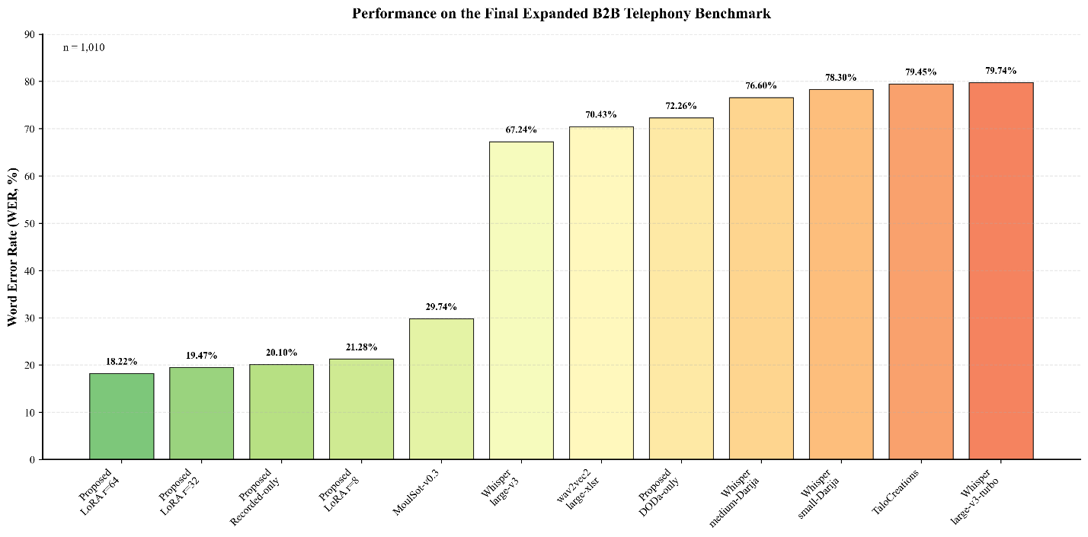
Figure 1WER comparison on the held-out general-Darija benchmark
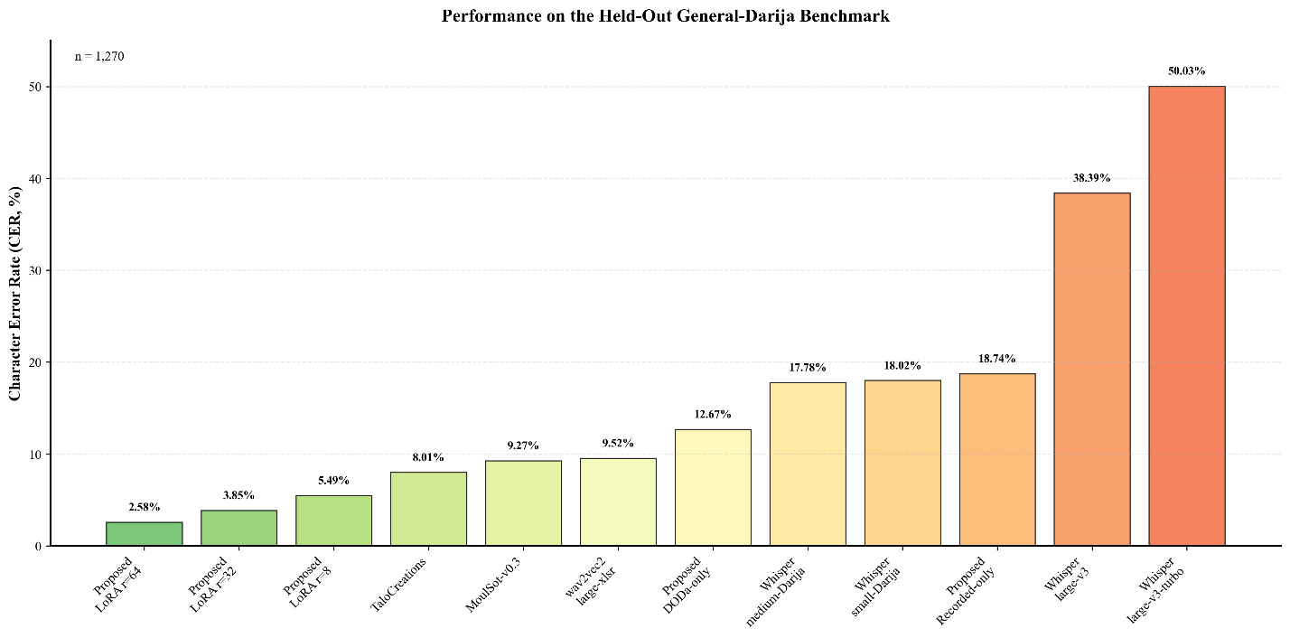
Figure 2CER comparison on the held-out general-Darija benchmark

6.2 Performance on the Frozen B2B Telephony Benchmark
Table 5 presents the results on the final expanded B2B evaluation benchmark containing 1,010 utterances. The benchmark represents the primary evaluation setting of the study because it reflects the target deployment domain.
The benchmark combines the original 372-utterance development-time evaluation subset with 638 additional B2B recordings collected after the relevant model-training phase. The original subset was excluded from model training but was used during development for checkpoint evaluation and model selection. The additional 638 recordings were collected after training and were not used for model optimization or checkpoint selection.
Therefore, the complete 1,010-utterance benchmark should be interpreted as a final expanded evaluation benchmark rather than as a completely independent test set. The 638 newly added recordings constitute the post-training evaluation subset and provide an additional assessment of generalization to subsequently collected B2B speech.
Model | WER (%) [95% CI] | CER (%) | RTF
Proposed model, LoRA (r=64) | 18.22 [17.00–19.52] | 8.93 | 0.047
Proposed model, LoRA (r=32) | 19.47 [18.23–20.81] | 10.77 | 0.047
Proposed model, recorded-data-only | 20.10 [18.80–21.44] | 9.69 | 0.047
Proposed model, LoRA (r=8) | 21.28 [19.99–22.63] | 10.03 | 0.046
MoulSot-v0.3 | 29.74 [28.28–31.17] | 14.32 | 0.138
whisper-large-v3 | 67.24 [62.63–73.45] | 46.03 | 0.143
boumehdi-wav2vec2-large-xlsr | 70.43 [68.68–72.19] | 55.33 | 0.005
Proposed model, DODa-only | 72.26 [65.88–79.52] | 49.31 | 0.049
ychafiqui-whisper-medium-darija | 76.60 [72.02–81.62] | 62.89 | 0.086
ychafiqui-whisper-small-darija | 78.30 [74.36–82.72] | 63.72 | 0.050
TaloCreations-whisper-darija | 79.45 [75.02–84.51] | 64.78 | 0.055
whisper-large-v3-turbo | 79.74 [71.01–90.54] | 55.64 | 0.048
Table 5Performance of all evaluated systems on the frozen B2B telephony benchmark containing 1,010 previously unseen utterances
The LoRA $r=64$model achieves the best result on the final expanded B2B evaluation benchmark, obtaining a WER of 18.22% and a CER of 8.93%. The rank-32 model achieves 19.47% WER and 10.77% CER, while the rank-8 model obtains 21.28% WER and 10.03% CER.
Compared with MoulSot-v0.3, the strongest external baseline in this evaluation, the rank-64 model reduces WER by 11.52 absolute percentage points, corresponding to a relative reduction of approximately 38.7%. The rank-32 model achieves a relative WER reduction of approximately 34.6% compared with MoulSot-v0.3.
The results demonstrate a substantial performance gap between models adapted to the target task and models that were not specifically trained for the evaluated B2B telephony conditions. MoulSot-v0.3 achieves a WER of 29.74% and a CER of 14.32%, while the remaining external baselines obtain WER values between approximately 67% and 80%.
The DODa-only model performs particularly poorly on the B2B benchmark, obtaining a WER of 72.26% and a CER of 49.31%. This result provides direct evidence that general Darija speech data alone is insufficient for robust recognition of the target B2B telephony domain.
By contrast, the recorded-data-only model achieves a WER of 20.10% and a CER of 9.69%, substantially outperforming the DODa-only model and remaining competitive with the combined-data models. This result demonstrates the importance of domain-matched recordings. Nevertheless, the combined-data models provide the strongest overall performance, with the LoRA $r=64$configuration achieving the lowest WER and CER on the final expanded B2B benchmark.
Because the final benchmark includes 638 recordings collected after the relevant training phase, the results also provide evidence that the performance advantage is not limited to the original development-time benchmark. The expanded evaluation therefore strengthens the assessment of model generalization to subsequently collected B2B speech, while the complete 1,010-utterance result should be interpreted as a combined final evaluation rather than as a fully independent post-training test.

6.3 Effect of Training-Data Composition
To directly investigate the contribution of each training-data source, three models were trained using the same model architecture and the same training configuration:
- DODa-only: trained using the general Darija dataset;
- Recorded-data-only: trained using the project-specific recorded domain data; and
- Combined: trained using both DODa and the recorded domain data.
The results are summarized in Table 6.
Training data | DODa WER (%) | B2B WER (%) | DODa CER (%) | B2B CER (%)
DODa-only | 39.92 | 72.26 | 12.67 | 49.31
Recorded-data-only | 51.70 | 20.10 | 18.74 | 9.69
DODa + recorded domain data, LoRA $r=32$ | 11.45 | 19.47 | 3.85 | 10.77
DODa + recorded domain data, LoRA $r=64$ | 6.64 | 18.22 | 2.58 | 8.93
Table 6Dataset-composition and combined-training results on the two evaluation benchmarks
The dataset ablation reveals a strong domain-specific effect. The DODa-only model performs substantially better on general Darija than on B2B speech, whereas the recorded-data-only model shows the opposite pattern. This contrast confirms that the two datasets represent significantly different distributions.
The DODa-only model achieves a WER of 39.92% on the general-Darija benchmark but degrades to 72.26% on the B2B benchmark. Conversely, the recorded-data-only model achieves 20.10% WER on B2B speech but performs substantially worse on general Darija, with a WER of 51.70%.
The combined training configuration substantially improves both domains. At LoRA rank 32, combining the two data sources reduces WER to 11.45% on general Darija and 19.47% on B2B speech. Increasing the LoRA rank to 64 further improves performance to 6.64% and 18.22%, respectively.
These results provide direct experimental support for the central hypothesis of this study: general dialect coverage and target-domain speech are complementary rather than interchangeable sources of supervision. General Darija data alone does not provide sufficient robustness to the acoustic and conversational characteristics of B2B telephony, while domain-specific recordings alone do not provide sufficient coverage for general dialect recognition.
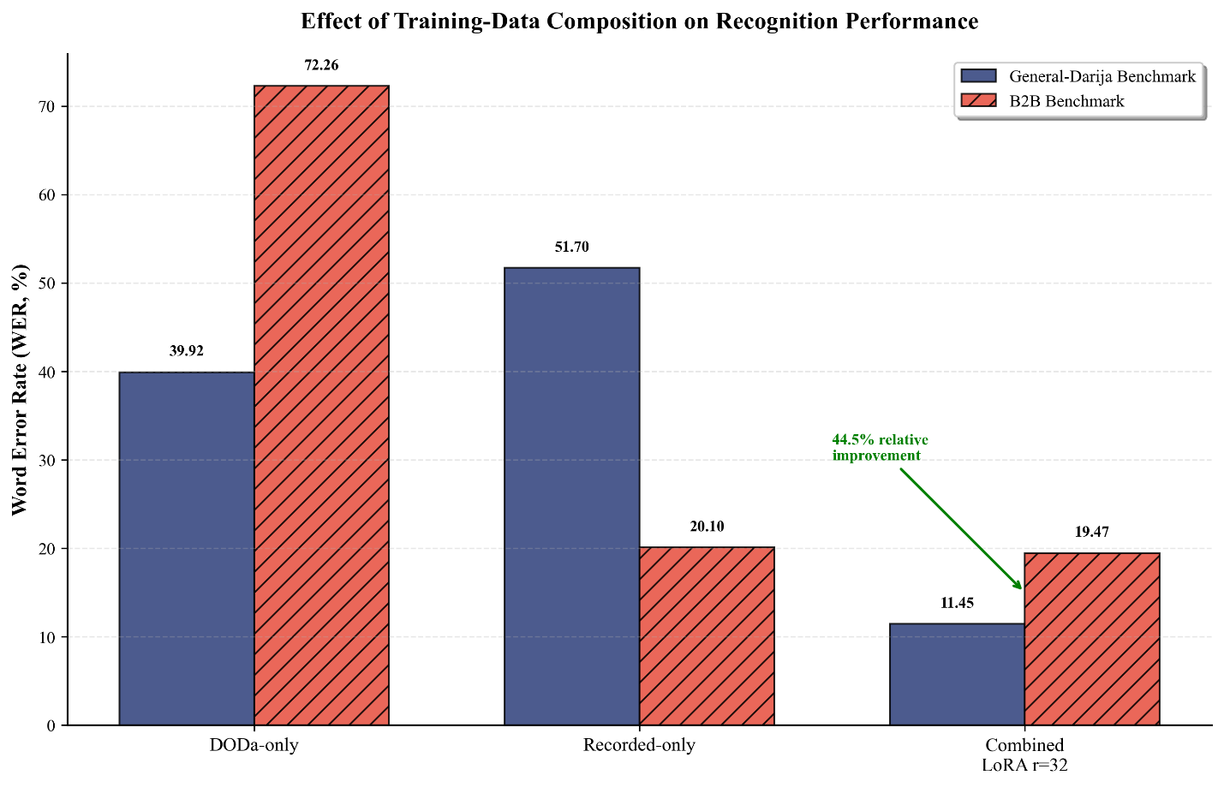
Figure 3Dataset ablation results

6.4 Effect of LoRA Rank
The effect of adapter capacity was evaluated using three LoRA ranks: $r=8$, $r=32$, and $r=64$. The models were trained using the same combined training data and the same general training configuration, with the LoRA rank being the principal experimental variable.
LoRA rank | DODa WER (%) | DODa CER (%) | B2B WER (%) | B2B CER (%) | B2B RTF
(r=8) | 14.93 | 5.49 | 21.28 | 10.03 | 0.046
(r=32) | 11.45 | 3.85 | 19.47 | 10.77 | 0.047
(r=64) | 6.64 | 2.58 | 18.22 | 8.93 | 0.047
Table 7Effect of LoRA rank on recognition performance using the combined training corpus
Increasing the LoRA rank improves recognition performance on both evaluation benchmarks. On the held-out general-Darija benchmark, WER decreases from 14.93% at rank 8 to 11.45% at rank 32 and 6.64% at rank 64. CER follows the same trend, decreasing from 5.49% to 3.85% and then 2.58%.
A similar trend is observed on the final expanded B2B evaluation benchmark. WER decreases from 21.28% at rank 8 to 19.47% at rank 32 and 18.22% at rank 64. The corresponding CER values are 10.03%, 10.77%, and 8.93%, respectively.
The improvement from rank 32 to rank 64 is smaller than the improvement from rank 8 to rank 32 on the B2B benchmark. This suggests that increasing adapter capacity continues to improve performance, but with diminishing returns in the target domain. Nevertheless, the rank-64 configuration provides the best overall performance on both evaluation benchmarks.
The inference measurements show no meaningful latency penalty associated with the higher LoRA rank. The B2B RTF values remain approximately 0.046–0.047 across the three configurations. This indicates that, under the evaluation conditions used in this study, the additional trainable adapter capacity does not materially affect inference speed.
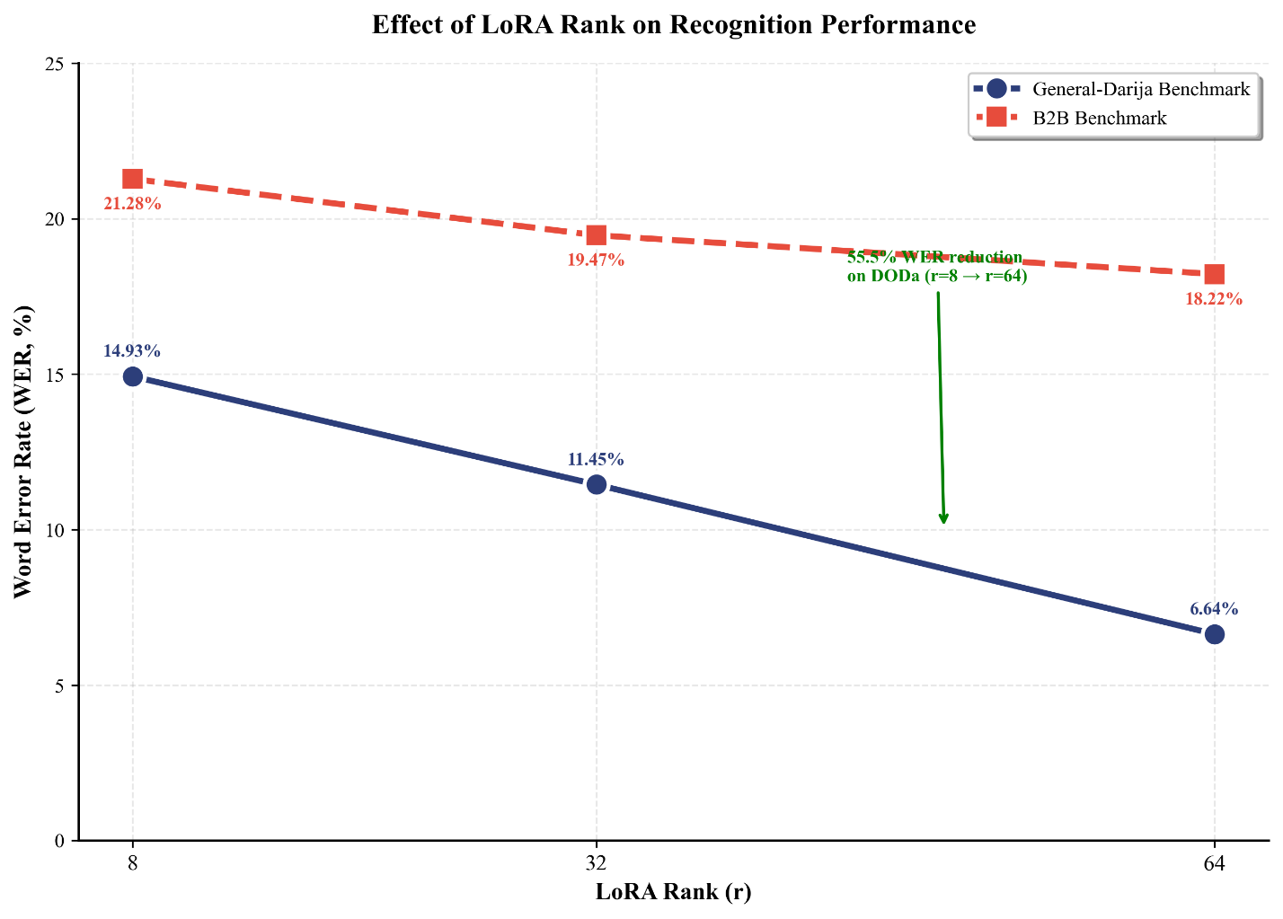
Figure 4Effect of LoRA rank on WER

6.5 Recognition Accuracy and Inference Latency
Because the proposed model is intended for integration into a real-time conversational voice-agent system, recognition accuracy must be considered together with inference speed. Table 4 and 5 report the Real-Time Factor (RTF) measured using sequential batch-size-one inference.
The proposed models achieve RTF values of approximately 0.046–0.047 on the B2B benchmark and 0.063–0.064 on the DODa benchmark. These values indicate that transcription proceeds substantially faster than the duration of the corresponding audio input.
Among the proposed models, the rank-64 configuration achieves the best recognition performance while maintaining an RTF of 0.047 on the B2B benchmark. The rank-8 model is marginally faster at 0.046, but this difference is extremely small compared with the recognition-performance difference between the two configurations.
The CTC-based wav2vec2 model achieves the lowest RTF in the comparison, with an RTF of 0.005 on the B2B benchmark. However, this speed advantage is accompanied by a WER of 70.43%. The result illustrates that inference speed alone is insufficient to determine suitability for a conversational ASR system.
MoulSot-v0.3 achieves a substantially higher RTF of 0.138 on the B2B benchmark, while obtaining a WER of 29.74%. The proposed models therefore provide a more favorable joint accuracy–latency profile for the target application.
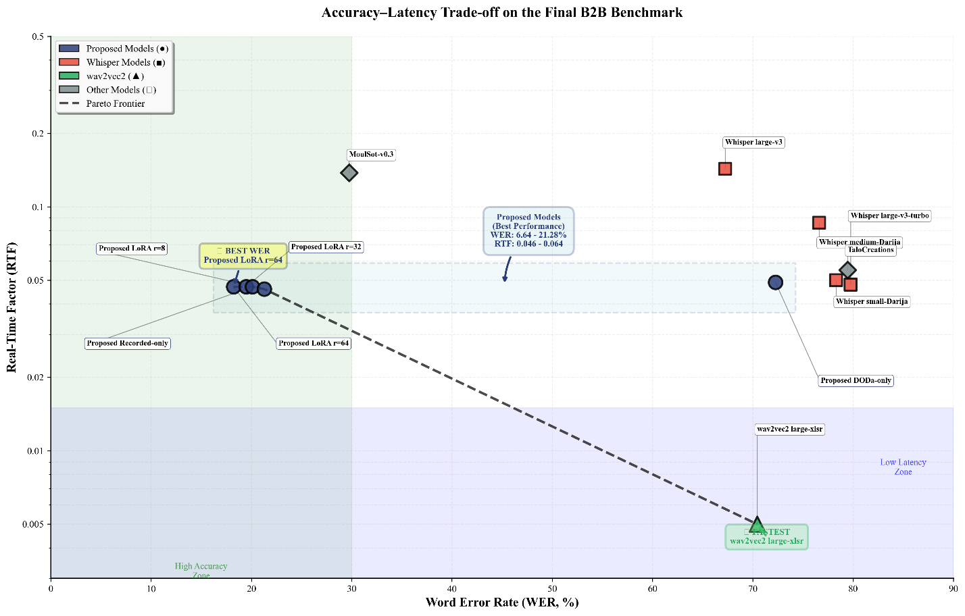
Figure 5Accuracy–latency trade-off on the frozen B2B benchmark

6.6 Summary of Experimental Findings
The experimental results support four main conclusions.
First, the proposed domain-adapted models substantially outperform the publicly available baselines on the final expanded B2B telephony benchmark. The best configuration, using LoRA rank 64, achieves 18.22% WER and 8.93% CER on the 1,010-utterance benchmark. This benchmark combines the original 372-utterance development-time evaluation subset with 638 additional recordings collected after the relevant training phase. The 638 newly added recordings provide a post-training evaluation subset that was not used for model optimization or checkpoint selection.
Second, the dataset ablation demonstrates that training-data composition has a major effect on cross-domain performance. DODa-only training performs poorly on B2B speech, while recorded-data-only training performs poorly on general Darija. Combining both sources provides the strongest overall performance.
Third, increasing LoRA rank from 8 to 32 and then to 64 improves recognition performance on both evaluation domains. The rank-64 model achieves the lowest WER and CER on both the general-Darija and B2B benchmarks.
Finally, the accuracy improvements do not require a substantial inference-latency penalty. The proposed models maintain RTF values close to 0.05 on the B2B benchmark, demonstrating that parameter-efficient domain adaptation can provide strong recognition performance while remaining compatible with real-time conversational ASR deployment.
The following section examines the recognition errors in greater detail, with particular attention to the linguistic and conversational characteristics of the evaluated speech.

7. ERROR ANALYSIS
To better understand the remaining recognition errors, we analyzed the predictions of the best-performing proposed model, the LoRA $r=64$configuration, according to reference utterance length. This analysis was motivated by the characteristics of conversational telephone speech rather than by a generic diagnostic procedure. Many turns in customer-service conversations consist of very short acknowledgements, confirmations, names, or brief responses. Consequently, any systematic evaluation effect affecting short utterances can have a disproportionate impact on the interpretation of ASR performance in this domain.
The analysis was performed on the 372-utterance development-time B2B evaluation subset, which was excluded from model training but was used during development for checkpoint evaluation and model selection. This subset was selected because the utterance-level predictions and reference lengths were available for detailed error stratification. The results are presented in Table 8.

Length (reference words) | Mean WER | n
1–2 words | 36.5% | 63
3–4 words | 27.6% | 63
5–8 words | 21.5% | 78
>8 words | 21.8% | 168
Table 8Mean WER by reference utterance length on the 372-utterance development-time B2B evaluation subset
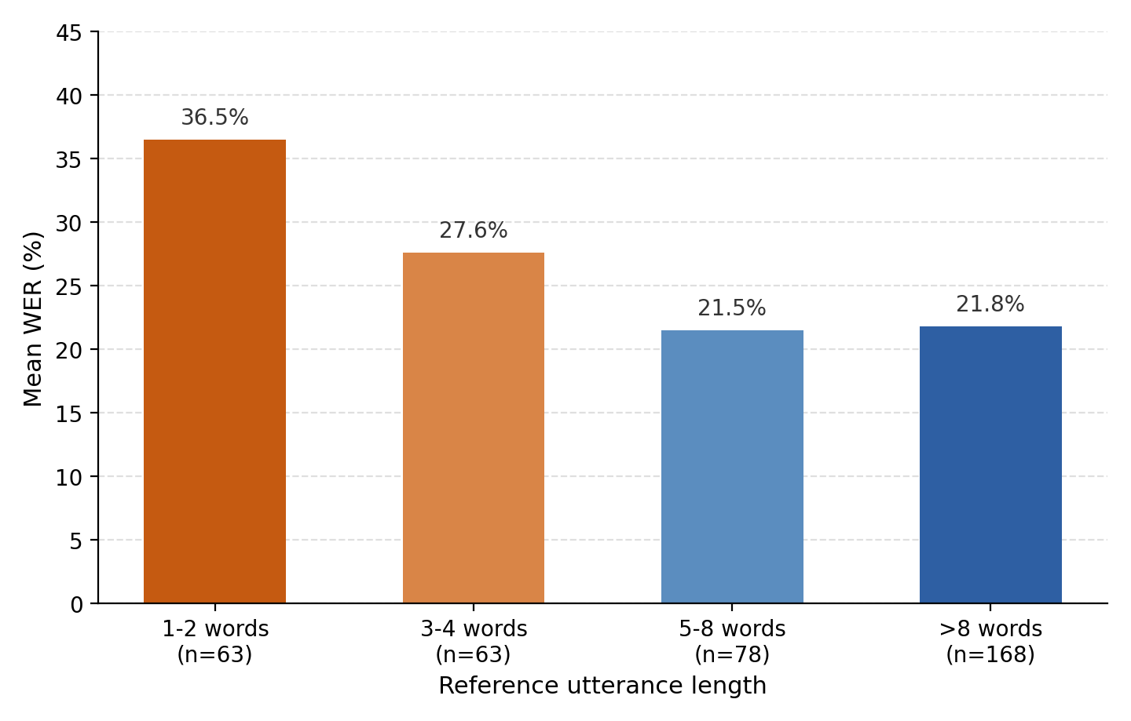
Figure 7Mean WER by reference utterance length on the B2B evaluation subset
A clear relationship emerges between utterance length and measured WER. Utterances containing one or two words exhibit substantially higher error rates than longer utterances, while performance stabilizes once the reference exceeds approximately five words. This pattern is largely explained by the mathematical properties of WER itself. Because WER is normalized by the number of reference words, a single substitution in a one-word utterance necessarily produces a score of 100%, whereas the same error in a twenty-word utterance contributes only 5%. Consequently, identical recognition mistakes have a much larger numerical impact on short conversational turns than on longer ones.
This effect is particularly relevant to telephone-based customer-service conversations, where short utterances are common. A brief response such as an acknowledgement or confirmation may therefore receive a disproportionately high WER even when the underlying recognition error is limited to a single token. The length-stratified results should consequently be interpreted as both a property of the model and a limitation of the metric when applied to short conversational speech.
Inspection of individual high-WER examples further suggests that some of these apparent errors do not represent complete failures of linguistic comprehension. Several involve alternative spellings of the same lexical item or proper name, particularly in cases where Moroccan Darija lacks standardized orthographic conventions. For example, the Arabic name "عبد الله" may be transcribed as "abdallah" in Latin script without necessarily altering its pronunciation or intended meaning. Similar behavior is observed for short acknowledgement tokens, which may occasionally be rendered using English equivalents such as "yeah" instead of "آه". Such cases increase edit-distance metrics despite preserving much of the intended semantic content, illustrating a limitation of strict orthographic evaluation for dialectal Arabic (Haboussi et al., 2025).
Recent work has proposed semantic-aware alternatives to traditional edit-distance metrics for conversational ASR (Tawara et al., 2026). Although this work focuses primarily on overlapping multi-speaker conversations rather than short single-speaker utterances, it reflects a broader trend toward evaluation methods that better capture semantic correctness when surface forms vary. Investigating whether similar approaches are appropriate for Moroccan Darija, particularly in the presence of orthographic variation and code-switching, represents an interesting direction for future work.

7.1 Effect of Code-Switching
We also examined whether French code-switching independently increases recognition difficulty. A simple comparison initially suggested the opposite pattern: code-switched utterances achieved a lower WER of 22.7%, compared with 34.4% for purely Darija utterances. However, the two groups differed substantially in average utterance length. Code-switched utterances contained an average of 11.2 reference words, compared with only 4.5 reference words for purely Darija utterances.
Because the length-stratified analysis above shows that WER increases markedly for shorter utterances, the initial comparison is confounded by utterance length. The lower WER observed for code-switched speech may therefore partially reflect the fact that these utterances tend to be longer.
To partially control for this effect, we repeated the comparison using only utterances containing more than four reference words. Under this restriction, the difference narrowed considerably, with WER values of 23.9% for purely Darija speech and 21.4% for code-switched speech.
Although a small difference remains, the results do not provide strong evidence that French code-switching independently increases recognition difficulty within this benchmark. Instead, the analysis suggests that utterance length is a stronger observable factor associated with measured WER than the presence of code-switching alone.
However, this conclusion should be interpreted cautiously. The comparison is based on a relatively limited evaluation subset, and the two language categories may differ in other factors, including speaker distribution, acoustic conditions, lexical content, and the frequency and position of French segments within the utterance. A larger evaluation corpus would permit a more rigorous statistical analysis, for example using regression models that simultaneously account for utterance length, speaker variation, code-switching frequency, and other acoustic or linguistic factors.
Overall, the error analysis indicates that the remaining recognition errors are influenced by both evaluation-related effects and linguistic variation. Short utterances are particularly vulnerable to inflated WER values because of the denominator effect inherent in word-level edit-distance metrics. In addition, orthographic variation in Moroccan Darija and cross-script representations can increase measured error rates even when the intended lexical or semantic content is largely preserved. Finally, within the available benchmark, the apparent effect of code-switching is substantially reduced after accounting for utterance length.
These findings motivate the use of complementary evaluation measures in future work, including CER, length-stratified WER, and potentially semantic or normalized metrics that are better suited to code-switched dialectal speech.

8. DISCUSSION
The results in Sections 6 and 7 indicate that domain adaptation plays a critical role in Moroccan Darija ASR for conversational B2B telephony. Although trained on substantially less speech than several publicly available alternatives, the proposed model achieved the best performance on both benchmarks, with 6.64% WER on general Darija and 18.22% WER on B2B speech. This comparison does not isolate domain adaptation as the sole causal factor, since the evaluated systems differ in architecture, pretraining data, and training procedures. Nonetheless, the results suggest that representative in-domain speech can compensate for substantial differences in overall training-data volume. This interpretation is reinforced by the community Whisper-based Darija models, which perform substantially worse on B2B speech, with WER values between 76.60% and 78.30%, than on general Darija. Because these models share the same underlying architecture family as the proposed system, the results suggest that adaptation to acoustic conditions, conversational register, and telephony characteristics is at least as important as adaptation to the dialect itself.
The dataset-composition ablation provides further support for this interpretation. The DODa-only model degrades from 39.92% WER on general Darija to 72.26% on B2B speech, whereas the recorded-data-only model shows the reverse pattern, achieving 20.10% WER on B2B speech but 51.70% on general Darija. These results indicate that the two sources capture different distributions: the general corpus provides broader dialectal coverage, while the recorded data captures characteristics of the target domain. Combining both sources therefore yields the strongest overall performance.
The error analysis provides two further observations. First, the apparent advantage of code-switched utterances over purely Darija utterances narrows substantially after controlling for utterance length, with WER values of 23.9% and 21.4%, respectively, for utterances containing more than four reference words. This suggests that utterance length contributes more strongly to measured WER than code-switching alone within the evaluated benchmark. Second, WER is disproportionately higher for short utterances, reaching 36.5% for one- to two-word turns compared with approximately 21.5–21.8% for longer utterances. Because WER is normalized by reference length, individual errors have a much larger proportional effect on short utterances, potentially amplifying the apparent severity of errors in conversational domains where short acknowledgements and confirmations are common.
These findings are consistent with prior work emphasizing the importance of representative training data for Arabic dialect and code-switching ASR. They suggest that collecting additional B2B conversational speech may provide greater practical benefit than expanding generic Darija corpora alone. The frozen, append-only evaluation protocol, which distinguishes the original development-time subset from the 638 subsequently collected recordings, also provides a more stable basis for tracking performance as the system evolves.
Finally, the proposed models offer a favorable accuracy–latency balance. The LoRA-adapted models achieve RTF values of approximately 0.046–0.047 on B2B speech, with the rank-64 model achieving the best accuracy at 18.22% WER and 8.93% CER. The CTC-based wav2vec2 model achieves a substantially lower RTF of 0.005 but has a WER of 70.43%, while MoulSot-v0.3 achieves 29.74% WER with an RTF of 0.138. These results confirm that latency and recognition accuracy must be considered jointly when selecting an ASR model for conversational deployment. Under the evaluation conditions used in this study, the proposed adaptation achieves improved recognition accuracy without an appreciable inference-latency penalty, keeping the ASR component compatible with real-time conversational deployment. End-to-end system performance, however, will also depend on downstream language-model inference, speech synthesis, streaming, and interruption handling, which were outside the scope of the present evaluation.

9. LIMITATIONS AND FUTURE WORK
Several limitations should be considered when interpreting the results.
First, although the final expanded B2B benchmark contains 1,010 utterances, it combines two subsets with different roles in the development process. The original 372-utterance subset was excluded from training but was used for checkpoint evaluation, model selection, and the detailed error analysis presented in Section 7, whereas the additional 638 recordings were collected after the relevant training phase and were not used for model optimization or checkpoint selection. Consequently, the complete benchmark provides a larger and more representative final evaluation but should not be interpreted as a completely independent post-training test set. Future work should expand the post-training evaluation component with more speakers, call types, regional variation, and acoustic conditions.
Second, the proprietary B2B corpus remains limited in conversational diversity. The collected recordings primarily represent professional call-agent speech and do not include customer speech. Therefore, the reported results characterize agent-side speech rather than complete two-party telephone conversations. Future work should extend the corpus to include customer utterances and more diverse interactions while maintaining appropriate consent, anonymization, and data-protection procedures.
Third, although the dataset-composition experiments demonstrate that DODa and recorded B2B data provide complementary information, the study does not fully characterize the optimal amount or proportion of each data source. Future experiments should investigate data-scaling curves and controlled mixtures of general Darija and domain-specific speech to determine how much in-domain data is required to achieve specific performance levels. Although the recorded-domain data were augmented during training, the study did not evaluate established spectrogram-based augmentation methods such as SpecAugment (Park et al., 2019) in a controlled ablation. Combining such techniques with the proposed domain-adaptation strategy could further improve robustness under limited in-domain data.
Fourth, the adaptation study is limited to LoRA applied to Whisper-large-v3-turbo and evaluates only three ranks: r=8, r=32, and r=64. Other parameter-efficient adaptation methods, target-module configurations, full-parameter fine-tuning, and alternative ASR architectures were not evaluated under comparable computational budgets. Future work should investigate these alternatives to better characterize the trade-offs between accuracy, computational cost, trainable parameter count, and inference latency.
Fifth, the comparison with publicly available Darija ASR systems should be interpreted as a comparison under a common evaluation protocol rather than as a reproduction of their originally published results. The evaluated models differ in their original training data, preprocessing, decoding configurations, and implementations. Although all systems were evaluated using the same general pipeline and normalization procedure described in Section 5, complete reproduction of the original training and inference procedures was not possible for every external model.
Sixth, the transcription convention used in this study—Arabic script for Moroccan Darija and Latin script for French—was selected for linguistic consistency and annotation practicality but was not compared experimentally with alternative conventions. Because Moroccan Darija lacks a fully standardized orthography, alternative spellings can affect both training and edit-distance-based evaluation. Future work should investigate alternative normalization strategies and semantic-, phonetic-, or human-judgment-based evaluation methods.
Seventh, the error analysis showed that short utterances produce substantially higher WER because individual errors represent a larger proportion of the reference transcript. Orthographic variation can further increase edit distance without necessarily changing the intended meaning. Future evaluation protocols should therefore consider combining WER and CER with semantic similarity, task-oriented correctness, or human evaluation, particularly for short conversational turns.
Finally, the latency measurements characterize only isolated ASR inference. RTF was measured using sequential batch-size-one inference on a single NVIDIA RTX 3080 Ti GPU. Complete conversational latency will additionally depend on audio transport, voice activity detection, endpointing, language-model inference, speech synthesis, network communication, and deployment optimizations. Metrics such as time to first audio, interruption recovery latency, and end-to-end response latency were not evaluated in this study and remain important directions for future work.
Overall, future research should extend the evaluation toward larger post-training benchmarks, more diverse two-party conversations, broader adaptation strategies, alternative evaluation methods, and complete end-to-end voice-agent measurements.

10. CONCLUSION
This study demonstrated that combining a relatively small amount of domain-matched B2B telephony data with a general Moroccan Darija corpus substantially improves ASR performance in a real commercial telephony setting. The proposed domain-adapted model achieved the best results on both evaluation benchmarks, reaching 6.64% WER on the held-out general-Darija benchmark and 18.22% WER on the final expanded B2B benchmark, while maintaining an RTF of 0.047 on the target-domain evaluation.
The results further showed that the accuracy improvement did not require a substantial latency penalty. The proposed model achieved a favorable accuracy–latency balance compared with the evaluated external systems, although the mechanism behind its slightly lower RTF than the original Whisper-large-v3-turbo remains unverified and requires further investigation.
The error analysis also demonstrated that conventional WER disproportionately penalizes very short conversational utterances, which are common in telephone interactions. This finding highlights the importance of considering utterance length and complementary evaluation measures when assessing conversational ASR systems.
Finally, this study introduced a frozen, append-only evaluation methodology designed to preserve meaningful comparisons as the broader voice-agent project continues to collect data and improve its models. The present work is deliberately scoped to the ASR component of a larger real-time conversational system. Future work will address the integration of low-latency language-model serving, real-time audio streaming, speech synthesis, and microservice orchestration. The present results therefore establish a strong ASR foundation, but complete system performance will ultimately depend on the interaction between all stages of the end-to-end conversational pipeline.

ACKNOWLEDGMENTS
The authors thank Arboris Management for providing access to B2B call data, computational resources, and the industrial context that made this research possible. The authors also acknowledge the Faculty of Sciences Ben M'Sick (FSBM), Hassan II University of Casablanca, for academic supervision and support throughout this research.

REFERENCES
Ali, A., Shon, S., Samih, Y., Mubarak, H., Abdelali, A., Glass, J., Renals, S., &amp; Choukri, K. The MGB-5 Challenge: Recognition and Dialect Identification of Dialectal Arabic Speech. 2019 IEEE Automatic Speech Recognition and Understanding Workshop (ASRU), 2019, pp. 1026–1033. https://doi.org/10.1109/ASRU46091.2019.9003960
Ardila, R., Branson, M., Davis, K., Henretty, M., Kohler, M., Meyer, J., Morais, R., Saunders, L., Tyers, F. M., &amp; Weber, G. Common Voice: A Massively-Multilingual Speech Corpus. Proceedings of the Twelfth Language Resources and Evaluation Conference (LREC 2020), Marseille, France, 2020, pp. 4218–4222.
AtlasIA. Building MoulSot: How We Curated 1,500 Hours of Moroccan Darija Speech. AtlasIA Blog, 2026. Available at: https://huggingface.co/blog/abdeljalilELmajjodi/moulsot (Accessed 13 July 2026).
AtlasIA. MoulSot v0.3: The New Champ of Darija ASR. Hugging Face Model Card, 2026. Available at: https://huggingface.co/atlasia/moulsot.v0.3 (Accessed 13 July 2026).
Babu, A., Wang, C., Tjandra, A., Lakhotia, K., Xu, Q., Goyal, N., Singh, K., von Platen, P., Saraf, Y., Pino, J., Baevski, A., Conneau, A., &amp; Auli, M. XLS-R: Self-Supervised Cross-Lingual Speech Representation Learning at Scale. arXiv preprint arXiv:2111.09296, 2021.
Baevski, A., Zhou, Y., Mohamed, A., &amp; Auli, M. wav2vec 2.0: A Framework for Self-Supervised Learning of Speech Representations. Advances in Neural Information Processing Systems (NeurIPS), vol. 33, 2020, pp. 12449–12460.
Bidry, M., Zaidoune, Y., et al. Moroccan Darija Speech Dataset (DODa). Hugging Face Datasets, AtlasIA, 2025. Available at: https://huggingface.co/datasets/atlasia/DODa-audio-dataset (Accessed 13 July 2026).
Bisani, M., & Ney, H. Bootstrap estimates for confidence intervals in ASR performance evaluation. Proceedings of the IEEE International Conference on Acoustics, Speech, and Signal Processing (ICASSP), Vol. 1, 2004, pp. I-409-I-412.
Dettmers, T., Pagnoni, A., Holtzman, A., &amp; Zettlemoyer, L. QLoRA: Efficient Finetuning of Quantized LLMs. Advances in Neural Information Processing Systems (NeurIPS), vol. 36, 2023.
Ding, N., Qin, Y., Yang, G., Wei, F., Yang, Z., Su, Y., Hu, S., Chen, Y., Chan, C.-M., Chen, W., et al. Parameter-Efficient Fine-Tuning of Large-Scale Pre-Trained Language Models. Nature Machine Intelligence, 5(3), 2023, pp. 220–235.
El Majjodi, A. Moroccan Darija ASR Leaderboard. Hugging Face Spaces, 2026. Available at: https://huggingface.co/spaces/abdeljalilELmajjodi/moroccan_darija_asr_leaderboard (Accessed 13 July 2026).
Gaanoun, K., Naira, A. M., Allak, A., &amp; Benelallam, I. DarijaBERT: A Step Forward in NLP for the Written Moroccan Dialect. International Journal of Data Science and Analytics, 2024, pp. 1–13. https://doi.org/10.1007/s41060-023-00498-2
Godfrey, J. J., Holliman, E. C., &amp; McDaniel, J. SWITCHBOARD: Telephone Speech Corpus for Research and Development. Proceedings of ICASSP-92: 1992 IEEE International Conference on Acoustics, Speech, and Signal Processing, vol. 1, 1992, pp. 517–520.
Graves, A., Fernández, S., Gomez, F., &amp; Schmidhuber, J. Connectionist Temporal Classification: Labelling Unsegmented Sequence Data with Recurrent Neural Networks. Proceedings of the 23rd International Conference on Machine Learning (ICML), 2006, pp. 369–376.
Haboussi, S., Oukas, N., Zerrouki, T., & Djettou, H. Arabic speech recognition using neural networks: concepts, literature review and challenges. Journal of Umm Al-Qura University for Applied Sciences, 2025. https://doi.org/10.1007/s43994-025-00213-w
Houlsby, N., Giurgiu, A., Jastrzebski, S., Morrone, B., de Laroussilhe, Q., Gesmundo, A., Attariyan, M., &amp; Gelly, S. Parameter-Efficient Transfer Learning for NLP. Proceedings of the 36th International Conference on Machine Learning (ICML), PMLR 97, 2019, pp. 2790–2799.
Hu, E. J., Shen, Y., Wallis, P., Allen-Zhu, Z., Li, Y., Wang, S., Wang, L., & Chen, W. LoRA: Low-Rank Adaptation of Large Language Models. International Conference on Learning Representations (ICLR), 2022.
Levinson, S. C., & Torreira, F. Timing in turn-taking and its implications for processing models of language. Frontiers in Psychology, 6:731, 2015. https://doi.org/10.3389/fpsyg.2015.00731
Liu, H., Zhang, H., Zhang, Q., Zhang, X., Shi, D., Chng, E. S., & Li, H. Code-switching Speech Recognition Under the Lens: Model- and Data-Centric Perspectives. arXiv preprint arXiv:2509.24310, 2025.
Lyu, D.-C., Tan, T.-P., Chng, E.-S., &amp; Li, H. SEAME: A Mandarin-English Code-Switching Speech Corpus in South-East Asia. Proc. Interspeech 2010, 2010, pp. 1986–1989.
Menacer, M. A., & Smaïli, K. Investigating data sharing in speech recognition for an under-resourced language: the case of Algerian dialect. Proceedings of the 7th International Conference on Natural Language Processing (NATP 2021), Vienna, Austria, 2021. HAL: hal-03137048.
OpenAI. Whisper Large-v3 Turbo Model Release. GitHub Discussion #2363, 2024. Available at: https://github.com/openai/whisper/discussions/2363 (Accessed 13 July 2026).
Outchakoucht, A., & Es-Samaali, H. The Evolution of Darija Open Dataset: Introducing Version 2. arXiv preprint arXiv:2405.13016, 2024.
Park, D. S., Chan, W., Zhang, Y., Chiu, C.-C., Zoph, B., Cubuk, E. D., &amp; Le, Q. V. SpecAugment: A Simple Data Augmentation Method for Automatic Speech Recognition. Proc. Interspeech 2019, 2019, pp. 2613–2617.
Radford, A., Kim, J. W., Xu, T., Brockman, G., McLeavey, C., & Sutskever, I. Robust speech recognition via large-scale weak supervision. Proceedings of the 40th International Conference on Machine Learning (ICML), 2023.
Reitmaier, T., Wallington, E., Kalarikalayil Raju, D., Klejch, O., Pearson, J., Jones, M., Bell, P., & Robinson, S. Opportunities and Challenges of Automatic Speech Recognition Systems for Low-Resource Language Speakers. Proceedings of the CHI Conference on Human Factors in Computing Systems (CHI '22), 2022. https://doi.org/10.1145/3491102.3517639
Sitaram, S., Chandu, K. R., Rallabandi, S. K., &amp; Black, A. W. A Survey of Code-Switched Speech and Language Processing. arXiv preprint arXiv:1904.00784, 2019.
Tawara, N., Cornell, S., Polok, A., Delcroix, M., Burget, L., & Watanabe, S. Who Spoke What When? Evaluating Spoken Language Models for Conversational ASR with Semantic and Overlap-Aware Metrics. arXiv preprint arXiv:2603.22709, 2026.
Vaswani, A., Shazeer, N., Parmar, N., Uszkoreit, J., Jones, L., Gomez, A. N., Kaiser, Ł., &amp; Polosukhin, I. Attention Is All You Need. Advances in Neural Information Processing Systems (NeurIPS), vol. 30, 2017, pp. 5998–6008.

