
Department of Electrical and Electronic Engineering Science
University of Johannesburg
South Africa

Complex Engineering Problem
Description & Design Report
(D1 + D2 Combined Document)
Project Topic:
Intelligent WiFi Congestion
Monitoring and Recommendation System

Student Name: | Njabulo Sibambo
Student Number: | 223124407
Supervisor: | Dr Bessie Malila
Submission Date: | 3 May 2026

___________________________________
Student, University of Johannesburg
Date: 03 May 2026

Plagiarism Declaration
I, an Electrical and Electronic Engineering Student at the University of Johannesburg, hereby declare that the content of this document is my own work. I understand what plagiarism constitutes, and that all unethical academic behaviour is punishable by disciplinary action as deemed fit by the university.
Surname: Sibambo Initials: NN
Student Number: 223124407
Signature:__ ______________ Date: 03/05/2026

━
PART D1
Complex Engineering Problem – Description and Overview
━━━━━━━━━━━━━━━━━━━━━━━━━━━━━━━━

1. Problem Description
Wireless Local Area Networks (WLANs) allow devices such as laptops, smartphones, and tablets to connect to the internet using radio frequency signals, eliminating the need for physical cables. In university environments these networks are critical infrastructure that supports teaching and learning activities including programming laboratories, software installation sessions, and online examinations.

During laboratory sessions it is common for many students to simultaneously download the same software, stream instructional videos, or access online assessment platforms. When this occurs inside a lecture hall or computer laboratory, dozens of devices begin requesting large volumes of data at the same time. Each device automatically connects to the wireless access point (AP) that provides the strongest received signal strength indicator (RSSI). This is the default behavior of standard WiFi association algorithms.

This signal-strength-first connection behavior consistently produces an uneven distribution of users across the available APs. One AP may accumulate twenty or more connected devices while a physically nearby AP remains nearly unused. The overloaded AP is forced to share its limited radio channel bandwidth among all connected users. According to the Shannon-Hartley Theorem, the maximum channel capacity is physically bounded and cannot be exceeded. When this fixed capacity is divided among many users, each individual user receives a much smaller fraction, resulting in severely slow download speeds and very long waiting times.

The engineering problem is therefore formally defined as: the inefficient and unbalanced distribution of wireless network traffic among multiple access points in a high-density indoor environment, resulting in severe congestion and significantly degraded network performance for all users connected to overloaded access points.

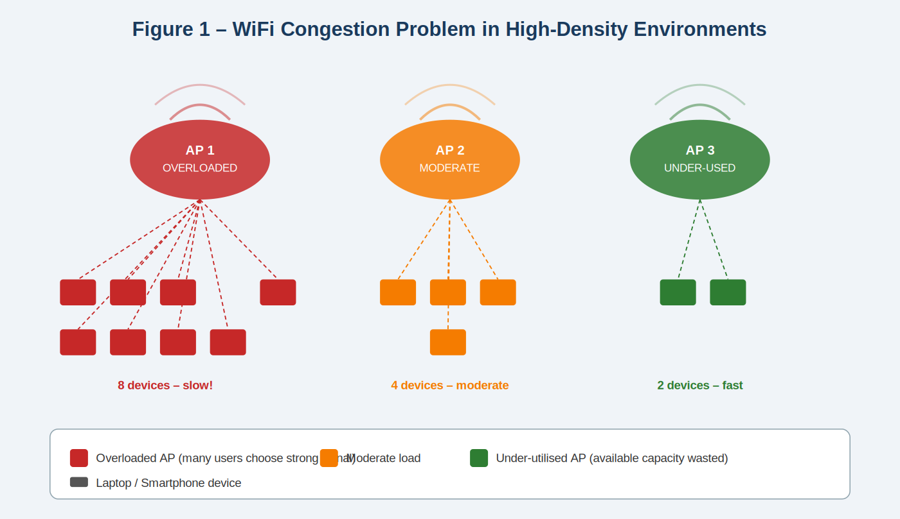
Figure 1 – WiFi Congestion in a High-Density Environment: AP 1 is overloaded with 8 devices while AP 3 serves only 2 devices and has spare capacity

1.1 System Boundary Definition
The system boundary defines which elements are included in the engineering analysis and which are excluded. Table 1 presents this boundary.

System Element | Included | Reason
Student laptops and smartphones | Yes | Primary sources of network traffic in the environment
Wireless access points (APs) | Yes | Provide wireless communication services to all devices
Radio frequency (RF) communication channel | Yes | Physical medium through which WiFi signals propagate
Building environment (walls, layout) | Yes | Directly influences signal attenuation, reflection, and interference patterns
On-device monitoring software | Yes | Core system under design – scans, scores, and displays results
External internet backbone | No | Congestion occurs at the local AP level, not the ISP or backbone
Remote servers hosting downloads | No | Not responsible for the local traffic imbalance between APs
Table 1 – System Boundary Definition
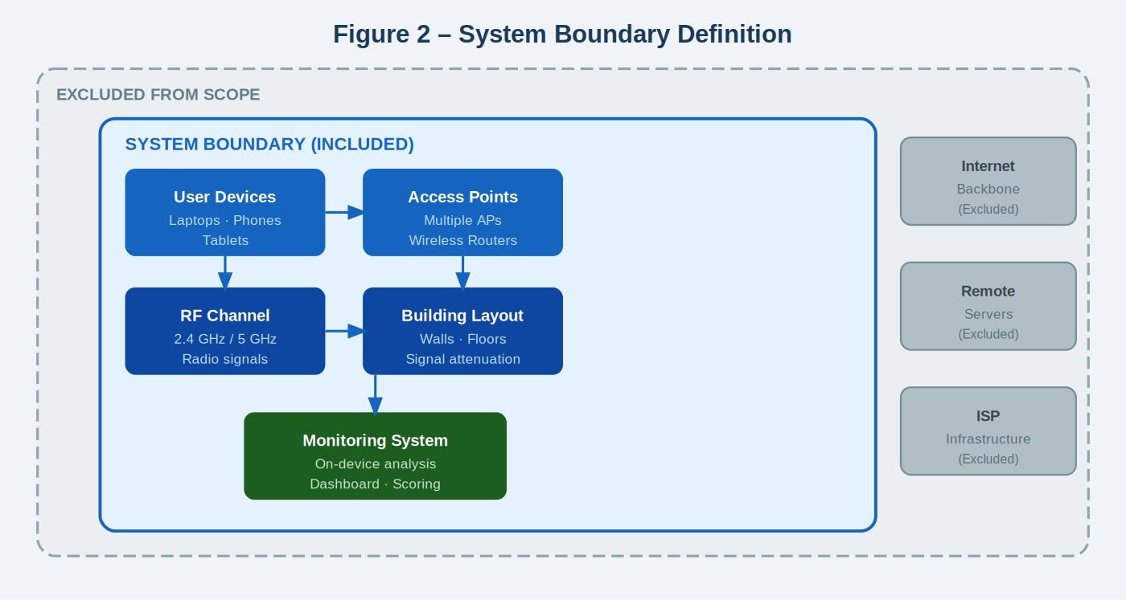
Figure 2 – System Boundary: Included and excluded components. The monitoring system runs entirely within the user device with no modifications to network infrastructure.

1.2 Stakeholders Affected
Multiple stakeholders are directly and indirectly affected by WiFi congestion in a university environment, as described in Table 2.

Stakeholder | Impact of WiFi Congestion
Students | Delayed software downloads, failed exam submissions, and interrupted learning activities during laboratory sessions
Lecturers | Reduced time available for instruction due to troubleshooting and waiting for student downloads to complete
IT Administrators | Increased network troubleshooting workload, system monitoring, and user complaints
University Management | Financial pressure from infrastructure upgrade costs; reputational impact from poor service quality
Table 2 – Stakeholders and Their Impacts

2. Argument That This is a Complex Engineering Problem
According to the Engineering Council of South Africa (ECSA), a complex engineering problem is one that involves several interacting systems, presents conflicting engineering constraints, and requires analysis using engineering fundamentals such as electromagnetic theory, information theory, and mathematical modeling rather than simple configuration adjustments or standard procedures.

This section demonstrates that the WiFi congestion problem satisfies all ECSA criteria for a complex engineering problem.

2.1 Systems-Level Interactions
The WiFi network is not a single component but a collection of interacting subsystems. The behavior of the overall system depends on the dynamic interaction between these subsystems, which cannot be predicted or optimized by considering any one component in isolation.

Subsystem | Role | Engineering Discipline
User devices | Generate and receive network traffic | Computer networking, protocol engineering
Access points (APs) | Distribute wireless bandwidth to connected users | Wireless communications, RF engineering
RF channels (2.4 GHz / 5 GHz) | Carry modulated signals between devices and APs | Electromagnetic theory, information theory
Indoor building environment | Causes signal attenuation, reflection, and multipath | Electromagnetics, propagation modeling
Network protocols (TCP/IP, 802.11) | Control packet routing, acknowledgment, and retransmission | Networking theory, queueing theory
Table 3 – Interacting Subsystems and Their Engineering Disciplines

2.2 Conflicting Technical Constraints
Wireless network design must simultaneously balance several competing engineering objectives. Because these objectives conflict with each other, the system cannot be optimised using any single simple strategy.

Objective | Conflict | Trade-Off
Maximum data throughput | May reduce fairness between individual users | Speed vs. equity
Strong signal connection (RSSI) | May cause device to overload a specific AP | Signal strength vs. load balance
Balanced traffic distribution | Requires temporary disconnection when switching APs | Balance vs. connection stability
Stable wireless connections | Prevents the system from redistributing traffic | Stability vs. dynamic optimization
Low device energy consumption | Limits the frequency of active scanning and monitoring | Energy vs. monitoring accuracy
Table 4 – Conflicting Engineering Constraints

2.3 Requirement for First Principles Analysis
Analysis of the WiFi congestion problem requires the direct application of fundamental engineering laws and mathematical models from multiple disciplines.
Shannon-Hartley Theorem
The Shannon-Hartley Theorem defines the theoretical maximum data rate that can be achieved on a communication channel under the presence of noise:

C = B · log₂(1 + SNR)
where C = channel capacity (bps), B = bandwidth (Hz), SNR = signal-to-noise ratio

This law proves that the capacity of a wireless channel is physically bounded. When many users share the same AP channel simultaneously, the available capacity must be divided among them. This is the fundamental cause of congestion.
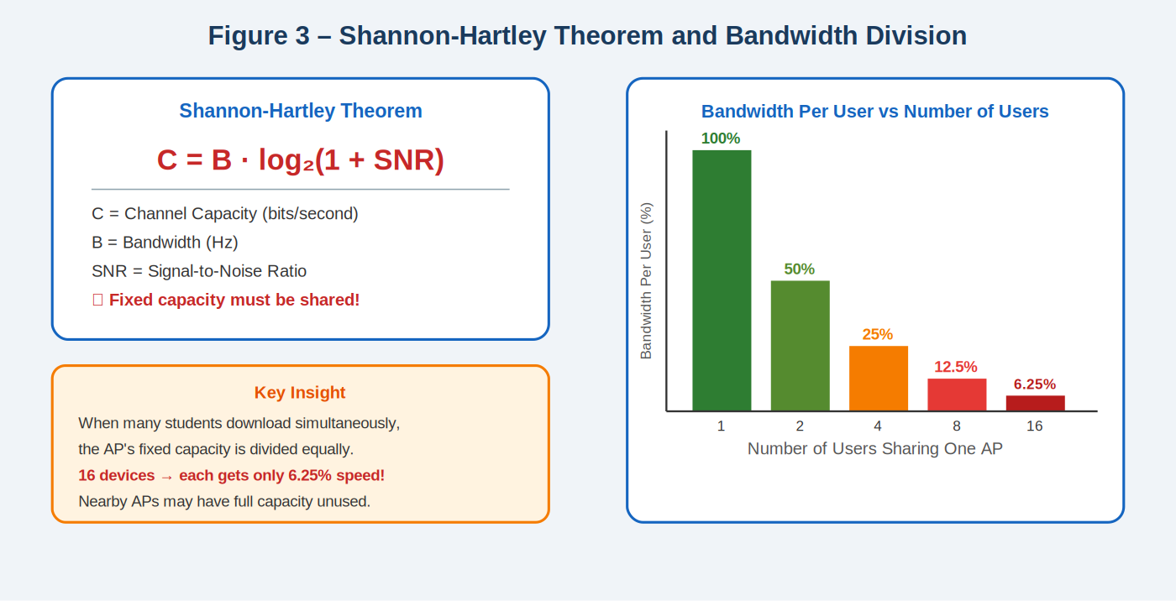
Figure 3 – Shannon-Hartley Theorem and the effect of user load: as the number of users increases, bandwidth per user decreases exponentially

2.4 Absence of Standard Solutions
Standard WiFi association algorithms (IEEE 802.11 specification) rely exclusively on signal strength (RSSI) to select access points. These algorithms do not account for the current load on each AP or the traffic congestion level. As a direct result, devices may connect to and remain connected to an already severely overloaded AP, even when neighbouring APs with significant available capacity are physically nearby. This represents a fundamental limitation of existing standard procedures, confirming that the problem requires engineering analysis beyond routine methods.

3. User Requirements
User requirements describe the expected outcomes and performance characteristics of the system from the perspective of the stakeholders. These requirements do not prescribe specific design solutions but instead define measurable performance targets that any acceptable solution must satisfy.

ID | Requirement | Measurement Method | Priority
UR1 | Support a large number of simultaneous users in one location | Number of concurrently connected devices | High
UR2 | Maintain acceptable download speed during peak usage periods | Average download speed in Mbps | High
UR3 | Ensure balanced distribution of users across available APs | Standard deviation of users per AP | High
UR4 | Maintain stable wireless connections for all users | Connection drop rate per session | Medium
UR5 | Operate within existing campus infrastructure without hardware changes | Compatibility verification | High
UR6 | Minimise energy consumption of user devices during monitoring | Device battery usage during operation | Low
UR7 | Provide real-time visibility of AP congestion status to the user | Dashboard refresh rate and responsiveness | High
UR8 | Protect user privacy – all data must be processed and stored locally | Data transmission audit – no external uploads | High
Table 5 – User Requirements

4. Engineering Fundamentals and Scientific Underpinning
Several distinct engineering and mathematical disciplines are required to fully understand, model, and address the WiFi congestion problem. Each discipline contributes specific analytical tools and theoretical frameworks.

Engineering Field | Application to This Problem | Key Principle or Equation
Electromagnetic Theory | Explains how radio signals propagate, attenuate through walls, and create interference patterns | Free-space path loss equation
Wireless Communication Theory | Determines practical data transmission limits under real-world conditions | Shannon-Hartley: C = B·log₂(1+SNR)
Information Theory | Defines the maximum theoretical channel capacity and the effect of noise | Shannon entropy and channel capacity bounds
Computer Networking | Explains packet routing, congestion control protocols, and TCP behavior under load | TCP/IP congestion window, 802.11 MAC
Queueing Theory | Models the relationship between traffic load, waiting time, and packet delays at each AP | M/M/1 queue: W = 1/(μ − λ)
Graph Theory | Represents the network topology and relationships between devices, APs, and links | Weighted graph models, shortest path
Statistics and Data Science | Used in the scoring model to normalise raw metrics and weight multiple performance indicators | Weighted scoring, normalisation
Table 6 – Engineering Theory and Application
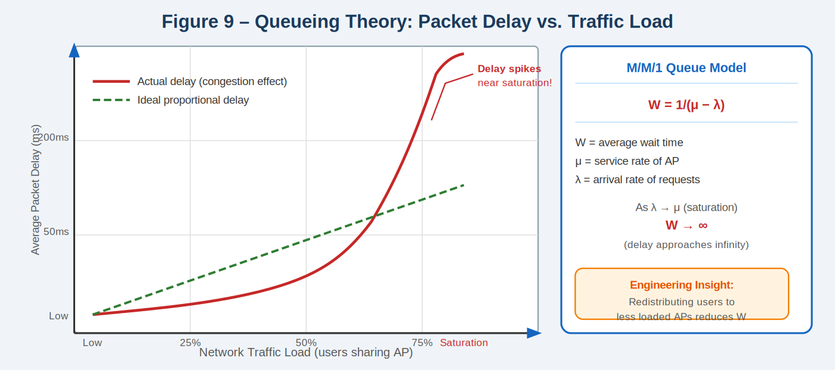
Figure 4 – Queueing Theory: the M/M/1 model shows how packet delay rises exponentially as traffic load approaches AP capacity (saturation point)

5. Resource Use, Environmental Impact and Lifecycle Considerations
Engineering solutions must always be evaluated for their resource usage, environmental impact, and long-term sustainability. The design of the monitoring system explicitly addresses these considerations to ensure responsible and sustainable deployment.
Constraint | Impact | Design Response
Hardware cost | Adding new APs requires significant capital investment | System runs on existing user devices – no new hardware required
Energy consumption | Congestion causes repeated packet retransmissions, wasting energy | Better AP selection reduces retransmissions and saves battery life
Maintenance complexity | Advanced infrastructure systems require specialist technicians | On-device software is simple to update and maintain
Scalability | Infrastructure must support future growth in device numbers | Software scales automatically to any number of devices
Equipment lifespan | Existing AP infrastructure should remain useful for many years | Better traffic distribution extends the effective life of current APs
Table 7 – Resource and Lifecycle Constraints

━━━━━━━━━━━━━━━━━━━━━━━━━━━━━━━━
PART D2
Detailed Design of the Selected Engineering Solution
━━━━━━━━━━━━━━━━━━━━━━━━━━━━━━━━

6. Five Possible Engineering Solutions
Before selecting a final design approach, five distinct engineering solutions were identified and evaluated. Each addresses the WiFi congestion problem from a different engineering perspective with different implications for feasibility, cost, and infrastructure requirements.

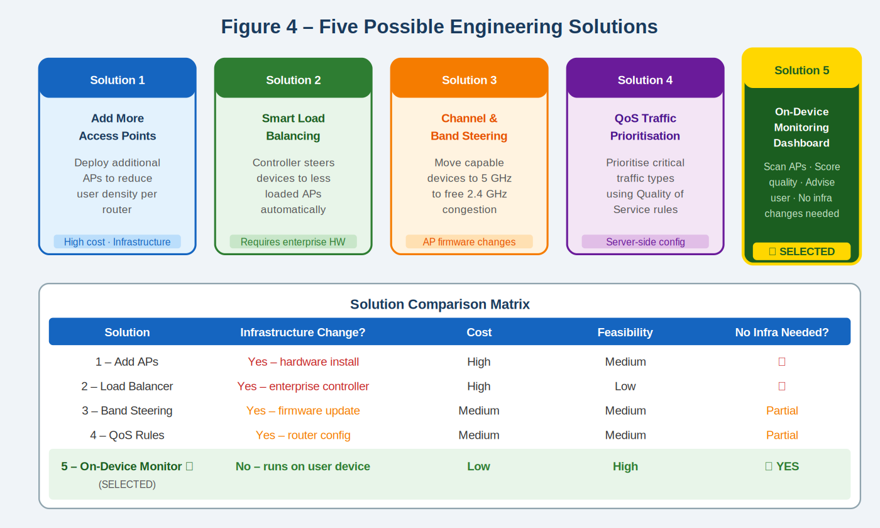
Figure 5 – Five Possible Solutions Comparison Matrix: Solution 5 (On-Device Monitoring) is selected as the most feasible option requiring no infrastructure changes

6.1 Solution 1 – Deploy Additional Access Points
This approach increases the number of APs in the environment, thereby reducing the number of users per AP. While effective in principle, it requires physical installation of hardware, electrical cabling, configuration by IT staff, and significant capital expenditure. This solution is not feasible for this project scope.

6.2 Solution 2 – Enterprise Load Balancing Controller
A centralised controller monitors all AP loads and forces devices to roam to less-loaded APs. This requires enterprise-grade wireless controllers (such as Cisco or Aruba) that are expensive and require complex network integration. This approach is excluded due to infrastructure and budget constraints.

6.3 Solution 3 – Channel and Band Steering
Capable devices are guided from the crowded 2.4 GHz band to the less congested 5 GHz band, freeing capacity on both. This requires firmware-level changes to the APs and is not available on standard university infrastructure without administrative access and vendor support.

6.4 Solution 4 – Quality of Service (QoS) Traffic Prioritisation
QoS rules are configured on routers to prioritise critical traffic types such as video streaming or exam submissions over software downloads. This requires administrative access to the router configuration and applies only to one category of traffic, without solving the fundamental load imbalance.

6.5 Solution 5 – On-Device Intelligent Monitoring System (SELECTED)
The selected solution runs entirely on the user's own device (laptop, smartphone, or tablet). It continuously scans nearby APs, measures real-world performance metrics including signal strength, latency, and packet loss, calculates a quality score for each AP, and presents this information through a real-time colour-coded dashboard. The system recommends the best available AP to the user without requiring any changes to the network infrastructure.

This solution was selected because it requires no hardware, no infrastructure changes, no administrative access, and no additional cost. It operates within the engineering constraints of a student project while delivering a measurable and practical impact on the user experience.

7. Selected Solution: Detailed System Design

7.1 Core Project Concept
The Multi-Device Intelligent WiFi Congestion Monitoring and Recommendation System is an on-device software tool that helps users identify and connect to the best available wireless access point in high-density environments. The system performs all processing locally on the user's device and does not modify or interact with the network infrastructure in any way.

The system operates on three device categories: laptops (primary prototype), smartphones, and tablets. On each device the system performs three core functions: it observes WiFi conditions by scanning nearby access points, analyses connection quality by measuring real-world performance metrics, and recommends better connectivity options to the user through a visual dashboard.
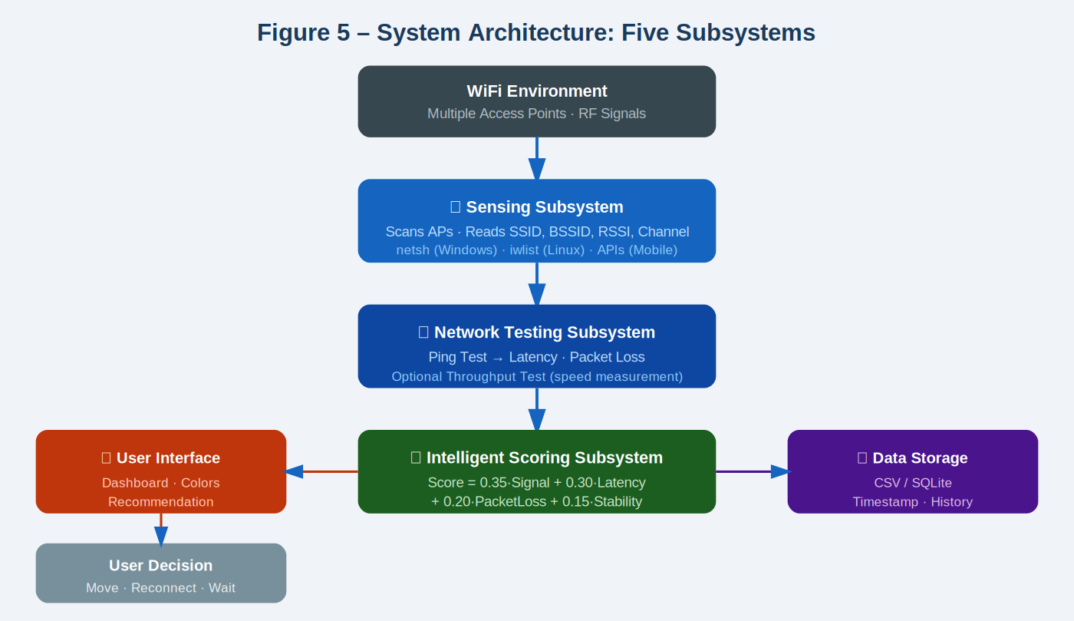
Figure 6 – System Architecture: Five subsystems process WiFi data from the environment through sensing, testing, scoring, storage, and display to the user

7.2 System Architecture – Five Subsystems
The system is structured as five clearly defined subsystems, each responsible for a distinct function. The subsystems interact in a linear pipeline with a feedback loop.

Subsystem | Function | Input | Output
① Sensing | Detect and list all nearby WiFi APs | RF signals from environment | List of APs with SSID, BSSID, RSSI, channel
② Network Testing | Measure current connection quality | Active network connection | Latency (ms) and packet loss (%)
③ Scoring | Calculate a quality score for each AP | Normalised RSSI, latency, packet loss, stability | Score (0–100) and status classification
④ Data Storage | Store all measurements with timestamps | Scores and raw measurements | Historical data in CSV or SQLite file
⑤ User Interface | Display results and recommendations | Scores and status classifications | Colour-coded dashboard and message
Table 8 – Five Subsystems: Functions, Inputs and Outputs

8. Detailed System Data Flow
The following flow diagram describes the complete step-by-step operation of the system from startup to continuous real-time monitoring. The system repeats this process every few seconds to provide up-to-date information.
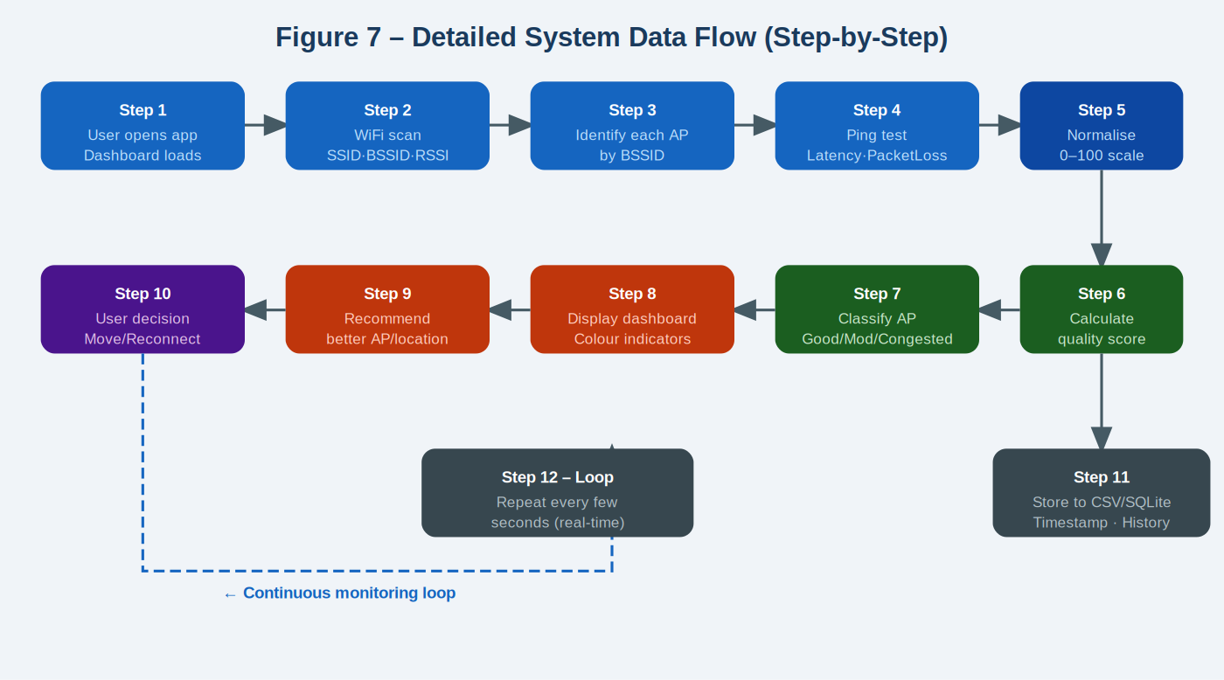
Figure 7 – Step-by-Step Data Flow Diagram: the system continuously loops through scanning, testing, scoring, displaying, and storing in a real-time monitoring cycle

8.1 Step-by-Step Description
Step | Action | Detail
1 | Launch application | User opens the application on a laptop, smartphone, or tablet. The dashboard interface loads and the monitoring loop begins.
2 | WiFi scan | The device uses operating system commands (netsh on Windows, iwlist on Linux, platform APIs on mobile) to scan for all nearby WiFi networks.
3 | Identify APs | Each discovered network is uniquely identified using its BSSID (MAC address). This ensures that networks with the same name (SSID) but from different physical APs are treated as separate access points.
4 | Performance test | A ping test is conducted to measure network latency (in milliseconds) and packet loss percentage for the currently connected AP. An optional throughput test may also be performed.
5 | Normalise metrics | Raw metric values are converted to a normalised 0–100 scale. For example: RSSI of −30 dBm maps to 100 (excellent signal) and −90 dBm maps to 0 (no signal). Latency of <20 ms maps to 100 and >200 ms maps to 0.
6 | Calculate score | The normalised scores are combined using the weighted scoring formula: Score = 0.35×Signal + 0.30×Latency + 0.20×PacketLoss + 0.15×Stability. A higher score indicates a better quality connection.
7 | Classify AP | The numerical score is translated into a status category: Score ≥ 75 = GOOD (green); Score 50–74 = MODERATE (orange); Score < 50 = CONGESTED (red).
8 | Display dashboard | The dashboard displays a table of all nearby APs with their RSSI, latency, packet loss, score, and colour-coded status. The current AP is highlighted.
9 | Recommend | If a better AP is detected, the system displays a recommendation message such as "Better connection available: AP-Lab-01 (North). Move towards that direction to improve speed."
10 | User acts | The user may choose to physically move to a better location, manually disconnect and reconnect to the recommended AP, or wait. The system does not force any action.
11 | Store data | All measurements, scores, classifications, and timestamps are saved to a local CSV file or SQLite database for historical analysis and future improvement of the model.
12 | Loop | The system returns to Step 2 and repeats the entire process every few seconds, providing continuous real-time monitoring throughout the session.
Table 9 – Detailed Step-by-Step System Operation

9. Intelligent Scoring Algorithm
The core intelligence of the system is the weighted scoring algorithm. This algorithm converts multiple raw WiFi measurements into a single, easy-to-interpret quality score for each access point. The scoring approach is designed to be computationally lightweight, transparent, and explainable.
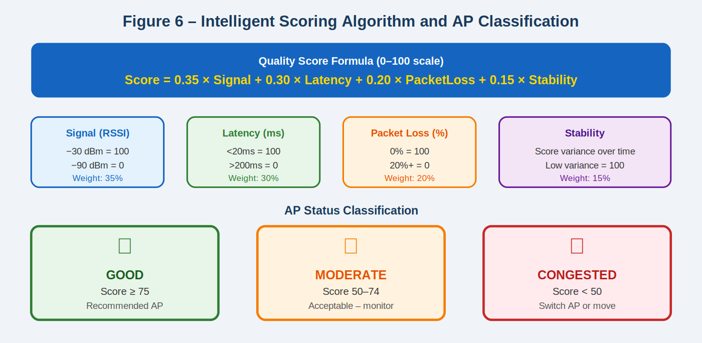
Figure 8 – Intelligent Scoring Algorithm: four normalised metrics are combined with specific weights to produce a quality score, which is then classified into Green/Orange/Red status

9.1 Scoring Formula
Score = 0.35 × Signal + 0.30 × Latency + 0.20 × PacketLoss + 0.15 × Stability

Metric | Weight | Normalisation | Justification
Signal Strength (RSSI) | 35% | −30 dBm → 100; −90 dBm → 0 | RSSI is the most widely available metric and directly indicates link quality
Latency (ms) | 30% | <20 ms → 100; >200 ms → 0 | High latency directly impacts the user experience during downloads and interactive tasks
Packet Loss (%) | 20% | 0% → 100; ≥20% → 0 | Packet loss forces TCP retransmissions, significantly reducing effective throughput
Stability (variance) | 15% | Low variance → 100; high → 0 | A stable connection is preferable to a variable one even if average quality is similar
Table 10 – Scoring Weights and Normalisation

9.2 AP Classification Thresholds

Status | Score Range | Meaning | User Action Recommended
🟢 GOOD | 75 – 100 | Excellent connection, low congestion | Stay connected – best available option
🟠 MODERATE | 50 – 74 | Acceptable but monitor for degradation | Monitor; consider moving if better AP is visible
🔴 CONGESTED | 0 – 49 | Significant congestion, poor performance | Move location or manually reconnect to a GOOD AP
Table 11 – AP Classification Thresholds

10. Dashboard User Interface Design
The user interface is the primary interaction point between the system and the user. It is designed to present complex network performance information in a simple, clear, and actionable format. The dashboard uses colour-coded indicators so that users can immediately understand the status of each AP without any technical knowledge.
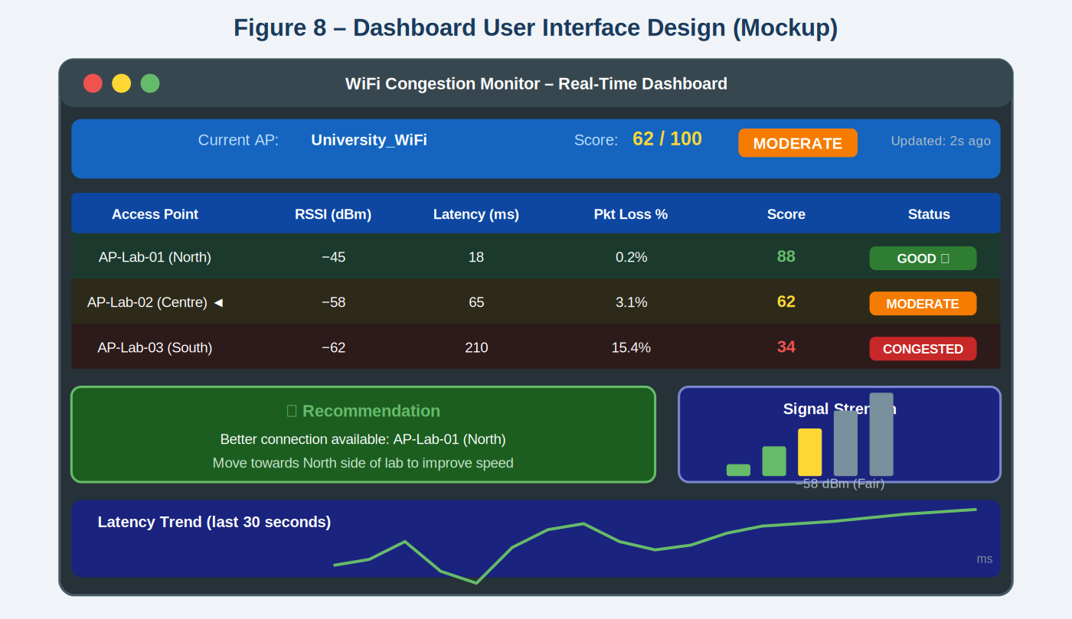
Figure 9 – Dashboard UI Mockup: real-time display showing AP table, colour-coded status indicators, recommendation message, signal strength bars, and latency trend graph

10.1 Dashboard Components

Component | Content | Purpose
Status bar | Current AP name, score, and status badge | Immediate overview of current connection quality
AP table | All detected APs with RSSI, latency, packet loss, score, and status | Comparison of all available connection options
Colour indicators | Green / Orange / Red per AP row | Instant visual communication without requiring numerical understanding
Recommendation box | Best available AP name and directional guidance | Actionable advice for the user to improve their connection
Signal strength bars | Visual bar chart of RSSI levels | Familiar WiFi bar representation for non-technical users
Latency trend graph | Time-series graph of latency over last 30 seconds | Shows whether connection is improving or degrading over time
Last updated timestamp | Time of most recent scan | Confirms the data is current and the system is running
Table 12 – Dashboard Components and Their Purpose

11. Multi-Device Support Architecture
The system is designed to support three device types. The same core architecture, scoring algorithm, and dashboard design apply across all devices. The only component that differs between platforms is the WiFi sensing method used to scan for access points, as different operating systems provide different APIs and levels of access to WiFi scanning data.
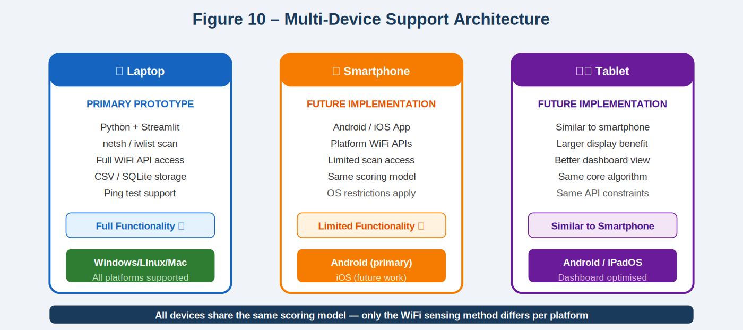
Figure 10 – Multi-Device Architecture: Laptop is the primary prototype with full functionality; Smartphone and Tablet share the same algorithm with different sensing methods

Device | Sensing Method | Implementation Stack | Status
Laptop | netsh (Windows), iwlist (Linux/Mac) | Python + Streamlit/Flask, Pandas, SQLite | PRIMARY PROTOTYPE
Smartphone | Android WifiManager API / iOS (limited) | Android App (Java/Kotlin or Flutter) | Future Implementation
Tablet | Same as smartphone platform | Same codebase, optimised for larger screen | Future Implementation
Table 13 – Device Support Matrix

12. Engineering Constraints and Trade-Off Analysis
The system design must balance multiple engineering constraints simultaneously. The radar diagram below visualises how the design choices perform across six key constraint dimensions, and the trade-off table explains the specific decisions made.
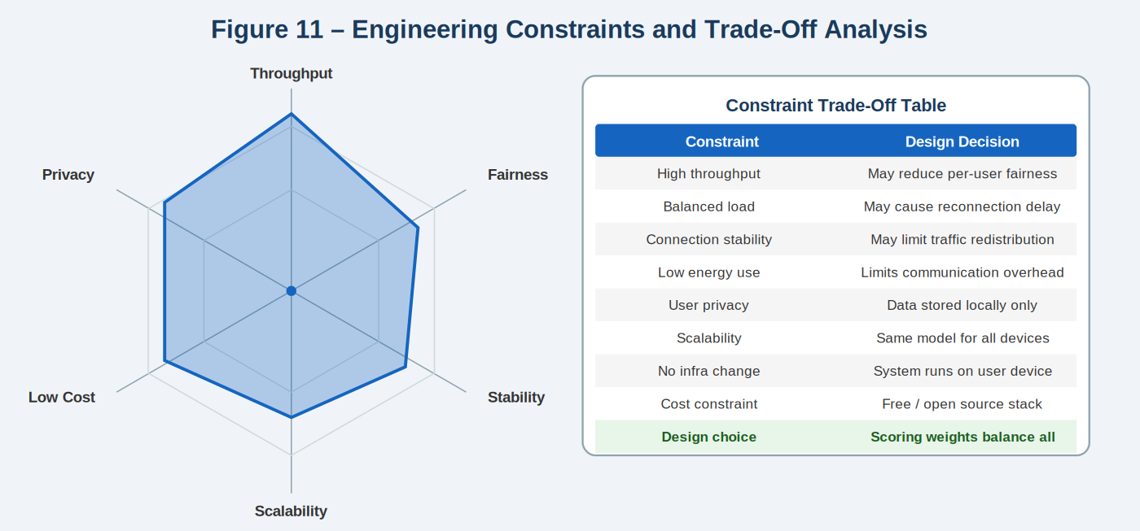
Figure 11 – Engineering Constraint Trade-Off Analysis: radar chart shows the selected design's performance profile across six key engineering dimensions

13. Testing Plan and Validation Strategy
The system will be tested in a real-world environment that simulates the high-density university laboratory scenario. Testing will be conducted in three phases corresponding to different density conditions.

Test Phase | Scenario | Measurement | Expected Outcome
Phase 1 | Low user density (1–5 devices connected) | Score ≥ 75, latency < 30ms, packet loss < 1% | All APs show GOOD status
Phase 2 | High user density (15+ devices on one AP) | Score drops below 50, latency > 100ms | Dashboard shows CONGESTED, recommendation fires
Phase 3 | User moves from overloaded AP towards better AP | Score improves progressively as user moves | Dashboard updates in real-time, confirms improvement
Phase 4 | Multiple APs available simultaneously | System correctly ranks APs by score | Best AP highlighted, recommendation accurate
Table 14 – Testing Plan

14. System Requirements
System requirements define the specific technical behaviours and capabilities the software must deliver to satisfy the user requirements. These are derived directly from the user requirements presented in D1.

ID | System Requirement | Linked User Requirement
SR1 | The system shall scan all visible WiFi APs and return a list within 5 seconds | UR1, UR7
SR2 | The system shall uniquely identify each AP using its BSSID | UR3
SR3 | The system shall measure network latency by performing a ping test | UR2, UR7
SR4 | The system shall calculate packet loss percentage from the ping test results | UR2
SR5 | The system shall compute a quality score (0–100) for each AP using the defined weighted formula | UR2, UR3
SR6 | The system shall classify each AP as GOOD, MODERATE, or CONGESTED | UR2, UR7
SR7 | The system shall display a real-time colour-coded dashboard refreshed every few seconds | UR7
SR8 | The system shall display a recommendation message when a better AP is available | UR2, UR3
SR9 | The system shall store all measurements and scores locally in CSV or SQLite format | UR8
SR10 | The system shall not transmit any data to external servers – all processing is local | UR5, UR8
Table 15 – System Requirements Traced to User Requirements

15. Known Limitations
The following limitations are recognised as inherent constraints of the current design and are documented for transparency:

- The system cannot determine the exact physical location of each access point within the building.
- The system cannot force a device to disconnect from one AP and reconnect to another – this decision remains with the operating system.
- Hidden network load information (the number of users connected to each AP) is not accessible without infrastructure-level access.
- RSSI values are affected by physical obstacles, interference from other devices, and temporary RF reflections, which may introduce measurement variability.
- Mobile operating systems (particularly iOS) impose restrictions on third-party WiFi scanning, which may limit the sensing capability on those platforms.
- The weighted scoring formula uses fixed weights that were selected based on engineering judgment. These weights may be further optimised through real-world testing and machine learning in future work.

16. References
[1] Engineering Council of South Africa (ECSA), Accreditation Standard for Engineering Programmes, 2019.
[2] C. E. Shannon, "A Mathematical Theory of Communication," Bell System Technical Journal, vol. 27, pp. 379–423, 1948.
[3] L. Kleinrock, Queueing Systems Volume 1: Theory. New York: Wiley, 1975.
[4] IEEE 802.11-2020, IEEE Standard for Information Technology – Telecommunications and Information Exchange Between Systems, 2020.
[5] A. Goldsmith, Wireless Communications. Cambridge University Press, 2005.
[6] D. Tse and P. Viswanath, Fundamentals of Wireless Communication. Cambridge University Press, 2005.

