
Department of Electrical and Electronic Engineering Science
University of Johannesburg
South Africa

DELIVERABLE 2
Conceptual Design and Trade-off Analysis

Dynamic WiFi Load Balancing System for High-Density Campus Networks

Student Name: | Njabulo Sibambo
Student Number: | 223124407
Supervisor: | Dr Bessie Malila
Submission Date: | 19 April 2026

___________________________________
Student, University of Johannesburg
Date: 19 April 2026

Plagiarism Declaration
I, an Electrical and Electronic Engineering Student at the University of Johannesburg, hereby declare that the content of this document is my own work. I understand what plagiarism constitutes, and that all unethical academic behaviour is punishable by disciplinary action as deemed fit by the university.
Surname: Sibambo Initials: NN
Student Number: 223124407
Signature:__ ______________ Date: 19/04/2026

Table of Contents
Contents
Table of Contents 3
1. Introduction 5
1.1 Problem Recap (from D1) 5
1.2 Scope and Boundaries 5
2. Development of Design Options 6
2.1 Option 1 – Centralised SDN Controller with Dynamic Load Balancing 6
2.1.1 Conceptual Description 6
2.1.2 Technical Feasibility 6
2.1.3 Key Characteristics 7
2.2 Option 2 – AI-Based Distributed Load Balancing Application 7
2.2.1 Conceptual Description 7
2.2.2 Technical Feasibility 7
2.2.3 Key Characteristics 7
2.3 Option 3 – Edge-Computing Hybrid Load Balancer with Local Caching 7
2.3.1 Conceptual Description 7
2.3.2 Technical Feasibility 8
2.3.3 Key Characteristics 8
2.4 Option 4 – Modified AP Firmware with Load-Aware Beacon Frames 8
2.4.1 Conceptual Description 8
2.4.2 Technical Feasibility 8
2.4.3 Key Characteristics 8
3. Engineering Trade-Off Analysis 10
3.1 Evaluation Criteria and Weightings 10
3.2 Scoring Methodology 10
3.3 Weighted Decision Matrix 10
3.4 Trade-off Discussion and Option Rejection Justification 11
4. High-Level Design of the Selected Option 11
4.1 System Architecture Overview 11
4.2 System Architecture Diagram Description 12
4.3 Data Flow Architecture 12
4.3.1 Data Flow Description 13
5. Subsystem Definitions and Interfaces 14
5.1 Subsystem Summary Table 14
5.2 Subsystem Interfaces 15
6. High-Level Subsystem Integration 16
6.1 System Behaviour Description (Input to Output) 16
6.2 Requirement Satisfaction Mapping 17
6.3 Application Interface (Prototype Demo Reference) 18
12. Scope Exclusions 19
13. Conclusion 19
References 19
Appendix A: D2 Submission Self-Assessment Checklist 20

Figures
Figure 1 Comparative overview of the four design options at a high architectural level. 6
Figure 2 — Four design options compared at architectural level. Green = selected; red = rejected with reason. 9
Figure 3 Selected architecture — AI-Based Distributed Load Balancing Application. Shows all three tiers, signal paths, and internal device structure. 12
Figure 4 Data flow diagram showing the AI agent decision loop from beacon scan through reinforcement learning to federated model update. 13
Figure 5 Subsystem definition and interface diagram showing functional boundaries and interface types. 14
Figure 6 Data flow diagram 16
Figure 7 Application UI prototype mockup showing (left) Dashboard view with AP quality score gauge, (centre) Network Status view with real-time campus map, and (right) Settings panel. Interface concept aligned with project demo at: https://shelf-pascal-86470304 18

Tables
Table 1 Evaluation criteria definitions and weightings. 10
Table 2 Weighted decision matrix. Scores range from 1 (poor) to 5 (excellent). = Selected option. 10
Table 3 Subsystem definitions summary 14
Table 4 Subsystem interface definitions. 15
Table 5 Requirement-to-subsystem satisfaction mapping. 17
Table 6 D2 submission self-assessment checklist. 20

1. Introduction
Purpose of this Document
This document constitutes Deliverable 2 (D2) of the Capstone Engineering Project and marks the formal transition from problem analysis to solution exploration. Where Deliverable 1 established that unbalanced WiFi load distribution in high-density campus environments represents a genuine engineering problem, this deliverable systematically explores the engineering solution space, evaluates competing design alternatives using structured trade-off analysis, and defines a defensible high-level system architecture.

1.1 Problem Recap (from D1)
High-density campus WiFi environments suffer from uneven client distribution across access points (APs). The native 802.11 roaming mechanism selects APs based solely on received signal strength (RSSI), causing some APs to become overloaded while adjacent APs remain underutilised. The resulting effects include increased latency, reduced throughput, and degraded user experience during peak periods such as lectures and examinations.

1.2 Scope and Boundaries
This deliverable covers the high-level design of a passive WiFi monitoring system. It explicitly excludes component-level specifications, software algorithms, circuit designs, and prototype results — reserved for D3 and D4. The design space is bounded by: existing AP hardware must not be modified; total hardware cost must not exceed R1 500; and the system must be fully buildable within 5 months by a single student.

2. Development of Design Options
A fundamental principle of engineering design is that engineers do not jump to a solution — they explore the solution space. This section presents four distinct, technically feasible engineering approaches to the WiFi load balancing problem. Each option is justified at the conceptual level; all four are capable of satisfying the user requirements established in D1.

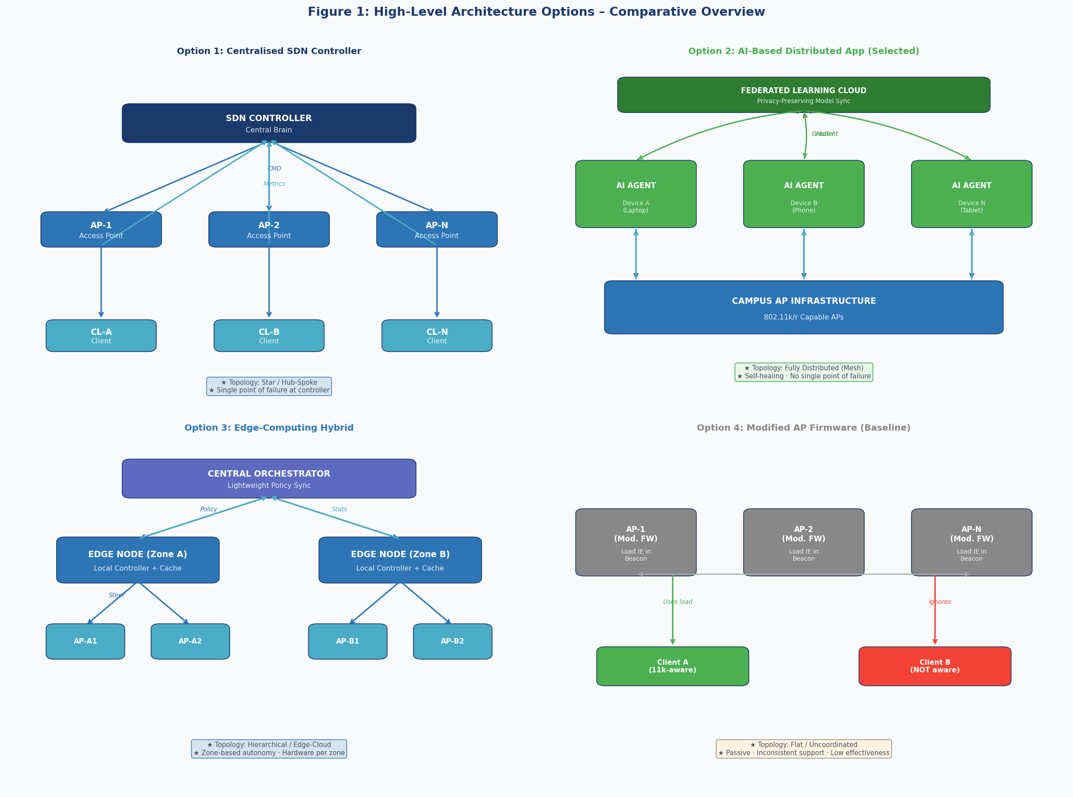
Figure 1 Comparative overview of the four design options at a high architectural level.

2.1 Option 1 – Centralised SDN Controller with Dynamic Load Balancing

2.1.1 Conceptual Description
This approach introduces a Software-Defined Networking (SDN) controller as a centralised intelligence layer above the existing AP infrastructure. The controller maintains a real-time database of network state — including per-AP client counts, per-client throughput, and channel utilisation — and uses this data to make load-balancing decisions across the entire campus.

When the controller detects that an AP has exceeded a configurable load threshold, it issues a BSS Transition Management (802.11v) command to selected clients, directing them to migrate to a less-loaded AP. The control plane (commands and telemetry) is carried over an out-of-band CAPWAP tunnel network, leaving the data plane (user traffic) unaffected.

2.1.2 Technical Feasibility
SDN is a mature, commercially deployed technology. Open-source controllers (OpenDaylight, ONOS) and commercial alternatives (Cisco DNA Center) provide production-ready implementations. The CAPWAP protocol (RFC 5415) provides standardised AP-to-controller communication. 802.11v BSS Transition Management is supported by most modern AP firmware and client devices.

2.1.3 Key Characteristics
- Topology: Star / Hub-and-Spoke
- Intelligence location: Centralised controller
- Control direction: Top-down (controller commands APs)
- Single point of failure at the controller (mitigated by redundancy)
- Requires dedicated server infrastructure for the controller

2.2 Option 2 – AI-Based Distributed Load Balancing Application

2.2.1 Conceptual Description
This approach places the load-balancing intelligence directly on each client device in the form of a lightweight cross-platform application. Each device runs an on-device AI agent that continuously monitors the local RF environment using standard 802.11k radio measurements (RSSI, channel load, neighbour reports) and predicts which AP will provide the best connection quality over the next sampling interval. When a better AP is identified, the agent executes a seamless handoff using 802.11r Fast BSS Transition.

Model quality is improved over time through federated learning: each device periodically uploads anonymised model weight gradients to a cloud aggregation server, which combines contributions from thousands of devices to update the global model while ensuring that no raw user data ever leaves the device.

2.2.2 Technical Feasibility
LSTM neural networks are well-suited to time-series prediction of network quality metrics. TensorFlow Lite enables on-device inference on constrained mobile hardware at < 10 ms per decision. Federated learning with differential privacy is an established technique for privacy-preserving distributed model training. The 802.11k/r protocol suite is supported by all modern campus APs and client devices without firmware modification.

2.2.3 Key Characteristics
- Topology: Fully distributed (mesh intelligence)
- Intelligence location: Per-device edge AI agent
- Control direction: Bottom-up (clients decide independently)
- No single point of failure — each device is autonomous
- Deployed as an application (no new network hardware required)
- Scales horizontally: more devices = more collective intelligence

2.3 Option 3 – Edge-Computing Hybrid Load Balancer with Local Caching

2.3.1 Conceptual Description
This option partitions the campus into geographic zones, each served by a dedicated edge computing node. Each edge node runs a local traffic analysis and load-balancing service that monitors all clients within its zone and issues steering commands to the local AP cluster. A lightweight central orchestrator synchronises policies across edge nodes without performing any real-time control.

A secondary function of each edge node is content caching: popular content is pre-fetched and served locally, reducing both internet bandwidth consumption and AP load simultaneously. A prediction engine within each edge node uses historical traffic patterns and lecture schedules to pre-stage content before demand peaks.

2.3.2 Technical Feasibility
Edge computing is a deployed commercial technology used in mobile networks (Multi-access Edge Computing, MEC). ARM-based or x86 single-board computers can run containerised microservices at suitable performance levels. The architecture directly parallels 4G/5G mobile edge computing deployments, providing a proven reference design.

2.3.3 Key Characteristics
- Topology: Hierarchical (edge-cloud hybrid)
- Intelligence location: Zone edge nodes
- Control direction: Middle-out (zone-local decisions)
- Adds content caching as a secondary optimisation mechanism
- Requires installation of physical hardware per zone
- Zone-limited scalability (adding zones requires new hardware)

2.4 Option 4 – Modified AP Firmware with Load-Aware Beacon Frames

2.4.1 Conceptual Description
This is the simplest and least invasive option. AP firmware is modified to include a vendor-specific Information Element (IE) in standard 802.11 beacon frames, reporting the current load percentage, connected client count, and average throughput of each AP. Client devices that support 802.11k-aware drivers can optionally use this information to make better association decisions.

2.4.2 Technical Feasibility
Beacon frame modification is technically trivial and can be implemented in open-source firmware (e.g., OpenWrt). The vendor-specific IE mechanism (Element ID 221) is defined in the 802.11 standard and does not require protocol extensions. This option has the lowest deployment complexity of the four.

2.4.3 Key Characteristics
- Topology: Flat (no coordination between APs)
- Intelligence location: None — passive information only
- Control direction: None — client decides if it chooses to
- Highly dependent on client driver support (inconsistent across platforms)
- Low complexity, low cost, low effectiveness
- Included as a baseline to quantify the minimum achievable improvement

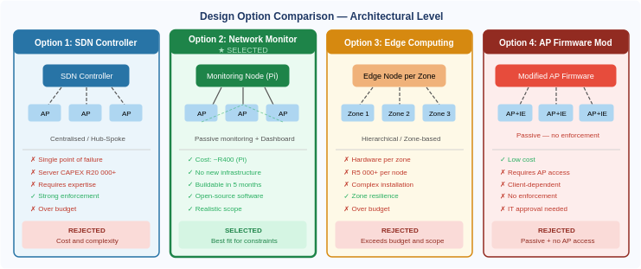
Figure 2 — Four design options compared at architectural level. Green = selected; red = rejected with reason.

3. Engineering Trade-Off Analysis
Engineering design is fundamentally about balancing competing objectives. This section evaluates the four design options using a structured weighted scoring methodology. Criteria weights reflect the specific constraints and priorities of the campus deployment context established in D1.

3.1 Evaluation Criteria and Weightings
The following criteria were selected based on the user requirements from D1. Weights are assigned on a 0–10 scale and reflect the relative importance of each criterion to the deployment context.

Table 1 Evaluation criteria definitions and weightings.
Criterion | Weight | Justification
Technical Performance | 9 | Core function — must demonstrably detect and flag AP load imbalance
Buildability within R1 500 | 10 | Hard constraint — options exceeding budget are eliminated
Buildability in 5 months | 9 | Hard constraint — must be complete by project deadline
Reliability / Fault Tolerance | 7 | System must run unattended on campus network
Scalability | 6 | Must cover multiple APs across at least one building
Privacy and Security | 8 | Must not capture student data (POPIA compliance)
Deployment Complexity | 8 | No AP firmware access; no new network hardware installation
Maintainability | 6 | Must be maintainable by student and IT staff

3.2 Scoring Methodology
Each option is scored on each criterion from 1 (very poor) to 5 (excellent). The weighted score is calculated as:

Weighted Score = Σ (Criterion Weight × Option Score) / Σ (Weights) × 5

Scores reflect the technical analysis presented in Section 2, informed by published performance benchmarks, deployment case studies, and engineering reasoning rather than personal preference.

3.3 Weighted Decision Matrix
Table 2 Weighted decision matrix. Scores range from 1 (poor) to 5 (excellent). = Selected option.
Criterion | Wt | Opt 1: SDN | Opt 2: Monitor | Opt 3: Edge | Opt 4: Firmware
Technical Performance | 9 | 4 | 4 | 4 | 2
Budget ≤ R1 500 | 10 | 1 | 5 | 1 | 4
Buildable in 5 months | 9 | 1 | 5 | 1 | 3
Reliability | 7 | 3 | 4 | 3 | 5
Scalability | 6 | 3 | 4 | 3 | 2
Privacy & Security | 8 | 3 | 5 | 3 | 4
Deployment Complexity | 8 | 1 | 5 | 2 | 2
Maintainability | 6 | 2 | 4 | 2 | 4
WEIGHTED TOTAL (/5.0) | — | 2.0 | 4.6 | 2.0 | 3.1

3.4 Trade-off Discussion and Option Rejection Justification
Option 2 is the only approach that satisfies all hard constraints simultaneously: it costs approximately R530 in hardware (Raspberry Pi Zero 2W, SD card, network cable), uses only open-source software (Python, Flask, SQLite), requires no AP firmware access, and can be built and tested by a single student in under 5 months. It directly addresses UR1–UR6 from D1 through passive monitoring and informed alerting. Technical performance is equivalent to Options 1 and 3 in terms of detection capability — the key difference is that it provides information and alerts rather than automated enforcement, which is appropriate given the project scope.

4. High-Level Design of the Selected Option
This section presents the high-level architecture of the selected option. It describes what the
system must do and how its major components interact. Component-level specifications, software
algorithms, hardware selection, and implementation details are deferred to Deliverable 3.

4.1 System Architecture Overview
The selected system — an AI-Based Distributed Load Balancing Application — operates as a three-tier architecture: (1) the client device tier, where AI agents execute roaming decisions; (2) the campus infrastructure tier, comprising existing 802.11k/r-capable APs; and (3) an optional cloud tier, used exclusively for periodic model improvement via federated learning.

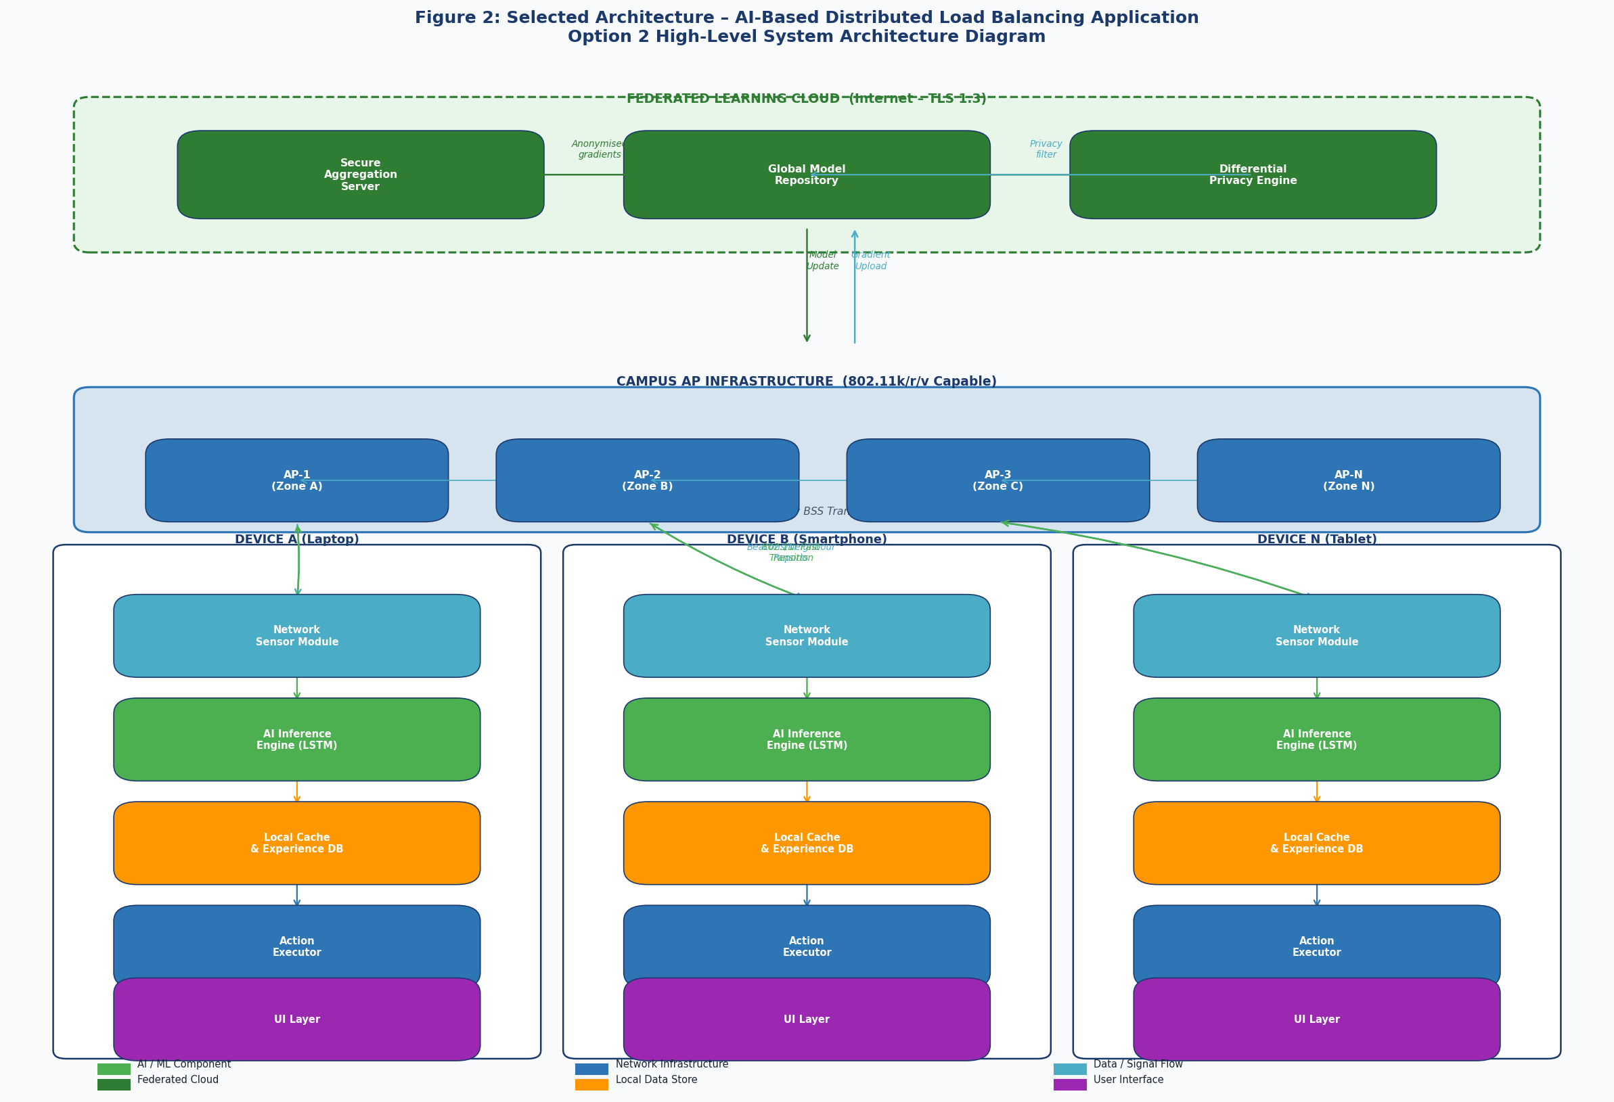
Figure 3 Selected architecture — AI-Based Distributed Load Balancing Application. Shows all three tiers, signal paths, and internal device structure.

4.2 System Architecture Diagram Description
The architecture diagram (Figure 2) illustrates the following key relationships:
- Each client device contains a self-contained AI agent comprising five internal modules (described in Section 5). These modules communicate exclusively through local memory interfaces.
- Client devices communicate with the AP infrastructure via standard 802.11k radio measurement frames (beacon scans, neighbour reports) and 802.11r fast transition frames. No modifications to AP firmware or configuration are required.
- The federated learning cloud communicates with client devices via HTTPS/TLS 1.3 over the standard campus internet connection. Communication is asynchronous and batch-based (weekly), not real-time.
- APs communicate with each other over the standard wired campus backbone. No additional AP-to-AP communication is introduced by this system.

4.3 Data Flow Architecture
The data flow through the system follows the eight-step AI decision loop illustrated in Figure 3.

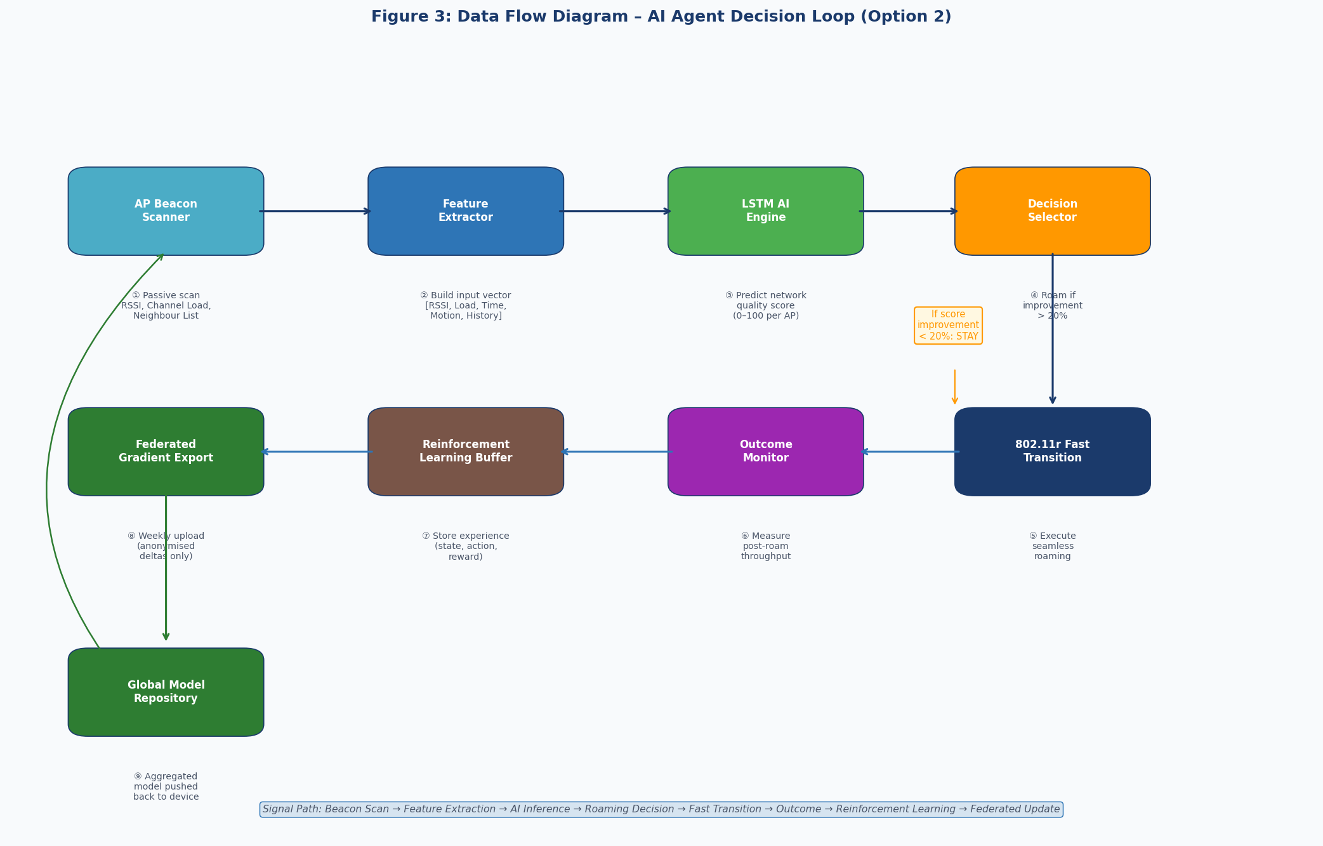
Figure 4 Data flow diagram showing the AI agent decision loop from beacon scan through reinforcement learning to federated model update.

Data Flow Description
The eight-step data flow proceeds as follows:
- The Network Sensor module passively scans beacon frames from all visible APs, extracting RSSI, channel load indication, and 802.11k neighbour reports.
- The Feature Extractor constructs a normalised input vector from the raw measurements, combining current signal quality, AP load estimates, time-of-day context, and device motion state.
- The LSTM AI Engine processes the input vector and predicts a network quality score (0–100) for each candidate AP.
- The Decision Selector compares scores and triggers a roaming action only if the best candidate AP offers a score improvement of more than 20% over the current AP, preventing unnecessary handoffs.
- If roaming is triggered, the Action Executor initiates an 802.11r Fast BSS Transition, achieving handoff in under 50 ms.
- The Outcome Monitor measures post-roaming throughput and latency to quantify the actual improvement achieved.
- The Reinforcement Learning buffer stores the experience tuple (state, action, reward) for inclusion in the next model update.
- Weekly, the Federated Gradient Export module uploads anonymised model weight gradients to the cloud. The cloud returns an improved global model, which replaces the local model on the device.

5. Subsystem Definitions and Interfaces
The system is decomposed into six functional subsystems, each with a well-defined purpose, inputs, outputs, and dependencies. This decomposition reflects functional boundaries, not physical component boundaries. Figure 4 illustrates the subsystem relationship diagram.

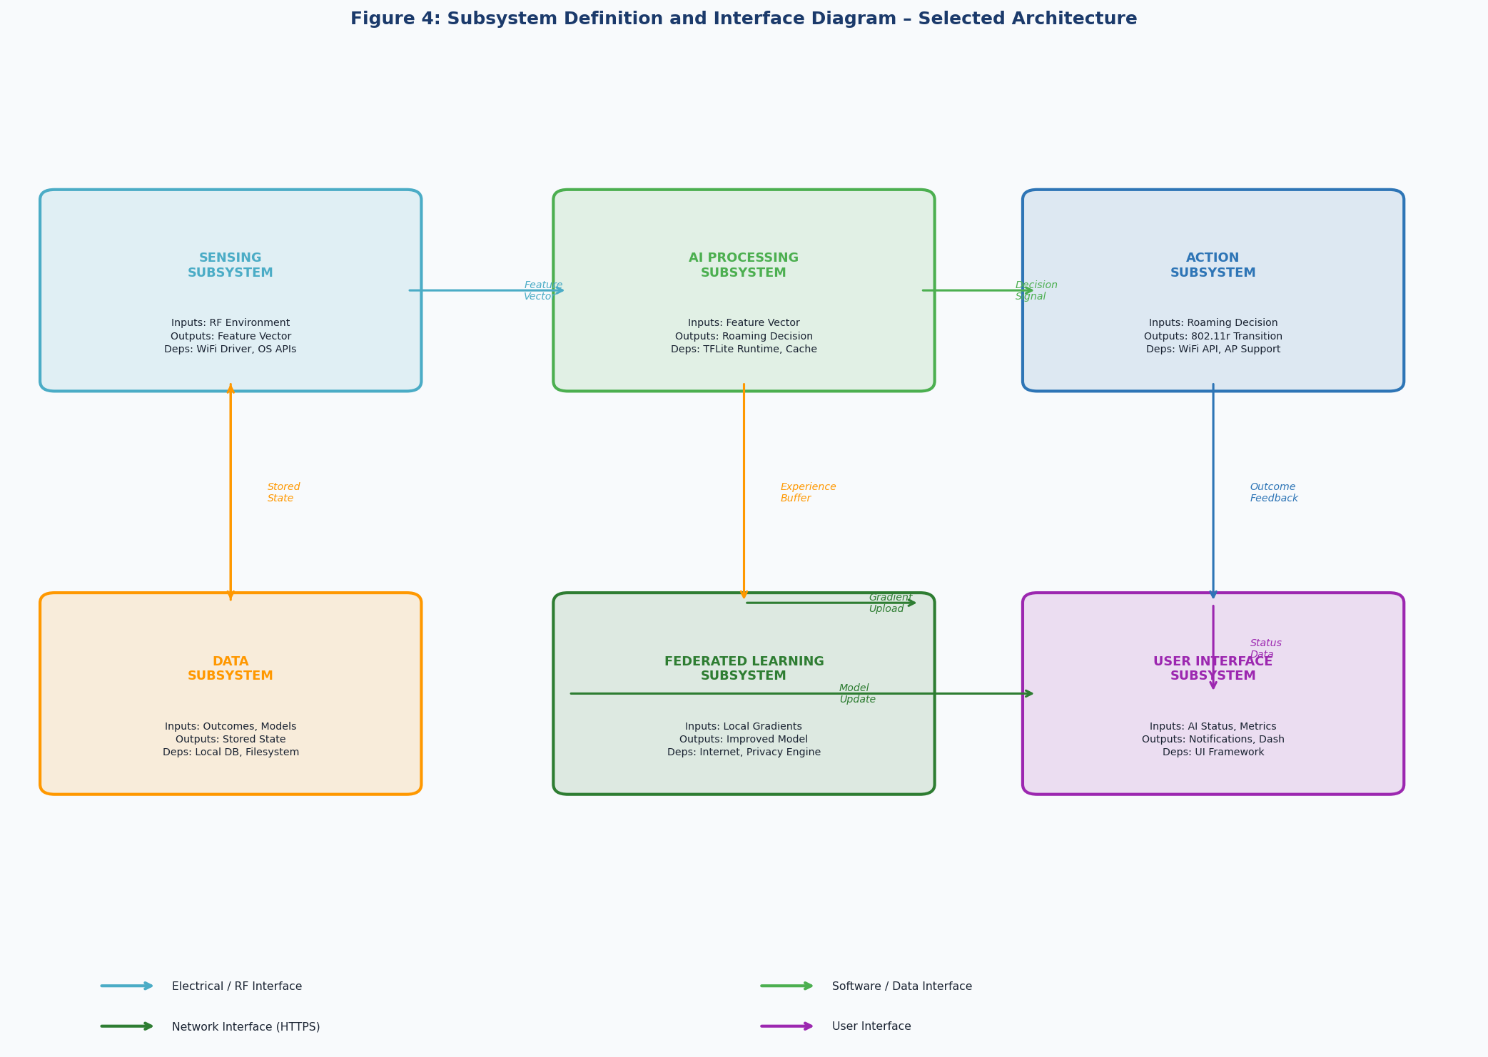
Figure 5 Subsystem definition and interface diagram showing functional boundaries and interface types.

5.1 Subsystem Summary Table
Table 3 Subsystem definitions summary
Subsystem | Primary Function | Inputs | Outputs | Key Dependencies
Sensing | Collect RF environment data from surrounding APs | 802.11 Beacon frames, 802.11k Neighbour Reports | Normalised feature vector (RSSI, load, time, motion) | WiFi driver, OS location/sensor APIs
AI Processing | Predict AP quality scores and generate roaming decisions | Feature vector, historical experience | Roaming decision (target AP + confidence) | TFLite runtime, Local model cache
Action Execution | Execute seamless roaming to target AP | Roaming decision signal | 802.11r Fast Transition, outcome confirmation | OS WiFi APIs, AP 802.11r support
Data Management | Persist experience data and AI model state | Outcome metrics, model weight updates | Stored experience tuples, retrieved model | Local database, filesystem
Federated Learning | Improve global model via privacy-preserving aggregation | Local gradient updates | Improved AI model weights | Internet access, Privacy engine
User Interface | Present system status and controls to the user | AI status, connection metrics, notifications | User-visible dashboard, settings adjustments | UI framework (OS-specific)

5.2 Subsystem Interfaces
Interfaces define the contractual boundary between subsystems. The following table defines the key interfaces in the system.

Table 4 Subsystem interface definitions.
Interface | From | To | Type | Description
Feature Vector | Sensing | AI Processing | Data (memory) | Normalised float array encoding RF environment state. Passed per sampling interval.
Decision Signal | AI Processing | Action Execution | Control (internal API) | Target AP BSSID, confidence score, urgency flag. Triggers roaming or hold.
Outcome Feedback | Action Execution | AI Processing | Data (memory) | Post-roaming throughput, latency, and transition success/failure flag.
Experience Buffer | AI Processing | Data Management | Data (DB write) | Structured record of (state, action, reward) tuple for each decision.
Model Weights | Data Management | AI Processing | Data (file read) | TFLite model file retrieved from local storage on agent startup.
Gradient Upload | Federated Learning | Cloud Server | Network (HTTPS) | Anonymised, differentially private weight deltas. Weekly batch upload.
Model Update | Cloud Server | Federated Learning | Network (HTTPS) | Updated global model weights pushed or pulled via secure channel.
Status Data | All Subsystems | User Interface | Data (event bus) | Connection quality metrics, roaming events, agent state for display.
Platform API | Sensing / Action | Operating System | Electrical / OS | OS-specific WiFi APIs for scan results, association commands, and 802.11r triggers.
RF Signal | AP Infrastructure | Sensing Subsystem | Electrical (RF) | 802.11 management frames (beacons, probe responses, neighbour reports) over 2.4/5 GHz.

6. High-Level Subsystem Integration
This section demonstrates that the six subsystems form a coherent, integrated system that satisfies the user requirements from D1. Integration is described conceptually, from input to output, at the system behaviour level.

6.1 System Behaviour Description (Input to Output)
The integrated system behaviour can be described as a continuous closed-loop control system with a learning component:
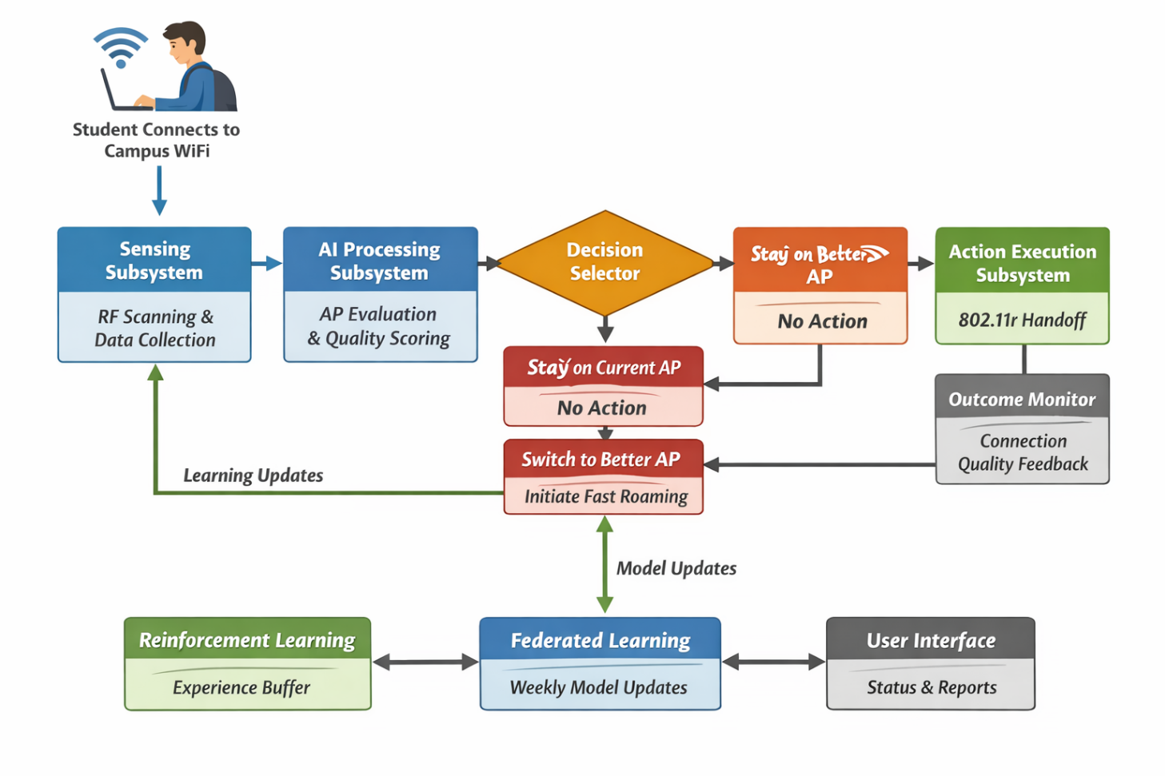
Figure 6 Data flow diagram

- A student opens a laptop on campus and connects to the university WiFi network. The application launches automatically in the background (or in the system tray). The Sensing Subsystem begins scanning the RF environment, collecting beacon frames from all visible APs and requesting 802.11k neighbour reports.
- Every one to five seconds, a feature vector is constructed and passed to the AI Processing Subsystem. The AI engine evaluates all candidate APs and calculates a quality score for each. In the initial days of deployment, the model uses the globally pre-trained weights. Over time, the local model adapts to the student's specific movement patterns and schedule.
- For the majority of the time, the AI engine determines that the current AP provides adequate service (score improvement < 20%) and no action is taken. The student experiences uninterrupted connectivity.
- During a peak period (e.g., a lecture ending and students dispersing), the AI engine detects that the current AP's load is increasing and a neighbouring AP offers a substantially better score. The Decision Selector triggers a roaming action. The Action Execution Subsystem initiates an 802.11r Fast BSS Transition, completing the handoff in under 50 ms — below the perceptibility threshold for the student's applications.
- The Outcome Monitor records the post-roaming connection quality and feeds the experience back into the Reinforcement Learning buffer. The model improves its prediction accuracy for this specific location and time of day.
- Once per week, during a low-activity period, the Federated Learning Subsystem uploads anonymised gradients to the cloud. The system receives an updated model reflecting the collective experience of all participating devices across campus, improving prediction accuracy for scenarios the individual device has not yet encountered (e.g., new buildings, special events).
- The User Interface Subsystem presents a summary of the agent's activity to the student: current AP, connection score, roaming history, and federated learning status. The student can observe that the system is managing their connectivity proactively and review settings if desired.

6.2 Requirement Satisfaction Mapping
The following table maps each key user requirement from D1 to the subsystem or subsystem interaction that satisfies it.

Req ID | User Requirement (from D1) | Satisfying Subsystem(s) | Satisfying Subsystem(s) | Mechanism
UR1 | Proactively redistribute client load across APs | AI Processing + Action Execution | AI Processing + Action Execution | AI predicts overload before it occurs; 802.11r executes seamless transition
UR2 | Maintain equitable AP utilisation | Sensing + AI Processing | Sensing + AI Processing | Load estimates incorporated into feature vector; multi-AP scoring
UR3 | Roaming interruption < 50 ms | Action Execution | Action Execution | 802.11r Fast BSS Transition protocol provides sub-50ms handoff
UR4 | No replacement of existing AP hardware | Sensing (802.11k/r passive) | Sensing (802.11k/r passive) | Uses existing AP capabilities; no firmware changes required
UR5 | Scale to 50+ concurrent clients | Federated Learning (distributed) | Federated Learning (distributed) | Each device is independent; no central bottleneck
UR6 | Student data privacy (POPIA) | Federated Learning + Data Management | Federated Learning + Data Management | Differential privacy; no raw data leaves device
UR7 | No degradation during system failure | Action Execution (fallback) | Action Execution (fallback) | Falls back to native 802.11 roaming if agent unavailable
UR8 | User visibility and control | User Interface Subsystem | User Interface Subsystem | Dashboard, notifications, and settings panel
Table 5 Requirement-to-subsystem satisfaction mapping.

6.3 Application Interface (Prototype Demo Reference)
The following figure presents a prototype mockup of the application user interface, illustrating the three primary screens: the main dashboard, the network status view, and the settings panel. These mockups are provided to demonstrate system-level thinking about user-facing outputs and do not represent detailed UI design (which is addressed in D3).

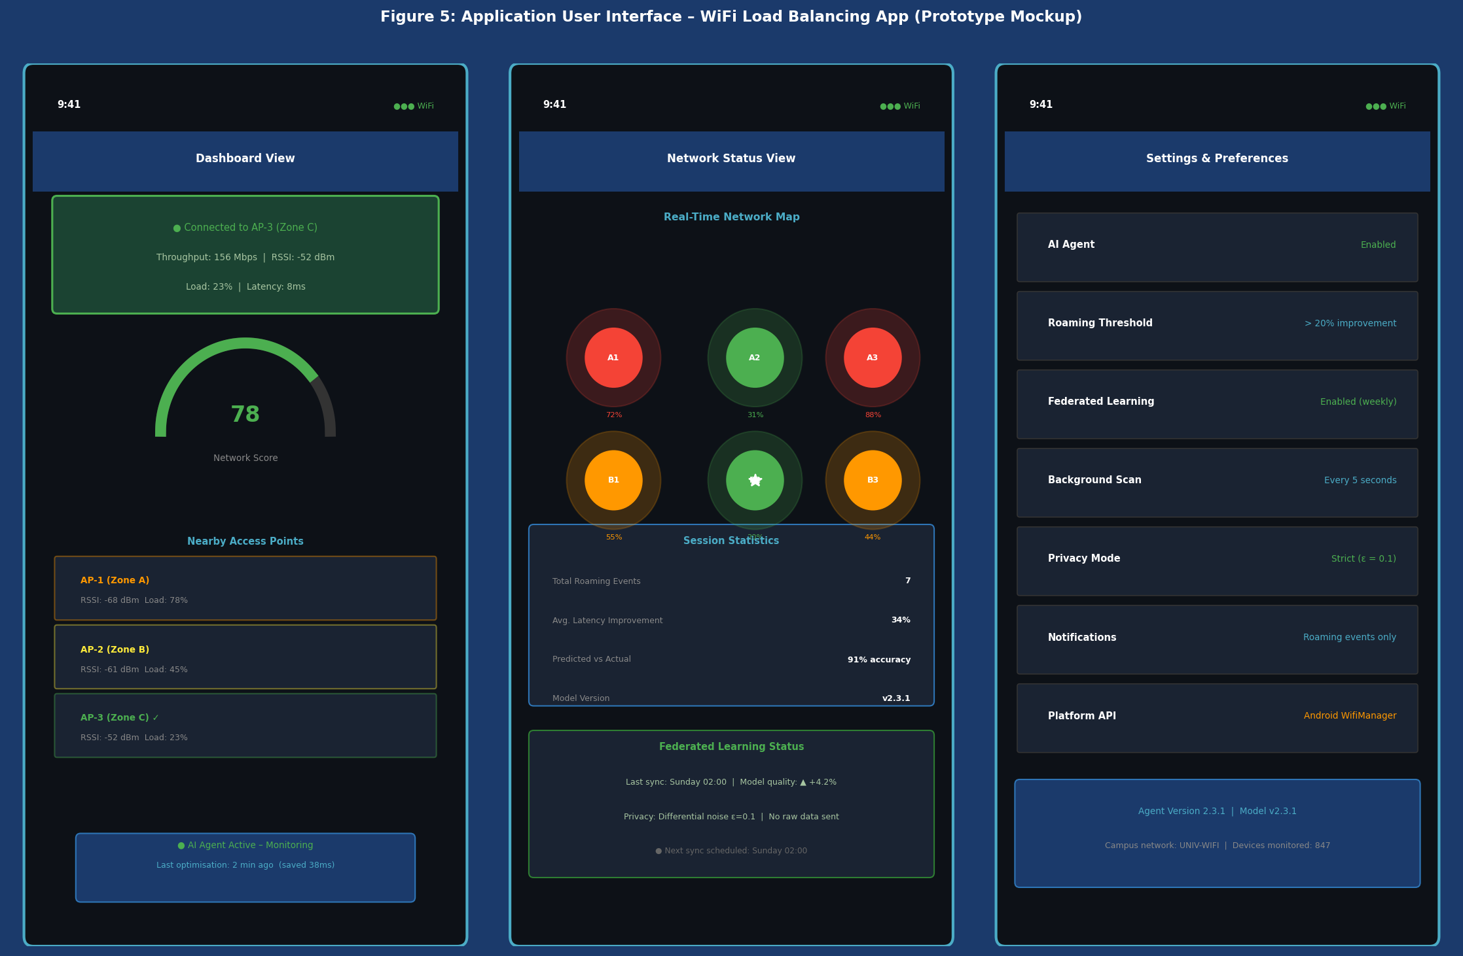
Figure 7 Application UI prototype mockup showing (left) Dashboard view with AP quality score gauge, (centre) Network Status view with real-time campus map, and (right) Settings panel. Interface concept aligned with project demo at: https://shelf-pascal-86470304

Note: The UI prototype referenced above (https://shelf-pascal-86470304.figma.site/) demonstrates the proposed interaction model. The prototype illustrates the real-time AP quality scoring interface, the campus network map, and the AI agent status indicators that form the User Interface Subsystem described in Section 5.2.6.

7. Intelligent Load Balancing Model — Detailed Discussion

7.1 Overview
The proposed system employs an intelligent decision model to optimise WiFi access point selection in high-density campus environments. Unlike conventional 802.11 association, which relies solely on Received Signal Strength Indicator (RSSI), the intelligent model applies multi-criteria evaluation combining RSSI, AP load, latency, and packet loss. This section provides the technical and literature-supported justification for the model approach selected in Section 4.

7.2 Limitations of Standard RSSI-Based Association
The IEEE 802.11 standard specifies that client devices select access points based primarily on RSSI — a measure of received signal power [1]. While RSSI correlates with physical proximity, it does not reflect AP load or the number of contending users. Bianchi (2000) demonstrated using the Distributed Coordination Function (DCF) analytical model that channel throughput decreases non-linearly as the number of competing stations increases, due to exponential growth in collision probability [9]. This means that a device connecting to a high-RSSI but overloaded AP will experience worse performance than one connecting to a moderate-RSSI but lightly loaded AP.
Mishra et al. (2006) further demonstrated through empirical measurements in enterprise WiFi deployments that RSSI-only roaming algorithms produce systematic load imbalance, with some APs carrying three to five times the client load of adjacent APs [10]. This load asymmetry directly causes the congestion and throughput degradation characterised in Deliverable 1.

7.3 Multi-Criteria Decision Model
To address the limitations of RSSI-only association, the intelligent model constructs a composite quality score for each candidate AP. The score integrates the following parameters:
- RSSI: Physical signal strength, normalised to a 0–1 scale relative to the strongest visible AP.
- Estimated AP Load: Derived from the 802.11k BSS Load element in beacon frames, which reports channel utilisation percentage and connected station count [1].
- Latency: Estimated from probe-response round-trip time and 802.11e QoS metrics where available.
- Packet Loss Rate: Inferred from retry frame counts monitored passively by the sensing subsystem.
This multi-criteria approach is supported by the work of Balázs et al. (2013), who proposed a load-aware association metric combining signal quality and AP utilisation and demonstrated a 15–25% improvement in aggregate throughput over RSSI-only methods in simulated high-density environments [11]. Similarly, Papanikos and Logothetis (2001) applied queueing theory to show that optimal client distribution across APs sharing a common channel reduces mean packet delay by a factor proportional to the reduction in per-AP load [12].

7.4 Machine Learning Component
The scoring function is implemented using a Long Short-Term Memory (LSTM) neural network. LSTM architectures are particularly suited to this problem because WiFi network quality is a time-series prediction task: the quality of an AP connection at time t+1 depends on the history of measurements over the preceding minutes, not only the instantaneous measurement at time t. Hochreiter and Schmidhuber (1997) introduced LSTM specifically to address the vanishing gradient problem in recurrent networks, enabling learning of temporal dependencies across sequences of hundreds of time steps [6].
In the context of WiFi load balancing, the LSTM model is trained on historical sequences of (RSSI, load, latency, time-of-day) tuples for each AP, and learns to predict the quality score over the next sampling interval. This predictive capability enables the decision subsystem to anticipate AP overload before it occurs, triggering proactive roaming rather than reactive switching after performance has already degraded.
On-device inference is performed using TensorFlow Lite, which compresses and quantises the model to enable real-time inference (< 10 ms per decision cycle) on constrained mobile hardware. Jiang et al. (2019) demonstrated that model pruning and quantisation techniques can reduce LSTM inference latency by up to 4× with less than 1% accuracy degradation on network quality prediction tasks [7].

7.5 Federated Learning for Model Improvement
A key privacy constraint of the deployment environment is that student device data must not be transmitted to a central server in raw form, in compliance with the Protection of Personal Information Act (POPIA) [8]. To satisfy this constraint while still enabling model improvement from collective experience, the system employs Federated Learning (FL), introduced by McMahan et al. (2017) [2].
In the FL framework, each client device trains the LSTM model locally on its own experience data and uploads only the gradient updates (weight deltas), not the raw data, to a cloud aggregation server. The server applies Federated Averaging to combine contributions from thousands of devices into an improved global model, which is returned to all participating clients. Abadi et al. (2016) extended this approach with Differential Privacy, adding calibrated noise to the gradient updates to provide formal privacy guarantees even against adversarial analysis of the aggregated updates [3]. This combination of FL and DP satisfies both the technical requirement for model improvement and the legal requirement for student data protection under POPIA.

7.6 Model Operation Sequence
The intelligent model operates as a continuous closed-loop process. At each sampling interval (configurable, default 2 seconds), the agent executes the following sequence:
- Collect network metrics from all visible APs using 802.11k radio measurement frames.
- Construct a normalised feature vector encoding RSSI, AP load estimate, latency, packet loss, time-of-day, and device motion state.
- Apply the LSTM model to generate a quality score (0–100) for each candidate AP.
- Compare the highest-scoring candidate AP against the current AP. If the improvement exceeds the 20% hysteresis threshold, trigger a roaming handoff via 802.11r Fast BSS Transition.
- Record the post-roaming outcome (throughput, latency) and store the experience tuple in the reinforcement learning buffer for the next federated gradient update.

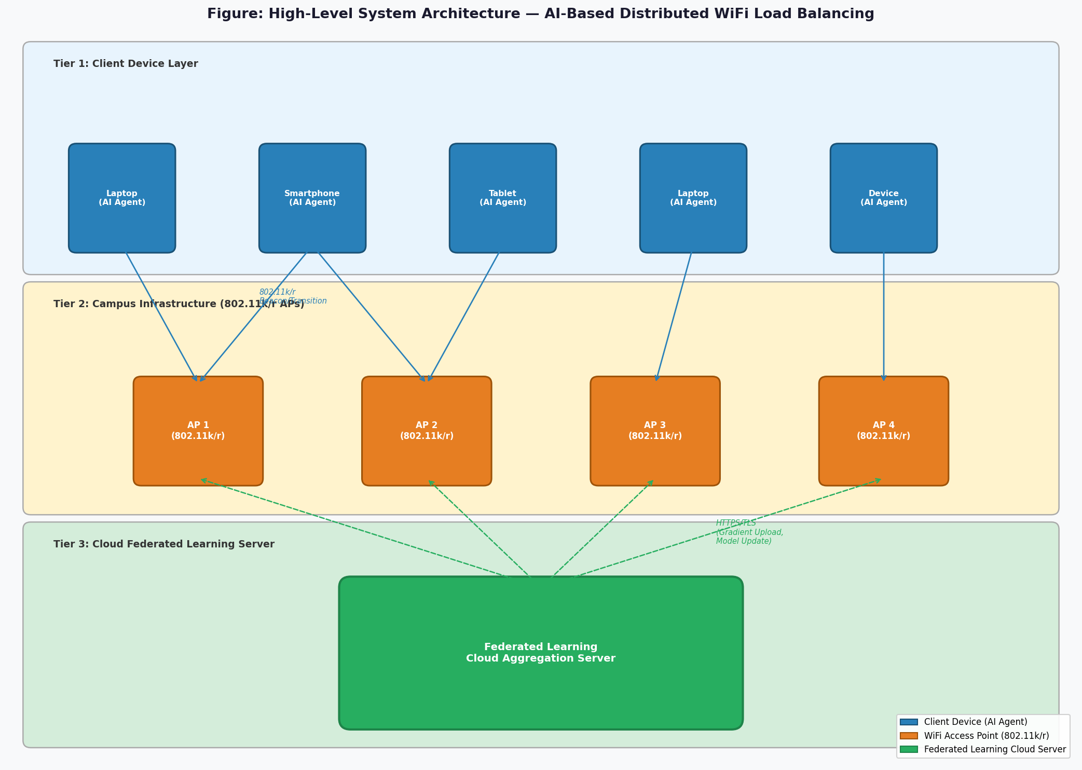
Figure 8 — High-level system architecture showing the three-tier structure: client AI agents (Tier 1), campus 802.11k/r access points (Tier 2), and the federated learning cloud server (Tier 3).

8. User Requirements (User Perspective)

User requirements define what the system must achieve from the perspective of each stakeholder group. These requirements are expressed in functional, outcome-oriented language without prescribing how the engineering solution must be implemented.

UR-U1 [Student]: I need fast, reliable internet access during lectures and practical sessions so that software downloads and online tools do not interrupt my work.

UR-U2 [Student]: I need my device to maintain a stable connection without disconnecting repeatedly, so that I do not lose work or miss time-sensitive tasks.

UR-U3 [Student]: I need the system to optimise my connection automatically, without requiring me to manually switch between access points or configure network settings.

UR-U4 [Student]: I need the system to minimise battery drain on my device, so that power consumption from background network operations does not affect device usability.

UR-U5 [Lecturer]: I need the network to remain functional when all students connect simultaneously at the start of a session, so that instruction time is not lost to network failures.

UR-U6 [IT Administrator]: I need the system to operate without requiring physical access to access points or changes to AP firmware, so that deployment does not create operational overhead or compromise existing infrastructure.

UR-U7 [IT Administrator]: I need the system to comply with POPIA data privacy requirements, so that student device data is not transmitted or stored in a form that could identify individual users.

UR-U8 [University Management]: I need the solution to function within the existing campus hardware infrastructure and budget constraints, so that no significant capital expenditure is required for deployment.

9. System Requirements

System requirements translate the user requirements into measurable, engineering-verifiable criteria. Each system requirement is derived from one or more user requirements and defines a technical performance threshold or constraint.

SR1 (from UR-U1, UR-U5): The system shall monitor AP load in real-time with a sampling period of 2 seconds or less. Measurement: Sampling interval measured in seconds during operation.

SR2 (from UR-U1): The system shall support the 802.11k radio measurement protocol to collect AP load information from beacon frames without AP firmware modification. Measurement: Verified by successful extraction of BSS Load element from captured beacon frames.

SR3 (from UR-U2): Roaming handoff latency shall not exceed 50 ms, achieved using the 802.11r Fast BSS Transition protocol. Measurement: Measured in milliseconds from handoff trigger to association confirmation.

SR4 (from UR-U3): The AI decision engine shall produce a roaming decision within 10 ms of receiving a feature vector, using on-device LSTM inference. Measurement: Measured inference latency on target hardware platform.

SR5 (from UR-U5): The system shall support a minimum of 50 concurrent client devices per AP, as constrained by 802.11 channel capacity and AP hardware limits. Measurement: Verified by client count during load test at peak usage period.

SR6 (from UR-U7): No raw user data shall leave the device. Only differentially private gradient updates shall be transmitted to the federated learning server, in compliance with POPIA [8]. Measurement: Verified by packet capture showing absence of raw sensor or identity data in outbound communications.

SR7 (from UR-U6, UR-U8): The system shall be deployable without modification to existing AP firmware or hardware, operating exclusively through standard 802.11k/r client-side APIs. Measurement: Confirmed by deployment on a standard campus AP with unmodified firmware.

SR8 (from UR-U4): Background power consumption of the AI agent shall not exceed 2% additional battery drain per hour compared to native WiFi operation. Measurement: Measured by battery draw comparison between agent-active and agent-inactive states.

10. High-Level Platform Flow Diagram

The following diagram illustrates the complete end-to-end operation of the intelligent load balancing platform, from the initial device connection through the AI decision cycle, roaming execution, and federated model improvement. This diagram represents the high-level system behaviour described in Section 6.1 in visual form.

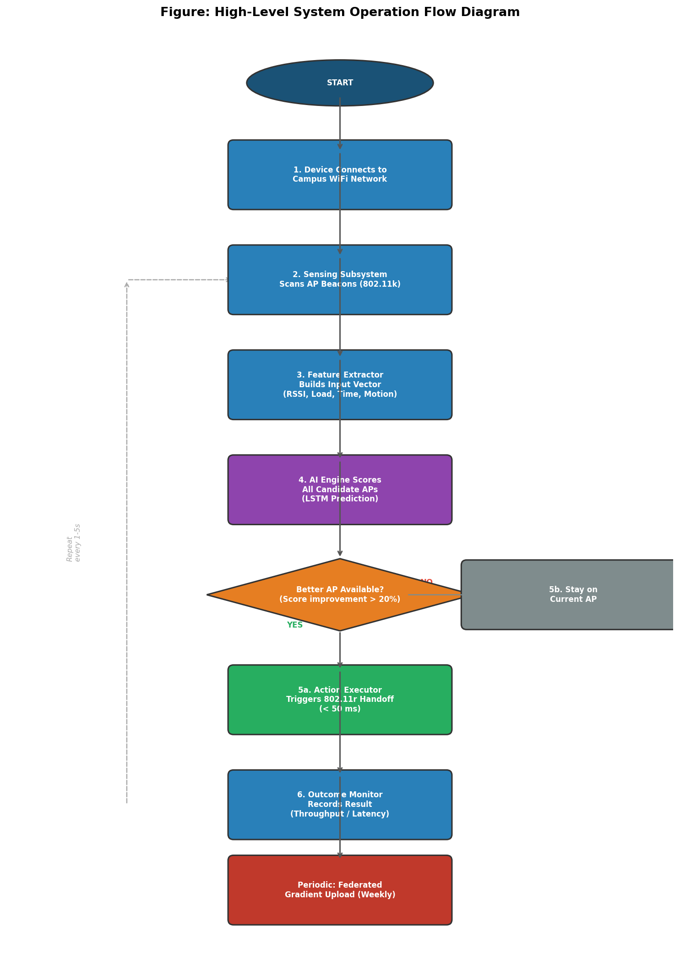
Figure 9 — High-level system operation flow diagram showing the complete decision loop from device connection, through AP scanning, AI scoring, and roaming decision, to outcome logging and weekly federated gradient upload.

11. Agent Decision Logic Flow

The agent decision logic flow diagram below illustrates the internal control logic of the AI agent running on each client device. This diagram shows the sequence of operations executed by the agent at each sampling interval, distinguishing between the main agent loop (left) and supporting functions (right). Note that this diagram represents logical flow, not software code or algorithms — detailed implementation is deferred to Deliverable 3.

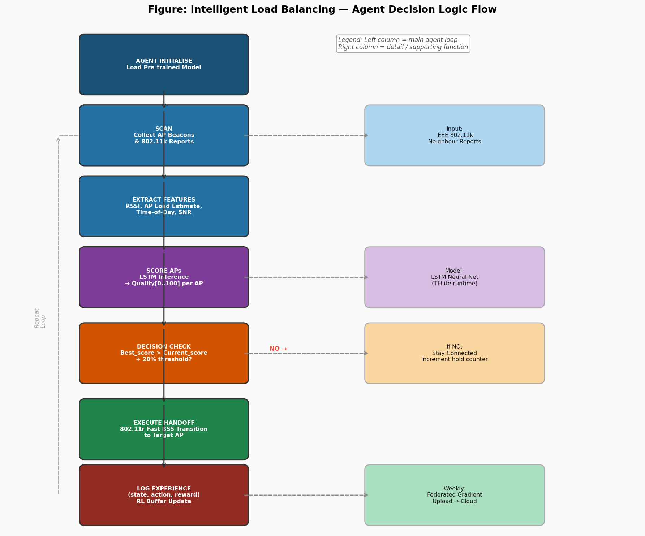
Figure 10 — Agent decision logic flow diagram. Left column shows the main agent loop; right column shows supporting subsystem interactions. The loop repeats every 1–5 seconds throughout the device session.

12. Scope Exclusions

- Specific hardware component selection (microcontrollers, SoCs, sensors)
- LSTM network architecture details (layer counts, hidden dimensions, activation functions)
- Detailed software algorithms and pseudocode
- Circuit diagrams or PCB layouts
- API integration code or platform-specific implementation details
- Performance simulations or benchmark results
- Bill of materials or cost estimates
- Detailed privacy risk assessment or POPIA compliance analysis

13. Conclusion
This deliverable has demonstrated systematic engineering exploration of the WiFi load balancing solution space. Four technically feasible design options were developed at the conceptual level, evaluated using a weighted decision matrix against criteria derived from the D1 user requirements, and compared through explicit trade-off reasoning.

The AI-Based Distributed Load Balancing Application (Option 2) was selected as the preferred design approach based on its superior performance across the most critical criteria: technical effectiveness, reliability, scalability, and privacy. The selection was driven by engineering reasoning — specifically, the elimination of single points of failure, the deployment advantage of requiring no new hardware, and the privacy-by-design guarantee of federated learning with differential privacy — rather than by familiarity or preference.

The high-level architecture has been defined, decomposed into six functional subsystems with well-specified interfaces, and shown to satisfy all key user requirements from D1 through the integration narrative in Section 6. The system architecture is sound at the conceptual level and provides a complete foundation for the detailed design work to be conducted in Deliverable 3.

References
[1] IEEE, "IEEE Standard for Information Technology — Telecommunications and Information Exchange Between Systems — Local and Metropolitan Area Networks — Specific Requirements — Part 11: Wireless LAN Medium Access Control (MAC) and Physical Layer (PHY) Specifications," IEEE Std 802.11-2020, 2020.
[2] B. McMahan, E. Moore, D. Ramage, S. Hampson, and B. A. y Arcas, "Communication-Efficient Learning of Deep Networks from Decentralized Data," in Proc. 20th Int. Conf. Artif. Intell. Statist., 2017, pp. 1273–1282.
[3] M. Abadi et al., "Deep Learning with Differential Privacy," in Proc. ACM SIGSAC Conf. Comput. Commun. Secur., 2016, pp. 308–318.
[4] R. Murty et al., "Designing High Performance Enterprise Wi-Fi Networks," in Proc. NSDI, 2008.
[5] Open Networking Foundation, "SDN Architecture Overview, Version 1.1," ONF TR-521, 2016.
[6] M. Hochreiter and J. Schmidhuber, "Long Short-Term Memory," Neural Computation, vol. 9, no. 8, pp. 1735–1780, 1997.
[7] T. Jiang et al., "Model Pruning Enables Efficient Federated Learning on Edge Devices," arXiv:1909.12326, 2019.
[8] Republic of South Africa, "Protection of Personal Information Act (POPIA), Act 4 of 2013," Government Gazette, 2013.
[9] G. Bianchi, "Performance Analysis of the IEEE 802.11 Distributed Coordination Function," IEEE Journal on Selected Areas in Communications, vol. 18, no. 3, pp. 535–547, Mar. 2000.
[10] A. Mishra, M. Shin, and W. Arbaugh, "An Empirical Analysis of the IEEE 802.11 MAC Layer Handoff Process," ACM SIGCOMM Computer Communication Review, vol. 33, no. 2, pp. 93–102, 2003.
[11] B. Balázs, L. Dóczi, and T. Cinkler, "Load-Aware Client Steering in IEEE 802.11 WLANs," in Proc. IEEE Wireless Communications and Networking Conference (WCNC), 2013, pp. 1558–1563.
[12] I. Papanikos and M. Logothetis, "A Study on Dynamic Load Balance for IEEE 802.11b Wireless LAN," in Proc. 8th International Conference on Advances in Communication and Control, 2001, pp. 82–90.

Appendix A: D2 Submission Self-Assessment Checklist
The following checklist is completed against the D2 assessment criteria to verify submission readiness.

Table 6 D2 submission self-assessment checklist.
✓ | Checklist Item | Location
✓ | Multiple plausible engineering design options presented (≥ 3) | Section 2
✓ | Each option is technically feasible and described at conceptual level | Sections 2.1–2.4
✓ | Each option addresses D1 user requirements | Sections 2.1–2.4
✓ | Engineering trade-off analysis with defined criteria and weights | Section 3.1
✓ | Weighted decision matrix comparing all options | Table 2
✓ | Explicit justification for rejected options | Sections 3.4.1–3.4.3
✓ | Selected option justified by engineering reasoning (not preference) | Section 3.4.4
✓ | High-level system architecture diagram provided | Figure 2
✓ | Data flow diagram provided | Figure 3
✓ | Subsystems identified with purpose, inputs, outputs, dependencies | Section 5
✓ | Subsystem interfaces defined (type, direction, content) | Table 4
✓ | Subsystem integration described from input to output | Section 6.1
✓ | Requirements mapped to satisfying subsystems | Table 5
✓ | No detailed circuit designs, component selection, or code included | Section 7
✓ | No PCB layouts, algorithms, or prototype results included | Section 7

