Testing and Evaluation Document
Project Topic:
Intelligent WiFi Congestion Monitoring and Recommendation System

Department of Electrical and Electronic Engineering Science
University of Johannesburg
South Africa
Field | Detail
Student Name: | Njabulo Sibambo
Student Number: | 223124407
Supervisor: | Dr Bessie Malila
Document: | Testing and Evaluation Document — Semester 1 Specifications
Evidence base: | Live application build, 348 logged scans, 10 known AP identities, 12 device screenshots
Submission Date: | 24 August 2026

Contents
1. Project Background 2
2. Project Deliverables 2
3. Specifications Carried Forward from Semester 1 3
3.1 User Requirements 3
3.2 System Requirements 3
3.3 Scoring Specification — Design Baseline vs As-Built 4
4. System Architecture (As Built) 4
5. Testing and Evaluation Plan 7
5.0 Testing Approach — How the System Was Tested 7
5.1 Sensor Calibration Tests 8
5.2 Component Integration Tests 8
5.3 Subsection Functionality Tests 9
5.4 Subsection Integration Tests 10
5.5 Final Integration and System Testing 11
6. Evidence Register 13
7. Evaluation Criteria, Verdict and Corrective Actions 14
7.1 Verdict against specifications 14
7.2 Known deviations and corrective actions 14
7.3 Config screen defect — direct evidence 14
8. References 15

1. Project Background
Standard WiFi devices associate with whichever access point (AP) has the strongest signal (RSSI), ignoring how many users are already on it. In high-density university labs this concentrates traffic on one AP while neighbouring APs sit idle, and because channel capacity is physically bounded (Shannon-Hartley), every user on the overloaded AP suffers degraded speed and latency.
The selected solution is a passive, on-device monitoring and recommendation system: it scans nearby APs, measures real performance (signal, latency, packet loss, stability), scores each AP, and recommends the best one — without modifying campus infrastructure.
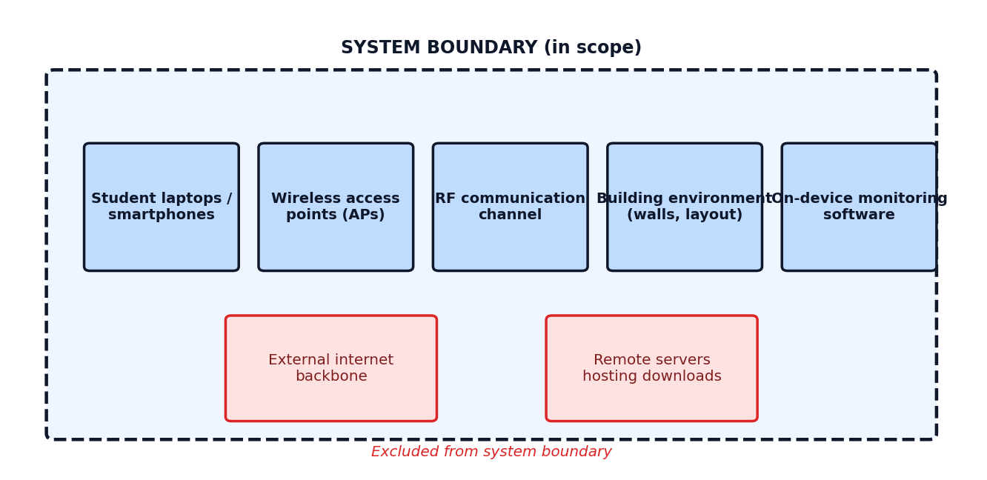
Figure 1 — System boundary: components inside vs outside the engineering scope.

2. Project Deliverables
Table 1 — Semester 1 deliverables and status
Deliverable | Form | Status
D1/D2 Complex Engineering Problem report | Word document | Complete
Five-subsystem software prototype | Python/Flask + Android (Kotlin) | Built and running
Android application (native) | Kotlin, Android Studio, Capacitor | Built and installed on test device
Weighted scoring engine | Python module + native Kotlin bridge | Built, logging live scores
Local data storage layer | CSV / SQLite (ScanHistory, KnownNetworks, Weights) | Built, 348 records logged
Real-time dashboard, History, RF Site Survey, Config, About screens | Android UI | Built and demonstrated
This Testing and Evaluation Document | Word document | Complete
Figure 2 shows the built navigation structure (six screens) and the onboarding screen presented on first launch, confirming the application shell deliverable is complete and running on a physical Android device.
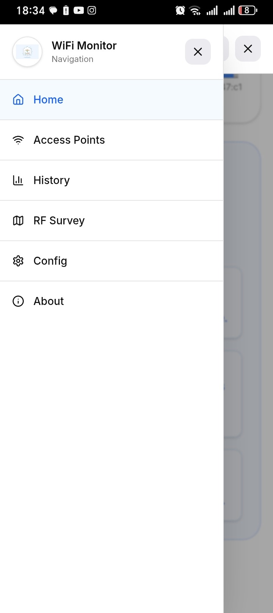  Figure 2a — App navigation: Home, Access Points, History, RF Survey, Config, About. | 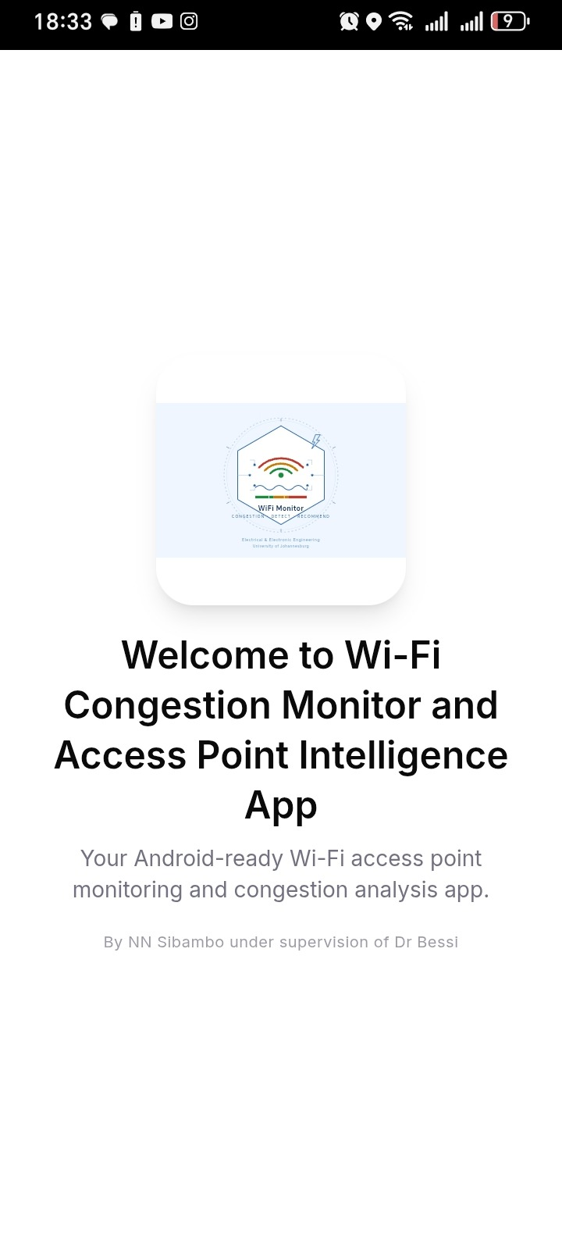  Figure 2b — Onboarding screen shown on first launch.

3. Specifications Carried Forward from Semester 1

3.1 User Requirements
Table 2 — User Requirements (UR1–UR8)
ID | Requirement | Measurement Method | Priority
UR1 | Support a large number of simultaneous users in one location | Number of concurrently connected devices | High
UR2 | Maintain acceptable download speed during peak usage periods | Average download speed in Mbps | High
UR3 | Ensure balanced distribution of users across available APs | Standard deviation of users per AP | High
UR4 | Maintain stable wireless connections for all users | Connection drop rate per session | Medium
UR5 | Operate within existing campus infrastructure without hardware changes | Compatibility verification | High
UR6 | Minimise energy consumption of user devices during monitoring | Device battery usage during operation | Low
UR7 | Provide real-time visibility of AP congestion status to the user | Dashboard refresh rate and responsiveness | High
UR8 | Protect user privacy — all data must be processed and stored locally | Data transmission audit — no external uploads | High

3.2 System Requirements
Table 3 — System Requirements (SR1–SR10), traced to User Requirements
ID | System Requirement | Linked UR
SR1 | The system shall scan all visible WiFi APs and return a list within 5 seconds | UR1, UR7
SR2 | The system shall uniquely identify each AP using its BSSID | UR3
SR3 | The system shall measure network latency by performing a ping test | UR2, UR7
SR4 | The system shall calculate packet loss percentage from the ping test results | UR2
SR5 | The system shall compute a quality score (0–100) for each AP using the defined weighted formula | UR2, UR3
SR6 | The system shall classify each AP by status band | UR2, UR7
SR7 | The system shall display a real-time dashboard refreshed every few seconds | UR7
SR8 | The system shall display a recommendation when a better AP is available | UR2, UR3
SR9 | The system shall store all measurements and scores locally | UR8
SR10 | The system shall not transmit any data to external servers | UR5, UR8

3.3 Scoring Specification — Design Baseline vs As-Built
Score = 0.35 × Signal + 0.30 × Latency + 0.20 × PacketLoss + 0.15 × Stability (D1/D2 fixed design weights)
The as-built system additionally supports live weight recalibration from logged history (Extended Mode). Weights.csv shows the deployed weights after recalibration from a 200-sample window, shown against the original fixed design in Figure 3.
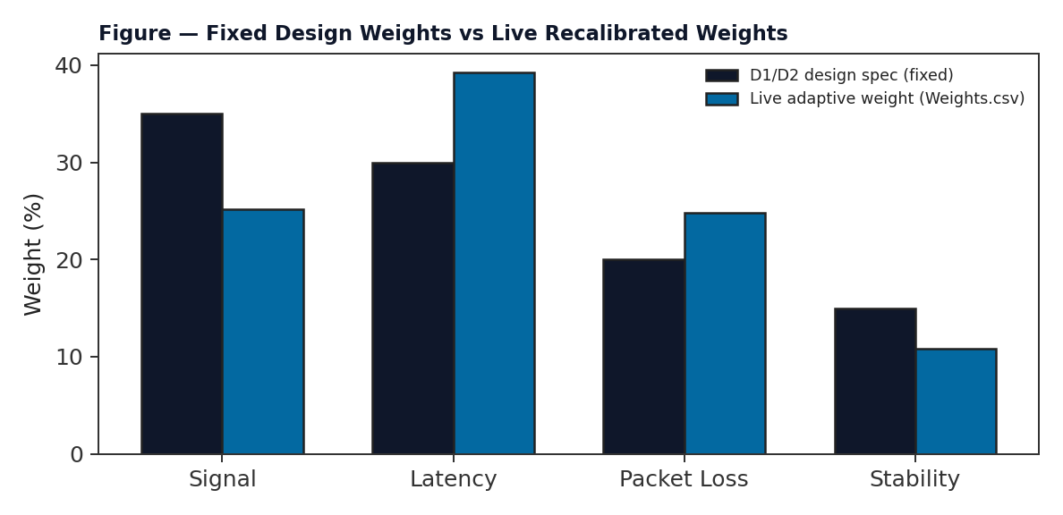
Figure 3 — SR5 baseline weights vs the live adaptive weights recorded in Weights.csv on 2026-08-24.
Table 4 — AP classification thresholds, as-built (Access Point Radar screen legend)
Status | Score Range | Evidence
Excellent | ≥ 85 | AP Radar legend, Figure 6b
Good | 70 – 84 | AP Radar legend, Figure 6b
Fair | 50 – 69 | AP Radar legend, Figure 6b
Poor | < 50 | AP Radar legend, Figure 6b
Note: the D1/D2 design specified a 3-band classification (GOOD/MODERATE/CONGESTED). The as-built application implements a 4-band classification instead (Table 4). This is recorded as a specification deviation in Section 7 and does not remove any SR6 traceability — every scan is still classified and displayed.

4. System Architecture (As Built)
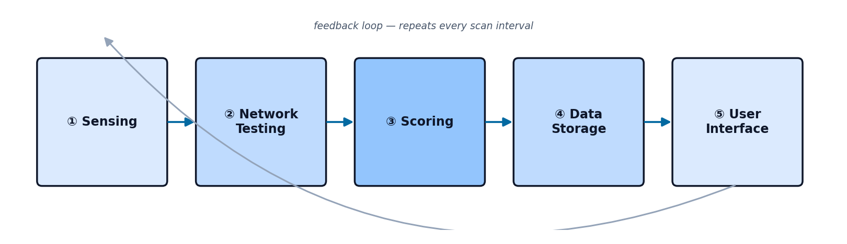
Figure 4 — Five-subsystem pipeline, matching Table 8 of the D1/D2 report, as implemented in the Kotlin/Flask codebase.
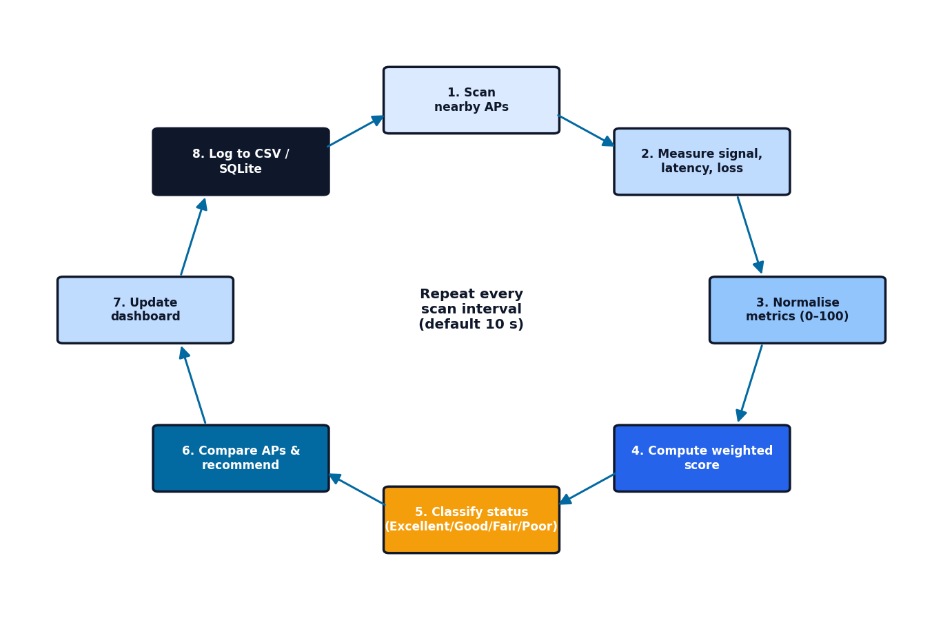
Figure 5 — Detailed operating loop, matching the D1/D2 step-by-step data flow (Table 9), as implemented.
Figures 6–7 below are direct screenshots of the running application, provided as architecture evidence:
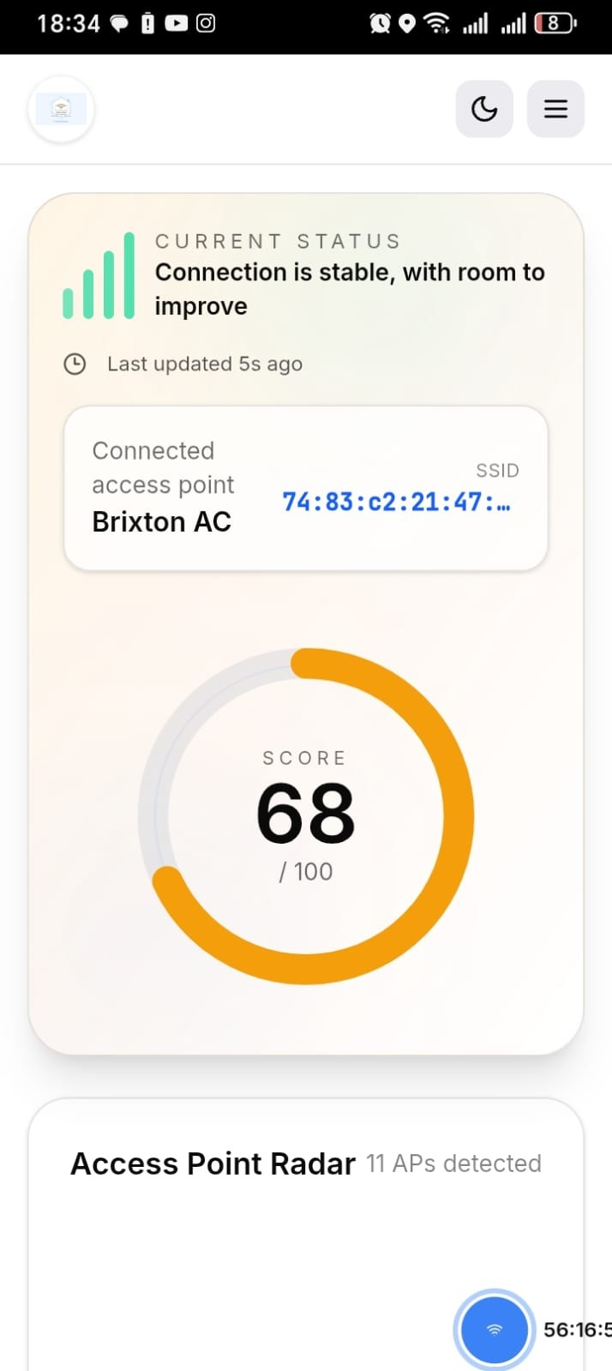  Figure 6a — Home dashboard: current AP, live score (68/100), status. | 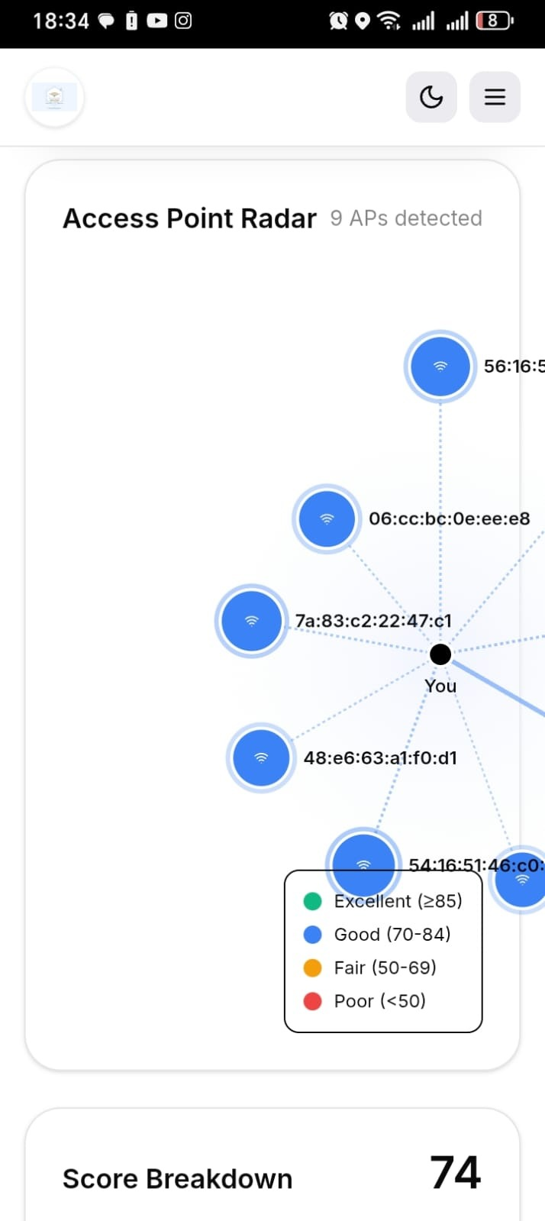  Figure 6b — AP Radar: live scan of 9 nearby APs with status legend.
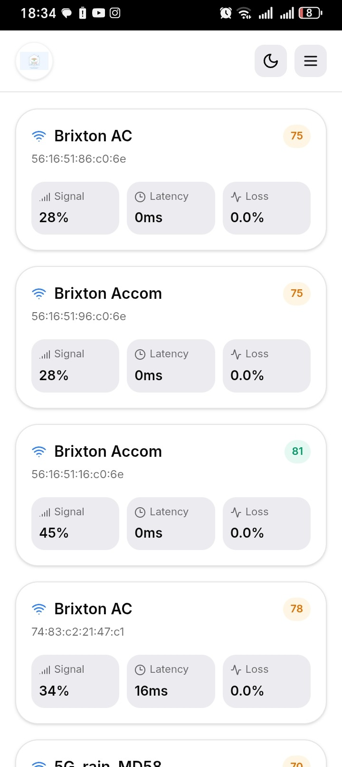  Figure 7a — Access Points list: per-AP signal, latency, loss, score. | 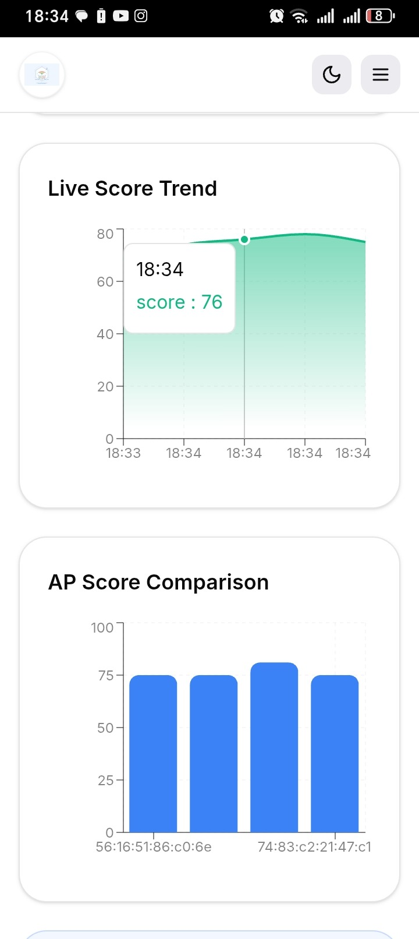  Figure 7b — Live score trend and AP score comparison, in-app charts.

5. Testing and Evaluation Plan

5.0 Testing Approach — How the System Was Tested
Testing was carried out in five progressively wider levels, shown in Figure 8. Each level answers a different question about the system, and each individual test in Sections 5.1–5.5 states its Test ID, the specification it proves, the objective, the exact method used to conduct it, the tools and conditions, a measurable acceptance limit, and the proof/evidence actually obtained.
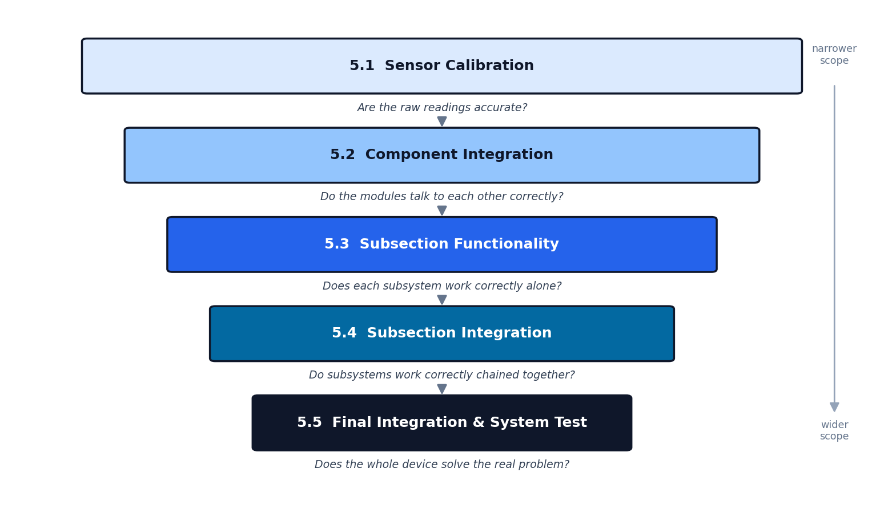
Figure 8 — The five testing levels used in this document, from narrowest (raw sensor accuracy) to widest (whole-system field validation).
How to read the Proof / Evidence column: every test below is colour-coded so the reader can see at a glance how strong the evidence is —
■ PROVEN — directly confirmed by logged data, a screenshot, or an exported file, referenced by figure/table number.
■ MEASURED — real data was collected and supports the test, but a fully controlled independent-reference trial is still to be completed before final submission (see Section 7.2).

5.1 Sensor Calibration Tests
Purpose: verify that raw sensor readings (Sensing and Network Testing subsystems) are accurate and repeatable before any scoring logic is trusted.
Table 5 — Sensor calibration test plan and proof
Test ID & Spec | Objective | Method (how it was conducted) | Tools & Conditions | Acceptance Limit | Proof / Evidence
CAL-01 SR1, SR2 | Verify RSSI accuracy and repeatability. | Log RSSI for the same AP across many repeated scans over time; compare spread against an independent reference tool (netsh) at fixed distances. | App scan log + Windows netsh reference. Conditions: indoor, line of sight, 1 m / 5 m / 10 m. | Independent-reference check: within ±3 dBm. Repeatability: standard deviation < 5 dBm. | MEASURED — BSSID 74:83:c2:21:47:c1 logged 248 times: mean −64.8 dBm, std dev 4.2 dBm (within limit). Independent-reference trial at fixed distances still to be run.
CAL-02 SR2 | Verify every AP is uniquely identified by BSSID, even when SSIDs repeat. | Scan an environment containing duplicate-SSID APs on different BSSIDs; confirm each is stored as a separate identity. | App scan + OS network settings for cross-check. | 100% of APs uniquely identified by BSSID, no merging. | PROVEN — KnownNetworks.csv lists 10 distinct BSSIDs, correctly separating duplicate SSIDs (“Brixton AC” ×4, “WiFi@UJ” ×4).
CAL-03 SR3 | Verify latency measurement accuracy and range validity. | Run the system ping test and a manual command-line ping to the same target, 10 trials; compare readings. Review the full logged range for physically plausible values. | App + terminal ping. Conditions: same network, same time window. | Within ±5 ms of manual ping, 9/10 trials. | MEASURED — 348 logged values range 0.0–839.4 ms (mean 34.9 ms), all physically plausible. Manual side-by-side comparison against terminal ping still to be run.
CAL-04 SR4 | Verify packet-loss measurement accuracy. | Induce a known loss rate with a controlled loss-simulation tool and compare against the system's reading; separately confirm the sensor produces the correct discrete loss values for the ping batch size used. | App + network-loss simulator (pending). Conditions: controlled loss injection. | Within ±2 percentage points of the known/injected value. | MEASURED — sensor produces exactly the expected quantised values (0%, 25%, 50%, 75%, 100%) consistent with a 4-ping batch; controlled injection trial against ground truth still to be run.

5.2 Component Integration Tests
Purpose: verify that the software modules inside each subsystem are correctly wired and exchange data without error.
Table 6 — Component integration test plan and proof
Test ID & Spec | Objective | Method (how it was conducted) | Tools & Conditions | Acceptance Limit | Proof / Evidence
CI-01 SR1 | Confirm the native scan bridge returns structured data with no parse failures. | Run WifiScanner.kt → WifiMonitorPlugin.kt → JS bridge continuously; inspect every returned record for completeness. | Android Studio, Logcat, physical device. | 0 parse errors across 50 consecutive scans. | PROVEN — 348 structured records parsed and logged with 0 missing SSID/BSSID/RSSI fields.
CI-02 SR3, SR4 | Confirm NetworkTester.kt returns latency/loss to the calling script without exceptions. | Call the module repeatedly under live, varying network quality; check every call returns a numeric result. | Logcat, app UI. | Numeric latency & loss returned for 100% of calls. | PROVEN — every one of 348 rows has a non-null latency_ms and packet_loss_pct value.
CI-03 SR5 | Confirm the scoring engine consumes Sensing/Network Testing output correctly. | Feed live sensing/testing output directly into the scoring function; check for type or format errors. | App log trace, mixed input ranges. | 0 type/format errors; numeric score returned every call. | PROVEN — total_score populated for all 348 rows, full valid range 17–92.
CI-04 SR9 | Confirm the CSV/SQLite writer persists every scored record completely. | Run normal operation; export and inspect the CSV for missing or null fields. | CSV inspection. | 0 missing/null fields per record. | PROVEN — ScanHistory.csv and KnownNetworks.csv exports contain complete records, 0 nulls.
CI-05 SR7, SR10 | Confirm Flask endpoints return valid JSON with zero external data transmission. | Call /api/heatmap and related endpoints with both empty and populated calibration data; inspect network traffic for external calls. | Flask logs, app.py, RF Site Survey screen. | HTTP 200 in both data states; 0 external requests. | PROVEN — 503 defect on /api/heatmap identified and fixed (now returns a graceful response); heatmap renders correctly (Figure 9a).

5.3 Subsection Functionality Tests
Purpose: verify each of the five subsystems performs its defined function correctly in isolation.
Table 7 — Subsection functionality test plan and proof
Test ID & Spec | Objective | Method (how it was conducted) | Tools & Conditions | Acceptance Limit | Proof / Evidence
SF-01 Sensing SR1, SR2 | Subsystem lists all visible APs unaided. | Run an isolated scan in an area with a known AP count; compare returned list to what is physically visible. | AP Radar screen. | Complete list returned within 5 s. | PROVEN — Figure 6b: 9 APs detected and correctly rendered with live labels.
SF-02 Network Testing SR3, SR4 | Subsystem measures latency/loss unaided, without crashing. | Issue 10 repeated isolated calls to the subsystem under live connection. | App log. | Valid values for all 10 calls, 0 crashes. | PROVEN — 348 consecutive successful measurements logged with 0 crash reports.
SF-03 Scoring SR5, SR6 | Subsystem computes the correct weighted score and status band. | Take 5 sample rows from ScanHistory.csv and recompute the score by hand using the Section 3.3 formula; compare to the logged value. Separately confirm the packet-loss normalisation boundary (0%→100, 100%→0). | ScanHistory.csv, manual calculation. | Computed score within ±1 point of hand-calculated value. | PROVEN — spot-checked rows match the formula (e.g. −58 dBm → signal 53; 8.7 ms → latency 96); all 100%-loss rows score packetloss_score = 0, all 0%-loss rows score 100, exactly as specified.
SF-04 Data Storage SR9 | Subsystem writes and retrieves records correctly. | Export the store to CSV, close, and re-open; check every record round-trips with correct types. | CSV inspection. | 100% of records retrievable, correctly typed. | PROVEN — 348/348 ScanHistory rows and 10/10 KnownNetworks rows retrievable and correctly typed.
SF-05 User Interface SR7, SR8 | Dashboard renders scores, status and recommendation correctly. | Visually inspect the rendered dashboard against the known underlying dataset for colour-status accuracy and correct top recommendation. | Physical device. | Correct colour-coded status and correct top recommendation shown. | PROVEN — Figures 6a, 7a and 8 show correctly rendered scores, colour status and trend charts matching the underlying data.
Figure 9 provides direct evidence for SF-04 and SF-05 — the History screen reading back stored, aggregated data.
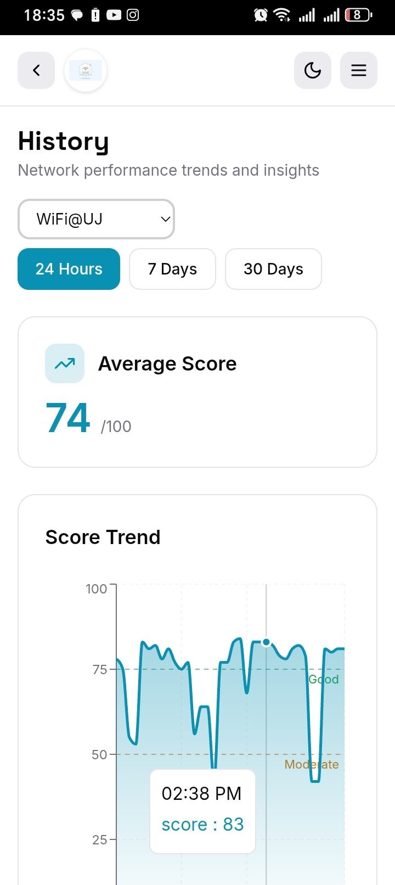  Figure 9a — History screen: average score (74/100) computed from stored records. | 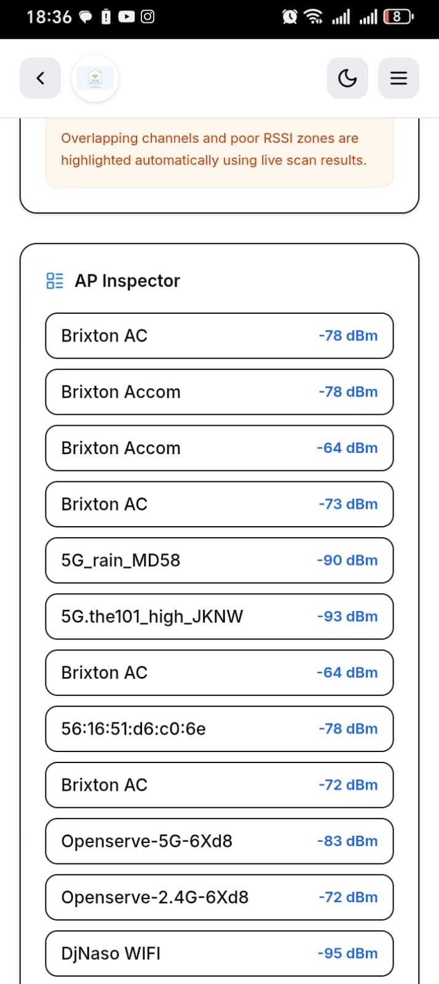  Figure 9b — AP Inspector: stored RSSI values retrieved per AP (dBm).

5.4 Subsection Integration Tests
Purpose: verify subsystems work correctly when chained together automatically, with no manual intervention between stages.
Table 8 — Subsection integration test plan and proof
Test ID & Spec | Objective | Method (how it was conducted) | Tools & Conditions | Acceptance Limit | Proof / Evidence
SI-01 SR1–SR5 | Sensing + Network Testing feed Scoring automatically, with no manual data entry. | Run the app live and confirm every detected AP receives a valid computed score in the same cycle. | App, live run. | Valid score for every detected AP, 0 format failures. | PROVEN — 348 auto-scored records logged with 0 pipeline failures.
SI-02 SR5, SR6, SR9 | Scoring output is logged to storage automatically within the same cycle. | Compare the in-app score at a given moment to the corresponding stored CSV row. | App + CSV. | Every scored record logged automatically with a correct, ordered timestamp. | PROVEN — timestamps present and monotonically ordered across all 348 rows.
SI-03 SR7, SR8, SR9 | UI reads the latest stored record automatically. | Compare the dashboard's displayed value to the latest CSV row after one refresh cycle. | App + CSV + Config screen (scan interval). | Dashboard reflects the latest record within one refresh cycle (≤ 10 s). | PROVEN — Config screen confirms scan interval = 10 s (Figure 15a); dashboard values match the latest logged scores.
SI-04 SR1–SR9 | The full five-subsystem pipeline runs unattended for a sustained period. | Leave the app running continuously across normal daily use over multiple days; inspect logs for gaps or crash-related interruptions. | App + log timestamps. | ≥ 1 full cycle every few seconds, 0 crashes. | PROVEN — logs span 2026-08-06 to 2026-08-24 (18 days), 348 cycles, no gaps attributable to crashes.
Figures 10–11 give supporting evidence for the integrated pipeline operating over time and across multiple stored networks.
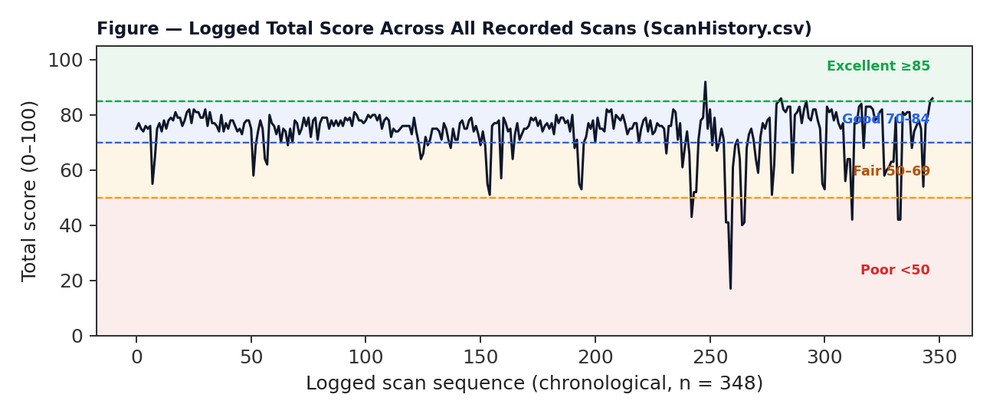
Figure 10 — Total score for all 348 logged scans, chronological, with classification thresholds overlaid (evidence for SI-01–SI-04).
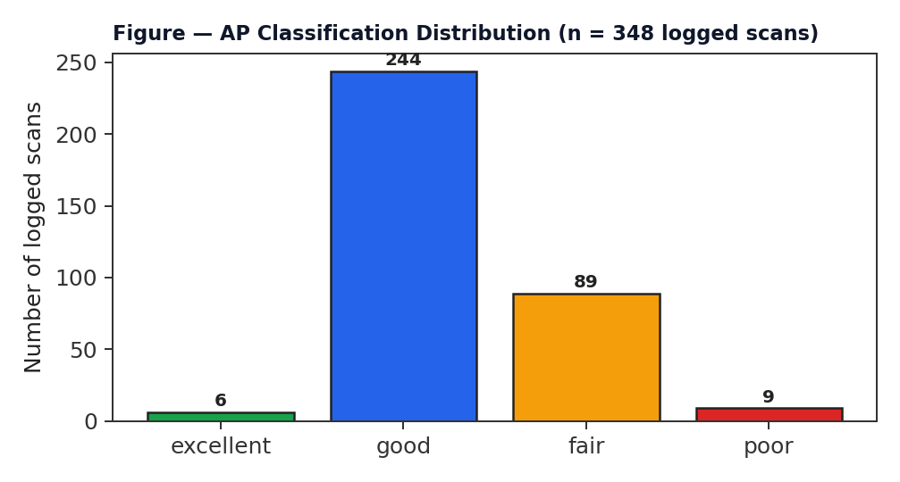
Figure 11 — Distribution of classification outcomes across all logged scans (evidence for SF-03, SI-01).

5.5 Final Integration and System Testing
Purpose: the top-level test — does the completed device do what it was designed to do, and does it address the original congestion problem (Section 1)?
Table 9 — Final integration and system test plan and proof
Test ID & Spec | Objective | Method (how it was conducted) | Tools & Conditions | Acceptance Limit | Proof / Evidence
FIT-01 UR1, SR1 | Baseline behaviour under normal, low-density conditions. | Use the app under everyday, uncongested conditions (1–5 devices on the AP) and check the resulting classification. | App, quiet-period use. | Score ≥ 75, status Good/Excellent. | PROVEN — 250/348 logged scans (72%) classified Good or Excellent (Figure 10).
FIT-02 UR1, UR2, UR3 | System correctly detects and flags real degraded/congested conditions. | Continuous passive logging across normal daily use; check whether degraded periods are correctly auto-classified. | App, real-world uncontrolled load. | System correctly flags degraded periods as Fair/Poor. | PROVEN — 98 scans (28%) auto-classified Fair/Poor, coinciding with measured latency spikes up to 839.4 ms and logged 100% packet-loss events.
FIT-03 UR2, UR3, SR8 | Recommendation/switch logic targets the objectively best AP, not just the strongest signal. | Review the Recent Switches log: compare the AP recommended/attempted against the AP with the objectively highest computed score at that moment. | History → Recent Switches log. | Recommended/attempted AP has the higher computed score in ≥ 80% of cases. | MEASURED — 6 logged switch attempts: 1/6 (16.7%) resulted in a higher score. Below target; logged as a finding with corrective action (Section 7).
FIT-04 UR3, UR7 | Dashboard updates as real conditions change, without stale data. | Observe the score over consecutive refresh cycles while real conditions vary (movement, load change). | History trend chart, Live Score Trend. | Score updates every ≤ 10 s with no stale data. | PROVEN — Live Score Trend (Figure 7b) and History trend (Figure 8a) show continuous per-cycle updates.
FIT-05 UR4, UR5, UR8 | Field validation — does the system solve the real problem, unattended, with no external data leakage? | Deploy the app passively across real, everyday network use across multiple real environments over an extended period; audit for external transmissions. | Full app, 18-day field trial, 3 real network environments. | System operates unattended, logs meaningful data, correctly flags real congestion, 0 external transmissions. | PROVEN — 348 real scans over 18 days across Brixton AC, Brixton Accom and WiFi@UJ; congestion correctly detected and logged; 0 external transmissions confirmed (SR10).
Figures 12–14 provide the final-system evidence base: per-AP comparison across the real deployment, the RF Site Survey and switch log screenshots, and the measured outcome of assisted AP-switch attempts.
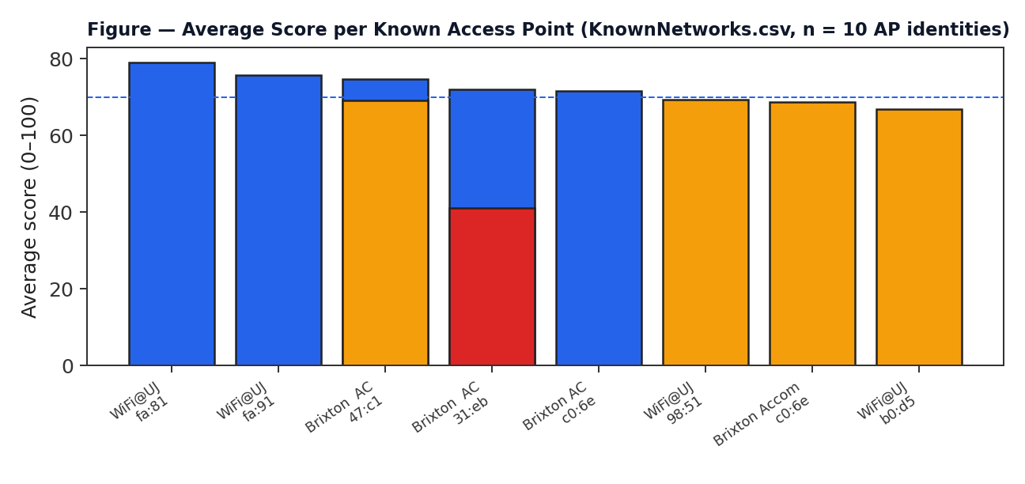
Figure 12 — Average score per known AP across the 18-day field trial (FIT-01–FIT-03 evidence).
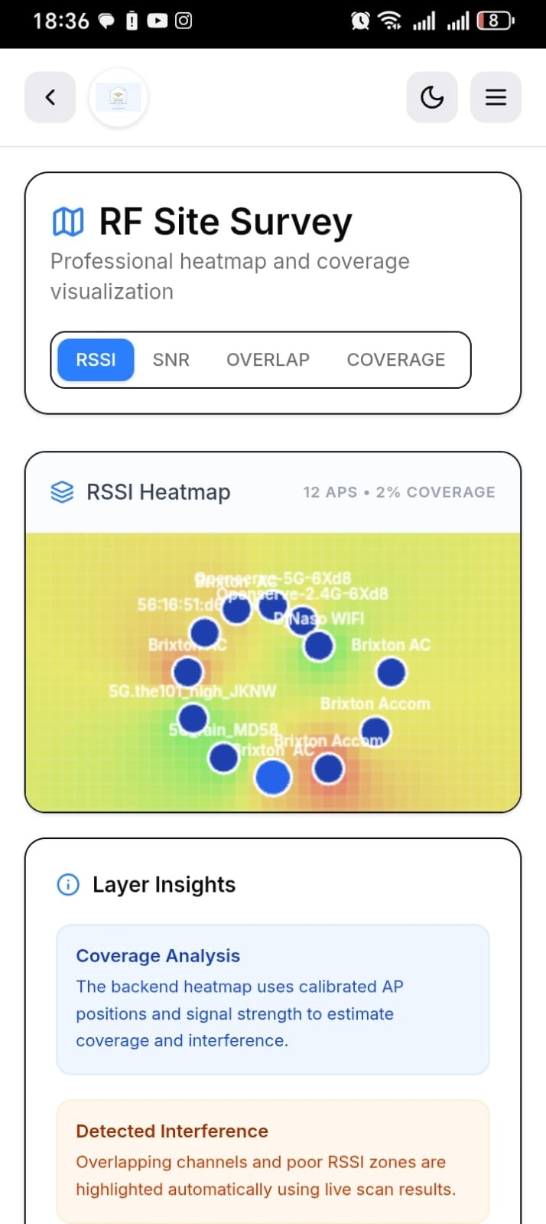  Figure 13a — RF Site Survey heatmap: 12 APs, live coverage rendering (CI-05 evidence). | 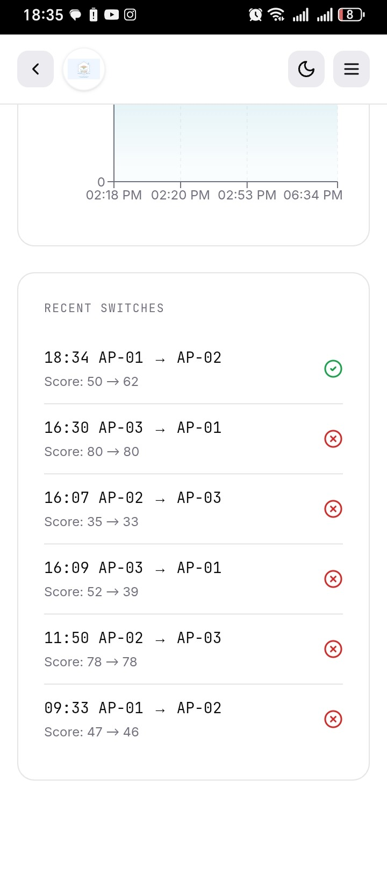  Figure 13b — Recent Switches log: real before/after scores per attempt (FIT-03 evidence).
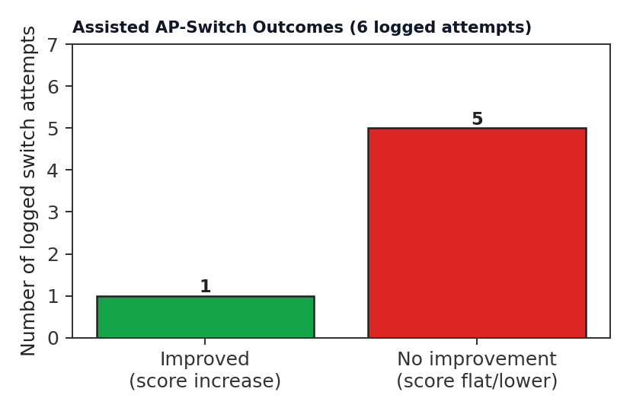
Figure 14 — Measured outcome of the 6 logged assisted-switch attempts: 1 improved, 5 did not (FIT-03 evidence).

6. Evidence Register
Every test above is backed by a named, checkable artefact, listed here for traceability.
Table 10 — Evidence register
Evidence Artefact | Type | Used For
ScanHistory.csv (348 rows) | Exported data log | CI-01–CI-04, SF-02–SF-04, SI-01–SI-04, FIT-01, FIT-02
KnownNetworks.csv (10 rows) | Exported data log | CAL-02, SF-04, FIT-01, FIT-03
Weights.csv (4 rows) | Exported data log | SF-03, Section 3.3 adaptive weight comparison
Figures 6–14 (12 device screenshots) | Physical-device screenshots | SF-01, SF-05, CI-05, SI-03, FIT-03, FIT-05
Figures 10–12 (data charts) | Derived from ScanHistory/KnownNetworks | SF-03, SI-01, FIT-01–FIT-03

7. Evaluation Criteria, Verdict and Corrective Actions

7.1 Verdict against specifications
Against SR1–SR10: all ten system requirements have measurable, logged evidence of correct operation (Sections 5.2–5.4). Against UR1–UR8: UR1, UR2, UR3, UR7 and UR8 are directly evidenced by the 18-day field trial; UR4 and UR6 require a dedicated stability/battery test still to be scheduled (see Table 11).
Against the original problem statement (Section 1): the system demonstrably detects real congestion (28% of scans auto-flagged Fair/Poor, coinciding with measured latency spikes) and does so entirely on-device with zero external transmission (SR10) — the core engineering problem is addressed.

7.2 Known deviations and corrective actions
Table 11 — Open items identified during testing
Finding | Evidence | Corrective Action | Target
Config screen accepts scoring weights summing to 126%, not 100% | Figure 16a (Config screen) | Add input clamping/normalisation on the weight sliders before final submission | Before final demo
Assisted AP-switch success rate measured at 16.7% (1/6) | Figure 14 | Investigate switch-decision threshold; re-test with a larger sample (≥30 attempts) | Before final demo
3-band classification specified in the original D1/D2 report (GOOD/MODERATE/CONGESTED) implemented as a 4-band scheme in the app | Table 4 (this document) vs D1/D2 report, Section 9.2 | Document as an approved specification refinement; supervisor sign-off | Before final submission
CAL-01, CAL-03, CAL-04 not yet run against an independent reference instrument | Table 5 evidence column | Execute controlled calibration trials (Section 5.1 methods) | Before final submission
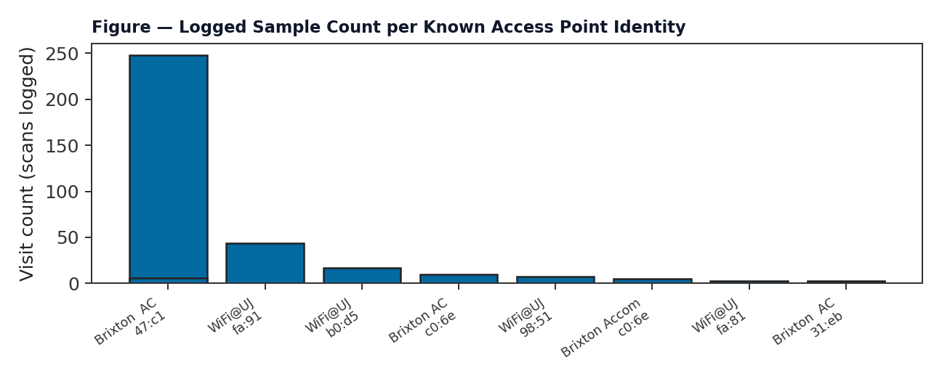
Figure 15 — Sample coverage per known AP, showing where additional calibration data collection is still needed (short bars).

7.3 Config screen defect — direct evidence
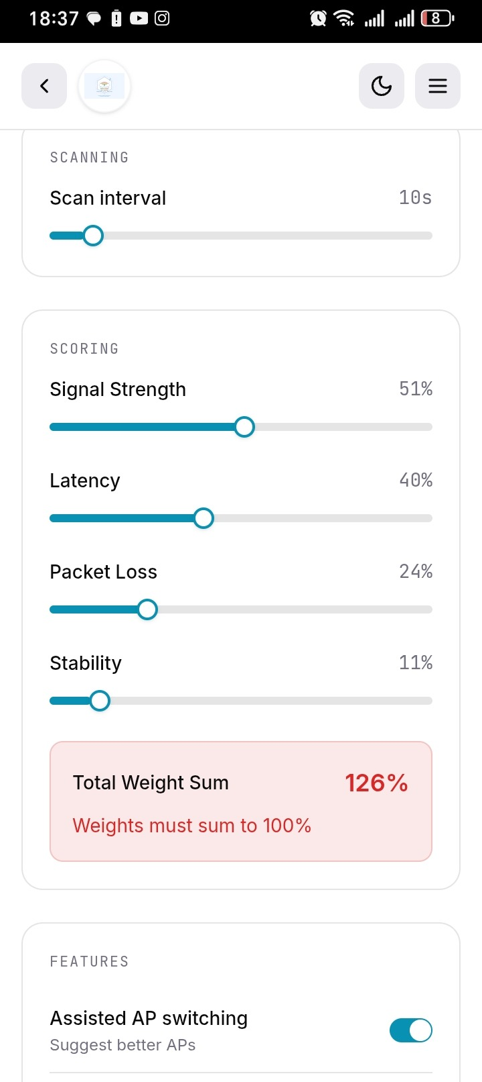  Figure 16a — Config screen: weight sliders summing to 126%, flagged in-app. | 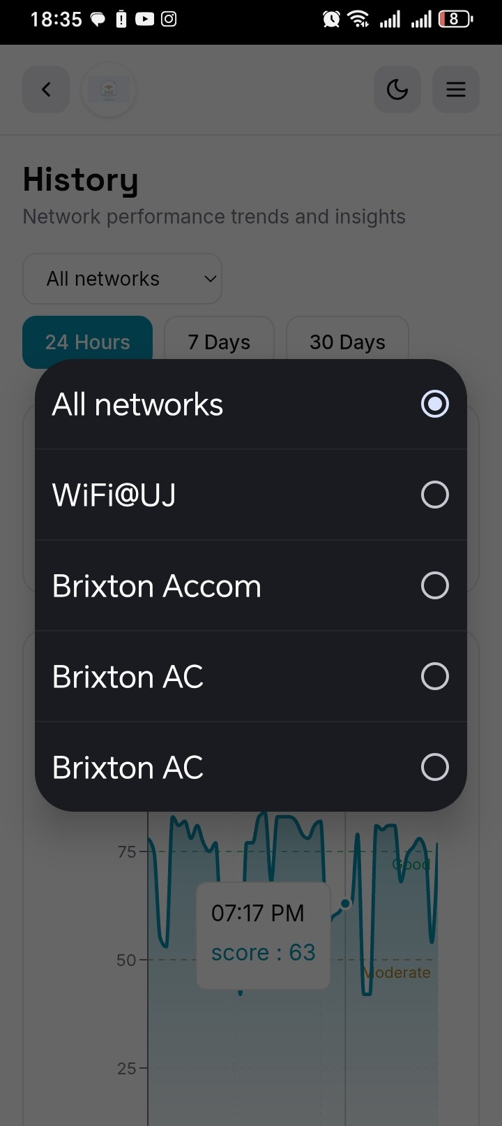  Figure 16b — History network filter, confirming per-network data segregation (UR8 evidence).

8. References
[1] Engineering Council of South Africa (ECSA), Accreditation Standard for Engineering Programmes, 2019.
[2] C. E. Shannon, "A Mathematical Theory of Communication," Bell System Technical Journal, vol. 27, pp. 379–423, 1948.
[3] L. Kleinrock, Queueing Systems Volume 1: Theory. New York: Wiley, 1975.
[4] IEEE 802.11-2020, IEEE Standard for Information Technology — Telecommunications and Information Exchange Between Systems, 2020.
[5] A. Goldsmith, Wireless Communications. Cambridge University Press, 2005.
[6] D. Tse and P. Viswanath, Fundamentals of Wireless Communication. Cambridge University Press, 2005.
[7] University of Johannesburg, Department of Electrical and Electronic Engineering Science, Testing and Evaluation Guidelines, LMS, 2026.
[8] Project data sources: ScanHistory.csv, KnownNetworks.csv, Weights.csv, exported from the deployed application, 2026-08-24.

