FACULTY OF ENGINEERING, BUILT ENVIRONMENT AND INFORMATION TECHNOLOGY
Department of Electrical and b Electronic Engineering

DELIVERABLE 2
Conceptual Design and Trade-off Analysis

Dynamic WiFi Load Balancing System for High-Density Campus Networks

Student Name: | Njabulo Sibambo
Student Number: | 223124407
Supervisor: | Dr Bessie Malila
Submission Date: | 16 April 2026

Table of Contents
Contents
Table of Contents 2
1. Introduction 4
1.1 Problem Recap (from D1) 4
1.2 Scope and Boundaries 4
2. Development of Design Options 4
2.1 Option 1 – Centralised SDN Controller with Dynamic Load Balancing 4
2.1.1 Conceptual Description 4
2.1.2 Technical Feasibility 4
2.1.3 Key Characteristics 5
2.2 Option 2 – AI-Based Distributed Load Balancing Application 5
2.2.1 Conceptual Description 5
2.2.2 Technical Feasibility 5
2.2.3 Key Characteristics 5
2.3 Option 3 – Edge-Computing Hybrid Load Balancer with Local Caching 5
2.3.1 Conceptual Description 5
2.3.2 Technical Feasibility 6
2.3.3 Key Characteristics 6
2.4 Option 4 – Modified AP Firmware with Load-Aware Beacon Frames 6
2.4.1 Conceptual Description 6
2.4.2 Technical Feasibility 6
2.4.3 Key Characteristics 6
3. Engineering Trade-Off Analysis 7
3.1 Evaluation Criteria and Weightings 7
3.2 Scoring Methodology 7
3.3 Weighted Decision Matrix 7
3.4 Trade-off Discussion and Option Rejection Justification 8
3.4.1 Rejection of Option 1 (SDN Controller) 8
3.4.2 Rejection of Option 3 (Edge Computing Hybrid) 9
3.4.3 Rejection of Option 4 (Modified AP Firmware) 9
3.4.4 Selection of Option 2 (AI-Based Distributed Application) 9
4. High-Level Design of the Selected Option 11
4.1 System Architecture Overview 11
4.2 System Architecture Diagram Description 11
4.3 Data Flow Architecture 12
4.3.1 Data Flow Description 12
5. Subsystem Definitions and Interfaces 14
5.1 Subsystem Summary Table 14
5.2 Detailed Subsystem Descriptions 15
5.2.1 Sensing Subsystem 15
5.2.2 AI Processing Subsystem 15
5.2.3 Action Execution Subsystem 15
5.2.4 Data Management Subsystem 16
5.2.5 Federated Learning Subsystem 16
5.2.6 User Interface Subsystem 16
5.3 Subsystem Interfaces 16
6. High-Level Subsystem Integration 18
6.1 System Behaviour Description (Input to Output) 18
6.2 Requirement Satisfaction Mapping 18
6.3 Application Interface (Prototype Demo Reference) 19
7. Scope Exclusions 21
8. Conclusion 21
References 21
Appendix A: D2 Submission Self-Assessment Checklist 22

1. Introduction
Purpose of this Document
This document constitutes Deliverable 2 (D2) of the Capstone Engineering Project and marks the formal transition from problem analysis to solution exploration. Where Deliverable 1 established that unbalanced WiFi load distribution in high-density campus environments represents a genuine engineering problem, this deliverable systematically explores the engineering solution space, evaluates competing design alternatives using structured trade-off analysis, and defines a defensible high-level system architecture.

The document is structured in accordance with the D2 assessment criteria, covering: (1) development and justification of design options, (2) engineering trade-off analysis, (3) high-level design of the selected option, (4) subsystem definitions and interfaces, and (5) high-level subsystem integration.

1.1 Problem Recap (from D1)
High-density campus WiFi environments suffer from uneven client distribution across access points (APs). The native 802.11 roaming mechanism selects APs based solely on received signal strength (RSSI), causing some APs to become overloaded while adjacent APs remain underutilised. The resulting effects include increased latency, reduced throughput, and degraded user experience during peak periods such as lectures and examinations.

1.2 Scope and Boundaries
This deliverable addresses the architectural design of a load-balancing system. It explicitly excludes component-level specifications, software algorithms, circuit designs, and prototype results, which are reserved for Deliverable 3 (D3) and Deliverable 4 (D4). The design space is bounded by the following constraints:
- Existing AP hardware must not require replacement
- The solution must scale to at least 500 concurrent clients
- Roaming transitions must be imperceptible to users (< 50 ms interruption)
- The solution must operate within the university's network security policy
- Total system cost must remain within a reasonable budget for institutional deployment

2. Development of Design Options
A fundamental principle of engineering design is that engineers do not jump to a solution — they explore the solution space. This section presents four distinct, technically feasible engineering approaches to the WiFi load balancing problem. Each option is justified at the conceptual level; all four are capable of satisfying the user requirements established in D1.

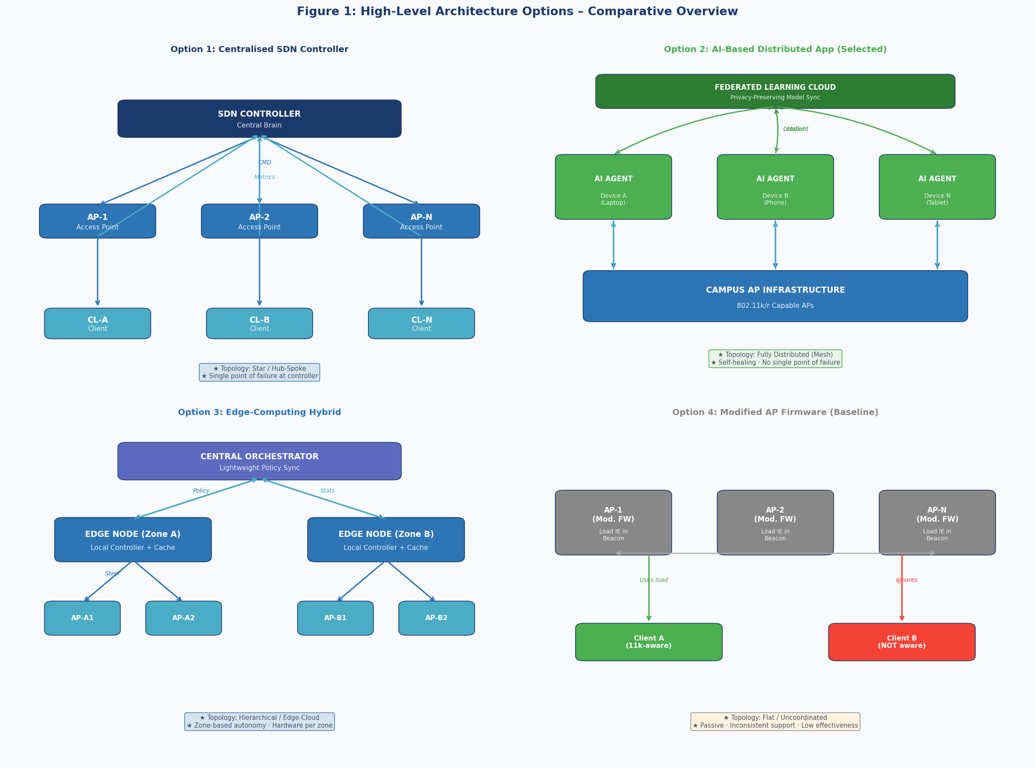
Figure 1 Comparative overview of the four design options at a high architectural level.

2.1 Option 1 – Centralised SDN Controller with Dynamic Load Balancing

2.1.1 Conceptual Description
This approach introduces a Software-Defined Networking (SDN) controller as a centralised intelligence layer above the existing AP infrastructure. The controller maintains a real-time database of network state — including per-AP client counts, per-client throughput, and channel utilisation — and uses this data to make load-balancing decisions across the entire campus.

When the controller detects that an AP has exceeded a configurable load threshold, it issues a BSS Transition Management (802.11v) command to selected clients, directing them to migrate to a less-loaded AP. The control plane (commands and telemetry) is carried over an out-of-band CAPWAP tunnel network, leaving the data plane (user traffic) unaffected.

2.1.2 Technical Feasibility
SDN is a mature, commercially deployed technology. Open-source controllers (e.g., OpenDaylight, ONOS) and commercial alternatives (e.g., Cisco DNA Center) provide production-ready implementations. The CAPWAP protocol (RFC 5415) provides standardised AP-to-controller communication. 802.11v BSS Transition Management is supported by most modern AP firmware and client devices.

2.1.3 Key Characteristics
- Topology: Star / Hub-and-Spoke
- Intelligence location: Centralised controller
- Control direction: Top-down (controller commands APs)
- Single point of failure at the controller (mitigated by redundancy)
- Requires dedicated server infrastructure for the controller

2.2 Option 2 – AI-Based Distributed Load Balancing Application

2.2.1 Conceptual Description
This approach places the load-balancing intelligence directly on each client device in the form of a lightweight cross-platform application. Each device runs an on-device AI agent that continuously monitors the local RF environment using standard 802.11k radio measurements (RSSI, channel load, neighbour reports) and predicts which AP will provide the best connection quality over the next sampling interval. When a better AP is identified, the agent executes a seamless handoff using 802.11r Fast BSS Transition.

Model quality is improved over time through federated learning: each device periodically uploads anonymised model weight gradients to a cloud aggregation server, which combines contributions from thousands of devices to update the global model while ensuring that no raw user data ever leaves the device.

2.2.2 Technical Feasibility
LSTM neural networks are well-suited to time-series prediction of network quality metrics. TensorFlow Lite enables on-device inference on constrained mobile hardware at < 10 ms per decision. Federated learning with differential privacy is an established technique for privacy-preserving distributed model training. The 802.11k/r protocol suite is supported by all modern campus APs and client devices without firmware modification.

2.2.3 Key Characteristics
- Topology: Fully distributed (mesh intelligence)
- Intelligence location: Per-device edge AI agent
- Control direction: Bottom-up (clients decide independently)
- No single point of failure — each device is autonomous
- Deployed as an application (no new network hardware required)
- Scales horizontally: more devices = more collective intelligence

2.3 Option 3 – Edge-Computing Hybrid Load Balancer with Local Caching

2.3.1 Conceptual Description
This option partitions the campus into geographic zones, each served by a dedicated edge computing node. Each edge node runs a local traffic analysis and load-balancing service that monitors all clients within its zone and issues steering commands to the local AP cluster. A lightweight central orchestrator synchronises policies across edge nodes without performing any real-time control.

A secondary function of each edge node is content caching: popular content is pre-fetched and served locally, reducing both internet bandwidth consumption and AP load simultaneously. A prediction engine within each edge node uses historical traffic patterns and lecture schedules to pre-stage content before demand peaks.

2.3.2 Technical Feasibility
Edge computing is a deployed commercial technology used in mobile networks (Multi-access Edge Computing, MEC). ARM-based or x86 single-board computers can run containerised microservices at suitable performance levels. The architecture directly parallels 4G/5G mobile edge computing deployments, providing a proven reference design.

2.3.3 Key Characteristics
- Topology: Hierarchical (edge-cloud hybrid)
- Intelligence location: Zone edge nodes
- Control direction: Middle-out (zone-local decisions)
- Adds content caching as a secondary optimisation mechanism
- Requires installation of physical hardware per zone
- Zone-limited scalability (adding zones requires new hardware)

2.4 Option 4 – Modified AP Firmware with Load-Aware Beacon Frames

2.4.1 Conceptual Description
This is the simplest and least invasive option. AP firmware is modified to include a vendor-specific Information Element (IE) in standard 802.11 beacon frames, reporting the current load percentage, connected client count, and average throughput of each AP. Client devices that support 802.11k-aware drivers can optionally use this information to make better association decisions.

2.4.2 Technical Feasibility
Beacon frame modification is technically trivial and can be implemented in open-source firmware (e.g., OpenWrt). The vendor-specific IE mechanism (Element ID 221) is defined in the 802.11 standard and does not require protocol extensions. This option has the lowest deployment complexity of the four.

2.4.3 Key Characteristics
- Topology: Flat (no coordination between APs)
- Intelligence location: None — passive information only
- Control direction: None — client decides if it chooses to
- Highly dependent on client driver support (inconsistent across platforms)
- Low complexity, low cost, low effectiveness
- Included as a baseline to quantify the minimum achievable improvement

3. Engineering Trade-Off Analysis
Engineering design is fundamentally about balancing competing objectives. This section evaluates the four design options using a structured weighted scoring methodology. Criteria weights reflect the specific constraints and priorities of the campus deployment context established in D1.

3.1 Evaluation Criteria and Weightings
The following criteria were selected based on the user requirements from D1. Weights are assigned on a 0–10 scale and reflect the relative importance of each criterion to the deployment context.

Table 1 Evaluation criteria definitions and weightings.
Criterion | Weight | Justification
Technical Performance (Load Balance Effectiveness) | 9 | Core function — must demonstrably reduce load variance across APs.
Reliability and Fault Tolerance | 8 | Campus network must remain operational 24/7; failures must not disrupt connectivity.
Deployment Complexity | 7 | Limited IT staff; solution must be deployable without replacing existing hardware.
Scalability | 8 | Solution must handle 500–2000+ concurrent clients as campus grows.
Cost (CAPEX + OPEX) | 7 | Institutional budget constraints; OPEX must remain sustainable long-term.
Privacy and Security | 9 | Student data protection is a legal and ethical requirement (POPIA compliance).
Latency (Roaming Interruption) | 8 | Transitions must be imperceptible to users (< 50 ms target from D1).
Maintainability | 6 | Solution must be maintainable by campus IT without specialist knowledge.

3.2 Scoring Methodology
Each option is scored on each criterion from 1 (very poor) to 5 (excellent). The weighted score is calculated as:

Weighted Score = Σ (Criterion Weight × Option Score) / Σ (Weights) × 5

Scores reflect the technical analysis presented in Section 2, informed by published performance benchmarks, deployment case studies, and engineering reasoning rather than personal preference.

3.3 Weighted Decision Matrix
Table 2 Weighted decision matrix. Scores range from 1 (poor) to 5 (excellent). = Selected option.
Criterion | Wt | Opt 1 SDN | Opt 2 AI App ★ | Opt 3 Edge | Opt 4 Firmware | Notes
Technical Performance | 9 | 4 | 5 | 4 | 2 | SDN & AI enforce roaming; Firmware is passive
Reliability | 8 | 3 | 5 | 4 | 5 | SDN SPOF; AI fully distributed; Firmware no added risk
Deployment Complexity | 7 | 2 | 5 | 3 | 4 | SDN needs controller infra; AI is app-install only
Scalability | 8 | 3 | 5 | 4 | 2 | AI scales with device count; Edge limited by zones
Cost | 7 | 2 | 4 | 3 | 5 | SDN: high CAPEX; AI: low (app); Edge: medium (hardware)
Privacy & Security | 9 | 3 | 5 | 3 | 4 | AI uses differential privacy; SDN & Edge centralise data
Latency (Roaming) | 8 | 4 | 5 | 4 | 2 | 802.11r enables < 50ms; Firmware has no enforcement
Maintainability | 6 | 3 | 4 | 3 | 5 | AI auto-updates; SDN needs controller expertise
WEIGHTED TOTAL SCORE (/5.0) | — | 3.1 | 4.8 | 3.5 | 3.4 | Option 2 selected

3.4 Trade-off Discussion and Option Rejection Justification

3.4.1 Rejection of Option 1 (SDN Controller)
Option 1 scores poorly on reliability (3/5) and cost (2/5). The centralised SDN controller introduces a single point of failure: if the controller becomes unavailable — due to hardware failure, network partition, or software crash — the entire load-balancing capability is lost, and the campus reverts to unmanaged roaming. While controller redundancy (active-standby pairs) can mitigate this, it doubles the hardware cost and operational complexity.

The cost penalty is significant: deploying a production SDN controller requires dedicated server hardware, licensed software or engineering effort for open-source deployment, and ongoing operational expertise that typical campus IT teams do not possess. The performance ceiling is also limited by the controller's processing capacity, meaning scalability is fundamentally vertical (a bigger controller) rather than horizontal.

3.4.2 Rejection of Option 3 (Edge Computing Hybrid)
Option 3 offers good technical performance (4/5) and reasonable reliability, but is penalised by cost (3/5) and the requirement for physical hardware installation per zone. Each edge node requires procurement, rack space, power, cooling, and network provisioning. This creates a recurring CAPEX burden as the campus network expands and makes the solution dependent on physical infrastructure that may be disrupted by building works or equipment failure.

The privacy score (3/5) reflects that the edge node aggregates client traffic data at a zone level, creating a data concentration point that must be secured and managed in compliance with student data protection requirements (POPIA). While less risky than a fully centralised controller, this adds governance overhead.

3.4.3 Rejection of Option 4 (Modified AP Firmware)
Option 4 is rejected on the grounds of technical performance (2/5) and latency (2/5). The fundamental weakness is that the solution is entirely passive: it provides information to clients but has no mechanism to enforce roaming decisions. Whether a client acts on the load information embedded in beacon frames depends entirely on the client's WiFi driver implementation. In practice, the majority of deployed client devices (Windows laptops, Android phones, iOS devices) do not parse vendor-specific beacon IEs for roaming decisions. The system would therefore fail to achieve consistent load balancing across the device population.

Option 4 is retained in the analysis as a performance baseline, providing a lower bound on achievable improvement against which the selected option can be validated.

3.4.4 Selection of Option 2 (AI-Based Distributed Application)
Option 2 achieves the highest weighted score (4.8/5.0) and is selected as the preferred design approach. The key engineering advantages that justify this selection are:

- Fully distributed architecture eliminates any single point of failure. Each device operates autonomously; the failure of any individual device, or the temporary unavailability of the federated learning cloud, does not degrade the system's load-balancing capability.
- Deployment requires no new network hardware. The solution is deployed as an application on existing client devices, using the standard 802.11k/r protocol stack already supported by campus APs. This eliminates procurement lead times and installation complexity.
- Horizontal scalability: adding more devices increases the collective intelligence of the system, as each device contributes to the federated model. This is the inverse of Option 1's vertical scaling limitation.
- Privacy by design: federated learning with differential privacy ensures that no raw user data leaves the device. Only anonymised, mathematically noise-perturbed model gradients are uploaded to the cloud, providing a strong privacy guarantee consistent with POPIA requirements.
- The predictive AI approach (anticipate and prevent congestion) outperforms the reactive approach of Option 1 (detect and correct) by acting before performance degradation occurs.

4. High-Level Design of the Selected Option
Note: This section presents the high-level architecture of the selected option. It describes what the
system must do and how its major components interact. Component-level specifications, software
algorithms, hardware selection, and implementation details are deferred to Deliverable 3.

4.1 System Architecture Overview
The selected system — an AI-Based Distributed Load Balancing Application — operates as a three-tier architecture: (1) the client device tier, where AI agents execute roaming decisions; (2) the campus infrastructure tier, comprising existing 802.11k/r-capable APs; and (3) an optional cloud tier, used exclusively for periodic model improvement via federated learning.

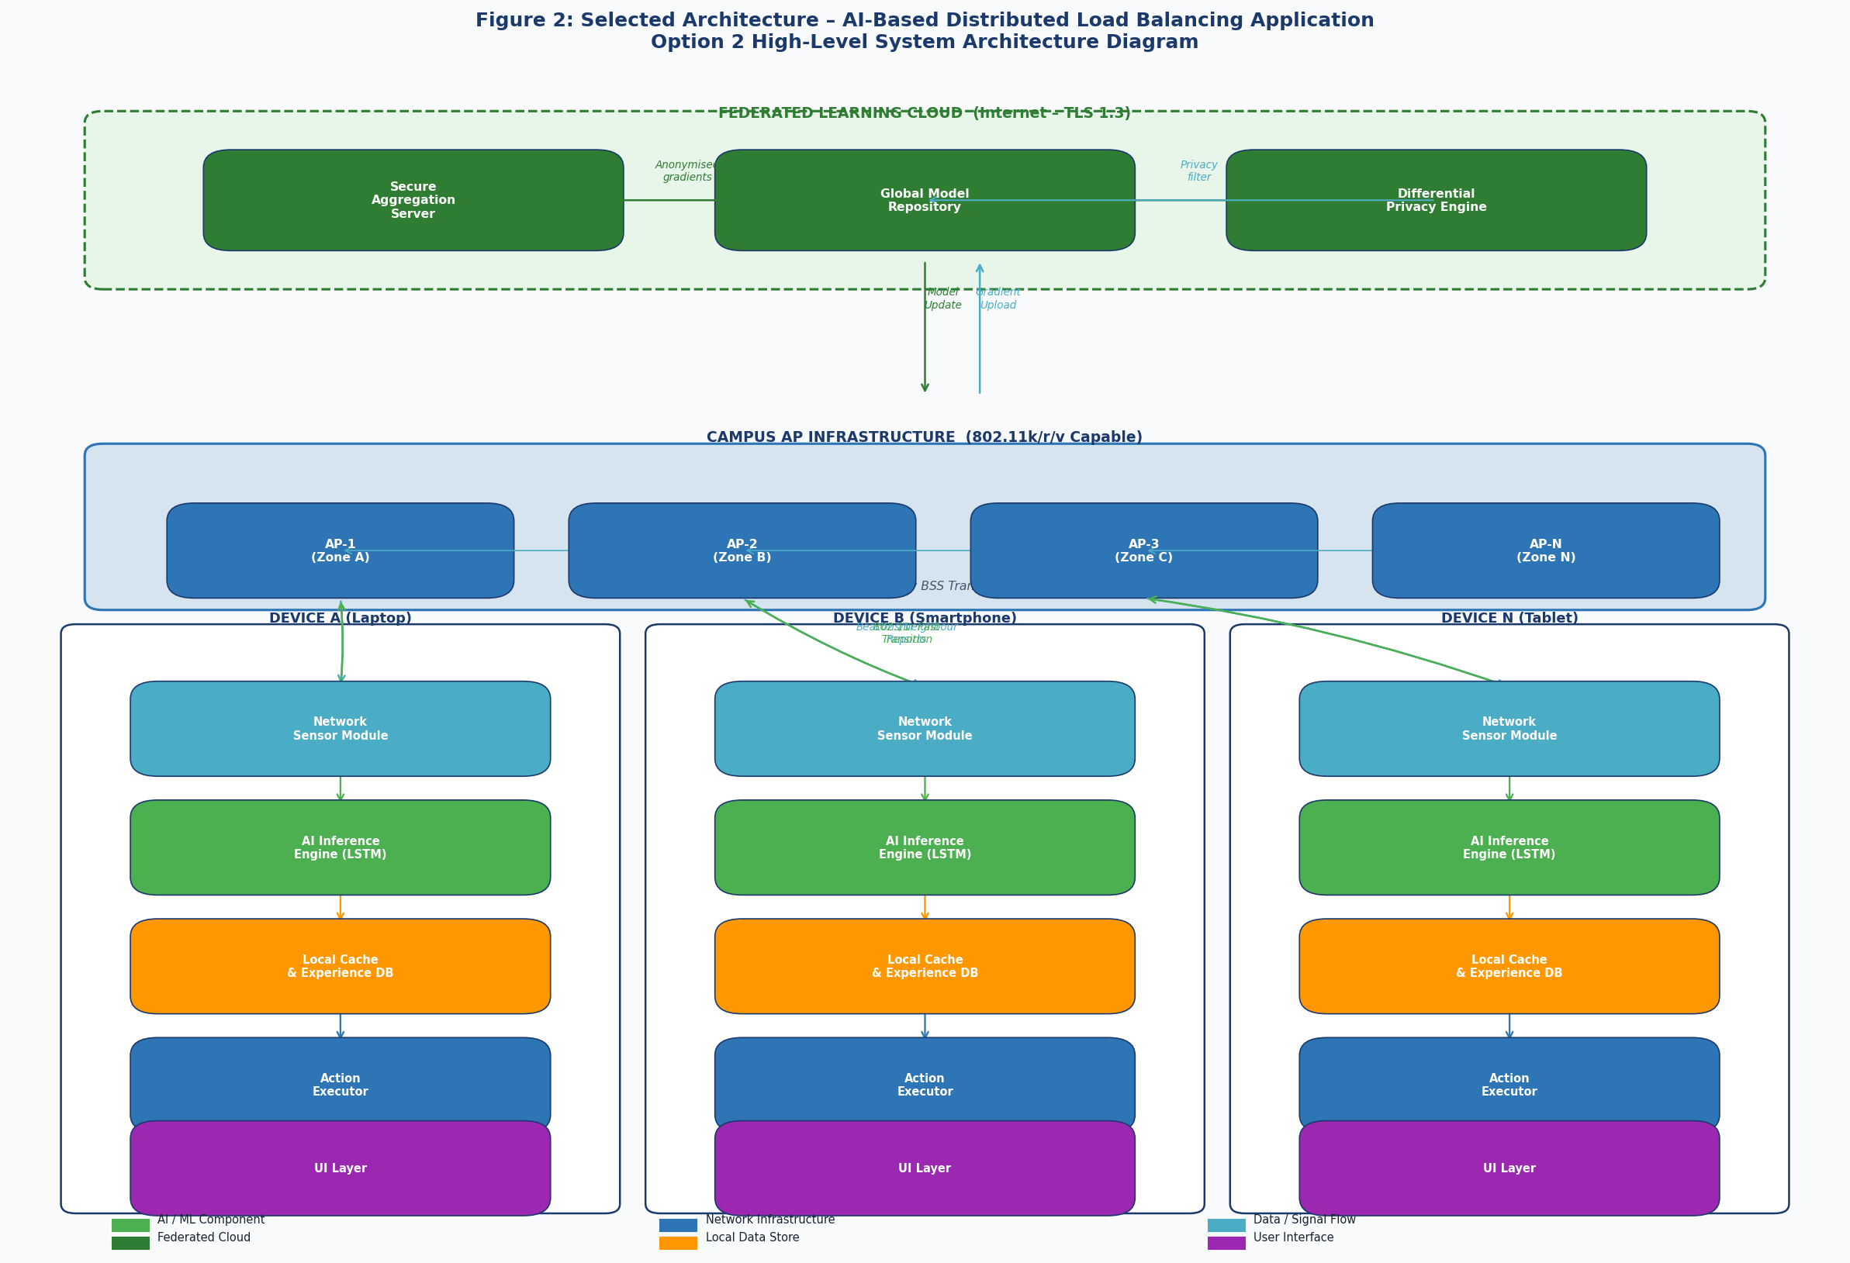
Figure 2 Selected architecture — AI-Based Distributed Load Balancing Application. Shows all three tiers, signal paths, and internal device structure.

4.2 System Architecture Diagram Description
The architecture diagram (Figure 2) illustrates the following key relationships:
- Each client device contains a self-contained AI agent comprising five internal modules (described in Section 5). These modules communicate exclusively through local memory interfaces.
- Client devices communicate with the AP infrastructure via standard 802.11k radio measurement frames (beacon scans, neighbour reports) and 802.11r fast transition frames. No modifications to AP firmware or configuration are required.
- The federated learning cloud communicates with client devices via HTTPS/TLS 1.3 over the standard campus internet connection. Communication is asynchronous and batch-based (weekly), not real-time.
- APs communicate with each other over the standard wired campus backbone. No additional AP-to-AP communication is introduced by this system.

4.3 Data Flow Architecture
The data flow through the system follows the eight-step AI decision loop illustrated in Figure 3.

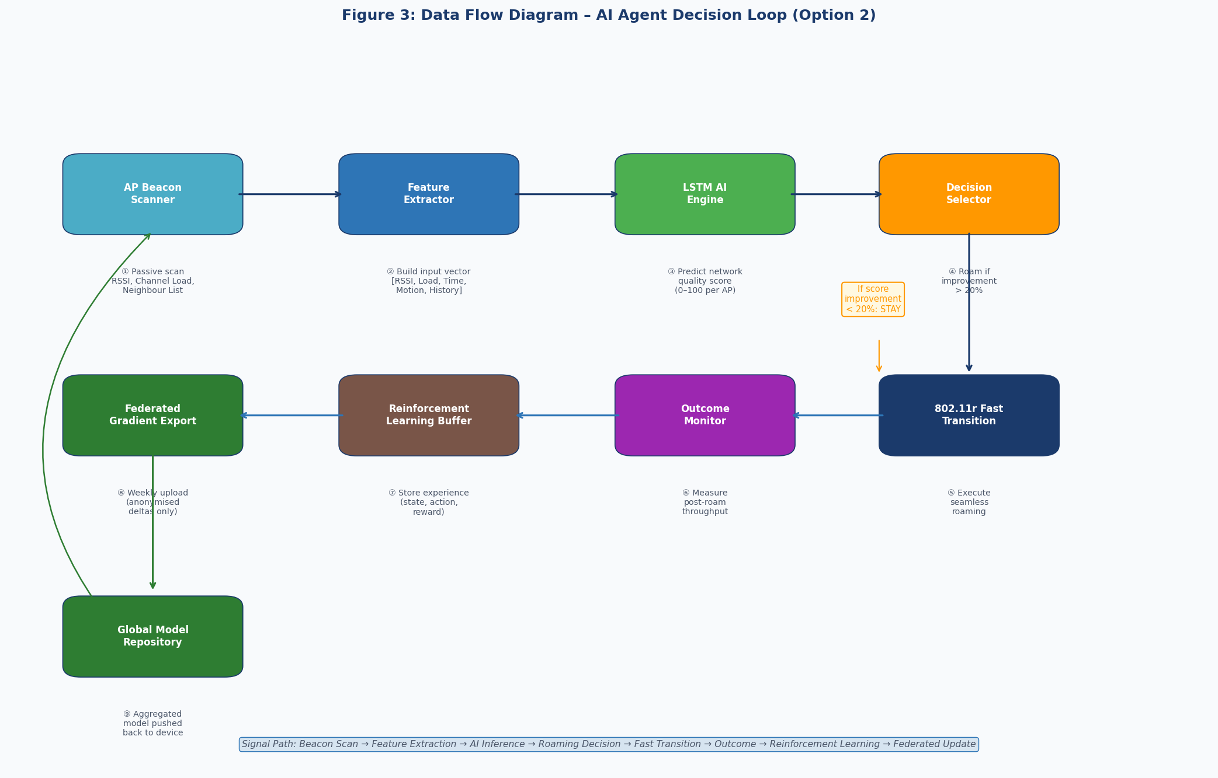
Figure 3 Data flow diagram showing the AI agent decision loop from beacon scan through reinforcement learning to federated model update.

Data Flow Description
The eight-step data flow proceeds as follows:
- The Network Sensor module passively scans beacon frames from all visible APs, extracting RSSI, channel load indication, and 802.11k neighbour reports.
- The Feature Extractor constructs a normalised input vector from the raw measurements, combining current signal quality, AP load estimates, time-of-day context, and device motion state.
- The LSTM AI Engine processes the input vector and predicts a network quality score (0–100) for each candidate AP.
- The Decision Selector compares scores and triggers a roaming action only if the best candidate AP offers a score improvement of more than 20% over the current AP, preventing unnecessary handoffs.
- If roaming is triggered, the Action Executor initiates an 802.11r Fast BSS Transition, achieving handoff in under 50 ms.
- The Outcome Monitor measures post-roaming throughput and latency to quantify the actual improvement achieved.
- The Reinforcement Learning buffer stores the experience tuple (state, action, reward) for inclusion in the next model update.
- Weekly, the Federated Gradient Export module uploads anonymised model weight gradients to the cloud. The cloud returns an improved global model, which replaces the local model on the device.

5. Subsystem Definitions and Interfaces
The system is decomposed into six functional subsystems, each with a well-defined purpose, inputs, outputs, and dependencies. This decomposition reflects functional boundaries, not physical component boundaries. Figure 4 illustrates the subsystem relationship diagram.

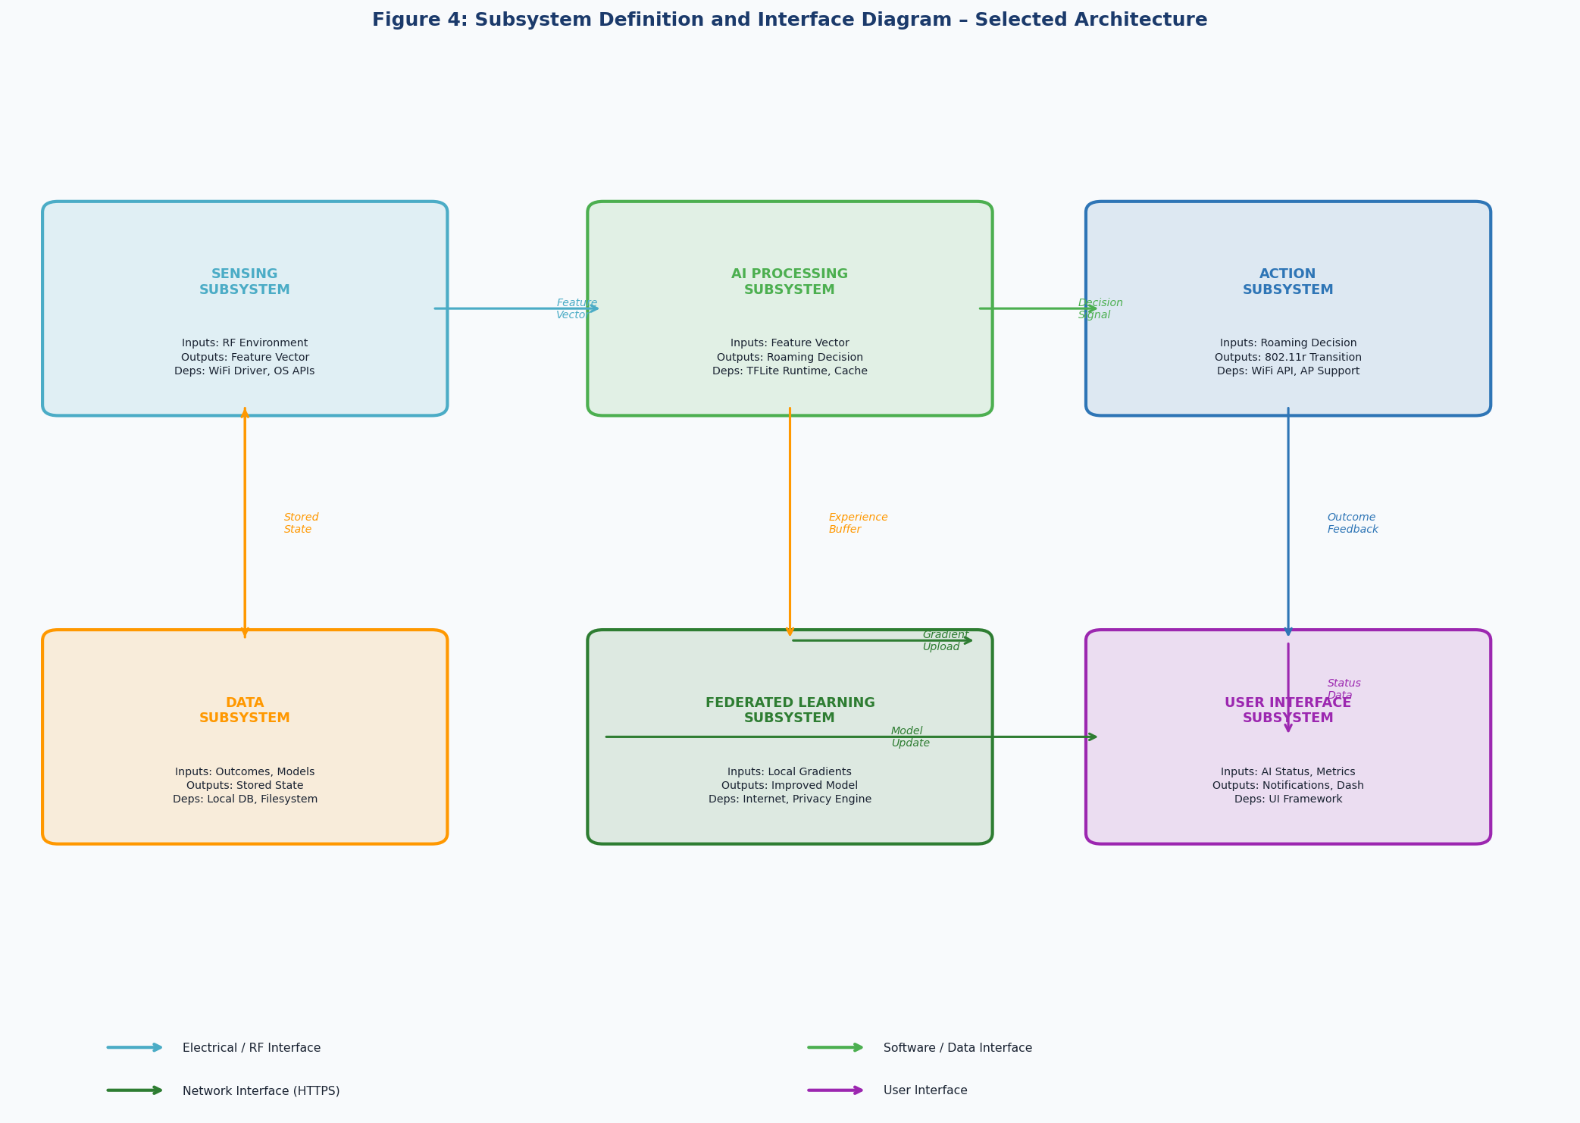
Figure 4 Subsystem definition and interface diagram showing functional boundaries and interface types.

5.1 Subsystem Summary Table
Table 3 Subsystem definitions summary
Subsystem | Primary Function | Inputs | Outputs | Key Dependencies
Sensing | Collect RF environment data from surrounding APs | 802.11 Beacon frames, 802.11k Neighbour Reports | Normalised feature vector (RSSI, load, time, motion) | WiFi driver, OS location/sensor APIs
AI Processing | Predict AP quality scores and generate roaming decisions | Feature vector, historical experience | Roaming decision (target AP + confidence) | TFLite runtime, Local model cache
Action Execution | Execute seamless roaming to target AP | Roaming decision signal | 802.11r Fast Transition, outcome confirmation | OS WiFi APIs, AP 802.11r support
Data Management | Persist experience data and AI model state | Outcome metrics, model weight updates | Stored experience tuples, retrieved model | Local database, filesystem
Federated Learning | Improve global model via privacy-preserving aggregation | Local gradient updates | Improved AI model weights | Internet access, Privacy engine
User Interface | Present system status and controls to the user | AI status, connection metrics, notifications | User-visible dashboard, settings adjustments | UI framework (OS-specific)

5.2 Detailed Subsystem Descriptions

5.2.1 Sensing Subsystem
The Sensing Subsystem is the entry point for all environmental data. It operates continuously in the background, passively monitoring 802.11 beacon frames and actively requesting 802.11k neighbour reports from the currently associated AP. The primary output is a normalised feature vector that encapsulates the current RF environment state, used as input to the AI Processing Subsystem.

The subsystem abstracts platform-specific WiFi APIs (iOS NEHotspot Configuration, Android WifiManager, Windows Native WiFi API, macOS CoreWLAN) behind a common interface, ensuring consistent behaviour across operating systems. It also incorporates motion sensor data (accelerometer) as a contextual feature, since a stationary device has different roaming requirements than one being carried across campus.

5.2.2 AI Processing Subsystem
The AI Processing Subsystem is the core intelligence of the system. It receives the feature vector from the Sensing Subsystem and runs inference through a Long Short-Term Memory (LSTM) neural network to predict the expected connection quality score for each nearby AP. The LSTM architecture is specifically selected for its ability to capture temporal patterns — for example, the predictable load patterns that arise from recurring lecture schedules.

The subsystem includes a reinforcement learning feedback loop: the outcome of each roaming decision is fed back into an experience buffer, which is used to fine-tune the local model between federated updates. This enables the model to adapt rapidly to the specific usage patterns of an individual device and campus location, even within the boundaries of the globally trained model.

5.2.3 Action Execution Subsystem
The Action Execution Subsystem translates the roaming decision produced by the AI Processing Subsystem into a concrete network action. When the AI engine identifies a target AP that offers a significant quality improvement, the Action Execution Subsystem initiates an 802.11r Fast BSS Transition. This protocol allows the device to pre-authenticate with the target AP before disassociating from the current AP, reducing the handoff interruption time to below 50 ms — imperceptible to most applications.

The subsystem also implements a hysteresis mechanism to prevent "ping-pong" roaming: once a transition has been executed, the subsystem enforces a minimum dwell time before the next transition can be evaluated, preventing oscillation between two APs of similar quality.

5.2.4 Data Management Subsystem
The Data Management Subsystem provides persistent storage for all system state, including the experience buffer (recent roaming decision records), the AI model weights, and historical connection quality metrics. It is the only subsystem with persistent state; all other subsystems operate from in-memory data structures derived from the stored state.

Data is stored locally on the device and never leaves the device in raw form. Access to stored data from other subsystems is mediated through defined data interfaces (see Section 5.3), ensuring that privacy boundaries are maintained.

5.2.5 Federated Learning Subsystem
The Federated Learning Subsystem manages the periodic model improvement process. It extracts gradient updates from the experience buffer (representing what the local model has learned since the last sync), applies differential privacy noise to prevent reverse-engineering of individual device behaviour, and uploads the anonymised gradients to the cloud aggregation server.

The cloud server aggregates gradients from thousands of devices using secure aggregation protocols, produces an improved global model, and distributes it back to participating devices. The local subsystem validates the received model before replacing the current model in the Data Management Subsystem. This process is scheduled during low-activity periods (e.g., 02:00 weekly) to minimise impact on the user.

5.2.6 User Interface Subsystem
The User Interface Subsystem presents the system's status and controls to the user. It provides a real-time dashboard showing current AP connection quality, AI agent activity, nearby AP load levels, and roaming history. The subsystem also exposes configuration controls allowing the user to adjust the roaming aggressiveness threshold and privacy settings.

The UI Subsystem is intentionally passive — it does not participate in the roaming decision process and cannot override the AI agent's decisions except through configuration parameters. This design ensures that the AI agent's operation is not affected by UI rendering delays or user interaction.

5.3 Subsystem Interfaces
Interfaces define the contractual boundary between subsystems. The following table defines the key interfaces in the system.

Table 4 Subsystem interface definitions.
Interface | From | To | Type | Description
Feature Vector | Sensing | AI Processing | Data (memory) | Normalised float array encoding RF environment state. Passed per sampling interval.
Decision Signal | AI Processing | Action Execution | Control (internal API) | Target AP BSSID, confidence score, urgency flag. Triggers roaming or hold.
Outcome Feedback | Action Execution | AI Processing | Data (memory) | Post-roaming throughput, latency, and transition success/failure flag.
Experience Buffer | AI Processing | Data Management | Data (DB write) | Structured record of (state, action, reward) tuple for each decision.
Model Weights | Data Management | AI Processing | Data (file read) | TFLite model file retrieved from local storage on agent startup.
Gradient Upload | Federated Learning | Cloud Server | Network (HTTPS) | Anonymised, differentially private weight deltas. Weekly batch upload.
Model Update | Cloud Server | Federated Learning | Network (HTTPS) | Updated global model weights pushed or pulled via secure channel.
Status Data | All Subsystems | User Interface | Data (event bus) | Connection quality metrics, roaming events, agent state for display.
Platform API | Sensing / Action | Operating System | Electrical / OS | OS-specific WiFi APIs for scan results, association commands, and 802.11r triggers.
RF Signal | AP Infrastructure | Sensing Subsystem | Electrical (RF) | 802.11 management frames (beacons, probe responses, neighbour reports) over 2.4/5 GHz.

6. High-Level Subsystem Integration
This section demonstrates that the six subsystems form a coherent, integrated system that satisfies the user requirements from D1. Integration is described conceptually, from input to output, at the system behaviour level.

6.1 System Behaviour Description (Input to Output)
The integrated system behaviour can be described as a continuous closed-loop control system with a learning component:

- A student opens a laptop on campus and connects to the university WiFi network. The application launches automatically in the background (or in the system tray). The Sensing Subsystem begins scanning the RF environment, collecting beacon frames from all visible APs and requesting 802.11k neighbour reports.
- Every one to five seconds, a feature vector is constructed and passed to the AI Processing Subsystem. The AI engine evaluates all candidate APs and calculates a quality score for each. In the initial days of deployment, the model uses the globally pre-trained weights. Over time, the local model adapts to the student's specific movement patterns and schedule.
- For the majority of the time, the AI engine determines that the current AP provides adequate service (score improvement < 20%) and no action is taken. The student experiences uninterrupted connectivity.
- During a peak period (e.g., a lecture ending and students dispersing), the AI engine detects that the current AP's load is increasing and a neighbouring AP offers a substantially better score. The Decision Selector triggers a roaming action. The Action Execution Subsystem initiates an 802.11r Fast BSS Transition, completing the handoff in under 50 ms — below the perceptibility threshold for the student's applications.
- The Outcome Monitor records the post-roaming connection quality and feeds the experience back into the Reinforcement Learning buffer. The model improves its prediction accuracy for this specific location and time of day.
- Once per week, during a low-activity period, the Federated Learning Subsystem uploads anonymised gradients to the cloud. The system receives an updated model reflecting the collective experience of all participating devices across campus, improving prediction accuracy for scenarios the individual device has not yet encountered (e.g., new buildings, special events).
- The User Interface Subsystem presents a summary of the agent's activity to the student: current AP, connection score, roaming history, and federated learning status. The student can observe that the system is managing their connectivity proactively and review settings if desired.

6.2 Requirement Satisfaction Mapping
The following table maps each key user requirement from D1 to the subsystem or subsystem interaction that satisfies it.

Table 5 Requirement-to-subsystem satisfaction mapping.
User Requirement (from D1) | Satisfying Subsystem(s) | Mechanism
Proactively redistribute client load across APs | AI Processing + Action Execution | AI predicts overload before it occurs; 802.11r executes seamless transition
Maintain equitable AP utilisation | Sensing + AI Processing | Load estimates incorporated into feature vector; multi-AP scoring
Roaming interruption < 50 ms | Action Execution | 802.11r Fast BSS Transition protocol provides sub-50ms handoff
No replacement of existing AP hardware | Sensing (802.11k/r passive) | Uses existing AP capabilities; no firmware changes required
Scale to 500+ concurrent clients | Federated Learning (distributed) | Each device is independent; no central bottleneck
Student data privacy (POPIA) | Federated Learning + Data Management | Differential privacy; no raw data leaves device
No degradation during system failure | Action Execution (fallback) | Falls back to native 802.11 roaming if agent unavailable
User visibility and control | User Interface Subsystem | Dashboard, notifications, and settings panel

6.3 Application Interface (Prototype Demo Reference)
The following figure presents a prototype mockup of the application user interface, illustrating the three primary screens: the main dashboard, the network status view, and the settings panel. These mockups are provided to demonstrate system-level thinking about user-facing outputs and do not represent detailed UI design (which is addressed in D3).

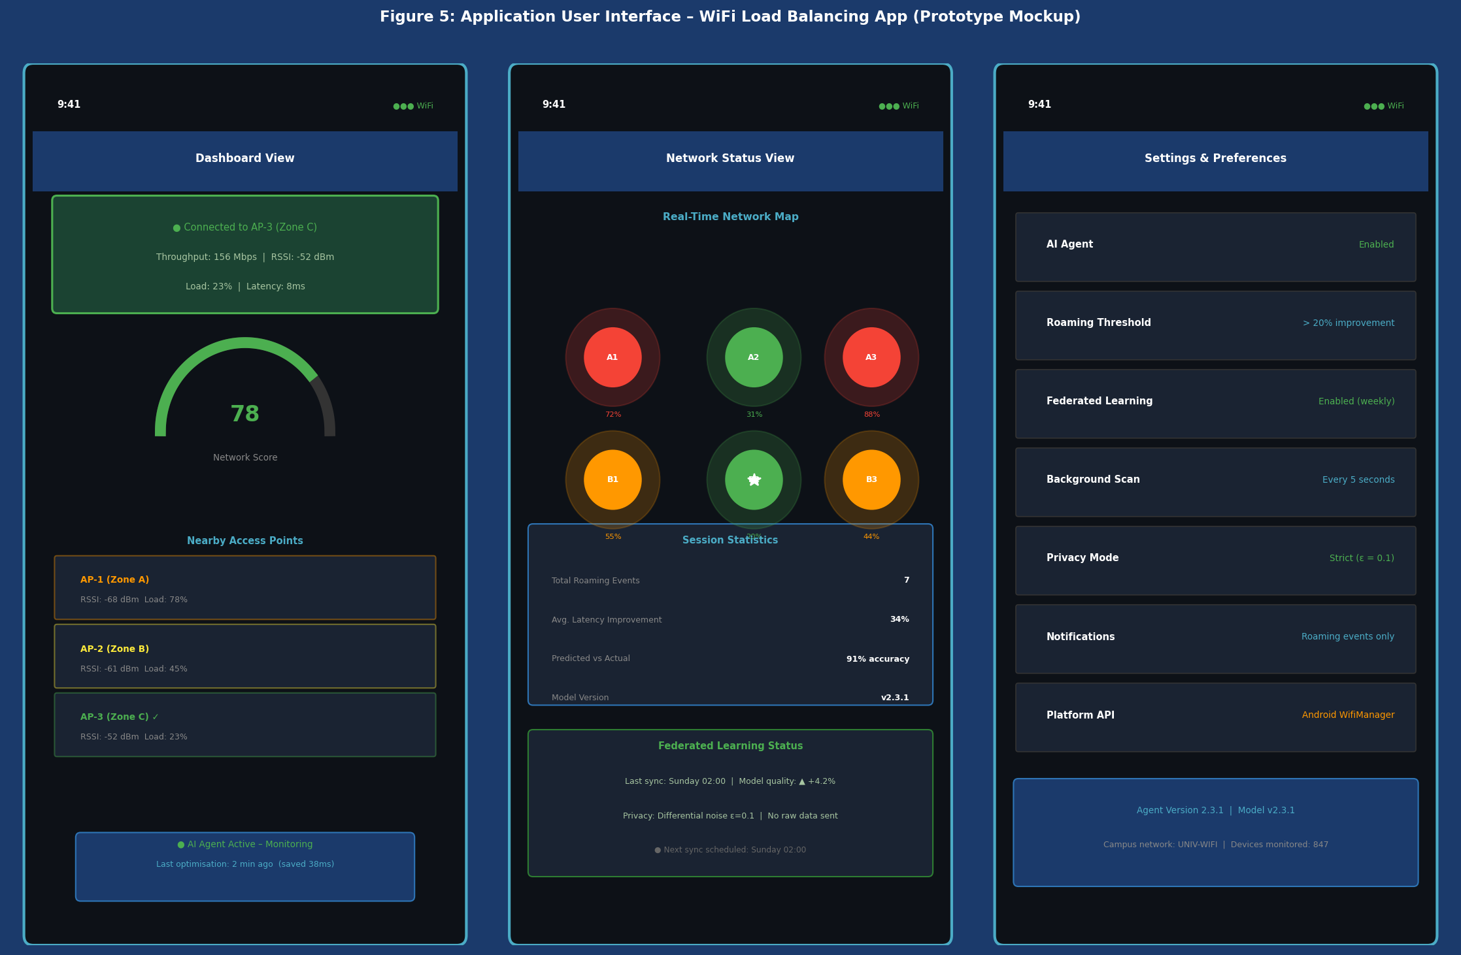
Figure 5 Application UI prototype mockup showing (left) Dashboard view with AP quality score gauge, (centre) Network Status view with real-time campus map, and (right) Settings panel. Interface concept aligned with project demo at: https://shelf-pascal-86470304

Note: The UI prototype referenced above (https://shelf-pascal-86470304.figma.site/) demonstrates the proposed interaction model. The prototype illustrates the real-time AP quality scoring interface, the campus network map, and the AI agent status indicators that form the User Interface Subsystem described in Section 5.2.6.

7. Scope Exclusions

- Specific hardware component selection (microcontrollers, SoCs, sensors)
- LSTM network architecture details (layer counts, hidden dimensions, activation functions)
- Detailed software algorithms and pseudocode
- Circuit diagrams or PCB layouts
- API integration code or platform-specific implementation details
- Performance simulations or benchmark results
- Bill of materials or cost estimates
- Detailed privacy risk assessment or POPIA compliance analysis

8. Conclusion
This deliverable has demonstrated systematic engineering exploration of the WiFi load balancing solution space. Four technically feasible design options were developed at the conceptual level, evaluated using a weighted decision matrix against criteria derived from the D1 user requirements, and compared through explicit trade-off reasoning.

The AI-Based Distributed Load Balancing Application (Option 2) was selected as the preferred design approach based on its superior performance across the most critical criteria: technical effectiveness, reliability, scalability, and privacy. The selection was driven by engineering reasoning — specifically, the elimination of single points of failure, the deployment advantage of requiring no new hardware, and the privacy-by-design guarantee of federated learning with differential privacy — rather than by familiarity or preference.

The high-level architecture has been defined, decomposed into six functional subsystems with well-specified interfaces, and shown to satisfy all key user requirements from D1 through the integration narrative in Section 6. The system architecture is sound at the conceptual level and provides a complete foundation for the detailed design work to be conducted in Deliverable 3.

References
[1] IEEE, "IEEE Standard for Information Technology — Telecommunications and Information Exchange Between Systems — Local and Metropolitan Area Networks — Specific Requirements — Part 11: Wireless LAN Medium Access Control (MAC) and Physical Layer (PHY) Specifications," IEEE Std 802.11-2020, 2020.
[2] B. McMahan, E. Moore, D. Ramage, S. Hampson, and B. A. y Arcas, "Communication-Efficient Learning of Deep Networks from Decentralized Data," in Proc. 20th Int. Conf. Artif. Intell. Statist., 2017, pp. 1273–1282.
[3] M. Abadi et al., "Deep Learning with Differential Privacy," in Proc. ACM SIGSAC Conf. Comput. Commun. Secur., 2016, pp. 308–318.
[4] R. Murty et al., "Designing High Performance Enterprise Wi-Fi Networks," in Proc. NSDI, 2008.
[5] Open Networking Foundation, "SDN Architecture Overview, Version 1.1," ONF TR-521, 2016.
[6] M. Hochreiter and J. Schmidhuber, "Long Short-Term Memory," Neural Computation, vol. 9, no. 8, pp. 1735–1780, 1997.
[7] T. Jiang et al., "Model Pruning Enables Efficient Federated Learning on Edge Devices," arXiv:1909.12326, 2019.
[8] Republic of South Africa, "Protection of Personal Information Act (POPIA), Act 4 of 2013," Government Gazette, 2013.

Appendix A: D2 Submission Self-Assessment Checklist
The following checklist is completed against the D2 assessment criteria to verify submission readiness.

Table 6 D2 submission self-assessment checklist.
✓ | Checklist Item | Location
✓ | Multiple plausible engineering design options presented (≥ 3) | Section 2
✓ | Each option is technically feasible and described at conceptual level | Sections 2.1–2.4
✓ | Each option addresses D1 user requirements | Sections 2.1–2.4
✓ | Engineering trade-off analysis with defined criteria and weights | Section 3.1
✓ | Weighted decision matrix comparing all options | Table 2
✓ | Explicit justification for rejected options | Sections 3.4.1–3.4.3
✓ | Selected option justified by engineering reasoning (not preference) | Section 3.4.4
✓ | High-level system architecture diagram provided | Figure 2
✓ | Data flow diagram provided | Figure 3
✓ | Subsystems identified with purpose, inputs, outputs, dependencies | Section 5
✓ | Subsystem interfaces defined (type, direction, content) | Table 4
✓ | Subsystem integration described from input to output | Section 6.1
✓ | Requirements mapped to satisfying subsystems | Table 5
✓ | No detailed circuit designs, component selection, or code included | Section 7
✓ | No PCB layouts, algorithms, or prototype results included | Section 7

