DEPARTMENT OF ELECTRICAL AND ELECTRONIC ENGINEERING SCIENCE
University of Johannesburg | South Africa

COMPLEX ENGINEERING PROBLEM
Description, High level Design and Detailed Design Report
(D1 + D2 + D3 Combined)
Intelligent WiFi Congestion Monitoring and Recommendation System
Field | Detail
Student Name | Njabulo Sibambo
Student Number | 223124407
Supervisor | Dr Bessie Malila
Department | Electrical and Electronic Engineering Science
Institution | University of Johannesburg
Submission Date | June 2026
Deliverables | D1 – Problem Description | D2 – Design | D3 – Detailed Design

PLAGIARISM DECLARATION
I, an Electrical and Electronic Engineering student at the University of Johannesburg, hereby declare that the content of this document is my own work. I understand what plagiarism constitutes, and that all unethical academic behaviour is punishable by disciplinary action as deemed fit by the university.
Surname: Sibambo Initials: NN Student Number: 223124407
Signature: _SIBAMBO_____________ Date: 2026/05/21

Table of Contents
1. Problem Description 7
1.1 System Boundary Definition 7
1.2 Stakeholders Affected 8
2. Argument That This Is a Complex Engineering Problem 9
2.1 Systems-Level Interactions 9
2.2 Conflicting Technical Constraints 9
2.3 Requirement for First-Principles Analysis 10
Shannon-Hartley Theorem 10
M/M/1 Queueing Model 10
2.4 Absence of Standard Solutions 11
3. User Requirements 11
4. Engineering Fundamentals and Scientific Underpinning 12
5. Resource Use, Environmental Impact and Lifecycle Considerations 12
6. Five Engineering Solution Alternatives 16
6.1 Alternative 1 – Access Point Hardware Upgrade 16
6.2 Alternative 2 – Enterprise Wireless LAN Controller (WLC) 16
6.3 Alternative 3 – AP-Side Client Load Balancing Firmware 16
6.4 Alternative 4 – 802.11k/v-Based Assisted Roaming 17
6.5 Alternative 5 – On-Device Intelligent Monitoring and Recommendation System (SELECTED) 17
7. Selected Solution: Detailed System Design 17
7.1 Core Project Concept 18
7.2 System Architecture – Five Subsystems 18
8. System Data Flow 18
9. Intelligent Scoring Algorithm 20
9.1 Scoring Formula 20
9.2 AP Classification Thresholds 21
10. Dashboard User Interface Design 21
11. Multi-Device Support Architecture 22
12. System Requirements 23
13. Testing Plan and Validation Strategy 23
14. Known Limitations 24
15. Introduction and Scope of D3 27
16. Refined System Architecture 27
16.1 Module File Structure 27
16.2 Interface Definitions 28
17. Sensing Subsystem – Detailed Design 29
17.1 OS Command and Parsed Fields 29
17.2 RSSI Derivation 29
17.3 APRecord Data Structure 29
17.4 Hardware Parameters 30
18. Network Testing Subsystem – Detailed Design 30
18.1 Ping Command 30
18.2 Derived Performance Metrics 31
18.3 Stability Score Derivation 31
18.4 PingResult Data Structure 31
19. Intelligent Scoring Subsystem – Detailed Design 31
19.1 Normalisation Specifications 31
Signal Strength Normalisation 32
Latency Normalisation 32
Packet Loss Normalisation 32
Stability Normalisation 32
19.2 Recommendation Decision Logic 32
19.3 ScoredAP Data Structure 32
20. Data Storage Subsystem – Detailed Design 32
20.1 CSV Schema 33
20.2 File Naming and Write Operation 33
20.3 Storage Capacity Calculation 34
21. Engineering Calculations 34
21.1 Shannon-Hartley Per-User Throughput 34
21.2 M/M/1 Queueing Latency Prediction 34
21.3 Measurement Accuracy Analysis 35
21.4 CPU and Memory Footprint 35
22. System Integration Design 36
22.1 Configuration Parameters 36
22.2 End-to-End Worked Example 36
Input Measurements 37
Step 1: Normalisation for AP-01 (connected) 37
Step 2: Score Calculation for AP-01 37
Step 3: AP-02 and AP-03 (not connected – signal score only, other sub-scores default to 50) 37
Step 4: Recommendation Decision 37
23. User Interface Subsystem – Detailed Design 38
23.1 Implementation: Streamlit 38
23.2 Streamlit Component Mapping 38
23.3 Recommendation Message Templates 38
24. Unit and Integration Testing Plan 39
24.1 Unit Tests 39
24.2 Integration Tests 39
25. Known Limitations and Future Work 40
25.1 Known Limitations 40
25.2 Future Work 40
References 41

PART D1
Complex Engineering Problem
Description and Overview
1. Problem Description
Wireless Local Area Networks (WLANs) allow devices such as laptops, smartphones, and tablets to connect to the internet using radio frequency (RF) signals, eliminating the need for physical cabling infrastructure. In university environments these networks constitute critical infrastructure that supports all teaching and learning activities, including programming laboratories, software installation sessions, and online examination platforms.
During laboratory sessions it is common for many students to simultaneously download large software packages, stream instructional videos, or access online assessment platforms. When this occurs inside a lecture hall or computer laboratory, dozens of devices begin requesting large volumes of data at the same time. Each device automatically connects to the wireless access point (AP) that provides the strongest Received Signal Strength Indicator (RSSI), which is the default behaviour of all standard IEEE 802.11 WiFi association algorithms [4].
This signal-strength-first association behaviour consistently produces an uneven distribution of users across the available APs in the vicinity. One AP may accumulate twenty or more connected devices while a physically nearby AP remains nearly unused. The overloaded AP is forced to share its fixed radio channel bandwidth among all connected users. According to the Shannon-Hartley Theorem, the maximum channel capacity is physically bounded by available bandwidth and signal-to-noise ratio and cannot be exceeded [2]. When this bounded capacity is divided among many simultaneous users, each individual user receives a much smaller fraction, resulting in severely degraded download speeds and long waiting times.
The engineering problem is formally defined as: the inefficient and unbalanced distribution of wireless network traffic among multiple access points in a high-density indoor environment, resulting in severe congestion and significantly degraded network performance for all users connected to overloaded access points [1, 4].
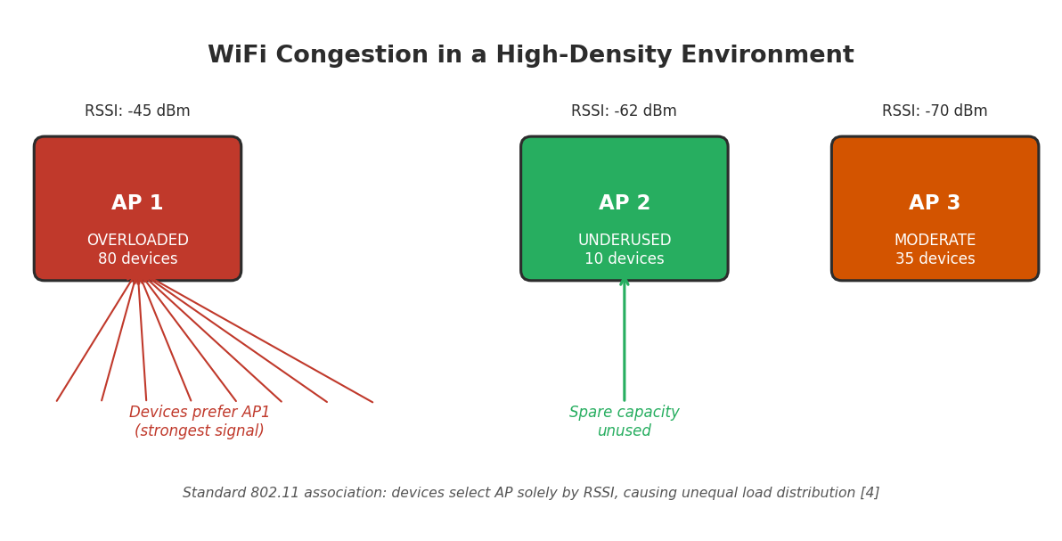
Figure 1 – WiFi Congestion in a High-Density Environment: AP 1 is overloaded while AP 2 has spare capacity [4]

1.1 System Boundary Definition
The system boundary defines which elements are included in the engineering analysis and which are excluded from the design scope. Table 1 presents this boundary.
System Element | Included | Reason
Student laptops and smartphones | Yes | Primary sources of network traffic in the high-density environment
Wireless access points (APs) | Yes | Provide wireless communication services to all connected devices
RF communication channel (2.4/5 GHz) | Yes | Physical medium through which WiFi signals propagate [5, 6]
Building environment (walls, layout) | Yes | Directly influences signal attenuation, reflection, and interference patterns [5]
On-device monitoring software | Yes | Core system under design – scans, scores, and displays AP quality
External internet backbone | No | Congestion occurs at the local AP level, not the ISP or backbone
Remote servers hosting downloads | No | Not responsible for the local traffic imbalance between APs
Table 1 – System Boundary Definition
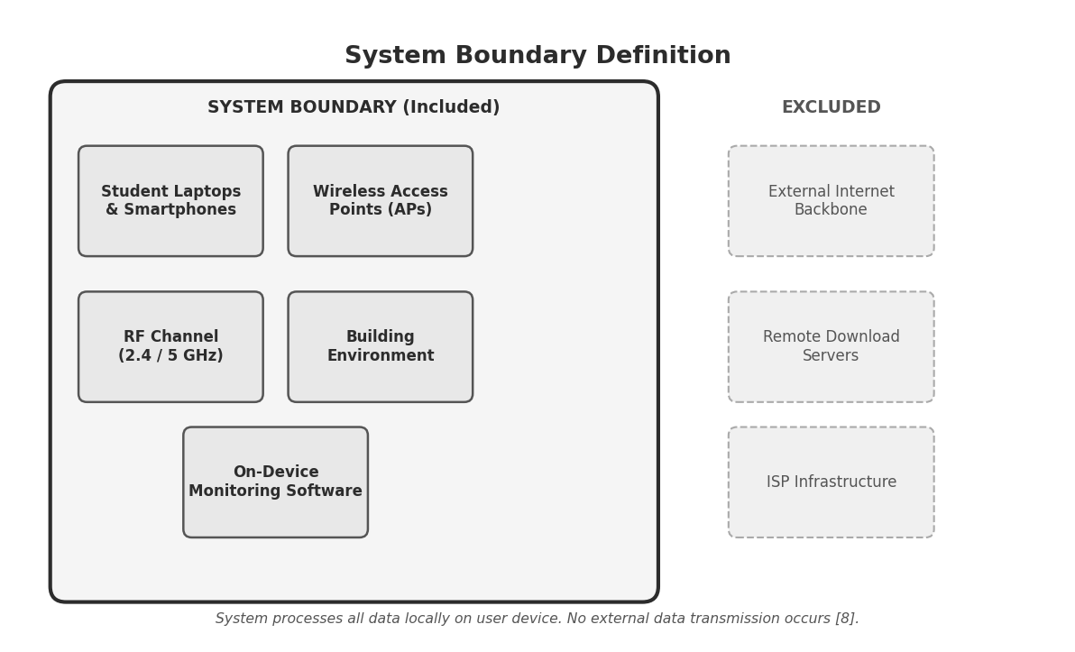
Figure 2 – System Boundary: Included components (inner box) and excluded components (outer, dashed)

1.2 Stakeholders Affected
Multiple stakeholders are directly and indirectly affected by WiFi congestion in a university environment, as described in Table 2.
Stakeholder | Impact of WiFi Congestion
Students | Delayed software downloads, failed exam submissions, and interrupted learning during laboratory sessions
Lecturers | Reduced instructional time due to troubleshooting and extended wait for student downloads to complete
IT Administrators | Increased network troubleshooting workload, system monitoring demand, and rising user complaints
University Management | Financial pressure from infrastructure upgrade costs; reputational impact from poor service quality
Table 2 – Stakeholders and Their Impacts

2. Argument That This Is a Complex Engineering Problem
According to the Engineering Council of South Africa (ECSA), a complex engineering problem is one that involves several interacting systems, presents conflicting engineering constraints, and requires analysis using engineering fundamentals such as electromagnetic theory, information theory, and mathematical modelling rather than simple configuration adjustments or standard procedures [1].
This section demonstrates that the WiFi congestion problem satisfies all ECSA criteria for a complex engineering problem.

2.1 Systems-Level Interactions
The WiFi network is not a single component but a collection of interacting subsystems. The overall system behaviour depends on dynamic interactions between these subsystems, which cannot be predicted or optimised by considering any one component in isolation [5, 6].
Subsystem | Role | Engineering Discipline
User devices | Generate and receive network traffic | Computer networking, protocol engineering
Access points (APs) | Distribute wireless bandwidth to connected users | Wireless communications, RF engineering
RF channels (2.4/5 GHz) | Carry modulated signals between devices and APs | Electromagnetic theory, information theory [2]
Indoor building environment | Causes signal attenuation, reflection, and multipath fading | Electromagnetics, propagation modelling [5, 6]
Network protocols (TCP/IP, 802.11) | Control packet routing, acknowledgment, and retransmission | Networking theory, queueing theory [3, 4]
Table 3 – Interacting Subsystems and Their Engineering Disciplines

2.2 Conflicting Technical Constraints
Wireless network design must simultaneously balance several competing engineering objectives. Because these objectives conflict with each other, the system cannot be optimised using any single simple strategy [1].
Objective | Conflict | Trade-Off
Maximum data throughput | May reduce fairness between individual users | Speed vs. equity
Strong signal connection (RSSI) | May cause device to overload a specific AP | Signal strength vs. load balance [4]
Balanced traffic distribution | Requires temporary disconnection when switching APs | Balance vs. connection stability
Stable wireless connections | Prevents the system from redistributing traffic dynamically | Stability vs. dynamic optimisation
Low device energy consumption | Limits frequency of active scanning and monitoring | Energy efficiency vs. monitoring accuracy
Table 4 – Conflicting Engineering Constraints

2.3 Requirement for First-Principles Analysis
Analysis of the WiFi congestion problem requires direct application of fundamental engineering laws and mathematical models from multiple disciplines [2, 3, 5].

Shannon-Hartley Theorem
The Shannon-Hartley Theorem defines the theoretical maximum data rate achievable on a communication channel in the presence of noise [2]:
C = B · log₂(1 + SNR)
where C = channel capacity (bps), B = channel bandwidth (Hz), SNR = signal-to-noise ratio (linear)
This law proves that the capacity of a wireless channel is physically bounded [2]. When many users share the same AP channel simultaneously, the available capacity must be divided among them, which is the fundamental cause of congestion.
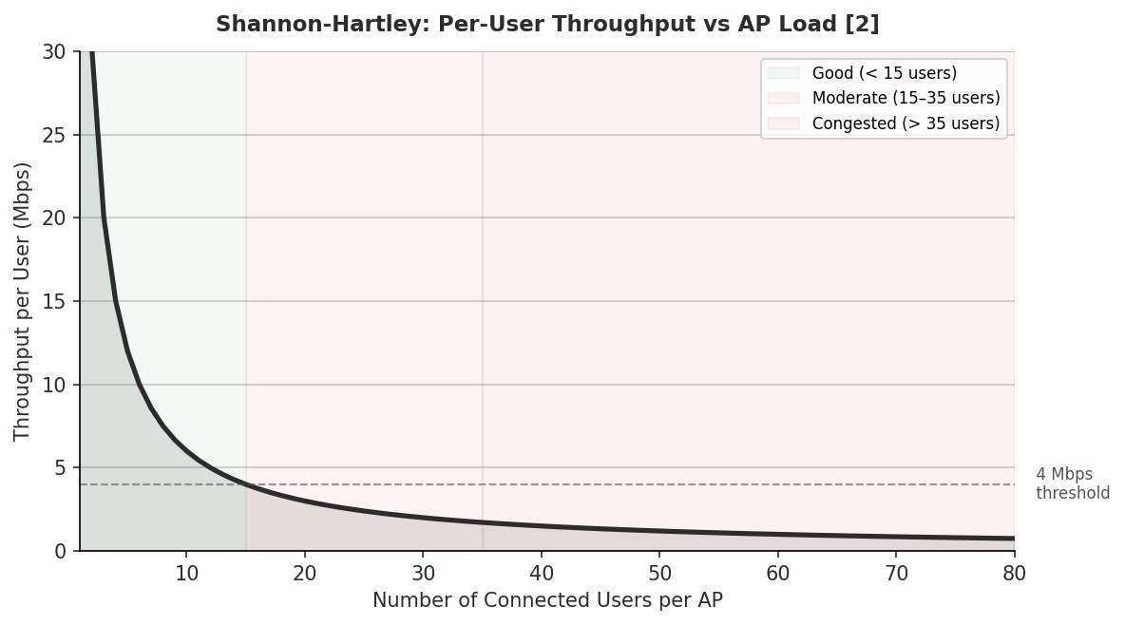
Figure 3 – Shannon-Hartley Model: Per-user throughput decreases as the number of users on one AP increases [2]

M/M/1 Queueing Model
The M/M/1 queueing model quantifies the relationship between traffic load, waiting time, and packet delay at an access point [3]:
W = 1 / (μ − λ)
where W = mean packet waiting time, μ = AP service rate (packets/s), λ = total arrival rate (packets/s)
As the traffic load λ approaches the service rate μ, the waiting time W rises non-linearly toward infinity. This explains why small increases in user count near saturation cause disproportionately large increases in latency [3].
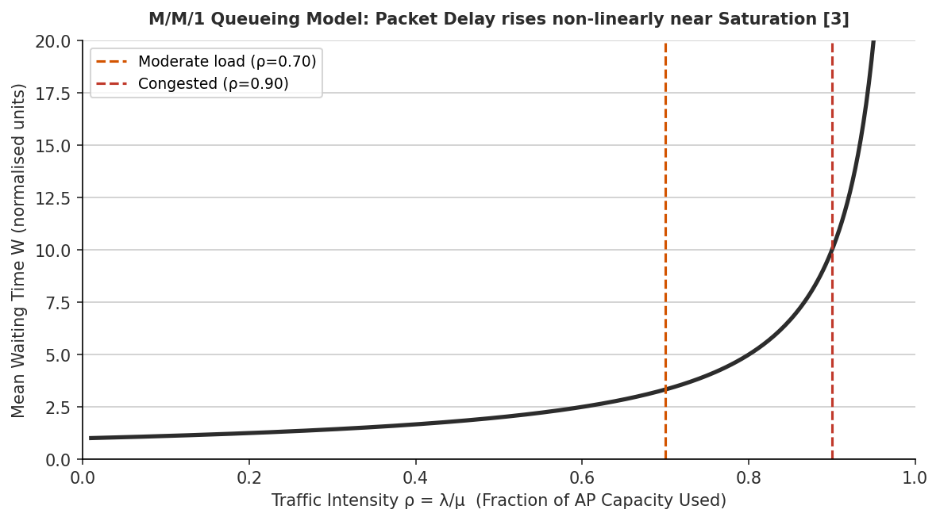
Figure 4 – M/M/1 Queueing Model: Mean packet delay rises exponentially as AP load approaches saturation [3]

2.4 Absence of Standard Solutions
Standard WiFi association algorithms defined by the IEEE 802.11 specification rely exclusively on signal strength (RSSI) to select access points [4]. These algorithms do not account for the current load on each AP or the actual congestion level. As a direct result, devices may connect to and remain connected to an already severely overloaded AP, even when neighbouring APs with significant available capacity are physically close. This represents a fundamental limitation of existing standard procedures, confirming that the problem requires engineering analysis beyond routine configuration methods [1].

3. User Requirements
User requirements describe the expected outcomes and performance characteristics of the system from the perspective of the stakeholders. These requirements do not prescribe specific design solutions but define measurable performance targets that any acceptable solution must satisfy.
Table 5 – User Requirements
ID | Requirement | Measurement Method | Priority
UR1 | Support a large number of simultaneous users in one location | Number of concurrently connected devices | High
UR2 | Maintain acceptable download speed during peak usage periods | Average download speed in Mbps | High
UR3 | Ensure balanced distribution of users across available APs | Standard deviation of users per AP | High
UR4 | Maintain stable wireless connections for all users | Connection drop rate per session | Medium
UR5 | Operate within existing campus infrastructure without hardware changes | Compatibility verification – no admin access needed | High
UR6 | Minimise energy consumption of user devices during monitoring | Device battery usage during operation | Low
UR7 | Provide real-time visibility of AP congestion status to the user | Dashboard refresh rate and responsiveness | High
UR8 | Protect user privacy – all data must be processed and stored locally | Data transmission audit – no external uploads | High

4. Engineering Fundamentals and Scientific Underpinning
Several distinct engineering and mathematical disciplines are required to fully understand, model, and address the WiFi congestion problem. Each discipline contributes specific analytical tools and theoretical frameworks.
Engineering Field | Application to This Problem | Key Principle or Reference
Electromagnetic Theory | Explains how radio signals propagate, attenuate through walls, and create interference | Free-space path loss equation [5, 6]
Wireless Communication Theory | Determines practical data transmission limits under real-world RF conditions | Shannon-Hartley: C = B·log₂(1+SNR) [2]
Information Theory | Defines the maximum theoretical channel capacity and the effect of noise | Shannon entropy and channel capacity bounds [2]
Computer Networking | Explains packet routing, congestion control, and TCP behaviour under load | TCP/IP congestion window, 802.11 MAC [4]
Queueing Theory | Models the relationship between traffic load, waiting time, and packet delay at each AP | M/M/1 queue: W = 1/(μ − λ) [3]
Graph Theory | Represents the network topology and relationships between devices, APs, and links | Weighted graph models, shortest path
Statistics and Data Science | Used in the scoring model to normalise raw metrics and weight multiple indicators | Weighted scoring, statistical normalisation
Table 6 – Engineering Theory and Application

5. Resource Use, Environmental Impact and Lifecycle Considerations
Engineering solutions must always be evaluated for their resource usage, environmental impact, and long-term sustainability [1]. The design of the monitoring system explicitly addresses these considerations.
Constraint | Impact | Design Response
Hardware cost | Adding new APs requires significant capital investment | System runs on existing user devices – no new hardware required
Energy consumption | Congestion causes repeated TCP retransmissions, wasting device energy [8] | Better AP selection reduces retransmissions and conserves battery life
Maintenance complexity | Advanced infrastructure systems require specialist network technicians | On-device software is simple to update and requires no specialist support
Scalability | Infrastructure must support future growth in device numbers | Software scales automatically to any number of devices without modification
Equipment lifespan | Existing AP infrastructure should remain useful for many years | Better traffic distribution extends the effective life of current APs
Table 7 – Resource and Lifecycle Constraints
PART D2
Complex Engineering Problem
System Design
6. Five Engineering Solution Alternatives
Before selecting a final design approach, five distinct engineering solution alternatives were identified and evaluated. The five alternatives presented here are closely related options that all address the WiFi congestion problem from a wireless network perspective. Each alternative was assessed against four key engineering criteria: feasibility within project scope, infrastructure change required, estimated cost, and expected effectiveness. The five alternatives and the multi-criteria evaluation are shown below.
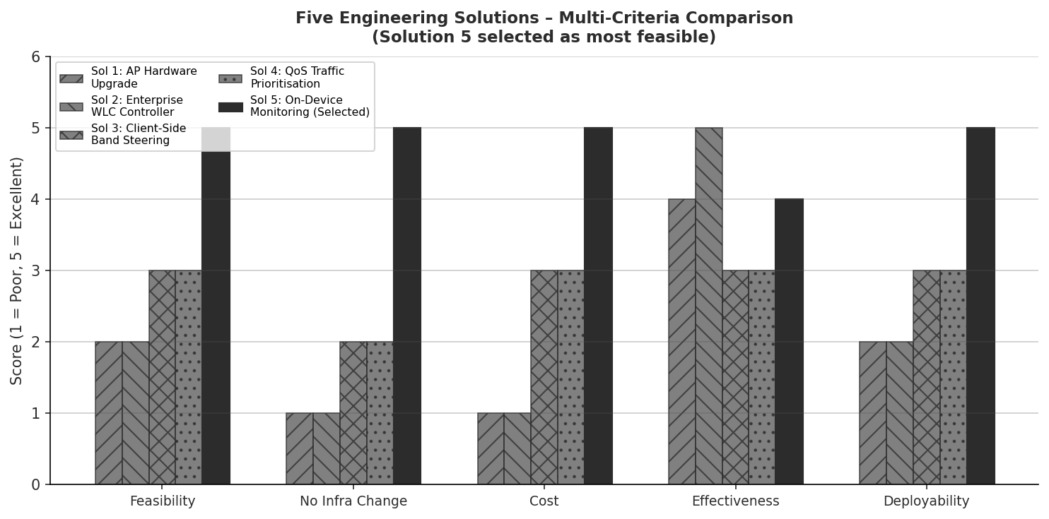
Figure 5 – Five Engineering Alternatives: Multi-Criteria Comparison Matrix (Solution 5 selected)

6.1 Alternative 1 – Access Point Hardware Upgrade
This alternative proposes replacing existing AP hardware with newer, higher-specification 802.11ax (Wi-Fi 6) access points that support MU-MIMO (Multi-User Multiple Input Multiple Output) technology. Wi-Fi 6 APs can serve multiple devices simultaneously on distinct spatial streams, reducing effective congestion per AP. However, this requires procurement, physical installation, electrical cabling, and configuration by IT staff with full administrative access. The capital expenditure for a single lab of 20 APs ranges from R80,000 to R200,000. This alternative is not feasible within the project scope and budget [4].

6.2 Alternative 2 – Enterprise Wireless LAN Controller (WLC)
A centralised Wireless LAN Controller (WLC) such as a Cisco Catalyst 9800 or Aruba Mobility Controller monitors all AP loads in real time and enforces client association policies. The WLC can issue disassociation frames to clients connected to overloaded APs and redirect them to less-loaded alternatives. While this is the most effective infrastructure-based solution, it requires enterprise-grade hardware costing from R150,000, complex integration with the campus network switch fabric, and exclusive administrative access to all APs on the campus LAN. This alternative is therefore excluded due to infrastructure and budget constraints [4].

6.3 Alternative 3 – AP-Side Client Load Balancing Firmware
Several AP firmware implementations (including OpenWRT and some vendor firmware) support proprietary client load-balancing features. These features allow individual APs to detect when a client's RSSI exceeds a threshold, and to defer association responses, effectively steering the client toward a less-loaded AP. This approach requires firmware modification or replacement on every campus AP, which is not possible without administrative access to the AP management system. Additionally, firmware modifications carry warranty and compliance risks for the university's network infrastructure [4].

6.4 Alternative 4 – 802.11k/v-Based Assisted Roaming
The IEEE 802.11k (Radio Resource Management) and 802.11v (BSS Transition Management) protocol extensions allow APs to broadcast neighbour reports and send BSS Transition Management Request frames to clients, suggesting or requesting a roam to a better AP. This is a standards-compliant mechanism that preserves open roaming without forcing disconnection. However, both the campus APs and client devices must support 802.11k/v, which requires verification and often firmware updates on the AP side. Campus network administrators must also enable these features in the wireless controller configuration. This alternative is therefore not feasible without infrastructure access [4].

6.5 Alternative 5 – On-Device Intelligent Monitoring and Recommendation System (SELECTED)
The selected solution runs entirely on the user's own device. It continuously scans nearby APs using operating system commands, measures real-world performance metrics including signal strength, latency, and packet loss, calculates a quality score for each AP, and presents this information through a real-time colour-coded dashboard. The system recommends the best available AP to the user without requiring any changes to the network infrastructure.
This alternative was selected because it requires no hardware procurement, no infrastructure changes, no administrative access, and no additional cost. It operates entirely within the engineering constraints of a student project while delivering a measurable and practical impact on the user experience. It also satisfies all eight user requirements identified in Section 3.
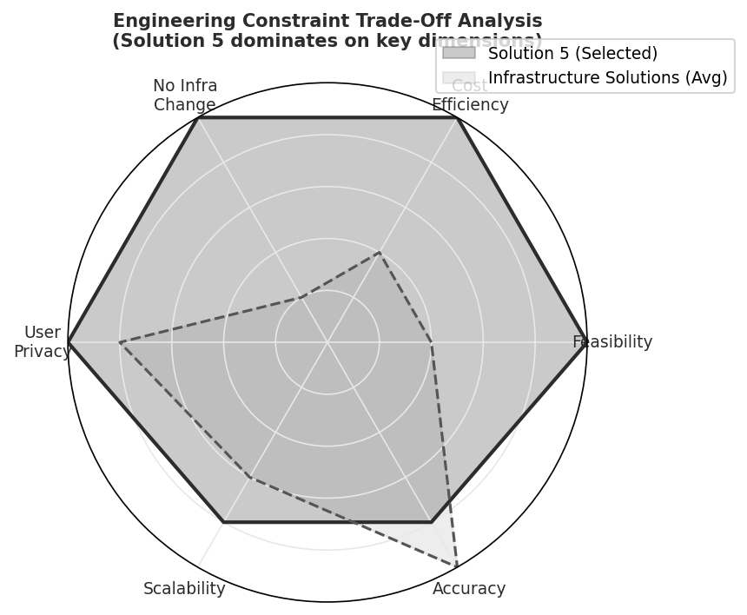
Figure 6 – Engineering Constraint Trade-Off Analysis: Solution 5 dominates across key dimensions

7. Selected Solution: Detailed System Design

7.1 Core Project Concept
The Multi-Device Intelligent WiFi Congestion Monitoring and Recommendation System is an on-device software tool that helps users identify and connect to the best available wireless access point in high-density environments. The system performs all processing locally on the user's device and does not modify or interact with the network infrastructure in any way.
The system operates on three device categories: laptops (primary prototype implemented on Windows 10/11), smartphones, and tablets. On each device the system performs three core functions: it observes WiFi conditions by scanning nearby access points, analyses connection quality by measuring real-world performance metrics, and recommends better connectivity options to the user through a visual dashboard.
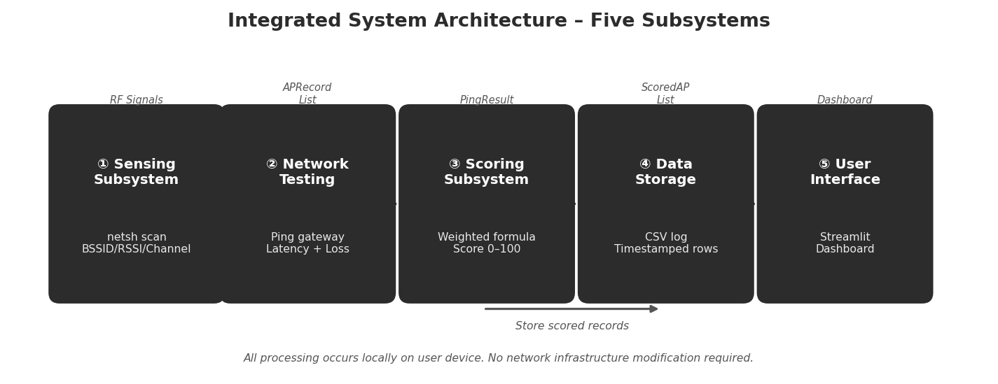
Figure 7 – Integrated System Architecture: Five subsystems process WiFi data in a continuous pipeline

7.2 System Architecture – Five Subsystems
The system is structured as five clearly defined subsystems, each responsible for a distinct function. The subsystems interact in a linear pipeline with a data storage feedback loop.
Subsystem | Function | Input | Output
① Sensing | Detect and list all nearby WiFi APs | RF signals from environment | List of APs with SSID, BSSID, RSSI, channel
② Network Testing | Measure current connection quality via ping | Active network connection | Latency (ms) and packet loss (%)
③ Scoring | Calculate a quality score for each AP using weighted formula | Normalised RSSI, latency, packet loss, stability | Score (0–100) and status classification
④ Data Storage | Store all measurements with timestamps | Scores and raw measurements | Historical data in CSV file
⑤ User Interface | Display results and recommendations | Scores and status classifications | Colour-coded dashboard and recommendation message
Table 8 – Five Subsystems: Functions, Inputs and Outputs

8. System Data Flow
The following data flow describes the complete step-by-step operation of the system from startup to continuous real-time monitoring. The system repeats this process every 10 seconds to provide up-to-date information.
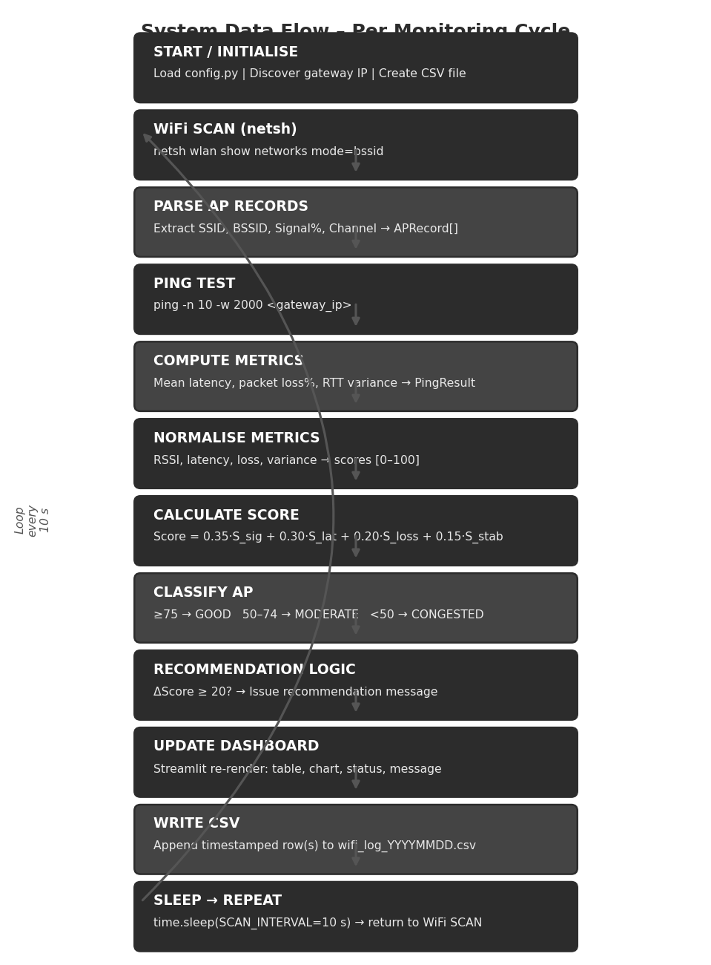
Figure 8 – Step-by-Step Data Flow Diagram: continuous monitoring loop from scan to store
Step | Action | Technical Detail
1 | Launch application | User opens Python application; Streamlit dashboard loads at localhost:8501; monitoring loop initialises
2 | WiFi scan | Device executes: netsh wlan show networks mode=bssid (Windows); scans all visible APs in RF vicinity
3 | Identify APs | Each network uniquely identified using BSSID (MAC address); same-SSID networks treated as separate APs
4 | Performance test | Ping test to default gateway: ping -n 10 -w 2000 <gateway_ip>; measures latency and packet loss
5 | Normalise metrics | Raw values converted to 0–100 scale; RSSI of −30 dBm → 100; −90 dBm → 0; latency <20 ms → 100; >200 ms → 0
6 | Calculate score | Score = 0.35×Signal + 0.30×Latency + 0.20×PacketLoss + 0.15×Stability
7 | Classify AP | Score ≥ 75 → GOOD (green); Score 50–74 → MODERATE (orange); Score < 50 → CONGESTED (red)
8 | Display dashboard | Streamlit renders colour-coded AP table, signal bars, latency trend, current AP status
9 | Recommend | If ΔScore ≥ 20: display message: 'Better connection available: [AP name]. Move toward that direction.'
10 | User acts | User may move location, manually reconnect to recommended AP, or remain; system does not force action
11 | Store data | All measurements appended to wifi_log_YYYYMMDD_HHMMSS.csv with ISO-8601 timestamp
12 | Loop | time.sleep(10 seconds) → return to Step 2; continuous real-time monitoring throughout session
Table 9 – Step-by-Step System Operation

9. Intelligent Scoring Algorithm
The core intelligence of the system is the weighted scoring algorithm. This algorithm converts multiple raw WiFi measurements into a single, easy-to-interpret quality score for each access point. The scoring approach is computationally lightweight, transparent, and explainable.
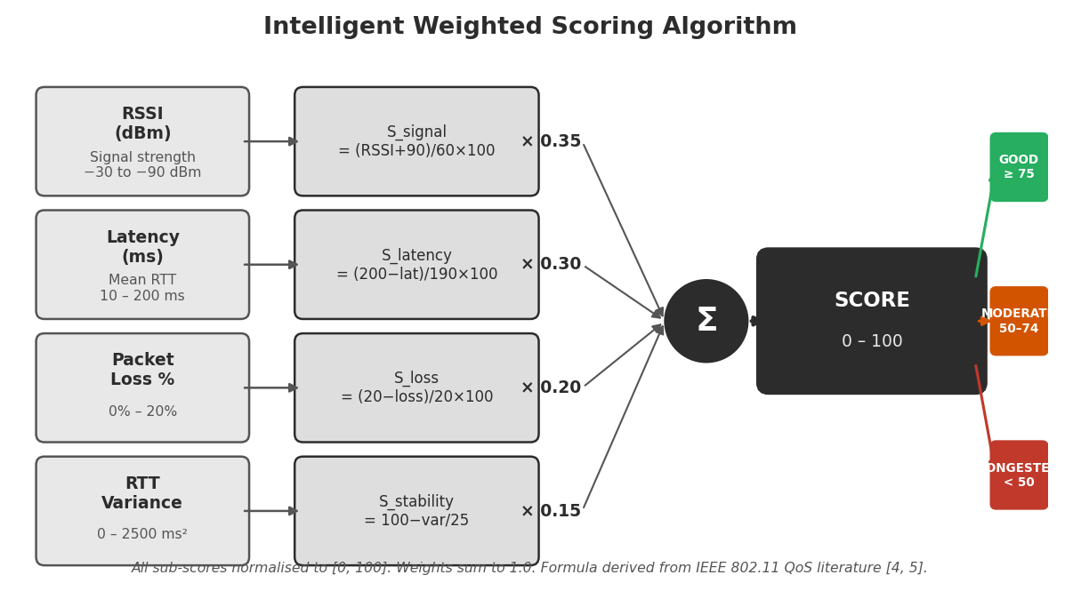
Figure 9 – Intelligent Scoring Algorithm: four normalised metrics combined with weights to produce a classified score

9.1 Scoring Formula
Score = 0.35 × S_signal + 0.30 × S_latency + 0.20 × S_loss + 0.15 × S_stability
Metric | Weight | Normalisation | Justification
Signal Strength (RSSI) | 35% | −30 dBm → 100; −90 dBm → 0 | Most widely available metric; directly indicates link quality; accounts for over-reliance on RSSI by current algorithms [4]
Latency (ms) | 30% | <20 ms → 100; >200 ms → 0 | High latency directly degrades user experience for downloads, browsing, and online assessments [3]
Packet Loss (%) | 20% | 0% → 100; ≥20% → 0 | Packet loss triggers TCP retransmission and window collapse; even 5% loss can halve effective throughput [8]
Stability (variance) | 15% | Low variance → 100; high → 0 | A stable connection is preferable to a variable one even at the same mean quality; indicates queue stability [3]
Table 10 – Scoring Weights, Normalisation and Justification

9.2 AP Classification Thresholds
Status | Score Range | Meaning | Recommended Action
GOOD | 75 – 100 | Excellent connection, low congestion | Stay connected – best available option
MODERATE | 50 – 74 | Acceptable but monitor for degradation | Monitor; consider moving if better AP is visible
CONGESTED | 0 – 49 | Significant congestion, poor performance | Move location or manually reconnect to a GOOD AP
Table 11 – AP Classification Thresholds

10. Dashboard User Interface Design
The user interface is the primary interaction point between the system and the user. It is designed to present complex network performance information in a simple, clear, and actionable format using colour-coded indicators so that users can understand AP status without any technical knowledge.
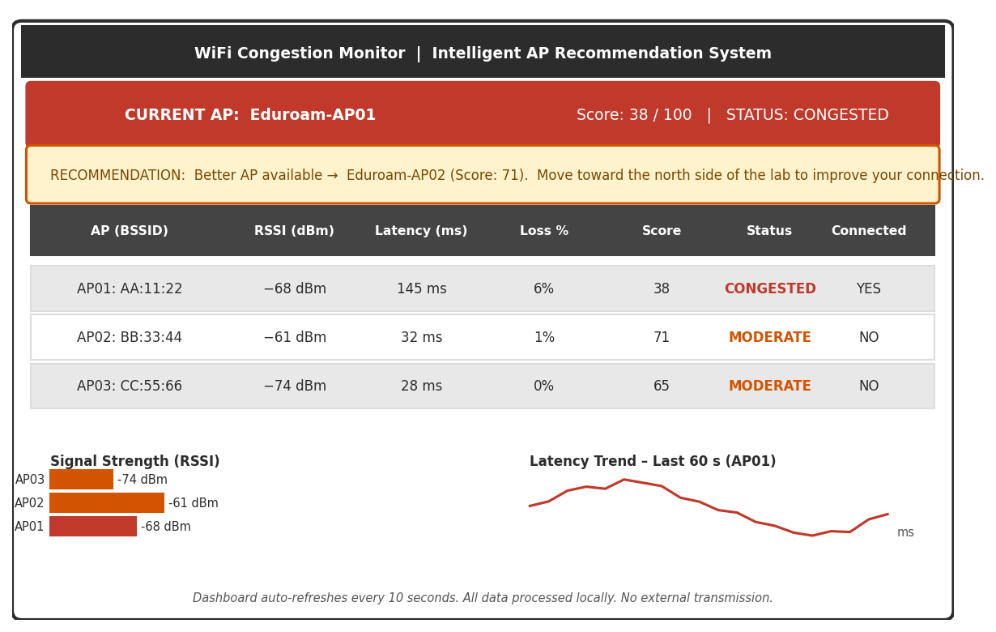
Figure 10 – Dashboard UI Mockup: AP table, status indicators, recommendation box, and latency trend graph
Component | Content | Purpose
Status bar | Current AP name, score, and status badge | Immediate overview of current connection quality
AP comparison table | All detected APs with RSSI, latency, packet loss, score, and status | Comparison of all available connection options
Colour indicators | Green / Orange / Red per AP row | Instant visual communication without numerical understanding required
Recommendation box | Best available AP name and directional guidance message | Actionable advice for the user to improve their connection
Signal bars | Visual bar chart of RSSI levels for all detected APs | Familiar WiFi bar representation for non-technical users
Latency trend graph | Time-series graph of latency over last 60 seconds | Shows whether connection is improving or degrading over time
Timestamp footer | Time of most recent scan | Confirms data is current and monitoring loop is running
Table 12 – Dashboard Components and Their Purpose

11. Multi-Device Support Architecture
The system is designed to support three device types. The same core architecture, scoring algorithm, and dashboard design apply across all devices. The only component that differs between platforms is the WiFi sensing method, as different operating systems provide different levels of access to WiFi scanning data.
Device | Sensing Method | Implementation Stack | Status
Laptop (Windows 10/11) | netsh wlan show networks mode=bssid | Python 3.11, Streamlit, Pandas, CSV | PRIMARY PROTOTYPE
Smartphone (Android) | Android WifiManager API | Android app (Java/Kotlin or Flutter) | Future Implementation
Tablet | Same as smartphone platform API | Same codebase, optimised for larger screen | Future Implementation
Table 13 – Device Support Matrix

12. System Requirements
System requirements define the specific technical behaviours and capabilities the software must deliver to satisfy the user requirements presented in Section 3. These are derived directly from the user requirements.
ID | System Requirement | Linked UR
SR1 | The system shall scan all visible WiFi APs and return a list within 5 seconds | UR1, UR7
SR2 | The system shall uniquely identify each AP using its BSSID | UR3
SR3 | The system shall measure network latency by performing a 10-packet ICMP ping test to the default gateway | UR2, UR7
SR4 | The system shall calculate packet loss percentage from the ping test results | UR2
SR5 | The system shall compute a quality score (0–100) for each AP using the defined weighted formula | UR2, UR3
SR6 | The system shall classify each AP as GOOD, MODERATE, or CONGESTED based on defined thresholds | UR2, UR7
SR7 | The system shall display a real-time colour-coded dashboard refreshed every 10 seconds | UR7
SR8 | The system shall display a recommendation message when a better AP (ΔScore ≥ 20) is available | UR2, UR3
SR9 | The system shall store all measurements and scores locally in a CSV file with ISO-8601 timestamps | UR8
SR10 | The system shall not transmit any data to external servers – all processing is local | UR5, UR8
Table 14 – System Requirements Traced to User Requirements

13. Testing Plan and Validation Strategy
The system will be tested in a real-world environment that simulates the high-density university laboratory scenario. Testing is conducted in four phases corresponding to different density and mobility conditions.
Phase | Scenario | Measurement | Expected Outcome
Phase 1 | Low user density (1–5 devices on one AP) | Score, latency < 30 ms, packet loss < 1% | All APs show GOOD status; no recommendation issued
Phase 2 | High user density (15+ devices on one AP) | Score drop, latency > 100 ms | Dashboard shows CONGESTED; recommendation message fires
Phase 3 | User moves across room to a better AP | Score change per cycle | Score improves progressively; dashboard updates in real-time
Phase 4 | Multiple APs simultaneously visible | AP ranking accuracy | Best AP correctly highlighted; recommendation accurate
Table 15 – D2 Testing Plan

14. Known Limitations
The following limitations are recognised as inherent constraints of the current design and are documented for transparency and academic integrity.
- The system cannot determine the exact physical location of each access point within the building.
- The system cannot force a device to disconnect from one AP and reconnect to another – this decision remains with the operating system.
- Hidden network load information (the number of users connected to each AP) is not accessible without infrastructure-level access.
- RSSI values are affected by physical obstacles, interference from other devices, and temporary RF reflections, which may introduce measurement variability of ±3–5 dBm [5, 6].
- Mobile operating systems (particularly iOS) impose restrictions on third-party WiFi scanning APIs, which limits sensing capability on those platforms.
- The weighted scoring formula uses fixed weights selected based on engineering judgement; these weights may be further optimised through real-world testing and machine learning in future work.

PART D3
Complex Engineering Problem
Detailed Design

15. Introduction and Scope of D3
Deliverable D2 established the conceptual architecture of the system and selected the on-device monitoring approach as the most feasible engineering solution. Deliverable D3 now converts that conceptual design into a complete, technically implementable specification. This section answers the question: how exactly does each subsystem work?
D3 provides component-level software design, algorithm pseudocode, data structure definitions, interface specifications, engineering calculations, and a full system integration model. The document is structured such that any qualified engineer could implement the system from this specification without further design decisions.
D2 (Conceptual) | D3 (Technical)
High-level block diagram | Module-level software architecture with file names
Subsystem descriptions | Data structures, function signatures, pseudocode
Formula stated | Formula derived, bounds justified, normalisation calculated
CSV storage mentioned | 18-column schema defined, write operation specified, capacity calculated
Dashboard described | Component-to-Streamlit-element mapping, refresh mechanism, message templates
Testing phases listed | Unit tests with quantitative pass criteria
Table 16 – D2 vs D3 Design Depth Comparison

16. Refined System Architecture

16.1 Module File Structure
The system is implemented as a Python 3.11 application running on Windows 10/11. It is structured as six independent modules that communicate through well-defined in-memory data structures. All processing occurs locally on the user device with no external network communication between modules [10].
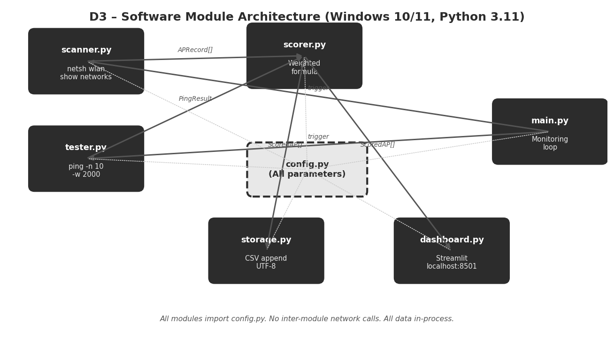
Figure 11 – D3 Software Module Architecture: six Python modules with defined interfaces
Module File | Subsystem | Responsibility
scanner.py | Sensing | Executes netsh wlan show networks mode=bssid and parses raw output into APRecord dataclass instances
tester.py | Network Testing | Executes ping -n 10 -w 2000 <gateway> and computes latency, packet loss, and RTT variance statistics
scorer.py | Scoring | Normalises raw metrics and applies weighted scoring formula; implements recommendation decision logic
storage.py | Data Storage | Appends ScoredAP records to a timestamped CSV file; validates schema on first write
dashboard.py | User Interface | Renders real-time Streamlit dashboard at localhost:8501; reads from Streamlit session state
main.py | Orchestrator | Controls the main monitoring loop; coordinates data flow between all modules every 10 seconds
config.py | Configuration | Centralises all tunable parameters: weights, thresholds, scan interval, normalisation bounds, file paths
Table 17 – Module File Structure and Responsibilities

16.2 Interface Definitions
Interface | From | To | Data Type | Format
I1 – AP List | scanner.py | scorer.py + storage.py | List[APRecord] | Python dataclass list
I2 – Ping Result | tester.py | scorer.py + storage.py | PingResult | Python dataclass
I3 – Scored APs | scorer.py | dashboard.py + storage.py | List[ScoredAP] | Python dataclass list
I4 – Config Params | config.py | All modules | Constants | Python module import
I5 – CSV Row | storage.py | Filesystem (./logs/) | String | Comma-separated UTF-8
Table 18 – System Interface Definitions

17. Sensing Subsystem – Detailed Design

17.1 OS Command and Parsed Fields
The sensing subsystem invokes the following Windows OS command via Python's subprocess module to retrieve WiFi scan data [7]:
import subprocess

result = subprocess.run(
['netsh', 'wlan', 'show', 'networks', 'mode=bssid'],
capture_output=True, text=True, encoding='utf-8'
)
raw_output = result.stdout

The raw multi-line text output is parsed using regular expressions to extract the following fields:
Field | netsh Output Line | Data Type | Example
SSID | SSID : Eduroam | String | Eduroam
BSSID | BSSID 1 : AA:11:22:33:44:55 | String | AA:11:22:33:44:55
Signal (%) | Signal : 72% | Integer | 72
Channel | Channel : 6 | Integer | 6
Radio type | Radio type : 802.11n | String | 802.11n (2.4 GHz)
RSSI (dBm) | Derived from Signal% | Float | −64.0
Table 19 – Sensing Subsystem Parsed Fields

17.2 RSSI Derivation
The Windows netsh utility reports signal quality as a percentage (0–100) rather than directly in dBm units. The RSSI in dBm is derived using the standard Windows NDIS WLAN API conversion formula [7]:
RSSI (dBm) = (Signal% / 2) − 100
Validation examples:
- Signal% = 100 → RSSI = (100/2) − 100 = −50 dBm (excellent signal, very close to AP)
- Signal% = 72 → RSSI = (72/2) − 100 = −64 dBm (good signal, typical indoor range)
- Signal% = 0 → RSSI = (0/2) − 100 = −100 dBm (no signal, hardware noise floor)

17.3 APRecord Data Structure
from dataclasses import dataclass

@dataclass
class APRecord:
ssid: str # Network name (e.g. 'Eduroam')
bssid: str # Unique AP MAC address (e.g. 'AA:11:22:33:44:55')
signal_pct: int # Windows signal quality 0–100
rssi_dbm: float # Derived: (signal_pct / 2) − 100
channel: int # WiFi channel number (1–14 for 2.4 GHz; 36–165 for 5 GHz)
band: str # '2.4GHz' or '5GHz'
timestamp: str # ISO-8601 scan timestamp

17.4 Hardware Parameters
Parameter | Typical Value | Impact on Design
RSSI measurement range | −30 to −90 dBm | Defines normalisation bounds for signal sub-score
Supported bands | 2.4 GHz and 5 GHz | System must handle both frequency bands in parsed output
Scan completion time | 2–4 s (OS-controlled) | Sets minimum practical scan interval to 5 seconds
Maximum visible APs | Up to 50 in dense areas | Scoring and display must handle variable-length AP lists
RSSI measurement error | ±3–5 dBm (multipath fading) [5, 6] | Score uncertainty ≈ ±5–8 points; mitigated by 20-point switching threshold
Table 20 – WiFi Adapter Hardware Parameters

18. Network Testing Subsystem – Detailed Design

18.1 Ping Command
The network testing subsystem measures the quality of the current active connection by sending ICMP Echo Request packets to the default network gateway. The gateway is identified programmatically using ipconfig and used as the ping target [7]. The exact command executed is:
import subprocess

result = subprocess.run(
['ping', '-n', '10', '-w', '2000', gateway_ip],
capture_output=True, text=True
)

Parameter | Value | Justification
-n 10 | 10 packets sent | Sufficient sample for statistically reliable packet loss (10% resolution); matches RFC 2544 [9]
-w 2000 | 2000 ms per-packet timeout | Allows for high-latency congested links; 2 s upper bound is practical for user experience assessment
Packet size | 32 bytes (default) | Small probe packets do not themselves cause additional congestion on the tested link
Target | Default gateway (ipconfig) | Closest network hop; measures only local AP-level congestion, not internet backbone latency
Table 21 – Ping Parameters and Engineering Justification

18.2 Derived Performance Metrics
Metric | Calculation | Unit
Mean latency | Arithmetic mean of all received RTT values from 10-packet sample | ms
Minimum latency | Minimum RTT in the sample | ms
Maximum latency | Maximum RTT in the sample | ms
RTT variance | Var(RTT) = (1/n) × Σ(RTTᵢ − RTT̄)² where n = 10 | ms²
Jitter | Standard deviation of RTT sample; approximates RFC 3393 jitter | ms
Packet loss | (Packets sent − Packets received) / Packets sent × 100 | %
Table 22 – Derived Network Performance Metrics

18.3 Stability Score Derivation
The Stability metric is derived from the RTT variance. High variance indicates an unstable connection where individual packets experience very different delays, characteristic of a congested AP where the queue length fluctuates [3]:
Var(RTT) = (1/n) × Σ(RTTᵢ − RTT̄)² [n = 10 samples]
S_stability = clamp( 100 − (Var / 25), 0, 100 )

18.4 PingResult Data Structure
@dataclass
class PingResult:
target_ip: str # IP address of gateway or fallback DNS
mean_latency_ms: float # Mean RTT across 10 packets (ms)
min_latency_ms: float # Minimum RTT (ms)
max_latency_ms: float # Maximum RTT (ms)
packet_loss_pct: float # Percentage packets lost (0.0 – 100.0)
variance_ms2: float # RTT variance (ms²) – stability input
jitter_ms: float # Standard deviation of RTT (ms)
timestamp: str # ISO-8601 test timestamp

19. Intelligent Scoring Subsystem – Detailed Design

19.1 Normalisation Specifications
Each raw metric is linearly normalised to [0, 100] before applying the weights. The normalisation bounds are derived from IEEE 802.11 performance standards and established network quality benchmarks [4, 5].

Signal Strength Normalisation
S_signal = clamp( (RSSI_dBm + 90) / 60 × 100, 0, 100 )
RSSI (dBm) | S_signal | Classification
−30 dBm | 100 | Excellent – very close to AP
−50 dBm | 66.7 | Good – typical classroom proximity
−65 dBm | 41.7 | Fair – usable but moderate attenuation
−75 dBm | 25.0 | Weak – near edge of reliable coverage [5]
−90 dBm | 0 | No signal – minimum threshold
Table 23 – Signal Score Normalisation Examples

Latency Normalisation
S_latency = clamp( (200 − mean_latency_ms) / 190 × 100, 0, 100 )

Packet Loss Normalisation
S_loss = clamp( (20 − packet_loss_pct) / 20 × 100, 0, 100 )

Stability Normalisation
S_stability = clamp( 100 − (variance_ms2 / 25), 0, 100 )

19.2 Recommendation Decision Logic
The system issues a recommendation only when ALL three conditions are simultaneously satisfied:
- The current AP score is below 75 (not GOOD)
- At least one other visible AP has a score greater than the current AP by at least 20 points
- The recommended AP is on a compatible band (5 GHz preferred over 2.4 GHz for equivalent scores)
The 20-point threshold is an engineering decision: it exceeds the combined measurement uncertainty of ±5–12 points identified in Section 21, preventing recommendations based on measurement noise rather than genuine quality differences.

19.3 ScoredAP Data Structure
@dataclass
class ScoredAP:
ap_record: APRecord # Full AP scan record from scanner.py
ping_result: PingResult # None if AP not currently connected
s_signal: float # Normalised signal sub-score [0–100]
s_latency: float # Normalised latency sub-score [0–100]
s_loss: float # Normalised loss sub-score [0–100]
s_stability: float # Normalised stability score [0–100]
total_score: float # Weighted composite score [0–100]
status: str # 'GOOD' | 'MODERATE' | 'CONGESTED'
is_connected: bool # True if this is the currently active AP
is_recommended: bool # True if recommended by decision logic

20. Data Storage Subsystem – Detailed Design

20.1 CSV Schema
Each row in the CSV file represents one AP measurement at one point in time. The schema is defined as follows:
Column Name | Data Type | Source | Example
timestamp | ISO-8601 datetime | System clock | 2026-06-10T14:23:05
ssid | String | APRecord | Eduroam
bssid | String (MAC) | APRecord | AA:11:22:33:44:55
channel | Integer | APRecord | 6
band | String | APRecord | 2.4GHz
rssi_dbm | Float | APRecord | −62.0
signal_pct | Integer | APRecord | 76
mean_latency_ms | Float | PingResult | 87.3
packet_loss_pct | Float | PingResult | 3.0
variance_ms2 | Float | PingResult | 412.5
s_signal | Float | ScoredAP | 46.7
s_latency | Float | ScoredAP | 59.3
s_loss | Float | ScoredAP | 85.0
s_stability | Float | ScoredAP | 83.5
total_score | Float | ScoredAP | 62.4
status | String | ScoredAP | MODERATE
is_connected | Boolean (0/1) | ScoredAP | 1
is_recommended | Boolean (0/1) | ScoredAP | 0
Table 24 – CSV File Schema (18 Columns)

20.2 File Naming and Write Operation
import csv, os
from datetime import datetime

LOG_DIR = './logs/'
os.makedirs(LOG_DIR, exist_ok=True)

# New file per session
filename = f"wifi_log_{datetime.now().strftime('%Y%m%d_%H%M%S')}.csv"
filepath = os.path.join(LOG_DIR, filename)

def write_records(scored_aps: list[ScoredAP], filepath: str):
file_exists = os.path.isfile(filepath)
with open(filepath, 'a', newline='', encoding='utf-8') as f:
writer = csv.DictWriter(f, fieldnames=SCHEMA_COLUMNS)
if not file_exists:
writer.writeheader() # Write header only on first write
for ap in scored_aps:
writer.writerow(ap.to_dict())

20.3 Storage Capacity Calculation
- Monitoring cycle interval: 10 seconds
- Maximum APs per scan: 20 (typical dense indoor environment)
- Bytes per CSV row: approximately 200 bytes (18 fields × ~11 characters average)
- Rows per hour: (3600 / 10) × 20 = 7,200 rows/hour
- Storage per hour: 7,200 × 200 bytes ≈ 1.4 MB/hour
- Full 8-hour session: 1.4 × 8 = 11.2 MB
- Full semester (120 active hours): 1.4 × 120 ≈ 168 MB → negligible on any modern laptop

21. Engineering Calculations

21.1 Shannon-Hartley Per-User Throughput
The Shannon-Hartley Theorem defines the maximum channel capacity for a 2.4 GHz 802.11n channel of bandwidth B = 20 MHz at SNR = 20 dB (linear SNR = 100) [2]:
C_total = 20×10⁶ × log₂(1 + 100) = 20×10⁶ × 6.658 ≈ 133 Mbps
Accounting for 802.11n protocol overhead, CSMA/CA collisions, and guard intervals (efficiency ≈ 45%):
C_practical ≈ 133 × 0.45 ≈ 60 Mbps (practical AP channel capacity)
Users on AP | Throughput / User | User Experience
5 | 60 / 5 = 12.0 Mbps | Excellent – software downloads complete in seconds
15 | 60 / 15 = 4.0 Mbps | Acceptable – noticeable slowdown during peak
30 | 60 / 30 = 2.0 Mbps | Poor – large downloads take minutes
60 | 60 / 60 = 1.0 Mbps | Severe congestion – system timeout risk
80 | 60 / 80 = 0.75 Mbps | Critical – consistent failures expected
Table 25 – Per-User Throughput vs AP Load (Shannon-Hartley Model) [2]

21.2 M/M/1 Queueing Latency Prediction
Using the M/M/1 model with AP service rate μ = 1000 packets/second and average user rate λ_user = 50 packets/second [3]:
Users | λ_total (pkt/s) | μ − λ | W (ms) | Status
5 | 250 | 750 | 1.3 ms | GOOD
10 | 500 | 500 | 2.0 ms | GOOD
15 | 750 | 250 | 4.0 ms | MODERATE
18 | 900 | 100 | 10.0 ms | MODERATE
19 | 950 | 50 | 20.0 ms | CONGESTED
20 | 1000 | → 0 | → ∞ | Saturation – queue collapse
Table 26 – M/M/1 Model: Latency vs User Load [3]
This non-linear relationship justifies weighting latency at 30% – the second highest weight – in the scoring formula. Small increases in user load near saturation cause disproportionately large latency increases [3].

21.3 Measurement Accuracy Analysis
Metric | Error Source | Magnitude | Score Impact
RSSI (dBm) | RF multipath fading; adapter calibration [5, 6] | ±3–5 dBm | ±5–8 score points
Latency (ms) | OS scheduling jitter; background processes | ±2–5 ms | ±1–3 score points
Packet loss | Statistical sampling error (n=10) | ±10% | ±5 score points
Variance | Small sample noise | ±100–200 ms² | ±4–8 score points
Total score | Combined weighted error propagation | ±5–12 points | Boundary misclassification risk
Table 27 – Measurement Accuracy Analysis and Score Impact
The combined score uncertainty of ±5–12 points is the engineering justification for the 20-point switching threshold. A threshold below the measurement uncertainty would trigger recommendations based on noise rather than genuine quality differences.

21.4 CPU and Memory Footprint
Operation | CPU Time | Memory
netsh WiFi scan | 2–4 s (OS I/O wait) | < 1 MB
Text parsing (regex) | < 5 ms | < 1 MB
Ping test (10 × 2 s max) | 2–5 s (I/O wait) | < 1 MB
Scoring (20 APs) | < 1 ms | < 1 MB
CSV write (20 rows) | < 5 ms | < 1 MB
Streamlit dashboard | < 100 ms per render | ~30 MB (browser tab)
Total per cycle | ~4–10 s active | ~35 MB resident
Table 28 – CPU and Memory Footprint Estimate
The 35 MB memory footprint is negligible on any laptop with 4+ GB RAM. The application will not perceptibly impact normal student laptop usage.

22. System Integration Design

22.1 Configuration Parameters
Parameter | Default | Description
SCAN_INTERVAL | 10 s | Time between complete monitoring cycles
PING_COUNT | 10 | ICMP packets per ping test
PING_TIMEOUT_MS | 2000 | Per-packet timeout (ms)
RSSI_MIN / MAX | −90 / −30 | Normalisation bounds for signal sub-score
LATENCY_MIN / MAX | 10 / 200 ms | Normalisation bounds for latency sub-score
LOSS_MAX | 20% | Upper bound for packet loss normalisation
VARIANCE_MAX | 2500 ms² | Upper bound for stability normalisation
W_SIGNAL | 0.35 | Scoring weight – signal strength
W_LATENCY | 0.30 | Scoring weight – latency
W_LOSS | 0.20 | Scoring weight – packet loss
W_STABILITY | 0.15 | Scoring weight – stability
THRESHOLD_GOOD | 75 | Score above which AP classified GOOD
THRESHOLD_MOD | 50 | Score above which AP classified MODERATE
SWITCH_THRESHOLD | 20 | Min score improvement to trigger recommendation
LOG_DIR | ./logs/ | Directory for CSV log files
PING_FALLBACK | 8.8.8.8 | DNS fallback if gateway discovery fails
Table 29 – config.py Parameters with Defaults

22.2 End-to-End Worked Example
The following worked example traces one complete monitoring cycle using realistic values from a congested university laboratory environment.
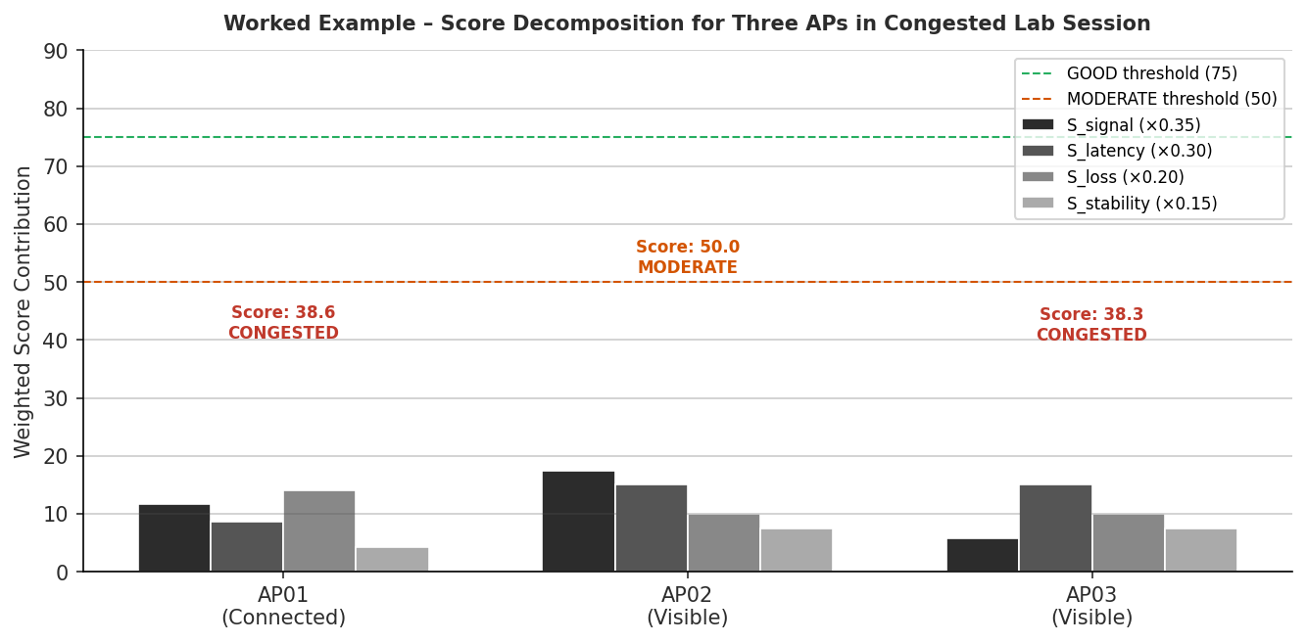
Figure 12 – Worked Example: Score decomposition for three APs showing CONGESTED classification with no recommendation issued

Input Measurements
AP | BSSID (short) | Signal% | RSSI (dBm) | Connected?
AP-01 | AA:11:22 | 60% | −70.0 dBm | YES
AP-02 | BB:33:44 | 80% | −60.0 dBm | NO
AP-03 | CC:55:66 | 40% | −80.0 dBm | NO
Ping result for connected AP-01: mean latency = 145 ms, packet loss = 6%, variance = 1800 ms²

Step 1: Normalisation for AP-01 (connected)
- S_signal = (−70 + 90) / 60 × 100 = 20/60 × 100 = 33.3
- S_latency = (200 − 145) / 190 × 100 = 55/190 × 100 = 28.9
- S_loss = (20 − 6) / 20 × 100 = 14/20 × 100 = 70.0
- S_stability = 100 − (1800 / 25) = 100 − 72 = 28.0

Step 2: Score Calculation for AP-01
Score = 0.35×33.3 + 0.30×28.9 + 0.20×70.0 + 0.15×28.0 = 11.7+8.7+14.0+4.2 = 38.6 → CONGESTED

Step 3: AP-02 and AP-03 (not connected – signal score only, other sub-scores default to 50)
Score_AP02 = 0.35×50.0 + 0.30×50.0 + 0.20×50.0 + 0.15×50.0 = 50.0 → MODERATE
Score_AP03 = 0.35×16.7 + 0.30×50 + 0.20×50 + 0.15×50 = 38.3 → CONGESTED

Step 4: Recommendation Decision
- Current AP (AP-01) score: 38.6 – below GOOD threshold (75) ✓
- Best alternative: AP-02, score 50.0 | Delta = 50.0 − 38.6 = 11.4
- Delta (11.4) is BELOW switching threshold (20) ✗
- Result: No recommendation issued. Dashboard message: 'Current AP congested. No significantly better AP detected. Consider moving to a different area.'

23. User Interface Subsystem – Detailed Design

23.1 Implementation: Streamlit
The dashboard is implemented using Streamlit, a Python framework that renders interactive web dashboards directly from Python code accessible via the browser at http://localhost:8501. No HTML, CSS, or JavaScript is required. Streamlit is installed via pip without administrator rights and is the chosen framework because it provides native support for real-time refresh (st.rerun()), colour-coded metric boxes (st.metric), and inline chart rendering (st.line_chart, st.bar_chart) [10].

23.2 Streamlit Component Mapping
Dashboard Component | Streamlit Element | Content
Page header | st.title + st.caption | System name, scan count, last updated timestamp
Current AP status | st.metric (3 columns) | AP name, score, status badge
Status alert | st.success / st.warning / st.error | Colour-coded GOOD / MODERATE / CONGESTED alert
AP table | st.dataframe with Styler | All APs: BSSID, RSSI, latency, loss, score, status
Recommendation | st.info or st.warning block | Recommended AP name, score delta, directional advice
Signal bar chart | st.bar_chart | RSSI values for all detected APs
Latency trend | st.line_chart | 30-second rolling latency window for connected AP
Raw data expander | st.expander + st.dataframe | Full PingResult and APRecord on demand
Table 30 – Streamlit Component Mapping

23.3 Recommendation Message Templates
Condition | Message Displayed
Current AP is GOOD | Connected to best available AP. Score: {score}/100. No action needed.
Better AP available (ΔScore ≥ 20) | Better connection available: {ssid} ({bssid}) – Score: {alt_score}/100. Move toward that area to improve your speed. Improvement: +{delta} points.
Congested, no better alternative | Current AP is congested (Score: {score}/100). No significantly better AP detected. Consider moving to a different area of the building.
Scan returned no APs | No WiFi networks detected. Please verify that WiFi is enabled on this device.
Table 31 – Recommendation Message Templates

24. Unit and Integration Testing Plan

24.1 Unit Tests
Test ID | Module | Description | Pass Criterion
UT-01 | scanner.py | Execute netsh scan; verify ≥ 1 APRecord with valid BSSID returned | List length ≥ 1; BSSID matches MAC regex ^([0-9A-Fa-f]{2}:){5}[0-9A-Fa-f]{2}$
UT-02 | scanner.py | Inject Signal% = 72; verify derived RSSI = −64.0 dBm | RSSI within ±0.1 dBm of −64.0
UT-03 | tester.py | Execute ping to 8.8.8.8 n=10; verify PingResult populated | mean_latency_ms > 0; packet_loss_pct in [0, 100]
UT-04 | scorer.py | Input RSSI=−45, latency=30 ms, loss=0%, variance=0; verify score ≥ 75 | total_score ≥ 75; status = 'GOOD'
UT-05 | scorer.py | Input RSSI=−88, latency=195 ms, loss=18%, variance=2400; verify score < 50 | total_score < 50; status = 'CONGESTED'
UT-06 | scorer.py | Two APs: current score=40, alternative score=65 (delta=25); verify recommendation fires | is_recommended = True on alt AP
UT-07 | scorer.py | Two APs: current score=40, alternative score=59 (delta=19); verify no recommendation | is_recommended = False on all APs
UT-08 | storage.py | One monitoring cycle; verify CSV created with correct 18-column header and rows | Header matches Table 24 schema; row count = AP count
UT-09 | storage.py | Verify timestamp field parses as valid ISO-8601 | datetime.fromisoformat(timestamp) succeeds without exception
Table 32 – Unit Test Specifications with Pass Criteria

24.2 Integration Tests
Test ID | Scenario | Method | Pass Criterion
IT-01 | Low density: 1–3 devices | Monitor during off-peak hours; 10 cycles | Score ≥ 75 in ≥ 8 of 10 cycles; no recommendation
IT-02 | High density: 15+ devices | Monitor during lab session; 10 cycles | Score < 50 detected; CONGESTED shown; recommendation fires
IT-03 | Physical movement test | Move laptop across room; record score per cycle | Score changes ≥ 10 points over 3+ cycles; trend visible in CSV
IT-04 | Multi-AP comparison | Scan in area with ≥ 3 visible APs | All APs shown in table with distinct scores; best AP highlighted
IT-05 | 30-minute continuous operation | Leave system running; verify no crashes | No unhandled exceptions; CSV grows at expected rate; refresh every 10 s
Table 33 – Integration Test Specifications

25. Known Limitations and Future Work

25.1 Known Limitations
Limitation | Engineering Root Cause | System Impact
Ping data available for connected AP only | Windows ICMP tests not possible through non-connected interfaces | Unconnected APs scored on signal alone; ranking uncertainty introduced
RSSI noise of ±3–5 dBm [5, 6] | RF multipath fading and adapter calibration variation | Score uncertainty ±8 points; mitigated by 20-point threshold
netsh scan takes 2–4 s (OS-controlled) | Windows WLAN service controls scan timing internally | Minimum cycle is 5–10 s; real-time reaction to sudden congestion limited
Hidden AP load data unavailable | Client count not broadcast in 802.11 beacon frames [4] | Congestion inferred indirectly from latency/loss; no direct user count
Windows-only prototype | netsh is Windows-specific [7] | Cross-platform port requires iwlist (Linux) or airport (macOS)
Table 34 – Known Limitations and Root Causes

25.2 Future Work
- Machine learning scoring model: replace fixed weights with a Random Forest model trained on labelled AP quality data collected during testing.
- Android mobile prototype: implement sensing using Android WifiManager API to extend to smartphones and tablets.
- Multi-node architecture: deploy Raspberry Pi sensing nodes in multiple rooms, aggregating data to a central dashboard via MQTT protocol.
- Automatic AP switching: investigate 802.11r BSS Fast Transition support on campus APs to enable seamless roaming triggered by the recommendation engine [4].
- Live user count estimation: correlate latency patterns with user density using M/M/1 model inversion to estimate connected users per AP [3].

References
[1] Engineering Council of South Africa (ECSA), Accreditation Standard for Engineering Programmes, Pretoria: ECSA, 2019.
[2] C. E. Shannon, "A Mathematical Theory of Communication," Bell System Technical Journal, vol. 27, no. 3, pp. 379–423, July 1948.
[3] L. Kleinrock, Queueing Systems Volume 1: Theory. New York: John Wiley & Sons, 1975.
[4] IEEE 802.11-2020, IEEE Standard for Information Technology – Telecommunications and Information Exchange Between Systems – Local and Metropolitan Area Networks – Specific Requirements – Part 11: Wireless LAN Medium Access Control (MAC) and Physical Layer (PHY) Specifications. New York: IEEE, 2020.
[5] A. Goldsmith, Wireless Communications. Cambridge: Cambridge University Press, 2005.
[6] D. Tse and P. Viswanath, Fundamentals of Wireless Communication. Cambridge: Cambridge University Press, 2005.
[7] Microsoft Corporation, "NDIS_WLAN_ASSOCIATION_ATTRIBUTES structure (windot11.h)," Windows Hardware Developer Documentation, 2023. [Online]. Available: https://docs.microsoft.com/en-us/windows-hardware/drivers/ddi/windot11/
[8] V. Jacobson, "Congestion avoidance and control," in Proc. ACM SIGCOMM, Stanford, CA, 1988, pp. 314–329.
[9] RFC 2544, "Benchmarking Methodology for Network Interconnect Devices," Internet Engineering Task Force (IETF), Feb. 1999.
[10] Streamlit Inc., Streamlit Documentation, Version 1.32, 2024. [Online]. Available: https://docs.streamlit.io

