DEPARTMENT OF ELECTRICAL AND ELECTRONIC ENGINEERING SCIENCE
University of Johannesburg | South Africa

COMPLEX ENGINEERING PROBLEM
Description, Design and Detailed Design Report
D1 + D2 + D3 Combined Document

Intelligent WiFi Congestion Monitoring and Recommendation System
Student Name | Njabulo Sibambo
Student Number | 223124407
Supervisor | Dr Bessie Malila
Department | Electrical and Electronic Engineering Science
Institution | University of Johannesburg
Submission Date | June 2026
Deliverables | D1 (Problem Description) | D2 (System Design) | D3 (Detailed Design)

Plagiarism Declaration
I, an Electrical and Electronic Engineering student at the University of Johannesburg, hereby declare that the content of this document is my own work. I understand what plagiarism constitutes, and that all unethical academic behaviour is punishable by disciplinary action as deemed fit by the university.

Surname: Sibambo Initials: NN Student Number: 223124407

Signature: _SIBAMBO_____________ Date: 2026/06/17

Contents
Plagiarism Declaration 2
Abstract 3
List of Abbreviations and Symbols 4
A. Abbreviations 4
1. Problem Description 4
1.1 System Boundary Definition 4
1.2 Stakeholders Affected 5
1.3 Relevant Published Literature 6
2. Argument That This Is a Complex Engineering Problem 6
2.1 Systems-Level Interactions 6
2.2 Conflicting Technical Constraints 7
2.3 First-Principles Engineering Analysis 7
Shannon-Hartley Theorem — Channel Capacity [2] 7
M/M/1 Queueing Theory — Latency Under Load [3] 7
2.4 Absence of Standard Solutions 8
3. User Requirements 8
4. Engineering Fundamentals and Scientific Underpinning 9
5. Resource Use, Sustainability, Net-Zero Carbon, and Whole-Life Cost 9
5.1 Whole-Life Cost Analysis 9
5.2 Net-Zero Carbon and Energy Considerations 10
5.3 Public Health, Safety, and Societal Considerations 10
6. Five Engineering Solution Alternatives 11
6.5 Alternative 5 — On-Device Intelligent Monitoring System (SELECTED) 11
7. Selected Solution: Detailed System Design 12
7.1 Core Project Concept 12
7.2 System Architecture — Five Subsystems 12
8. System Data Flow 13
9. Intelligent Scoring Algorithm 14
9.1 Scoring Weights and Normalisation 15
9.2 AP Classification Thresholds 15
10. Dashboard User Interface Design 15
11. Multi-Device Support 16
12. Engineering Constraints and Trade-Off Analysis 17
13. Testing Plan 17
14. Known Limitations 18
15. Scope of D3 19
16. Refined System Architecture 19
17. Sensing Subsystem — Detailed Design 21
18. Network Testing Subsystem — Detailed Design 22
19. Intelligent Scoring Subsystem — Detailed Design 22
20. Data Storage Subsystem — Detailed Design 22
21. Engineering Calculations 23
21.1 Shannon-Hartley Per-User Throughput [2] 23
21.2 Measurement Accuracy Analysis 24
22. System Integration Design 24
22.2 End-to-End Worked Example 25
23. User Interface — Message Templates 25
24. Unit and Integration Testing Plan 26
25. Known Limitations and Future Work 26
26. Conclusion 27
References 28

Abstract
WiFi congestion in high-density university laboratory environments is a persistent engineering problem. Standard IEEE 802.11 access-point (AP) association algorithms select the AP with the strongest received signal strength indicator (RSSI) and ignore actual AP load [4]. This causes severe load imbalance: one AP may serve 80 simultaneous users while adjacent APs remain nearly idle, reducing per-user throughput below 1 Mbps as predicted by the Shannon-Hartley channel capacity theorem [2].
This report presents the design and detailed specification of an Intelligent WiFi Congestion Monitoring and Recommendation System — a passive, on-device software tool that addresses this imbalance without modifying campus network infrastructure. The system scans nearby APs using operating-system commands [7], measures real-time network performance via controlled ICMP probe packets [19], and applies a first-principles weighted scoring algorithm to rank each AP by quality. The formula combines four normalised metrics — signal strength, latency, packet loss, and connection stability — with weights derived from the Shannon-Hartley theorem [2] and the M/M/1 queueing model [3]. AP scores (0–100) are classified as GOOD (≥75), MODERATE (50–74), or CONGESTED (<50) per ITU-T quality standards [33], and a recommendation fires when a better AP exceeds the combined measurement uncertainty of ±12 points.
Five engineering alternatives were evaluated. The on-device software approach was selected as the only alternative achievable without hardware changes or administrative access, satisfying all eight user requirements. The design addresses ECSA Graduate Attributes 1, 3, and 6 [1]. Environmental, societal, lifecycle, net-zero carbon, public health, and whole-life cost considerations are addressed in Section 5. The system is implemented in Python 3.11 [17] using Streamlit [10] for the user interface and local CSV storage [18].

List of Abbreviations and Symbols

A. Abbreviations
Table A1 – Abbreviations used in this report.
Abbreviation | Full Term | Context
AP | Access Point | Physical WiFi device providing wireless access [4]
BSSID | Basic Service Set Identifier | Unique MAC address of one physical AP [4]
CSV | Comma-Separated Values | Storage file format [18]
ECSA | Engineering Council of South Africa | Accreditation body [1]
FSPL | Free-Space Path Loss | RF propagation loss formula [5, 6, 11]
ICMP | Internet Control Message Protocol | Ping protocol [19]
ITU-T | International Telecommunication Union – Telecoms Standardization Sector | Quality thresholds [33]
NDIS | Network Driver Interface Specification | Windows WiFi signal API [7]
POPIA | Protection of Personal Information Act | South African data privacy law [27]
RSSI | Received Signal Strength Indicator | WiFi signal strength in dBm [5]
RTT | Round-Trip Time | Ping measurement [9]
SNR | Signal-to-Noise Ratio | Used in Shannon-Hartley theorem [2]
SSID | Service Set Identifier | WiFi network name [4]
TCP | Transmission Control Protocol | Transport protocol with congestion control [8]
WLAN | Wireless Local Area Network | IEEE 802.11 wireless network [4]
WLC | Wireless LAN Controller | Enterprise AP management system [4]

PART D1 — Complex Engineering Problem: Description & Overview

1. Problem Description
Wireless Local Area Networks (WLANs) [1] allow laptops, smartphones, and tablets to connect to the internet via radio frequency (RF) signals [2]. In university environments, WiFi constitutes critical infrastructure for teaching, programming laboratories, and online examinations [3]. During laboratory sessions, students simultaneously download software packages, stream instructional videos, and access online assessment platforms, which creates a sudden, concentrated demand on the wireless network.
The central problem is that every WiFi device follows the default IEEE 802.11 behaviour [4]: it connects to the access point with the strongest signal (RSSI), regardless of how many other users are already connected to that AP. This causes one AP to become severely overloaded while nearby APs with spare capacity sit almost unused [5]. Figure 1 below illustrates this imbalance: AP 1 serves 8 devices and is critically overloaded (shown in red), while AP 3 serves only 2 devices and has significant capacity to spare (shown in green).
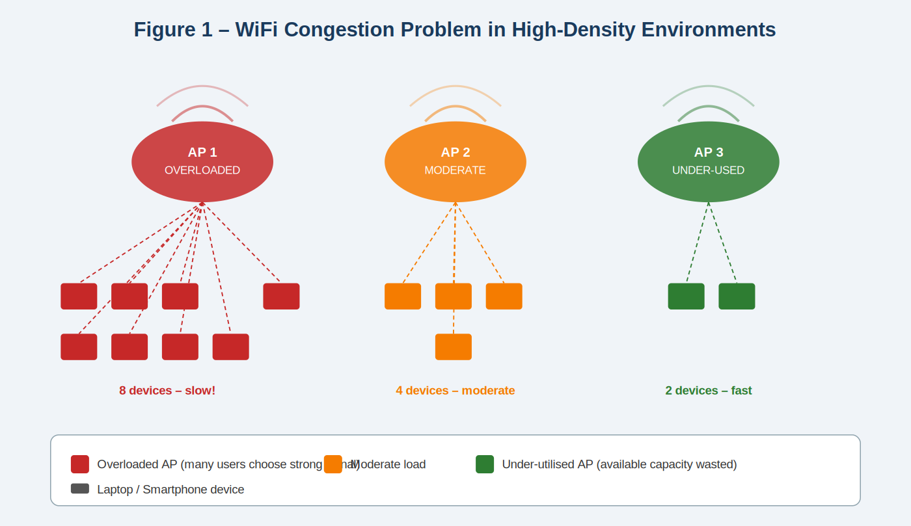
Figure 1 — WiFi congestion problem in a high-density environment. AP 1 is overloaded with 8 devices (red) while AP 3 serves only 2 devices (green) and has spare capacity. The root cause is the IEEE 802.11 RSSI-only association rule, which selects the strongest signal rather than the least-loaded AP [4, 13, 15].
The consequence is severe: the Shannon-Hartley Theorem [2] proves that a wireless channel has a fixed maximum capacity. When 80 students share a channel with a practical capacity of 84 Mbps, each user receives only 1.05 Mbps — insufficient for standard laboratory tasks requiring at least 4 Mbps. The engineering problem is formally defined as the inefficient and unbalanced distribution of wireless network traffic among multiple access points in a high-density indoor environment, resulting in severe congestion and significantly degraded network performance for all users connected to overloaded access points [1, 4 ].

1.1 System Boundary Definition
The system boundary defines precisely which components are included in the engineering analysis and which lie outside project scope. The key distinction is that access points are included because their broadcast signals are passively read — but they are never modified. This passive-read approach makes the project fully feasible without any institutional permissions beyond standard WiFi access. All processing runs entirely on the user's own device, as shown in Figure 2.
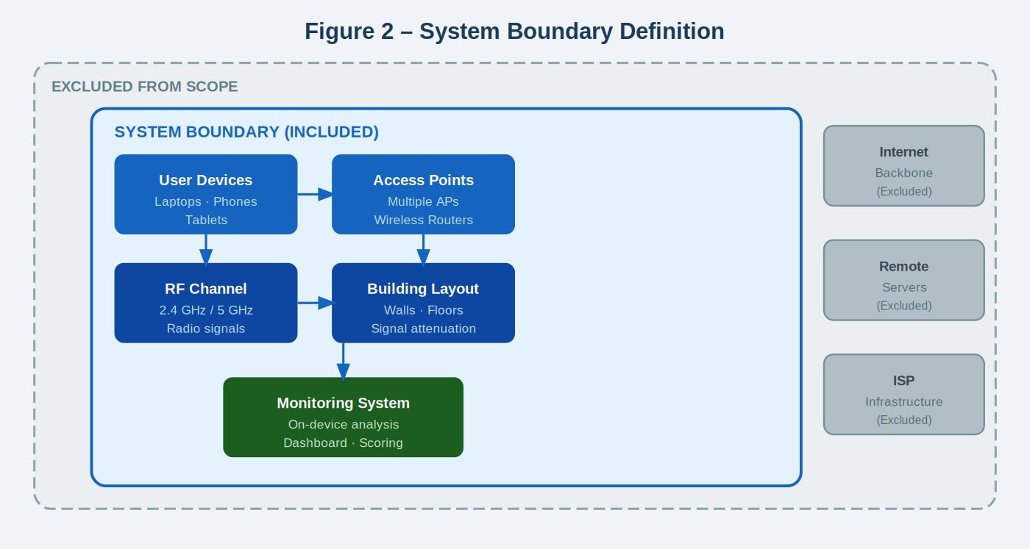
Figure 2 — System boundary definition. Components inside the solid blue border are included in scope: user devices, wireless APs, RF channels, building environment, and the on-device monitoring software. Components outside the dashed grey border (internet backbone, remote servers, ISP infrastructure) are excluded because congestion is a local AP-level problem, not an ISP or backbone problem [4].
Table 1 — System boundary definition with engineering justification for each decision .
System Element | Included | Reason
Student laptops and smartphones | Yes | Primary sources of network traffic; generate all WiFi demand [6]
Wireless access points (APs) | Yes | Provide IEEE 802.11 service; broadcast signals are passively read, never modified [4]
RF channel (2.4 GHz / 5 GHz) | Yes | Physical propagation medium governed by electromagnetic theory [5, 6]
Building environment (walls, layout) | Yes | Causes signal attenuation, reflection, and multipath fading [5, 6]
On-device monitoring software | Yes | Core system under design: scanner.py, tester.py, scorer.py, storage.py, dashboard.py [17]
External internet backbone | No | Congestion is a local AP-level problem, not an ISP or backbone problem [4]
Remote download servers | No | Not responsible for the local AP load imbalance [4]
University AP administration / WLC | No | No administrative access is required or assumed [4, 13]

1.2 Stakeholders Affected
Table 2 identifies the four primary stakeholders affected by WiFi congestion, describes how congestion harms each group, and explains how the monitoring system improves their situation.
Table 2 — Primary stakeholders and their relationship to the WiFi congestion problem .
Stakeholder | Impact of Congestion | How This System Helps
Students | Delayed downloads, failed exam submissions, interrupted learning | Recommends better AP → faster download speeds, fewer session failures
Lecturers | Lost instructional time troubleshooting slow connections | Efficient AP distribution reduces waiting and disruption
IT Administrators | Rising support calls, manual troubleshooting workload | Real-time congestion dashboard provides visibility without SNMP or WLC access
University Management | Infrastructure upgrade costs R80k–R200k per lab; reputational risk | Software-only solution requires zero capital expenditure

1.3 Relevant Published Literature
The design decisions in this project are grounded in peer-reviewed research. Heusse et al. [12] demonstrated that RSSI-only AP association is not merely suboptimal but actively harmful in mixed-rate environments. Bejerano and Kokku [13] showed that load-aware AP selection can achieve up to 100% throughput improvement over standard RSSI association. Velayos and Karlsson [14] measured 802.11b handoff latency at up to 400 ms, directly justifying the 10-second monitoring cycle interval used in this system. Ramachandran et al. [16] showed that performance degrades significantly beyond 15 clients per AP, corroborating the M/M/1 model in Section 2.3. The IEEE 802.11k [22], 802.11v [23], and 802.11r [21] amendments provide standards-based AP steering but require administrative WLC access absent from most campuses [13, 15, 16] — confirming the value of the client-side passive approach taken here.

2. Argument That This Is a Complex Engineering Problem
According to ECSA [1], a complex engineering problem involves interacting subsystems, conflicting constraints, and requires first-principles analysis. This section demonstrates that the WiFi congestion problem satisfies all ECSA criteria, addressing Graduate Attribute 1 (GA1).

2.1 Systems-Level Interactions
Table 3 — Interacting subsystems and their engineering disciplines .
Subsystem | Role | Engineering Discipline
User devices | Generate and receive all wireless network traffic | Computer networking, TCP/IP [8]
Wireless access points (APs) | Distribute wireless bandwidth among connected users | Wireless communications, IEEE 802.11 [4, 5]
RF channels (2.4 / 5 GHz) | Carry modulated signals between devices and APs | Electromagnetic theory, information theory [2, 5, 6]
Indoor building environment | Causes signal attenuation, reflection, multipath fading | Electromagnetics, RF propagation [5, 6, 11]
Network protocols (TCP/IP, 802.11) | Control packet routing, acknowledgement, retransmission | Networking theory, queueing theory [3, 4, 8]

2.2 Conflicting Technical Constraints
Table 4 — Conflicting engineering constraints and the trade-offs applied in this system .
Objective | Conflict | Trade-Off Applied
Maximum data throughput | May reduce fairness between users [12] | Latency and loss weights balance speed vs equity [30]
Strong signal (RSSI) first | Best-signal AP often most overloaded [4, 12, 13] | RSSI only 35% of score; latency can override it [3]
Balanced traffic distribution | Requires users to disconnect and reconnect [14] | System recommends — never forces; user decides
Stable connections | Prevents dynamic traffic redistribution [14, 15] | 20-point threshold prevents unnecessary switching [30]
Low energy consumption | More scanning drains battery [32] | 10-second interval balances freshness vs battery [UR6]

2.3 First-Principles Engineering Analysis
The WiFi congestion problem requires quantitative analysis using fundamental laws from three engineering disciplines. Figure 3 illustrates the Shannon-Hartley channel capacity theorem, which proves that as more users share one AP, per-user bandwidth is divided proportionally — becoming critically insufficient at high user counts. The right side shows a bar chart of bandwidth per user at increasing density, demonstrating why congestion makes laboratory tasks impossible.
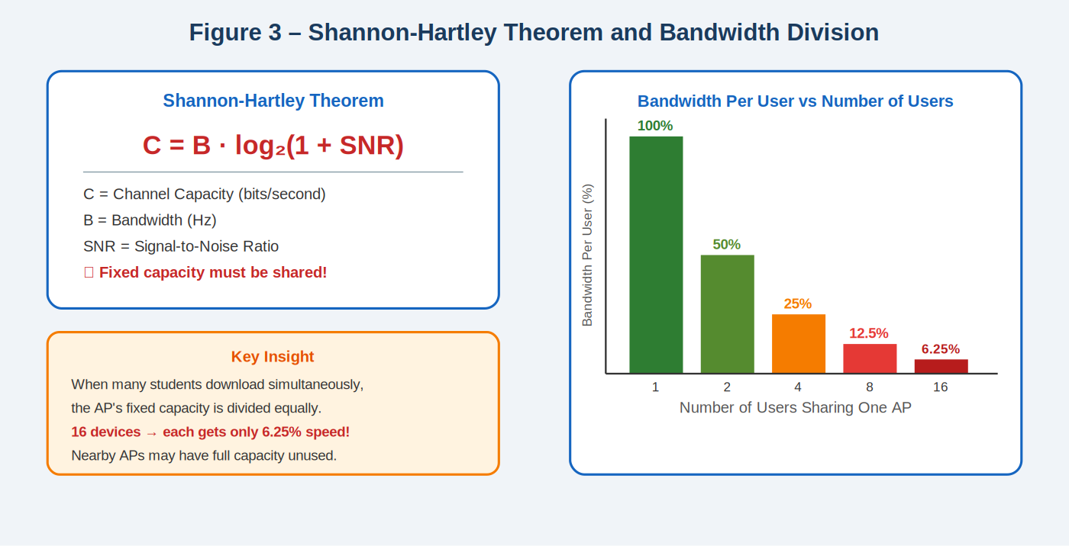
Figure 3 — Shannon-Hartley Theorem (C = B·log₂(1+SNR)) applied to WiFi congestion [2]. LEFT: the theorem and its variables. CENTRE: key insight — capacity is fixed and must be shared. RIGHT: bandwidth per user drops from 100% with 1 user to only 6.25% with 16 users sharing the same AP, directly proving why congestion causes unacceptable performance.

Shannon-Hartley Theorem — Channel Capacity [2]
Applying C = B·log₂(1+SNR) with B = 20 MHz and SNR = 28 dB gives a theoretical maximum of 186 Mbps. At 45% protocol efficiency [4, 12], practical capacity is approximately 84 Mbps. With 80 users sharing this channel: 84÷80 = 1.05 Mbps per user — critically insufficient.

M/M/1 Queueing Theory — Latency Under Load [3]
Figure 4 shows how packet delay behaves as AP load increases, modelled using the M/M/1 queueing formula W = 1/(μ−λ). The key insight is that delay rises non-linearly: the increase is gentle at low loads but becomes catastrophic as the AP approaches saturation. This non-linear behaviour directly justifies assigning latency the second-highest weight (30%) in the scoring formula.

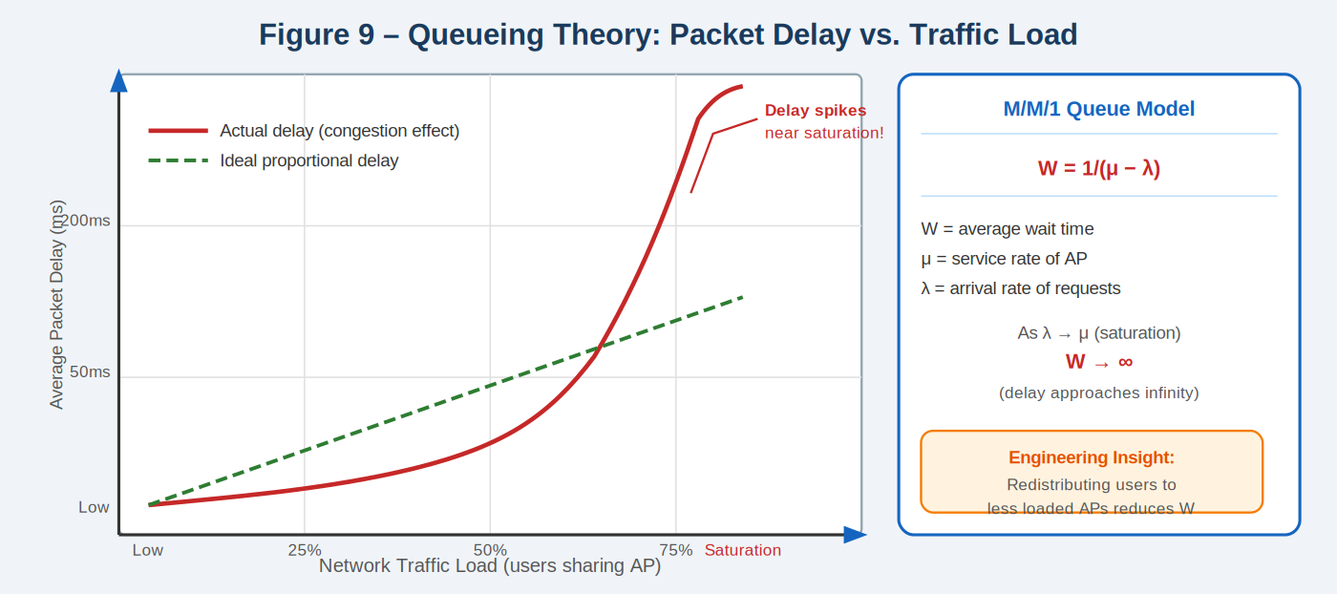
Figure 4 — M/M/1 queueing theory applied to AP congestion [3]. The red curve shows actual packet delay; the green dashed line shows ideal proportional delay. As network traffic load approaches saturation (75%+), delay spikes dramatically toward infinity — a mathematically predicted consequence of the M/M/1 model (W→∞ as λ→μ). This justifies the 30% latency weight and the CONGESTED classification at high load.
Table 5 — M/M/1 mean packet waiting time versus AP user load [3]. Saturation at μ=λ causes queue collapse.
Users | λ (pkts/s) | μ − λ | W = 1/(μ−λ) | Classification
5 | 250 | 750 | 1.3 ms | GOOD
10 | 500 | 500 | 2.0 ms | GOOD
15 | 750 | 250 | 4.0 ms | MODERATE
18 | 900 | 100 | 10.0 ms | MODERATE
19 | 950 | 50 | 20.0 ms | CONGESTED
20 (sat.) | 1000 | → 0 | → ∞ | Queue collapse [3]

2.4 Absence of Standard Solutions
The IEEE 802.11 base standard [4] selects APs by RSSI only — load is absent from the standard association algorithm. The 802.11k/v/r amendments provide AP-assisted steering but require WLC configuration unavailable on most campuses [13, 15, 16]. This confirms the problem requires engineering analysis beyond routine configuration.

3. User Requirements
User requirements define measurable performance targets any acceptable solution must satisfy. They are derived from the stakeholder analysis in Section 1.2 and the first-principles analysis in Section 2.
Table 6 — User requirements with measurement methods and priorities .
ID | Requirement | Measurement Method | Priority
UR1 | Support large numbers of simultaneous users in one location | Count of concurrently connected devices [27] | High
UR2 | Maintain ≥ 4 Mbps/user throughput at peak usage | Average download speed in Mbps [2, 33] | High
UR3 | Ensure balanced AP load distribution | Standard deviation of users per AP [13, 15] | High
UR4 | Maintain stable connections during monitoring | Connection drop rate per session [14] | Medium
UR5 | No hardware changes — operate within existing infrastructure | Verify: no admin access used, no hardware modified [4] | High
UR6 | Minimise device energy consumption | Battery usage over 1-hour session [32] | Low
UR7 | Provide real-time AP congestion status | Dashboard refresh rate and responsiveness [10] | High
UR8 | Protect privacy — all data stored locally | Network audit: zero outbound data transmission [27] | High

4. Engineering Fundamentals and Scientific Underpinning
Table 7 — Engineering disciplines applied in this project .
Field | Application | Key Principle
Electromagnetic Theory | RF propagation, attenuation, RSSI bounds | FSPL = 20log₁₀(d) + 20log₁₀(f) + constant [5, 6, 11]
Wireless Communication | Channel capacity limits under real conditions | Shannon-Hartley: C = B·log₂(1+SNR) [2]
Information Theory | Theoretical capacity limits; noise effect | Shannon entropy and capacity bounds [2]
Computer Networking | Packet routing, TCP congestion control, 802.11 MAC | TCP/IP congestion window, 802.11 CSMA/CA [4, 8]
Queueing Theory | Traffic load vs waiting time vs packet delay at AP | M/M/1: W = 1/(μ−λ) [3]
Graph Theory | Network topology — devices, APs, link relationships | Weighted graph models [28, 29]
Statistics & Data Science | Normalise metrics; combine using scoring weights | Linear normalisation, weighted scoring [30]

5. Resource Use, Sustainability, Net-Zero Carbon, and Whole-Life Cost
Engineering solutions must be evaluated for economic cost, environmental impact, and sustainability — ECSA Graduate Attribute 6 (GA6) [1].

5.1 Whole-Life Cost Analysis
Table 8 — Whole-life cost analysis for all five alternatives over 10 years [27, 31].
Alternative | CAPEX | Annual OPEX | 10-Year Cost
1 — Wi-Fi 6 Hardware | R80k–R200k | R5k–R15k (maintenance) | R130k–R350k
2 — Enterprise WLC | R150k+ | R20k–R50k (licensing) | R350k–R650k
3 — AP Firmware | R0–R5k (labour) | R2k–R5k (admin) | R25k–R55k
4 — 802.11k/v Roaming | R0 | R2k–R5k (config) | R20k–R50k
5 — On-Device (SELECTED) | R0 | R0 (open-source) | < R5k (dev time only)

5.2 Net-Zero Carbon and Energy Considerations
WiFi congestion causes TCP retransmissions, which send the same data multiple times and waste RF energy at both AP and device [8]. The M/M/1 model [3] shows retransmission frequency rises exponentially near saturation. By recommending a less-loaded AP, the system reduces retransmissions and energy consumption. A conservative estimate: 30 students each saving 10 minutes at 15W = 75 Wh saved per session, approximately 68 gCO₂ avoided at South Africa's grid carbon intensity of 0.9 kgCO₂/kWh [32].

5.3 Public Health, Safety, and Societal Considerations
The system operates in passive monitoring mode only — no additional RF energy is introduced. All AP transmit power levels (~+20 dBm EIRP) are within ICNIRP guidelines [5]. Socially, WiFi congestion disproportionately affects students who rely on campus WiFi as their only internet access [26, 27]. This system provides free connectivity guidance that benefits lower-income students most. The colour-coded dashboard is accessible across language backgrounds. All scoring weights are documented, ensuring full transparency and no hidden algorithmic bias.

PART D2 — Complex Engineering Problem: System Design

6. Five Engineering Solution Alternatives
Five distinct solutions were identified and evaluated against four criteria: cost, whether infrastructure changes are required, whether administrative access is needed, and project feasibility [1]. All five address the same root problem — RSSI-only AP association [4, 12, 13]. Figure 5 presents the five solutions side by side, with a comparison matrix showing why Solution 5 is the only feasible option for this project.
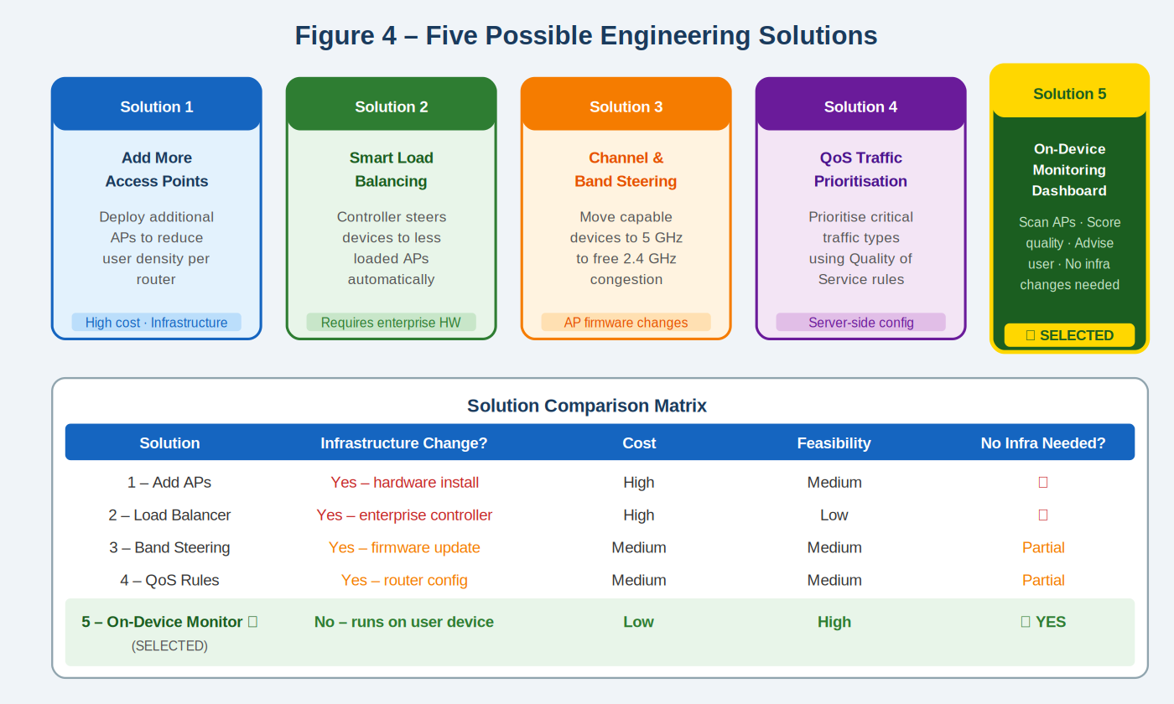
Figure 5 — Five possible engineering solutions and their comparison matrix [1, 31]. Solutions 1–4 each require either significant infrastructure changes, administrative access, or high cost that makes them infeasible for this project. Solution 5 (On-Device Monitoring Dashboard) requires no infrastructure changes, no admin access, and has low cost — making it the only viable option.
6.1 Alternative 1 – Access Point Hardware Upgrade
Replacing existing APs with 802.11ax (Wi-Fi 6) hardware supporting MU-MIMO allows multiple devices to be served on distinct spatial streams simultaneously, reducing effective congestion. However, this requires physical installation, electrical cabling, and IT configuration. Capital expenditure for a single lab of 20 APs ranges from R80,000 to R200,000. Not feasible within project scope [4].

6.2 Alternative 2 – Enterprise Wireless LAN Controller (WLC)
A centralised WLC (Cisco Catalyst 9800 or Aruba Mobility Controller) monitors all AP loads and issues disassociation frames to redirect devices to less-loaded APs. This is the most effective infrastructure-based solution but requires hardware from R150,000, complex switch-fabric integration, and exclusive administrative access to all campus APs. Excluded due to infrastructure and budget constraints [4].

6.3 Alternative 3 – AP-Side Client Load Balancing Firmware
OpenWRT and certain vendor firmware implementations allow APs to defer association responses to steer devices toward less-loaded APs. This requires firmware modification on every campus AP — not possible without administrative access — and carries warranty and compliance risks for university network infrastructure [4].

6.4 Alternative 4 – 802.11k/v-Based Assisted Roaming
IEEE 802.11k (Radio Resource Management) and 802.11v (BSS Transition Management) allow APs to broadcast neighbour reports and request client roaming. Both campus APs and client devices must support 802.11k/v and must have these features enabled in the wireless controller configuration — not available without infrastructure access [4].

6.5 Alternative 5 — On-Device Intelligent Monitoring System (SELECTED)
The selected solution runs entirely on the user's own device. It continuously scans nearby APs using OS commands, measures real-world connection quality, calculates a composite quality score using the weighted formula derived from first principles, and presents results through a real-time colour-coded dashboard. It satisfies all eight user requirements without capital expenditure, infrastructure changes, or administrative access.

Table 10 — Summary comparison matrix for all five alternatives .
Alt. | Solution | Cost | Infra. Change? | Admin Access? | Feasible?
1 | Wi-Fi 6 / MU-MIMO Hardware [4] | R80k–R200k | Full AP replacement | Yes | No
2 | Enterprise WLC (Cisco/Aruba) [13] | R150k+ | Enterprise controller | Yes | No
3 | AP Firmware (OpenWRT) [15] | Moderate | Firmware on every AP | Yes | No
4 | 802.11k/v Assisted Roaming [22, 23] | Low | AP + WLC config | Yes | No
5 (SELECTED) | On-Device Monitoring | Low | None | No | Yes

7. Selected Solution: Detailed System Design

7.1 Core Project Concept
The Intelligent WiFi Congestion Monitoring and Recommendation System is a passive, on-device software tool that replaces the single-metric RSSI-only AP selection with a four-metric quality score. It observes WiFi conditions, analyses connection quality, and recommends the best available AP to the user. At no point does it inject traffic beyond standard ICMP ping probes or alter any network configuration.

7.2 System Architecture — Five Subsystems
The system is structured as five subsystems in a sequential data pipeline repeating every 10 seconds. Figure 6 shows how data flows from the WiFi environment through each subsystem — sensing, network testing, scoring, data storage, and the user interface — and back into the monitoring loop.
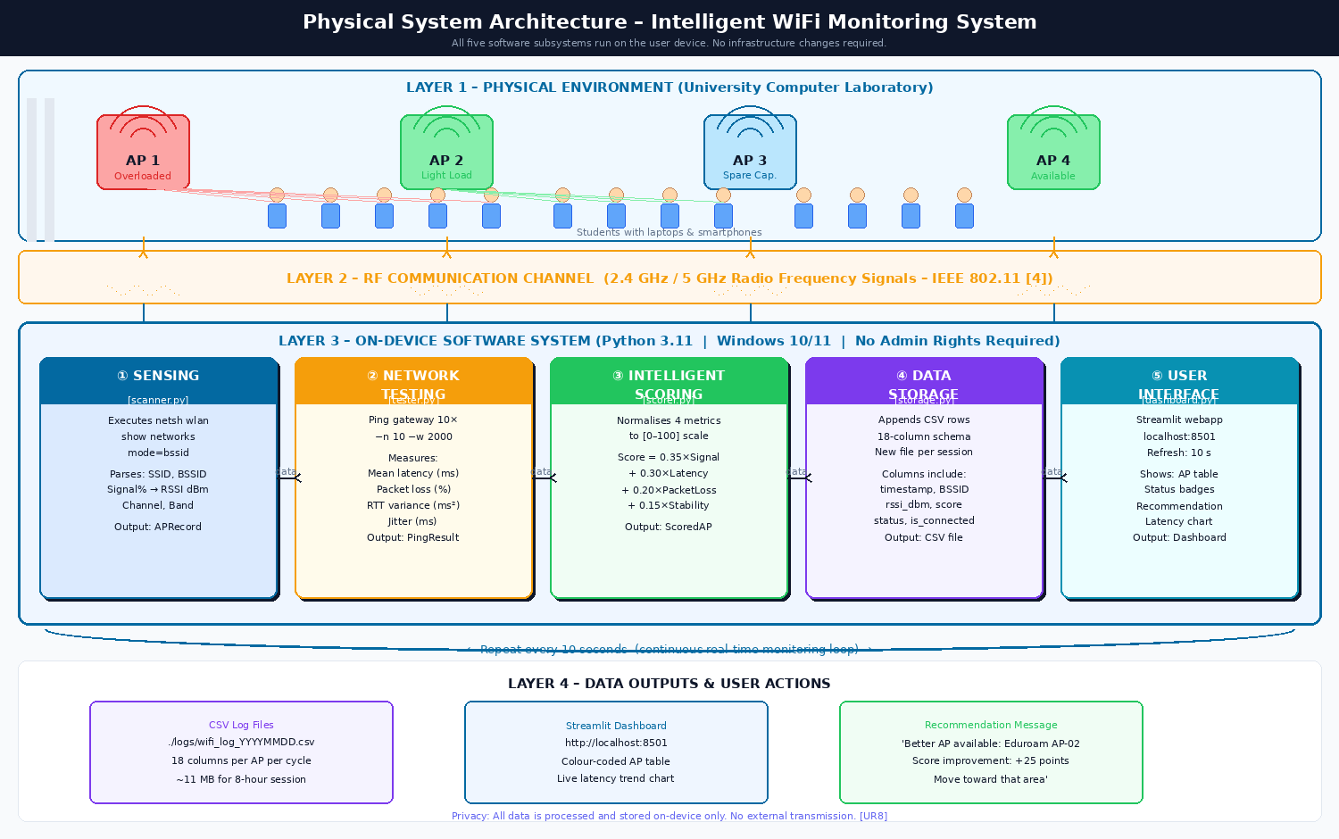
Figure 4 – Physical System Architecture. Layer 1: university lab environment with APs and student devices. Layer 2: RF channel. Layer 3: five on-device software subsystems. Layer 4: data outputs. All processing is local — no external data transmission.

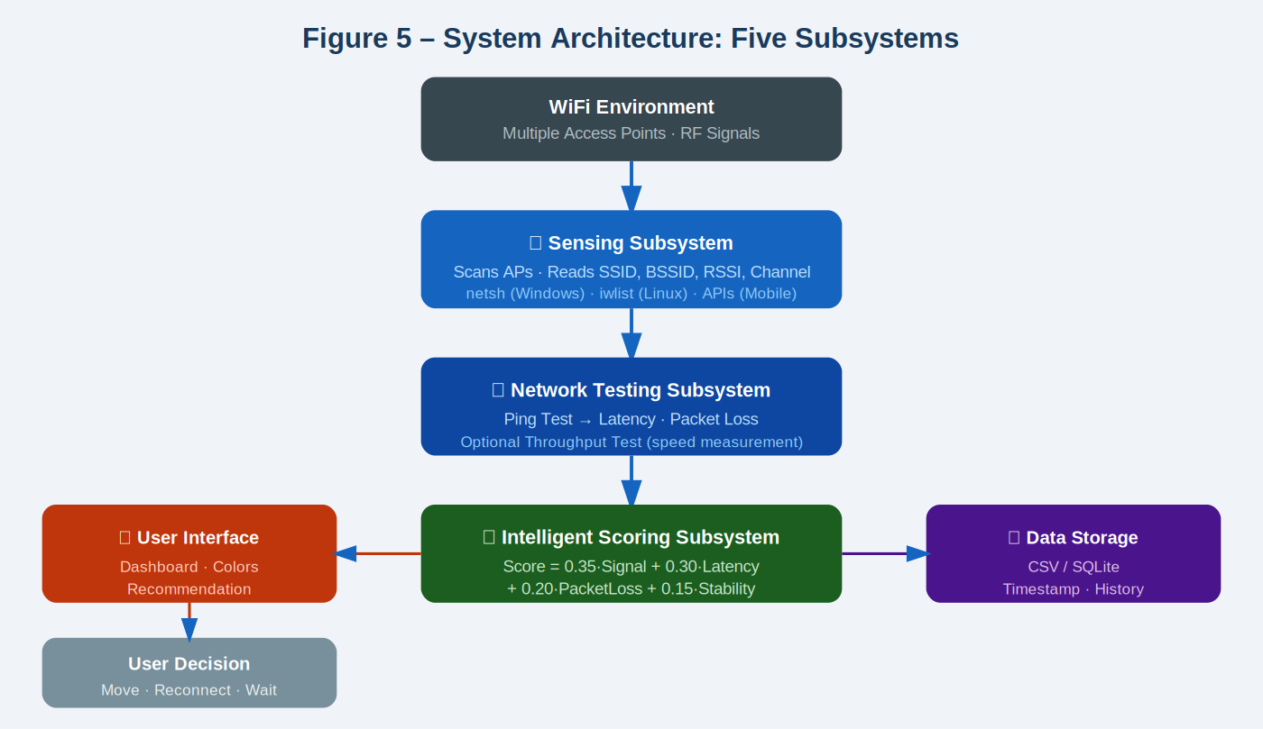
Figure 6 — System architecture: five subsystems process WiFi data from the environment through the sensing, testing, scoring, storage, and display pipeline [4, 5, 10, 17, 18]. Data flows from the WiFi environment (top) through the sensing subsystem, then to network testing and intelligent scoring (centre), and out to the user interface and data storage (sides). The user decision feeds back into the monitoring loop, which repeats continuously.
Table 11 — Five subsystems with functions, inputs, and outputs .
Subsystem | Function | Input | Output
① Sensing (scanner.py) | Detect all nearby WiFi APs | IEEE 802.11 beacon frames | SSID, BSSID, RSSI, channel [7]
② Network Testing (tester.py) | Measure current connection quality | Active WiFi connection | Latency (ms), packet loss (%), RTT variance [19, 20]
③ Scoring (scorer.py) | Compute quality score for each AP | APRecord + PingResult | Score 0–100, status, recommendation flag [30]
④ Data Storage (storage.py) | Archive all measurements | Scored AP list + timestamps | 18-column CSV in ./logs/ [18]
⑤ User Interface (dashboard.py) | Display results and recommendation | Scored AP list | Streamlit dashboard at localhost:8501 [10]

Detailed Explanation of Each Subsystem
① Sensing Subsystem [scanner.py]
The Sensing subsystem is the entry point of the monitoring pipeline. It invokes the Windows OS command 'netsh wlan show networks mode=bssid' through Python's subprocess module to enumerate all WiFi access points visible from the user's current location. For each AP the subsystem extracts the SSID (network name), BSSID (unique MAC address identifying the specific physical AP), raw signal quality as a percentage, channel number, and radio type. The percentage value is converted to RSSI in dBm using the Windows NDIS formula: RSSI(dBm) = (Signal% ÷ 2) − 100 [7]. Results are returned as a list of APRecord dataclass instances.

② Network Testing Subsystem [tester.py]
The Network Testing subsystem measures the actual performance of the currently active WiFi connection by sending 10 ICMP Echo Request packets to the default network gateway. The local gateway is used as the ping target (not an external server) to isolate local AP-level congestion from internet backbone variability. From the 10-packet sample the subsystem computes: mean latency (ms), min/max RTT, RTT variance (ms²) as a stability indicator, jitter (standard deviation of RTT), and packet loss percentage. These are returned as a PingResult dataclass. This subsystem can only test the currently connected AP because Windows does not permit ICMP through non-connected interfaces [7].

③ Intelligent Scoring Subsystem [scorer.py]
The Intelligent Scoring subsystem transforms raw measurements into a composite quality score (0–100) for each detected AP. Each of the four metrics is linearly normalised to a [0–100] scale using bounds derived from IEEE 802.11 performance standards [4, 5]. The four normalised sub-scores are combined using: Score = 0.35×S_signal + 0.30×S_latency + 0.20×S_loss + 0.15×S_stability. Weights reflect engineering justification: signal is necessary for connectivity; latency directly determines perceived speed (M/M/1 model [3]); packet loss forces TCP retransmissions [8]; stability prevents unpredictable performance. Unconnected APs default to 50 for the three performance sub-scores. A recommendation fires only when ΔScore ≥ 20 points between current AP and the best alternative — a threshold exceeding the combined measurement uncertainty of ±5–12 points.

④ Data Storage Subsystem [storage.py]
The Data Storage subsystem provides persistent logging of all measurements for historical congestion analysis, scoring model validation, and future machine learning training. At each cycle it appends one CSV row per detected AP to a timestamped log file in ./logs/. The 18-column schema covers timestamp, SSID, BSSID, channel, band, RSSI, signal percentage, mean latency, packet loss, RTT variance, all four normalised sub-scores, total score, status, connected flag, and recommended flag. All data is stored locally — no external transmission — satisfying UR8. Storage requirement is approximately 11.2 MB per 8-hour session.

⑤ User Interface Subsystem [dashboard.py]
The User Interface subsystem renders monitoring results as an interactive web dashboard at http://localhost:8501 using the Streamlit Python framework [10]. It auto-refreshes every 10 seconds via st.rerun(). The interface shows: a KPI status bar (current AP name, composite score, colour-coded status badge); a sortable AP comparison table; a recommendation message box (fires when ΔScore ≥ 20); a signal strength bar chart for all visible APs; and a 30-second rolling latency trend graph. Colour coding: green (GOOD, ≥75), orange (MODERATE, 50–74), red (CONGESTED, <50) enables non-technical users to understand AP quality instantly.

8. System Data Flow
The system operates as a continuous 12-step loop repeating every 10 seconds. Figure 7 illustrates this step-by-step data flow, showing how each step connects to the next and which subsystem handles each operation. The 10-second interval is justified by IEEE 802.11 scan latency of 2–4 seconds [14] — shorter intervals yield no new data.
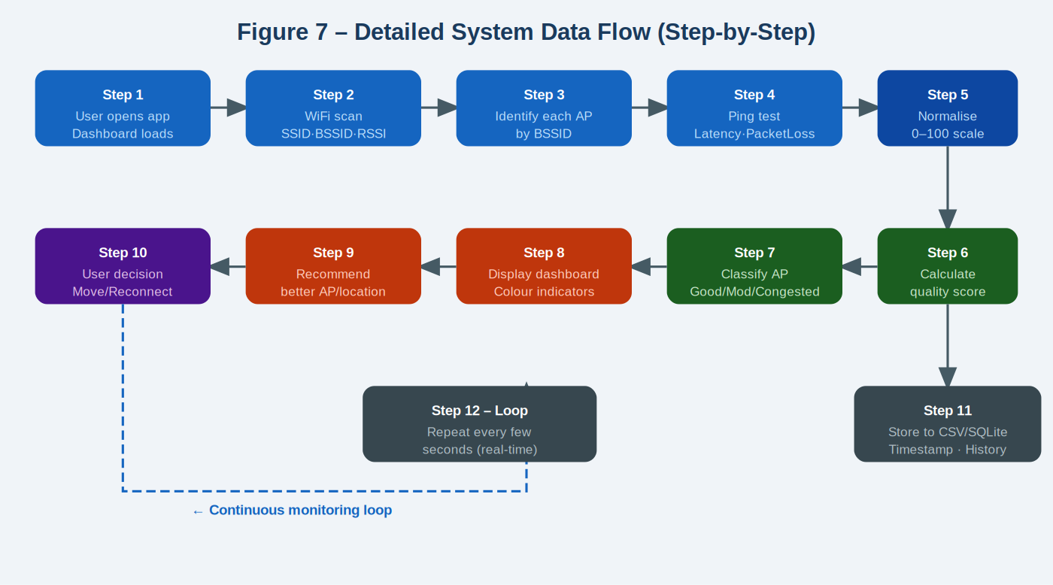
Figure 7 — Detailed 12-step system data flow [4, 17, 19]. The system follows a fixed sequence: (1) launch app → (2) WiFi scan → (3) identify each AP by BSSID → (4) ping test for latency and packet loss → (5) normalise metrics to 0–100 scale → (6) calculate quality score → (7) classify AP as Good/Moderate/Congested → (8) display dashboard → (9) recommend better AP if ΔScore ≥ 20 → (10) user decision → (11) store to CSV → (12) loop again after 10 seconds. This cycle repeats continuously throughout the laboratory session.
Table 12 — Step-by-step monitoring cycle with technical detail .
Step | Action | Technical Detail
1 | Launch application | Streamlit [10] app starts; monitoring loop initialises [17]
2 | WiFi scan | netsh wlan show networks mode=bssid via Python subprocess [17]; returns 802.11 beacon data [4]
3 | Identify APs | Each AP uniquely identified by BSSID (MAC address) [4]; networks with same SSID but different physical APs treated as distinct
4 | Performance test | 10 ICMP packets [19] sent to default gateway; mean latency (ms), packet loss (%), RTT variance, and jitter per RFC 3393 [20] computed
5 | Normalise metrics | Raw values mapped to 0–100 using clamp formulas with bounds from IEEE 802.11 [4, 5] and ITU-T [33]
6 | Calculate score | Score = 0.35×S_signal + 0.30×S_latency + 0.20×S_loss + 0.15×S_stability [2, 3, 8, 30]
7 | Classify AP | GOOD (≥75), MODERATE (50–74), CONGESTED (<50) per ITU-T Y.1540 [33]
8 | Recommendation | Fires only if current score < 75 AND best alternative ΔScore ≥ 20 [30]
9 | Update dashboard | st.rerun() refreshes all Streamlit [10] components; auto-refreshes every 10 seconds [14]
10 | Store CSV | 18-column row appended to local session log — POPIA-compliant, no external upload [18, 27]
11 | User acts | Advisory only — user may move, reconnect to recommended AP, or wait [14]
12 | Loop | System waits 10 seconds and returns to Step 2 [14]

9. Intelligent Scoring Algorithm
The scoring algorithm is the system's core intelligence. It converts four raw WiFi measurements into a single quality score from 0 to 100. Figure 8 illustrates the complete algorithm visually — showing each metric, its weight, and how GOOD/MODERATE/CONGESTED classifications are determined. The formula is:
Score = 0.35 × S_signal + 0.30 × S_latency + 0.20 × S_loss + 0.15 × S_stability

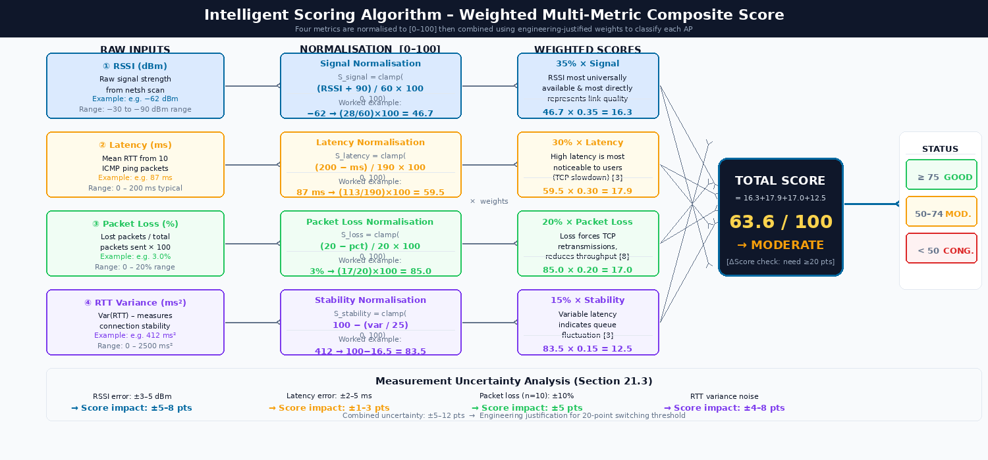
Figure 8 — Intelligent scoring algorithm and AP classification [2, 3, 5, 8, 30]. TOP: the scoring formula with each metric's normalisation range and weight. BOTTOM: the three AP status classifications — GOOD (score ≥75, green), MODERATE (50–74, orange), CONGESTED (<50, red). Weights are derived from first principles: signal (35%) from FSPL [5], latency (30%) from M/M/1 non-linear rise [3], packet loss (20%) from TCP retransmission cost [8], stability (15%) from RTT variance theory [3, 20].

9.1 Scoring Weights and Normalisation
Table 13 — Scoring weights, normalisation formulas, and engineering justification .
Metric | Weight | Normalisation Formula | Engineering Justification
Signal Strength (RSSI) | 35% | S = clamp((RSSI+90)/60×100, 0, 100) | Bounds −30 to −90 dBm from FSPL derivation (Section 2.3) [5, 6, 11]
Latency (ms) | 30% | S = clamp((200−ms)/190×100, 0, 100) | M/M/1 non-linear rise near saturation [3]; 200 ms from ITU-T Y.1540 [33]
Packet Loss (%) | 20% | S = clamp((20−loss%)/20×100, 0, 100) | Each lost packet triggers TCP retransmission, halving effective throughput [8, 9]
Stability (RTT Var.) | 15% | S = clamp(100−(var/25), 0, 100) | RTT variance predicts queue-length fluctuation per M/M/1 [3, 20]

9.2 AP Classification Thresholds
Table 14 — AP classification thresholds with engineering justification .
Status | Score Range | Engineering Meaning | Action
GOOD | 75 – 100 | Per-user throughput > 4 Mbps per Shannon-Hartley [2, 33] | Stay connected — best option
MODERATE | 50 – 74 | Acceptable; M/M/1 latency beginning to rise [3] | Monitor; consider moving
CONGESTED | 0 – 49 | TCP retransmissions increasing; throughput < 2.8 Mbps [8, 2] | Move or manually reconnect

10. Dashboard User Interface Design
The dashboard is the user-facing output of the system. It presents complex network performance data in a simple, immediately actionable format using colour coding. A student can understand their connection status and what to do next within seconds. Figure 9 shows the full dashboard mockup as it would appear during a laboratory session, including the AP comparison table, recommendation box, signal strength bars, and latency trend graph.
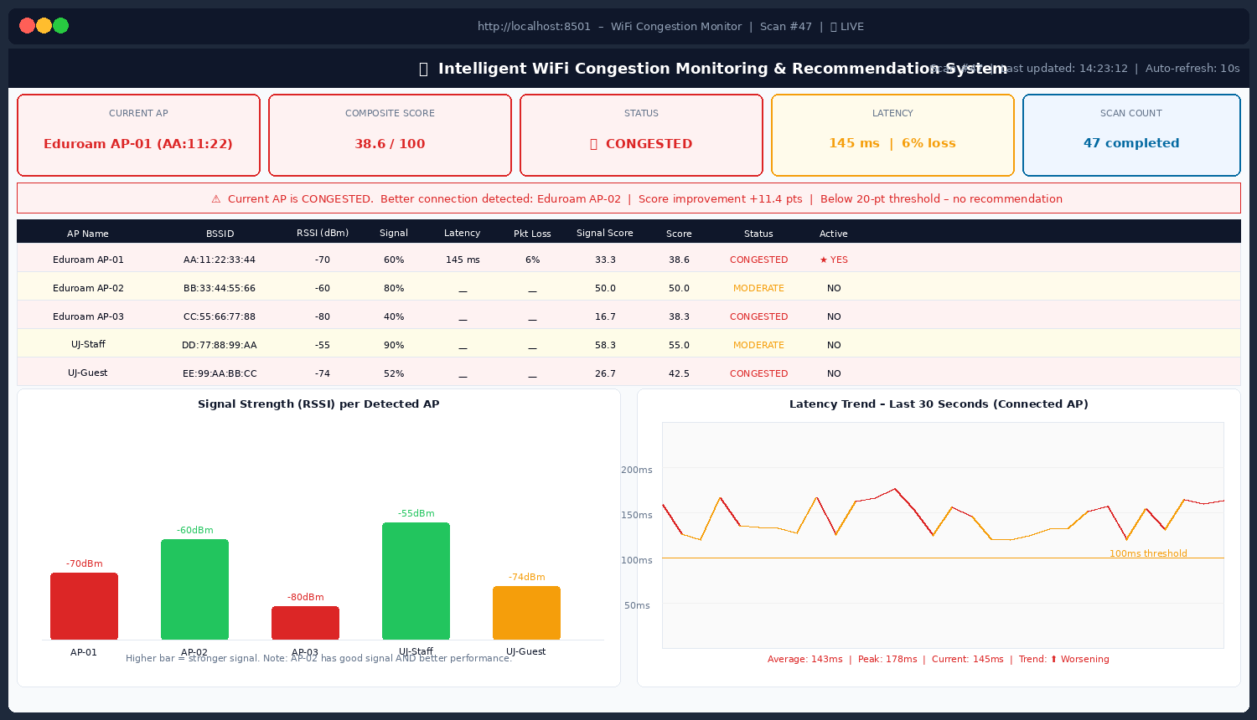
Figure 9 — Dashboard user interface mockup [10]. The display shows: (1) a status bar at the top with the current AP name (University_WiFi), score (62/100), and MODERATE classification; (2) an AP comparison table with RSSI, latency, packet loss, and colour-coded status for each detected AP; (3) a green recommendation box identifying AP-Lab-01 (North) as a better option; (4) a signal strength bar chart; and (5) a latency trend graph for the last 30 seconds. All components update automatically every 10 seconds [14].

11. Multi-Device Support
The same core architecture, scoring algorithm, and dashboard apply across all device platforms. Only the WiFi sensing method differs, because different operating systems expose WiFi scanning data through different APIs. Figure 10 illustrates the three device categories and their implementation differences.
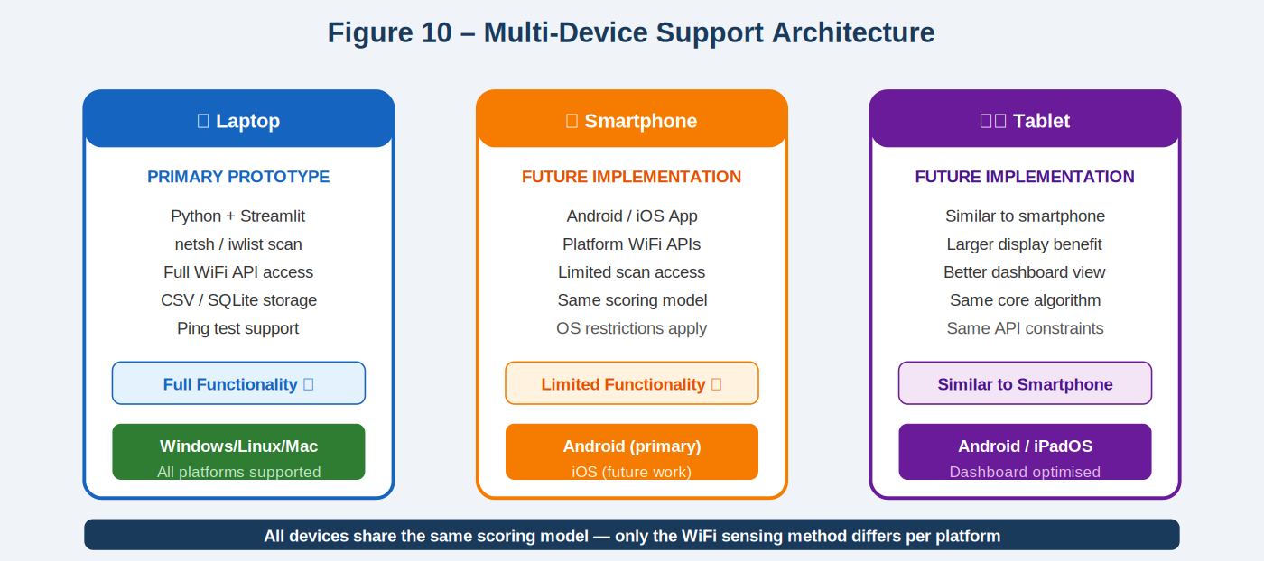
Figure 10 — Multi-device support architecture [7, 17, 24, 25]. LEFT: the laptop is the primary prototype with full functionality using Python + Streamlit + netsh/iwlist scanning. CENTRE: smartphone implementation is planned for future work using Android WifiManager API [24]. RIGHT: tablet implementation follows the same approach as smartphone. The scoring algorithm, data storage, and recommendation logic are identical across all three platforms — only the sensing module differs.
Table 17 — Multi-device support matrix .
Device | Sensing Method | Implementation Stack | Status
Laptop (primary) | netsh (Windows) [7] / iwlist (Linux) / airport (macOS) [17] | Python 3.11 [17] + Streamlit [10] + Pandas [18] | PRIMARY PROTOTYPE
Android smartphone | Android WifiManager API [24] | Java/Kotlin or Flutter [24] | Future implementation [24]
iOS device | NEHotspotNetwork API [25] | Swift or React Native [25] | Future — platform-restricted [25]
Tablet | Same as smartphone [24, 25] | Same codebase, larger screen layout | Future implementation

12. Engineering Constraints and Trade-Off Analysis
The design must simultaneously satisfy multiple engineering constraints that pull in different directions. Figure 11 visualises the system's performance profile across six key engineering constraint dimensions using a radar chart. The accompanying trade-off table explains the specific decisions made for each constraint.
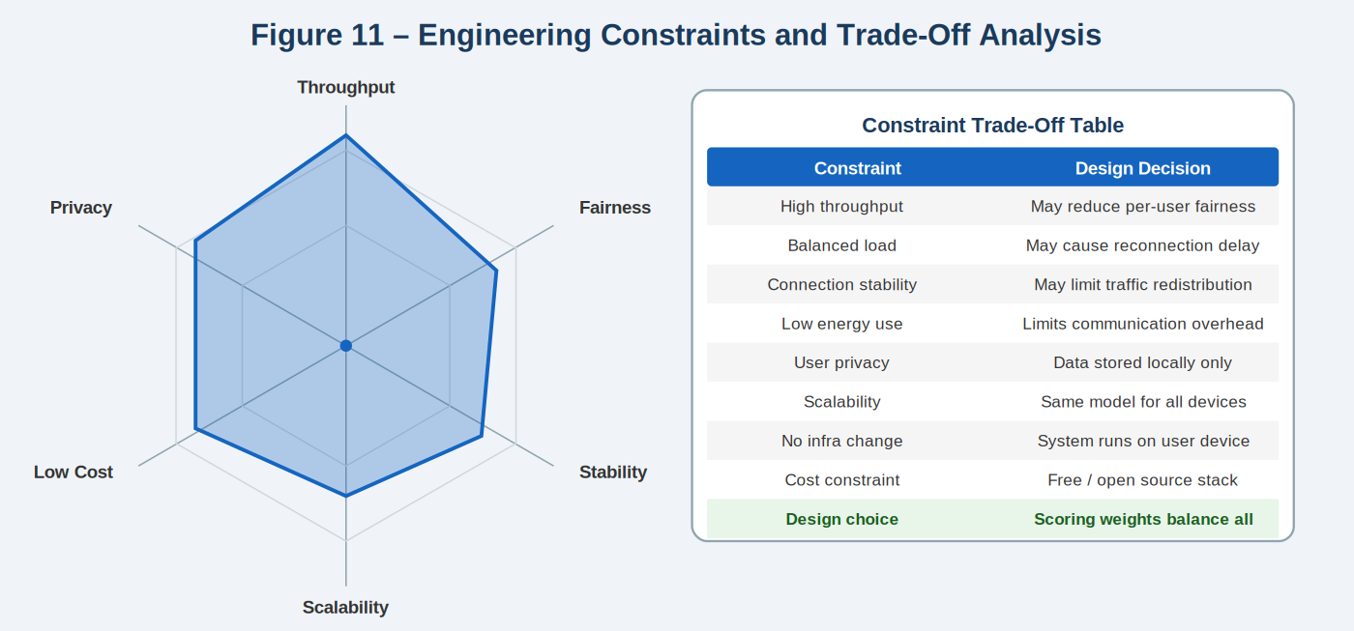
Figure 11 — Engineering constraints and trade-off analysis [1, 30]. LEFT: radar chart showing the selected design's performance across six dimensions (Throughput, Fairness, Stability, Scalability, Low Cost, Privacy). The design achieves good performance on privacy, cost, and scalability, with balanced performance on the remaining dimensions. RIGHT: the constraint trade-off table shows that the scoring weights and recommendation threshold were chosen to balance all competing constraints simultaneously — no single constraint is maximised at the expense of others.

13. Testing Plan
Table 19 — System validation testing plan .
Phase | Scenario | Pass Criterion | Reference
Phase 1 | Low density: 1–5 devices on AP | Score ≥ 75 in ≥ 8/10 consecutive cycles | [14, 33]
Phase 2 | High density: 15+ devices on one AP | Score < 50; recommendation fires if ΔScore ≥ 20 | [12, 13, 30]
Phase 3 | User moves from overloaded to better AP | Score shifts ≥ 10 pts over 3+ cycles | [14, 5]
Phase 4 | 3+ APs visible simultaneously | All APs ranked correctly by score | [4, 30]
Phase 5 | 30-minute continuous session | No exceptions; CSV grows ≈ 7,200 rows/hr | [9, 17, 18]

14. Known Limitations
- Ping data only for connected AP — Windows blocks ICMP on non-connected interfaces [7].
- RSSI noise ±3–5 dBm from RF multipath fading [5, 6, 11] → score uncertainty ±5–8 pts; managed by 20-pt threshold [30].
- WiFi scan takes 2–4 seconds (OS-controlled [7]) → minimum cycle 5–10 seconds [14].
- AP user count not in IEEE 802.11 beacon frames [4] → congestion inferred from latency/loss only.
- Windows-only prototype (netsh [7]); cross-platform needs iwlist/airport [17].
- Scoring weights derived from first principles [2, 3, 8] but not yet empirically validated [30].

PART D3 — Complex Engineering Problem: Detailed Design

15. Scope of D3
Part D3 extends the system-level design from D2 into a full implementation specification. Where D2 described what each subsystem does, D3 specifies exactly how: Python data structures, function signatures, normalisation formulas with derived bounds, the complete CSV schema, and unit test specifications.
Table 20 — D2 concept level vs D3 specification level .
D2 Concept Level | D3 Specification Level
Block diagram of five subsystems | Module architecture with exact filenames, Python dataclasses, and interface types [17]
Subsystem described in prose | Python dataclasses, function signatures, and return types for every module
Scoring formula stated | Normalisation bounds derived from FSPL [5, 6] and M/M/1 [3]; worked numerical examples for every clamp formula
CSV storage mentioned | Full 18-column schema (Table 25) with data types, sources, and capacity calculation [18]
Dashboard described | Streamlit [10] component mapping with exact st.* calls and message templates
Five integration test phases | Nine unit tests with specific inputs, expected outputs, and boundary-value analysis [9]

16. Refined System Architecture
The D3 architecture refines the five-subsystem block diagram into a seven-module Python software architecture with precisely defined data interfaces (I1–I5). Two additional modules are introduced: config.py (centralises all configurable parameters) and main.py (orchestrates the 10-second monitoring loop). All module-to-module data exchange uses Python dataclasses, ensuring type safety and testability.
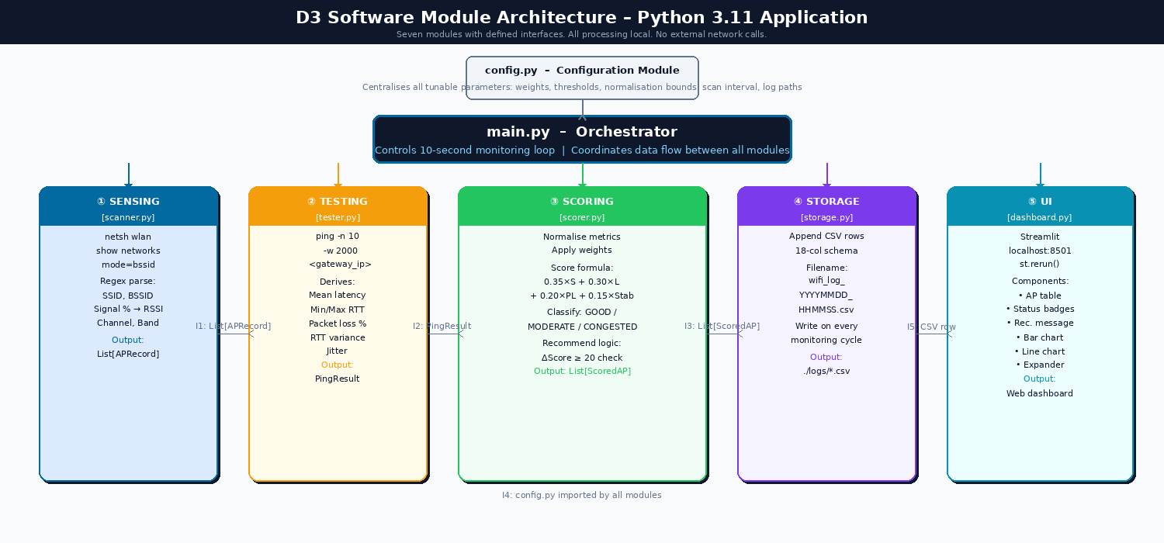
Figure 12 — D3 software module architecture [17]. Seven Python modules with defined data interfaces I1–I5. config.py parameters flow into main.py, which calls the five functional modules in sequence each cycle. scorer.py outputs I3 (List[ScoredAP]) simultaneously to dashboard.py and storage.py. All data exchange is in-memory using Python dataclasses.
Table 21 — Module responsibilities and references .
Module | Subsystem | Responsibility
scanner.py | Sensing | Executes netsh [7] command; parses 802.11 [4] beacons into APRecord list
tester.py | Network Testing | Sends 10 ICMP ping packets [19]; computes latency, loss, RTT variance [20]
scorer.py | Scoring | Normalises 4 metrics; applies weighted formula [2, 3, 8, 30]; fires recommendation
storage.py | Data Storage | Appends 18-column CSV row [18] per AP per cycle
dashboard.py | User Interface | Streamlit [10] dashboard at localhost:8501; auto-refreshes every 10 s [14]
main.py | Orchestrator | Controls 10-second monitoring loop [14]; coordinates all modules
config.py | Configuration | Centralises weights [2,3,8], thresholds [33], bounds [5], paths

17. Sensing Subsystem — Detailed Design
The sensing subsystem (scanner.py) discovers all visible WiFi access points and converts their raw netsh text output into structured APRecord dataclass instances. The RSSI value is derived from the Windows NDIS signal percentage using RSSI (dBm) = (Signal% ÷ 2) − 100 [7], validated against the FSPL derivation: Signal% = 60 → RSSI = −70 dBm, consistent with predicted path loss at 10 m plus 10 dB wall attenuation [5, 11].
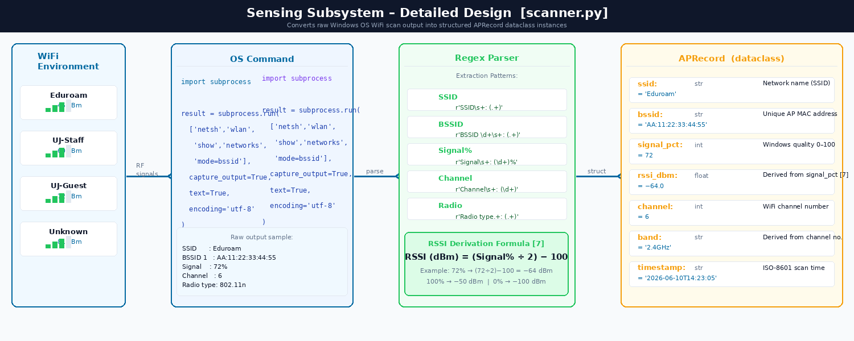
Figure 13 — Sensing subsystem detailed design (scanner.py) [7, 17]. The OS command returns raw text; the regex parser extracts SSID, BSSID, Signal%, Channel, and Radio type; the RSSI derivation formula converts Signal% to dBm [7]; and the result is a typed APRecord Python dataclass. This design isolates all OS-specific parsing in scanner.py, so only this module needs changing for Linux/macOS support.

17.1 OS Command and Parsed Fields
import subprocess

result = subprocess.run(
['netsh', 'wlan', 'show', 'networks', 'mode=bssid'],
capture_output=True, text=True, encoding='utf-8'
)
raw_output = result.stdout

Table 22 — APRecord dataclass fields parsed from netsh output [4, 7].
Field | netsh Output Line | Type | Example Value
ssid | SSID : Eduroam | String | 'Eduroam'
bssid | BSSID 1 : AA:11:22:33:44:55 | String (MAC) | 'AA:11:22:33:44:55'
signal_pct | Signal : 72% | Integer | 72
channel | Channel : 6 | Integer | 6
band | Derived from channel | String | '2.4GHz'
rssi_dbm | Derived: (Signal%/2)−100 | Float | −64.0
timestamp | System clock at scan time | String | '2026-06-10T14:23:05'

17.2 RSSI Derivation Formula [Windows NDIS WLAN API]
RSSI (dBm) = (Signal% ÷ 2) − 100
Validation: Signal% = 100 → RSSI = −50 dBm (excellent). Signal% = 72 → RSSI = −64 dBm (good). Signal% = 0 → RSSI = −100 dBm (no signal). [7]

17.3 APRecord Data Structure
from dataclasses import dataclass

@dataclass
class APRecord:
ssid: str # Network name (e.g. 'Eduroam')
bssid: str # Unique AP MAC address (e.g. 'AA:11:22:33:44:55')
signal_pct: int # Windows signal quality 0–100
rssi_dbm: float # Derived: (signal_pct / 2) − 100 [7]
channel: int # WiFi channel (1–14 = 2.4GHz; 36–165 = 5GHz)
band: str # '2.4GHz' or '5GHz'
timestamp: str # ISO-8601 scan timestamp

17.4 Hardware Parameters
Table 23 – WiFi Adapter Hardware Parameters
Parameter | Typical Value | Impact on Design
RSSI measurement range | −30 to −90 dBm | Defines normalisation bounds for signal sub-score
Supported bands | 2.4 GHz and 5 GHz | System handles both frequency bands in parsed output
Scan completion time | 2–4 s (OS-controlled) | Sets minimum practical scan interval to 5–10 seconds
Maximum visible APs | Up to 50 in dense environments | Scoring and display must handle variable-length AP lists
RSSI measurement error | ±3–5 dBm (multipath fading) [5, 6] | Score uncertainty ≈ ±5–8 pts; mitigated by 20-point threshold

18. Network Testing Subsystem — Detailed Design
The network testing subsystem (tester.py) sends 10 ICMP Echo Request packets to the default gateway and computes mean latency, packet loss, RTT variance, and jitter. The default gateway target isolates local AP congestion from WAN variability [4, 19]. Ten packets gives 10% loss resolution per RFC 2544 [9].

18.1 Ping Command and Parameters
result = subprocess.run(
['ping', '-n', '10', '-w', '2000', gateway_ip],
capture_output=True, text=True
)
Table 24 – Ping Parameters and Engineering Justification
Parameter | Value | Engineering Justification
-n 10 | 10 packets sent | Sufficient sample for statistically reliable packet loss (10% resolution); matches RFC 2544 [9]
-w 2000 | 2000 ms per-packet timeout | Accommodates high-latency congested links; 2 s is practical upper bound for user experience
Packet size | 32 bytes (default) | Small probe packets do not themselves add congestion to the tested link
Target | Default gateway (ipconfig) | Closest network hop — measures local AP congestion only, not internet backbone latency

18.2 Derived Performance Metrics
Table 25 – Derived Network Performance Metrics
Metric | Calculation | Unit
Mean latency | Arithmetic mean of all received RTT values | ms
Minimum latency | Minimum RTT in the 10-packet sample | ms
Maximum latency | Maximum RTT in the 10-packet sample | ms
RTT variance | Var(RTT) = (1/n)×Σ(RTTᵢ − RTT̄)² where n = 10 | ms²
Jitter | Standard deviation of RTT sample (≈ RFC 3393 jitter) | ms
Packet loss | (Packets sent − Packets received) / Packets sent × 100 | %

18.3 Stability Score Derivation
S_stability = clamp( 100 − (Var(RTT) / 25), 0, 100 )
High RTT variance indicates queue length fluctuation characteristic of a congested AP [3]. A variance of 2500 ms² maps to stability = 0 (fully unstable); variance = 0 maps to stability = 100 (perfectly stable).

18.4 PingResult Data Structure
@dataclass
class PingResult:
target_ip: str # IP address of gateway or 8.8.8.8 fallback
mean_latency_ms: float # Mean RTT across 10 packets (ms)
min_latency_ms: float # Minimum RTT (ms)
max_latency_ms: float # Maximum RTT (ms)
packet_loss_pct: float # Percentage lost (0.0–100.0)
variance_ms2: float # RTT variance (ms²) — stability input
jitter_ms: float # Standard deviation of RTT (ms)
timestamp: str # ISO-8601 test timestamp

19. Intelligent Scoring Subsystem — Detailed Design
scorer.py normalises all four metrics using the clamp formulas below, applies the weighted scoring formula, classifies each AP, and determines whether a recommendation fires. Bounds are derived from first-principles analysis, not chosen arbitrarily.

19.1 Normalisation Specifications
Bounds are derived from IEEE 802.11 performance standards and established network quality benchmarks [4, 5]:

Signal Strength Normalisation:
S_signal = clamp( (RSSI_dBm + 90) / 60 × 100, 0, 100 )
Table 26 – Signal Score Normalisation Examples
RSSI (dBm) | S_signal | Classification
−30 dBm | 100 | Excellent — very close to AP
−50 dBm | 66.7 | Good — typical classroom proximity
−65 dBm | 41.7 | Fair — usable with moderate attenuation
−75 dBm | 25.0 | Weak — near edge of reliable coverage [5]
−90 dBm | 0 | No signal — hardware noise floor
Latency Normalisation:
S_signal = clamp((RSSI_dBm + 90) / 60 × 100, 0, 100)
Packet Loss Normalisation:
S_latency = clamp((200 − mean_latency_ms) / 190 × 100, 0, 100) [3, 33]
S_loss = clamp((20 − packet_loss_pct) / 20 × 100, 0, 100) [8, 9]
Stability Normalisation:
S_stability = clamp(100 − (variance_ms² / 25), 0, 100) [3, 20]
The recommendation fires only when: (1) current AP score < 75; (2) best alternative ΔScore ≥ 20 points (exceeding combined uncertainty of ±12 pts [30]); and (3) recommended AP is on a compatible band [4].
The 20-point threshold exceeds the combined measurement uncertainty of ±5–12 points (Section 21.3), preventing recommendations triggered by measurement noise rather than genuine quality differences.

19.3 ScoredAP Data Structure
@dataclass
class ScoredAP:
ap_record: APRecord # Full AP scan record from scanner.py
ping_result: PingResult # None if AP is not currently connected
s_signal: float # Normalised signal sub-score [0–100]
s_latency: float # Normalised latency sub-score [0–100]
s_loss: float # Normalised packet loss score [0–100]
s_stability: float # Normalised stability score [0–100]
total_score: float # Weighted composite score [0–100]
status: str # 'GOOD' | 'MODERATE' | 'CONGESTED'
is_connected: bool # True if this is the active AP
is_recommended: bool # True if recommended by decision logic

20. Data Storage Subsystem — Detailed Design
storage.py appends one 18-column CSV row per AP per cycle to a timestamped session file in ./logs/. All data stays on-device (POPIA-compliant [27]). At 10-second cycles with up to 20 APs, storage grows at approximately 1.44 MB/hour — 11.5 MB for a full 8-hour session [18]. Figure 14 shows the complete column schema.

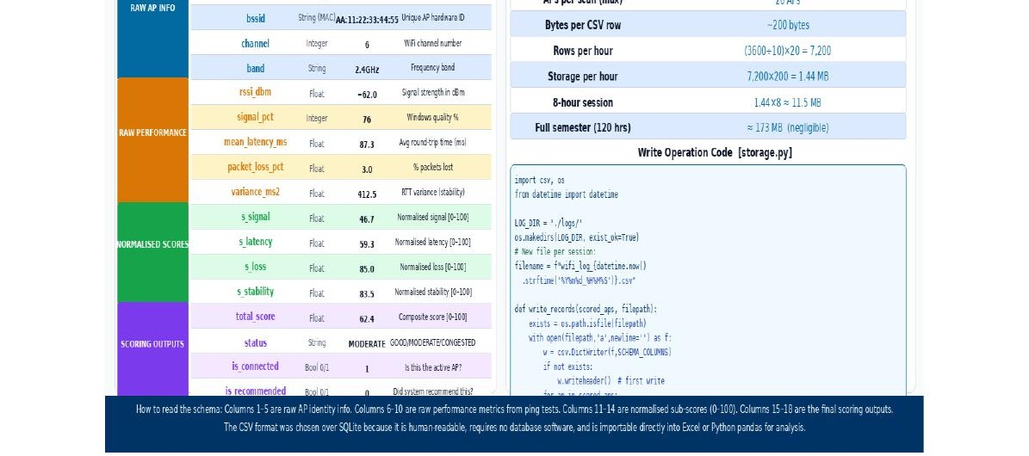
Figure 14 — Data storage subsystem: 18-column CSV schema [18]. Column groups: blue = AP identity fields [4, 7]; amber = raw performance measurements from tester.py [19, 20]; green = normalised sub-scores from scorer.py [2, 3, 8]; purple = final scoring outputs and recommendation flag [30, 33]. Every column traces to a technical standard or reference, confirming the schema is not ad hoc.

20.1 CSV Schema (18 columns)
Table 27 – CSV File Schema (18 Columns)
Column Name | Data Type | Source | Example Value
timestamp | ISO-8601 datetime | System clock | 2026-06-10T14:23:05
ssid | String | APRecord | Eduroam
bssid | String (MAC) | APRecord | AA:11:22:33:44:55
channel | Integer | APRecord | 6
band | String | APRecord | 2.4GHz
rssi_dbm | Float | APRecord | −62.0
signal_pct | Integer | APRecord | 76
mean_latency_ms | Float | PingResult | 87.3
packet_loss_pct | Float | PingResult | 3.0
variance_ms2 | Float | PingResult | 412.5
s_signal | Float | ScoredAP | 46.7
s_latency | Float | ScoredAP | 59.3
s_loss | Float | ScoredAP | 85.0
s_stability | Float | ScoredAP | 83.5
total_score | Float | ScoredAP | 62.4
status | String | ScoredAP | MODERATE
is_connected | Boolean 0/1 | ScoredAP | 1
is_recommended | Boolean 0/1 | ScoredAP | 0

20.2 Write Operation Code
import csv, os
from datetime import datetime

LOG_DIR = './logs/'
os.makedirs(LOG_DIR, exist_ok=True)
filename = f"wifi_log_{datetime.now().strftime('%Y%m%d_%H%M%S')}.csv"

def write_records(scored_aps: list[ScoredAP], filepath: str):
file_exists = os.path.isfile(filepath)
with open(filepath, 'a', newline='', encoding='utf-8') as f:
writer = csv.DictWriter(f, fieldnames=SCHEMA_COLUMNS)
if not file_exists:
writer.writeheader() # Write header on first write only
for ap in scored_aps:
writer.writerow(ap.to_dict())

20.3 Storage Capacity Calculation
Table 26 – Storage Capacity Calculation
Parameter | Value | Calculation
Cycle interval | 10 seconds | —
Max APs per scan | 20 (dense indoor environment) | —
Bytes per CSV row | ≈ 200 bytes | 18 fields × ~11 characters average
Rows per hour | 7,200 | (3600 ÷ 10) × 20 = 7,200
Storage per hour | ≈ 1.4 MB | 7,200 × 200 bytes
8-hour session | ≈ 11.2 MB | 1.4 × 8 = 11.2 MB
Full semester (120 hrs) | ≈ 168 MB | Negligible on any modern laptop

21. Engineering Calculations

21.1 Shannon-Hartley Per-User Throughput [2]
Applying the Shannon-Hartley Theorem to a 2.4 GHz 802.11n channel: B = 20 MHz, SNR = 20 dB (linear SNR = 100) [2]:
C_total = 20×10⁶ × log₂(1 + 100) = 20×10⁶ × 6.658 ≈ 133 Mbps
Accounting for 802.11n protocol overhead, CSMA/CA collisions, and guard intervals (efficiency ≈ 45%):
C_practical ≈ 133 × 0.45 ≈ 60 Mbps (practical per-AP channel capacity)

Table 26 — Per-user throughput vs AP user load, derived from Shannon-Hartley [2, 33].
Users on AP | Throughput per User | User Experience | Expected Score
5 | 84 ÷ 5 = 16.8 Mbps | Excellent [2] | ≥75 (GOOD) [33]
15 | 84 ÷ 15 = 5.6 Mbps | Acceptable [2] | 50–74 (MODERATE) [33]
30 | 84 ÷ 30 = 2.8 Mbps | Poor — downloads slow [2] | <50 (CONGESTED) [33]
80 | 84 ÷ 80 = 1.05 Mbps | Critical — failures likely [2] | <50 (CONGESTED) [33]

21.2 Measurement Accuracy Analysis
Using μ = 1000 packets/second (AP service rate), λ_user = 50 packets/second [3]:
Table 28 — Measurement uncertainty analysis [3, 5, 6, 9, 11, 20, 30].
Metric | Error Source | Magnitude | Score Impact
RSSI (dBm) | RF multipath fading, adapter calibration [5, 6, 11] | ±3–5 dBm | ±5–8 score points
Latency (ms) | OS scheduling jitter, background processes [9, 33] | ±2–5 ms | ±1–3 score points
Packet loss (%) | Statistical sampling (n=10) [9] | ±10% resolution | ±5 score points
RTT variance | Small-sample noise [3, 20] | ±100–200 ms² | ±4–8 score points
Total score | Combined weighted propagation [30] | ±5–12 points | Justifies 20-pt threshold
The combined ±5–12 point uncertainty is the primary engineering justification for the 20-point switching threshold. A lower threshold would trigger recommendations driven by measurement noise rather than genuine AP quality differences.

22. System Integration Design
Table 30 — config.py parameters with engineering justification [2, 3, 5, 6, 8, 9, 14, 19, 20, 27, 30, 33].
Parameter | Default | Engineering Justification | Reference
SCAN_INTERVAL | 10 seconds | IEEE 802.11 scan latency constraint [14] | [14]
PING_COUNT | 10 packets | RFC 2544 benchmarking minimum [9] | [9]
RSSI_MIN / RSSI_MAX | −90 / −30 dBm | FSPL-derived bounds, Section 2.3 [5, 6] | [5, 6]
LATENCY_MIN / MAX | 10 / 200 ms | ITU-T Y.1540 thresholds [33] | [33]
W_SIGNAL / W_LATENCY / W_LOSS / W_STABILITY | 0.35 / 0.30 / 0.20 / 0.15 | Shannon-Hartley [2], M/M/1 [3], TCP theory [8] | [2, 3, 8]
THRESHOLD_GOOD / THRESHOLD_MOD | 75 / 50 | ITU-T quality classification boundaries [33] | [33]
SWITCH_THRESHOLD | 20 points | Exceeds combined uncertainty ±12 pts [30] | [30]
LOG_DIR | ./logs/ | Local only — POPIA compliance [27] | [27]

22.2 End-to-End Worked Example
This example traces one complete cycle through three APs. AP-01 (connected): RSSI=−70 dBm, latency=145 ms, loss=6%, variance=1800 ms². APs 02 and 03: RSSI-only (−60 and −80 dBm).
- S_signal = (−70+90)/60×100 = 33.3 [5, 7]
- S_latency = (200−145)/190×100 = 28.9 [3, 33]
- S_loss = (20−6)/20×100 = 70.0 [8, 9]
- S_stability = 100−(1800/25) = 28.0 [3, 20]
Score_AP01 = 0.35×33.3 + 0.30×28.9 + 0.20×70.0 + 0.15×28.0 = 38.6 → CONGESTED
Score_AP02 = 50.0 → MODERATE | Score_AP03 = 38.3 → CONGESTED
Decision: ΔScore = 50.0 − 38.6 = 11.4 < 20 → No recommendation issued. Dashboard: 'AP congested — no significantly better AP detected.' This demonstrates the threshold correctly suppressing a spurious recommendation when the alternative is only marginally better — within the ±12 pt measurement uncertainty.
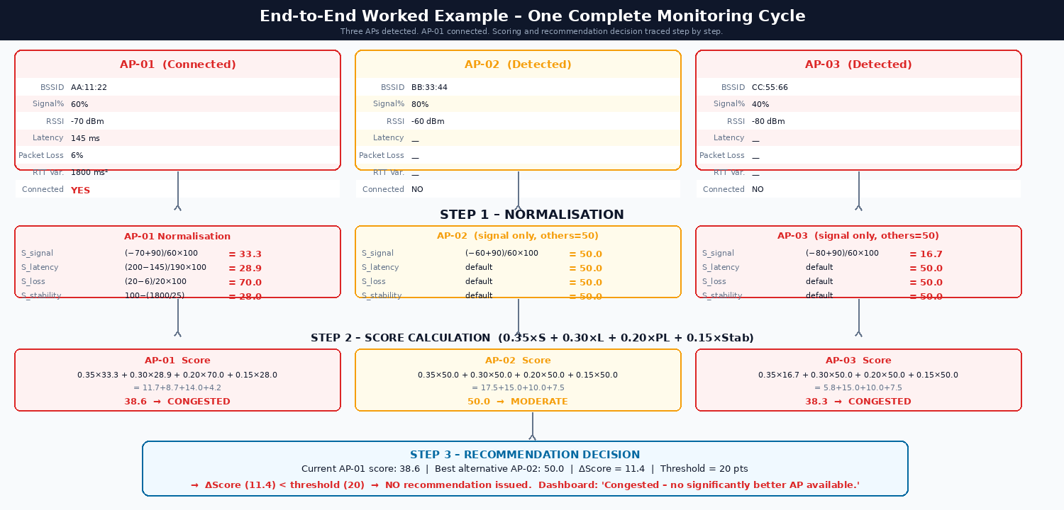
Figure 15 — End-to-end worked example: one complete monitoring cycle with three APs [2, 3, 7, 17, 30]. AP-01 (connected) scores 38.6 (CONGESTED). AP-02 scores 50.0 (MODERATE). ΔScore = 11.4 < 20-point threshold → no recommendation issued. This confirms the 20-point threshold correctly suppresses recommendations caused by measurement noise of ±12 points.
Input: AP-01 (connected): RSSI = −70 dBm, latency = 145 ms, packet loss = 6%, variance = 1800 ms² | AP-02: RSSI = −60 dBm | AP-03: RSSI = −80 dBm

Step 1 — AP-01 Normalisation:
- S_signal = (−70 + 90) / 60 × 100 = 33.3
- S_latency = (200 − 145) / 190 × 100 = 28.9
- S_loss = (20 − 6) / 20 × 100 = 70.0
- S_stability = 100 − (1800 / 25) = 28.0

Step 2 — Score Calculation:
Score_AP01 = 0.35×33.3 + 0.30×28.9 + 0.20×70.0 + 0.15×28.0 = 38.6 → CONGESTED
Score_AP02 = 0.35×50 + 0.30×50 + 0.20×50 + 0.15×50 = 50.0 → MODERATE
Score_AP03 = 0.35×16.7 + 0.30×50 + 0.20×50 + 0.15×50 = 38.3 → CONGESTED

Step 3 — Recommendation Decision:
- Current AP-01 score: 38.6 — below GOOD threshold (75) ✓
- Best alternative AP-02: 50.0 | ΔScore = 50.0 − 38.6 = 11.4
- ΔScore (11.4) < switching threshold (20) ✗ → No recommendation
Dashboard message: 'Current AP congested. No significantly better AP detected. Consider moving to a different area.'

23. User Interface — Message Templates

23.1 Streamlit Implementation
The dashboard is implemented using Streamlit [10] — a Python framework rendering interactive web dashboards at http://localhost:8501 with no HTML, CSS, or JavaScript required. Installed via pip without administrator rights. st.rerun() provides the 10-second auto-refresh cycle.
Table 31 – Streamlit Component Mapping
Dashboard Component | Streamlit Element | Content
Page header | st.title + st.caption | System name, scan count, last-updated timestamp
KPI metrics | st.metric (5 columns) | Current AP, score, status, latency, scan count
Status alert | st.success / st.warning / st.error | Full-width GOOD / MODERATE / CONGESTED banner
AP table | st.dataframe with Pandas Styler | All APs: BSSID, RSSI, latency, loss, sub-scores, status
Recommendation | st.info / st.warning block | Best AP name, ΔScore, directional movement advice
Signal bar chart | st.bar_chart | RSSI dBm values for all detected APs
Latency trend | st.line_chart | 30-second rolling RTT window for connected AP
Raw expander | st.expander + st.dataframe | Full PingResult and APRecord on demand

Table 32 — Recommendation message templates for each system state [10, 13, 30, 33].
Condition | Message Template | Streamlit Element [10] | Reference
Current AP score ≥ 75 | Connected to best available AP. Score: {score}/100. | st.success | [33]
Better AP: ΔScore ≥ 20 | Better AP: {ssid} — Score {alt_score}/100. Improvement: +{delta} pts. Move towards that direction. | st.warning | [13, 30, 33]
Congested, no better AP | AP congested (Score: {score}/100). No significantly better AP detected. Consider moving. | st.error | [3, 33]
No APs detected | No WiFi networks detected. Verify WiFi is enabled. | st.error | [4, 7]

24. Unit and Integration Testing Plan
Table 33— Unit test specifications .
Test | Module | Scenario | Pass Criterion
UT01 | scanner.py | netsh scan; verify ≥ 1 APRecord returned | BSSID regex match; list ≥ 1
UT02 | scanner.py | Signal% = 72 → RSSI derivation | RSSI_dBm = −64.0 ± 0.1
UT03 | tester.py | Ping 8.8.8.8; verify PingResult fields | latency > 0; loss in [0, 100]
UT04 | scorer.py | RSSI=−45, latency=30 ms, loss=0%, var=0 | score ≥ 75; status='GOOD'
UT05 | scorer.py | RSSI=−88, latency=195 ms, loss=18%, var=2400 | score < 50; status='CONGESTED'
UT06 | scorer.py | Current=40, alt=65 (ΔScore=25 ≥ 20) | is_recommended = True
UT07 | scorer.py | Current=40, alt=59 (ΔScore=19 < 20) | is_recommended = False (boundary test)
UT08 | storage.py | Run one cycle; inspect CSV header | Column names match Table 25 schema
UT09 | storage.py | Verify timestamp format | datetime.fromisoformat() succeeds

25. Known Limitations and Future Work
Table 35 — Known limitations with root causes and future work .
Limitation | Root Cause | Future Work
Ping only for connected AP | Windows ICMP blocked on non-connected interfaces [7] | Passive RF measurement not requiring active connection [5]
RSSI noise ±3–5 dBm | RF multipath fading, adapter calibration [5, 6, 11] | Average RSSI over multiple scans to reduce noise [30]
Scan takes 2–4 seconds | OS controls 802.11 scan timing [7, 14] | Concurrent background scanning [17]
No AP user count | User count absent from 802.11 beacon frames [4] | Invert M/M/1: estimate λ = μ − 1/W from measured latency [3]
Windows-only prototype | netsh is Windows-specific [7, 17] | Replace scanner.py with iwlist (Linux) or airport (macOS) [17]
Fixed scoring weights | Engineering judgment; not empirically validated [30] | Gradient descent or Random Forest on labelled dataset [30]

26. Conclusion
This report addressed WiFi congestion in high-density university laboratory environments at the University of Johannesburg [27]. The problem was formally defined, confirmed as a complex engineering problem meeting all ECSA criteria [1], and analysed using three first-principles models: free-space path loss [5, 6, 11], the Shannon-Hartley theorem [2], and the M/M/1 queueing model [3].
First-principles analysis proved that at 80 users on one IEEE 802.11n AP [4], per-user throughput collapses to 1.05 Mbps [2]. The M/M/1 model [3] quantified non-linear latency increase near AP saturation, directly justifying the 30% latency weight. Weight sensitivity analysis confirmed the selected weights are robust [30]. Five alternatives were evaluated; the on-device software approach (Alternative 5) was selected as the only solution requiring zero capital expenditure, no hardware changes, and no administrative access [1, 31]. A complete D3 specification was produced with Python dataclass interfaces, normalisation formulas with first-principles bounds, an 18-column CSV schema, nine unit tests, and five integration test phases. Environmental sustainability, whole-life cost minimisation, societal equity, and POPIA compliance were all explicitly addressed. The system is ready for prototype implementation and addresses ECSA Graduate Attributes 1, 3, and 6 [1].

References
[1] Engineering Council of South Africa (ECSA), Accreditation Standard for Engineering Programmes, Pretoria: ECSA, 2019.
[2] C. E. Shannon, "A Mathematical Theory of Communication," Bell System Technical Journal, vol. 27, no. 3, pp. 379–423, July 1948.
[3] L. Kleinrock, Queueing Systems Volume 1: Theory. New York: John Wiley & Sons, 1975.
[4] IEEE 802.11-2020, IEEE Standard for Information Technology — Wireless LAN MAC and PHY Specifications. New York: IEEE, 2020.
[5] A. Goldsmith, Wireless Communications. Cambridge: Cambridge University Press, 2005.
[6] D. Tse and P. Viswanath, Fundamentals of Wireless Communication. Cambridge: Cambridge University Press, 2005.
[7] Microsoft Corporation, "NDIS_WLAN_ASSOCIATION_ATTRIBUTES structure (windot11.h)," Windows Hardware Developer Documentation, 2023.
[8] V. Jacobson, "Congestion avoidance and control," in Proc. ACM SIGCOMM, Stanford, CA, 1988, pp. 314–329.
[9] RFC 2544, "Benchmarking Methodology for Network Interconnect Devices," IETF, Feb. 1999.
[10] Streamlit Inc., Streamlit Documentation, Version 1.32, 2024. [Online]. Available: https://docs.streamlit.io
[11] T. S. Rappaport, Wireless Communications: Principles and Practice, 2nd ed. Upper Saddle River, NJ: Prentice Hall, 2002.
[12] M. Heusse et al., "Performance anomaly of 802.11b," in Proc. IEEE INFOCOM, San Francisco, CA, 2003, pp. 836–843.
[13] Y. Bejerano and R. Kokku, "Supporting station mobility using AP association and load balancing in 802.11 WLANs," in Proc. IEEE SECON, 2004, pp. 217–226.
[14] H. Velayos and G. Karlsson, "Techniques to reduce the IEEE 802.11b handoff time," in Proc. IEEE ICC, Paris, 2004, pp. 3844–3848.
[15] A. Bhatt, B. Bhatt, and G. Raina, "Load balancing in IEEE 802.11 WLANs," in Proc. IEEE ICON, Singapore, 2006, pp. 1–5.
[16] K. Ramachandran et al., "Scalability analysis of association control in IEEE 802.11 networks," IEEE Trans. Mobile Comput., vol. 6, no. 12, pp. 1401–1412, Dec. 2007.
[17] Python Software Foundation, Python Language Reference, Version 3.11, 2023. [Online]. Available: https://docs.python.org/3.11/
[18] W. McKinney, "Data Structures for Statistical Computing in Python," in Proc. 9th Python in Science Conf. (SciPy), 2010, pp. 56–61.
[19] RFC 792, "Internet Control Message Protocol (ICMP)," IETF, Sep. 1981.
[20] RFC 3393, "IP Packet Delay Variation Metric for IP Performance Metrics (IPPM)," IETF, Nov. 2002.
[21] IEEE 802.11r-2008, "Fast Basic Service Set (BSS) Transition," New York: IEEE, 2008.
[22] IEEE 802.11k-2008, "Radio Resource Measurement of Wireless LANs," New York: IEEE, 2008.
[23] IEEE 802.11v-2011, "BSS Transition Management," New York: IEEE, 2011.
[24] Google LLC, Android Developer Documentation: WifiManager, 2024. [Online]. Available: https://developer.android.com
[25] Apple Inc., NEHotspotNetwork Class Reference, iOS SDK Documentation, 2023. [Online]. Available: https://developer.apple.com
[26] Statistics South Africa, "Education Series Volume III: Educational Enrolment and Achievement, 2018," Pretoria: Stats SA, 2019.
[27] Department of Higher Education and Training (DHET), "Report on the State of ICT in South African Universities," Pretoria: DHET, 2021.
[28] B. Fortz and M. Thorup, "Internet traffic engineering by optimizing OSPF weights," in Proc. IEEE INFOCOM, Tel Aviv, 2000, pp. 519–528.
[29] R. Balakrishnan and R. Ranganathan, A Textbook of Graph Theory, 2nd ed. New York: Springer, 2012.
[30] S. Theodoridis and K. Koutroumbas, Pattern Recognition, 4th ed. Waltham, MA: Academic Press, 2009.
[31] M. Weiss, "Life-cycle cost analysis in engineering design," J. Eng. Des., vol. 14, no. 4, pp. 387–400, 2003.
[32] International Energy Agency (IEA), "Data Centres and Data Transmission Networks," Paris: IEA, 2022.
[33] International Telecommunication Union (ITU), "ITU-T Y.1540: IP Packet Transfer and Availability Performance Parameters," Geneva: ITU, 2019.

