Website Project Proposal
Golden Crust Bakery

Subject: Web Development (WEDE5020)
Part 1: Building the Foundation
Full name: Njabulo Zondi
Student number: ST10534338
Group: Not applicable

Table of Contents

1. Organisation Overview
Name: Golden Crust Bakery. A family-owned bakery founded by Thandi and Pieter Naidoo in Melville, Johannesburg, in 2012. It now operates three branches (Melville, Rosebank and Fourways).
Mission: To bake honest, high-quality food that brings people together every day.
Vision: To be Johannesburg's most trusted neighbourhood bakery.
Target audience: Local families, office workers, event planners and small businesses aged 20 to 55 who value fresh, locally made food.

2. Website Goals and Objectives
- Generate online enquiries for custom cakes and catering.
- Increase local search visibility and website traffic.
- Provide clear product, price and branch information.
Key performance indicators (KPIs):
KPI | Target (6 months)
Monthly website visitors | 1 500
Enquiry form submissions | 60 per month
Bounce rate | Below 50%
Mobile page load time | Under 3 seconds

3. Current Website Analysis
The bakery has no website and relies on Facebook. Strengths: an active social following. Weaknesses: no prices, no online enquiries and poor search visibility. Improvement: a searchable product list, enquiry forms and local SEO.

4. Proposed Website Features and Functionality
- Home (index.html): hero image, introduction, call to action, gallery and FAQ.
- About Us (about.html): history, mission, vision and team.
- Products (products.html): searchable, filterable product list.
- Enquiry (enquiry.html): form giving cost and availability.
- Contact (contact.html): contact form and map showing three branches.

5. Design and User Experience
Element | Proposal
Colour scheme | Brown #5A2D0C, golden #F4A63A, cream #FFF8EC (warm, bakery feel, high contrast)
Typography | Poppins headings and body, system sans-serif fallback; scale of 1.25
Layout | Flexbox header, CSS Grid content, single column on mobile

User experience: a consistent navigation menu, readable text, alt text on images and large touch targets for mobile users. The sitemap and low-fidelity wireframes follow.
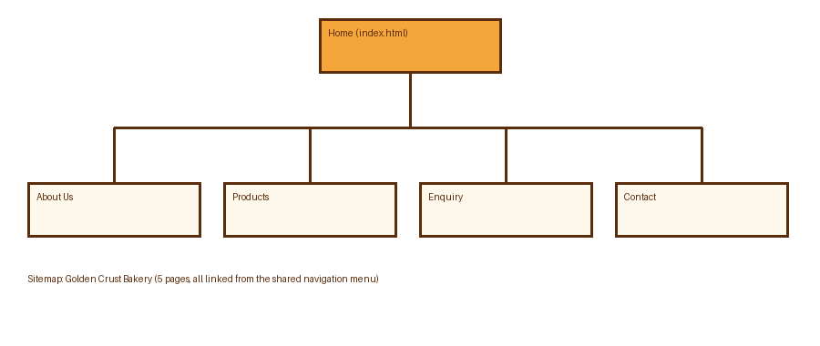
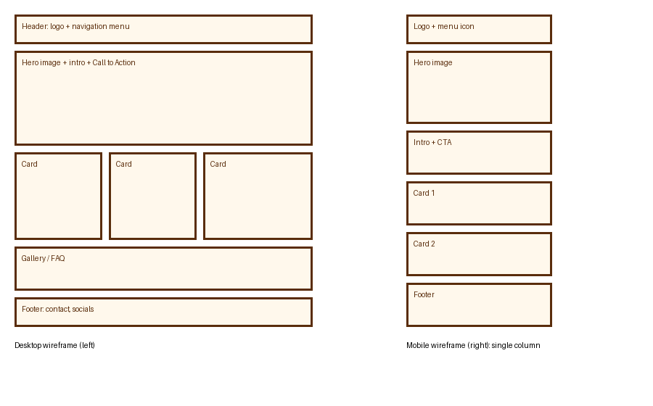

6. Technical Requirements
HTML5, CSS3 and JavaScript (Leaflet for maps), written in Visual Studio Code and versioned with Git/GitHub. Free hosting on Netlify with a free subdomain; a custom .co.za domain is optional.

7. Timeline and Milestones
Week | Milestone
1 | Proposal, research, folder structure, HTML pages (Part 1)
2 to 3 | CSS styling and responsive design (Part 2)
4 to 5 | JavaScript, SEO, forms and deployment (Part 3)
Weeks will be aligned to the official submission dates for the subject.

8. Budget
Item | Estimated cost (ZAR)
Development (about 40 hours at R250) | R10 000
Hosting (Netlify free plan) | R0
Domain (.co.za, per year) | R150
Maintenance (R500 per month, 12 months) | R6 000
Total (first year) | R16 150

9. References
Google (n.d.) SEO starter guide. Available at: https://developers.google.com/search/docs/fundamentals/seo-starter-guide (Accessed: 6 November 2026).
Leaflet (n.d.) Leaflet: an open-source JavaScript library for interactive maps. Available at: https://leafletjs.com (Accessed: 6 November 2026).
Mozilla Developer Network (n.d.) HTML: HyperText Markup Language. Available at: https://developer.mozilla.org/en-US/docs/Web/HTML (Accessed: 6 November 2026).
Netlify (n.d.) Netlify docs. Available at: https://docs.netlify.com (Accessed: 6 November 2026).
OpenStreetMap contributors (n.d.) OpenStreetMap. Available at: https://www.openstreetmap.org (Accessed: 6 November 2026).

