# Campus Travel Planner

## The Steps Taken to Assign a Bus:

### Step 1:

The Timetabling (TT) writes to the CODs (Chairs of departments.) asking if there are any trips from their departments at the beginning of the semester.

### Step 2:

The CODs write to TT in response to step 1 above and in the response, they must indicate the following:

* Place of visit
* The budget
* The Purpose of the Visit
* Unit involved
* Date of visit

### Step 3:

The director TT compiles provisional Trips TT to DVC AA (Deputy vice chancellor of Academic Affairs) who approves.

### Step 4:

After approval, the Director TT (Time Tabling) compiles the list.

### Step 5:

The director of Timetabling advices the Transport Manager to provide vehicles on the said date.

### Step 6:

Lectures apply for funds from the DVC AA.

### Step 7:

The final list is copied/shared with Registrar AA, DVC APD (Deputy Vice Chancellor Administration Planning and Development.) all CODs, and the Transport manager.

## The Process Flowchart

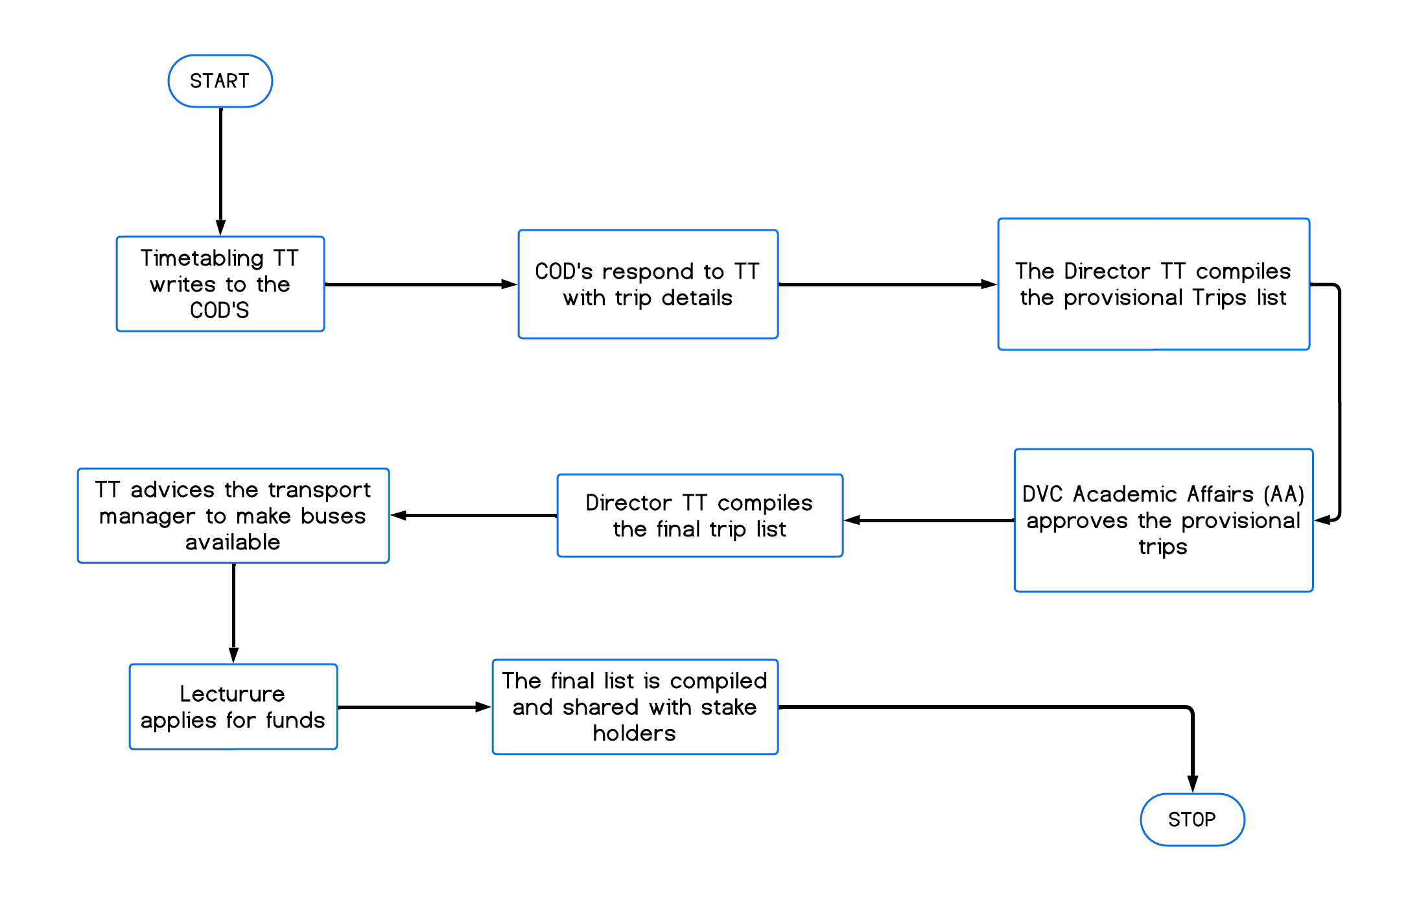

## Schema for the database:

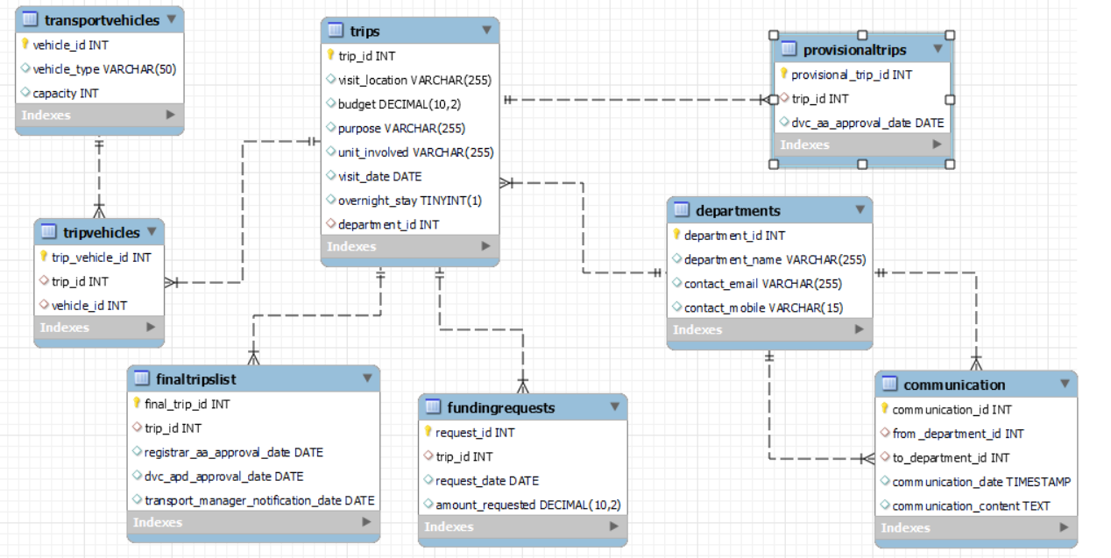

## Forms and Reports:

### HTML Forms for Data Input:

1. Form to add a new department.
2. Form to add a new trip.
3. Form to add a new provisional trip.
4. Form to add a new transport vehicle.
5. Form to add a new trip vehicle.
6. Form to add a new funding request.
7. Form to add a new final trip list record.
8. Form to add a new communication record.

### HTML Pages for Reports:

1. Report on all departments.
2. Report on all trips.
3. Report on provisional trips.
4. Report on transport vehicles.
5. Report on trip vehicles.
6. Report on funding requests.
7. Report on final trip lists.
8. Report on communications.