OMSe orders & you

Phone feature change examples

This document is to show examples of what is necessary for multiple changes in phone provisioning, without requiring autocomplete. These examples are all done in OMSe, and can change block/allow status for all features such as international calling, call forwarding, and can remove numbers from call blocking.

**What is necessary in all orders**:

(Type Switch, of course this won't work with voicemail orders)

ACP

Update

Due Date(today)

Account Number

Service ID(TN)

Telephone Number to make changes upon

**List of Calling features(BLOCK):**

976(you know what these are)

900(you know what these are)

CASUAL(ADDL Charges, will automatically set all others to Y if this is Y)

DA(Directory Assistance(charge, local))

INTL(International)

NDA(Directory Assistance(charge, national))

411(allow ability to call directory assistance)

0+(Collect calls)

**\*List of Forwarding features:**

CFNA(Call Forward No Answer):

Active(Y/N)

Forward(TN)

NumberOfRings(0-10)

CFB(Call Forward Busy)

Active(Y/N)

Forward(TN)

CFU(Call Forward Unconditional)

Active(Y/N)

Forward(TN)

*Note that they will appear to have an attribute of Forward(TN) to be forwarded to. This is a trick. The real attribute is FDN/0, which upon you would place the TN when creating these.

**List of Call Acceptance/Call Block features:**

SCA(Acceptance, whitelist)

SCR(Rejection, blacklist)

Active(Y/N)

number(TN)

*Note I have yet to figure out how to **add** numbers to this list. I have figured out how to remove them though.

**Other features and attributes:**

SIMULRING(answer anywhere)

active(Y/N)

number(TN)

*Note that TN 6467988400 is Nomorobo

DRCW(Distinctive Ring(Call Waiting, but works for normal calls as well as busy calls))

active(Y/N

number(TN)

**How to Block/Allow calling features:**

Create a Provisioning Order, Type Switch, for whatever area your account is in.

Set ACP/Update/DD/Acct#/ServiceID

Select Equipment and click Order→Add

Select Equipment Details and click Order→Add

Select TN and click Order→Add

Select the **Second** TN and place the TN in the TN# field, do not fill out any other fields

Select the Feature folder and click Order→Add

In the **Second** Feature Folder, name it(Feature Code) “BLOCK”, all captials

Select Attributes and click Order→Add

Name your Attribute exactly after one of the calling features listed above; INTL for international, 900 or 976 for 900 numbers, etc. You may add more than one feature code change to a single order, but the example will only have INTL.

Note that the Value must be N to allow that feature. Y is to block it so people may not use that feature.

Example below(next page):

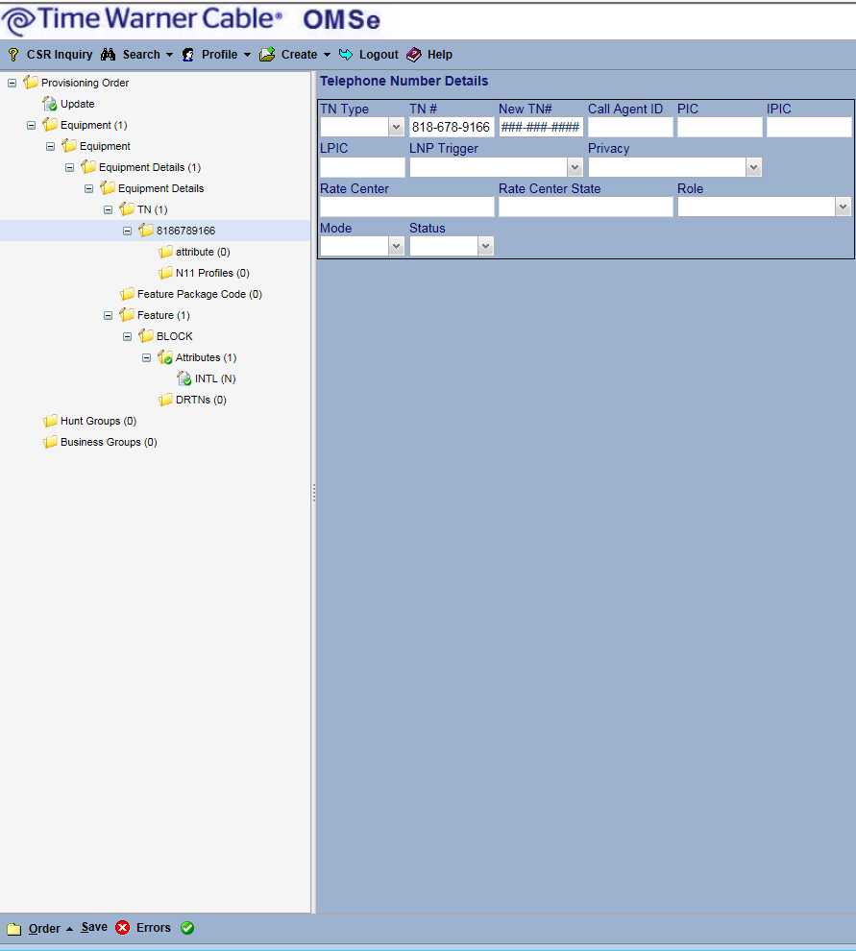

As can be seen, the order type is Update, there is a feature attribute of INTL(N) under the BLOCK section of Features, and the TN has a phone number filled out but does not have any other details listed. This order will unblock(allow) International calling for the account.

**Deleting TN(s) from SCR/SCA:**

Create an order as above; However, you will change Action under Update to: “Delete Specific” and you will change the Feature to either SCR or SCA. No attribute is required to remove numbers from these lists, as it removes **all** numbers from these lists. Afterwards you would have to manually re-enter the numbers into OBO for the customer.

This should only be used when OBO is not allowing you to add/remove numbers from the call blocking/acceptance lists. Deleting and restoring the lists fixes the problem.

Example:

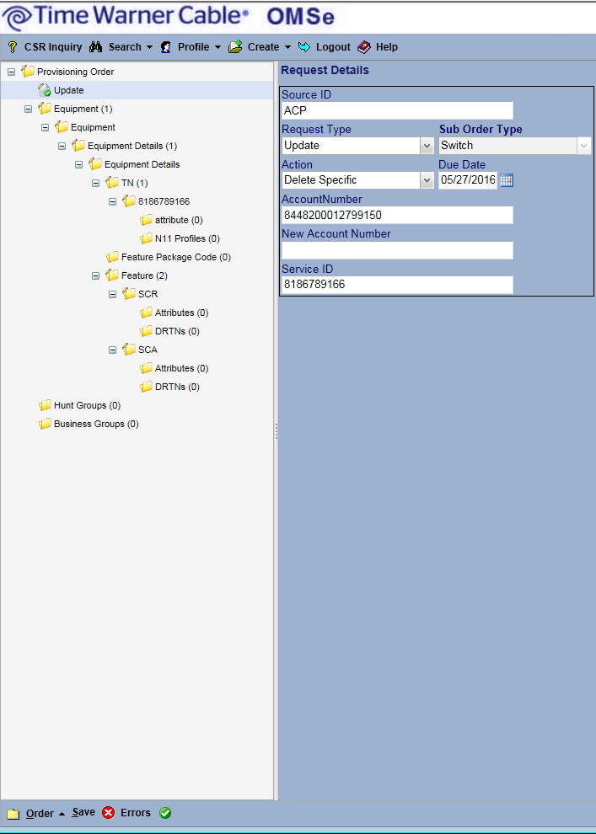

**Placing a number into Call Forwarding status:**

Create an order like you are changing a feature, however, the feature folder is going to be names CFU, CFB, or CFNA. Unconditional, Busy, and No Answer, respectively.

Once created, set the Attributes as active(Y/N) to turn it on or off, and set the forward to FDN/0(TN) so that it updates the number to forward(TN) in a service query.

Example:

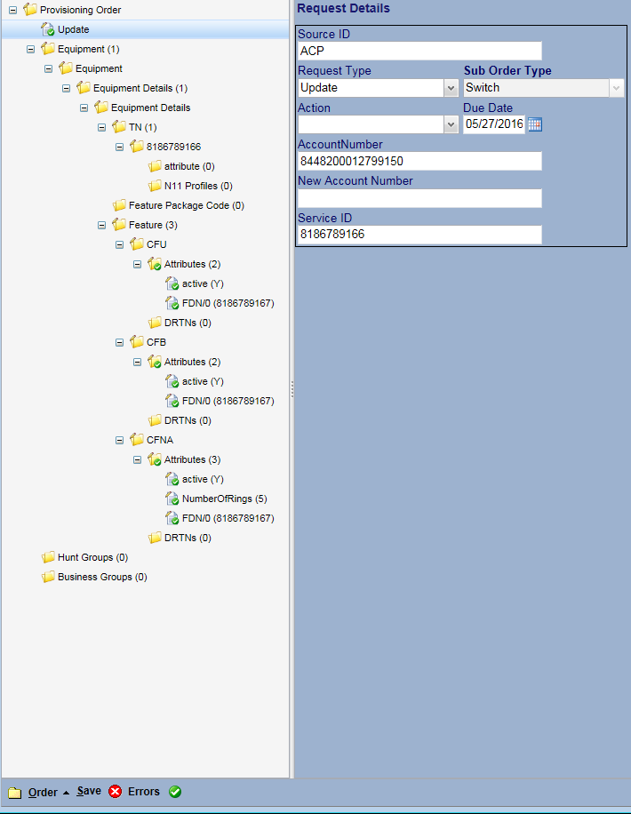

Changing all other features follow the same exact method as changing calling features; You just name the feature itself something other than BLOCK; CFNA for call forward no answer, etc. Then set up the Attributes. The examples above are the three types of update orders you would create. Either update, delete, or update and forward(special case with FDN/0).

Once done, of course you save and provision the order. There should be no errors so long as you fill out the fields as shown above.