High-Level Design
Parking Availability Web App

CS 498 Software Engineering for Senior Project
University of Kentucky, Fall 2026
Instructor Kevin Eby
Nathan Jones
Nathan Galante
Rylan Moseley
David Eliassen
Kevin Nguyen
Version 0.3 (draft for team review), October 15, 2026

1. Introduction

1.1 Purpose
This document describes the high-level design of a web app that turns periodic photos of outdoor parking lots into a simple display of open and occupied spaces. It is the shared reference for the team while we write user stories (Milestone 1, October 9), build the first prototype (Milestone 2, November 11) and deliver the final system and report (December 4).

1.2 Scope of the MVP
The app has two sides. The driver side is public and read only. The admin side is signed in and controls how each lot is set up and shown, from the lot map to which spaces are closed. This split came out of team review, and the admin side doubles as one of the strongest parts of the demo.
In scope
- Any number of outdoor parking lots, each photographed from a small set of fixed camera positions. During the course a drone hovers at each position as a stand-in for a pole-mounted camera.
- An authenticated admin interface where a team member uploads a photo with a lot ID, viewpoint ID and capture time. These uploads stand in for future permanent cameras.
- Lot onboarding from one photo per camera position. The system proposes every stall outline from the parked cars and painted lines it finds, an admin confirms or corrects them on the mapping page, and the confirmed outlines generate the white 2D map and a versioned layout.
- One layout as the source of truth. Publishing keeps the database, the stored layout snapshots, the worker and the driver view in sync.
- Space closures, so an admin can block off spaces for construction, events or maintenance for a set time window.
- A background job that processes each photo once, scores every mapped space with ACPDS, checks for missed cars with YOLO26m and decides the state of each space.
- A public driver view where drivers pick a lot from a list and see its white 2D map, with each space shown by state and the time of the last observation.
- Correct handling of stale data, failed jobs, duplicate uploads and photos that arrive out of order.
- A local version that runs on any team laptop, then the same code deployed to AWS.
Out of scope for the MVP
- Live video, or drivers uploading photos.
- Photos from camera positions that have not been onboarded. Each position is set up and confirmed once before its photos are scored.
- University camera integration. It stays a documented future extension because team, instructor and university approval are not confirmed.
- Fully automatic mapping with no admin review, and training or fine-tuning our own models. Reservations, payments, navigation and native mobile apps are also out.

1.3 Terms
Term | Meaning in this project
Lot | One physical parking lot with a fixed set of spaces.
Space | A single parking stall with a stable ID such as A-12. It appears as a polygon on each reference image and as a rectangle on the schematic.
Viewpoint | A fixed camera position for a lot, at roughly pole height (8 to 12 m) and angled down. During the course a drone hovers there in place of an installed camera. Each viewpoint has one reference image with space outlines on it.
Snapshot | One uploaded photo plus the record of its processing job.
Alignment | Warping a new photo onto its reference image using feature matching and a homography, so space polygons line up with the photo.
Observation | The state of one space as seen in one snapshot, either FREE, OCCUPIED or UNKNOWN.
Stale | A space or lot whose newest observation is older than the lot's allowed data age.
Layout version | A published, read-only copy of a lot's spaces, schematic and photo polygons. Every snapshot records which version it was processed with.
Closure | An admin rule that marks one or more spaces CLOSED for a time window, for example during construction. It overrides whatever the detector sees.
Occupancy score | The 0 to 1 estimate from ACPDS that a space is occupied. It is stored as the observation's confidence.
Onboarding | Adding a lot or camera position from one photo. The system proposes stall outlines and an admin confirms them before the first layout is published.
Proposed outline | A stall outline the system suggested during onboarding. It stays in the draft as suggested until an admin accepts, edits or rejects it.
Row tool | A mapping tool that splits one outlined row into a given number of evenly spaced stalls, so a row takes four clicks instead of four per stall.
Presigned URL | A short-lived URL that lets the browser upload one file directly to object storage without holding storage credentials.

1.4 Changes in version 0.3
This version records the detection and onboarding decisions made after Milestone 1. The full comparison behind them is in the team's detection plan doc.
- ACPDS is the primary per-space scorer, with YOLO26m as a car check. LocateAnything-3B is dropped (section 4.4).
- New space state rules, where FREE needs both models to agree (section 4.5).
- New lot onboarding from one photo, with proposed outlines, the row tool and an admin review step (sections 4.6 and 6.5).
- Multiple lots are in scope, matching US-15 and US-16 (section 1.2).
- The drone stands in for a pole-mounted camera at fixed positions (sections 1.2 and 1.3).
- A failed alignment now keeps prior states instead of setting spaces to UNKNOWN, matching US-12 #1 and US-06 #2 (section 4.1).
- Components, interfaces, data fields, configuration, quality targets, privacy, testing, schedule, risks and open decisions are updated to match.
Figures 1 to 6 still reflect version 0.2 and will be redrawn for version 0.4.

2. System overview

2.1 Users and roles
Actor | Goal | Access
Driver | See which spaces are open before arriving, and how recent that information is. | Public, read only. No login.
Admin (team member) | Onboard lots, confirm proposed layouts, publish layouts, close spaces, upload photos, watch processing and retry failed jobs. | Signed in. Member of the admin group.
Fixed lot camera (future) | Submit photos on a schedule through the same upload interface an admin uses. | Machine credentials. Not built in the MVP.

2.2 System context
Figure 1 shows the system as a single box with the people and outside sources around it. Admins push photos and lot layouts in. Drivers pull status out. A future fixed camera would use the same upload path, which is why the upload API takes the same three inputs a camera would supply. Weights for ACPDS (mirrored from its GitHub release to our S3 bucket) and YOLO26m (from Ultralytics) are packaged into the worker at build time. OpenAI's Decisions API is an optional cloud scorer that the pilot may test (section 4.4).
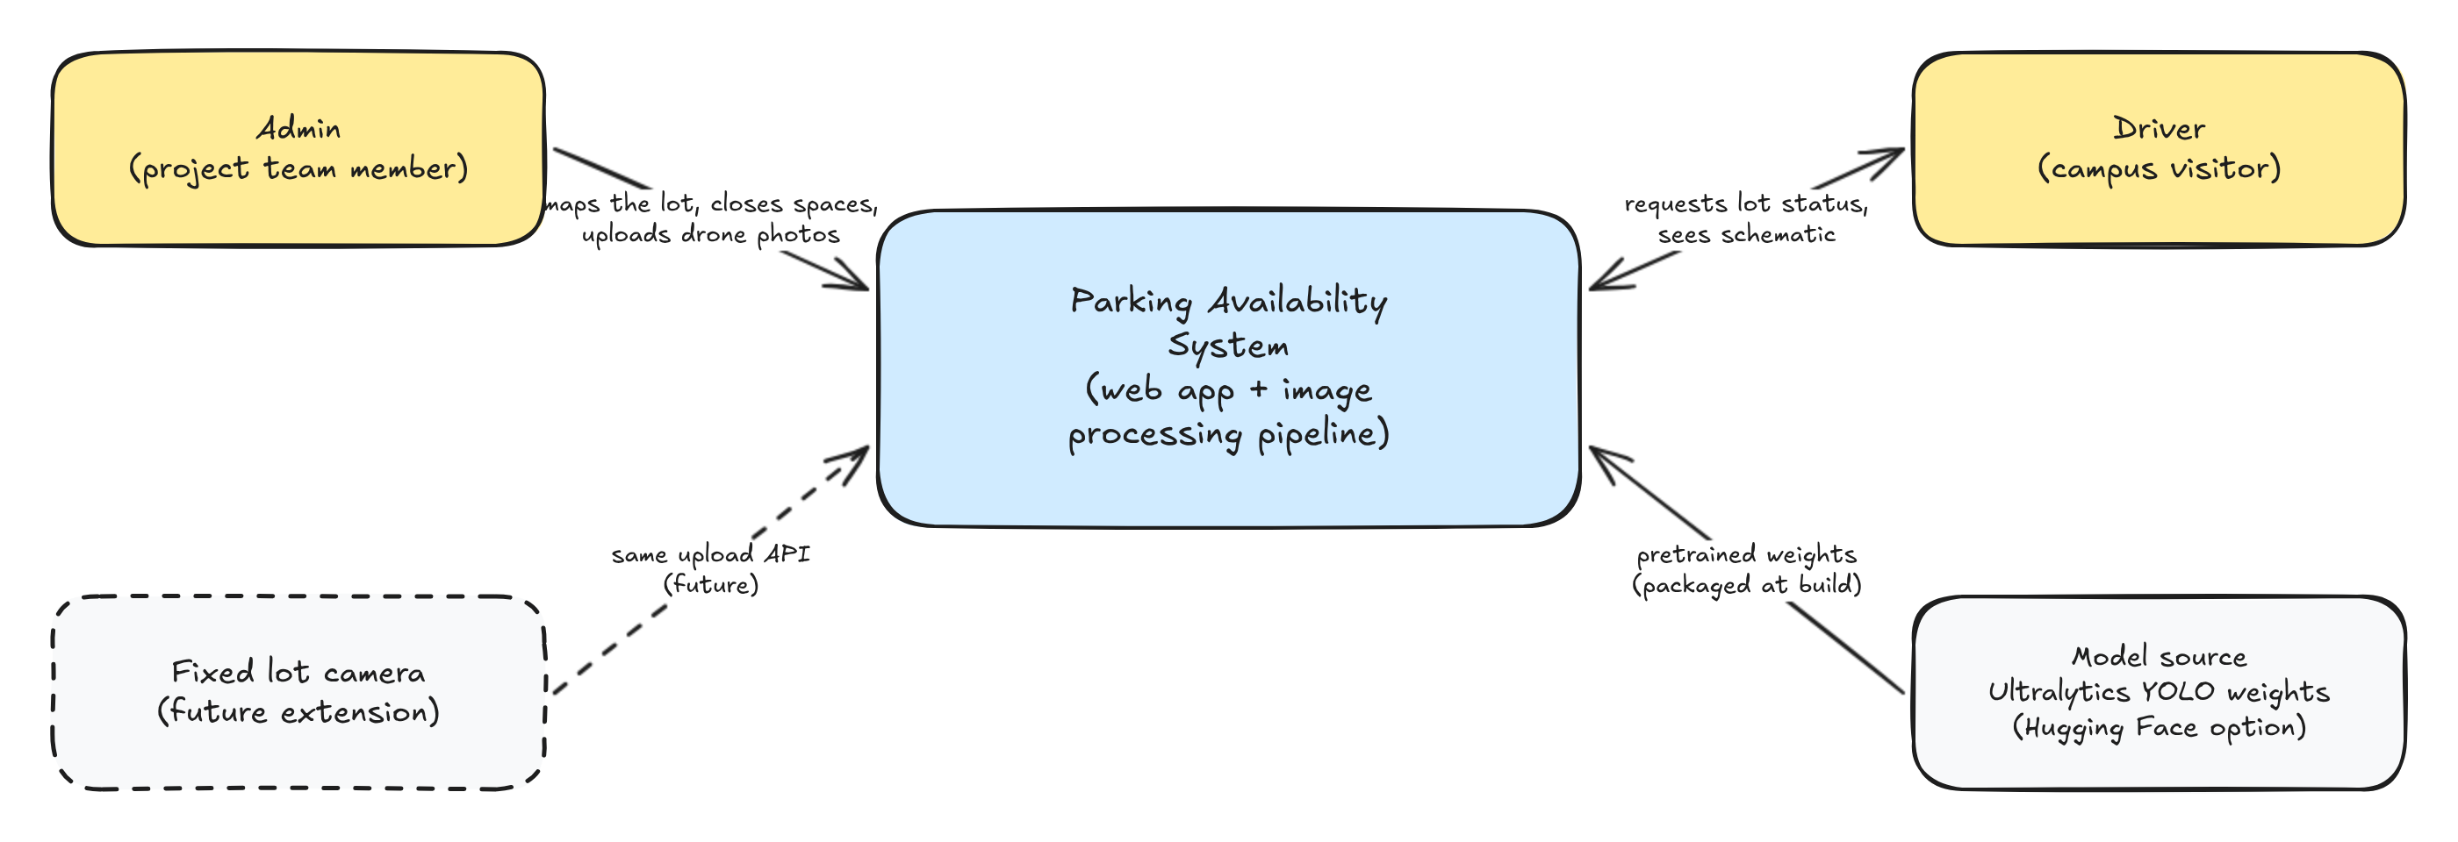
Figure 1. System context

2.3 Design principles
- Never report a space as free without evidence. A missed car or a blocked view produces UNKNOWN, not FREE. A driver who trusts a wrong FREE wastes a trip.
- FREE needs two signals. A space is FREE only when ACPDS scores it empty and YOLO26m finds no car on it. Any disagreement becomes UNKNOWN.
- A camera position is set up once. Each position is onboarded and confirmed by an admin, and every later photo from it reuses that layout.
- Process each photo once. Refreshing the dashboard only reads saved results. It never reruns the detector.
- Newer data wins. An older photo that finishes late cannot overwrite a newer observation. Ordering is by capture time, not upload time or finish time.
- Admin decisions beat detection. An active closure shows a space as CLOSED whatever the detector sees, and only the published layout is used by the worker and the dashboard.
- Same code in both phases. The local stack uses AWS-compatible emulators, so moving to AWS changes configuration, not application code.
- The scorer is replaceable. Space scoring sits behind one interface, so ACPDS, YOLO26m or a cloud scorer can be swapped by configuration without touching the API or UI.
- Keep it cheap and simple. Serverless and pay-per-use services in the cloud phase, and no GPU unless testing proves we need one.

3. Architecture

3.1 Components
The system has eleven logical components. Each one has a local implementation for Phase 1 and an AWS implementation for Phase 2.
Component | Responsibility | Phase 1 (local) | Phase 2 (AWS)
Driver dashboard | Shows the lot schematic, space states, last observed time and stale warning | React + Vite + TypeScript dev server | React build on Amplify Hosting
Admin console | Sign in, map lots, publish layouts, manage closures, upload photos, view job status, retry failures | Same React app, /admin routes | Same, with Cognito sign-in
Lot mapping editor | Review proposed outlines, add rows with the row tool, adjust corners, validate and publish layout versions. The 2D map is generated from the confirmed outlines | React canvas page (react-konva) in the admin app | Same build on Amplify
API service | REST endpoints, validation, presigned URLs, job creation | FastAPI container | API Gateway HTTP API + Lambda (FastAPI via Mangum)
Auth | Proves an admin is who they say they are | Dev JWT signer with one seeded admin | Cognito user pool and JWT authorizer
Object storage | Raw photos and reference images | MinIO (S3 API) | Private S3 bucket
Job queue | Decouples upload from processing, retries failures | ElasticMQ (SQS API) | SQS queue + dead-letter queue
Processing worker | Alignment, ACPDS space scoring, YOLO26m car check, state rules, status writes | Python container polling the queue | Lambda container image triggered by SQS
Layout proposer | Proposes stall outlines for a new lot or camera position from one photo, using YOLO26m car boxes, painted line detection and row fitting | Onboarding job type in the worker container | Same worker Lambda, invoked through the queue
Database | Lots, spaces, viewpoints, snapshots, observations, current status | DynamoDB Local | DynamoDB (on-demand)
Seed and calibration tool | Bootstraps the first lot and test data. Day-to-day layout edits move to the mapping page | Python CLI | Same CLI pointed at AWS

3.2 Interfaces that make local and cloud interchangeable
Application code depends on six small interfaces. A settings module picks the implementation from environment variables at startup. Because MinIO, ElasticMQ and DynamoDB Local all speak the AWS APIs, three of the six use the same boto3 code in both phases with only the endpoint URL changed.
Interface | Used by | Local implementation | AWS implementation
ObjectStore | API, worker, seed tool | boto3 S3 client with MinIO endpoint | boto3 S3 client, default endpoint
JobQueue | API, worker | boto3 SQS client with ElasticMQ endpoint | API sends to SQS, Lambda receives SQS events
Repository | API, worker, seed tool | boto3 DynamoDB with local endpoint | boto3 DynamoDB, default endpoint
AuthVerifier | API | Checks HS256 tokens from the dev signer | API Gateway checks Cognito tokens, API reads claims
SpaceScorer | Worker | ACPDS on CPU, with YOLO26m as a car check | Same in the worker Lambda, or OpenAI's Decisions API if the pilot picks it
LayoutProposer | Worker | YOLO26m, OpenCV line detector and row fitting on CPU | Same in the worker Lambda

3.3 Repository layout
One GitHub monorepo keeps the pieces versioned together and lets one CI pipeline test the whole system.
- web/ React app with driver and admin routes
- api/ FastAPI service, with a Lambda handler wrapper for Phase 2
- worker/ alignment, scoring, state rules and layout proposal code, plus the queue poller and Lambda handler
- core/ shared Python package with domain models, the six interfaces and their implementations
- seed/ calibration CLI and lot definition files (JSON with space IDs, polygons and schematic rectangles)
- infra/ AWS CDK app for Phase 2
- eval/ labeled pilot photos, PKLot fixtures, the benchmark script and the outline shift test
- models/ pinned weight files for ACPDS and YOLO26m with their hashes, also mirrored to S3
- docker-compose.yml and .github/workflows/ at the root

4. Image-to-availability pipeline
Figure 2 follows one photo from upload to the driver screen. Steps 1 to 3 run in the API and finish in well under a second. Steps 4 to 7 run in the worker. Step 8 happens whenever a driver loads or refreshes the page.
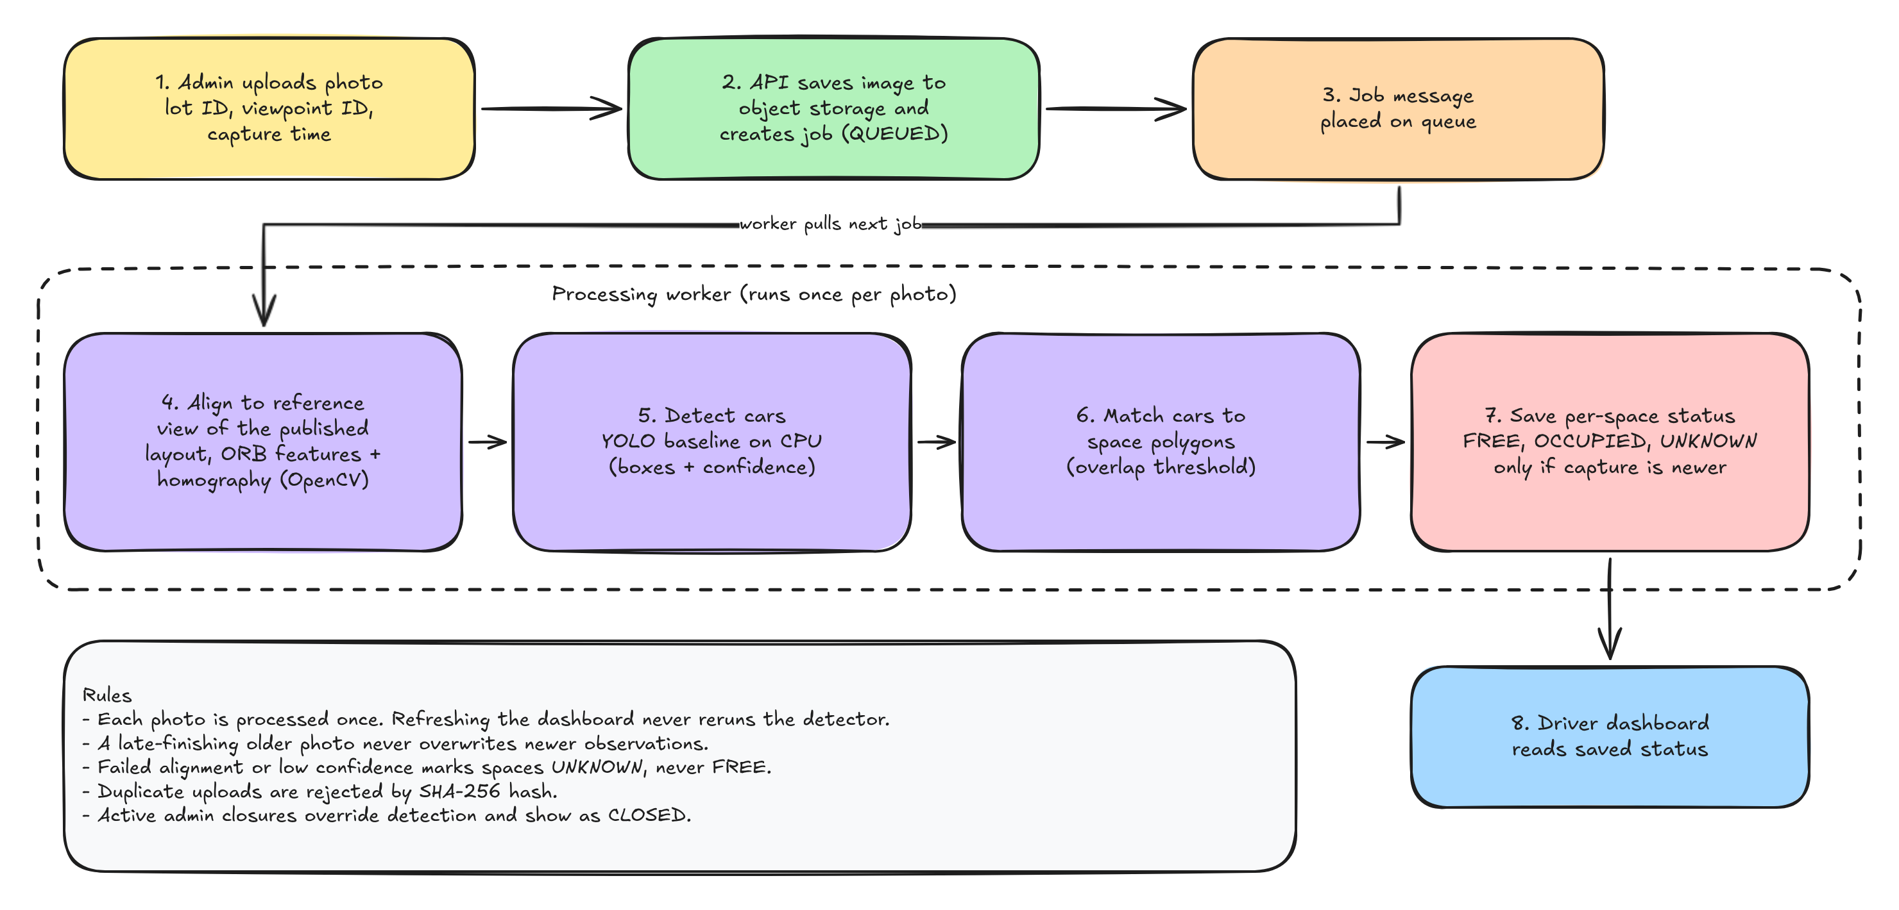
Figure 2. Image-to-availability pipeline

4.1 Step by step
- The admin picks a lot and viewpoint, chooses a photo and confirms the capture time. The browser fills the capture time from the photo's EXIF timestamp when present.
- The browser computes the photo's SHA-256 hash and asks the API for an upload slot. The API rejects duplicates, creates a snapshot record in state UPLOAD_PENDING and returns a presigned PUT URL. The browser uploads the file straight to object storage, then tells the API the upload is complete. The API confirms the object exists and moves the job to QUEUED.
- The API places a message with the image ID on the job queue.
- The worker loads the photo, the lot's current published layout and the viewpoint's reference image, finds ORB features in both, matches them and fits a homography with RANSAC (OpenCV). Too few inliers means the photo does not match the viewpoint. The job is marked FAILED with "Too few matches", writes no observations, and every space keeps its previous state and time (US-12 #1, US-06 #2).
- The worker maps each space outline into the photo through the homography. ACPDS scores every outline from 0 (empty) to 1 (occupied), and YOLO26m returns car boxes with confidence scores.
- The worker turns the two signals into a state with the rules in section 4.5. FREE needs both models to agree, either model can mark a space OCCUPIED, and everything in between is UNKNOWN. The cutoffs and the 30 percent car overlap threshold are tuned in the pilot.
- The worker writes one observation per space and updates each space's current status with a conditional write that only succeeds if the new capture time is later than the stored one. The ACPDS score is stored as the observation's confidence, and the snapshot records the layout version and scorer it used.
- The driver dashboard reads the current status for the lot in one query.

4.2 Job states
State | Set by | Meaning
UPLOAD_PENDING | API | Upload slot issued, file not confirmed yet. Expires after 15 minutes.
QUEUED | API | File confirmed and message on the queue.
PROCESSING | Worker | Worker has claimed the job.
COMPLETE | Worker | Observations written. Some spaces may have been skipped because newer data already existed.
FAILED | Worker | Error recorded on the snapshot. After three attempts the message moves to the dead-letter queue and an admin can retry from the console.

4.3 Correctness rules
- Duplicate uploads. A hash record keyed on the photo's SHA-256 is written with a conditional put. A second upload of the same bytes gets HTTP 409 and a link to the original snapshot.
- Out of order photos. Status updates are per space and conditional on capture time, so a late older photo never overwrites a newer result. Its observations are still saved as history.
- Repeated delivery. Queues can deliver a message more than once. Writes are keyed on image ID and space ID, so reprocessing produces the same records.
- Previous results stay visible. While a new photo is processing, the dashboard keeps showing the last results with their timestamp, plus a small processing indicator.
- Stale data. Each lot has an allowed data age (staleAfterMinutes). Past that age the dashboard shows a warning banner and greys the affected spaces. The value is an open decision tied to capture frequency.
- Closures. The API applies active closures when it builds the status response. The worker never needs to know about them, a new closure shows up on the next refresh, and an expired one stops applying on its own because the API compares its time window with the current time.
- Layout changes. Publishing a new layout version does not rewrite history. The worker picks up the new version on its next job, observations for retired spaces stay in history but are not shown, and new spaces start as UNKNOWN until a photo covers them.

4.4 Detection models
ACPDS, a per-space occupancy classifier, makes the open or taken call for every mapped space. YOLO26m runs beside it as a safety net for missed cars and supplies the car boxes used during onboarding. The team does not train or fine-tune either model. Only cutoffs, image size and matching rules are tuned, and a labeled pilot confirms the choice by October 23.
 | ACPDS (primary) | YOLO26m (car check)
Output | An occupied score from 0 to 1 for each space outline it is given | Boxes around cars, each with a confidence score
Trained on | 293 photos from a GoPro about 10 m up a pole, close to our camera view | COCO, about 118K everyday ground-level photos
Hardware | CPU, fits the worker Lambda | CPU, about 220 ms per 640 px pass
License | MIT | AGPL-3.0 or Ultralytics Enterprise
Origin | ParkDots and PosAm, Slovakia | Ultralytics, US
Phase 2 host | Worker Lambda | Worker Lambda
Role | Primary scorer on every photo | Car check on every photo and car finder during onboarding

The optional cloud scorer is OpenAI's Decisions API (public beta, gpt-6-luna, $0.10 per 1M input tokens), which returns a 0 to 1 probability for each cropped space. It needs an OpenAI key and sends crops outside AWS, so it can only run in Phase 2, and ACPDS stays in the same container as the local and fallback scorer. TypeSafe's Jev now accepts images in an early-access, not-yet-production state and can join the pilot if the team gets access.
Five ACPDS details fail without an error if missed. Build the model with RCNN(roi_res=128, pooling_type='square'), pass corners as fractions of the image size, convert OpenCV's BGR to RGB, read output index 1 as occupied, and keep a copy of the weights in our S3 bucket.
Options ruled out include RANGER (Hong Kong publisher, undisclosed training data, non-commercial license), NVIDIA LocateAnything-3B (NVIDIA GPU only, no per-box confidence, non-commercial), the DOTA and VisDrone overhead models (training data from Chinese universities), Amazon Rekognition (needs AWS credentials, so no laptop mode) and open-vocabulary detectors (weak on aerial imagery).
The pilot uses 20 to 30 labeled photos from every camera position and three times of day, with at least 300 occupied spaces. It compares ACPDS alone, ACPDS with YOLO26m, YOLO26m alone and, if allowed, the Decisions API. It records the occupied-reported-as-free rate, per-space accuracy with UNKNOWN counted as wrong, the UNKNOWN rate, end-to-end time including model loading, and peak memory. PKLot (CC BY 4.0, fixed pole cameras) tests the pipeline end to end before drone photos exist.

4.5 Space state rules
A space is FREE only when both models agree it is empty. Either model alone can mark it OCCUPIED.
State | When | Driver map
OCCUPIED | ACPDS score above the high cutoff, or a confident YOLO26m car box covers 30 percent or more of the space | Car icon
FREE | ACPDS score below the low cutoff, no YOLO26m car box touches the space beyond a small margin (about 5 percent), and the whole space is in the photo | Empty outline
UNKNOWN | Everything else, including in-between scores, a car over the line (US-11 #2), trees or glare (US-12 #3) and spaces cut off by the frame | Hatched grey with a question mark
CLOSED | An active admin closure, applied by the API when it builds the status | Barrier icon with the reason
The pilot sets both cutoffs. A photo that fails alignment changes no state.

4.6 Lot onboarding
The system proposes a full layout from one photo per camera position, and an admin confirms it before it is saved. No ready-made model finds empty stalls reliably, so the proposal leans on parked cars and painted lines.
- The admin selects Add a lot, enters the name and allowed data age, and uploads one photo from each camera position. A photo taken when the lot is busy works best, since every parked car anchors a stall.
- YOLO26m finds the parked cars, and the OpenCV line detector finds painted stall lines.
- Row and gap fitting groups the cars into rows, measures stall width and angle, and proposes an outline for every stall, including empty ones in gaps and at row ends. Each proposal carries an evidence score.
- The admin reviews the proposals on the mapping page, accepts all, deletes extras, drags corners, and adds any missing row with the row tool.
- The system flattens the confirmed outlines to a top-down view, labels rows A, B, C and stalls A-01 onward, and saves the white 2D map with the first layout version.
- ACPDS scores the onboarding photo, so the new lot shows real states immediately. A stall it calls occupied where YOLO26m saw no car is flagged for a second look.
A fully empty row with faded paint gives the system nothing to find, so the admin adds it with the row tool. Later, accumulated photos let the system suggest stalls where cars keep appearing but no outline exists.

5. Data design
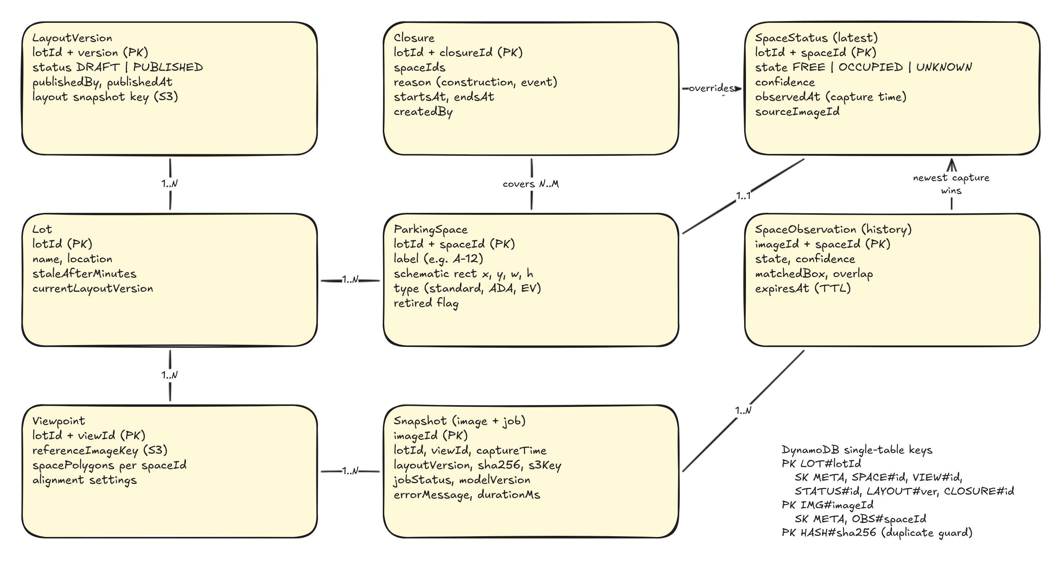
Figure 3. Data model

5.1 Entities
Entity | Key fields | Notes
Lot | lotId, name, location, staleAfterMinutes, currentLayoutVersion | Created on the mapping page or seeded from a JSON file.
ParkingSpace | lotId + spaceId, label, schematic rectangle, type, retired flag | Stable IDs connect the photo polygons to the UI rectangles. Spaces are retired, never deleted, so history stays valid.
Viewpoint | lotId + viewId, reference image key, outline per space, camera height and angle | Reference photo and outlines come from onboarding and are edited on the mapping page. Each outline records whether it was proposed or drawn and whether an admin accepted it. One per fixed camera position.
Snapshot | imageId, lotId, viewId, captureTime, layoutVersion, s3Key, sha256, jobStatus, modelVersion | Combines the photo and its job record. modelVersion names the scorer, weight file hash and cutoffs.
SpaceObservation | imageId + spaceId, state, acpdsScore, carConfidence, overlap (optional) | History. Expires through a DynamoDB TTL.
SpaceStatus | lotId + spaceId, state, confidence, observedAt, sourceImageId | Current view for the dashboard. Updated only by newer captures.
LayoutVersion | lotId + version, status, publishedBy, publishedAt, snapshot key | Immutable once published. The JSON snapshot in S3 is what the worker and dashboard load.
Closure | lotId + closureId, spaceIds, reason, startsAt, endsAt, createdBy | Applied by the API at read time. Ends on its own once endsAt passes.

5.2 DynamoDB key design
One table holds every entity. The partition key (PK) groups items that are read together and the sort key (SK) tells them apart. DynamoDB Local uses the identical schema in Phase 1.
Access pattern | Key condition
Load the published layout | Lot META gives currentLayoutVersion, then read layouts/{lotId}/v{version}.json from S3
Edit the draft layout (admin) | PK = LOT#lotId, SK begins with SPACE# or VIEW#
Load current status for the dashboard | PK = LOT#lotId, SK begins with STATUS#
Load active closures for the dashboard | PK = LOT#lotId, SK begins with CLOSURE#, filter on the time window
Load a viewpoint for alignment | PK = LOT#lotId, SK = VIEW#viewId
Get a snapshot and its job state | PK = IMG#imageId, SK = META
Get observations from one snapshot | PK = IMG#imageId, SK begins with OBS#
List recent snapshots for a lot (admin) | GSI1 with PK = LOT#lotId, SK = captureTime
List layout versions (admin) | PK = LOT#lotId, SK begins with LAYOUT#
Reject a duplicate upload | Conditional put on PK = HASH#sha256

5.3 Object storage layout
- raw/{lotId}/{viewId}/{imageId}.jpg for uploaded photos
- reference/{lotId}/{viewId}.jpg for calibrated reference images
- layouts/{lotId}/v{version}.json for published layout snapshots
- models/{model}/{hash} for pinned model weights (ACPDS, YOLO26m)
The bucket blocks all public access. Raw photos expire after a fixed number of days through a lifecycle rule (30 days proposed). Reference images and layout snapshots do not expire.

6. Interface design

6.1 REST API
All routes are JSON over HTTPS. Admin routes require a bearer token. The OpenAPI document that FastAPI generates is the contract between the frontend and backend owners.
Method | Path | Auth | Purpose
GET | /lots | Public | List lots
GET | /lots/{lotId} | Public | Lot details and the published schematic layout
GET | /lots/{lotId}/status | Public | Current state of every space, last observed time, stale flag, processing flag
POST | /admin/uploads | Admin | Request an upload slot with lot, viewpoint, capture time and SHA-256. Returns imageId and presigned URL, or 409 for a duplicate
POST | /admin/uploads/{imageId}/complete | Admin | Confirm the file arrived and queue the job
GET | /admin/snapshots?lotId= | Admin | Recent snapshots and their job states
GET | /admin/snapshots/{imageId} | Admin | One snapshot with its observations
POST | /admin/snapshots/{imageId}/retry | Admin | Requeue a failed job
POST | /admin/lots | Admin | Create a lot
GET | /admin/lots/{lotId}/layout/draft | Admin | Load the editable draft layout
PUT | /admin/lots/{lotId}/layout/draft | Admin | Save spaces, schematic rectangles and photo polygons
POST | /admin/lots/{lotId}/views/{viewId}/reference | Admin | Get a presigned URL for a new reference photo
POST | /admin/lots/{lotId}/views/{viewId}/proposals | Admin | Run the layout proposer on the reference photo and add proposed outlines to the draft
POST | /admin/lots/{lotId}/layout/draft/review | Admin | Accept, edit or reject proposed outlines, singly or in bulk
POST | /admin/lots/{lotId}/layout/publish | Admin | Validate the draft, save a new version and snapshot, point the lot at it
GET | /admin/lots/{lotId}/layout/versions | Admin | Version history with who published each one
GET | /admin/lots/{lotId}/closures | Admin | List current and upcoming closures
POST | /admin/lots/{lotId}/closures | Admin | Close spaces with a reason and time window
DELETE | /admin/lots/{lotId}/closures/{closureId} | Admin | End a closure early
GET | /health | Public | Liveness check for compose and monitoring

6.2 Status response fields
Field | Type | Meaning
lotId | string | Lot this status belongs to
lastObservedAt | ISO 8601 time | Newest capture time across all spaces
isStale | boolean | True when lastObservedAt is older than the lot's allowed data age
processing | boolean | True when a newer snapshot is queued or processing
layoutVersion | number | Published layout behind this response. The app refetches the schematic when it changes
spaces[].spaceId | string | Matches the schematic rectangle
spaces[].state | FREE, OCCUPIED, UNKNOWN or CLOSED | Current state. CLOSED comes from an active closure
spaces[].observedAt | ISO 8601 time | Capture time of the photo behind this state
spaces[].score | number or null | ACPDS occupied score behind this state, for tooltips and admin views
spaces[].closure | object or null | Reason and end time when the space is closed
counts | object | Totals per state for the summary bar. Closed spaces never count as free

6.3 Driver dashboard
- A lot list comes first (US-15). Picking a lot opens its white 2D map, drawn as SVG from the rectangles generated from the confirmed outlines.
- Occupied spaces show a car icon. Free spaces are empty outlines. Unknown spaces are hatched grey with a question mark. A legend explains all three, so the meaning never depends on color alone.
- Closed spaces show a barrier icon with the admin's reason and end date, and they are left out of the free count.
- A summary bar shows counts and "Last observed 12 minutes ago". Past the allowed data age a warning banner appears.
- A refresh button reloads status. Optional polling every 60 seconds can be turned on later.

6.4 Admin console
- Sign-in page (dev token locally, Cognito in AWS).
- Add a lot flow that uploads one photo per camera position and opens the proposed layout for review (section 6.5).
- Closures page for blocking off spaces (section 6.6).
- Upload form with lot and viewpoint selectors, capture time prefilled from EXIF, and an upload progress bar.
- Snapshot list with job state, processing time, model version, errors and a retry button.
- Optional stretch goal, a debug view that overlays ACPDS scores, YOLO26m boxes and space outlines on the aligned photo. This helps the team tune thresholds and makes a strong demo.

6.5 Lot mapping and layout sync
The mapping page is where an admin confirms the proposed layout and turns a parking lot into data the rest of the system can use. Figure 4 shows the planned layout. It is mostly standard front-end work on a canvas library, so it is quick to build, and it is the most visual part of the demo.
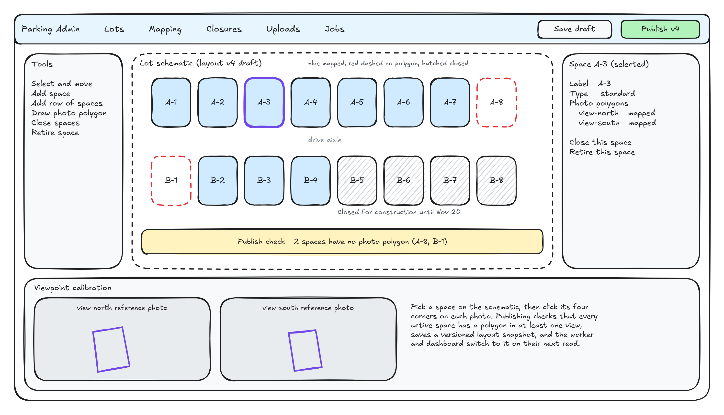
Figure 4. Admin lot mapping page (wireframe)
- Review proposals. Proposed outlines appear on the reference photo, weakest evidence first. The admin accepts all, deletes extras, drags corners, and sets labels and types (standard, ADA, EV). Spaces that no longer exist are retired.
- Fill gaps with the row tool. The admin clicks the four corners of a row the proposer missed and types the stall count and starting label, and the tool splits it into evenly spaced outlines. Single spaces can still be outlined corner by corner, and one space can have outlines in several viewpoints.
- Generate the 2D map. Confirmed outlines are flattened to a top-down view, grouped into rows and labeled A-01 onward, which produces the schematic rectangles drivers see.
- Validate before publishing. The publish check lists spaces with no polygon in any view, duplicate labels and polygons that fall outside the photo. Proposed outlines still waiting for review also block publishing. Only hard errors block it. Unmapped spaces are allowed and show as UNKNOWN.
- Publish a version. Publishing saves a JSON snapshot to object storage, then writes the LayoutVersion and moves the lot's currentLayoutVersion pointer in one DynamoDB transaction. Earlier versions stay available for rollback.
Keeping copies in sync. The draft in DynamoDB is the only place a layout is edited, and the published snapshot is the only copy anything else reads. The worker checks the lot's current version at the start of each job and reloads when it changed. The driver app compares layoutVersion in each status response with the version it has cached and refetches the schematic when they differ. Any future outside source, such as fixed camera configuration or university parking data, would read the same published snapshot instead of keeping its own copy. Which outside sources matter is an open decision (section 13.2).

6.6 Space closures
- An admin selects spaces on the schematic, or a whole row, and gives a reason (construction, event, maintenance, reserved) with a start time and an optional end time.
- The API overlays active closures on the detector's results when it builds a status response. A closure appears on the next refresh and an expired one drops off without any scheduled job.
- Detection keeps running under a closure. Those observations stay in history, which helps if the team later wants to report on lot use during events.
- Each closure records who created it and when, and an admin can end it early.

7. Phase 1, local deployment
Phase 1 runs the whole system on one laptop with Docker Compose. It is the target for Milestone 2 (First Prototype, November 11). Every service in Figure 5 maps one to one to an AWS service in Phase 2.
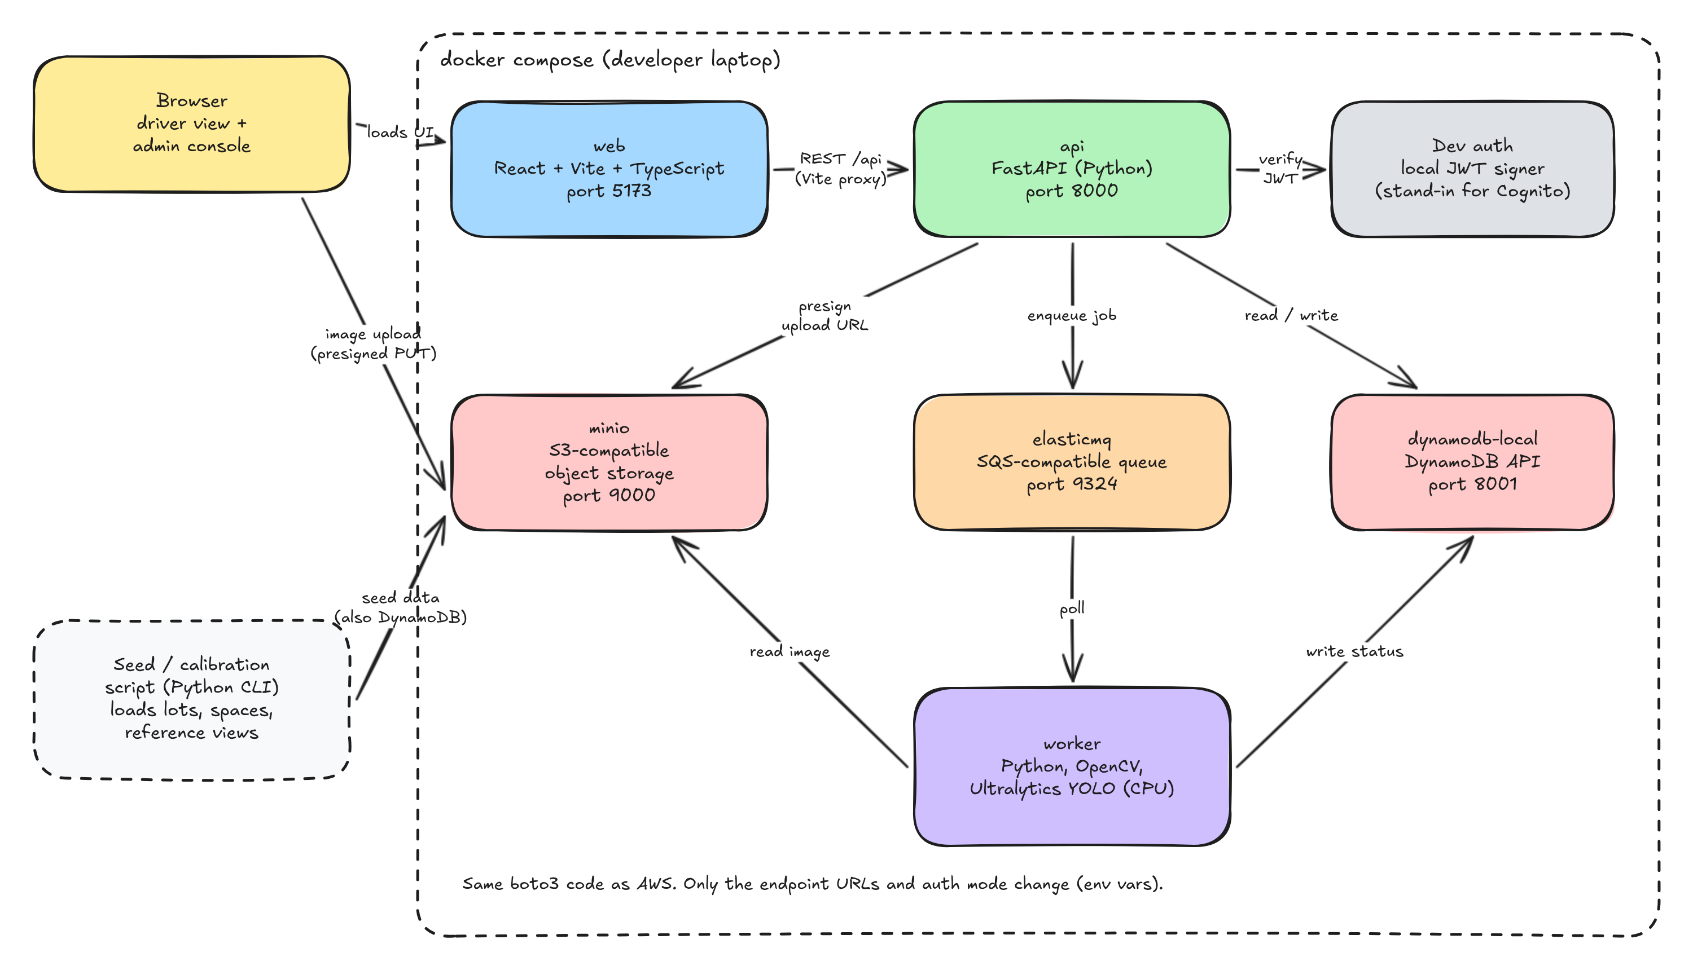
Figure 5. Phase 1 local architecture

7.1 Services
Service | Image or runtime | Port | Purpose
web | Node 20 with Vite | 5173 | React app. Proxies /api calls to the api service
api | Python 3.12 with FastAPI and Uvicorn | 8000 | REST API, dev auth, presigned URLs
worker | Python 3.12 with OpenCV 4.5.4 or later, PyTorch and torchvision CPU (pinned for ACPDS), Ultralytics, and the ACPDS and YOLO26m weights | none | Polls the queue, scores photos and proposes layouts
minio | minio/minio | 9000, 9001 | S3-compatible storage and web console
elasticmq | softwaremill/elasticmq-native | 9324 | SQS-compatible queue with a dead-letter queue
dynamodb-local | amazon/dynamodb-local | 8001 (host) | DynamoDB API with the same table schema

7.2 Configuration
Variable | Phase 1 value | Phase 2 value
APP_ENV | local | aws
S3_ENDPOINT_URL, SQS_ENDPOINT_URL, DYNAMODB_ENDPOINT_URL | Compose service URLs | Unset (AWS defaults)
AUTH_MODE | dev | cognito
DETECTOR | acpds_yolo | acpds_yolo, or decisions_api if the pilot picks it
OPENAI_API_KEY | Unset | Secrets Manager value, only when decisions_api is used
BUCKET_NAME, QUEUE_URL, TABLE_NAME | Local names | Outputs from the CDK stacks

7.3 Developer workflow
- Clone the repo and copy .env.example to .env.
- Run docker compose up --build.
- Run the seed script to create the table, bucket and queue and load the test lot.
- Open the app on localhost port 5173 and sign in with the seeded dev admin.
- Upload a sample photo from eval/ and watch the schematic update.

7.4 Phase 1 exit criteria
- A labeled sample photo goes from upload to correct per-space status on a clean clone with one command plus seeding.
- An admin can onboard the test lot from one photo, confirm the proposed outlines, publish it and close a space from the browser, and the driver view reflects each change on refresh.
- Duplicate, out of order, failed alignment and stale data cases pass automated tests.
- The pilot has run on the labeled set, the scorer and cutoffs are chosen, and NFR-3, NFR-4 and NFR-11 pass on the held-out session.
- CI runs unit and integration tests on every pull request.

8. Phase 2, AWS deployment
Phase 2 moves the same code to managed AWS services. Infrastructure is defined in AWS CDK (Python) so the whole environment can be created and torn down from the repo. The frontend deploys through Amplify Hosting's Git connection.
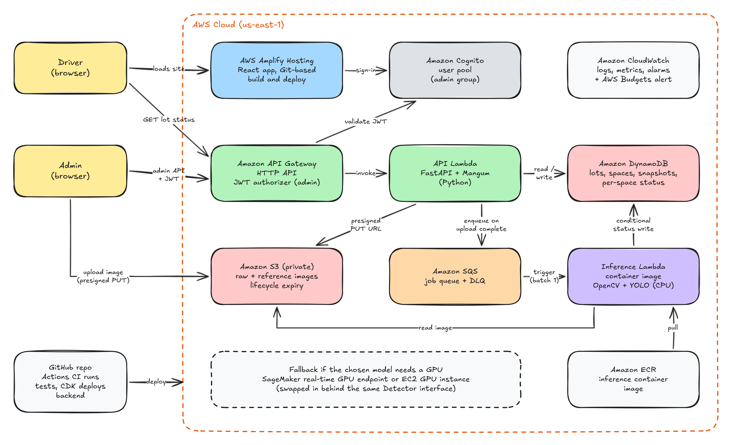
Figure 6. Phase 2 AWS architecture

8.1 Service mapping
Local | AWS | Why this choice
Vite dev server | Amplify Hosting | Git-connected builds and HTTPS with almost no setup. S3 with CloudFront is the fallback.
Dev JWT signer | Cognito user pool with an admin group | Managed sign-in. API Gateway validates its tokens before Lambda runs.
FastAPI container | API Gateway HTTP API + Lambda with Mangum | Same FastAPI app, pay per request, no server to patch.
MinIO | S3 (private, encrypted, lifecycle rule) | Presigned uploads keep large files off the API.
ElasticMQ | SQS standard queue + dead-letter queue | Retries and isolation of bad messages.
Worker container | Lambda container image from ECR, SQS trigger with batch size 1 | CPU inference fits Lambda limits (up to 10,240 MB memory, 15 minute timeout, 10 GB image).
DynamoDB Local | DynamoDB on-demand with TTL | Same schema, no capacity planning.
Docker logs | CloudWatch logs, metrics, alarms and an AWS Budgets alert | Visibility into failures and spend.

8.2 Inference sizing
Lambda gives more CPU as memory goes up, so the starting point is 4 GB of memory and a 2 minute timeout, adjusted from the pilot. Reserved concurrency of 2 caps cost and limits bursts of parallel jobs. ACPDS and YOLO26m both run on CPU, so no GPU host is planned. If the pilot picks the Decisions API, the worker calls it over HTTPS with the key from Secrets Manager and falls back to ACPDS when the call fails. Bedrock and AgentCore are not needed for this workflow.

8.3 CI and CD
- Pull request. GitHub Actions runs linting, pytest, Vitest, and the Docker Compose integration test. Merging requires a passing build and one reviewer.
- Merge to main. Actions assumes an AWS role through GitHub OIDC (no stored access keys), builds the inference image, pushes it to ECR and runs cdk deploy. Amplify rebuilds the frontend from the same commit.
- After deploy. A smoke test uploads a fixture photo to the AWS environment and checks the status endpoint.

8.4 Phase 2 exit criteria
- The final demo runs fully on AWS with a public driver URL and Cognito-protected admin pages.
- Infrastructure deploys from a clean account with one CDK command.
- Alarms fire on dead-letter queue messages and Lambda errors. A budget alert is set.
- The final report documents how a fixed camera would submit the same inputs.

9. Quality targets
Targets marked with an asterisk are starting values that the team confirms after the pilot.
ID | Requirement | Target | How we check
NFR-1 | Photo to updated status | 60 seconds or less at p95 on CPU* | Timestamps on snapshot records
NFR-2 | Dashboard load time | Under 2 seconds on campus Wi-Fi | Browser dev tools, Lighthouse
NFR-3 | Occupied spaces reported as free | 5 percent or less on the labeled set* | Benchmark script
NFR-4 | Overall per-space accuracy | 90 percent or more on the labeled set, with UNKNOWN counted as wrong* | Benchmark script
NFR-5 | Data freshness is always visible | Every screen shows last observed time | UI tests
NFR-6 | Admin actions require sign-in | 100 percent of /admin routes | API tests with and without tokens
NFR-7 | Same code local and cloud | Only configuration differs | Code review, shared test suite
NFR-8 | States readable without color | Icon, pattern and legend for each state | Manual accessibility check
NFR-9 | Monthly cloud cost | Below the team budget, alert at 80 percent | AWS Budgets
NFR-10 | Layout and closure changes reach drivers | Visible on the next dashboard refresh | Integration test
NFR-11 | Spaces left UNKNOWN | 10 percent or less of the spaces a person can judge* | Benchmark script

10. Security and privacy
- Admin routes require a valid token, checked by the API locally and by API Gateway in AWS. Drivers never need an account.
- Layout publishes and closures record who made them and when, and only members of the admin group can make them.
- The S3 bucket blocks public access and encrypts objects. Presigned upload URLs expire after 5 minutes, accept only JPEG or PNG, and cap size at 15 MB.
- Each Lambda gets an IAM role with only the actions and resources it needs.
- Drone photos can show people and license plates. We keep raw photos only as long as the retention rule allows, never show raw photos to drivers, and limit admin access to the team.
- Before collecting imagery the team confirms permission for the lot and follows FAA and university rules for drone flights. Flights hover at fixed, marked positions about 8 to 12 m up.
- If the Decisions API is used, cropped space images leave AWS and go to OpenAI. Crops can show license plates, so this needs team sign-off before any crops are sent.
- Licensing is reviewed before any use outside the course. YOLO26m is AGPL-3.0 unless an Enterprise license is bought, and ACPDS is MIT. Each model's developer and training-data origin is recorded, and options trained on China-origin data are excluded by team decision.

11. Testing strategy
Level | What it covers | Tools
Unit | Space matching math, overlap thresholds, conditional status updates, hash dedupe, job state transitions, schematic rendering, layout publish validation, closure time windows | pytest, Vitest, React Testing Library
Alignment | Synthetic tests that warp a reference image by a known transform and check the recovered homography | pytest with OpenCV
Integration | Full Compose stack. Upload a fixture photo and assert the status endpoint | pytest against Docker Compose in CI
Edge cases | Stale data, failed jobs, duplicate uploads, out of order photos, repeated queue delivery, a new layout published mid-job | Integration suite
Model evaluation | Per-space confusion matrix, occupied-as-free rate, UNKNOWN rate, latency, memory, plus the outline shift test (outlines moved 5 to 30 percent of a stall width) | eval/ benchmark script
Onboarding | Proposed outlines against hand-drawn ones on pilot photos, and row tool geometry on synthetic perspective tests | pytest
Cloud smoke | Upload and status check after each deploy | GitHub Actions job

Tests are written alongside features in line with the course's test-driven practice. The backend coverage target is 70 percent, and coverage is reported on every pull request.

12. Plan and ownership

12.1 Schedule
Dates | Work | Course deliverable
By Oct 9 | Agree on scope, owners and acceptance criteria. Write at least 10 user stories with every teammate contributing one or more | Milestone 1, User Stories
Oct 10 to Oct 23 | Collect and label pilot photos from fixed drone positions. Run PKLot through the pipeline, then the pilot comparing ACPDS, YOLO26m and any allowed cloud scorer. Scaffold the repo and CI | Midterm Oct 20, detector decision Oct 23
Oct 24 to Nov 6 | One photo updates a mapped set of spaces. Connect upload, queue, worker and dashboard in Compose. Add a lot flow with stalls proposed from parked cars, the row tool, and the 2D map generated from confirmed outlines
Nov 7 to Nov 11 | Closures, edge case tests and prototype demo | Milestone 2, First Prototype (Phase 1)
Nov 12 to Nov 25 | CDK stacks, Cognito, worker Lambda, deploy pipeline. Gap filling and line snapping for empty stalls, review screen with accept all | HW 4 Individual Contribution, Nov 20
Nov 26 to Dec 4 | Hardening, alarms, final demo on AWS, report | Project Final Report, Dec 4

12.2 Workstreams
Each workstream has one owner and one backup, matching the course advice to give every major component clear ownership.
Workstream | Owns | Owner | Backup
Frontend | Driver lot list and map, admin console, onboarding review page, row tool, schematic rendering | TBD | TBD
API and data | FastAPI routes, DynamoDB design, auth, layout publishing, closures | TBD | TBD
Vision pipeline | Alignment, ACPDS and YOLO26m scoring, state rules, layout proposer, pilot benchmark | TBD | TBD
Infrastructure | Docker Compose, CDK, CI and CD, monitoring | TBD | TBD
Quality and docs | Test plan, edge case suite, reports, traceability from stories to tests | TBD | TBD

13. Risks and open decisions

13.1 Risks
Risk | Impact | Mitigation
ACPDS or YOLO26m misses cars from our camera angle | Wrong FREE states | FREE needs both signals, bias toward UNKNOWN, tune cutoffs in the pilot, and fly at the pole height ACPDS learned from
Drone positions are not repeatable enough for alignment | Many UNKNOWN results | Mark takeoff points and altitudes, add more viewpoints, reject low-inlier photos
Model too slow or too large for Lambda | Missed latency target | Benchmark early in Docker capped at the Lambda size. Lower the image size or drop the YOLO26m check before adding any GPU
No permission to fly over or photograph the lot | No real test data | Confirm early. Use PKLot for development in the meantime
Cloud costs grow unexpectedly | Budget overrun | Budget alert, reserved concurrency, raw photo expiry, no always-on GPU
Late integration between workstreams | Prototype slips | Compose stack and API contract in week one, daily merges with CI
The admin side grows faster than the core pipeline | Prototype slips | Build mapping in two steps (schematic, then photo polygons). Keep closures a simple time window. The photo pipeline stays the first priority
Proposer misses stalls in empty rows or faded paint | Slower onboarding | Admin adds missing rows with the row tool, and onboards from a photo taken when the lot is busy
Cloud scorer beta changes before Dec 4 | Broken AWS scoring | Pin the model and keep ACPDS in the same container as an automatic fallback

13.2 Open decisions
Decision | Options | Needed by
Test lot | Pick one outdoor UK lot with permission to photograph | Oct 9
Capture frequency and allowed data age | For example every 15 minutes with a 30 minute stale threshold | Oct 16
Scorer and cutoffs | ACPDS alone, ACPDS with YOLO26m, or the Decisions API in AWS, decided by the pilot | Oct 23
Cloud scorer and crop sharing | Self-hosted only, or allow crops to go to OpenAI (Decisions API) or TypeSafe (Jev) | Oct 23
RANGER in the pilot | Keep it excluded, or allow it if the origin rule covers developers only | Oct 23
UNKNOWN cap | 10 percent of judgeable spaces, or another cap agreed with the instructor | Oct 23
Alignment approach | ORB with homography, or manual fiducial points per viewpoint | Oct 23
Auxiliary data sources the layout syncs with | Worker and driver app only, or also fixed camera configuration and university parking data later | Oct 23
Frontend hosting | Amplify Hosting, S3 with CloudFront, or Vercel with AWS backend | Nov 12
Hosting budget | Free tier and credits, or a fixed monthly cap | Nov 12
Image retention and access | Days to keep raw photos and who can view them | Nov 12
Admin roles | One admin group, or separate roles for mapping and for closures | Nov 12

References
- Team MVP report (parking-app plan), Fall 2026
- Team detection plan doc, Parking detection and lot onboarding plan, October 2026
- CS 498 Fall 2026 syllabus and lecture notes on continuous integration and requirements
- Ultralytics YOLO object detection documentation
- Ultralytics licensing
- ACPDS parking space occupancy classifier (code and weights)
- ACPDS paper, Marek 2021
- Ultralytics YOLO26 documentation
- OpenAI Decisions API guide
- TypeSafe Jev image support
- PKLot parking dataset
- AWS Lambda quotas
- AWS Amplify Hosting

